Supplementary Information
Supplementary Fig. 1: Participant flow diagram showing progressor and controller selection from the Adolescent Cohort Study. Progressors developed intrathoracic tuberculosis at least six months after Mycobacterium tuberculosis (Mtb) sensitisation was first detected. Controllers did not develop tuberculosis and were Mtb–sensitised at enrolment. A subset of 37 progressors and 37 matched controllers was selected for PBMC ICS analysis by mass cytometry, with one controller excluded due to quality control failure. Adapted from Zak et al. (2016). The QuantiFERON (QFT) threshold was ≥ 0.35 IU mL⁻¹ and the tuberculin skin test (TST) threshold was ≥ 10 mm.

Supplementary Fig. 2: Gating strategy used to validate automated gating by FAUST and StimGate.
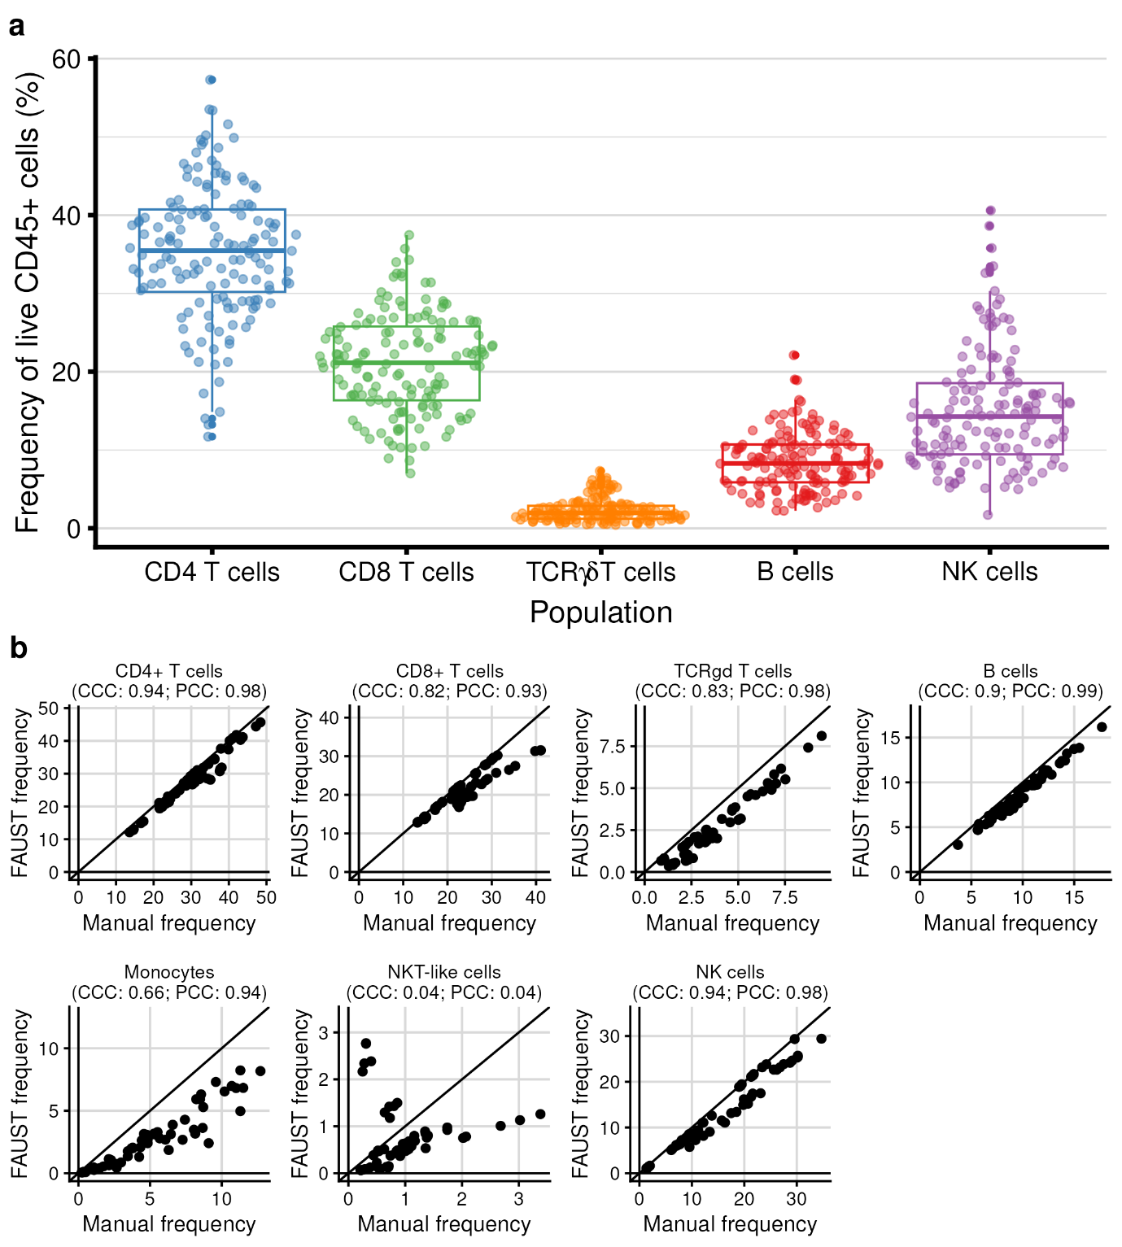
Supplementary Fig. 3: FAUST accurately identifies most cellular lineages. a Frequencies of major lymphocyte subsets identified by FAUST, expressed as a percentage of live CD45⁺ cells. b Correlations between FAUST-identified and manually-gated frequencies of major cell types in a subset of samples. The black line indicates the 45° line. CCC, concordance correlation coefficient; PCC, Pearson correlation coefficient. Values shown are the sample estimates.

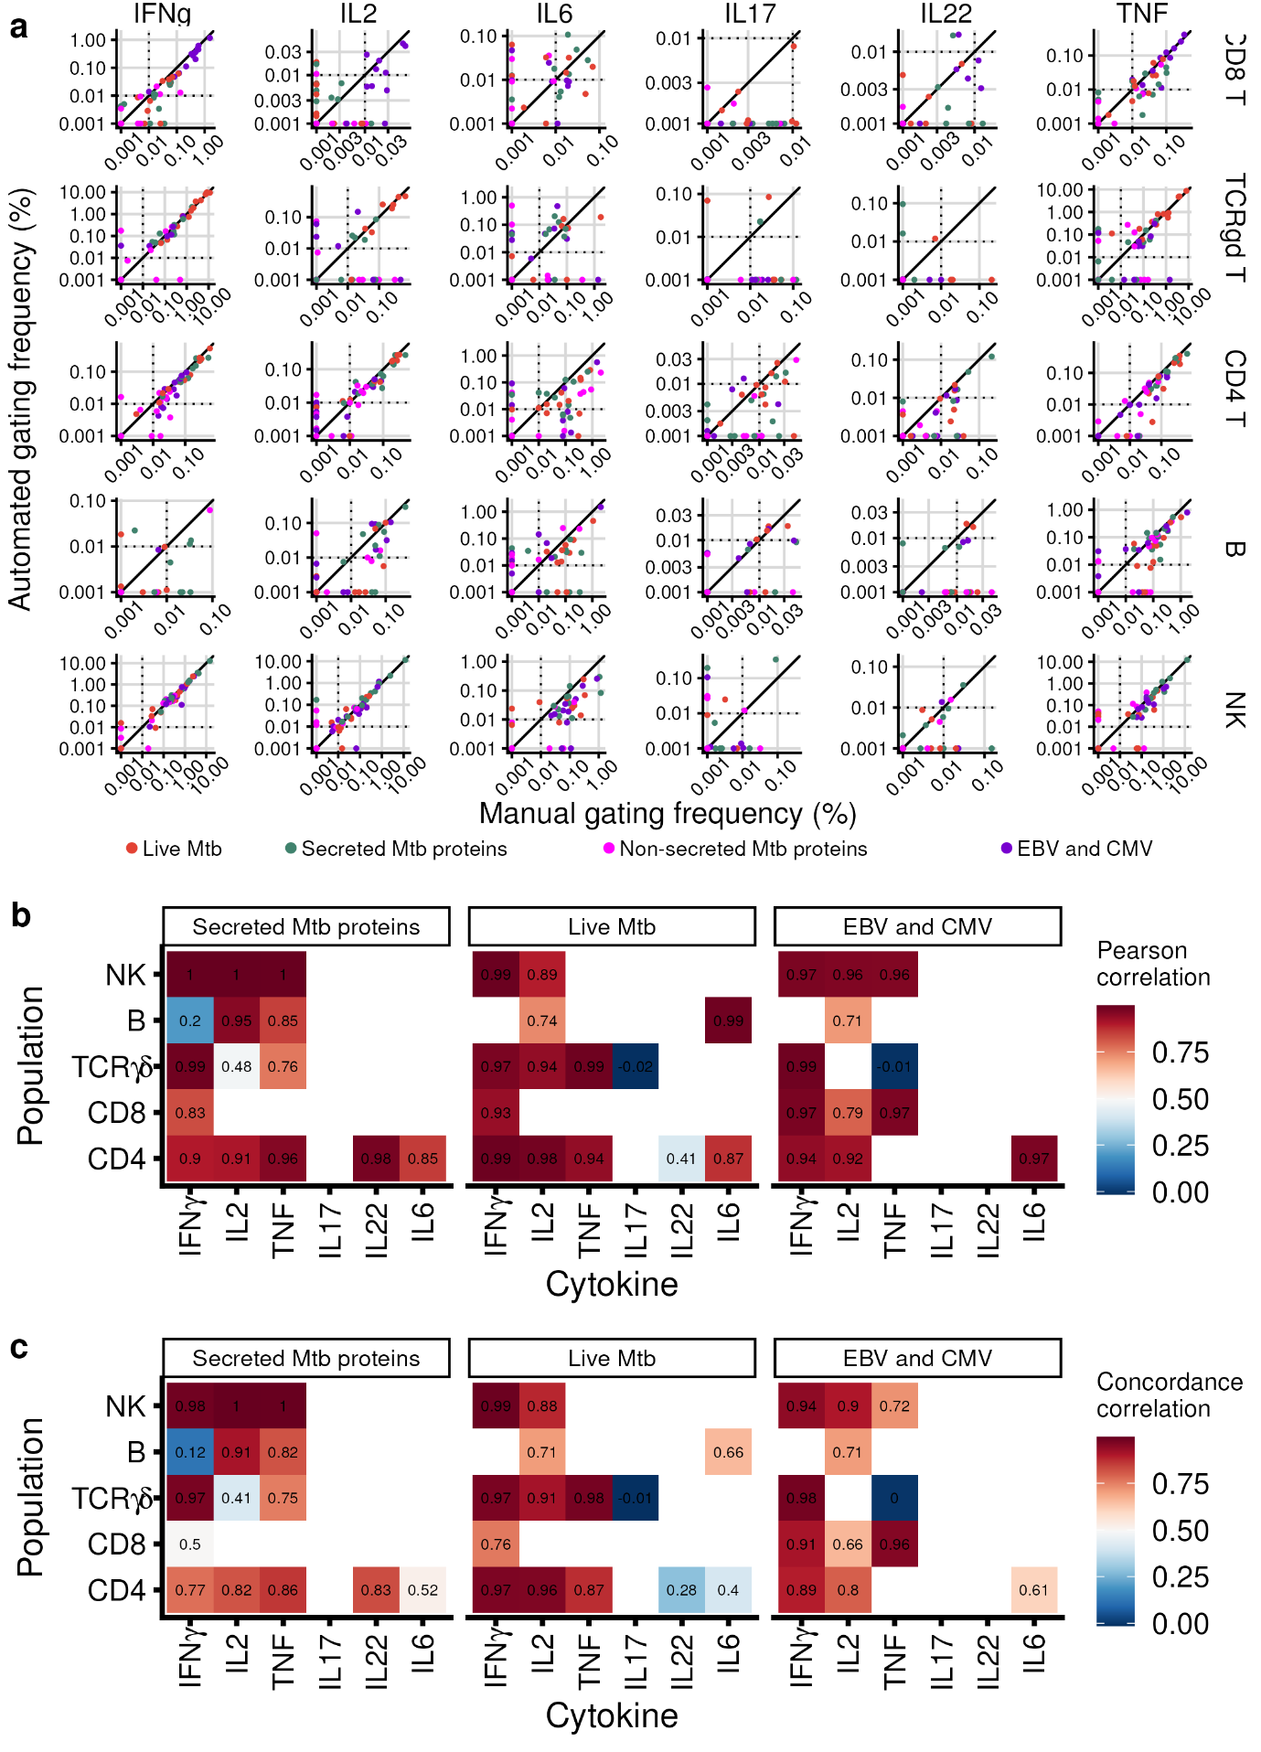
Supplementary Fig. 4: StimGate accurately identifies most cytokine-positive cells. a Comparison of automated (StimGate) and manually gated frequencies of cytokine-positive cells across cytokines, major lymphocyte populations, and stimulation conditions. The black line indicates the 45° line. b Pearson correlation between automated and manual background-subtracted frequencies across cytokines and major lymphocyte subsets, for cytokine-lymphocyte combinations with sufficient evidence of a response according to manual gating. c Concordance correlation between automated and manual background-subtracted frequencies across cytokines and major lymphocyte subsets, for cytokine-lymphocyte combinations with sufficient evidence of a response according to manual gating.
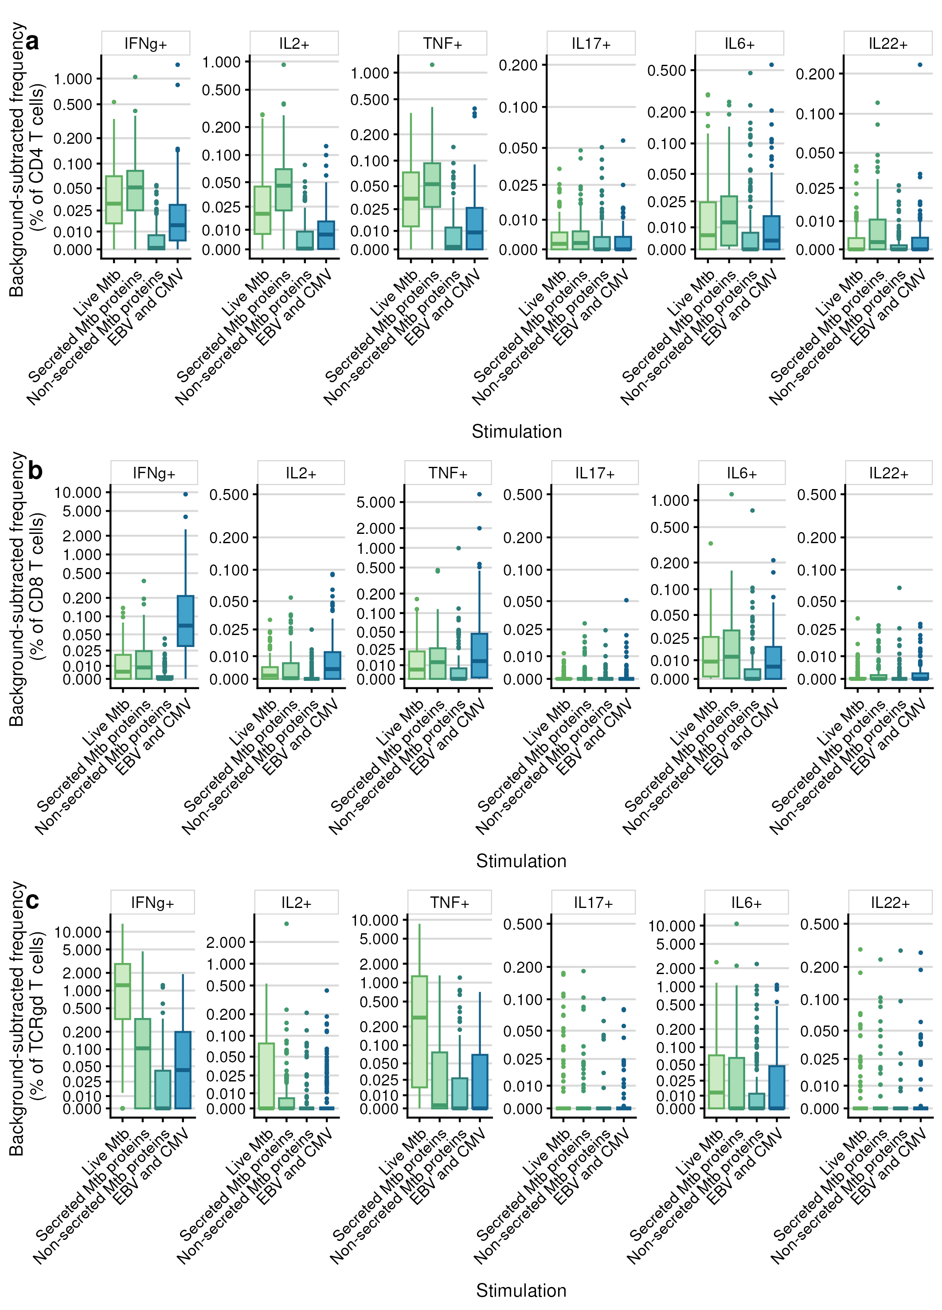
Supplementary Fig. 5: Background-subtracted frequencies of cytokine-positive cells across cytokines, stimulations and cell lineages for all samples. a CD4 T cells. b CD8 T cells. c TCRγδ T cells.
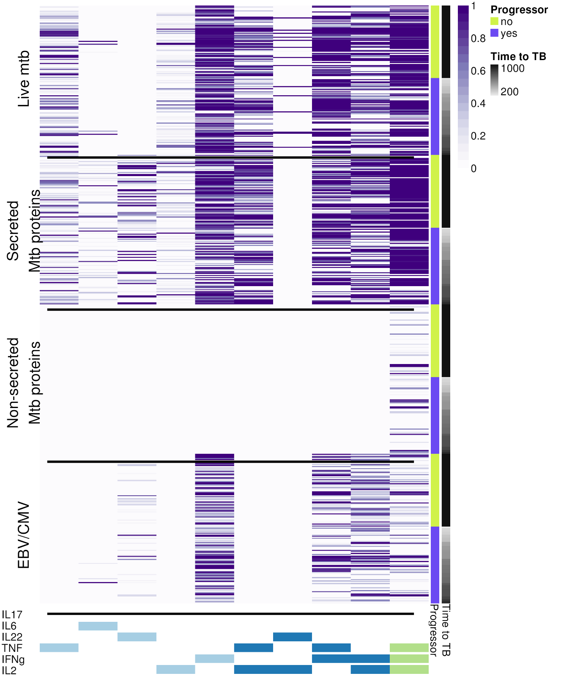
Supplementary Fig. 6: Cytokine co-expression profiles of Mtb-specific CD4 T cells across stimulations by progressor status. Heat map showing response probabilities for all cytokine combinations with sufficient evidence of a response. Colour indicates response probability, ranging from 0 (white) to 1 (purple).

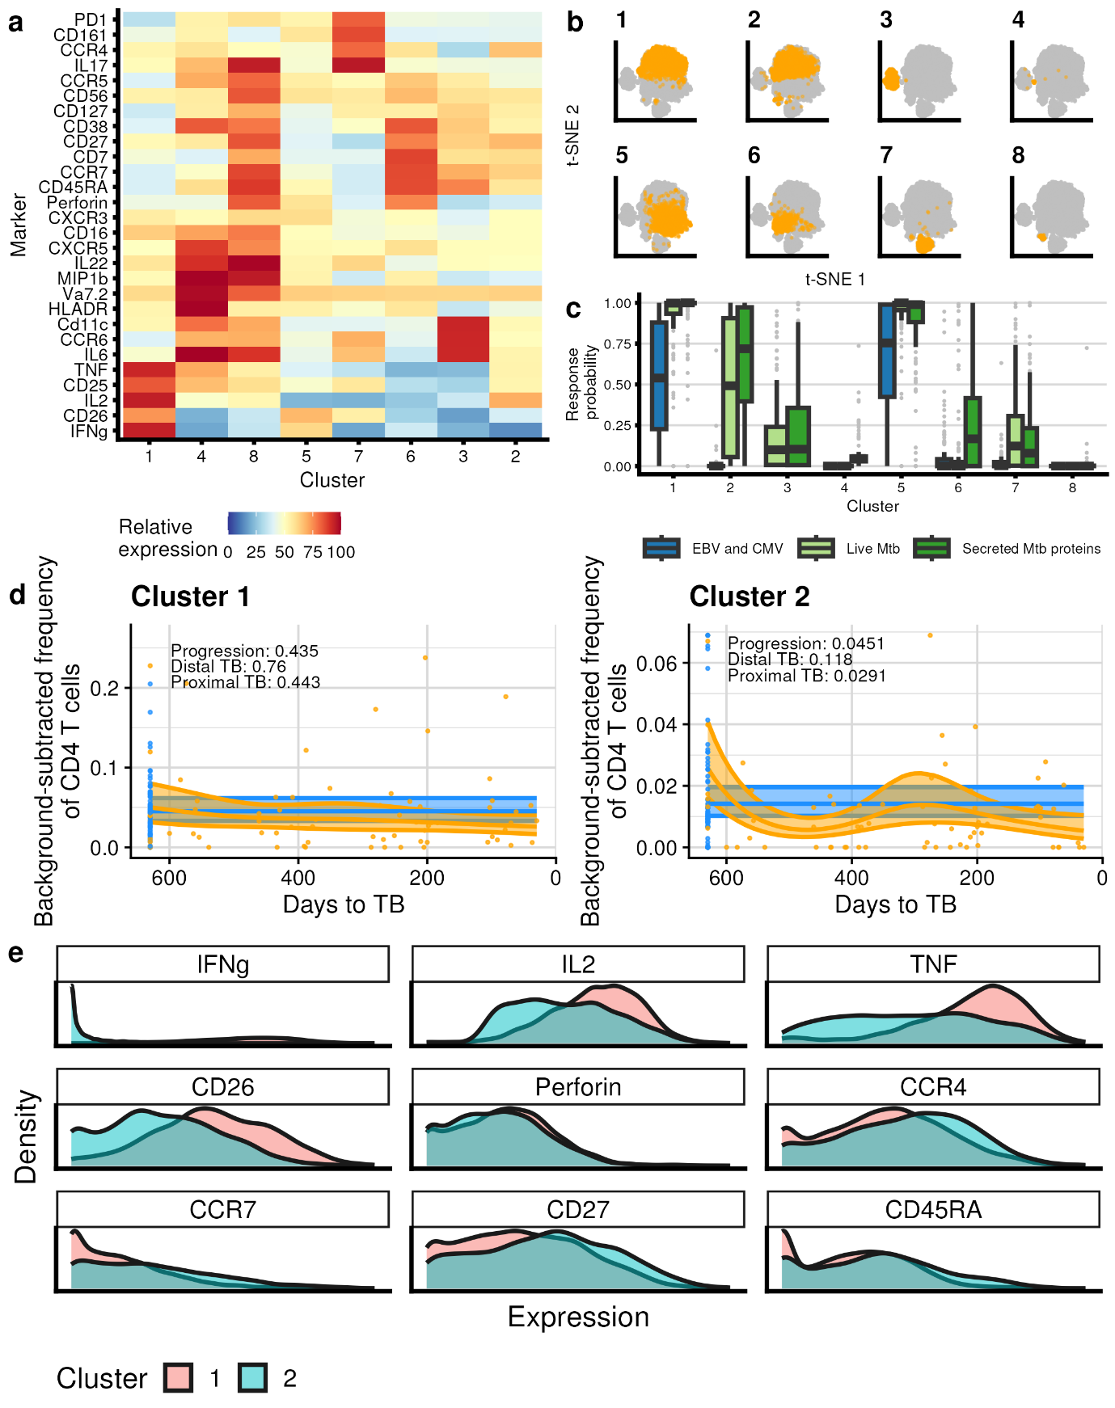
Supplementary Fig. 7: FlowSOM-based analysis of cytokine-positive CD4 T cells supports FAUST-based analysis. a Heat map of marker expression across FlowSOM clusters. Color for each marker and cluster represents the percentile rank (empirical cumulative distribution function value) of that cluster’s median expression relative to other clusters, with red indicating high expression and blue low expression. b Per-cluster cells overlaid on a t-SNE plot of all cytokine-positive CD4 T cells. c MIMOSA-estimated response probabilities across stimulations and FlowSOM clusters. d Modelled background-subtracted frequencies of antigen-specific FlowSOM clusters as a function of time to tuberculosis progression. The orange band denotes the 95% confidence interval for progressors, and the blue band that for controllers, extended across time to tuberculosis for ease of visual comparison. See the Fig. 2 caption for details. e Density plots showing marker expression distributions for FlowSOM clusters 1 and 2.
Supplementary Table 1: CyTOF panel. List of metal-conjugated antibody probes used in the CyTOF assay, grouped according to their experimental function. a Sample barcoding. b Extracellular staining. c Intracellular staining.
a
Metal | Probe | Clone | Origin
In113 | CD45 | Tu116 | In-house conjugation
In115 | CD45 | Tu116 | In-house conjugation
Pd108 | CD45 | Tu116 | In-house conjugation
Pd198 | CD45 | Tu116 | In-house conjugation
Bi209 | CD45 | Tu116 | Fluidigm

b
Metal | Probe | Clone | Origin
141Pr | CCR6 | 11A9 | Fluidigm
142Nd | Cd11c | 0.6 | In-house conjugation
143Nd | CD127 | A-019D5 | In-house conjugation
144Nd | CD27 | O323 | In-house conjugation
145Nd | CD4 | RPA-T4 | Fluidigm
147Sm | CD20 | 2H7 | Fluidigm
148Nd | CD16 | 3G8 | Fluidigm
149Sm | CD26 | M-A261 | In-house conjugation
151Eu | HLA-DR | G46-6 | In-house conjugation
152Sm | CD19 | HIB19 | Fluidigm
152Sm | TCRγδ | 11F2 | Fluidigm
153Eu | CCR4 | 205410 | Fluidigm
154Sm | CD3 | UCHT1 | Fluidigm
159Tb | CD161 | HP-3G10 | Fluidigm
160Gd | CD14 | M5E2 | Fluidigm
161Dy | CD33 | WM53 | In-house conjugation
162Dy | CD25 | M-A251 | In-house conjugation
163Dy | CXCR3 | G025H7 | Fluidigm
166Er | CD7 | M-T701 | In-house conjugation
167Er | CCR7 | 150503 | In-house conjugation
168Er | IgD | IA6-2 | In-house conjugation
168Er | CD8 | SK1 | Fluidigm
169Tm | CD45RA | HI100 | Fluidigm
170Er | CCR5 | 2D7/CCR5 | In-house conjugation
171Yb | CXCR5 | RF8B2 | Fluidigm
172Yb | Vα7.2 | 3C10 | In-house conjugation
173Yb | PD1 | EH12.2H7 | In-house conjugation
174Yb | CD38 | HIT2 | In-house conjugation
176Lu | CD56 | HCD56 | Fluidigm

c
Metal | Probe | Clone | Origin
155Gd | MIP1b | 24006 | In-house conjugation
158Gd | IL2 | MQ1-17H12 | Fluidigm
165Ho | IFNγ | B27 | Fluidigm
150Nd | IL22 | 22URTI | Fluidigm
164Dy | IL17A | N49-653 | Fluidigm
175Lu | Perforin | BD-48 | Fluidigm
156Gd | IL6 | MQ2-13A5 | Fluidigm
146Nd | TNF | Mab11 | Fluidigm

Supplementary Table 2: CD45-based barcoding scheme. Two samples - either from the same participant at different timepoints or from different participants - were simultaneously analysed by CyTOF across five stimulation conditions. Distinct combinations of metal-conjugated anti-CD45 isotypes were used to barcode each sample, allowing unique identification of every sample-stimulation pair. a Barcoding scheme for the first sample. b Barcoding scheme for the second sample.
a
 | Stimulation
Marker-Channel | Unstimulated | Secreted Mtb proteins | Non-secreted Mtb proteins | Live Mtb | EBV/CMV
CD45–In113
CD45–In115
CD45–Pd108
CD45–Pd198
CD45–Bi209

b
 | Stimulation
Marker-Channel | Unstimulated | Secreted Mtb proteins | Non-secreted Mtb proteins | Live Mtb | EBV/CMV
CD45–In113
CD45–In115
CD45–Pd108
CD45–Pd198
CD45–Bi209

Supplementary Table 3: Lineage definitions. FAUST assigned labels to clusters based on all markers used to partition. Cell subsets corresponding to specific lineages were defined as those whose FAUST label matched the marker expression pattern shown below. Markers without an indicated level were not used for lineage assignment.
 | Marker
Population | CD3 | CD4 | CD8-IgD | TCRγδ | CD20 | CD33 | CD14 | CD16 | HLADR | CD7
CD4 T | + | + | - | - | - | - | -
CD8 T | + | - | + | - | - | - | -
NKT | + |  |  | - | - | - | - | +
TCRγδ | + |  |  | + | - | - | -
NK | - |  |  | - | - | - | - |  |  | +
Monocyte | - |  | - | - | - | + | + |  | +
B | - |  |  | - |  | - | - |  | + | -

Supplementary Note 1: Members of the Adolescent Cohort Study team.
Fazlin Kafaar¹, Leslie Workman¹, Humphrey Mulenga¹, Thomas J. Scriba¹, E. Jane Hughes¹, Nicole Bilek¹, Mzwandile Erasmus¹, Onke Nombida¹, Ashley Veldsman¹, Yolundi Cloete¹, Deborah Abrahams¹, Sizulu Moyo¹, Sebastian Gelderbloem¹, Michele Tameris¹, Hennie Geldenhuys¹, Willem Hanekom¹, Gregory Hussey¹, Rodney Ehrlich² Suzanne Verver³, Larry Geiter⁴
¹South African Tuberculosis Vaccine Initiative, Institute of Infectious Disease and Molecular Medicine and Division of Immunology, Department of Pathology, University of Cape Town, Cape Town, South Africa
²School of Public Health and Family Medicine, University of Cape Town, Cape Town, South Africa.
³KNCV Tuberculosis Foundation, The Hague, and Amsterdam Institute of Global Health and Development, Academic Medical Centre, Amsterdam, the Netherlands.
⁴Aeras, Rockville, Maryland, USA.

