Supplementary Information
Origin of the p-type characteristics of organic semiconductors
Liqiang Li^{1,2#}, Yinan Huang^{1#}, Xiaosong Chen¹, Kunjie Wu², Yajing, Sun¹, Zhongwu Wang¹, Yongxu Hu¹, Liqian Yuan¹, Shuguang Wang¹, Jie Li¹, Deyang Ji¹, Xiaotao Zhang¹, and Wenping Hu^{1,2*}
¹Tianjin Key Laboratory of Molecular Optoelectronic Sciences, Department of Chemistry, Institute of Molecular Aggregation Science, Tianjin University, Tianjin 300072, China
²Joint School of National University of Singapore and Tianjin University, International Campus of Tianjin University, Binhai New City, Fuzhou 350207, China
³Suzhou Institute of Nano-Tech and Nano-Bionics (SINANO), Chinese Academy of Sciences, Suzhou, Jiangsu 215123, China
#These authors contributed equally to this work
Correspondence and requests for materials should be addressed to W.H.
(huwp@tju.edu.cn)

Table of contents
Section 1. Fundamental differences between our work and the previous reports
Section 2. Home-made in-situ system
Section 3. Details of the de-doping process
Section 4. Conductivity by two-terminal measurement
Section 5. Output characteristics in the processes of de-doping and re-doping
Section 6. Nondestructive de-doping by low-power plasma treatment
Section 7. Re-doping process in different gases
Section 8. Analysis with X-ray photoelectron spectroscopy
Section 9. Temperature dependence of susceptibility in EPR measurements
Section 10. Theoretical calculation of oxygen doping
Section 11. Simplified model to explain the oxygen doping and de-doping
Section 12. Re-doping process with different wavelengths
Section 13. Proposed re-doping route
Section 14. Stability investigation of the trace oxygen doping
Section 15. EPR signal of purified organic semiconductors

Section 1. Fundamental differences between our work and the previous reports
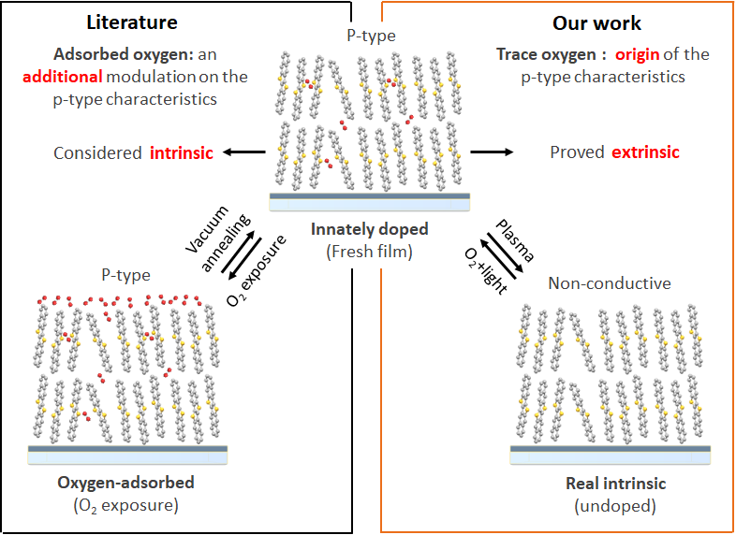
Supplementary Fig. 1∣Diagram of the fundamental differences between our work and the OSC oxygen-doping literature.
Although oxygen doping in organic electronics has been reported extensively in the literature¹⁻¹⁶, the type of oxygen doping investigated is exclusively that which is adsorbed on the surface or boundary of organic semiconductor (OSC) film. Notably, this can be easily removed by conventional vacuum annealing or sublimation methods^{1,5}. However, no previous works have reported or characterized the existence of trace oxygen (about 10⁻¹⁵ cm⁻³) that is innately incorporated in the lattice nor a method to remove the trace oxygen (the focus of this work). Therefore, through the reported so-called de-doping method (generally referred to the vacuum annealing), p-type OSCs still show p-type charge transporting properties (Supplementary Fig. 1). On this basis, in the literature the p-type characteristics are wrongly considered to be intrinsic for OSCs (i.e., OSCs are wrongly considered to be undoped) and oxygen doping is considered merely an additional modulation on the ‘inherent’ p-type characteristics. This is the cause of some perplexing observations and the fundamental reason why some classical physical models use in the field are invalid for organic devices.
In contrast, we developed an unprecedented de-doping method (low power plasma treatment) to remove the lattice-incorporated trace oxygen, leading to the complete disappearance of p-type characteristics (Supplementary Fig. 1). This fact, combined with other characterization and analysis, for the first time reveals that the innate trace amounts (about 10¹⁵ cm⁻³) of oxygen-induced organic radical cations (OIORCs) are inherent in OSCs as the innate hole carriers, and that this is the origin of the, supposedly intrinsic, p-type characteristics behavior.
We acknowledged that the oxygen in the lattice (Fig. 2b, the plot of TOF-SIMS) and the oxygen adsorbed on the surface or boundary (Supplementary Fig. 8b, the data of XPS) have the similar doping state (i.e., forming superoxide anion and organic semiconductor radical cations). However, the former plays a decisive role in the p-type charge transporting characteristics, and the latter is just an external factor amenable to tuning.
In our view, the discovery of decisive role of trace oxygen in the lattice will exert a great and revolutionary effect on the field of organic electronics. There is historical precedence for this; in 2014, Shuji Nakamura was awarded the Nobel Prize in Physics for the invention of efficient blue light-emitting diodes (LED). One key breakthrough was the realization of p-type gallium nitride (GaN) film by a method (low power electron irradiation or thermal annealing in N₂ over 600 ºC) to remove trace hydrogen, because it was revealed that the trace hydrogen in GaN film passivates acceptors and thus enables GaN to only show n-type characteristics¹⁷. The hydrogen in GaN is precisely analogous to oxygen in OSCs, therefore, understanding the key role of the trace impurities and developing a method to remove them is highly important for semiconductors and electronic devices.
In addition, despite the fact that many studies have found that irradiation can accelerate the adsorption and doping of oxygen^{1,5,16}, due to the lack of a de-doping method for the removal of lattice-incorporated oxygen, the modulation of the vital parameters of OSCs and devices could not be realized by the re-doping method alone. The combination of de-doping (low power plasma) and re-doping methods allows for the tuning of vital parameters such as the threshold voltage, conductivity, and mobility, and even the switching of p-type OSCs to n-type OSCs, and vice versa, which will expand the property space for all known OSC materials.

Section 2. Home-made in-situ system
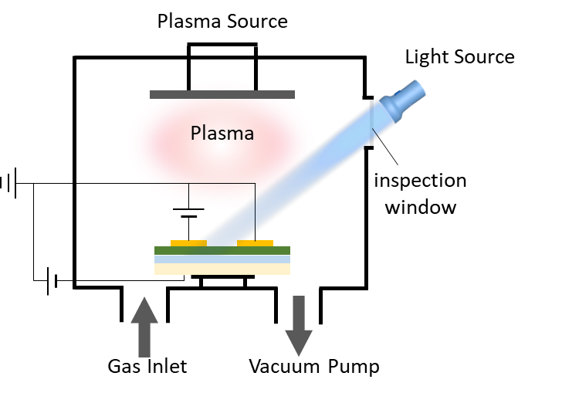
Supplementary Fig. 2∣Diagram of the home-made in-situ system.
The home-made system consists of three main components: electrical measurement modules, a vacuum system (environmental control), and a plasma source, all connected to an N₂ glovebox. Two types of semiconductor device analyzers (an Agilent B1500A and a PDA FS380) were used for electrical measurement through the flange connectors. The vacuum system includes a vacuum chamber with an inspection window, pump package, and pneumatic control equipment. The plasma source is an inductively coupled plasma, which can be operated in a wide pressure range with an adjustable output power between 0-300 W.
Section 3. Details of the de-doping process
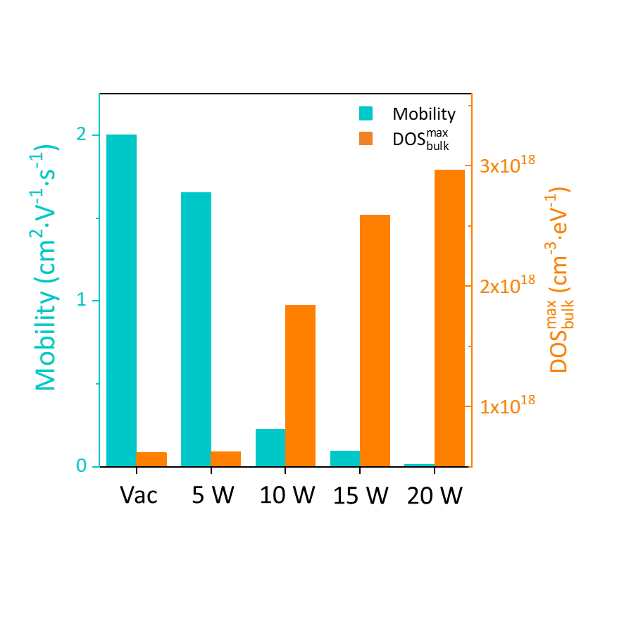
Supplementary Fig. 3∣Variation of the mobility and density of trap states (DOS) in bulk with the increase of the plasma power in the de-doping process.
Mobility in the saturation region was extracted by field-effect method:
$$I_{ds}=\frac{W}{2L}μC_{i}{(V_{g}-V_{th})}^{2} (1)$$
where W and L are width and length of the conducting channel, respectively, and C_{i} is the unit-area capacitance of the dielectric layer.
The Trap DOS was estimated by subthreshold swing, which is expressed as^{18,19}:
$$S≡\left(ln10\right)\frac{{dV}_{g}}{d(lnI_{ds})}=\left(ln10\right)\left(\frac{C_{i}{+C}_{t}}{C_{i}}\right)\frac{kT}{q} (2)$$
where C_{i} and C_{t} are the capacitance of the dielectric layer and traps, respectively. While the Fermi energy is pushed towards the transport level, trap states are filled. This process is equivalent to the charging of a capacitor, and the capacitor of the OSC film can be written as²⁰:
$$C_{t}=q^{2}{(D}_{it}+{t_{sc}D}_{bulk}) (3)$$
where D_{bulk} and D_{it} are density per volume and energy of the bulk trap and the interface trap, respectively, and 𝜀_{sc} is the permittivity of the semiconductor. The maximum density of the bulk trap can be estimated by setting D_{it} to zero¹⁹:
$$D_{bulk}^{max}=\frac{C_{i}}{t_{sc}q^{2}}(\frac{qS}{kTIn\left(10\right)}-1) (4)$$

Section 4. Conductivity by two-terminal measurement
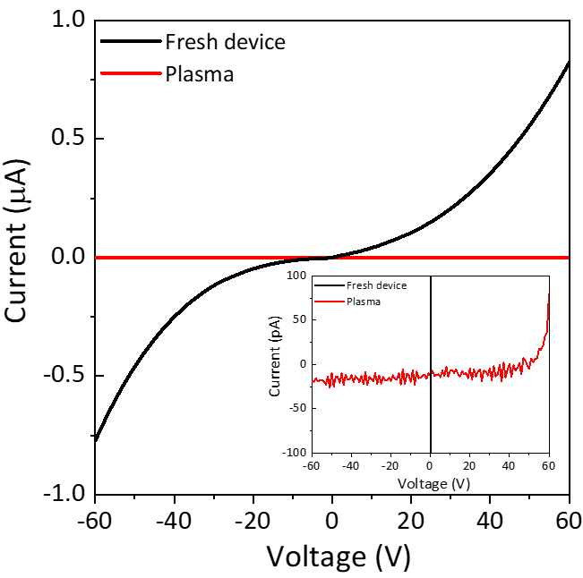
Supplementary Fig. 4∣Conductivity of the DNTT device by two-terminal measurement before and after plasma treatment. Insert shows the partially enlarged details.

Section 5. Output characteristics in the processes of de-doping and re-doping
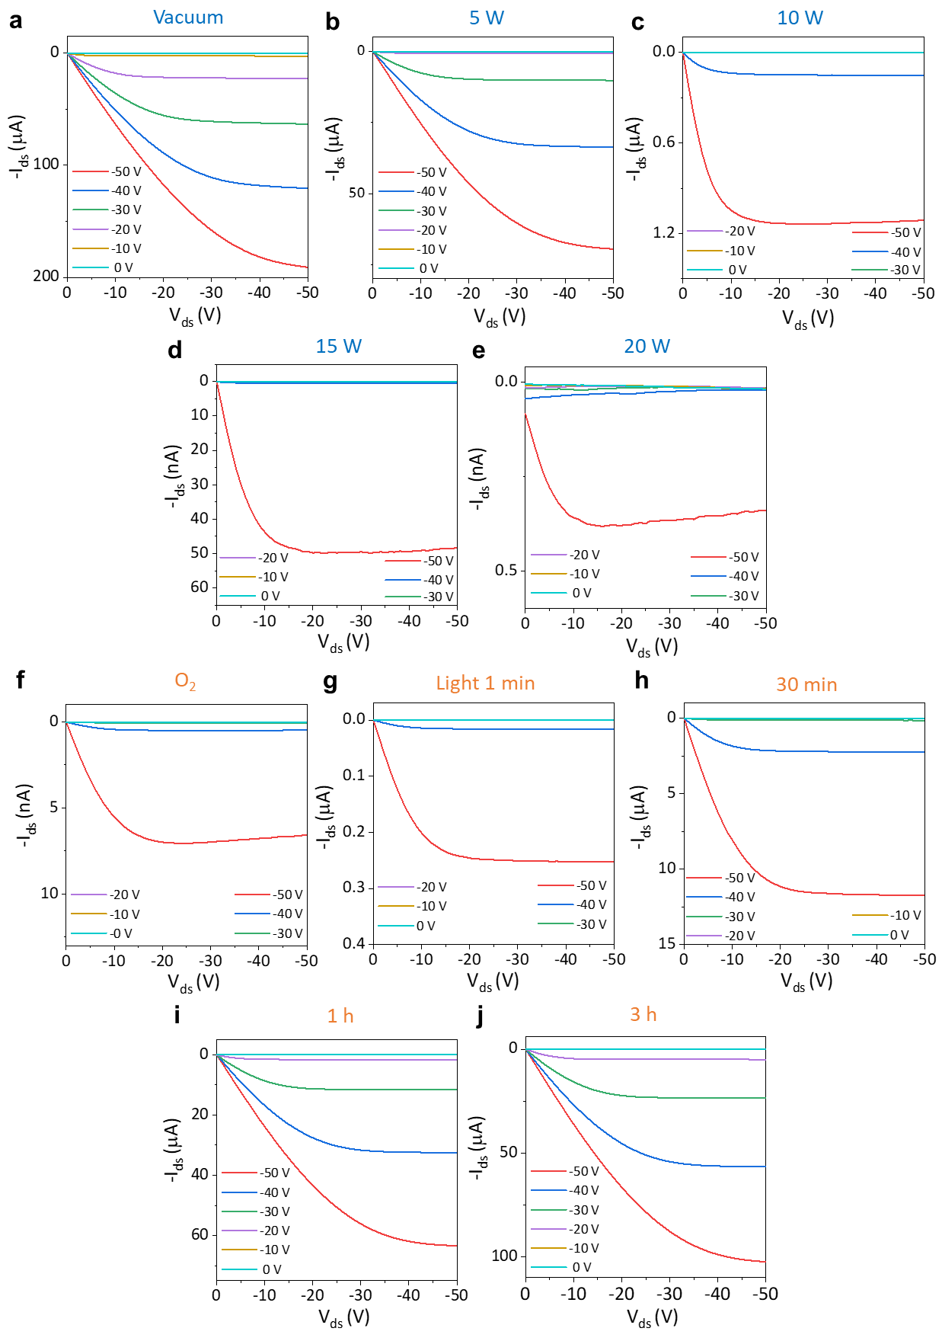
Supplementary Fig. 5∣Evolution of the output curves of the DNTT OFET in the processes of plasma treatment (a-e) and illumination in O₂ (f-j).
The DNTT OFET shows good output characteristic curves for 6 h in a high vacuum of 10⁻⁴ Pa. After the low-power plasma treatment for a short period (see Methods), the output current decreased. With the increase of the plasma power, the output current continuously decreased and the pinch-off point became noticeably smaller, suggesting conductivity and threshold voltage deterioration. The bias stress was observed in Supplementary Fig. 5d and e, which indicates the increase of the density of trap states. Finally, after high power plasma treatment, the output characteristics were difficult to observe even at high gate voltage. When 1 atm oxygen was filled in the system for 5 min, the output characteristics of the OFET recovered slightly (Supplementary Fig. 5f). By further extending the time of exposure to oxygen, the rate of recovery slowed. Interestingly, when the OFET was illuminated by a full-spectrum Xe lamp in an oxygen atmosphere, its output characteristics rapidly recovered, almost to the original level after 3 hours (Supplementary Fig. 5g-i).
Section 6. Nondestructive de-doping by low-power plasma treatment
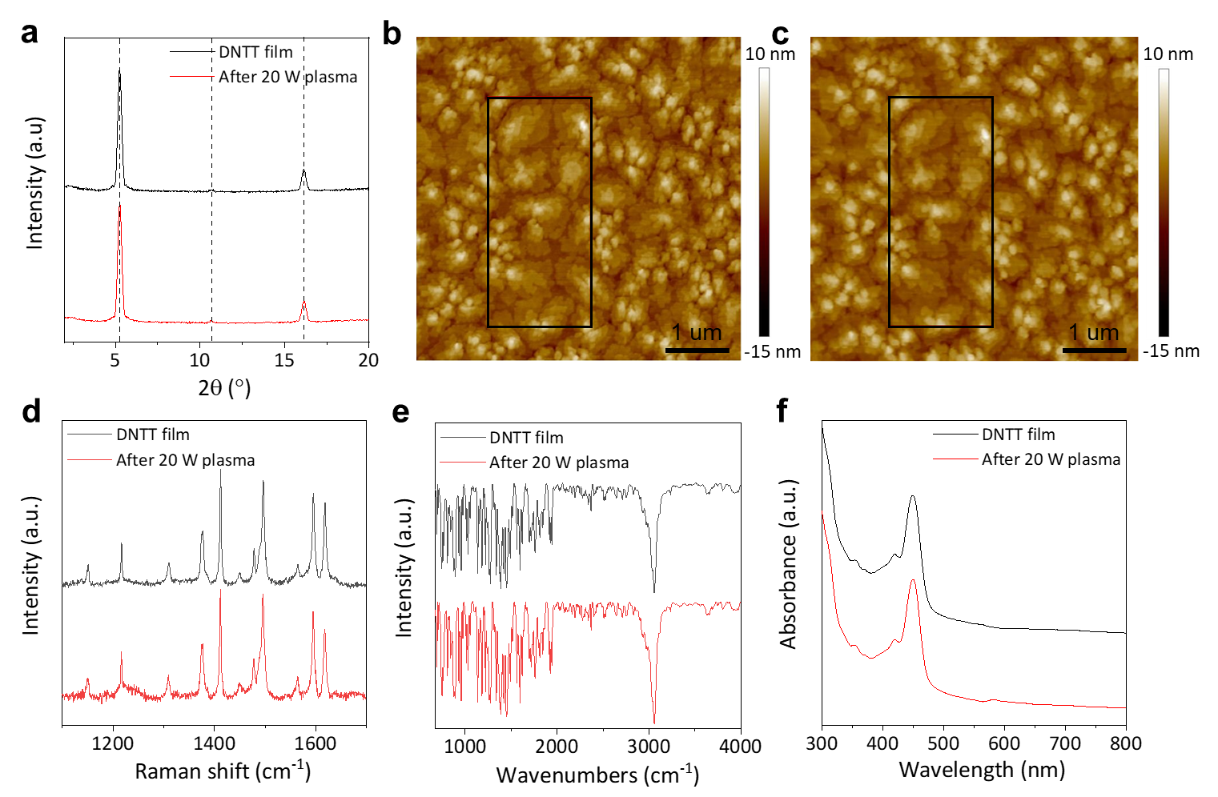
Supplementary Fig. 6∣ Morphology, physical phase, and chemical structure characterizations of the DNTT film before and after plasma treatment. a, X-ray diffraction spectra. b, c, Images of surface morphology by atomic force microscope. d, Raman spectra. e, IR spectra. f, UV-Vis absorption spectra.
These results of morphology, physical phase, and chemical structure characterizations show the negligible changes before and after plasma treatment, which suggests that the low-power plasma treatment should be nondestructive for the aggregation and molecular structures of OSCs.
Section 7. Re-doping process in different gases
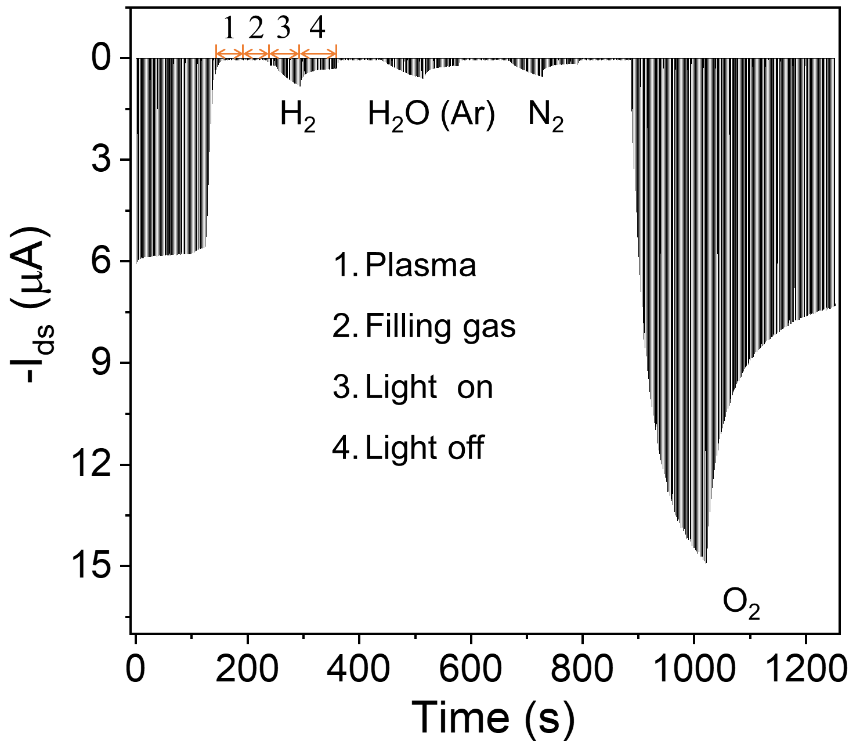
Supplementary Fig. 7∣Switching cycle of the ultrathin (about 5 nm) DNTT OFET in the multiple de-doping and re-doping processes under illumination in H₂, H₂O (Ar), N₂, and O₂.
Switching cycle of the ultrathin (about 5 nm) DNTT OFET in the multiple de-doping and re-doping processes was measured by a PDA FS380 (semiconductor device analyzers). V_{ds} was set as -30 V and V_{gs} was switched from 0 to -30 V at 1 s intervals. The on-state current rapidly decreased after plasma treatment and almost no recovery was observed when the gases were introduced. The on-state current recovered completely when illumination in O₂, but only showed a slight recovery when illuminated in H₂, H₂O (Ar was used as carrier gas through a gas-washing bottle with water to transfer H₂O), and N₂, which might be attributed to the residual O₂ in these gases (note that oxygen in present at ppm level in the purified gas (99.999%)).
Section 8. Analysis with X-ray photoelectron spectroscopy
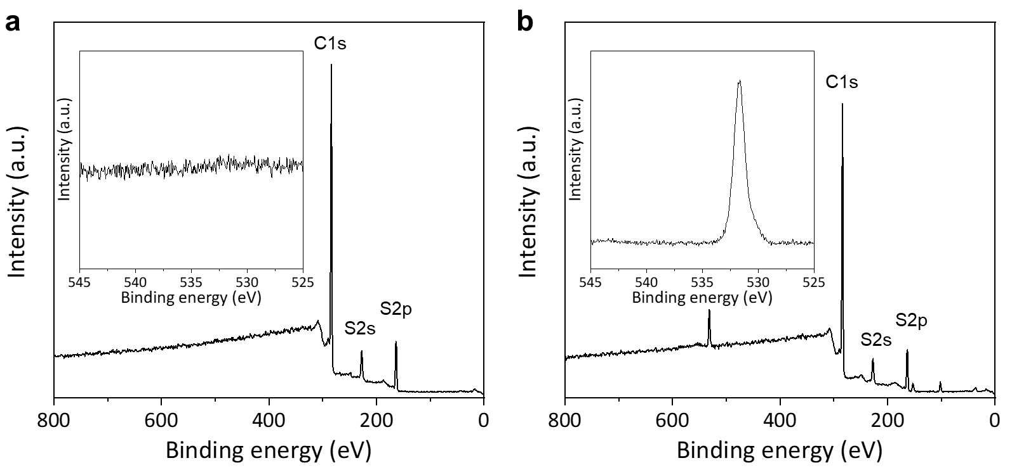
Supplementary Fig. 8∣X-ray photoelectron spectroscopy (XPS) of the DNTT films. a, the fresh film. b, the air-exposed film. Insert is the fine spectra of oxygen (around 532 eV).
The fresh DNTT film was sealed in a glass bottle filled in an N₂ glovebox and transferred into an X-ray photoelectron spectrometer that connects to an Ar glovebox. XPS of the fresh DNTT film showed no oxygen-relative peak. Considering the detection limit of XPS (≥ 0.1%), the result means that the innate oxygen in OSCs is a trace amount.
Section 9. Temperature dependence of susceptibility
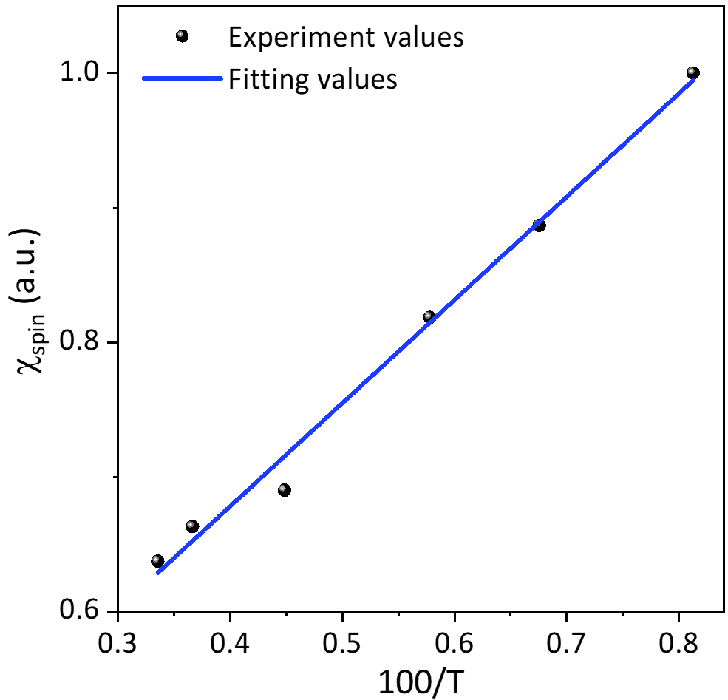
Supplementary Fig. 9∣Temperature dependence of susceptibility ꭕ_{spin}.
Susceptibility ꭕ_{spin} was obtained by twice integrating the first-derivative of the EPR signal of DNTT. The curve of ꭕ_{spin} versus 100/T shows a linear relationship, which implies that the ꭕ_{spin} obeys the Curie law²¹:
$$χ_{Curie}=\left(\frac{μ_{B}^{2}}{3kT}\right)N_{spin}g^{2}S\left(S+1\right) (5)$$
where k, N_{spin}, g, and S are the Boltzmann constant, total spin concentration, g-factor and the spin quantum number (S = 1/2). N_{spin} can be calculated from the Curie law by using diphenyl-1-picrylhydrazyl (DPPH) as a standard spin counting reference.

Section 10. Theoretical calculation of oxygen doping
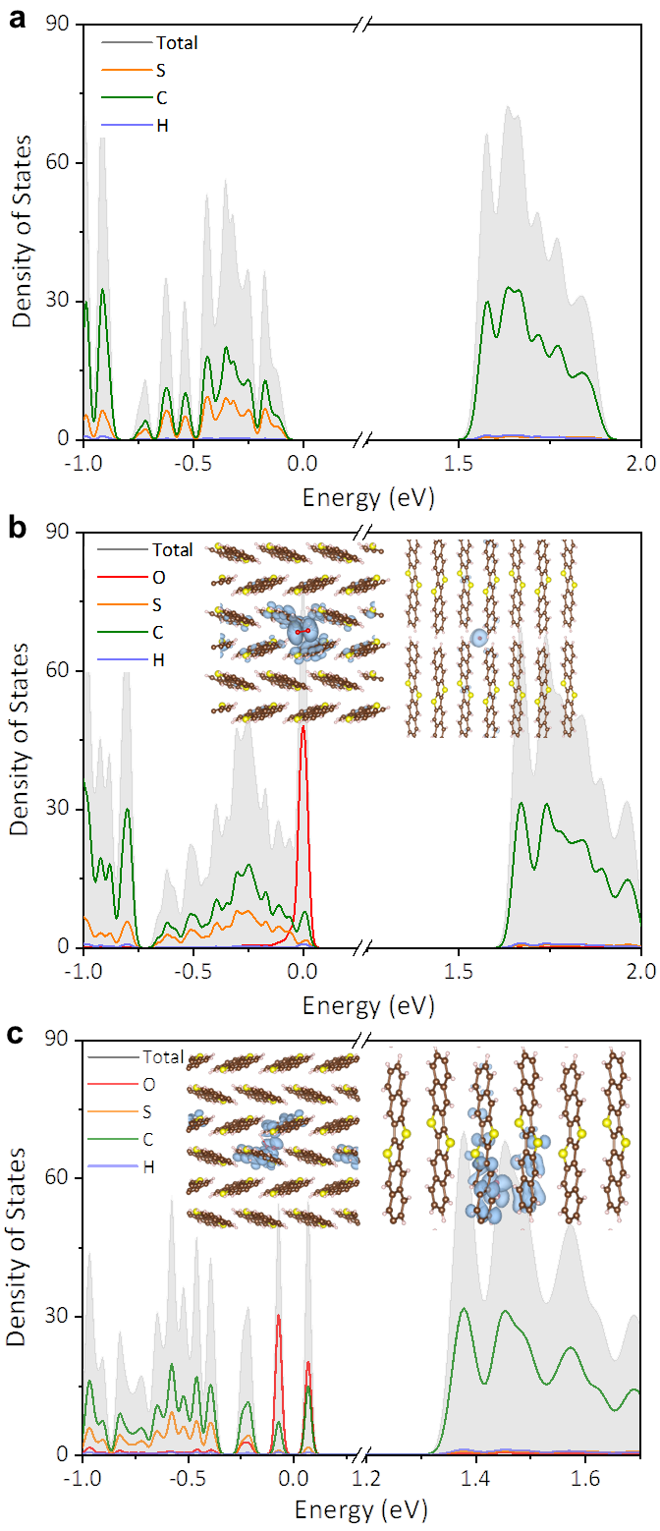
Supplementary Fig. 10∣Density of states (DOS) of DNTT. a, Intrinsic DNTT. DNTT with oxygen incorporation into the interstitial positions of molecular interlayers, (b) and molecular intralayers (c). Inserts are sketches of the occupancy sites of oxygen in the lattice of DNTT, and the yellow regions represent the spatial distribution of charge.
The occupancy sites of oxygen in the lattice of DNTT were investigated by first-principle molecular dynamics (FMD). According to the energy minimization principle, oxygen prefers the interstitial positions of molecules interlayers (insert in Supplementary Fig. 10b) and molecular intralayers (insert in Supplementary Fig. 10c), respectively.
Density functional theory (DFT) with the Perdew–Burke–Ernzerhof (PBE) exchange-correlation functional was employed to evaluate the DOS and charge spatial distribution of DNTT before and after the incorporation of oxygen. The results show that the incorporation of oxygen introduces the localized states distributed close to the edge of the HOMO and makes the extended tails shift towards higher energy levels (i.e., decreasing the relative distance between E_{F} and the HOMO), which suggests that oxygen plays the role of acceptor doping in OSCs.
Section 11. Simplified model to explain the oxygen doping and de-doping
Donor-like traps. The static/dynamic disorder, impurity, etc. in OSC devices usually cause trap states distributed in the forbidden band²²⁻²⁴. Some trap states distributed below the Fermi level (E_{F}) are generally occupied by electrons and show electrical neutrality. When E_{F} moves down across these trap states, they will donate electrons and thus are positively charged (i.e., trap states are emptied), a process that looks just like capturing hole carriers. These states are called as donor-like traps^{18,25,26}. Donor-like traps can pin E_{F}. E_{F} cannot be moved to the HOMO by doping or gate voltage until these traps are “filled”.
Metal/semiconductor interface. A Schottky junction generally forms at metal/semiconductor interfaces in organic photoelectric devices because of mismatched energy levels^{27,28}, interface dipoles^{29,30}, and surface states³¹, etc. The width of the depletion layer (W_{D}) can be described as¹⁸:
$$W_{D}=\sqrt{\frac{2ε_{s}}{qN_{A}}\left(φ_{bi}-V-\frac{kT}{q}\right)} (6)$$
where 𝜀_{s} and N_{A} are the relative dielectric constant and acceptor density (i.e., hole carrier density) of OSCs, respectively, and 𝝋_{bi} is the built-in potential. Carriers are injected into OSCs across junctions mainly by thermionic emission (TE) and thermionic field emission (TFE) at room temperature^{18,32,33}. The former is governed by the height of the Schottky barrier, and the latter is highly dependent on W_{D}.
Oxygen doping. Oxygen acts as an acceptor in OSCs and its states distribute along the edge of the HOMO. Oxygen doping pre-empties the donor-like traps and thus eliminates the E_{F} pinning, which renders the E_{F} close to the edge of the HOMO, leading to mobile hole carriers in the HOMO. According to the multiple trapping and release (MTR) model³⁴, mobility should increase, benefiting from the pre-emptying of traps:
$$μ_{eff}=μ_{0}\left(τ/(τ+τ_{tr})\right) (7)$$
where μ_{eff} and μ₀ are the effective and intrinsic mobility, respectively, and τ and τ_{tr} are the time that a hole carrier propagates between the traps, and spends within a trap, respectively. Ideally, the conductivity of OSCs is dependent on carrier density and mobility (σ = neμ). However, the conductivity by electrical measurement is inevitably affected by injection efficiency ($σ=\frac{L}{S(R_{ch}+2R_{C})}$, where L and S are length and cross-sectional area of the channel, and R_{ch} and R_{C} are channel resistance and contact resistance). The effect of oxygen doping on charge injection is reflected in W_{D}. In terms of equation (6), the increased carrier density by oxygen doping reduces W_{D}, which facilitates carrier injection through TFE. Accordingly, the conductivity of the OSC is improved.
De-doping. After plasma treatment, oxygen doping is eliminated, shifting E_{F} away from the HOMO and broadening the depletion layer. As a result, the hole carriers decrease sharply and TFE is suppressed, which causes a decrease in conductivity and off-state current. Furthermore, the de-doping makes the pre-emptied donor-like trap states occupied, and the carrier transport is strongly impeded by the trapping effect. Subsequently, the subthreshold swing deteriorates and mobility decreases. At this point, even if a large gate voltage is applied, E_{F} is not close enough to the HOMO due to the larger energy difference and the E_{F} pinning effect of the traps, and hence the threshold voltage dramatically increases. The above analyses qualitatively explain the decline and the ultimate disappearance of p-type characteristics.
Section 12. Re-doping process with different wavelengths
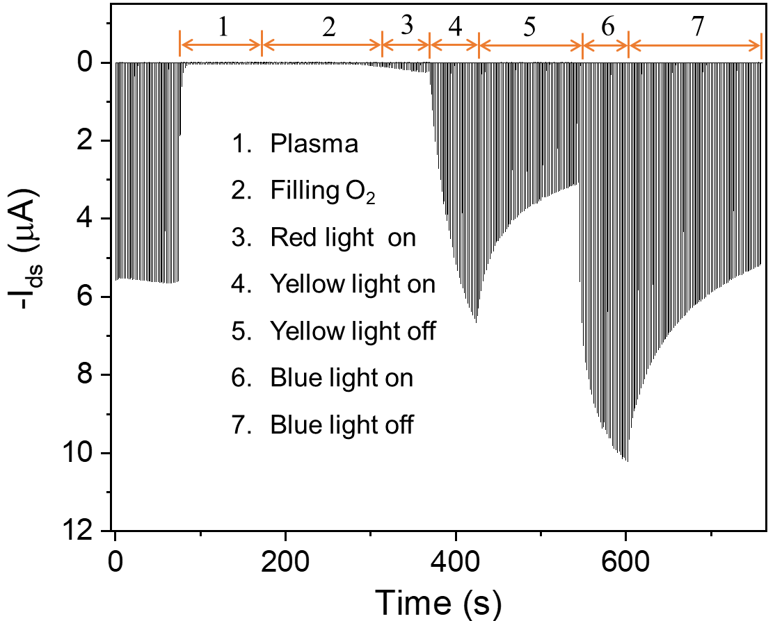
Supplementary Fig. 11∣Switching cycle of the ultrathin (about 5 nm) DNTT OFET in the de-doping and re-doping process under illumination with different wavelengths.
The method of electrical measurement is as described in Supplementary Section 7. The power of the LED light with different wavelengths was set to 15 W, and exposure time was controlled to be about 1 min. As shown in Supplementary Fig. 11, after plasma treatment, the on-state current rapidly decreased. It shows a little recovery under illumination in O₂ with the red light (760~622 nm). After illumination by the yellow light (597~577 nm), the on-state current significantly recovers to half of the original level. Following further illumination with the blue light (450~435 nm), the current almost completely returns to its initial value. The degree of recovery of the DNTT (bandgap absorption of about 450 nm) OFET are blue (450~435 nm) > yellow (597~577 nm) > red (760~622 nm). This implies that bandgap absorption efficiently produces excitons and thus is more beneficial to the re-doping process.

Section 13. Proposed re-doping route
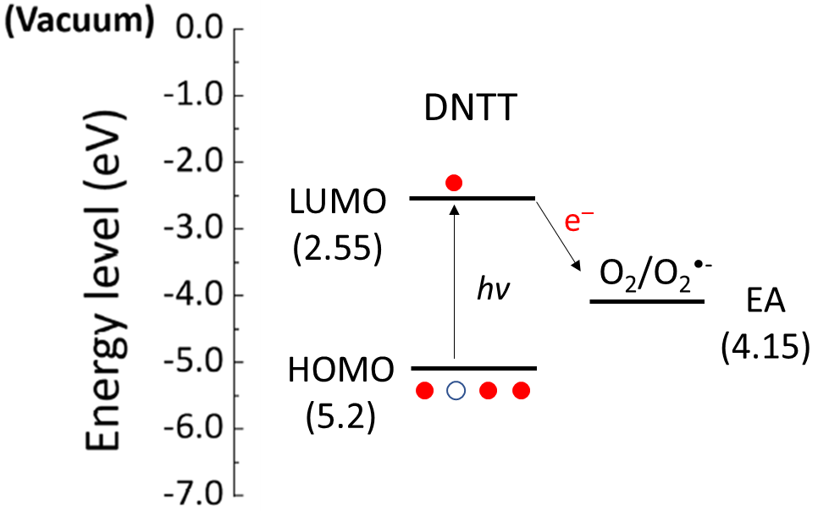
Supplementary Fig. 12∣Proposed re-doping route. Energy band diagram of DNTT and electronic affinity (EA) of O₂.
The HOMO level (about −5.2 eV) of DNTT was estimated by the equation E_{HOMO} = 21.22 – (E_{cut-off} – E_{F}) from Ultraviolet Photoelectron Spectroscopy (UPS). The LUMO level (about −2.55 eV) was estimated by subtracting the optical band gap (E_{g} was obtained from the UV-Vis absorption spectrum) from the HOMO level. EA of O₂ (i.e., the reduction potential of O₂/O₂^{•-}) is about -4.15 eV^{16,35}. The deductive re-doping route is that an OSC molecule is photoexcited, i.e., an electron is excited from HOMO to LUMO, and then the electron in the excited state is energetic enough to be transferred to a nearby interstitial oxygen molecule. As a result, the neutral organic molecule is oxidized to an organic radical cation (ORC), and O₂ is reduced to a superoxide anion (SA).

Section 14. Stability investigation of the trace oxygen doping
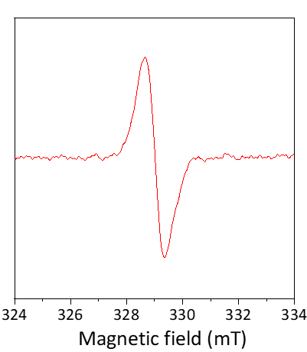
Supplementary Fig. 13∣EPR signal of purified material (DNTT).
The deposition of the semiconductor layer is the last process of the bottom-contact OFET, which was prepared in a vacuum thermal evaporation system that is connected with an N₂ glovebox and has many electrical interfaces. Upon deposition, the OFET was examined in situ and showed p-type transport behavior with a saturated mobility of 1.5 cm²·V⁻¹·s⁻¹. As demonstrated above, p-type characteristics will disappear once oxygen is eliminated in large quantities. Therefore, it can be validated that the trace oxygen is inherent in OSCs and can survive the thermal sublimation OSCs.
Furthermore, we examined the EPR signal of the purified DNTT raw material. The material was purified by vacuum sublimation, and then stored in a dark N₂ glovebox. The purified material was loaded into a glass capillary. After sealing with silicone grease, the glass capillary was inserted into a quartz tube for EPR testing. As shown in Supplementary Fig. 13, the purified material exhibited an identifiable EPR signal with g = 2.0032, and peak-to-peak linewidth (△H_{pp}) ≈ 7G. The broadening of △H_{pp} could be attributed to the larger disorder of powders that limits electron motion^{36,37}. This result further proves that the trace oxygen is inherent in OSCs and can survive the thermal sublimation. OSCs
Section 15. EPR signal of purified organic semiconductors
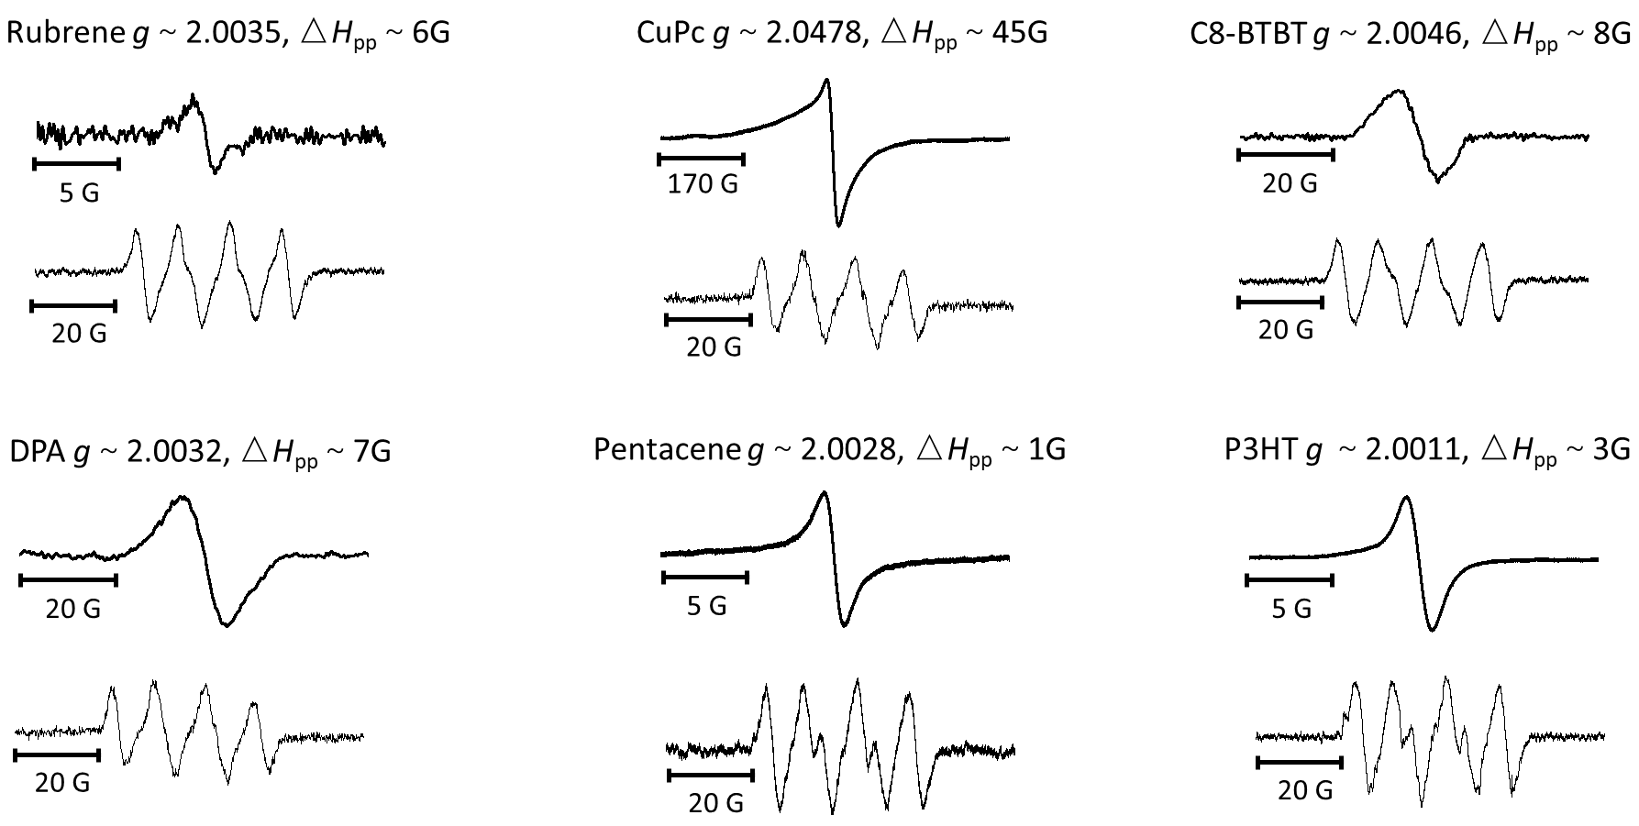
Supplementary Fig. 14∣EPR signal of purified OSCs.
The purification of these materials (except P3HT, 99% purchased from Sigma-Aldrich) are as described in Supplementary Section 14. The materials were loaded into glass capillaries. After sealing with silicone grease, the glass capillaries were inserted into quartz tubes for EPR testing. For the detection of SA, DMPO (volume ratio of 1:100 in methanol or dimethylsulphoxide) was used as a spin trapping agent. The powders of OSCs were ultrasonically dispersed in DMPO diluent under ultrasonic dispersion for at least 30 min. The suspension liquids were sucked up with glass capillaries and sealed with silicone grease. Then, the glass capillaries were inserted into quartz EPR tubes. As shown in Supplementary Fig. 14, EPR signals of SA (DMPO-OOH) were clearly observed in the suspension liquids. Some signals have only four obvious peaks, which is due to the weak intensity. The symmetrical EPR signals were observed in the powders, and show the relatively narrow ∆H_{pp} and g values close to the free electron g_{e} ≈ 2.0023 (except CuPc). Considering the observation of SA, these EPR signals were assigned to ORCs (except CuPc). The EPR signal in CuPc is assigned to the coordinated Cu²⁺ ³⁸. The signal of ORC may be obscured by this strong and broad peak and therefore not observable. These results are strong indicators of the universality of innate oxygen doping in OSCs.
Supplementary References
1 Abdou, M. S. A., Orfino, F. P., Son, Y. & Holdcroft, S. Interaction of Oxygen with Conjugated Polymers: Charge Transfer Complex Formation with Poly(3-alkylthiophenes). J. Am. Chem. Soc. 119, 4518-4524, (1997).
2 Vollmer, A. et al. The effect of oxygen exposure on pentacene electronic structure. Eur. Phys. J. E 17, 339-343, (2005).
3 Mitrofanov, O. et al. Oxygen-Related Band Gap State in Single Crystal Rubrene. Phys. Rev. Lett. 97, 166601, (2006).
4 Kawasaki, N. et al. Trap states and transport characteristics in picene thin film field-effect transistor. Appl. Phys. Lett. 94, 043310, (2009).
5 Maliakal, A. J. et al. Mechanism for Oxygen-Enhanced Photoconductivity in Rubrene: Electron Transfer Doping▽This publication involves research sponsored by the U.S. Department of Energy under grant no. DE FG02-04ER 46118 and Columbia University. Chem. Mater. 21, 5519-5526, (2009).
6 Zhuo, J.-M. et al. Direct Spectroscopic Evidence for a Photodoping Mechanism in Polythiophene and Poly(bithiophene-alt-thienothiophene) Organic Semiconductor Thin Films Involving Oxygen and Sorbed Moisture. Adv. Mater. 21, 4747-4752, (2009).
7 Lin, C.-S. & Lin, Y.-J. Enhancement of the hole mobility and concentration in pentacene by oxygen plasma treatment. J. Non-Cryst. Solids 356, 2820-2823, (2010).
8 Abate, A. et al. Lithium salts as “redox active” p-type dopants for organic semiconductors and their impact in solid-state dye-sensitized solar cells. Phys. Chem. Chem. Phys. 15, 2572-2579, (2013).
9 Lu, G. et al. Moderate doping leads to high performance of semiconductor/insulator polymer blend transistors. Nat. Commun. 4, 1588, (2013).
10 Ding, Z. et al. Effect of Oxygen, Moisture and Illumination on the Stability and Reliability of Dinaphtho[2,3-b:2′,3′-f]thieno[3,2-b]thiophene (DNTT) OTFTs during Operation and Storage. ACS Appl. Mater. Inter. 6, 15224-15231, (2014).
11 Zhang, H. et al. Novel Air Stable Organic Radical Semiconductor of Dimers of Dithienothiophene, Single Crystals, and Field-Effect Transistors. Adv. Mater. 28, 7466-7471, (2016).
12 Eyer, G. P., Kittilstved, K. R. & Andrew, T. L. Anomalous Paramagnetism in Closed-Shell Molecular Semiconductors. J Phys. Chem. C 121, 24929-24935, (2017).
13 Jia, R. et al. Unraveling the Mechanism of the Persistent Photoconductivity in Organic Phototransistors. Adv. Funct. Mater. 29, 1905657, (2019).
14 Wu, X. et al. Air Effect on the Ideality of p-Type Organic Field-Effect Transistors: A Double-Edged Sword. Adv. Funct. Mater. 29, 1906653, (2019).
15 Wu, X. et al. Roles of interfaces in the ideality of organic field-effect transistors. Nanoscale Horiz. 5, 454-472, (2020).
16 Kong, J. et al. CO2 doping of organic interlayers for perovskite solar cells. Nature 594, 51-56, (2021).
17 Nakamura, S. The Roles of Structural Imperfections in InGaN-Based Blue Light-Emitting Diodes and Laser Diodes. Science 281, 956-961, (1998).
18 Sze, S. M. & Ng, K. K. Physics of Semiconductor Devices. (John wiley & sons, 2006).
19 Blülle, B., Häusermann, R. & Batlogg, B. Approaching the Trap-Free Limit in Organic Single-Crystal Field-Effect Transistors. Phys. Rev. Appl. 1, 034006, (2014).
20 Scheinert, S., Pernstich, K. P., Batlogg, B. & Paasch, G. Determination of trap distributions from current characteristics of pentacene field-effect transistors with surface modified gate oxide. J. Appl. Phys. 102, 104503, (2007).
21 Kang, K. et al. 2D coherent charge transport in highly ordered conducting polymers doped by solid state diffusion. Nat. Mater. 15, 896-902, (2016).
22 Lüssem, B. et al. Doped Organic Transistors. Chem. Rev. 116, 13714-13751, (2016).
23 Yang, T. et al. Understanding, Optimizing, and Utilizing Nonideal Transistors Based on Organic or Organic Hybrid Semiconductors. Adv. Funct. Mater. 30, 1903889, (2020).
24 Haneef, H. F., Zeidell, A. M. & Jurchescu, O. D. Charge carrier traps in organic semiconductors: a review on the underlying physics and impact on electronic devices. J. Mater. Chem. C 8, 759-787, (2020).
25 Tietze, M. L. et al. Doped Organic Semiconductors: Trap-Filling, Impurity Saturation, and Reserve Regimes. Adv. Funct. Mater. 25, 2701-2707, (2015).
26 Tietze, M. L. et al. Fermi level shift and doping efficiency in p-doped small molecule organic semiconductors: A photoelectron spectroscopy and theoretical study. Phys. Rev. B 86, 035320, (2012).
27 Borchert, J. W. et al. Small contact resistance and high-frequency operation of flexible low-voltage inverted coplanar organic transistors. Nat. Commun. 10, 1119, (2019).
28 Kanagasekaran, T. et al. A new electrode design for ambipolar injection in organic semiconductors. Nat. Commun. 8, 999, (2017).
29 Betti, M. G. et al. Barrier Formation at Organic Interfaces in a Cu(100)-benzenethiolate-pentacene Heterostructure. Phys. Rev. Lett. 100, 027601, (2008).
30 Liu, Z. et al. Contact engineering for organic semiconductor devices via Fermi level depinning at the metal-organic interface. Phys. Rev. B 82, 035311, (2010).
31 Oehzelt, M., Koch, N. & Heimel, G. Organic semiconductor density of states controls the energy level alignment at electrode interfaces. Nat. Commun. 5, 4174, (2014).
32 Jiang, C. et al. Printed subthreshold organic transistors operating at high gain and ultralow power. Science 363, 719-723, (2019).
33 Lee, S. & Nathan, A. Subthreshold Schottky-barrier thin-film transistors with ultralow power and high intrinsic gain. Science 354, 302-304, (2016).
34 Podzorov, V. et al. Intrinsic Charge Transport on the Surface of Organic Semiconductors. Phys. Rev. Lett. 93, 086602, (2004).
35 Tang, C. G. et al. Doped polymer semiconductors with ultrahigh and ultralow work functions for ohmic contacts. Nature 539, 536-540, (2016).
36 Matsui, H. et al. Polaron Motional Narrowing of Electron Spin Resonance in Organic Field-Effect Transistors. Phys. Rev. Lett. 100, 126601, (2008).
37 Matsui, H. et al. Correlation between interdomain carrier hopping and apparent mobility in polycrystalline organic transistors as investigated by electron spin resonance. Phys. Rev. B 85, 035308, (2012).
38 Boguslavskii, E. G., Prokhorova, S. A. & Nadolinnyi, V. A. Evolution of ordered films of copper phthalocyanine according to EPR data. J. Struct. Chem. 46, 1014, (2005).

