Breeding emperor penguins repeatedly use shelf/slope-associated foraging areas across contrasting sea-ice seasons in the northwestern Weddell Sea
Hugo R. Guímaro^{1,2,3,*}, Peter T. Fretwell³, Klemens Pütz⁴, José C. Xavier^{1,2,3}, Victoria Warwick-Evans³, George Day³, Juliana A. Vianna^{5,6,7}, Eduardo J. Pizarro^{6,7,8}, Lucas Krüger^{7,9}, Neil E. Osborne¹⁰ and Norman Ratcliffe³
¹ Centre for Functional Ecology – Science for People & the Planet (CFE), Associate Laboratory TERRA, Department of Life Sciences, University of Coimbra, Calçada Martim de Freitas, Coimbra 3000-456, Portugal
² Centre for Functional Ecology – Science for People & the Planet (CFE), Associate Laboratory TERRA, University of Coimbra Campus at Figueira da Foz, Quinta das Olaias, 3080-183 Figueira da Foz, Portugal
³ British Antarctic Survey, Natural Environment Research Council, CB3 0ET, Cambridge, UK
⁴ Antarctic Research Trust, Bremervörde, Germany
⁵ One Health Institute, Faculty of Life Sciences, Universidad Andres Bello, Santiago, Chile
⁶ Millennium Institute Center for Genome Regulation (CGR), Santiago, Chile
⁷ Millennium Institute Biodiversity of Antarctic and Subantarctic Ecosystems (BASE), Santiago, Chile
⁸ Facultad de Ciencias Biológicas, Pontificia Universidad Católica de Chile, Santiago, Chile
⁹ Departamento Científico, Instituto Antártico Chileno INACH, Punta Arenas, Chile
¹⁰ Trent University, School of the Environment, Ontario, Canada
*Corresponding author: guimaro.hugo@gmail.com

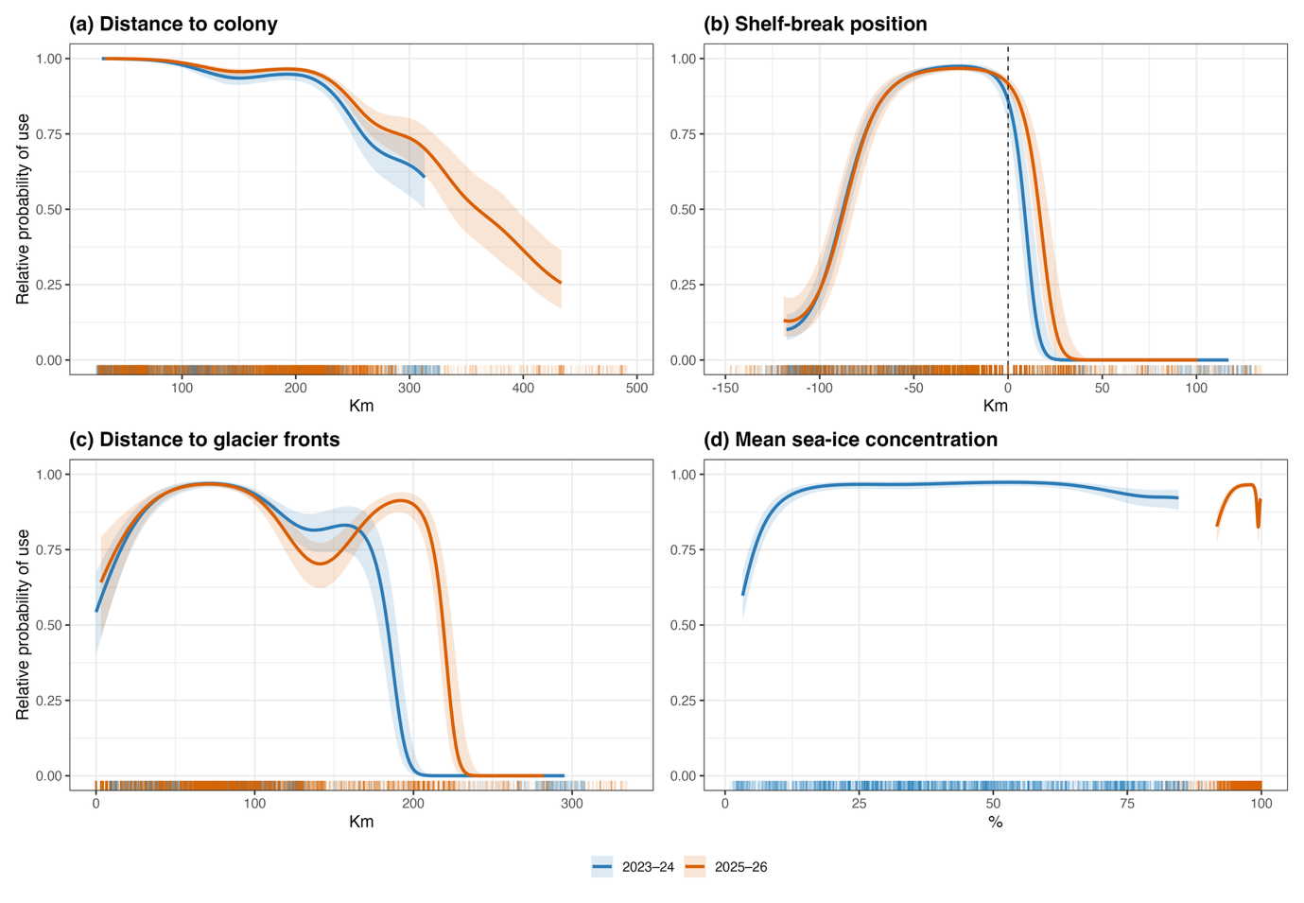
Figure S1. Conditional response curves from the selected population-level habitat-selection GAM. Curves show model-predicted relative probability of use in relation to distance to colony, signed distance to the 1,000 m isobath, distance to glacier front segments, and mean sea-ice concentration. Predictions are shown separately for the 2023-24 and 2025-26 chick-rearing seasons, with non-focal covariates held at season-specific median values from used locations. Shaded areas represent approximate 95% confidence intervals, and rug marks show observed used locations.
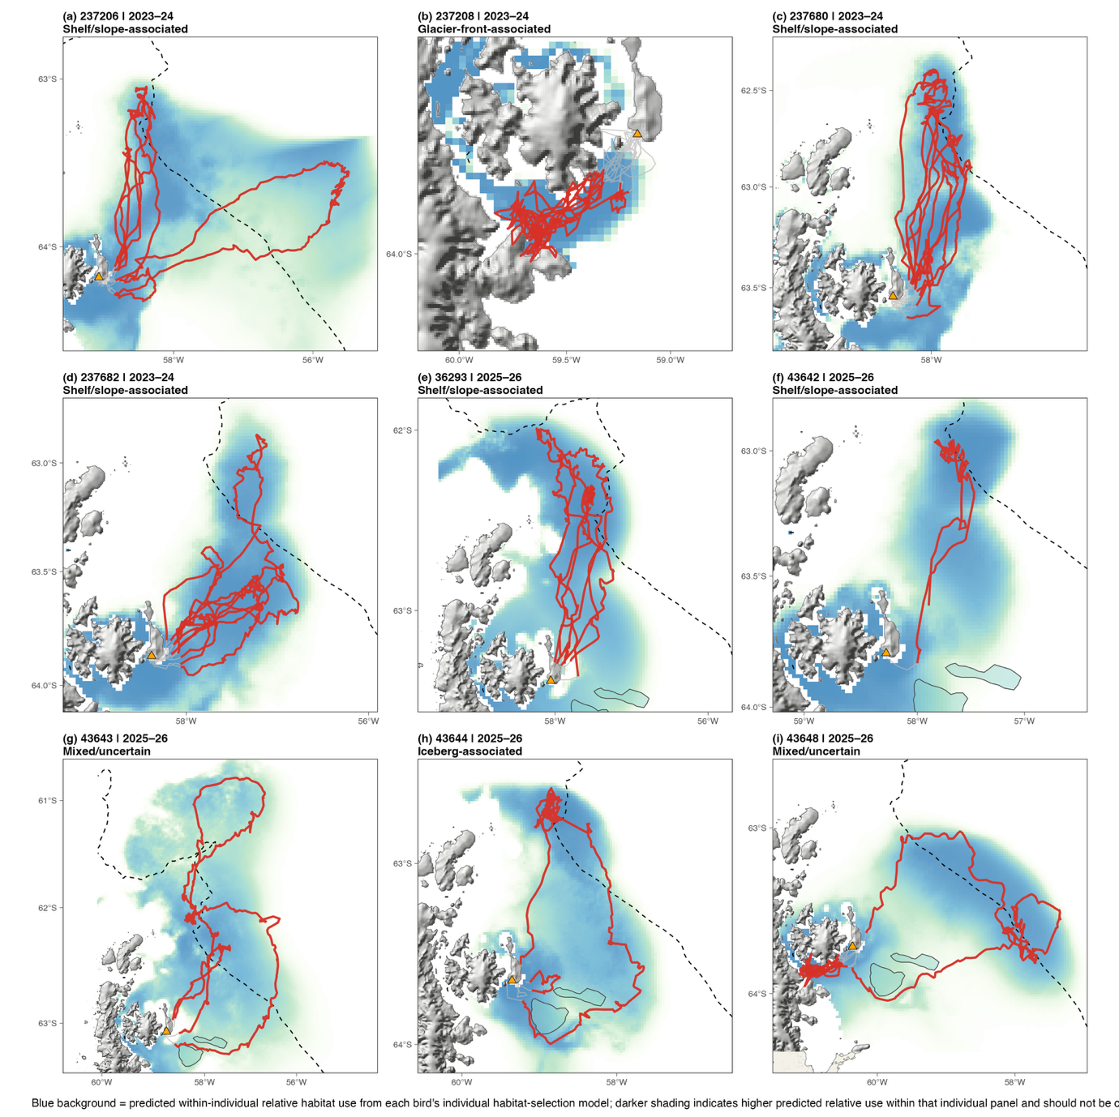
Figure S2. Individual habitat-use patterns of tracked breeding emperor penguins from Snow Hill Island during the 2023-24 and 2025-26 chick-rearing seasons. Panels show individual chick-rearing movements for each tracked breeder, with completed returned foraging trips highlighted in red and broader chick-rearing movement context shown in grey. Background shading shows the predicted within-individual relative habitat-use surface from each bird’s individual habitat-selection model, with darker shading indicating areas of higher predicted relative use within that individual’s available habitat. The Snow Hill Island colony, glacier-front segments, iceberg polygons where relevant, and the -1,000 m isobath used as a shelf-break proxy are shown to support interpretation of individual habitat-use patterns. Birds were assigned qualitative habitat-use classes based on their spatial association with shelf/slope habitat, glacier-front-associated areas, and mixed-use areas, including areas potentially influenced by iceberg-associated features.
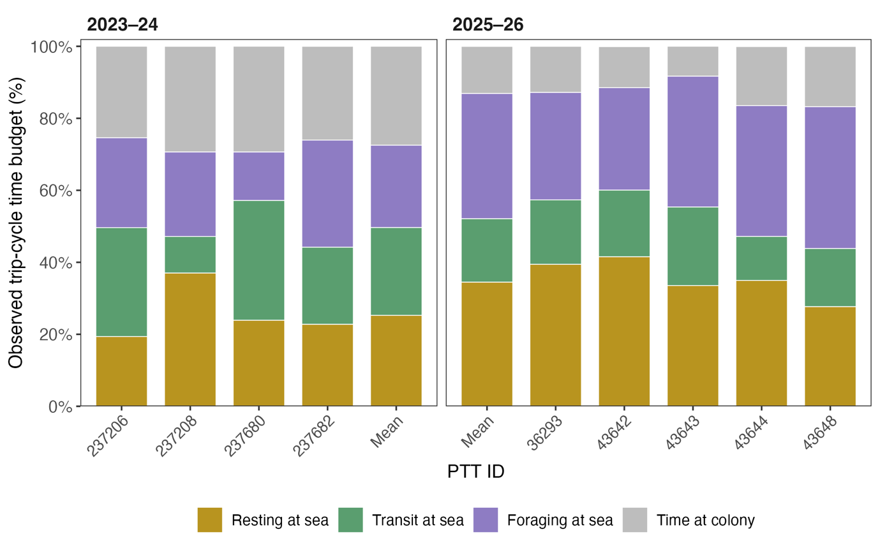
Figure S3. Observed chick-rearing trip-cycle time budget of inferred breeding emperor penguins tracked from Snow Hill Island during the 2023-24 and 2025-26 seasons. Stacked bars show the percentage of each individual’s observed trip-cycle time spent resting, transiting and foraging at sea, and attending the colony. Trip cycles comprised a complete at-sea foraging trip followed by the subsequent colony-attendance interval before the next departure. At-sea behavioural states were decoded from the Hidden Markov Model and weighted by trip duration to express them as full-cycle percentages. The final bar in each panel shows the duration-weighted pooled seasonal mean.
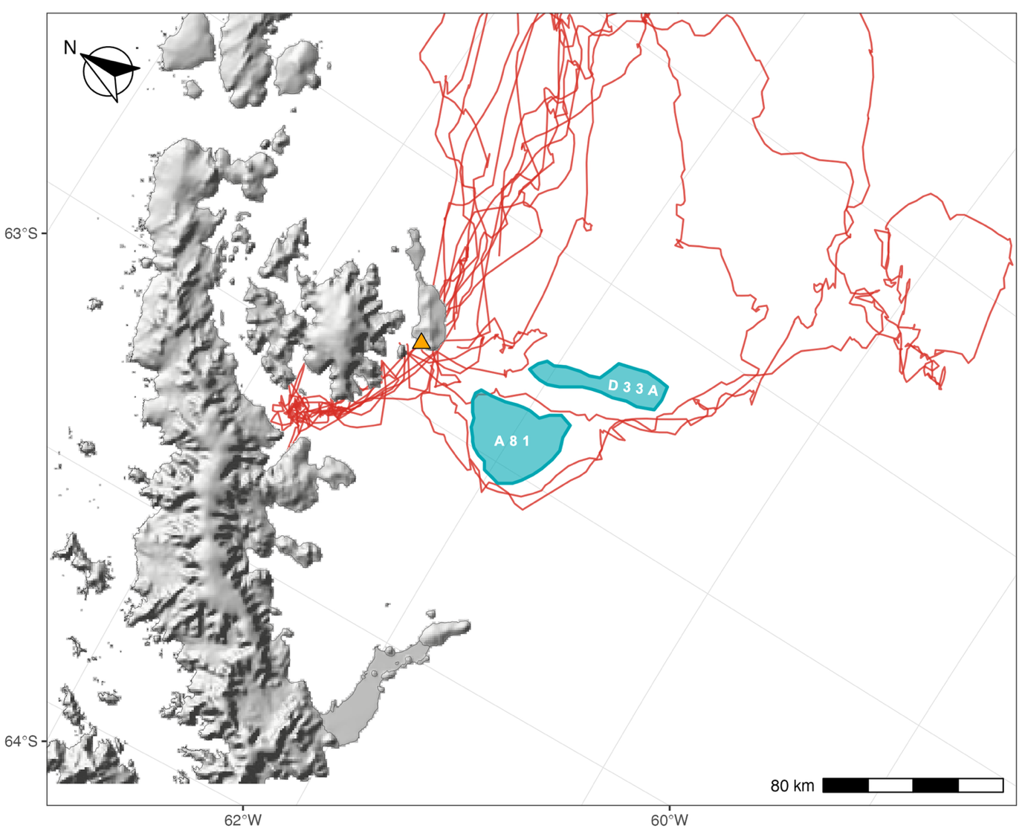
Figure S4. Position of icebergs A81 and D33A relative to Snow Hill Island and 2025-26 breeder emperor penguin tracks. Red lines indicate breeders tracking paths, and the orange triangle marks the colony location Icebergs outlines were manually digitised from a Sentinel-1 EW SAR image acquired on 28 November 2025 and are shown for visual reference only.

Table S1. Summary of completed at-sea foraging trips undertaken by inferred breeding emperor penguins tracked (N = 9) during the chick-rearing periods of the 2023-24 and 2025-26 seasons at Snow Hill Island (Weddell Sea, Antarctica).
Season | PTT ID | Trip ID | Trip distance (km) | Furthest distance (km) | Trip duration (days) | Departure date | Return time | Time at colony (days)
2023-24
 | 237206 | 1 | 918.6 | 319.9 | 12.0 | 17/11/2023 | 29/11/2023 | 1.0
 |  | 2 | 157.8 | 68.3 | 2.7 | 01/12/2023 | 04/12/2023 | 2.0
 |  | 3 | 651.3 | 231.2 | 7.5 | 06/12/2023 | 13/12/2023 | 1.9
 |  | 4 | 473.2 | 214.1 | 3.5 | 17/12/2023 | 20/12/2023 | 3.0
 |  | 5 | 332.1 | 156.8 | 2.8 | 22/12/2023 | 25/12/2023 | 1.8
 | 237208 | 1 | 261.2 | 74.8 | 4.5 | 17/11/2023 | 22/11/2023 | 1.0
 |  | 2 | 278.1 | 73.7 | 5.6 | 23/11/2023 | 29/11/2023 | 1.5
 |  | 3 | 205.9 | 67.6 | 3.5 | 01/12/2023 | 04/12/2023 | 1.7
 |  | 4 | 201.0 | 64.1 | 3.8 | 06/12/2023 | 09/12/2023 | 1.3
 |  | 5 | 41.3 | 35.8 | 0.9 | 11/12/2023 | 12/12/2023 | 1.8
 |  | 6 | 295.7 | 73.9 | 4.6 | 14/12/2023 | 19/12/2023 | 2.2
 | 237680 | 1 | 732.4 | 239.3 | 7.9 | 19/11/2023 | 27/11/2023 | 3.0
 |  | 2 | 487.9 | 182.1 | 5.0 | 29/11/2023 | 04/12/2023 | 1.9
 |  | 3 | 463.9 | 201.7 | 4.5 | 06/12/2023 | 10/12/2023 | 1.7
 |  | 4 | 581.5 | 231.3 | 5.5 | 12/12/2023 | 17/12/2023 | 1.7
 |  | 5 | 176.6 | 68.3 | 2.0 | 19/12/2023 | 21/12/2023 | 1.8
 |  | 6 | 386.3 | 151.2 | 3.7 | 23/12/2023 | 27/12/2023 | 1.8
 | 237682 | 1 | 280.8 | 114.4 | 3.0 | 19/11/2023 | 22/11/2023 | 2.0
 |  | 2 | 719.9 | 225.9 | 9.8 | 25/11/2023 | 05/12/2023 | 2.6
 |  | 3 | 330.5 | 112.0 | 5.0 | 06/12/2023 | 11/12/2023 | 1.5
 |  | 4 | 362.3 | 121.2 | 5.0 | 13/12/2023 | 18/12/2023 | 1.6
 |  | 5 | 164.8 | 67.2 | 2.3 | 19/12/2023 | 22/12/2023 | 1.4
 |  | 6 | 385.9 | 147.6 | 5.0 | 23/12/2023 | 28/12/2023 | 1.5
2025-26
 | 36293 | 1 | 798.0 | 260.6 | 16.4 | 23/11/2025 | 09/12/2025 | 0.5
 |  | 2 | 826.4 | 280.6 | 13.7 | 11/12/2025 | 25/12/2025 | 2.1
 |  | 3 | 677.5 | 221.7 | 12.4 | 27/12/2025 | 08/01/2026 | 1.7
 |  | 4 | 53.0 | 47.3 | 1.2 | 10/01/2026 | 12/01/2026 | 2.1
 | 43642 | 1 | 626.8 | 180.7 | 10.1 | 30/11/2025 | 10/12/2025 | 1.3
 | 43643 | 1 | 2,079.8 | 478.4 | 34.0 | 01/12/2025 | 04/01/2026 | 1.9
 |  | 2 | 516.8 | 192.0 | 9.2 | 06/01/2026 | 15/01/2026 | 2.0
 | 43644 | 1 | 1,450.0 | 228.9 | 21.4 | 30/11/2025 | 22/12/2025 | 1.3
 |  | 2 | 126.0 | 55.7 | 3.0 | 25/12/2025 | 28/12/2025 | 3.5
 | 43648 | 1 | 1,340.8 | 266.2 | 19.6 | 30/11/2025 | 19/12/2025 | 0.7
 |  | 2 | 202.7 | 78.1 | 4.0 | 21/12/2025 | 25/12/2025 | 1.6
 |  | 3 | 227.6 | 75.2 | 4.2 | 26/12/2025 | 30/12/2025 | 1.1
 |  | 4 | 204.0 | 72.4 | 3.3 | 01/01/2026 | 04/01/2026 | 1.2
 |  | 5 | 153.1 | 65.2 | 2.5 | 06/01/2026 | 08/01/2026 | 1.6
 |  | 6 | 149.9 | 60.1 | 2.7 | 09/01/2026 | 12/01/2026 | 1.1

Table S2. Model selection summary for habitat-selection models fitted to chick-rearing locations of breeding emperor penguins from Snow Hill Island during the 2023-24 and 2025-26 seasons. Habitat-selection models were used to evaluate relative probability of use. Population-level models were fitted to assess environmental predictors of habitat use, whereas the individual-level extension tested whether the selected tensor relationship varied among birds. AIC values are comparable only within each model set. Best-supported models are shown in bold.
Model set | Candidate model | AIC | ΔAIC | Deviance explained (%)
Population-level model | Season + Distance to Colony + SIC Mean (season-specific) + Distance to Shelf-break x Distance to Glacier Fronts | 9,270.04 | 0.00 | 68.0
Population-level model | Season + Distance to Colony + SIC Mean (season-specific) + Distance to Shelf-break + Distance to Glacier Fronts | 10,796.91 | 1,526.87 | 62.4
Population-level model | Season + Distance to Colony + SIC Mean (season-specific) + Depth x Distance to Glacier Fronts | 10,812.15 | 1,542.11 | 62.6
Population-level model | Season + Distance to Colony + SIC Mean (season-specific) + Distance to Shelf-break | 11,248.61 | 1,978.57 | 60.8
Population-level model | Season + Distance to Colony + SIC Mean (season-specific) + Depth + Distance to Glacier Fronts | 11,743.71 | 2,473.67 | 59.1
Population-level model | Season + Distance to Colony + SIC Mean + Distance to Shelf-break | 11,803.01 | 2,532.97 | 58.8
Population-level model | Season + Distance to Colony + SIC Mean (season-specific) + Distance to Glacier Fronts | 12,072.69 | 2,802.65 | 57.9
Population-level model | Season + Distance to Colony + SIC Mean (season-specific) + Depth | 12,448.01 | 3,177.96 | 56.6
Population-level model | Season + Distance to Colony + SIC Mean (season-specific) | 12,679.77 | 3,409.73 | 55.7
Population-level model | Season + Distance to Colony + SIC Mean + Distance to Glacier Fronts | 12,868.14 | 3,598.10 | 55.0
Population-level model | Season + Distance to Colony + SIC Mean + Depth | 13,364.77 | 4,094.73 | 53.3
Population-level model | Season + Distance to Colony + SIC Mean + Bathymetric Slope | 13,536.46 | 4,266.42 | 52.7
Population-level model | Season + Distance to Colony + SIC Mean + SIC SD | 13,545.11 | 4,275.07 | 52.7
Population-level model | Season + Distance to Colony + SIC Mean | 13,722.55 | 4,452.51 | 52.0
Population-level model | Season + Distance to Colony + Distance to Shelf-break | 14,638.11 | 5,368.07 | 48.8
Population-level model | Season + Distance to Colony + SIC SD | 15,196.05 | 5,926.01 | 46.8
Population-level model | Season + Distance to Colony + Distance to Glacier Fronts | 15,856.79 | 6,586.75 | 44.5
Population-level model | Season + Distance to Colony + Depth | 15,911.82 | 6,641.78 | 44.3
Population-level model | Season + Distance to Colony + Bathymetric Slope | 16,739.42 | 7,469.38 | 41.4
Population-level model | Season + Distance to Colony | 16,847.82 | 7,577.77 | 41.0
Individual-level model | Season + Distance to Colony + SIC Mean (season-specific) + Bird-specific tensor (Distance to Shelf-break x Distance to Glacier Fronts) | 6,534.03 | 0.00 | 78.0
Individual-level model | Season + Distance to Colony + SIC Mean (season-specific) + Distance to Shelf-break x Distance to Glacier Fronts | 9,270.04 | 2,736.01 | 68.0

Table S3. Smooth-term summary and habitat class for the selected individual-level habitat-selection model fitted to chick-rearing locations of breeding emperor penguins from Snow Hill Island during the 2023-24 and 2025-26 seasons. The model included shared effects of distance to colony and season-specific mean sea-ice concentration, together with bird-specific tensor smooths between distance to the shelf-break and distance to glacier fronts.
Model component | Term | Season / PTT ID | edf | X² | p-value | Habitat class
Shared smooth | Distance to Colony | – | 7.92 | 415.44 | < 0.001 | –
Shared smooth | SIC Mean | 2023-24 | 5.55 | 296.36 | < 0.001 | –
Shared smooth | SIC Mean | 2025-26 | 7.13 | 185.06 | < 0.001 | –
Individual effect | Bird identity | – | 4.07 | 2.83 | < 0.001 | –
Individual tensor | Distance to Shelf-break x  Distance to Glacier Fronts | 237206 | 13.86 | 342.44 | < 0.001 | Shelf-slope system
Individual tensor | Distance to Shelf-break x  Distance to Glacier Fronts | 237208 | 4.57 | 67.51 | < 0.001 | Glacier waters
Individual tensor | Distance to Shelf-break x  Distance to Glacier Fronts | 237680 | 8.95 | 248.15 | < 0.001 | Shelf-slope system
Individual tensor | Distance to Shelf-break x  Distance to Glacier Fronts | 237682 | 8.96 | 188.09 | < 0.001 | Shelf-slope system
Individual tensor | Distance to Shelf-break x  Distance to Glacier Fronts | 36293 | 8.38 | 421.31 | < 0.001 | Shelf-slope system
Individual tensor | Distance to Shelf-break x  Distance to Glacier Fronts | 43642 | 7.24 | 218.45 | < 0.001 | Shelf-slope system
Individual tensor | Distance to Shelf-break x  Distance to Glacier Fronts | 43643 | 16.32 | 245.80 | < 0.001 | Mixed
Individual tensor | Distance to Shelf-break x  Distance to Glacier Fronts | 43644 | 11.39 | 192.19 | < 0.001 | Mixed
Individual tensor | Distance to Shelf-break x  Distance to Glacier Fronts | 43648 | 13.60 | 377.64 | < 0.001 | Mixed

Table S4. Model selection summary for Hidden Markov Models fitted to chick-rearing trips periods of 2023-24 and 2025-26 of breeding emperor penguins from Snow Hill Island. HMMs were used to evaluate covariate effects on behavioural-state transition probabilities. AIC values are comparable only within each model set. Best-supported models are shown in bold.
Model set | Candidate model | AIC | ΔAIC
HMM transition model | Diel + SIC Mean | 34,460.00 | 0.00
HMM transition model | Diel × SIC Mean | 34,468.00 | 8.63
HMM transition model | Diel | 34,514.00 | 54.60
HMM transition model | SIC Mean | 34,592.00 | 132.00
HMM transition model | Null | 34,643.00 | 184.00
Note: SIC = sea-ice concentration; Diel = diel cycle represented as a 24 h cosinor function.

Table S5. Observed chick-rearing time budget of inferred breeding emperor penguins tracked from Snow Hill Island during the 2023-24 and 2025-26 seasons. Values are presented for individual trip cycles and summarised by individual and season. Each trip cycle comprised an at-sea foraging trip followed by the subsequent colony-attendance interval before the next departure. At-sea time was divided into resting, foraging and transit states decoded from the Hidden Markov Model, and all percentages were calculated relative to the full observed trip cycle.
Season | PTT ID | Trip |  | At-sea |  |  |  |  |  |  | Time at colony |  |  | Total cycle duration (days)
Season | PTT ID | Trip |  | Resting (%) | Transit (%) | Foraging (%) | Duration |  |  |  |  |  |  | Total cycle duration (days)
Season | PTT ID | Trip |  | Resting (%) | Transit (%) | Foraging (%) | (%) |  | (days) |  | (%) | (days) |  | Total cycle duration (days)
2023-24
 | 237206 | 1 |  | 22.2 | 30.1 | 47.7 | 92.1 |  | 11.6 |  | 7.9 | 1.0 |  | 12.6
 |  | 2 |  | 26.2 | 1.5 | 72.3 | 57.5 |  | 2.7 |  | 42.5 | 2.0 |  | 4.7
 |  | 3 |  | 36.5 | 40.9 | 22.7 | 79.9 |  | 7.5 |  | 20.1 | 1.9 |  | 9.4
 |  | 4 |  | 18.8 | 81.2 | 0.0 | 54.1 |  | 3.5 |  | 45.9 | 3.0 |  | 6.5
 |  | 5 |  | 22.7 | 71.2 | 6.1 | 60.4 |  | 2.8 |  | 39.6 | 1.8 |  | 4.6
 | Mean ± SD |  |  | 25.3 ± 6.8 | 45.0 ± 32.1 | 29.7 ± 30.1 | 68.9 ± 16.5 |  | 5.7 ± 4.0 |  | 31.1 ± 16.5 | 1.9 ± 0.7 |  | 7.6 ± 3.6
 | 237208 | 1 |  | 43.1 | 17.4 | 39.4 | 82.0 |  | 4.5 |  | 18.0 | 1.0 |  | 5.5
 |  | 2 |  | 52.9 | 5.8 | 41.3 | 77.1 |  | 5.0 |  | 22.9 | 1.5 |  | 6.5
 |  | 3 |  | 61.9 | 14.3 | 23.8 | 50.7 |  | 1.8 |  | 49.3 | 1.7 |  | 3.5
 |  | 4 |  | 54.4 | 8.9 | 36.7 | 71.7 |  | 3.3 |  | 28.3 | 1.3 |  | 4.6
 |  | 5 |  | 30.2 | 4.7 | 65.1 | 49.9 |  | 0.9 |  | 66.7 | 1.8 |  | 2.7
 |  | 6 |  | 56.4 | 28.2 | 15.5 | 67.6 |  | 4.6 |  | 32.4 | 2.2 |  | 6.8
 | Mean ± SD |  |  | 49.8 ± 11.4 | 13.2 ± 8.8 | 37.0 ± 17.0 | 67.2 ± 17.6 |  | 3.8 ± 1.6 |  | 32.8 ± 17.6 | 1.6 ± 0.4 |  | 5.4 ± 1.6
 | 237680 | 1 |  | 33.2 | 38.4 | 28.4 | 72.5 |  | 7.9 |  | 27.5 | 3.0 |  | 10.9
 |  | 2 |  | 33.1 | 46.3 | 20.7 | 72.6 |  | 5.0 |  | 27.4 | 1.9 |  | 6.9
 |  | 3 |  | 37.4 | 48.6 | 14.0 | 72.4 |  | 4.5 |  | 27.6 | 1.7 |  | 6.2
 |  | 4 |  | 35.9 | 51.9 | 12.2 | 76.3 |  | 5.5 |  | 23.7 | 1.7 |  | 7.2
 |  | 5 |  | 29.2 | 43.8 | 27.1 | 52.6 |  | 2.0 |  | 47.4 | 1.8 |  | 3.8
 |  | 6 |  | 31.5 | 59.6 | 9.0 | 67.3 |  | 3.7 |  | 32.7 | 1.8 |  | 5.5
 | Mean ± SD |  |  | 33.4 ± 3.0 | 48.1 ± 7.2 | 18.6 ± 8.1 | 69.0 ± 8.5 |  | 4.8 ± 2.0 |  | 31.0 ± 8.5 | 2.0 ± 0.5 |  | 6.8 ± 2.4
 | 237682 | 1 |  | 16.4 | 50.7 | 32.9 | 60.3 |  | 3.0 |  | 39.7 | 2.0 |  | 5.0
 |  | 2 |  | 37.4 | 27.7 | 34.9 | 79.0 |  | 9.8 |  | 21.0 | 2.6 |  | 12.4
 |  | 3 |  | 27.4 | 19.5 | 53.1 | 75.8 |  | 4.7 |  | 24.2 | 1.5 |  | 6.2
 |  | 4 |  | 34.7 | 26.4 | 38.8 | 75.9 |  | 5.0 |  | 24.1 | 1.6 |  | 6.6
 |  | 5 |  | 30.9 | 29.1 | 40.0 | 62.1 |  | 2.3 |  | 37.9 | 1.4 |  | 3.7
 |  | 6 |  | 26.1 | 30.3 | 43.7 | 76.8 |  | 5.0 |  | 23.2 | 1.5 |  | 6.5
 | Mean ± SD |  |  | 28.8 ± 7.4 | 30.6 ± 10.5 | 40.6 ± 7.2 | 71.8 ± 8.4 |  | 5.0 ± 2.6 |  | 28.2 ± 8.4 | 1.8 ± 0.5 |  | 6.8 ± 3.0
2025-26
 | 36293 | 1 |  | 48.5 | 16.8 | 34.7 | 96.1 |  | 12.4 |  | 3.9 | 0.5 |  | 12.9
 |  | 2 |  | 42.3 | 31.2 | 26.4 | 80.5 |  | 8.7 |  | 19.5 | 2.1 |  | 10.8
 |  | 3 |  | 44.2 | 13.7 | 42.2 | 85.9 |  | 10.4 |  | 14.1 | 1.7 |  | 12.1
 |  | 4 |  | 45.4 | 19.8 | 34.9 | 36.4 |  | 1.2 |  | 63.6 | 2.1 |  | 3.3
 | Mean ± SD |  |  | 45.1 ± 2.6 | 20.4 ± 7.6 | 34.5 ± 6.5 | 77.0 ± 27.5 |  | 10.9 ± 6.7 |  | 23.0 ± 27.5 | 1.6 ± 0.8 |  | 12.5 ± 6.3
 | 43642 | 1 |  | 46.9 | 20.9 | 32.1 | 86.3 |  | 8.2 |  | 13.7 | 1,3 |  | 9.5
 | Mean ± SD |  |  | 46.9 ± 0.0 | 20.9 ± 0.0 | 32.1 ± 0.0 | 88.6 ± 0.0 |  | 10.1 ± 0.0 |  | 11.4 ± 0.0 | 1.3 ± 0.0 |  | 11.4 ± 0.0
 | 43643 | 1 |  | 37.7 | 22.9 | 39.4 | 94.3 |  | 31.5 |  | 5.7 | 1.9 |  | 33.4
 |  | 2 |  | 32.4 | 27.2 | 40.5 | 78.3 |  | 7.2 |  | 21.7 | 2.0 |  | 9.2
 | Mean ± SD |  |  | 35.0 ± 3.8 | 25.0 ± 3.0 | 39.9 ± 0.7 | 88.4 ± 8.9 |  | 21.6 ± 17.5 |  | 11.6 ± 8.9 | 1.9 ± 0.1 |  | 23.5 ± 17.5
 | 43644 | 1 |  | 39.6 | 15.1 | 45.2 | 93.9 |  | 20.1 |  | 6.1 | 1.3 |  | 21.4
 |  | 2 |  | 57.7 | 11.3 | 31.0 | 45.8 |  | 3.0 |  | 54.2 | 3.5 |  | 6.5
 | Mean ± SD |  |  | 48.7 ± 12.8 | 13.2 ± 2.7 | 38.1 ± 10.1 | 70.2 ± 34.0 |  | 12.2 ± 13.0 |  | 29.8 ± 34.0 | 2.4 ± 1.6 |  | 14.6 ± 11.5
 | 43648 | 1 |  | 26.2 | 25.2 | 48.5 | 96.0 |  | 16.7 |  | 4.0 | 0.7 |  | 17.4
 |  | 2 |  | 42.9 | 11.4 | 45.7 | 47.7 |  | 1.5 |  | 52.3 | 1.6 |  | 3.1
 |  | 3 |  | 40.3 | 7.5 | 52.2 | 71.7 |  | 2.8 |  | 28.3 | 1.1 |  | 3.9
 |  | 4 |  | 42.5 | 18.8 | 38.8 | 73.5 |  | 3.3 |  | 26.5 | 1.2 |  | 4.5
 |  | 5 |  | 50.0 | 6.2 | 43.8 | 55.6 |  | 2.0 |  | 44.4 | 1.6 |  | 3.6
 |  | 6 |  | 32.5 | 20.3 | 47.1 | 71.1 |  | 2.7 |  | 28.9 | 1.1 |  | 3.8
 | Mean ± SD |  |  | 39.1 ± 8.4 | 14.9 ± 7.7 | 46.0 ± 4.5 | 75.4 ± 11.9 |  | 6.1 ± 6.7 |  | 24.6 ± 11.9 | 1.2 ± 0.3 |  | 7.3 ± 6.4

