Supplementary Material

Quantifying the impacts of cloud seeding on severe winter sea fog dissipation and visibility using a coupled atmosphere–ocean model

Soo-Hwan Moonª, Yun-Kyu Lim^{b}, Sang-Keun Song^{a,}, Ki-Young Heo^{c}, Sung-Bin Leeª, Seoung Soo Lee^{d,e,f}, Jin Ho Kimª

ª Department of Earth and Marine Sciences, Jeju National University, Jeju 63243, Republic of Korea
^{b} Research Applications Department, National Institute of Meteorological Sciences, Jeju 63568, Republic of Korea
^{c} Coastal Disaster & Safety Research Department, Korea Institute of Ocean Science and Technology, Busan, 49111, Republic of Korea
^{d} Science and Technology Corporation, Hampton, Virginia 23666, USA
^{e} Earth System Science Interdisciplinary Center, University of Maryland, College Park, Maryland 20740, USA
^{f} Research Center for Climate Sciences, Pusan National University, Busan 46241, Republic of Korea

Table S1. Details of the model grids and physical schemes used in the WRF and ROMS models.

[A] WRF
Domain | D1 | D2 | D3 | D4
Horizontal grid | 180 $×$ 180 | 184 $×$ 181 | 184 $×$ 181 | 235 $×$ 235
Horizontal resolution (km) | 13.5 km | 4.5 km | 1.5 km | 0.5 km
Vertical layers | 40 layers
Microphysics | Modified Morrison scheme⁶⁴ including AgI and CaCl₂ cloud-seeding parameterization
Initial & boundary condition | European Centre for Medium Range Weather Forecasts reanalysis version 5 (ERA5)
Long & shortwave radiation | Rapid Radiative Transfer Model for General Circulation Models⁷⁸
Planetary boundary layer | Shin-Hong⁷⁹
Land surface | Noah-Land Surface Model⁶¹
Land-use / Topography | KLAND / Advanced Spaceborne Thermal Emission and Reflection Radiometer (ASTER)

[B] ROMS
Domain | D1 | D2 | D3
Horizontal grid | 267 $×$ 267 | 279 $×$ 273 | 294 $×$ 285
Horizontal resolution (km) | 9 km | 3 km | 1 km
Vertical layers | 40 layers
Vertical mixing | Generic Length-Scale (GLS) mixing
Initial & boundary condition | Global Hybrid Coordinate Ocean Model (HYCOM)
Tidal data | TPXO 7

Table S2. Summary of the observed and simulated precipitation amounts (mm) at 60 and 120 min after the end of seeding in the drone-based cloud-seeding field experiment conducted on December 10, 2021. Artificial rainfall (AR) is defined as the difference between the seeding-affected and unaffected regions for the observations as well as between the SEED and UNSD simulations for the numerical model results.

 | Observed |  |  |  | Simulated
 | Affected | Unaffected | AR |  | SEED | UNSD | AR
60 min | 0.60 | 0.44 | 0.16 |  | 1.01 | 0.89 | 0.12
120 min | 0.56 | 0.41 | 0.15 |  | 1.04 | 0.90 | 0.14

Fig. S1. Schematic diagram of the methodology for fog-dissipation cloud-seeding simulations. SEED and UNSD represent simulations with and without cloud-seeding material (CaCl₂), respectively.

Fig. S2. Time series of the observed air-sea temperature difference and the corresponding simulations from the coupled (COAWST) and uncoupled (WRF) models. The blue shaded box indicates the severe sea fog event (December 23–24, 2017). ICB and YP denote the marine buoy sites at Incheon and Yeonpyeong, respectively (Fig. 1).

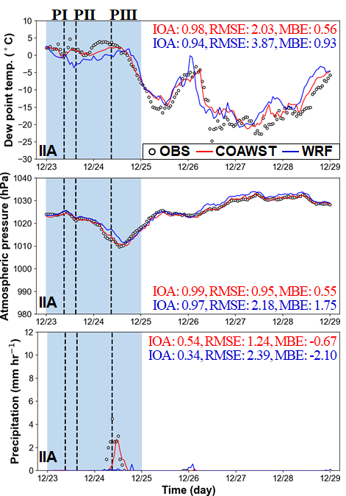

Fig. S3. Time series of observed and model-simulated variables from the coupled (COAWST) and uncoupled (WRF) models: dew point temperature, atmospheric pressure, and precipitation. The blue shaded box indicates the severe sea fog event (December 23–24, 2017). IIA denotes the meteorological monitoring site at Incheon international airport (Fig. 1).

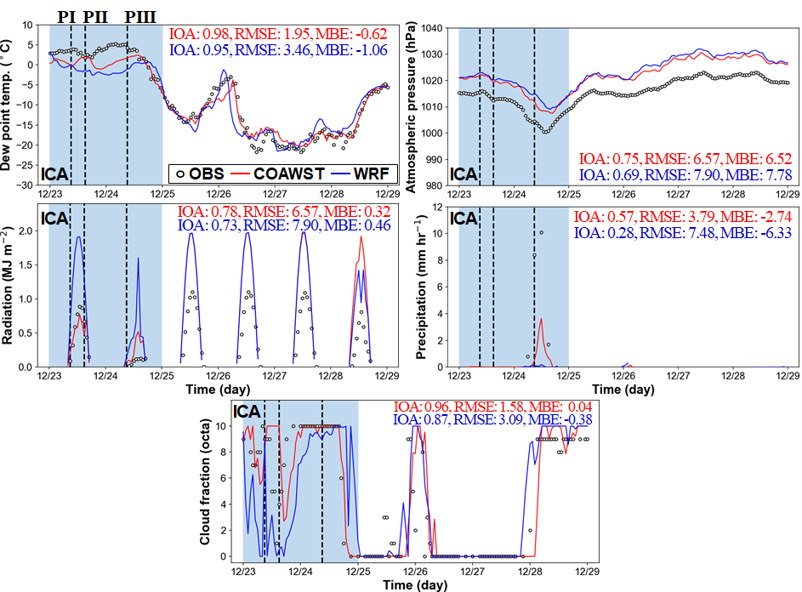
Fig. S4. Time series of observed and model-simulated variables from the coupled (COAWST) and uncoupled (WRF) models: dew point temperature, atmospheric pressure, solar radiation, precipitation, and cloud fraction. The blue shaded box indicates the severe sea fog event (December 23–24, 2017). ICA denotes the meteorological monitoring site at Incheon (Fig. 1).

(a)
(b)
(c)

Fig. S5. Spatial distributions of the near-surface differences between the SEED and UNSD simulations (SEED − UNSD) in (a) cloud-water mixing ratio (g kg⁻¹), (b) rainwater mixing ratio (g kg⁻¹), (c) rainwater mass per rain droplet (g drop⁻¹), (d) water vapor mixing ratio (g kg⁻¹), (e) relative humidity (%), and (f) air temperature ($℃$) at 60 and 120 min after the end of seeding. Cyan contours indicate the simulated transport pathway of the seeding material. Black dashed lines denote the locations of the vertical cross-sections.
(d)
(e)
(f)

Fig. S5. (Continued.)

(a)
(b)

Fig. S6. Spatial distributions of the differences in (a) cloud-water mixing ratio (g kg⁻¹) and (b) rainwater mixing ratio (g kg⁻¹) at the seeding altitude between the SEED and UNSD simulations (SEED − UNSD), at 60 and 120 min after the end of seeding. Cyan contours indicate the simulated transport pathway of the seeding material. Black dashed lines denote the locations of the vertical cross-sections.

(a)
(b)

Fig. S7. (a) Near-surface spatial distributions and (b) longitude–height cross-sections (along the lines shown in Fig. 5) of the liquid-phase extinction coefficient difference (km⁻¹) between the SEED and UNSD simulations (SEED − UNSD) at 60 and 120 min after the end of seeding.

(a)
(b)

Fig. S8. Longitude–height cross-sections (along the lines shown in Fig. 5) of the differences in (a) cloud-water mixing ratio (g kg⁻¹) and (b) rainwater mixing ratio (g kg⁻¹) between the SEED and UNSD simulations (SEED − UNSD) at 60 and 120 min after the end of seeding.

Fig. S9. Longitude–height cross-sections (along the lines shown in Fig. 5) of the rotated-u (arrows), and w (color-shaded contours) wind components (m s⁻¹) in the SEED simulation at 60 and 120 min after the end of seeding. The rotated-u component was calculated by rotating the horizontal wind vector onto the longitude–height cross-sectional plane. Black and green arrows indicate positive and negative values of the rotated-u wind component, respectively.

References

78 Iacono, M. J. et al. Radiative forcing by long‐lived greenhouse gases: Calculations with the AER radiative transfer models. J. Geophys. Res. Atmos. 113 (2008).
79 Shin, H. H. & Hong, S.-Y. Intercomparison of planetary boundary-layer parametrizations in the WRF model for a single day from CASES-99. Bound.-Layer Meteorol. 139, 261–281 (2011).

Corresponding author: Dept. of Earth and Marine Sciences, Jeju National University, 102 Jejudaehak-ro, Jeju 63243, Republic of Korea; E-mail: songsk@jejunu.ac.kr, Tel: +82-64-754-3431; Fax: +82-64-725-2461

