Supplementary Figures

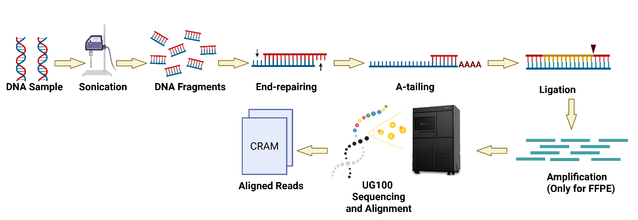

Supp. Fig 1. Wet-lab workflow for UG 100® sequencing. Genomic DNA is extracted, fragmented, and end-repaired with A-tailing for adapter ligation. Libraries are then amplified (FFPE samples only), indexed, and loaded onto the Ultima Genomics platform, producing up to 300 bp reads that are exported as aligned CRAM files for downstream analysis. (Figure created using BioRender)

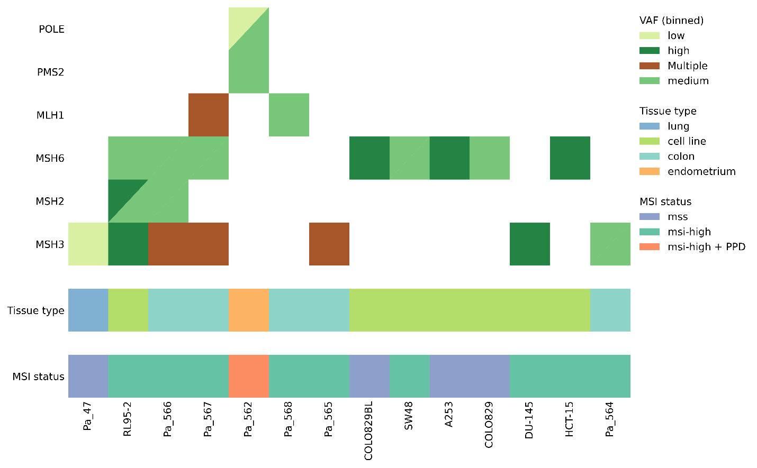

Supp. Fig 2. Co-mutation plot summarizing variants in DNA polymerase and mismatch repair (MMR) genes across samples with different microsatellite instability (MSI) statuses. Each column represents a sample, and each row corresponds to a gene or annotation category. Mutation type is shown by clinical significance (top panel), variant allele frequency (VAF) (middle panel), and tissue type and MSI classification (bottom panels). MSI status is categorized as MSI-high, MSI-suspicious, or MSS-likely. VAF categories were defined as: low (VAF < 0.2), medium (0.2 < VAF < 0.5), high (VAF > 0.5). The MSI cell-line LOVO has only low impact variants even though it is known to have MSH2 deficiency, therefore it is not shown on the co-mut plot.
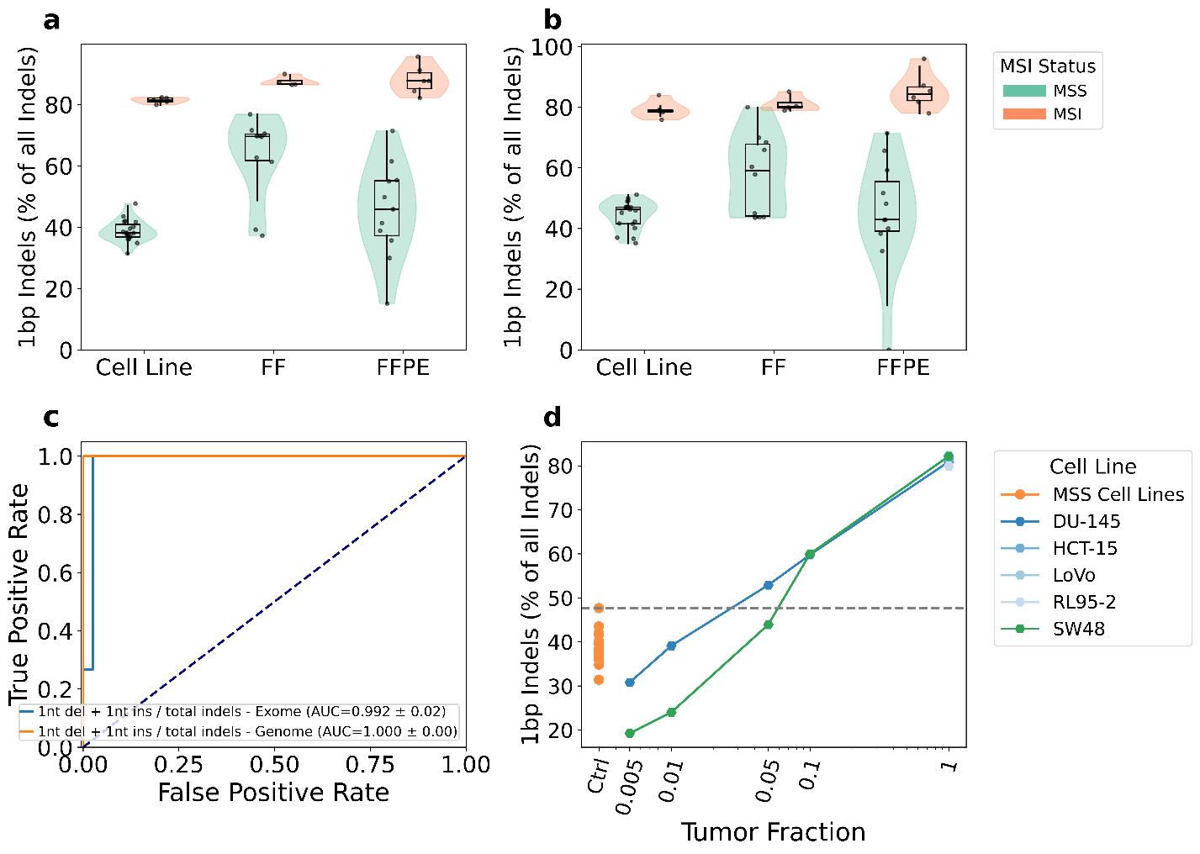
Supp. Fig. 3 - Detection of MSI using 1 bp indels across sequencing modalities and tumor fractions. (a–b) Distribution of percentages of 1bp A-homopolymer indels out of all indels in 10 to 15 bp A-homopolymers, in MSI-positive and MSS samples that were profiled using (a) genome-wide sequencing and (b) exome sequencing. (c) Receiver Operating Characteristic (ROC) curves evaluating MSI classification based on 1 bp deletion percentage. (d) Distribution of percentages of 1bp A-homopolymer deletions, as a function of tumor fraction in dilution series of MSI-positive cell lines, compared with MSS cell-line controls. AUC: Area Under the Curve. Ctrl: Control.

Supplementary Data
All supporting data generated in this study are provided in the Supplementary Tables listed below. These include full variant calling outputs from whole-genome and whole-exome sequencing, variant annotation files before and after filtering, mutational context summaries, signature activity profiles, and low-pass sequencing read-based results.
Supplementary Table S1. Full-coverage sequencing data used for variant calling and mutational signature analyses, including variant-level data, mutational burden metrics, and signature assignments for all samples at standard sequencing depth.
Supplementary Table S2. Filtered Variant Effect Predictor (VEP) annotations after application of study-specific quality and biological filtering criteria; used as input for CoMut visualization.
Supplementary Table S3. Complete VEP annotation output for all detected variants prior to filtering.
Supplementary Table S4. Counts and frequencies of somatic single-base substitutions stratified by trinucleotide sequence context for all analyzed samples.
Supplementary Table S5. Mutational signature activity estimates for all analyzed samples, including contributions of individual COSMIC mutational signatures.
Supplementary Table S6. Complete variant calling results from whole-genome sequencing (WGS) samples, including all detected variants prior to downstream filtering.
Supplementary Table S7. Complete variant calling results from whole-exome sequencing (WES) samples, including all detected variants prior to downstream filtering.
Supplementary Table S8. Complete variant calling results from diluted whole-genome sequencing (WGS) datasets generated for coverage downsampling analyses.
Supplementary Table S9. Complete variant calling results from diluted whole-exome sequencing (WES) datasets generated for coverage downsampling analyses.

