Supplementary Figure 1: All-Cause Mortality Subgroup Analysis
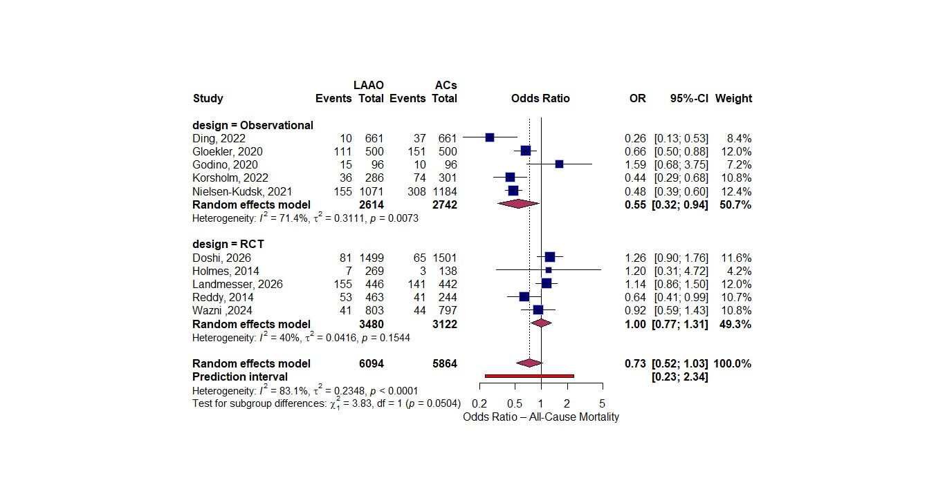
Supplementary Figure 2: All-Cause Mortality Leave-One-Out Sensitivity Analysis
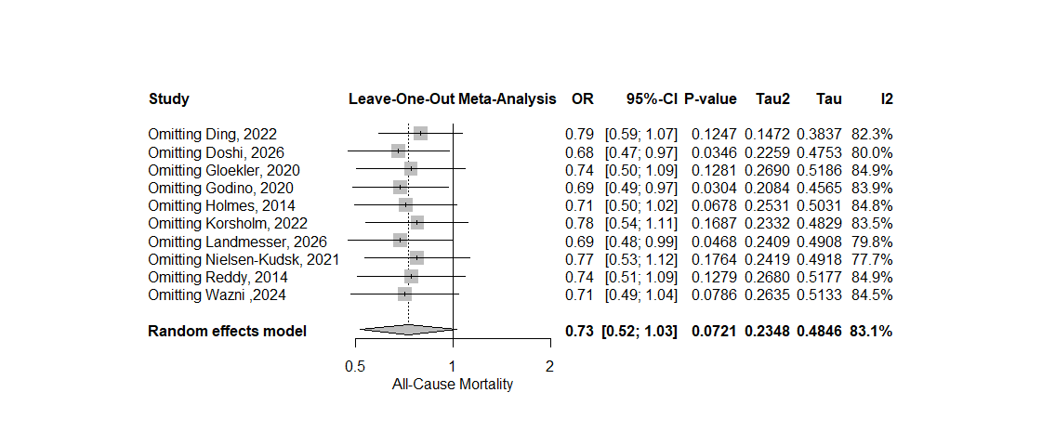
Supplementary Figure 3: All-Cause Mortality Contour Enhanced Funnel Plot for Publication Bias Assessment
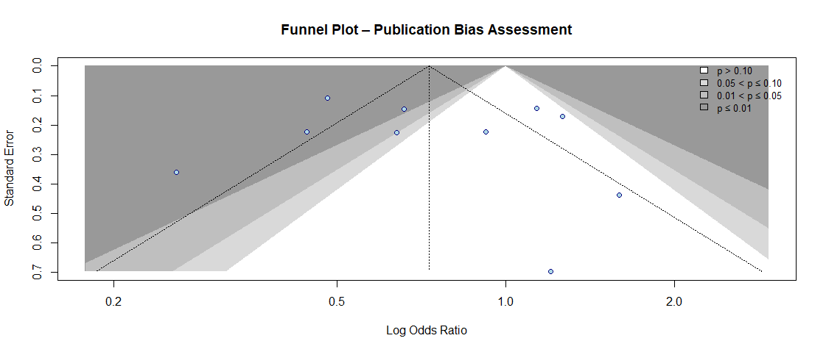
Supplementary Figure 4: All-Cause Mortality Meta-Regression with Age Imbalance
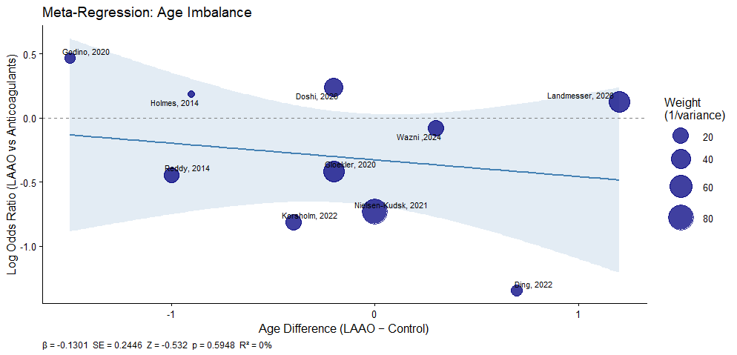
Supplementary Figure 5: Bleeding Rate Subgroup Analysis
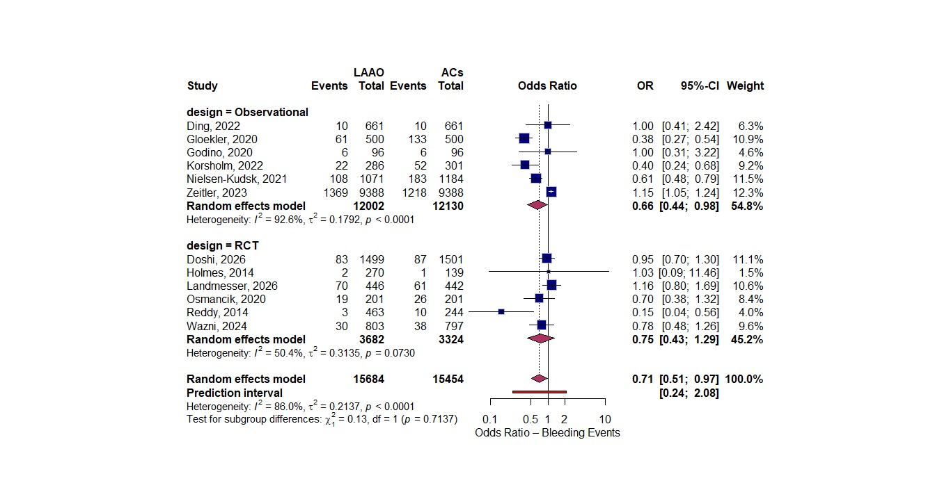
Supplementary Figure 6: Bleeding Rate Leave-One-Out Sensitivity Analysis
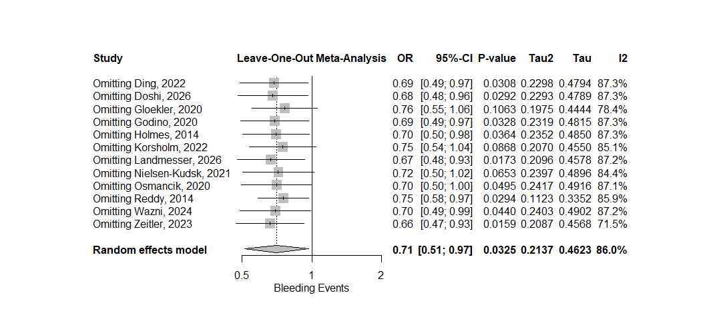
Supplementary Figure 7: Bleeding Rate Contour Enhanced Funnel Plot for Publication Bias Assessment
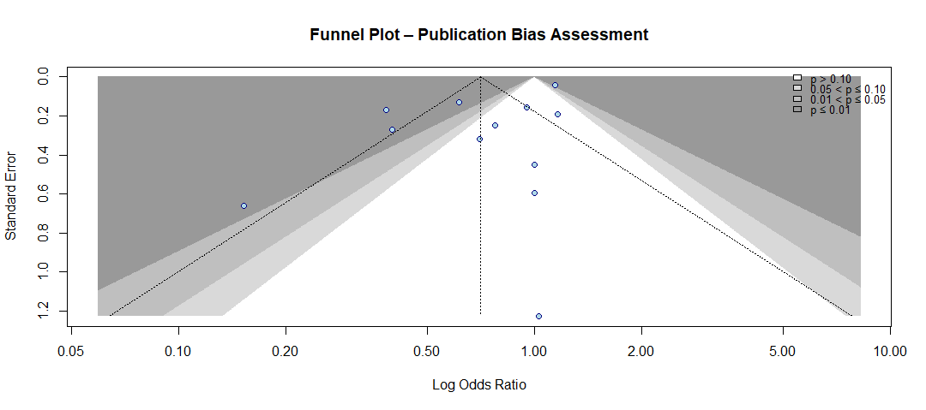
Supplementary Figure 8: Bleeding Rate Meta-Regression with Age-Imbalance
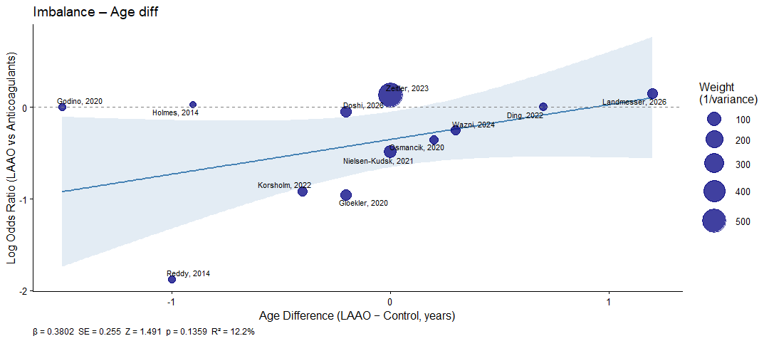
Supplementary Figure 9: Cardiac Mortality Subgroup Analysis
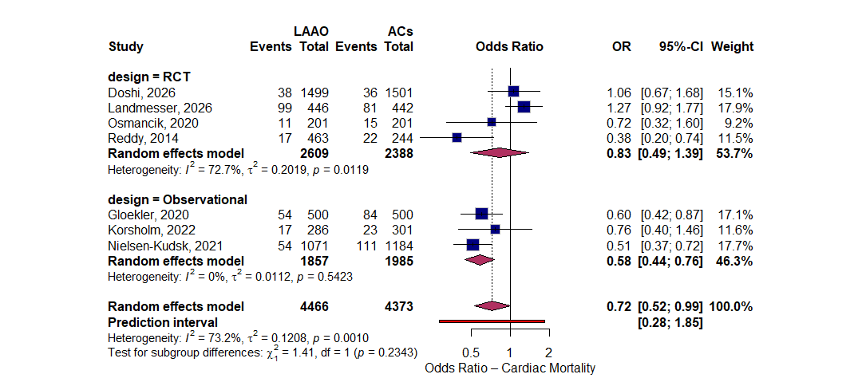
Supplementary Figure 10: Cardiac Mortality Leave-One-Out Sensitivity Analysis
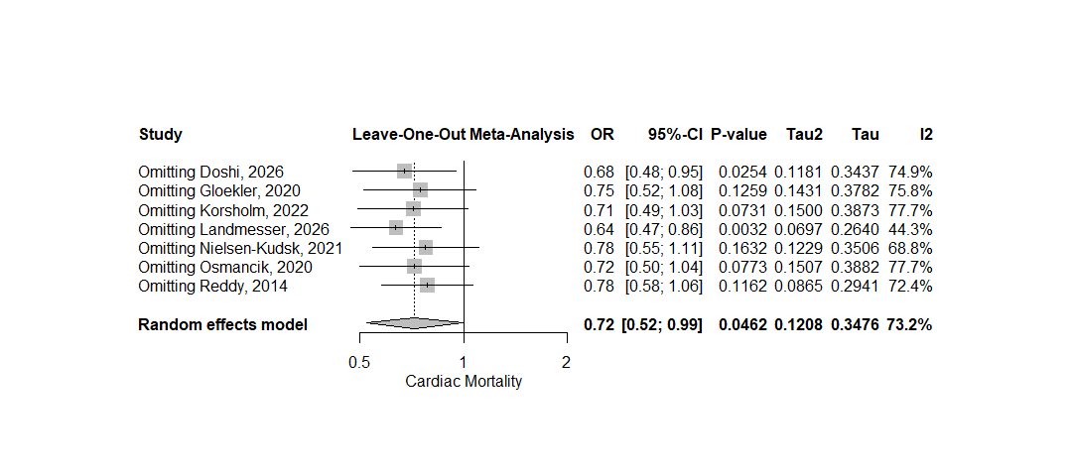
Supplementary Figure 11: Systemic Thromboembolism Subgroup Analysis
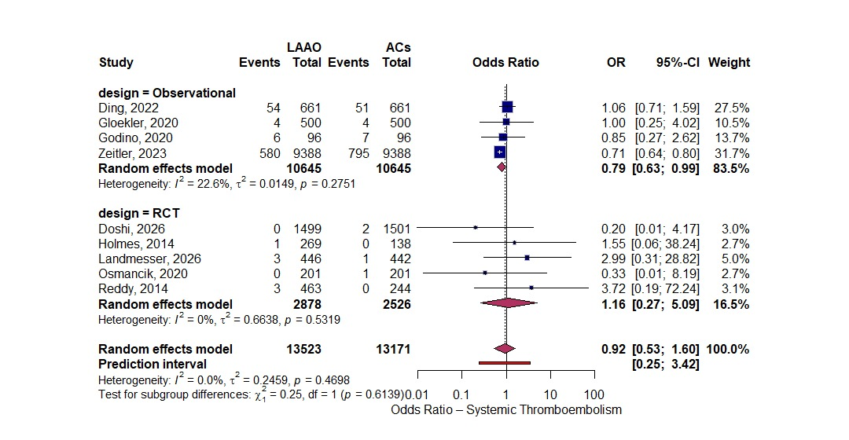
Supplementary Figure 12: Systemic Thromboembolism Leave-One-Out Sensitivity Analysis
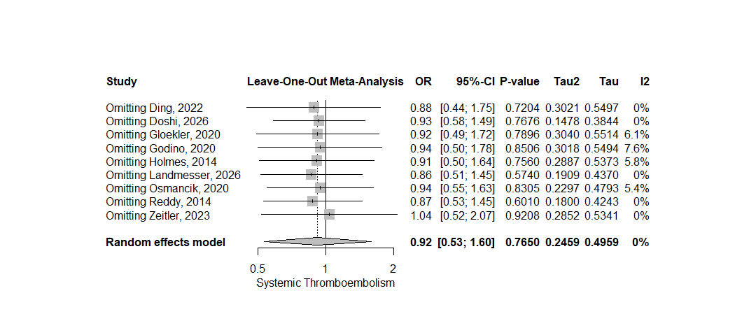
Supplementary Figure 13: Systemic Thromboembolism Contour Enhanced Funnel Plot for Publication Bias Assessment
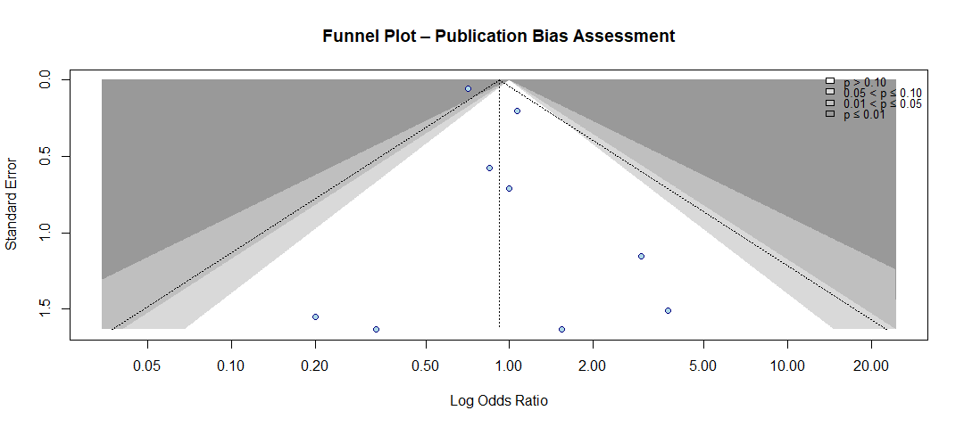
Supplementary Figure 14: Stroke Subgroup Analysis
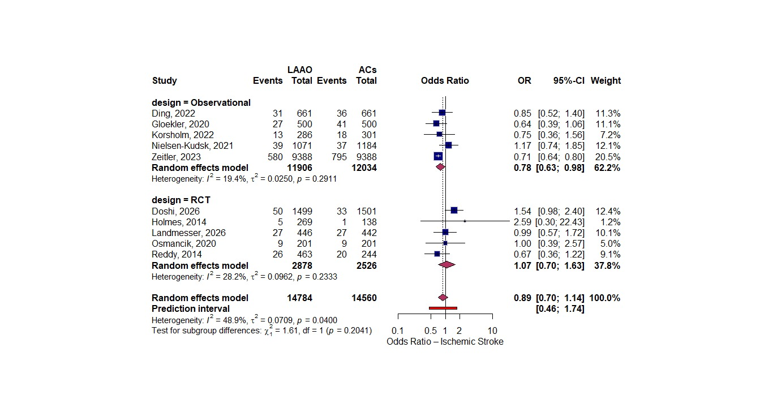
Supplementary Figure 15: Stroke Leave-One-Out Sensitivity Analysis
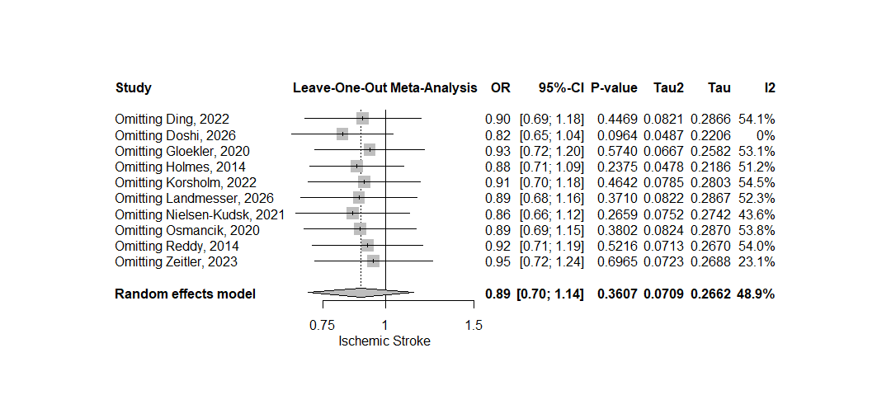
Supplementary Figure 16: Stroke Contour Enhanced Funnel Plot for Publication Bias Assessment
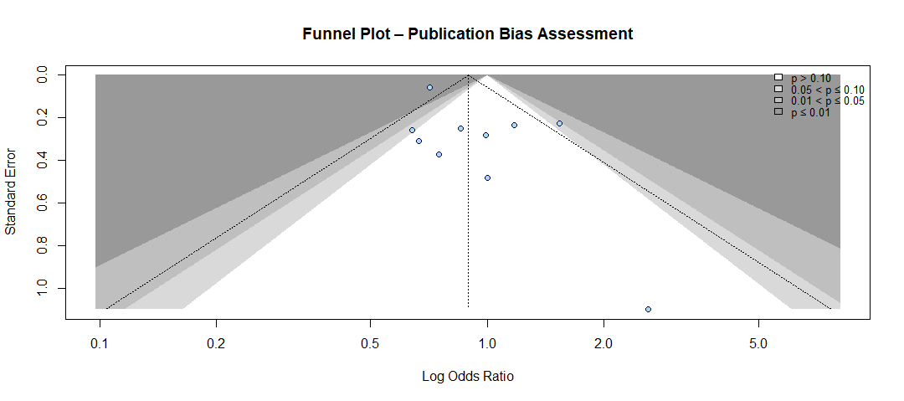
Supplementary Figure 17: Stroke Meta-Regression with Age-Imbalance
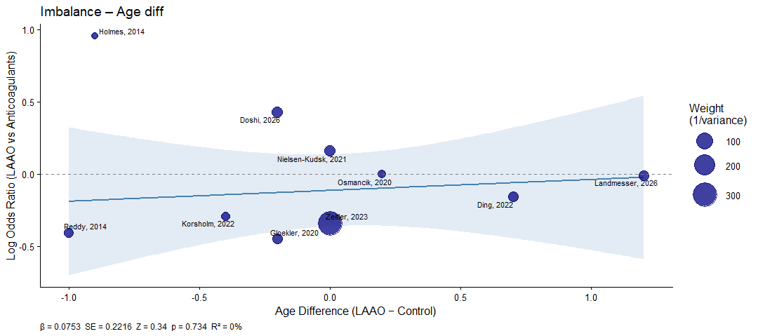
Supplementary Figure 18: Risk of Bias in Randomized Studies via RoB2
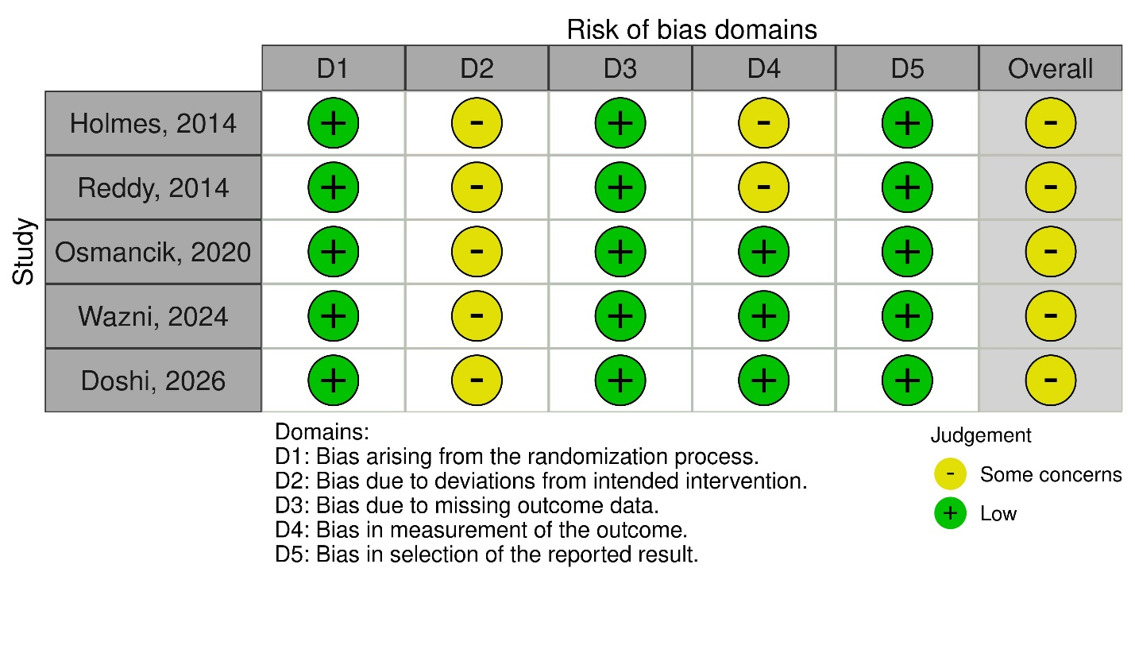
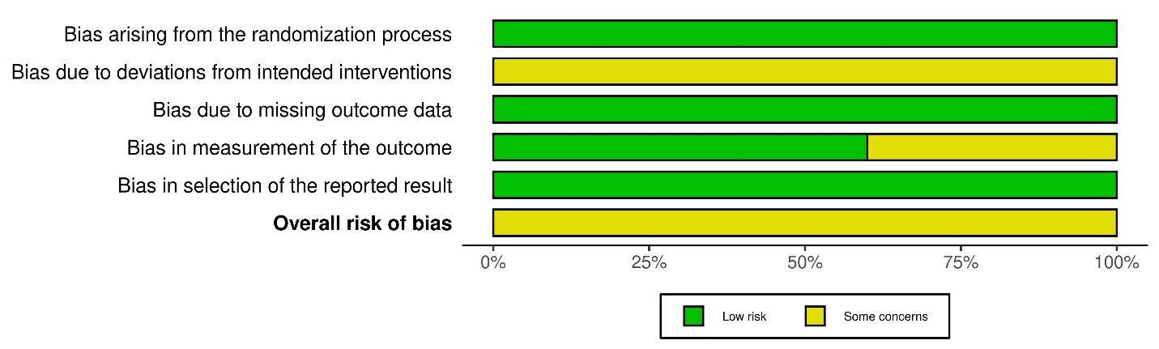
Supplementary Figure 19: Risk of Bias in Non-Randomized Studies via ROBINS-I
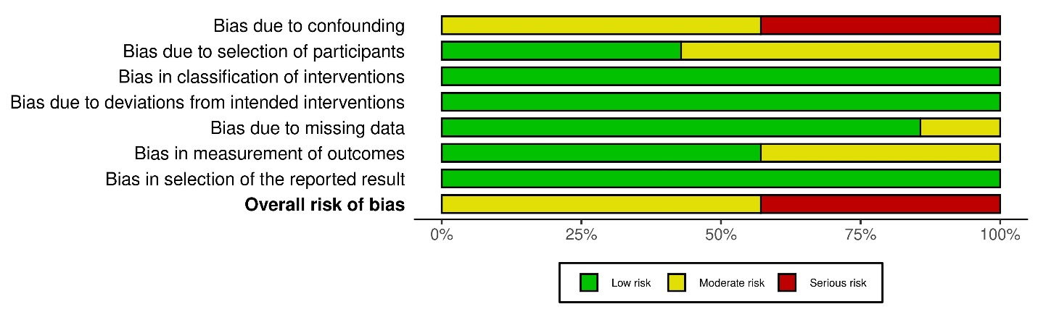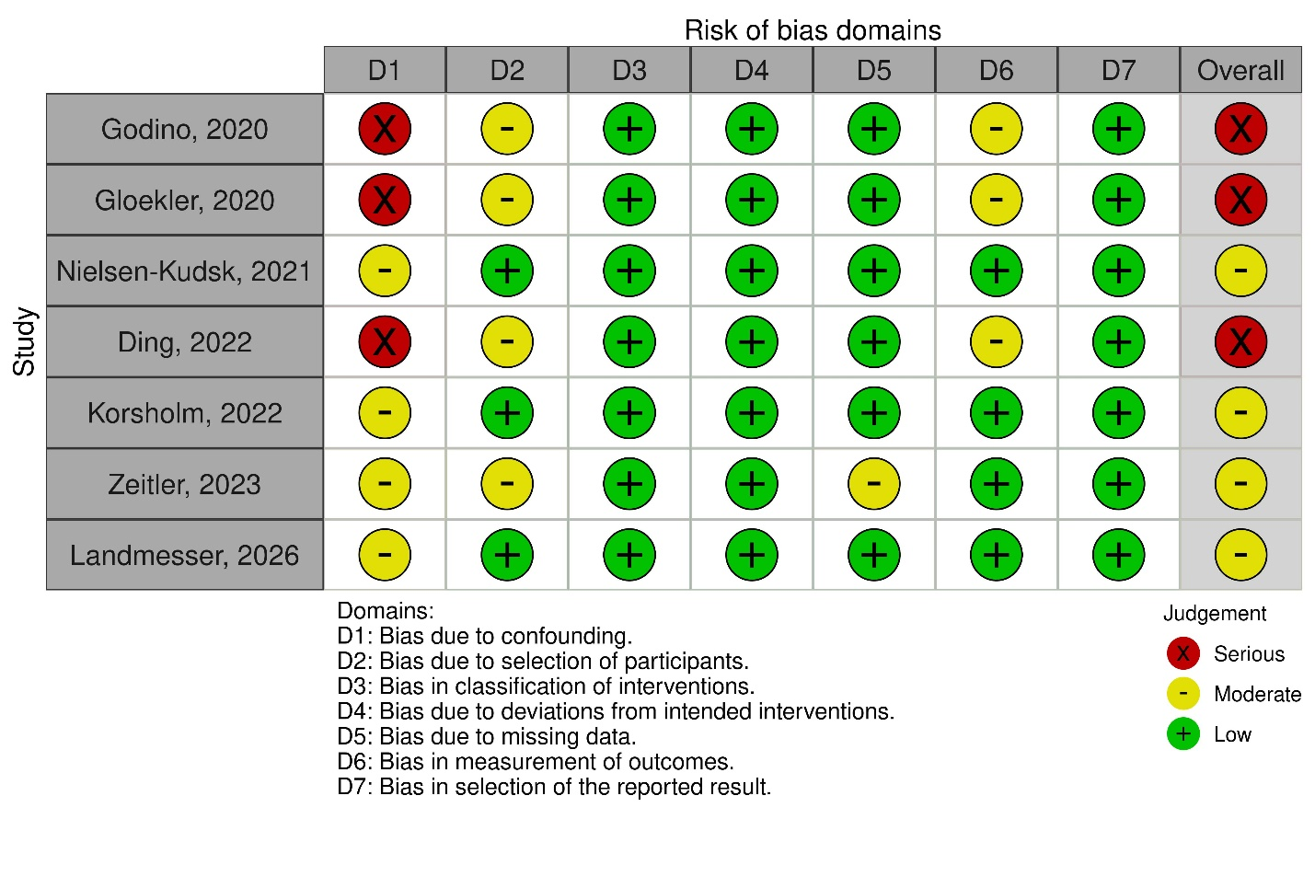
Supplementary Figure 20. Search strategy table

Database | Search Strategy
PubMed | (("atrial fibrillation"[MeSH Terms] OR "atrial fibrillation"[tiab] OR "auricular fibrillation"[tiab] OR "AF"[tiab] OR "NVAF"[tiab]) AND ("left atrial appendage"[MeSH Terms] OR "left atrial appendage"[tiab] OR "left atrial appendage occlusion"[tiab] OR "left atrial appendage closure"[tiab] OR "LAAO"[tiab] OR "LAAC"[tiab] OR "LAA closure"[tiab] OR "LAA occlusion"[tiab] OR "LAA exclusion"[tiab] OR "Watchman"[tiab] OR "Amplatzer Amulet"[tiab] OR "Lariat"[tiab] OR "Lambyre"[tiab])) AND ("anticoagulants"[MeSH Terms] OR "anticoagulant*"[tiab] OR "oral anticoagulation"[tiab] OR "OAC"[tiab] OR "DOAC*"[tiab] OR "NOAC*"[tiab] OR "warfarin"[tiab] OR "vitamin K antagonist*"[tiab] OR "VKA"[tiab] OR "apixaban"[tiab] OR "rivaroxaban"[tiab] OR "dabigatran"[tiab] OR "edoxaban"[tiab])
Embase | #1 'atrial fibrillation'/exp OR 'atrial fibrillation':ti,ab OR 'auricular fibrillation':ti,ab OR 'AF':ti,ab OR 'NVAF':ti,ab  #2 'left atrial appendage'/exp OR 'left atrial appendage occlusion':ti,ab OR 'left atrial appendage closure':ti,ab OR 'LAAO':ti,ab OR 'LAAC':ti,ab OR 'LAA closure':ti,ab OR 'LAA occlusion':ti,ab OR 'LAA exclusion':ti,ab OR 'Watchman':ti,ab OR 'Amplatzer Amulet':ti,ab OR 'Lariat':ti,ab OR 'Lambyre':ti,ab  #3 'anticoagulant agent'/exp OR 'anticoagulant*':ti,ab OR 'oral anticoagulation':ti,ab OR 'OAC':ti,ab OR 'DOAC*':ti,ab OR 'NOAC*':ti,ab OR 'warfarin':ti,ab OR 'vitamin K antagonist*':ti,ab OR 'VKA':ti,ab OR 'apixaban':ti,ab OR 'rivaroxaban':ti,ab OR 'dabigatran':ti,ab OR 'edoxaban':ti,ab  #4 #1 AND #2 AND #3
Cochrane CENTRAL | #1 Atrial Fibrillation OR atrial fibrillation OR auricular fibrillation OR AF OR NVAF  #2 Left Atrial Appendage OR left atrial appendage occlusion OR left atrial appendage closure OR LAAO OR LAAC OR LAA closure OR LAA occlusion OR LAA exclusion OR Watchman OR Amplatzer Amulet OR Lariat OR Lambyre  #3 Anticoagulants OR anticoagulant* OR oral anticoagulation OR OAC OR DOAC* OR NOAC* OR warfarin OR vitamin K antagonist* OR VKA OR apixaban OR rivaroxaban OR dabigatran OR edoxaban  #4 #1 AND #2 AND #3

