Supplementary Table 1: Search Strategy of Included Databases and Results Imported
Database | Search Strategy | Results
PubMed | #1 "Inflammatory Bowel Diseases"[MeSH Terms]  #2 "Colitis, Ulcerative"[MeSH Terms]  #3 "Crohn Disease"[MeSH Terms]  #4 "inflammatory bowel disease"[tiab] OR "IBD"[tiab]  #5 "ulcerative colitis"[tiab] OR "UC"[tiab]  #6 "Crohn's disease"[tiab] OR "Crohn disease"[tiab] OR "CD"[tiab]  #7 "colitis"[tiab] OR "proctitis"[tiab] OR "proctocolitis"[tiab]  OR "ileocolitis"[tiab]  #8 #1 OR #2 OR #3 OR #4 OR #5 OR #6 OR #7  #9 "Fecal Microbiota Transplantation"[MeSH Terms]  #10 "fecal microbiota transplant*"[tiab] OR "faecal microbiota transplant*"[tiab]  #11 "fecal transplant*"[tiab] OR "faecal transplant*"[tiab]  #12 "FMT"[tiab] OR "intestinal microbiota transfer"[tiab]  OR "donor feces infusion"[tiab] OR "donor feces transplant*"[tiab]  #13 "Probiotics"[MeSH Terms]  #14 "probiotic*"[tiab] OR "lactobacill*"[tiab] OR "bifidobacter*"[tiab]  OR "VSL#3"[tiab] OR "Escherichia coli Nissle"[tiab]  OR "Lactobacillus rhamnosus"[tiab]  #15 "Prebiotics"[MeSH Terms]  #16 "prebiotic*"[tiab] OR "inulin"[tiab] OR "fructooligosaccharide*"[tiab]  OR "FOS"[tiab] OR "galactooligosaccharide*"[tiab]  #17 "synbiotic*"[tiab]  #18 "antibiotic*"[tiab] AND ("fecal microbiota"[tiab]  OR "faecal microbiota"[tiab] OR "FMT"[tiab])  #19 "microbiota-directed therap*"[tiab] OR "microbiome therap*"[tiab]  OR "gut microbiota modulation"[tiab]  #20 #9 OR #10 OR #11 OR #12 OR #13 OR #14 OR #15 OR #16  OR #17 OR #18 OR #19  #21 "Randomized Controlled Trial"[pt]  #22 "randomized controlled trial*"[tiab] OR "randomised controlled trial*"[tiab]  #23 "RCT"[tiab] OR "random*"[tiab]  #24 "placebo"[tiab] OR "double-blind"[tiab] OR "double blind"[tiab]  #25 "Clinical Trial"[pt]  #26 #21 OR #22 OR #23 OR #24 OR #25  #27 #8 AND #20 AND #26 | 1846
Cochrane CENTRAL | #1 MeSH descriptor: [Inflammatory Bowel Diseases] explode all trees  #2 MeSH descriptor: [Colitis, Ulcerative] explode all trees  #3 MeSH descriptor: [Crohn Disease] explode all trees  #4 "inflammatory bowel disease" OR "IBD":ti,ab,kw  #5 "ulcerative colitis":ti,ab,kw  #6 "Crohn's disease" OR "Crohn disease":ti,ab,kw  #7 colitis OR proctitis OR proctocolitis OR ileocolitis:ti,ab,kw  #8 #1 OR #2 OR #3 OR #4 OR #5 OR #6 OR #7  #9 MeSH descriptor: [Fecal Microbiota Transplantation] explode all trees  #10 "fecal microbiota transplant*" OR "faecal microbiota transplant*"  OR "fecal transplant*" OR "faecal transplant*"  OR "FMT" OR "intestinal microbiota transfer":ti,ab,kw  #11 MeSH descriptor: [Probiotics] explode all trees  #12 "probiotic*" OR "lactobacill*" OR "bifidobacter*"  OR "VSL#3" OR "Escherichia coli Nissle":ti,ab,kw  #13 MeSH descriptor: [Prebiotics] explode all trees  #14 "prebiotic*" OR "inulin" OR "fructooligosaccharide*"  OR "galactooligosaccharide*":ti,ab,kw  #15 "synbiotic*":ti,ab,kw  #16 "antibiotic*" AND ("fecal microbiota" OR "FMT"):ti,ab,kw  #17 #9 OR #10 OR #11 OR #12 OR #13 OR #14 OR #15 OR #16  #18 #8 AND #17 | 2413
Embase | 1. 'inflammatory bowel disease'/exp  2. 'ulcerative colitis'/exp  3. 'Crohn disease'/exp  4. 'inflammatory bowel disease':ab,ti OR 'IBD':ab,ti  5. 'ulcerative colitis':ab,ti OR 'UC':ab,ti  6. 'Crohn disease':ab,ti OR 'Crohn\'s disease':ab,ti  7. 'colitis':ab,ti OR 'proctitis':ab,ti OR 'proctocolitis':ab,ti  OR 'ileocolitis':ab,ti  8. #1 OR #2 OR #3 OR #4 OR #5 OR #6 OR #7  9. 'fecal microbiota transplantation'/exp  10. 'fecal microbiota transplant*':ab,ti  OR 'faecal microbiota transplant*':ab,ti  11. 'fecal transplant*':ab,ti OR 'faecal transplant*':ab,ti  12. 'FMT':ab,ti OR 'intestinal microbiota transfer':ab,ti  OR 'donor feces infusion':ab,ti  13. 'probiotic agent'/exp  14. 'probiotic*':ab,ti OR 'lactobacillus'/exp OR 'lactobacill*':ab,ti  OR 'bifidobacterium'/exp OR 'bifidobacter*':ab,ti  OR 'VSL#3':ab,ti OR 'Escherichia coli Nissle':ab,ti  15. 'prebiotic'/exp  16. 'prebiotic*':ab,ti OR 'inulin':ab,ti  OR 'fructooligosaccharide*':ab,ti OR 'galactooligosaccharide*':ab,ti  17. 'synbiotic*':ab,ti OR 'synbiotic'/exp  18. 'antibiotic*':ab,ti AND ('fecal microbiota':ab,ti  OR 'faecal microbiota':ab,ti OR 'FMT':ab,ti)  19. 'microbiota directed therap*':ab,ti  OR 'microbiome therap*':ab,ti  OR 'gut microbiota modulation':ab,ti  20. #9 OR #10 OR #11 OR #12 OR #13 OR #14 OR #15 OR #16  OR #17 OR #18 OR #19  21. 'randomized controlled trial'/exp  22. 'randomized controlled trial*':ab,ti  OR 'randomised controlled trial*':ab,ti  23. 'random*':ab,ti OR 'RCT':ab,ti  24. 'placebo':ab,ti OR 'double blind procedure'/exp  OR 'double-blind':ab,ti OR 'double blind':ab,ti  25. #21 OR #22 OR #23 OR #24  26. #8 AND #20 AND #25 | 681
Scopus | (  TITLE-ABS-KEY("inflammatory bowel disease" OR "IBD"  OR "ulcerative colitis" OR "Crohn's disease"  OR "Crohn disease" OR "proctocolitis" OR "ileocolitis")  )  AND  (  TITLE-ABS-KEY("fecal microbiota transplant*"  OR "faecal microbiota transplant*"  OR "fecal transplant*" OR "faecal transplant*"  OR "FMT" OR "intestinal microbiota transfer"  OR "probiotic*" OR "prebiotic*" OR "synbiotic*"  OR "lactobacill*" OR "bifidobacter*" OR "VSL#3"  OR "Escherichia coli Nissle"  OR "fructooligosaccharide*" OR "inulin"  OR "microbiota-directed therap*"  OR "gut microbiota modulation")  )  AND  (  TITLE-ABS-KEY("randomized controlled trial"  OR "randomised controlled trial"  OR "RCT" OR "randomized" OR "randomised"  OR "placebo" OR "double-blind" OR "double blind")  ) | 1412

Supplementary Figure 1: Risk of Bias Assessment of Included Studies via RoB2
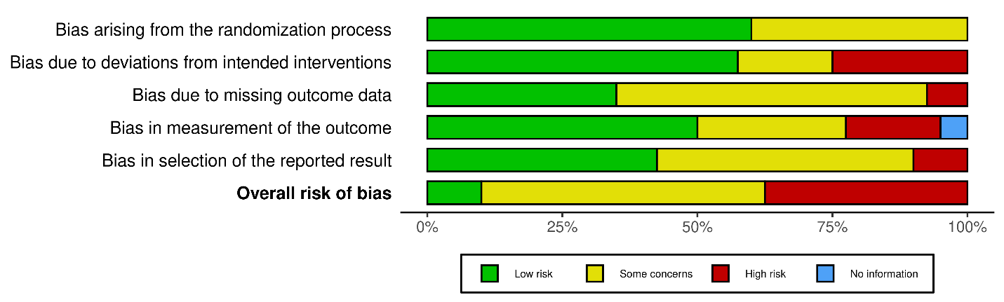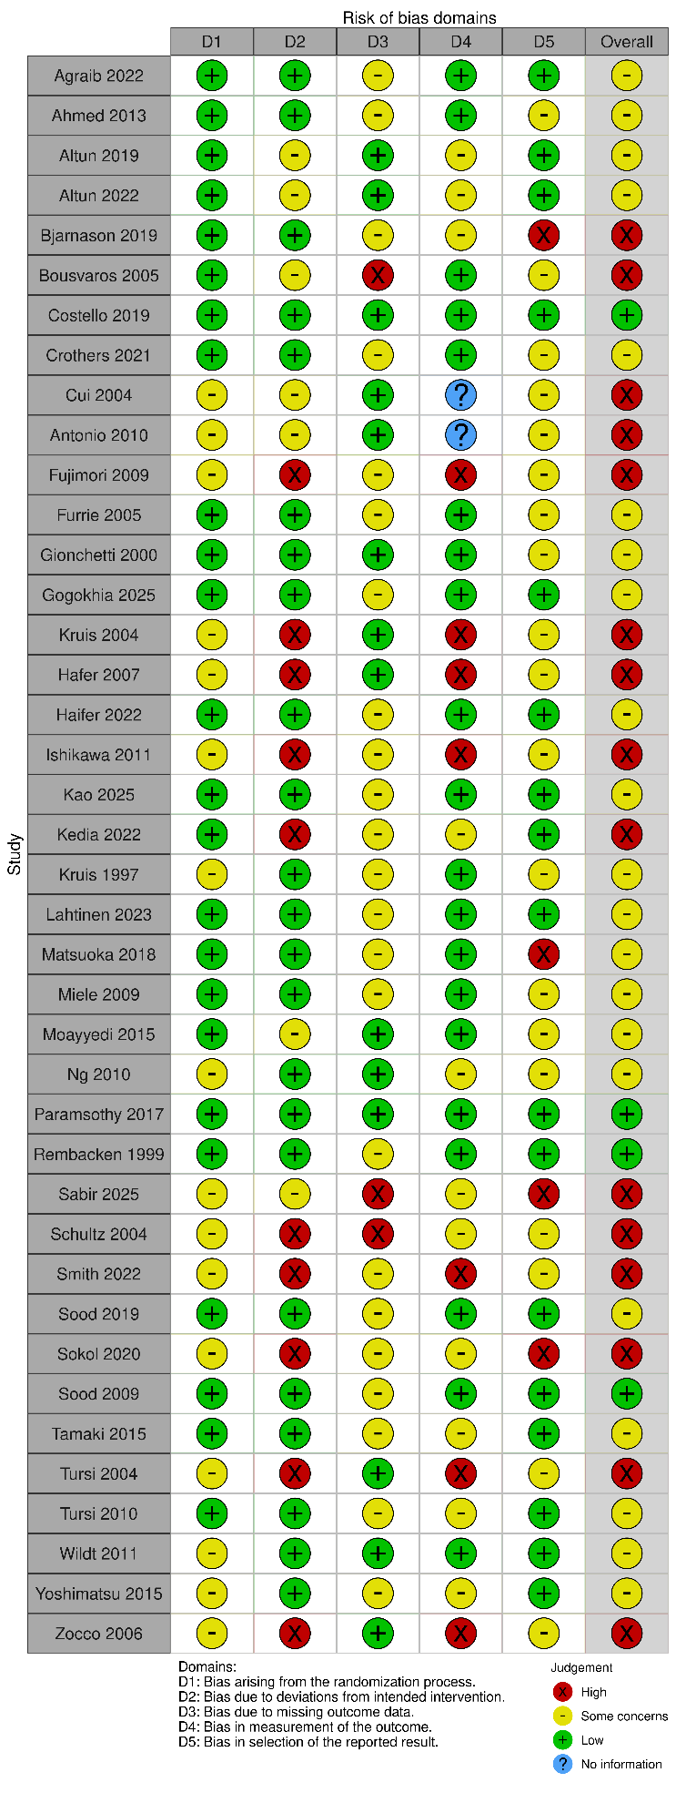
Supplementary Figure 2: Frequentist Forest Plot For Clinical Remission
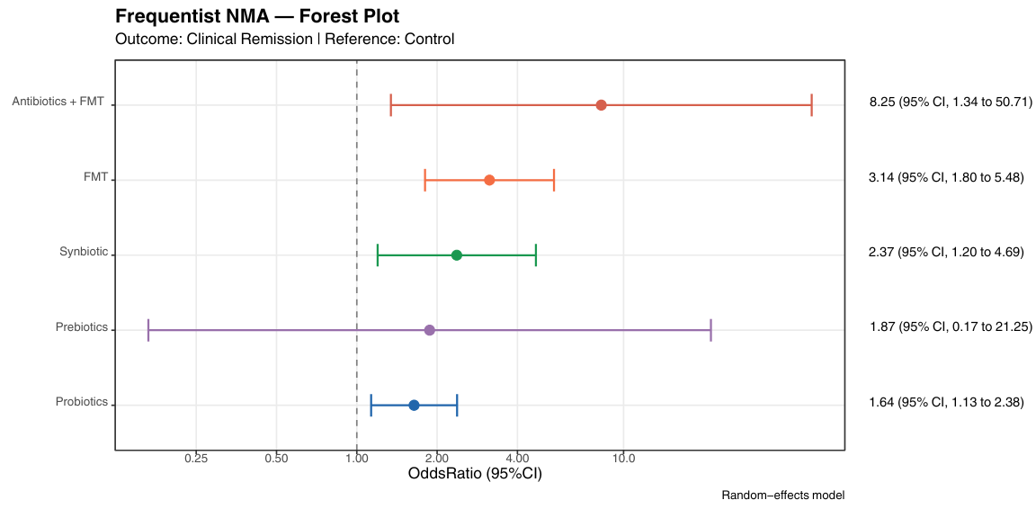
Supplementary Figure 3: Node-Split Forest Plot For Clinical Remission
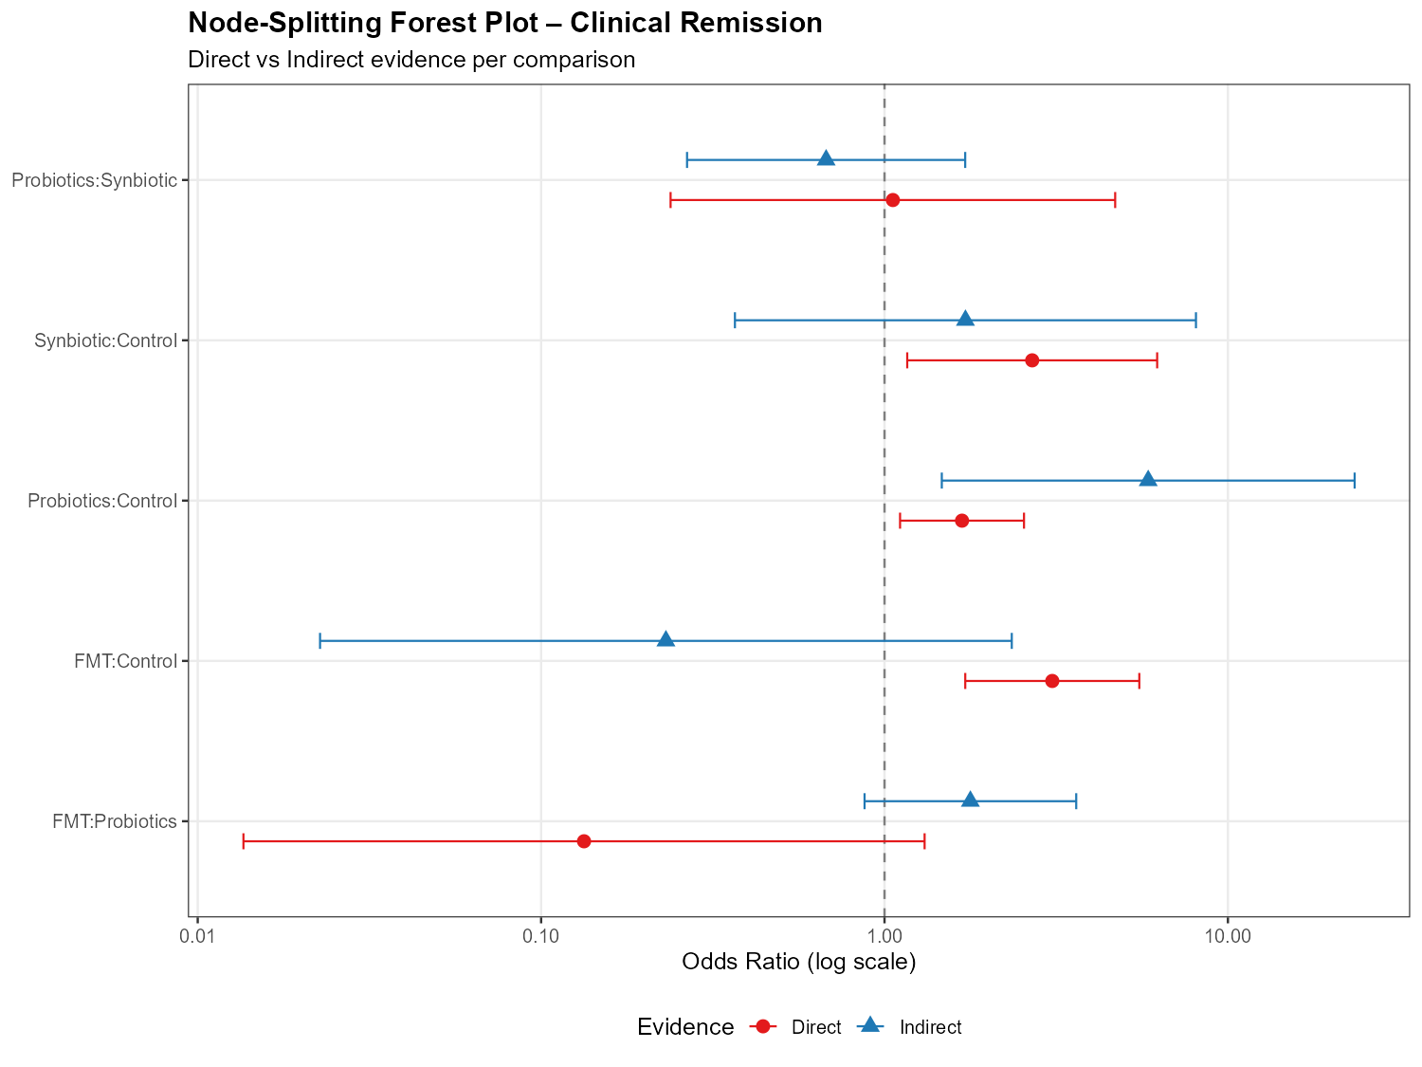
Supplementary Figure 4: Node-Splitting p Value For Clinical Remission
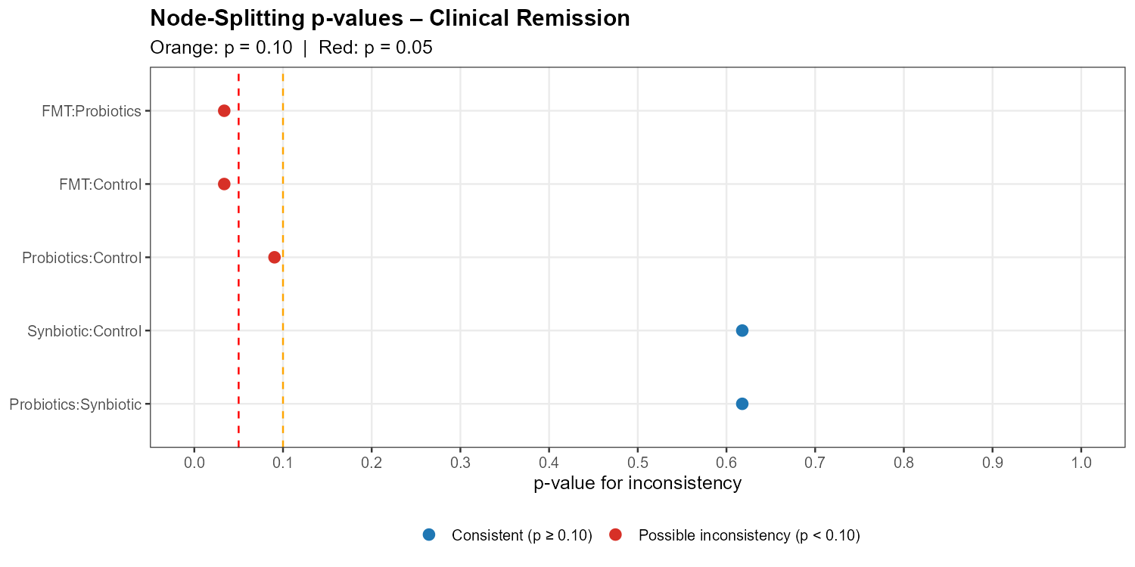
Supplementary Figure 5: Ranking Heat Map For Clinical Remission
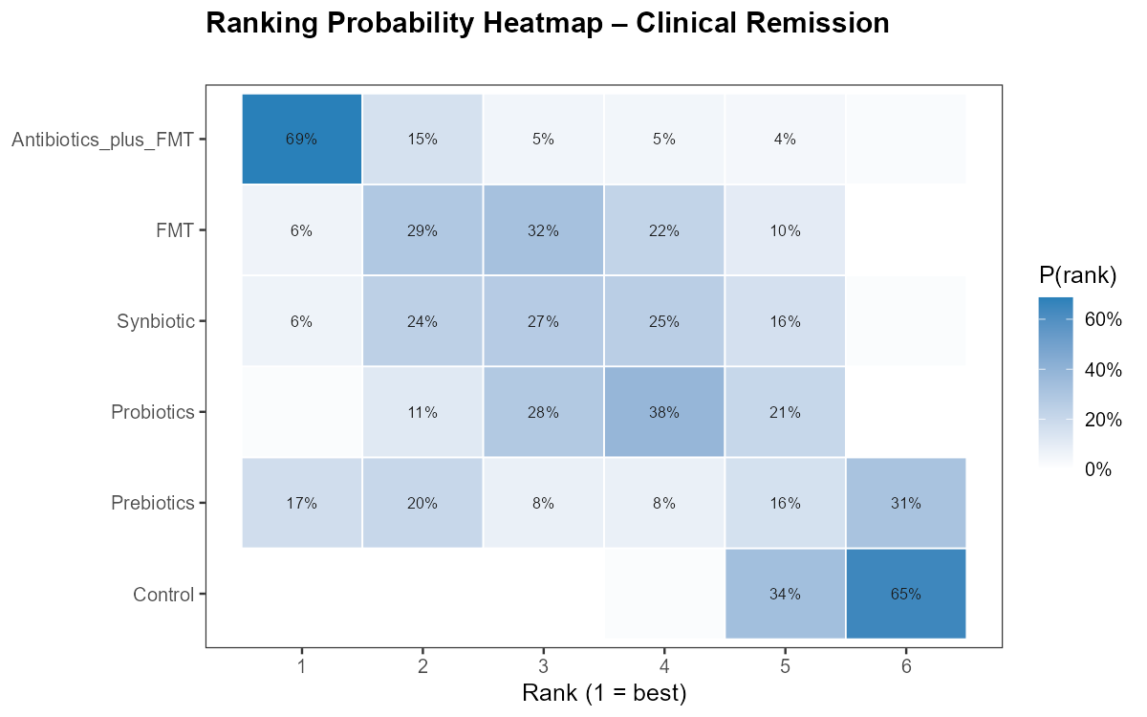
Supplementary Figure 6: Regression Overview For Clinical Remission
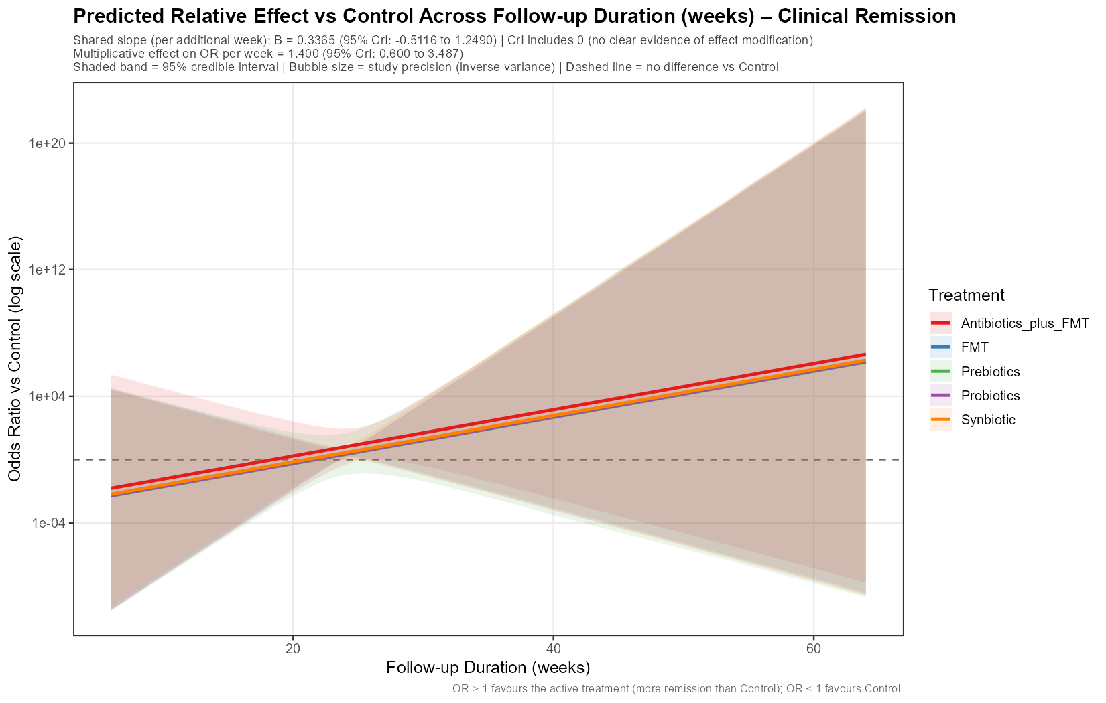
Supplementary Figure 7: Frequentist Forest Plot For Endoscopic Remission
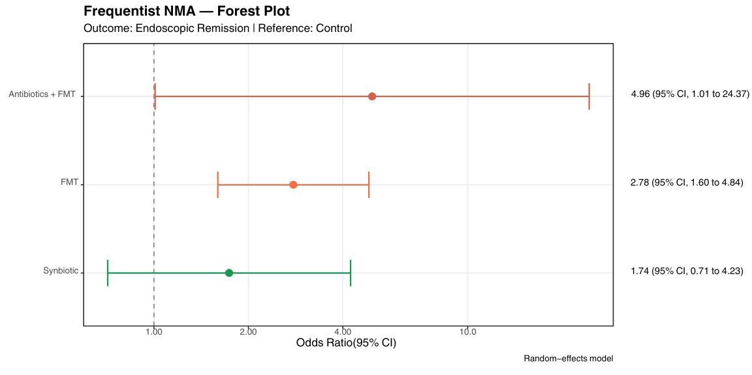
Supplementary Figure 8: Ranking Heat Map For Endoscopic Remission
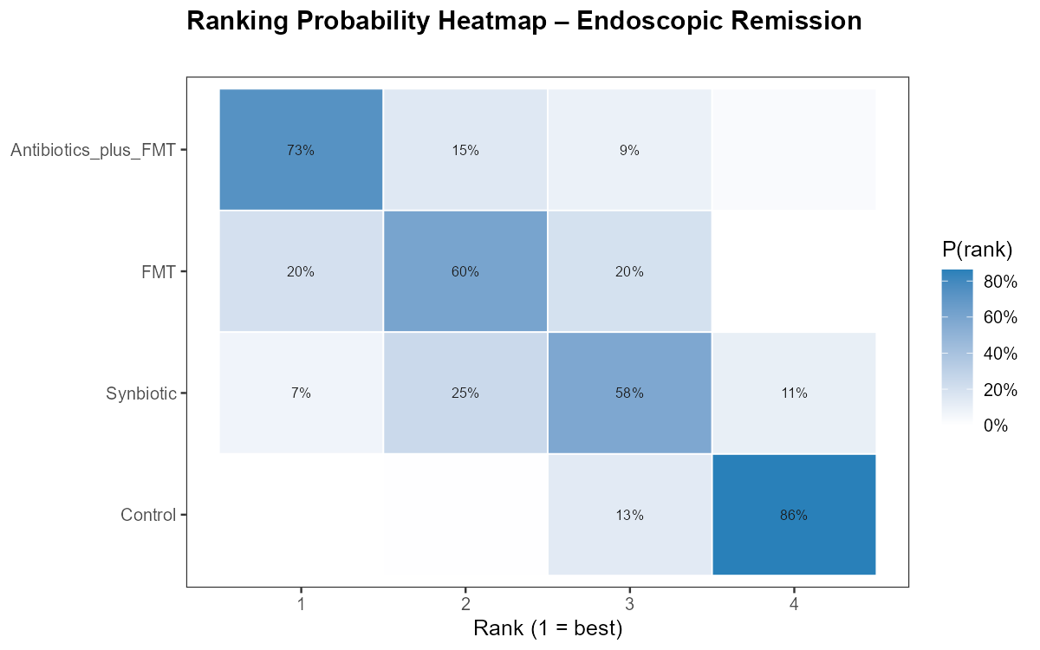
Supplementary Figure 9: Frequentist Forest Plot For Adverse Events
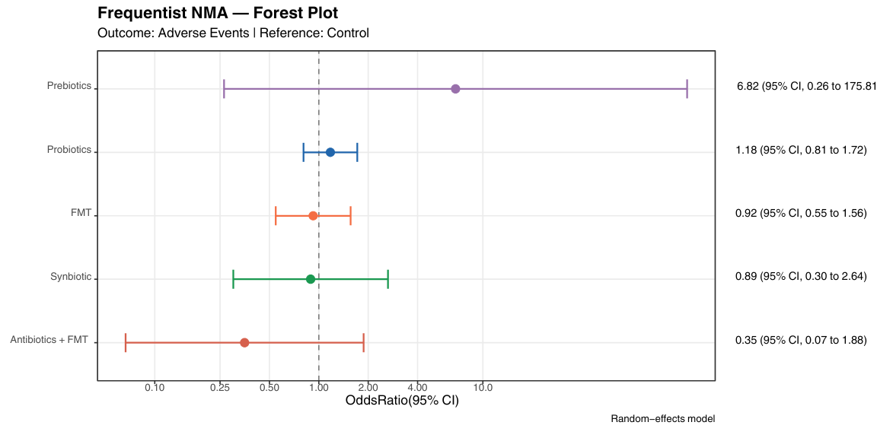
Supplementary Figure 10: Bayesian Forest Plot For Adverse Events
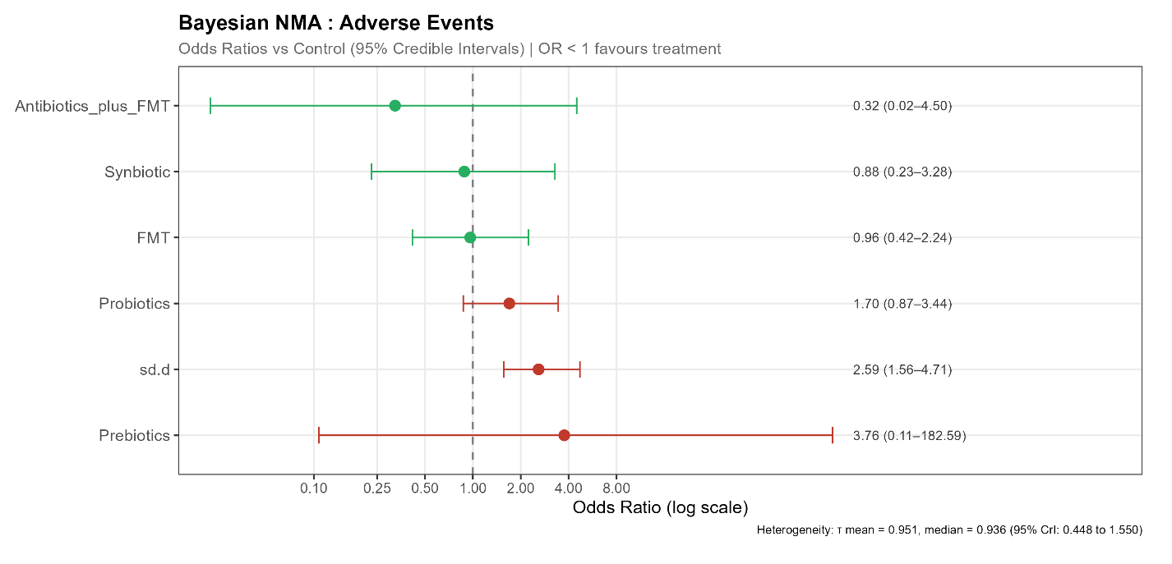
Supplementary Figure 11: League Table Heat Map For Adverse Events
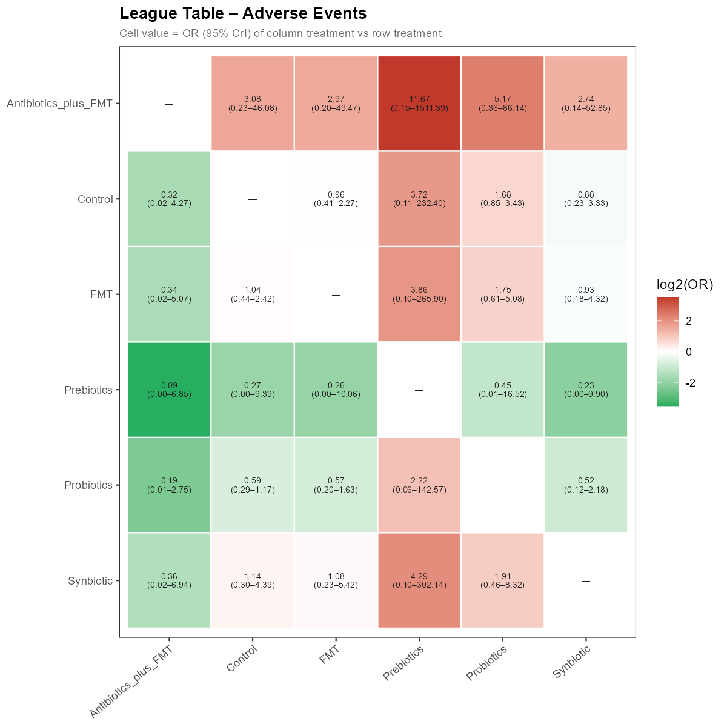
Supplementary Figure 12: SUCRA Bar Graph For Adverse Events
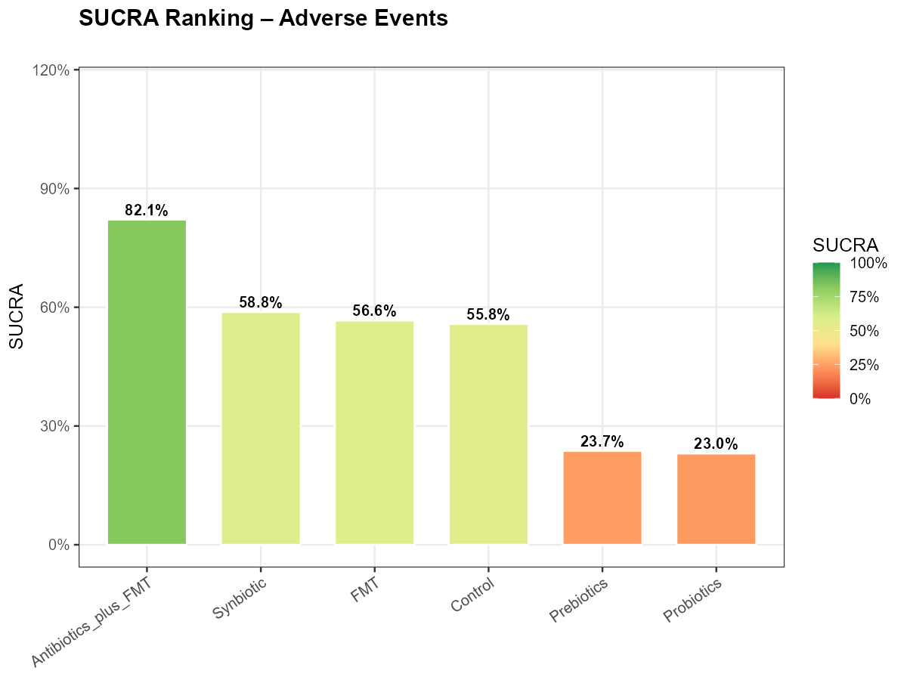
Supplementary Figure 13: SUCRA Cumulative Ranking Curve For Adverse Events
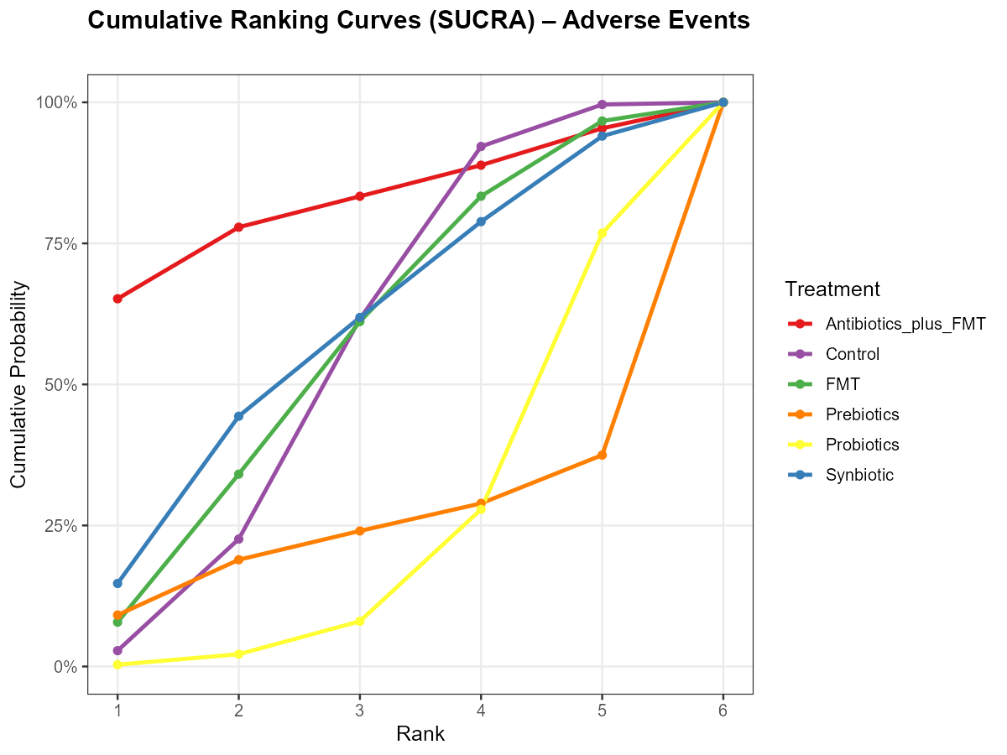
Supplementary Figure 14: Node-Split Forest Plot For Adverse Events
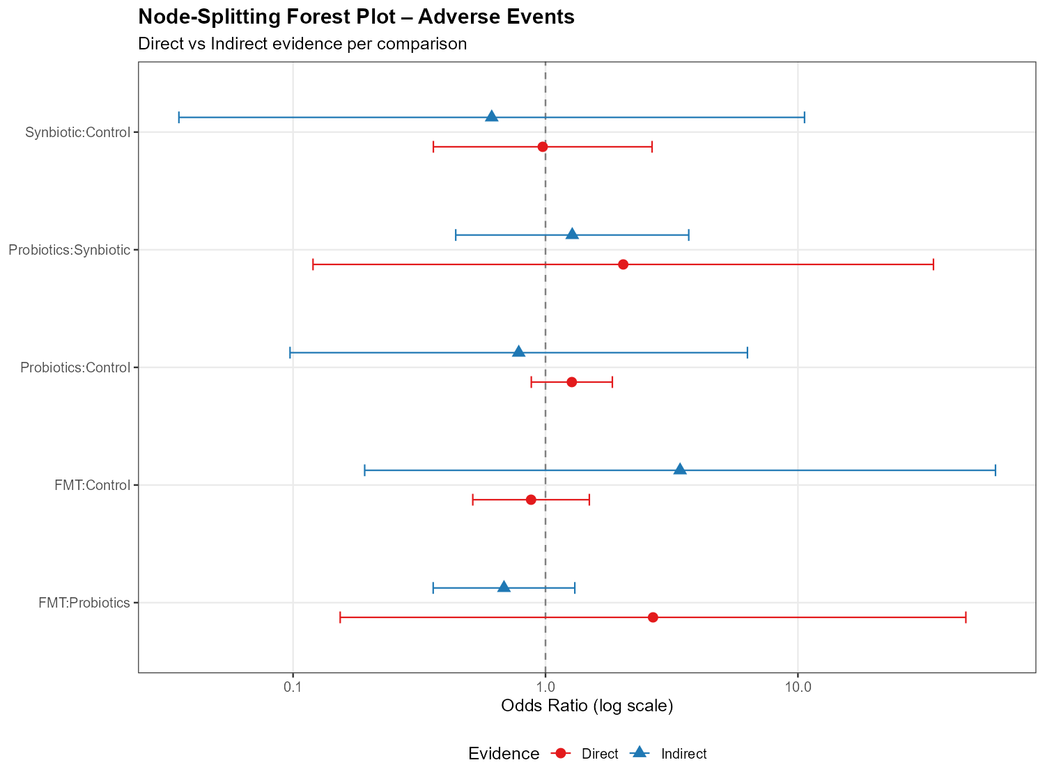
Supplementary Figure 15: Node-Splitting p Value For Adverse Events
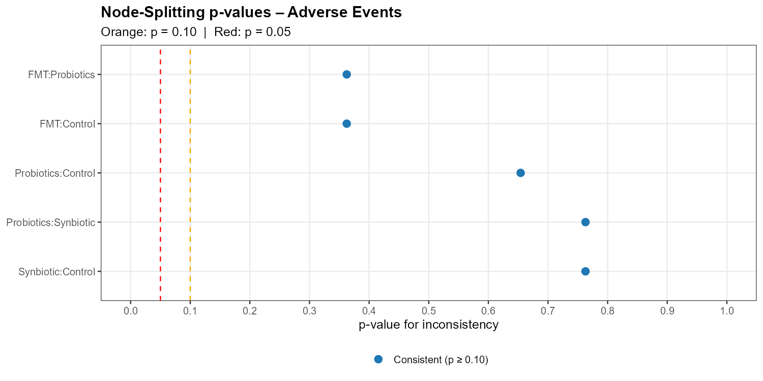
Supplementary Figure 16: Ranking Heat Map For Adverse Events
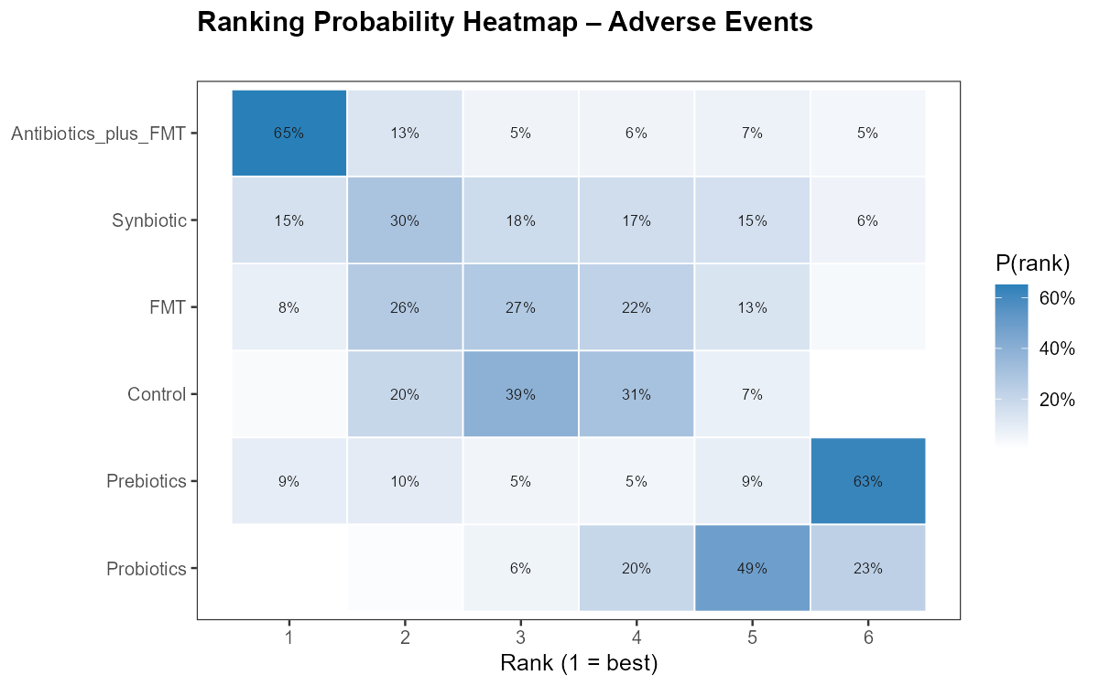
Supplementary Figure 17: Frequentist Forest Plot For Serious Adverse Events
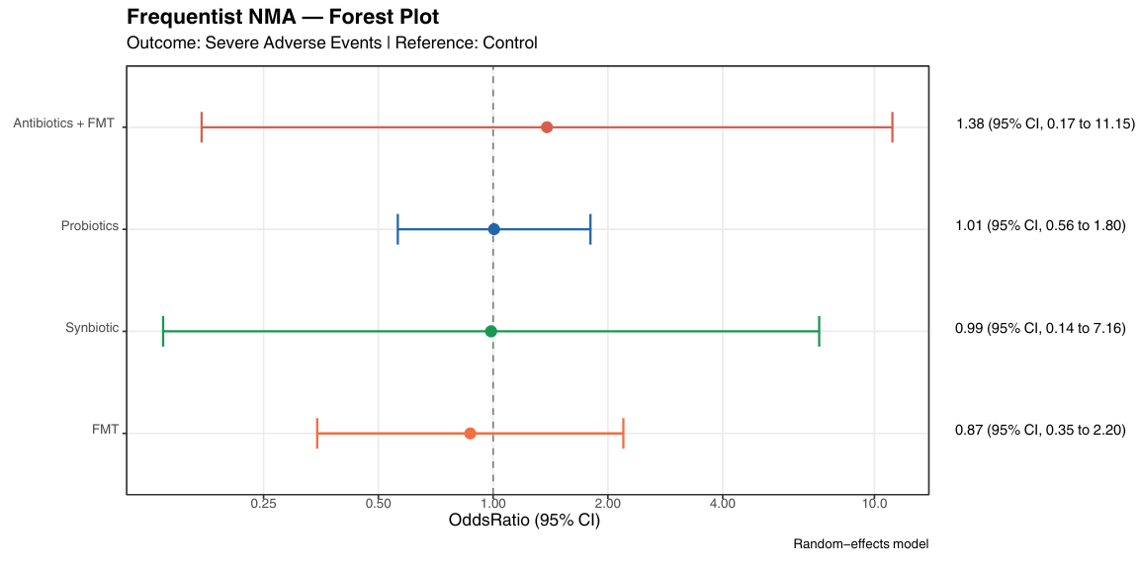
Supplementary Figure 18: Bayesian Forest Plot For Serious Adverse Events
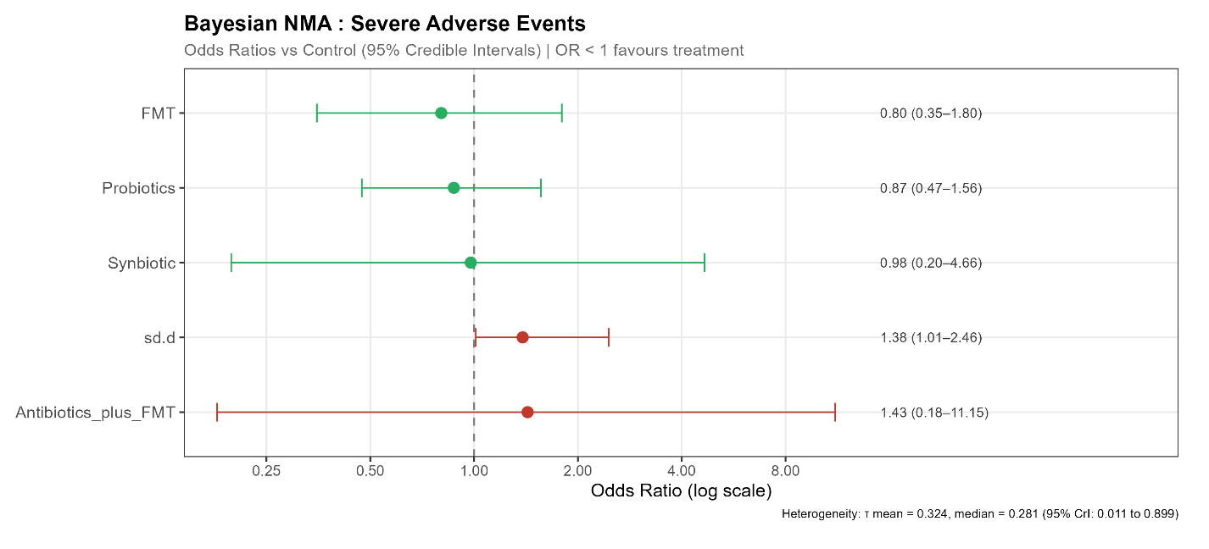
Supplementary Figure 19: League Table Heat Map For Serious Adverse Events
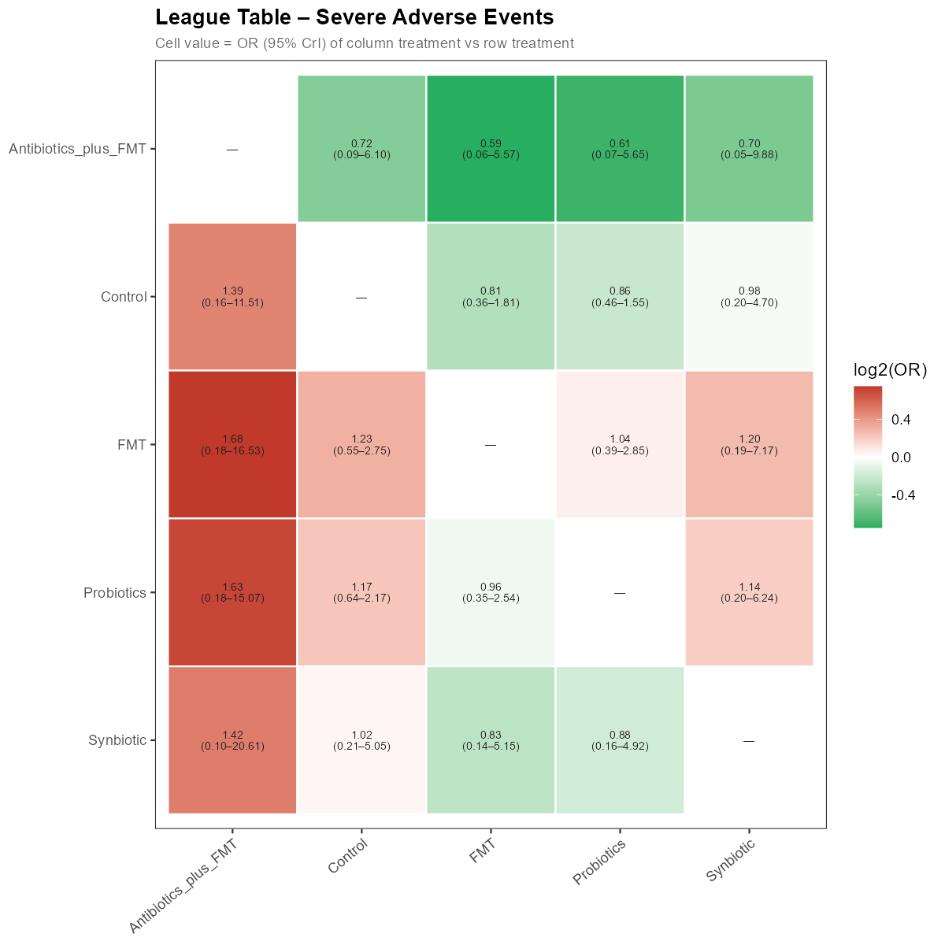
Supplementary Figure 20: SUCRA Bar Graph For Serious Adverse Events
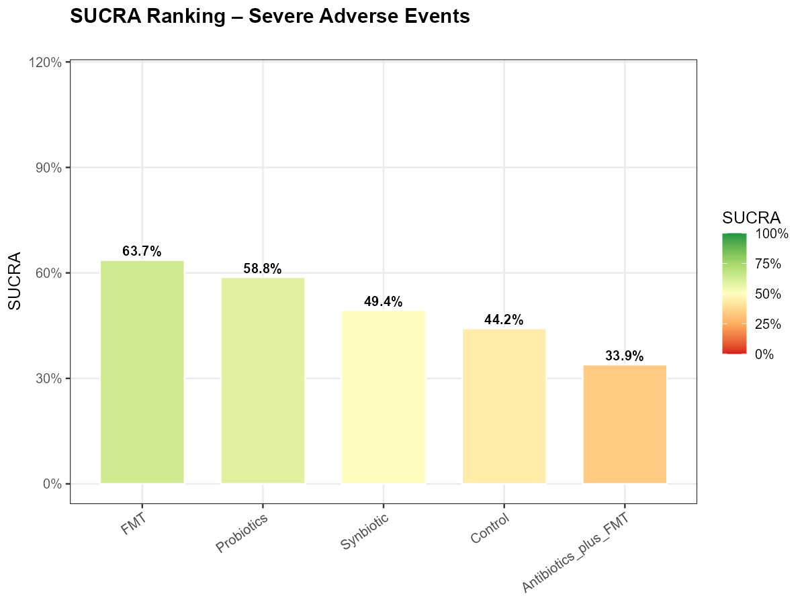
Supplementary Figure 21: SUCRA Cumulative Ranking Curve For Serious Adverse Events
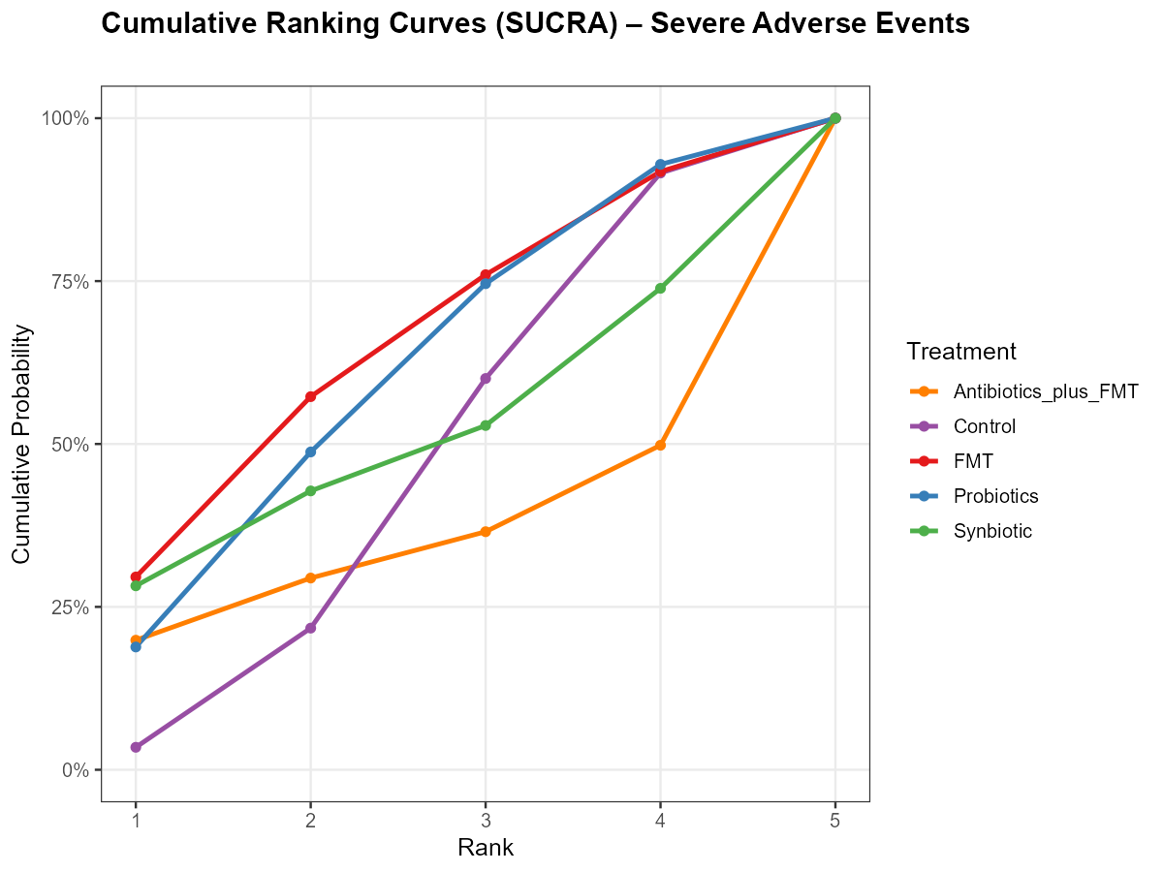
Supplementary Figure 22: Node-Split Forest Plot For Serious Adverse Events
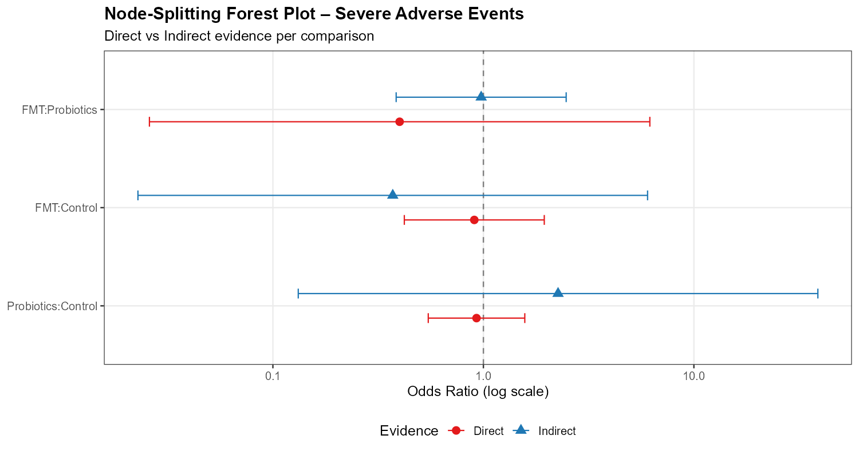
Supplementary Figure 23: Node-Splitting p Value For Serious Adverse Events
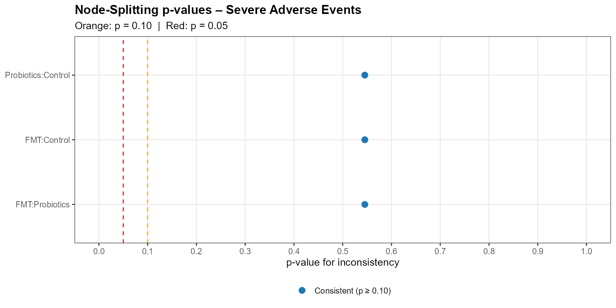
Supplementary Figure 24: Ranking Heat Map For Serious Adverse Events
