Supplementary Information for
Cerebrospinal fluid profile of lipid mediators in Alzheimer’s disease

Khanh V. Do, Erik Hjorth, Ying Wang, Bokkyoo Jun, Marie-Audrey I. Kautzmann, Makiko Ohshima, Maria Eriksdotter, Marianne Schultzberg, Nicolas G. Bazan

Marianne Schultzberg and Nicolas G. Bazan
Email: Marianne.Schultzberg@ki.se and NBazan@lsuhsc.edu

This PDF file includes:

Figures S1 to S3
Tables S1 to S2

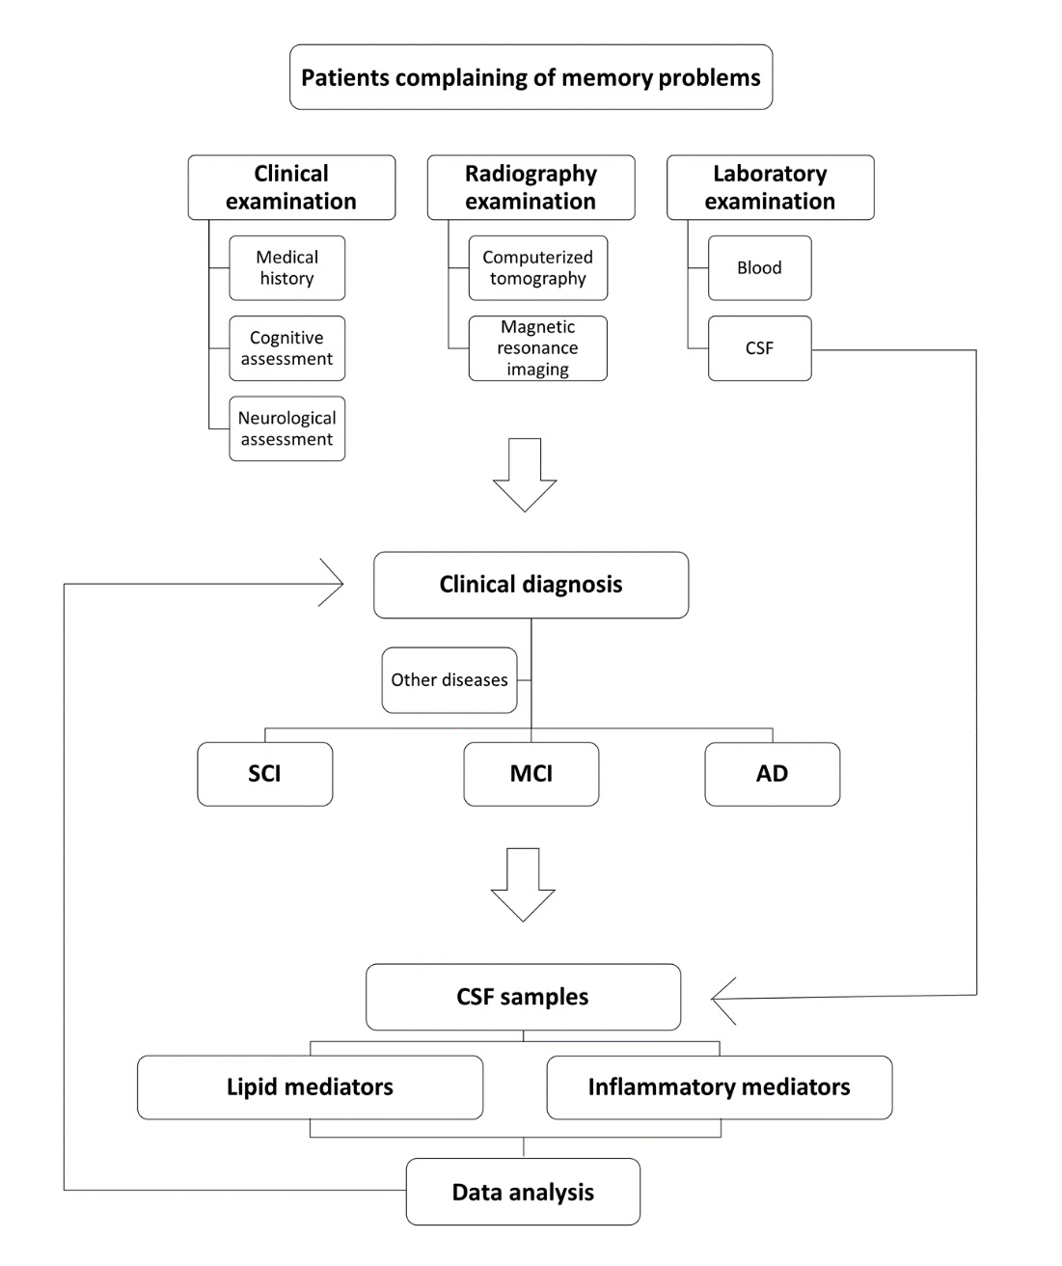

Fig. S1 Study flow-chart. Cerebrospinal fluid (CSF) samples were obtained from a cohort of 136 patients subjected to clinical, radiography, and laboratory examinations for the diagnosis of subjective cognitive impairment (SCI) (n = 53), mild cognitive impairment (MCI) (n = 43), and Alzheimer's disease (AD) (n = 40)

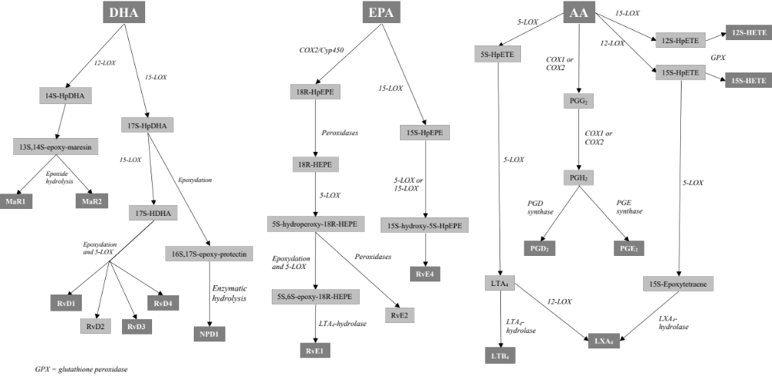

Fig. S2 Metabolic pathways of lipid mediators. Pro-resolving and pro-inflammatory lipid mediators (LMs) are derived from the omega-3 and -6 polyunsaturated fatty acids (PUFAs) docosahexaenoic acid (DHA), eicosapentaenoic acid (EPA), and arachidonic acid (AA). The figure shows the LMs analyzed in the present study and the biosynthetic enzymes involved in their synthesis. COX = cyclooxygenase, GPX = glutathione peroxidase, HDHA = hydroxydocosahexaenoic acid, HEPE = hydroxyeicosapentaenoic acid, HETE = hydroxyeicosatetraenoic acid, LOX = lipoxygenase, LT = leukotriene, LX = lipoxin, MaR = maresin, NPD = neuroprotectin D1, PG = prostaglandin, Rv = resolvin

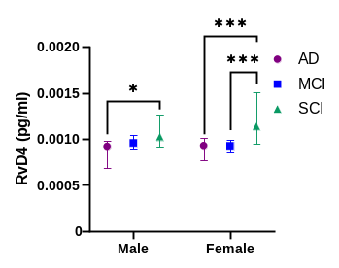
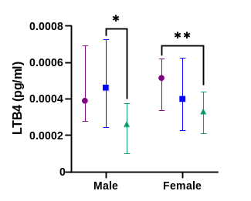
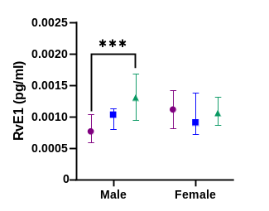
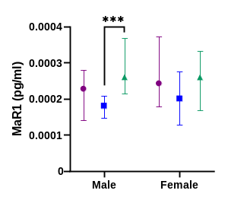
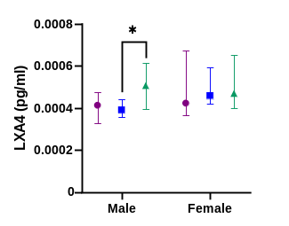
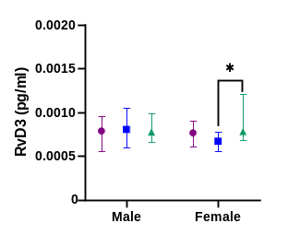
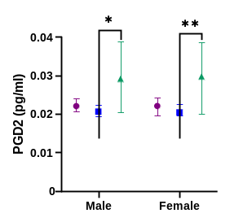
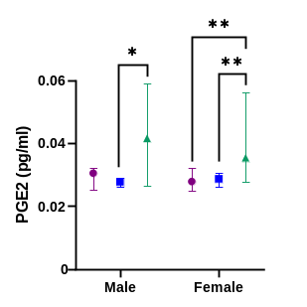
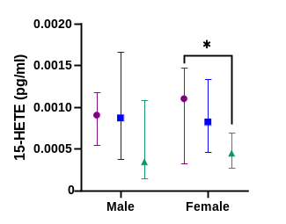
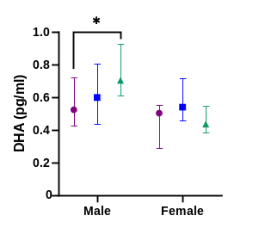
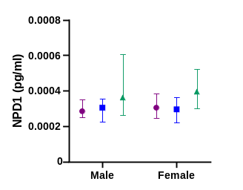
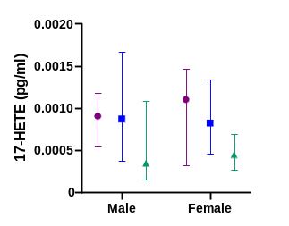
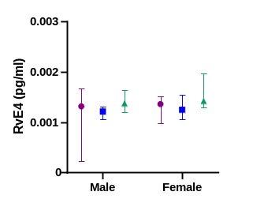
Fig. S3 Analysis of differences in LMs between diagnostic groups within each gender separately. LMs were assessed in the cerebrospinal fluid (CSF) samples from patients with Alzheimer's disease (AD) (F = 24, M = 16), mild cognitive impairment (MCI) (F = 23, M = 20) or subjective cognitive impairment (SCI) (F = 33, M = 20), using liquid chromatography-tandem mass spectrometry (LC-MS/MS). Comparisons were performed between diagnostic groups within the male and female cases, respectively. The analyses show differences that were not present when analyzing data from men and women together (Fig. 1), such as for resolvin (Rv) E1, lipoxin (LX) A4, RvD3, and docosahexaenoic acid (DHA). The analysis also indicates which gender is important for showing the differences when analyzing data from men and women together, such as for maresin 1 (MaR1). Comparisons between groups were performed by Kruskal-Wallis ANOVA with Dunn’s multiple comparisons post hoc test (*P < 0.05, **P < 0.005, ***P < 0.001, ****P < 0.0001)
Table S1. LMs in CSF from patients diagnosed with SCI, MCI or AD

LM | AD |  |  | MCI |  |  | SCI
 | Median | Lower Q | Upper Q | Median | Lower Q | Upper Q | Median | Lower Q | Upper Q
RvD1 | 7.85 | 3.72 | 8.06 | 7.98 | 7.72 | 8.09 | 7.95 | 7.82 | 8.38
RvD3 | 0.76 | 0.61 | 0.91 | 0.69 | 0.58 | 0.90 | 0.78 | 0.67 | 1.17
RvD4 | 0.93 | 0.78 | 1.01 | 0.94 | 0.87 | 1,00 | 1.10 | 0.94 | 1.35
MaR1 | 0.24 | 0.16 | 0.34 | 0.19 | 0.14 | 0.24 | 0.26 | 0.18 | 0.33
MaR2 | 0.20 | 0.17 | 0.26 | 0.20 | 0.15 | 0.23 | 0.20 | 0.18 | 0.26
NPD1 | 0.30 | 0.25 | 0.37 | 0.30 | 0.22 | 0.36 | 0.38 | 0.29 | 0.50
RvE1 | 0.95 | 0.73 | 1.27 | 0.93 | 0.78 | 1.35 | 1.18 | 0.93 | 1.53
RvE4 | 1.36 | 0.94 | 1.54 | 1.23 | 1.06 | 1.46 | 1.39 | 1.28 | 1.74
LXA4 | 0.42 | 0.35 | 0.56 | 0.43 | 0.37 | 0.51 | 0.48 | 0.41 | 0.64
LTB4 | 0.45 | 0.32 | 0.64 | 0.42 | 0.23 | 0.62 | 0.32 | 0.20 | 0.40
14-HDHA | 0.20 | 0.14 | 0.25 | 0.19 | 0.15 | 0.23 | 0.17 | 0.13 | 0.24
17-HDHA | 0.22 | 0.17 | 0.31 | 0.17 | 0.13 | 0.23 | 0.20 | 0.14 | 0.25
20-HDHA | 0.76 | 0.61 | 0.96 | 0.83 | 0.59 | 1.00 | 0.67 | 0.54 | 1.01
12-HETE | 1.32 | 0.28 | 1.76 | 1.22 | 1.01 | 1.66 | 1.08 | 0.00 | 1.55
15-HETE | 0.99 | 0.43 | 1.22 | 0.84 | 0.45 | 1.48 | 0.40 | 0.20 | 0.74
PGD2 | 22.06 | 20.37 | 23.91 | 20.53 | 19.49 | 22.47 | 29.74 | 20.46 | 38.53
PGE2 | 28.86 | 25.04 | 32.10 | 28.39 | 26.16 | 30.08 | 35.43 | 27.56 | 57.11
PGF2a | 10.50 | 4.95 | 11.73 | 10.28 | 9.04 | 11.02 | 9.35 | 8.04 | 13.34
DHA | 503.75 | 381.83 | 582.30 | 539.71 | 457.56 | 713.61 | 498.17 | 421.98 | 702.67
EPA | 54.90 | 38.05 | 84.34 | 67.23 | 45.06 | 85.02 | 58.65 | 42.92 | 84.08
AA | 138.57 | 112.77 | 161.06 | 143.13 | 103.19 | 187.31 | 116.21 | 95.79 | 186.70

The levels of lipid mediators (LMs) and polyunsaturated fatty acids (PUFAs) in cerebrospinal fluid (CSF) samples from individuals with Alzheimer's disease (AD), mild cognitive impairment (MCI) and subjective cognitive impairment (SCI) are presented as median and interquartile (Q) range in fg/ml. AA = arachidonic acid, DHA = docosahexaenoic acid, EPA = eicosapentaenoic acid, HDHA = hydroxy-docosahexaenoic acids, HETE = hydroxy-eicosatetraenoic, LT = leukotriene, LX = lipoxin, MaR = maresin, NPD = neuroprotectin D, PG = prostaglandin, Rv = resolvin

Table S2a-d. Correlation of LMs to cognition and CSF plaque and tangle biomarkers

Table 2a

MMSE | AD |  | MCI |  | SCI |  | All
MMSE | r | P value | r | P value | r | P value | r | P value
RvD1 | -0.24 | n.s. | -0.12 | n.s. | 0.36 | 0.0090 | 0.17 | 0.0434
RvD3 | -0.05 | n.s. | 0.12 | n.s. | 0.14 | n.s. | 0.17 | n.s.
RvD4 | -0.13 | n.s. | -0.22 | n.s. | 0.42 | 0.0018 | 0.29 | 0.0007
MaR1 | 0.09 | n.s. | -0.32 | 0.0377 | 0.14 | n.s. | 0.02 | n.s.
MaR2 | -0.12 | n.s. | -0.27 | n.s. | 0.12 | n.s. | -0.01 | n.s.
NPD1 | -0.25 | n.s. | 0.11 | n.s. | -0.22 | n.s. | 0.05 | n.s.
RvE1 | 0.03 | n.s. | -0.15 | n.s. | 0.16 | n.s. | 0.16 | n.s.
RvE4 | -0.03 | n.s. | -0.21 | n.s. | 0.34 | 0.0125 | 0.11 | n.s.
LXA4 | -0.13 | n.s. | -0.12 | n.s. | 0.07 | n.s. | 0.07 | n.s.
LTB4 | 0.02 | n.s. | 0.19 | n.s. | 0.29 | 0.0351 | -0.09 | n.s.
14-HDHA | 0.53 | 0.0004 | 0.19 | n.s. | 0.18 | n.s. | 0.13 | n.s.
17-HDHA | 0.18 | n.s. | 0.02 | n.s. | 0.14 | n.s. | -0.09 | n.s.
20-HDHA | 0.33 | 0.0355 | 0.30 | n.s. | -0.06 | n.s. | 0.04 | n.s.
12-HETE | 0.02 | n.s. | -0.06 | n.s. | -0.02 | n.s. | -0.08 | n.s.
15-HETE | 0.04 | n.s. | -0.12 | n.s. | 0.12 | n.s. | -0.15 | n.s.
PGD2 | -0.03 | n.s. | -0.02 | n.s. | 0.01 | n.s. | 0.11 | n.s.
PGE2 | 0.02 | n.s. | -0.10 | n.s. | 0.01 | n.s. | 0.18 | 0.0395
PGF2a | -0.04 | n.s. | -0.27 | n.s. | 0.12 | n.s. | 0.01 | n.s.
DHA | 0.53 | 0.0005 | 0.09 | n.s. | 0.10 | n.s. | 0.21 | 0.0143
EPA | 0.51 | 0.0008 | 0.05 | n.s. | 0.16 | n.s. | 0.18 | 0.0373
AA | 0.42 | 0.0066 | 0.04 | n.s. | 0.01 | n.s. | 0.04 | n.s.

Table 2b

Aβ₄₂ | AD |  | MCI |  | SCI |  | All
Aβ₄₂ | r | P value | r | P value | r | P value | r | P value
RvD1 | 0.14 | n.s. | 0.23 | n.s. | -0.14 | n.s. | 0.18 | 0.0319
RvD3 | 0.14 | n.s. | 0.23 | n.s. | -0.09 | n.s. | 0.11 | n.s.
RvD4 | 0.15 | n.s. | 0.14 | n.s. | 0.11 | n.s. | 0.29 | 0.0007
MaR1 | 0.23 | n.s. | 0.19 | n.s. | 0.13 | n.s. | 0.10 | n.s.
MaR2 | 0.30 | n.s. | -0.19 | n.s. | -0.26 | n.s. | -0.07 | n.s.
NPD1 | -0.09 | n.s. | 0.03 | n.s. | 0.12 | n.s. | 0.18 | 0.0398
RvE1 | -0.08 | n.s. | 0.19 | n.s. | 0.27 | 0.0474 | 0.23 | 0.0060
RvE4 | 0.32 | 0.0437 | 0.03 | n.s. | -0.07 | n.s. | 0.10 | n.s.
LXA4 | 0.35 | 0.0279 | -0.08 | n.s. | 0.05 | n.s. | 0.15 | n.s.
LTB4 | 0.33 | 0.0375 | -0.05 | n.s. | 0.00 | n.s. | -0.15 | n.s.
14-HDHA | 0.02 | n.s. | 0.09 | n.s. | -0.20 | n.s. | -0.18 | n.s.
17-HDHA | 0.22 | n.s. | -0.10 | n.s. | -0.06 | n.s. | -0.17 | n.s.
20-HDHA | 0.12 | n.s. | 0.04 | n.s. | -0.17 | n.s. | -0.06 | n.s.
12-HETE | 0.42 | 0.0064 | -0.05 | n.s. | -0.08 | n.s. | -0.05 | n.s.
15-HETE | 0.29 | n.s. | -0.04 | n.s. | -0.11 | n.s. | -0.14 | n.s.
PGD2 | -0.25 | n.s. | -0.14 | n.s. | 0.00 | n.s. | -0.01 | n.s.
PGE2 | -0.14 | n.s. | -0.24 | n.s. | 0.00 | n.s. | 0.11 | n.s.
PGF2a | 0.32 | 0.0440 | -0.05 | n.s. | -0.08 | n.s. | 0.01 | n.s.
DHA | 0.09 | n.s. | -0.15 | n.s. | -0.09 | n.s. | 0.04 | n.s.
EPA | 0.15 | n.s. | -0.01 | n.s. | -0.07 | n.s. | 0.04 | n.s.
AA | 0.22 | n.s. | -0.12 | n.s. | -0.08 | n.s. | -0.05 | n.s.

Table 2c

t-tau | AD |  | MCI |  | SCI |  | All
t-tau | r | P value | r | P value | r | P value | r | P value
RvD1 | -0.16 | n.s. | -0.05 | n.s. | 0.03 | n.s. | -0.16 | n.s.
RvD3 | 0.00 | n.s. | -0.24 | n.s. | -0.05 | n.s. | -0.13 | n.s.
RvD4 | -0.03 | n.s. | 0.10 | n.s. | -0.01 | n.s. | -0.17 | 0.0464
MaR1 | -0.35 | 0.0262 | -0.06 | n.s. | 0.05 | n.s. | -0.08 | n.s.
MaR2 | -0.23 | n.s. | 0.04 | n.s. | 0.01 | n.s. | -0.05 | n.s.
NPD1 | 0.11 | n.s. | -0.01 | n.s. | 0.11 | n.s. | -0.07 | n.s.
RvE1 | -0.08 | n.s. | -0.02 | n.s. | 0.19 | n.s. | -0.06 | n.s.
RvE4 | 0.02 | n.s. | -0.25 | n.s. | 0.18 | n.s. | -0.09 | n.s.
LXA4 | 0.19 | n.s. | -0.33 | 0.0304 | 0.20 | n.s. | -0.09 | n.s.
LTB4 | 0.09 | n.s. | -0.06 | n.s. | 0.09 | n.s. | 0.16 | n.s.
14-HDHA | -0.20 | n.s. | 0.08 | n.s. | -0.01 | n.s. | -0.01 | n.s.
17-HDHA | -0.07 | n.s. | -0.03 | n.s. | 0.15 | n.s. | 0.11 | n.s.
20-HDHA | -0.06 | n.s. | 0.10 | n.s. | 0.11 | n.s. | 0.08 | n.s.
12-HETE | -0.24 | n.s. | -0.32 | 0.0340 | 0.08 | n.s. | -0.07 | n.s.
15-HETE | -0.30 | n.s. | 0.03 | n.s. | -0.02 | n.s. | 0.03 | n.s.
PGD2 | 0.27 | n.s. | 0.03 | n.s. | 0.15 | n.s. | 0.04 | n.s.
PGE2 | -0.01 | n.s. | -0.23 | n.s. | 0.22 | n.s. | -0.09 | n.s.
PGF2a | 0.02 | n.s. | 0.14 | n.s. | 0.04 | n.s. | 0.00 | n.s.
DHA | -0.07 | n.s. | 0.04 | n.s. | 0.14 | n.s. | -0.06 | n.s.
EPA | -0.15 | n.s. | -0.12 | n.s. | 0.17 | n.s. | -0.07 | n.s.
AA | -0.26 | n.s. | 0.04 | n.s. | 0.13 | n.s. | 0.01 | n.s.

Table 2d

p-tau | AD |  | MCI |  | SCI |  | All
p-tau | r | P value | r | P value | r | P value | r | P value
RvD1 | -0.19 | n.s. | 0.00 | n.s. | 0.04 | n.s. | -0.13 | n.s.
RvD3 | 0.01 | n.s. | -0.19 | n.s. | 0.00 | n.s. | -0.01 | n.s.
RvD4 | -0.01 | n.s. | 0.15 | n.s. | 0.00 | n.s. | -0.12 | n.s.
MaR1 | -0.27 | n.s. | -0.01 | n.s. | 0.02 | n.s. | -0.08 | n.s.
MaR2 | -0.24 | n.s. | 0.04 | n.s. | -0.10 | n.s. | -0.10 | n.s.
NPD1 | 0.10 | n.s. | -0.08 | n.s. | 0.13 | n.s. | -0.06 | n.s.
RvE1 | -0.04 | n.s. | -0.02 | n.s. | 0.19 | n.s. | -0.05 | n.s.
RvE4 | 0.04 | n.s. | -0.21 | n.s. | 0.13 | n.s. | -0.07 | n.s.
LXA4 | 0.22 | n.s. | -0.33 | 0.0306 | 0.23 | n.s. | -0.05 | n.s.
LTB4 | 0.05 | n.s. | -0.06 | n.s. | 0.16 | n.s. | 0.14 | n.s.
14-HDHA | -0.18 | n.s. | 0.06 | n.s. | -0.05 | n.s. | 0.00 | n.s.
17-HDHA | -0.07 | n.s. | -0.04 | n.s. | 0.12 | n.s. | 0.09 | n.s.
20-HDHA | -0.05 | n.s. | 0.10 | n.s. | 0.13 | n.s. | 0.10 | n.s.
12-HETE | -0.18 | n.s. | -0.28 | n.s. | 0.07 | n.s. | -0.08 | n.s.
15-HETE | -0.27 | n.s. | 0.06 | n.s. | 0.03 | n.s. | 0.03 | n.s.
PGD2 | 0.32 | 0.0408 | 0.07 | n.s. | 0.15 | n.s. | 0.07 | n.s.
PGE2 | -0.02 | n.s. | -0.20 | n.s. | 0.20 | n.s. | -0.08 | n.s.
PGF2a | 0.02 | n.s. | 0.12 | n.s. | 0.00 | n.s. | -0.01 | n.s.
DHA | 0.02 | n.s. | 0.00 | n.s. | 0.06 | n.s. | -0.04 | n.s.
EPA | -0.05 | n.s. | -0.15 | n.s. | 0.14 | n.s. | -0.04 | n.s.
AA | -0.20 | n.s. | 0.02 | n.s. | 0.14 | n.s. | 0.02 | n.s.

Correlations of lipid mediator (LM) levels in CSF samples from individuals with Alzheimer’s disease (AD), mild cognitive impairment (MCI) or subjective cognitive impairment (SCI), or all cases together (All) to the mini-mental state examination (MMSE) test scores and to levels of Aβ₄₂, total (t)-tau, and phosphorylated (p)-tau. The data are presented by the r-value according to Spearman rank-order test together with the P-value, except when nonsignificant (n.s.). Significant correlations are presented in bold digits. AA = arachidonic acid, DHA = docosahexaenoic acid, EPA = eicosapentaenoic acid, HDHA = hydroxy-docosahexaenoic acids, HETE = hydroxy-eicosatetraenoic, LT = leukotriene, LX = lipoxin, MaR = maresin, NPD = neuroprotectin D, PG = prostaglandin, Rv = resolvin

