Supporting Information
Generalized additive models analysis of the atmospheric pollutants response to the emission reduction and meteorology during the COVID-19 lockdown in the north of Morocco
Salah Eddine Sbai¹ and Farida Bentayeb¹
¹Department of physics, Laboratoires de physique des hauts Energies Modélisation et Simulation, Mohammed V University in Rabat, Rabat, Morocco
Corresponding author (Salah Eddine Sbai): salaheddinechimie@gmail.com
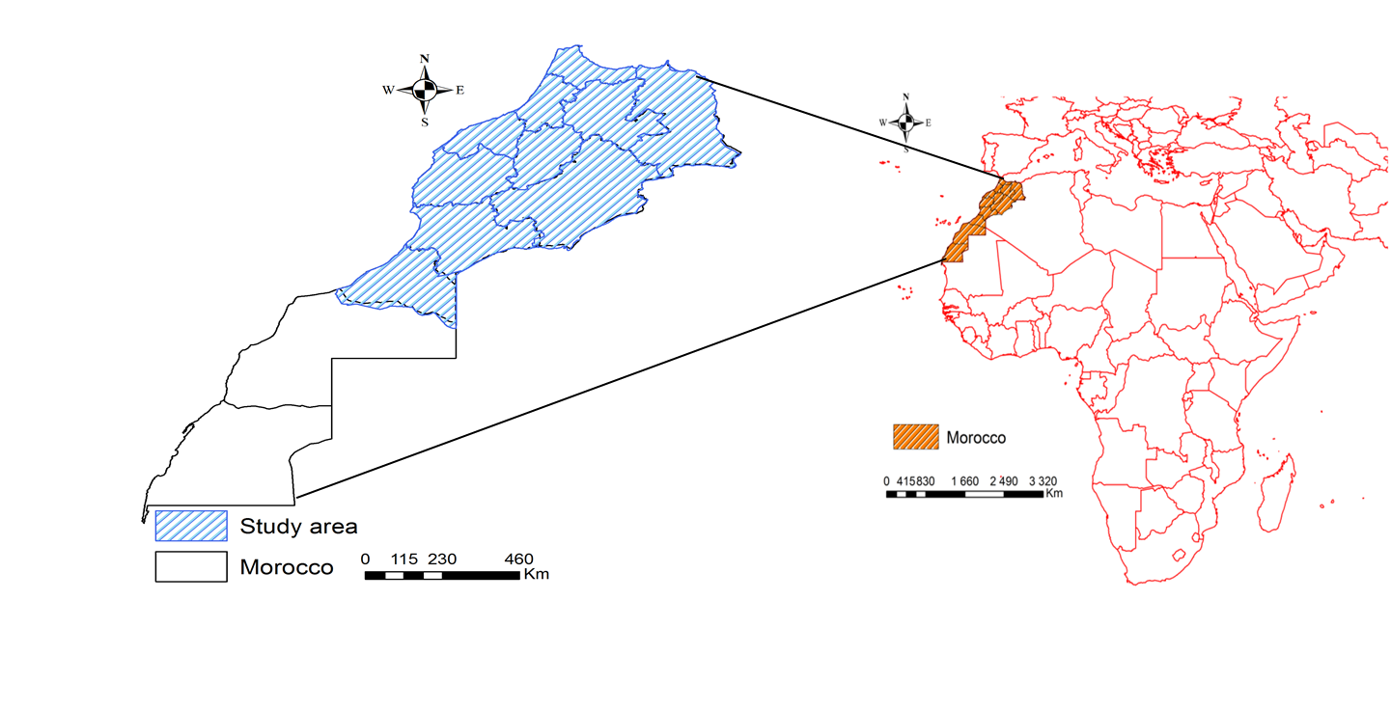
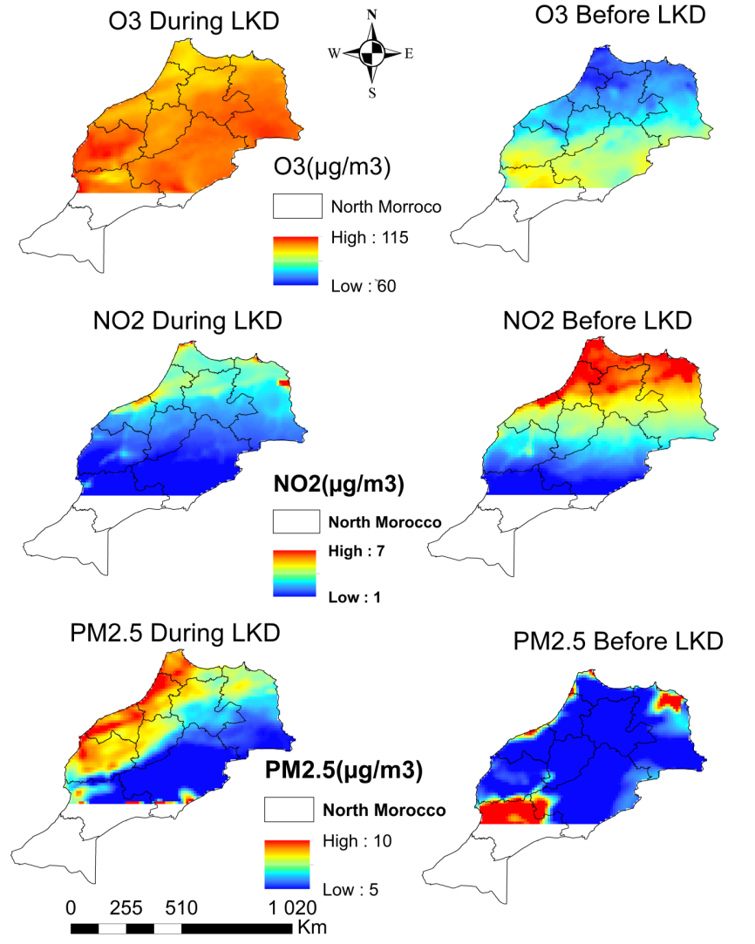

Figure The daily variation of O_{3 ,} NO₂, CO, PM2.5, PM10 , SO2 and SIA before and during LKD in
Casablanca

Figure Time series for the average mass concentration of SO₂, Secondary inorganic aerosols (SIA), PM₁₀, PM_{2.5}, NO₂ and O₃ before and during the LCD period in Casablanca industrial capital of Morocco

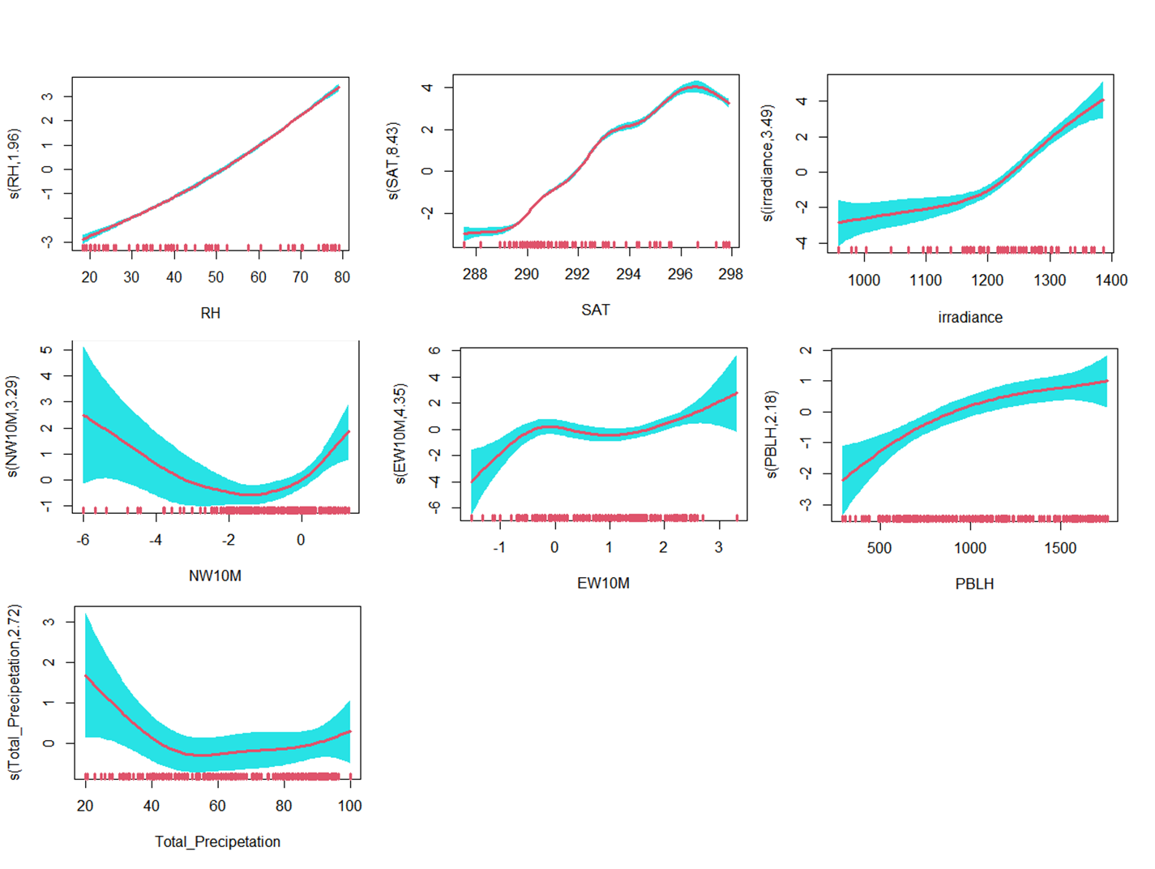
Figure : Marginal effect of individual meteorological variables including: Humidity (RH), Surface air temperature (SAT), wind direction including Eastward wind at 10m (EW10M) Northward Wind at 10m (NW10M), Total Precipitation (TP), Irradiance, Planetary Boundary Layer Height (PBLH) on PM2.5 mass concentration. Shaded bands represents the point wise 95% confidence interval. The estimated degrees of freedoms (EDFs), which show the linear or nonlinear degree of fitting, corresponding to the individual terms are noted in each figure. An EDFs of 1 indicates a linear effect.
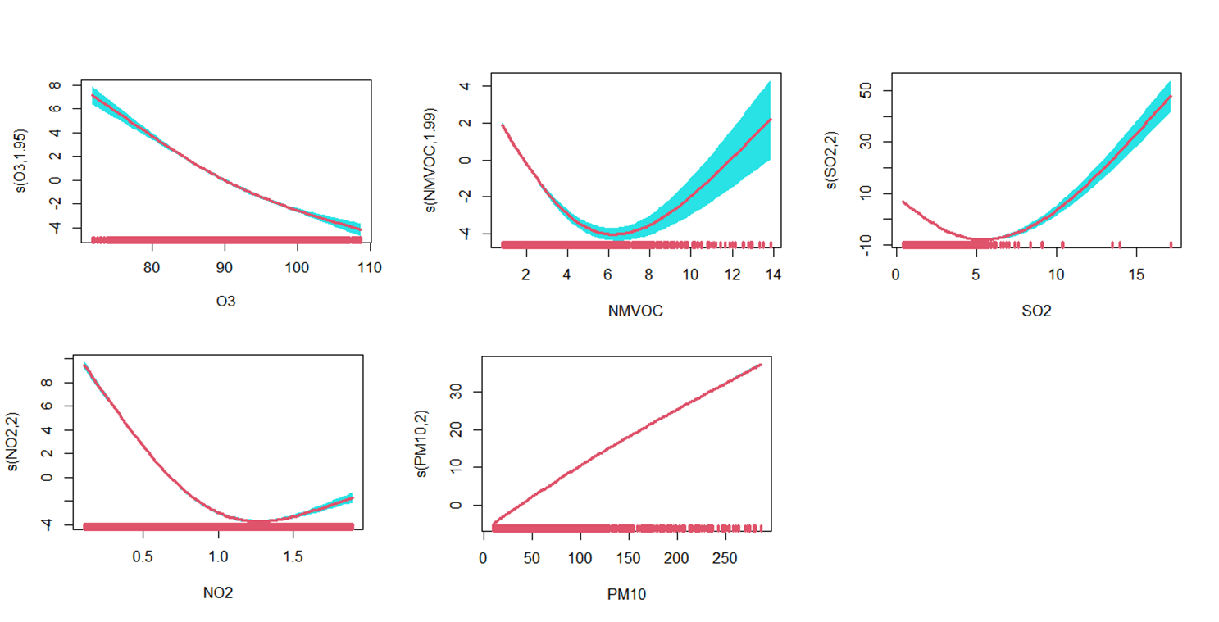
Figure : Marginal effect of individual pollutants (NO₂, SO₂, NMVOC , O₃, PM₁₀) on PM_{2.5} mass concentration during lockdown.
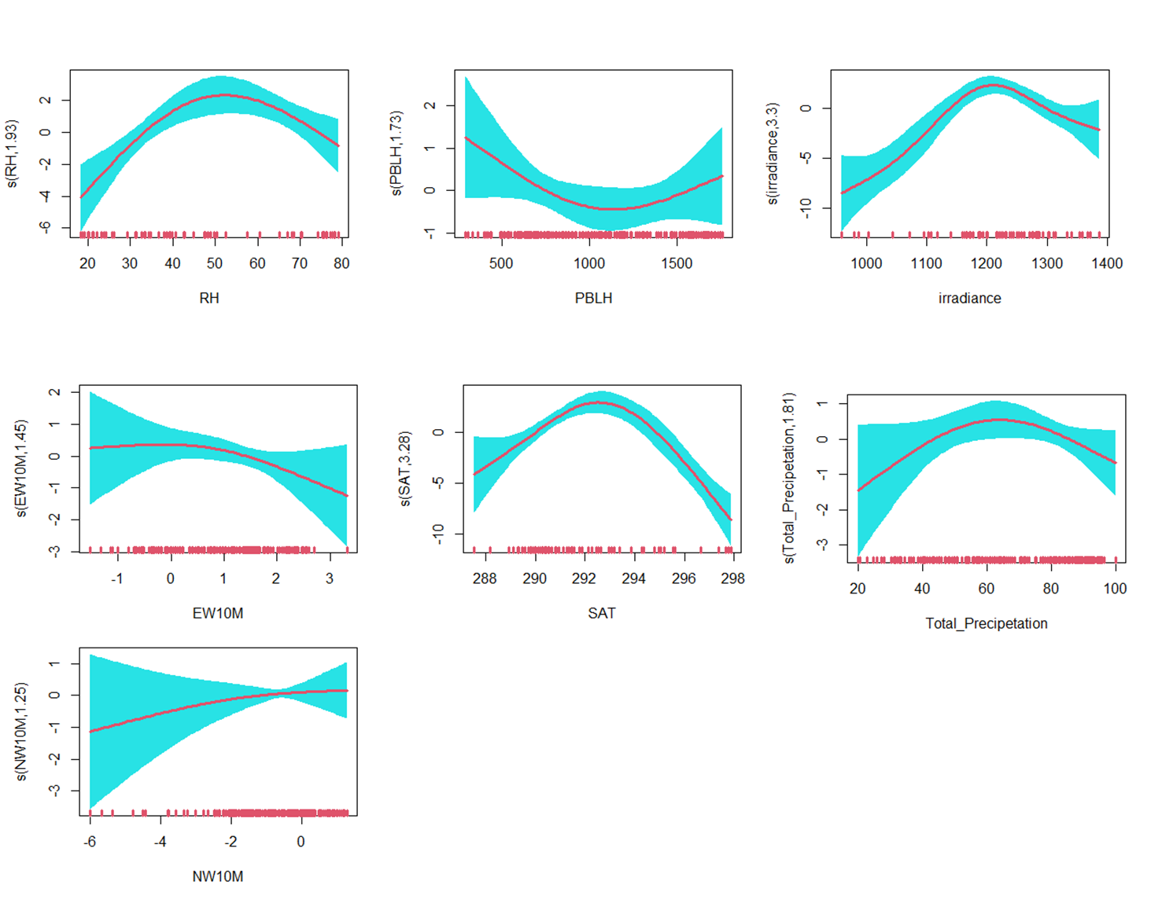
Figure : Figure : Marginal effect of individual meteorological variables including: Humidity (RH), Surface air temperature (SAT), wind direction including Eastward wind at 10m (EW10M) Northward Wind at 10m (NW10M), Total Precipitation (TP), Irradiance, Planetary Boundary Layer Height (PBLH) on O₃ mass concentration. Shaded bands represent the point wise 95% confidence interval. The estimated degrees of freedoms (EDFs), which show the linear or nonlinear degree of fitting, corresponding to the individual terms are noted in each figure. An EDFs of 1 indicates a linear effect.
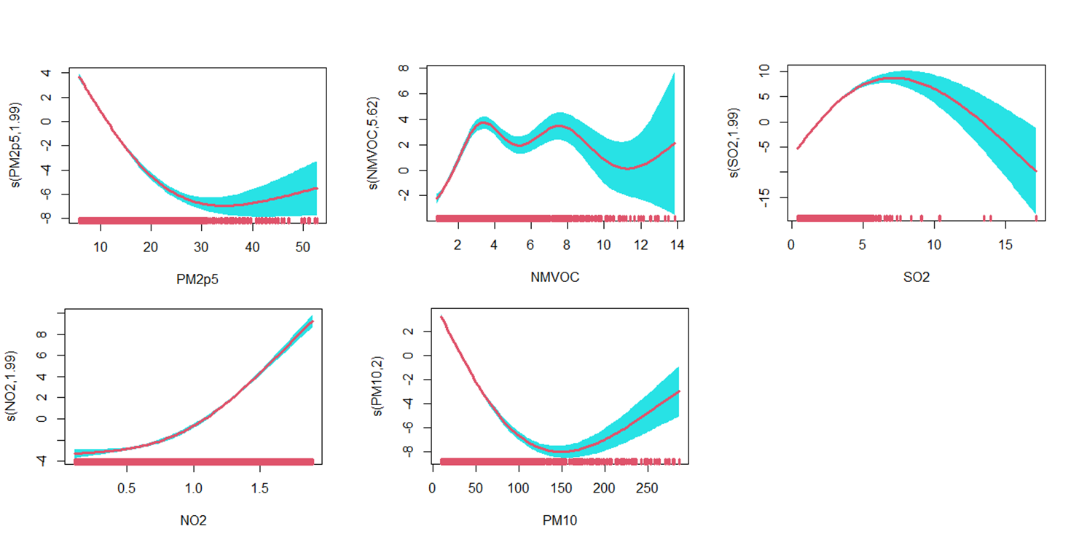
Figure :Marginal effect of individual pollutants on O3 mass concentration during lockdown.
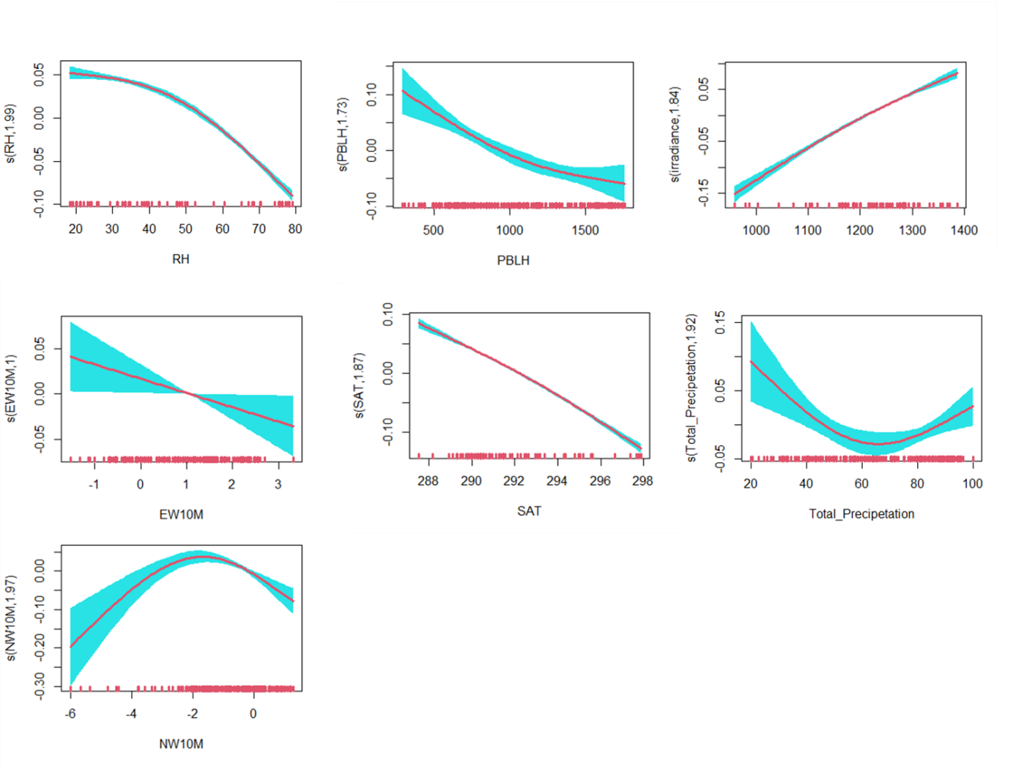 Figure : Marginal effect of individual meteorological variables including: Humidity (RH), Surface air temperature (SAT), wind direction including Eastward wind at 10m (EW10M) Northward Wind at 10m (NW10M), Total Precipitation (TP), Irradiance, Planetary Boundary Layer Height (PBLH) on NO₂ mass concentration. Shaded bands represents the point wise 95% confidence interval. The estimated degrees of freedoms (EDFs), which show the linear or nonlinear degree of fitting, corresponding to the individual terms are noted in each figure. An EDFs of 1 indicates a linear effect.
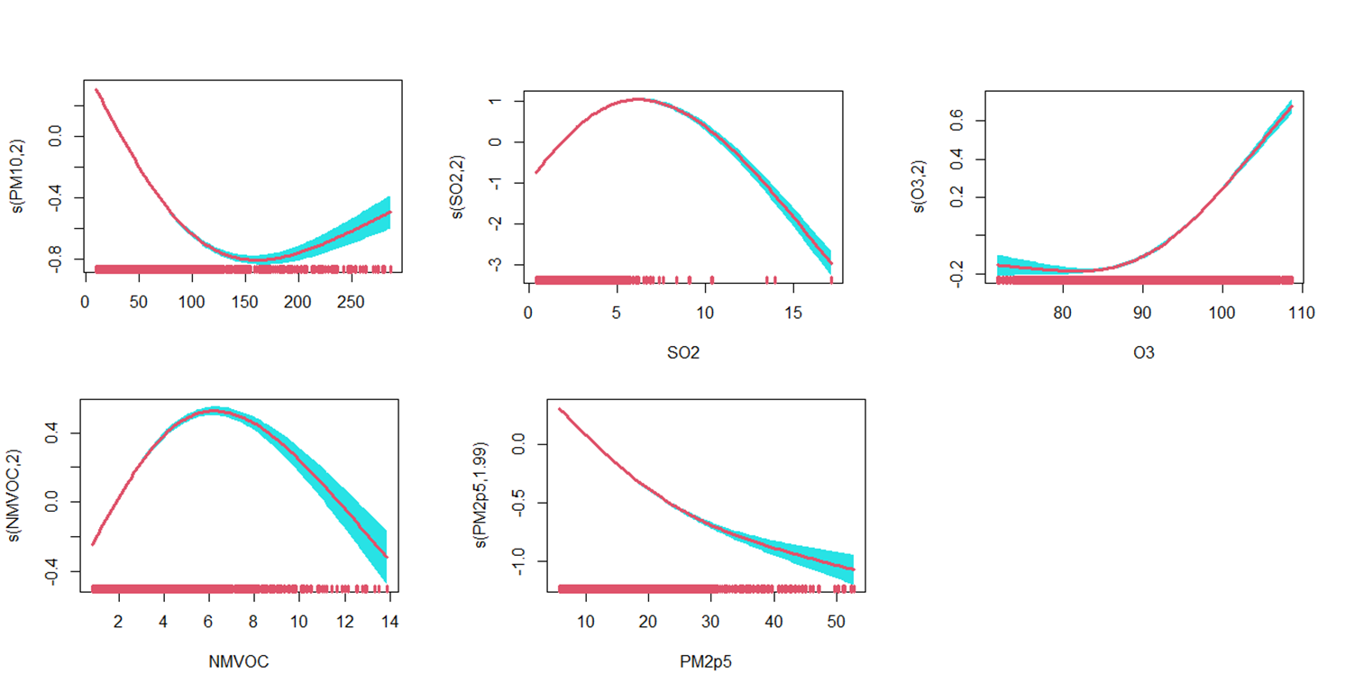
Figure Marginal effect of individual pollutants on NO₂ mass concentration
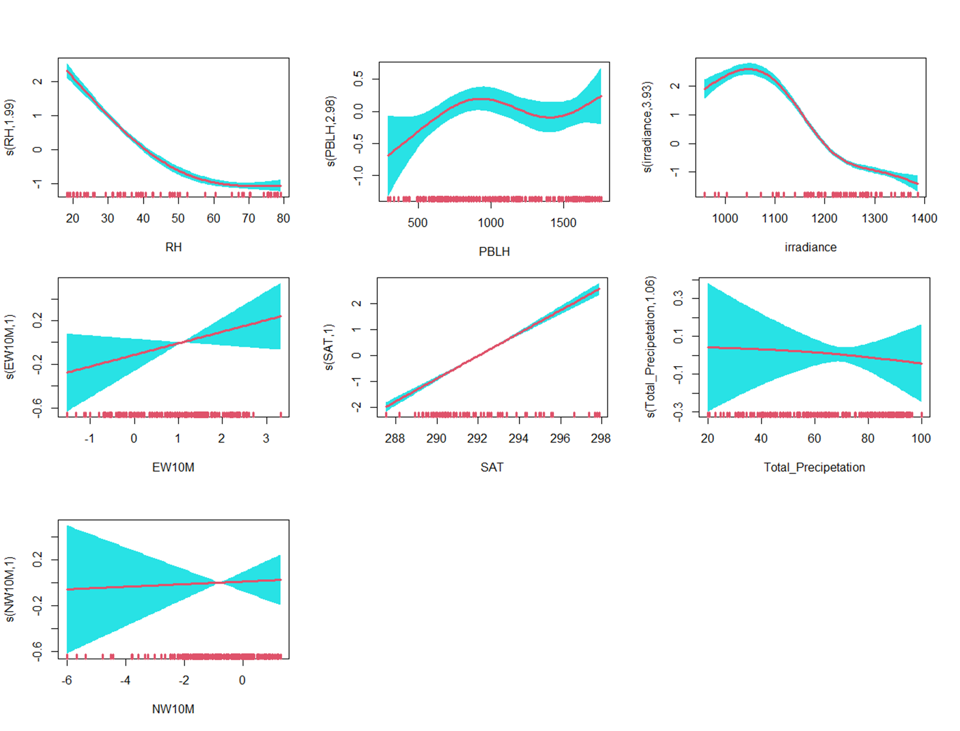
Figure : Marginal effect of individual meteorological variables including: Humidity (RH), Surface air temperature (SAT), wind direction including Eastward wind at 10m (EW10M) Northward Wind at 10m (NW10M), Total Precipitation (TP), Irradiance, Planetary Boundary Layer Height (PBLH) on SO₂ mass concentration. Shaded bands represents the point wise 95% confidence interval. The estimated degrees of freedoms (EDFs), which show the linear or nonlinear degree of fitting, corresponding to the individual terms are noted in each figure. An EDFs of 1 indicates a linear effect.

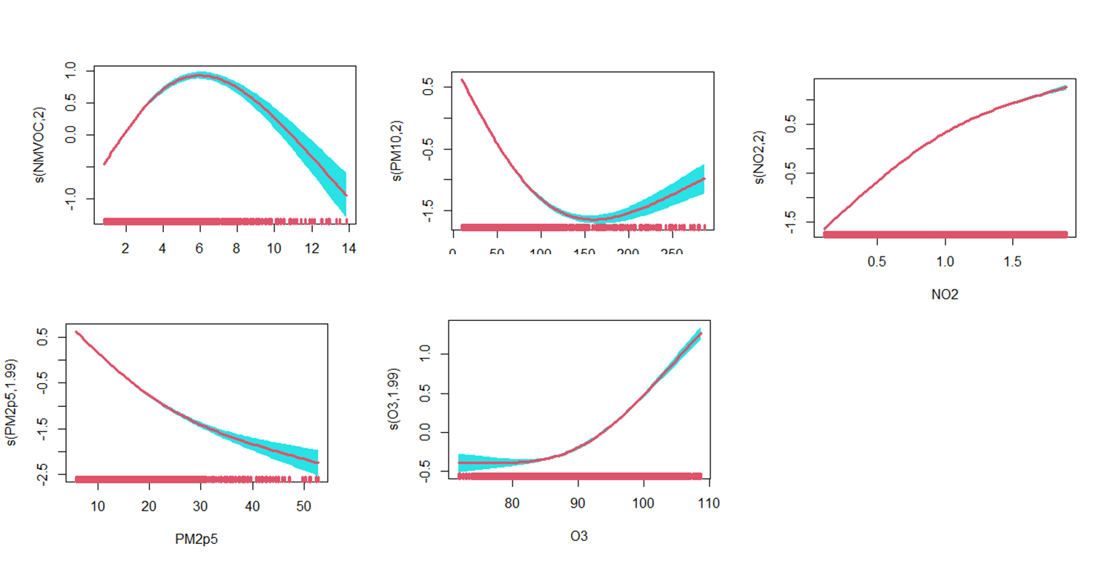

Figure Marginal effect of individual pollutants on SO₂ mass concentration.
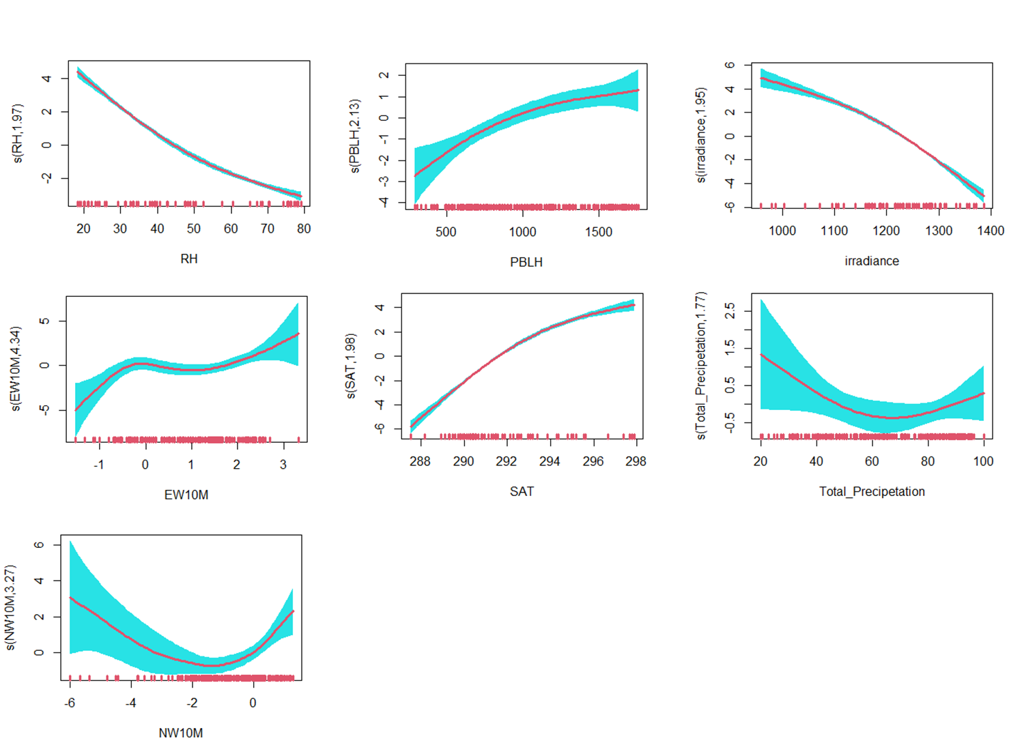
Figure S: Figure : Marginal effect of individual meteorological variables including: Humidity (RH), Surface air temperature (SAT), wind direction including Eastward wind at 10m (EW10M) Northward Wind at 10m (NW10M), Total Precipitation (TP), Irradiance, Planetary Boundary Layer Height (PBLH) on PM₁₀ mass concentration. Shaded bands represents the point wise 95% confidence interval. The estimated degrees of freedoms (EDFs), which show the linear or nonlinear degree of fitting, corresponding to the individual terms are noted in each figure. An EDFs of 1 indicates a linear effect.
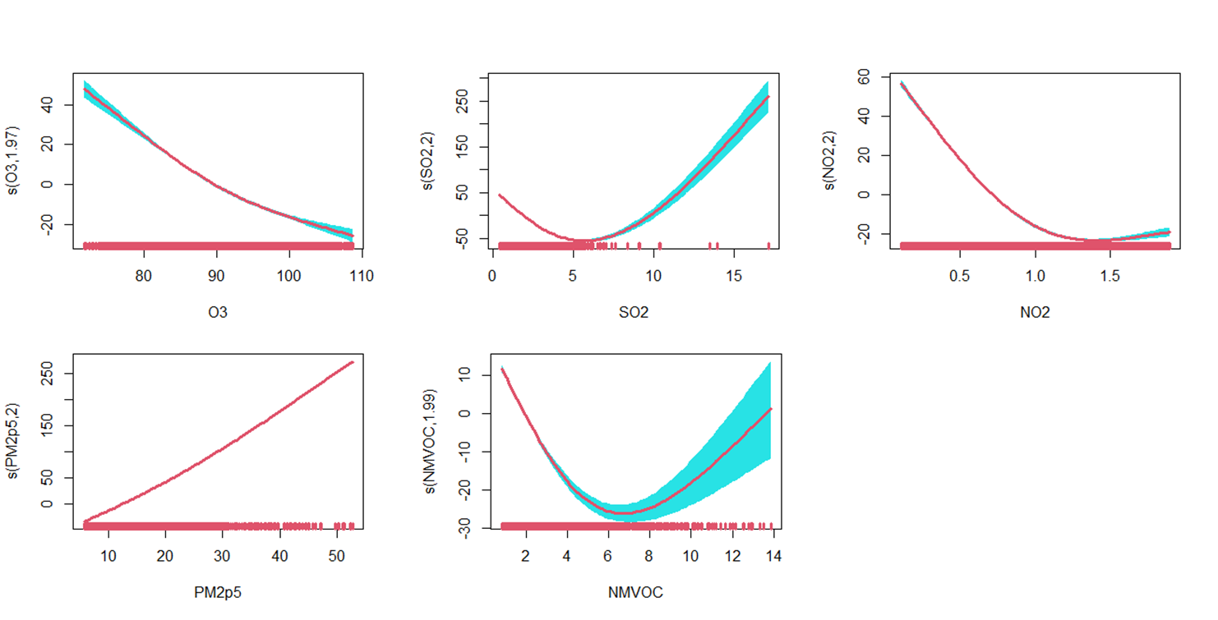
Figure S :Marginal effect of individual pollutants on PM10 mass concentration

Figure The bar plots of marginal effect of individual pollutants (bleu) and meteorological parameters (red) and their percentage before and during lockdown period
Figure The bar plots of marginal effect of individual pollutants s(pollutants) and meteorological parameters s(meteos) on O3,PM2,5,PM10,SO2 and SIA before and during lockdown period
Figure xx :The bar plots of pollutants mass concentration and contribution of meteorological parameters s(meteos) and pollutants s(pollutants) to each pollutant mass concentration during and before lockdown
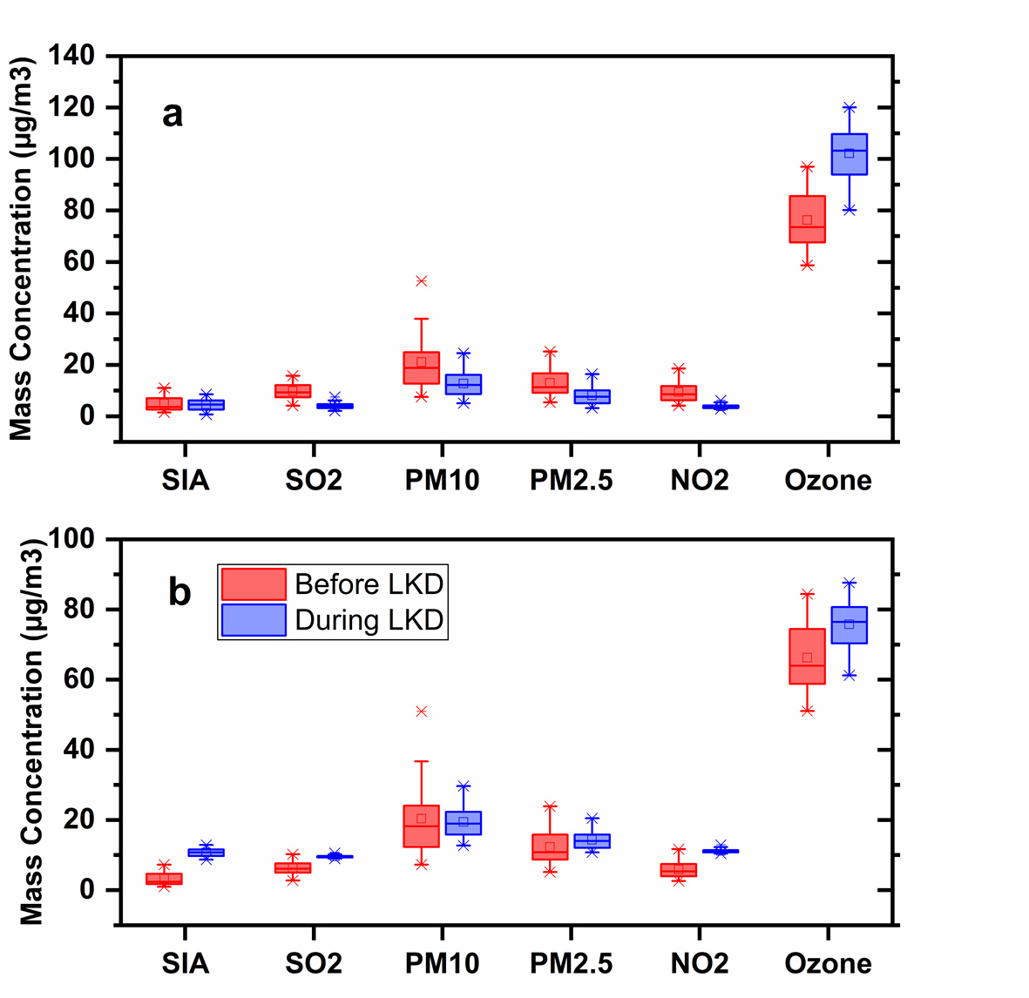
Figure : The box plots of Variation of Pollutants mass concentration before and after lockdown with contribution meteorological (a) and without (b) Each box plot is composed by mean value ( square points in the middle of boxes), median value (cross in the middle of boxes), 25% and 75% value (the lower and upper bounds of each boxplot). The top and bottom extend to a maximum of 1.5 * IQR (interquartile range) from the hinges.

