Supplementary Figures:
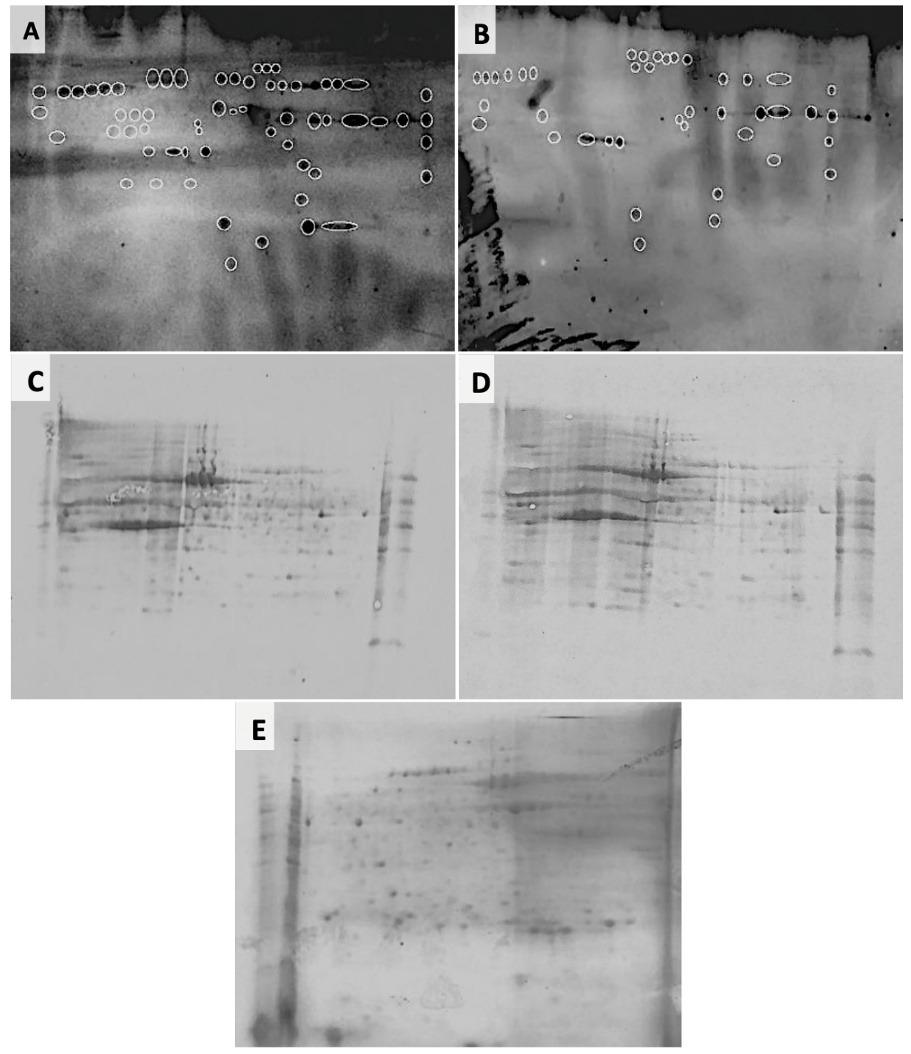
Supplementary Fig.1: In SERPA profiles of BrC (A) and non-BrC (B) sera, differential immunoreactive proteins are highlighted with circle. The post western blot PVDF membranes were stained with Coomassie blue for BrC (C) and non-BrC (D) groups and the flagged spots with differential expression in BrC were mapped on the CB stained master gel (E).

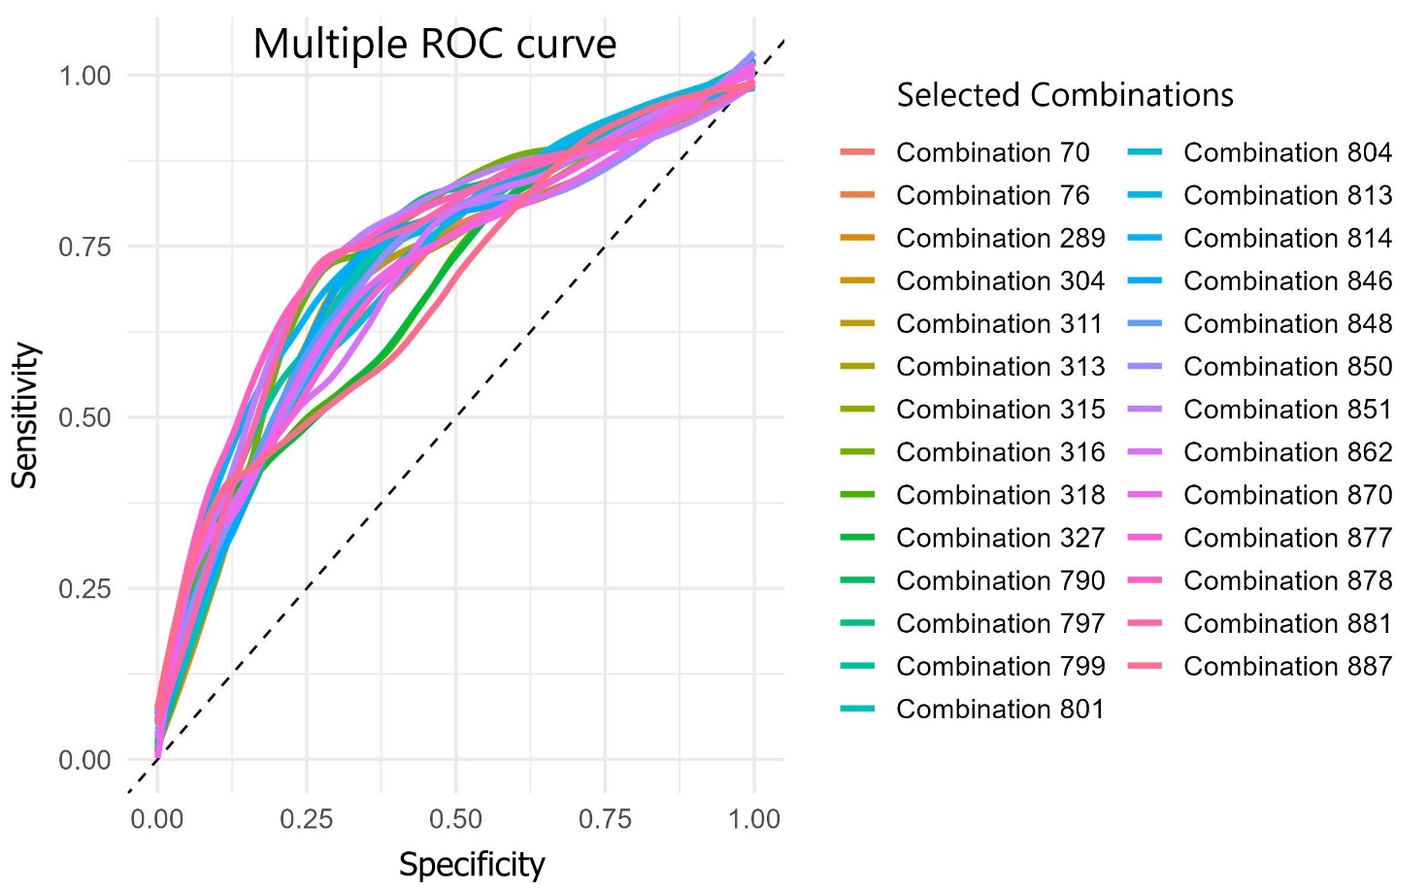
Supplementary Fig.2: The diagnostic performance of selected placental protein panels for identifying breast cancer-related autoantibodies. The diagnostic value of the identified placental antigens was assessed by comparing autoantibody reactivity in breast cancer (BrC) patients versus controls using Receiver Operating Characteristic (ROC) curve analysis. The Area under the curve (AUC) was determined for each antigen individually and for specific multi-antigen pane

