Supplementary Information
The PRIDE Affinity-Proteomics Archive (PRIDE-AP): Making Affinity Proteomics Data FAIR
Deepti J. Kundu^{1,&}, Asier Larrea-Sebal^{1,2,3&}, Selvakumar Kamatchinathan¹, Chakradhar Bandla¹, Jingwen Bai¹, Nithu Sara John¹^{,4}, Nandana Madhusoodanan¹, Suresh C. Hewapathirana¹, Boma Brown-Harry¹, Claudia Fredolini^{5,6}, Parul Tewatia^{6,7}, Klev Diamanti⁸, Kathleen T. Nevola⁸, Yue Wu⁹, William F. Beimers¹⁰, Joshua J. Coon^{10,11,12,13}, Jack S. Gisby¹⁴, James E. Peters¹⁴, Sara Ahadi¹⁵, Magnus Palmblad¹⁶, Michael P. Snyder⁹, Juan Antonio Vizcaíno¹^{,4}, Yasset Perez-Riverol¹^{,4,}*
¹ European Molecular Biology Laboratory, European Bioinformatics Institute (EMBL-EBI), Wellcome Genome Campus, Hinxton, Cambridge, CB10 1SD, UK

² Department of Biochemistry and Molecular Biology, UPV/EHU, Leioa, 48940, Spain

³ Biofisika Institute, UPV/EHU-CSIC, Leioa, 48940, Spain

⁴ Open Targets, Wellcome Genome Campus, Hinxton, Cambridge CB101SD, UK

⁵ School of Computer Science and Communication, KTH Royal Institute of Technology, Stockholm, 10044, Sweden

⁶ Science for Life Laboratory (or SciLifeLab), Solna, 171 65, Sweden.

⁷ Department of Immunology, Genetics and Pathologies, Uppsala University, Uppsala, 75185, Sweden
⁸ Olink, part of Thermo Fisher Scientific, Uppsala, 75330, Sweden
⁹ Department of Genetics, School of Medicine, Stanford University, Stanford, 94305, CA, USA

¹⁰ Department of Biomolecular Chemistry, University of Wisconsin-Madison, Madison, WI 53706, USA

¹¹ Department of Chemistry, University of Wisconsin-Madison, Madison, WI, 53706, USA

¹² National Center for Quantitative Biology of Complex Systems, Madison, WI, 53706, USA

¹³Morgridge Institute for Research, Madison, WI, 53715, USA

¹⁴Centre for Inflammatory Disease, Dept of Immunology and Inflammation, Imperial College London, London, W12 0NN, UK

¹⁵ Alkahest, Inc., San Carlos, CA, 94070, USA

¹⁶ Center for Proteomics and Metabolomics, Leiden University Medical Center (LUMC), Leiden, 2333ZA, The Netherlands

Correspondence to: Yasset Perez-Riverol (yperez@ebi.ac.uk)
& These authors contributed equally to this work.

Supplementary Note 1: Growth of affinity proteomics publications 4
Supplementary Note 2: Dataset submission using the PRIDE Submission Tool 5
Supplementary Note 3: Sample and Data Relationship Format (SDRF-Proteomics) for AP datasets 7
Supplementary Note 4: Quality control metrics implemented in PRIDE-AP 10
Supplementary Note 5: Linking affinity proteomics and mass spectrometry datasets in PRIDE 16
Supplementary Note 6: Protein-centric exploration and UniProt integration in PRIDE-AP 18
Supplementary Note 7: REstful API 22

Supplementary Note 1: Growth of affinity proteomics publications
To contextualize the increasing adoption of affinity proteomics (AP) technologies, we surveyed the number of open-access publications indexed in Europe PMC that reference widely used AP platforms, including Olink, SomaScan, and NULISA/ARGO HT. Publications were identified through keyword searches applied to the full manuscript content, and counts were aggregated based on the year of first publication.
As shown in Supplementary Figure 1, the number of AP-related publications has increased steadily from 2021 to 2025, with a marked acceleration beginning in 2023. This trend likely reflects both technological maturation and broader uptake of high-throughput proteomic profiling in clinical and population-scale studies. The observed growth underscores the expanding role of AP approaches in biomedical research and highlights the urgency of establishing standardized, domain-specific repositories to support data sharing, reproducibility, and reuse.
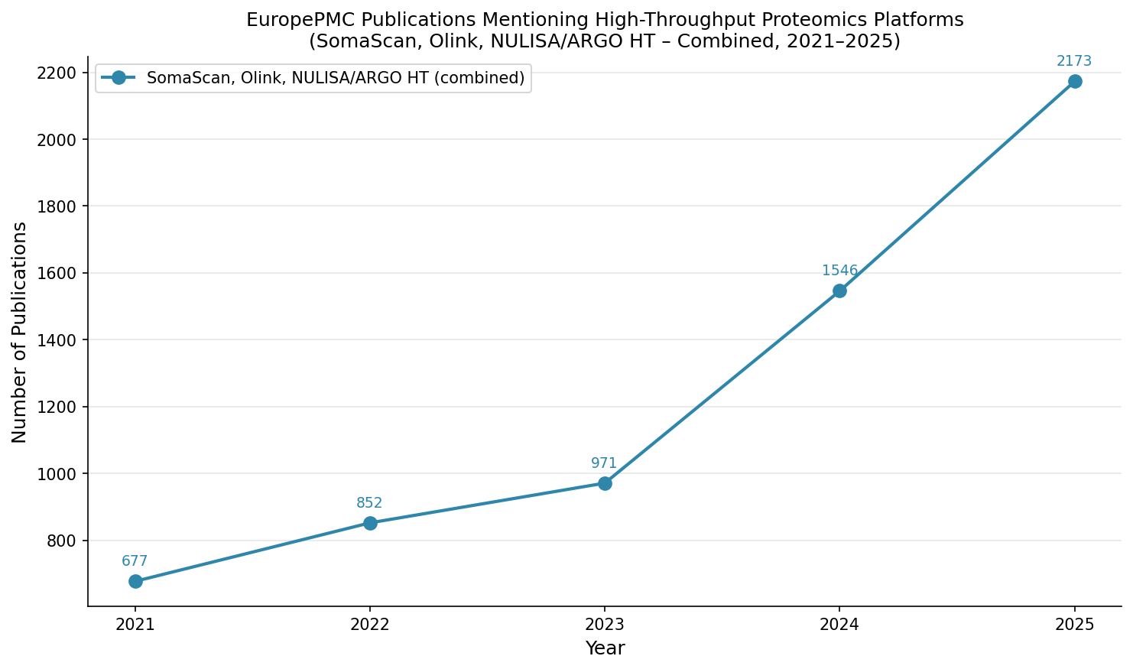
Supplementary Figure 1: Number of EuropePMC open access publications containing the terms Olink, SomaScan, NULISA/ARGO HT in the whole manuscript content.

Supplementary Note 2: Dataset submission using the PRIDE Submission Tool
Affinity proteomics (AP) datasets are submitted to PRIDE-AP via the PRIDE Submission Tool (Supplementary Figure 2), a Java-based application that provides a guided submission workflow. The tool is available for download from the PRIDE website and requires Java 21 or later. Datasets can be submitted to be publicly released or embargoed (private), with the latter remaining private during peer review and released automatically upon publication.
During submission, users provide standardized metadata including project (dataset) title, keywords, project (dataset) description, sample processing protocol, data processing protocol, and experiment type. Currently supported AP approaches include the Olink and SomaScan technologies. Experimental annotations, including species, tissue, disease, instrument, cell type, and quantification method, are captured in structured fields to ensure consistency and machine-readability across submissions.

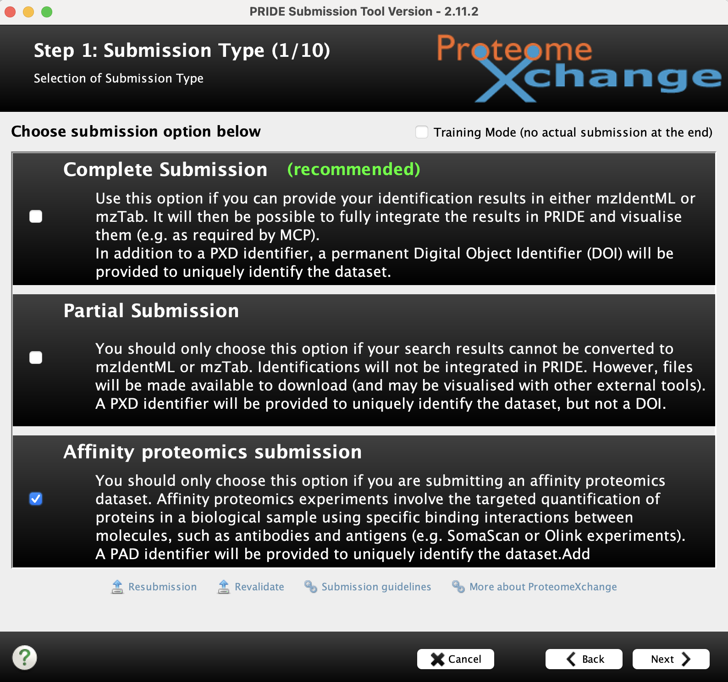
Supplementary Figure 2: Submission initiation screen of the PRIDE Submission Tool.
Submission files must conform to guidelines specifying mandatory and recommended file types for AP-based datasets (Supplementary Figure 3), available at https://www.ebi.ac.uk/pride/markdownpage/affinity. File integrity is verified automatically through MD5 checksum generation during the submission process, ensuring that uploaded data is transferred without corruption to the EMBL-EBI servers. Inclusion of a Sample and Data Relationship Format (SDRF-Proteomics) file (described in Supplementary Note 3) is recommended to maximize metadata completeness and interoperability.
Each accepted dataset is assigned a unique PAD (Proteomics Affinity Dataset) accession identifier, formatted as "PAD" followed by a six-digit number (e.g., PAD000001). PAD accessions are issued exclusively by PRIDE-AP and are intended to be cited upon data reporting and/or reuse. A Digital Object Identifier (DOI) is also assigned to each public dataset, enabling stable citation and indexing by external resources.

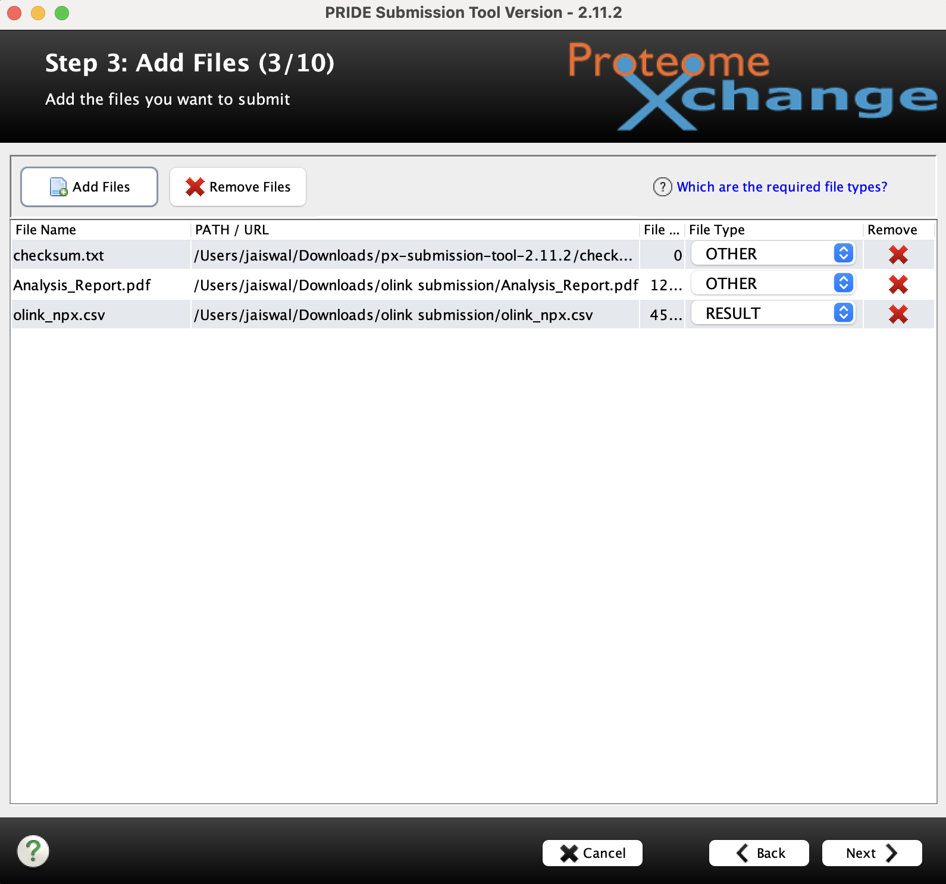
Supplementary Figure 3: File selection interface of the PRIDE Submission Tool

Supplementary Note 3: Sample and Data Relationship Format (SDRF-Proteomics) for AP datasets
The Sample and Data Relationship Format for Proteomics (SDRF-Proteomics) is a standardized, tab-delimited framework used to describe how biological samples, experimental variables, and data files are structured in proteomics datasets. It provides a machine-readable representation of three core elements: (i) biological sample metadata (e.g., organism, disease), (ii) data files and their properties, and (iii) experimental variables under investigation. In SDRF-Proteomics, each row represents a single sample–data file relationship, while columns capture sample characteristics, assay or file metadata, and study variables. This structure supports reproducibility, interoperability, and FAIR data reuse. A full description of the format is available at https://sdrf.quantms.org/index.html and https://sdrf.quantms.org/specification.html#quick-start.
SDRF-Proteomics uses a modular template system to support different experiment types. Parent templates define the majority of shared sample metadata columns (e.g., organism, disease, biological replicate), while technology-specific templates extend this structure by introducing assay- and data-specific fields. In this work, we extended SDRF-Proteomics to support affinity proteomics (AP) experiments through a dedicated template that builds on the existing framework while incorporating AP-specific requirements (https://sdrf.quantms.org/specification.html#_affinity_proteomics).
The AP template is designed for both antibody-based platforms (e.g., Olink, based on Proximity Extension Assays, PEA) and aptamer-based platforms (e.g., SomaScan, using SOMAmers for protein detection). A key distinction from mass spectrometry (MS)-based proteomics is that AP experiments typically produce a single processed and normalized data matrix (e.g., NPX or RFU values) containing measurements for many proteins across all samples. Consequently, multiple SDRF rows often reference the same data file, differing only in sample identifiers and associated study variables, in contrast to MS workflows where each raw file usually corresponds to an individual run.
To capture the specific characteristics of AP experiments, we introduced a set of technology-specific columns that complement the core SDRF structure (Supplementary Table 1). Two columns are defined as required due to their central role in interpreting AP data. The characteristics[sample type] field specifies the role of each sample within the assay (e.g., study sample, negative control, positive control, or calibrator). This distinction is essential because AP datasets commonly include internal controls and reference materials within the same data matrix, which are required for quality control, normalization, and downstream analysis. The comment[platform] field captures the affinity proteomics platform used (e.g., Olink Explore HT, Olink Target 96, SomaScan 11K). This information is critical, as different platforms rely on distinct chemistries and data processing pipelines that directly affect data interpretation and comparability.
Additional columns are defined as recommended or optional to improve metadata completeness. The comment[panel name] field (recommended) specifies the commercial panel used within a platform and becomes mandatory when it cannot be uniquely inferred from the platform name. The comment[instrument] field (optional) records the instrument used for data acquisition, and comment[quantification unit] (optional) specifies the measurement unit (e.g., NPX or RFU), facilitating interpretation and cross-study comparisons.
Further optional fields capture technical and processing-related aspects of the experiment. The comment[plate] and comment[lot number] columns record plate identifiers and reagent batches, supporting traceability and the assessment of batch effects. The comment[normalization method] field describes the normalization strategy applied to the data, while comment[dilution] captures the sample dilution factor, a parameter particularly relevant in workflows such as SomaScan.
Standardized annotation of AP-specific metadata is supported through the introduction of new controlled vocabulary (CV) terms in the PRIDE controlled vocabulary (https://www.ebi.ac.uk/ols4/ontologies/pride). These terms cover commonly used affinity proteomics platforms, assay types, and related technical descriptors, ensuring consistent and unambiguous metadata annotation across submissions. The use of CVs within SDRF-Proteomics facilitates interoperability and enables automated validation and downstream data integration.
The full SDRF-Proteomics specification for affinity proteomics is available at https://sdrf.quantms.org/specification.html#_affinity_proteomics, and SDRF files can be validated using the official sdrf-pipelines tool (https://github.com/bigbio/sdrf-pipelines).

Supplementary Table 1: Affinity proteomics–specific SDRF-Proteomics columns and their definitions
Column name | Requirement | Description | Example
characteristics[sample type] | required | Role of the sample in the assay. Distinguishes controls/reference materials. | study sample, negative control, positive control, calibrator
comment[platform] | required | Affinity proteomics platform used | Olink Explore HT, Olink Target 96, SomaScan Assay 11K
comment[instrument] | optional | Instrument used for data acquisition | Illumina NextSeq 2000, Agilent SureScan Microarray Scanner
comment[panel name] | recommended | Commercial panel/menu identifier within the platform. | Target 96 Inflammation, Explore 1536, SomaScan 7K, SomaScan 11K
comment[quantification unit] | optional | Unit of quantification for the assay (platform-specific) | NPX, RFU
comment[plate] | optional | Plate identifier for batch effect analysis | 1, 2
comment[normalization method] | optional | Normalization method applied | plate control normalized, bridge normalized
comment[dilution] | optional | Sample dilution factor | 0.005%, 0.5%, 20%, 40%
comment[lot number] | optional | Reagent lot number for traceability | SS-2023-001, lot_12345

Supplementary Note 4: Quality control metrics implemented in PRIDE-AP
The quality control (QC) framework in PRIDE-AP is designed to assess the analytical reliability, consistency, and usability of AP datasets, while enabling standardized comparisons across studies and technologies. To achieve this, PRIDE-AP implements a transparent and extensible QC framework based on the open-source Python library pyprideap (https://github.com/PRIDE-Archive/pyprideap). It draws on established analysis concepts from open-source tools such as OlinkAnalyze (https://github.com/Olink-Proteomics/OlinkRPackage) and SomaDataIO (https://github.com/SomaLogic/SomaDataIO), which serve as alternative resources, while extending them with additional methods tailored for cross-platform AP data.
QC workflow and data ingestion
QC analysis begins with the ingestion of standardized tabular outputs generated by the different AP platforms. For Olink datasets, this typically corresponds to tabular data containing Normalized Protein eXpression (NPX) values together with assay annotations and internal QC flags. For SomaScan datasets, input files follow the SomaScan tabular export structure, including normalized intensity values and sample-level annotations. The library parses these vendor-specific formats and transforms them into a unified internal representation, harmonizing identifiers, column structures, and data types to enable consistent downstream analysis.
If sample metadata are available in an SDRF, the library can incorporate these annotations to extend analyses. This allows stratified summaries and exploratory analyses based on experimental factors such as disease state or sex, including group-wise comparisons and visualizations of biological variation.
Common QC outputs across technologies
Across both Olink and SomaScan datasets, QC results include a dataset summary and a suite of core visualizations that capture data completeness, variability, and global structure. The dataset summary provides key characteristics, including platform, number of samples, assays, and proteins. It also reports missingness at both sample and protein levels (e.g., proportion of proteins not detected per sample or proportion of samples missing a given protein), as well as inter-sample and intra-/inter-plate variability metrics. Where available, normalization-related metrics and platform-provided QC columns are also included.
A central concept in AP QC is the limit of detection (LOD), which defines whether a protein measurement is reliable. Measurements below the LOD (or failing QC flags) are treated as missing and are used to derive metrics such as missingness, protein reliability, and sample completeness. Although the QC framework is harmonized, LOD estimation is technology-aware. For SomaScan, LOD is defined using an estimated LOD (eLOD) calculated from buffer samples via a median absolute deviation (MAD) approach. LOD-based filtering is less prominent for SomaScan, with QC interpretation focusing primarily on variability and control-based metrics. For Olink, LOD is central to assessing detectability, with multiple definitions depending on platform and dataset (described in detail below).
Several visualizations are shared across technologies. Intensity distribution plots (RFU for SomaScan, NPX for Olink) display the global distribution of protein measurements across samples, enabling detection of outliers, shifts in signal intensity, and batch effects. The coefficient of variation distributions summarizes relative variability across proteins, and values below 0.2 indicate tight reproducibility, while a long right tail highlights proteins with elevated biological or technical variability. Intra-plate and inter-plate coefficients of variation measure variability within and across assay plates, offering a view of technical reproducibility and potential batch effects. For Olink data, although the recommended approach is to compute the coefficient of variation using a lognormal approximation due to the log₂ nature of NPX values and approximately lognormal distribution of the measurements, here a uniform classical σ over μ definition is applied across all data types for consistency. Sample correlation heatmaps visualize pairwise correlations across samples, highlighting outliers or unexpected patterns, whereas expression heatmaps provide a protein-by-sample view of abundance patterns, supporting detection of structured variation and clustering. Dimensionality reduction methods, such as PCA and t-SNE, project samples into a lower-dimensional space, enabling the identification of clusters, batch effects, and separation between biological groups. Finally, the UniProt duplicate detection analysis assesses the extent to which multiple assays target the same protein, distinguishing assay-level redundancy from unique protein coverage and revealing potential redundancy or concordance between measurements.
SomaScan-specific QC metrics
SomaScan QC emphasizes platform-specific controls and reproducibility measures. Two key metrics include Calibrator QC ratio and Hybridization Control Normalization Scale Factor (HybControlNormScale) (https://somalogic.com/tech-notes/) (Supplementary Figure 4). Thresholds are applied to both metrics to flag potential technical issues: the Calibrator QC ratio acceptance range is [0.8, 1.2], while HybControlNormScale values within 0.8-1.2 indicate minor deviations and values outside 0.4-2.5 indicate potentially poor hybridization. These thresholds help highlight analytes or samples that may require caution in downstream analyses.
Olink-specific QC metrics
Olink QC focuses on protein detectability and measurement reliability using LOD-based criteria and internal QC flags. Multiple LOD definitions may be supported depending on the platform and dataset. These include: (i) reported LOD, directly from NPX files; (ii) NCLOD, computed from negative control samples when sufficient controls are available (n_{min}=10; ensure sample identifiers are unique across the entire project); and (iii) FixedLOD, precomputed reference values for specific platforms (Explore 3072, Explore HT, Reveal). The library applies a fallback strategy when multiple sources exist, ensuring robust and consistent classification of measurements as detected or missing.
Olink-specific visualizations include the QC and LOD summary, showing the proportion of assays that both pass internal QC and exceed the LOD, representing the fraction of reliable protein measurements. The LOD analysis (% samples above LOD) evaluates, for each protein, the proportion of samples in which it has a noisier signal. The missing frequency distribution summarizes the proportion of samples in which each protein is not reliably detected. The sample completeness analysis shows the fraction of proteins detected per sample, suggesting decreased quality of outlier samples identified by low-dimensional representations. When applicable, LOD calculation comparisons highlight differences between alternative definitions and their impact on QC metrics. Supplementary Figure 5 illustrates some Olink-specific QC visualizations.
Report generation and visualization in PRIDE-AP
QC outputs generated by pyprideap include tabular summaries and publication-ready plots. These are precomputed for each dataset and integrated into PRIDE-AP webpages, allowing users to explore QC metrics without local execution, directly assessing dataset quality and suitability for analysis.
Reproducibility and reuse
The QC workflow is fully reproducible and can be executed independently using the pyprideap Python API or command-line interface. By accepting standard vendor outputs and generating consistent summaries and visualizations, the framework enables reuse in independent studies, supports benchmarking, and facilitates integration into custom analysis pipelines.

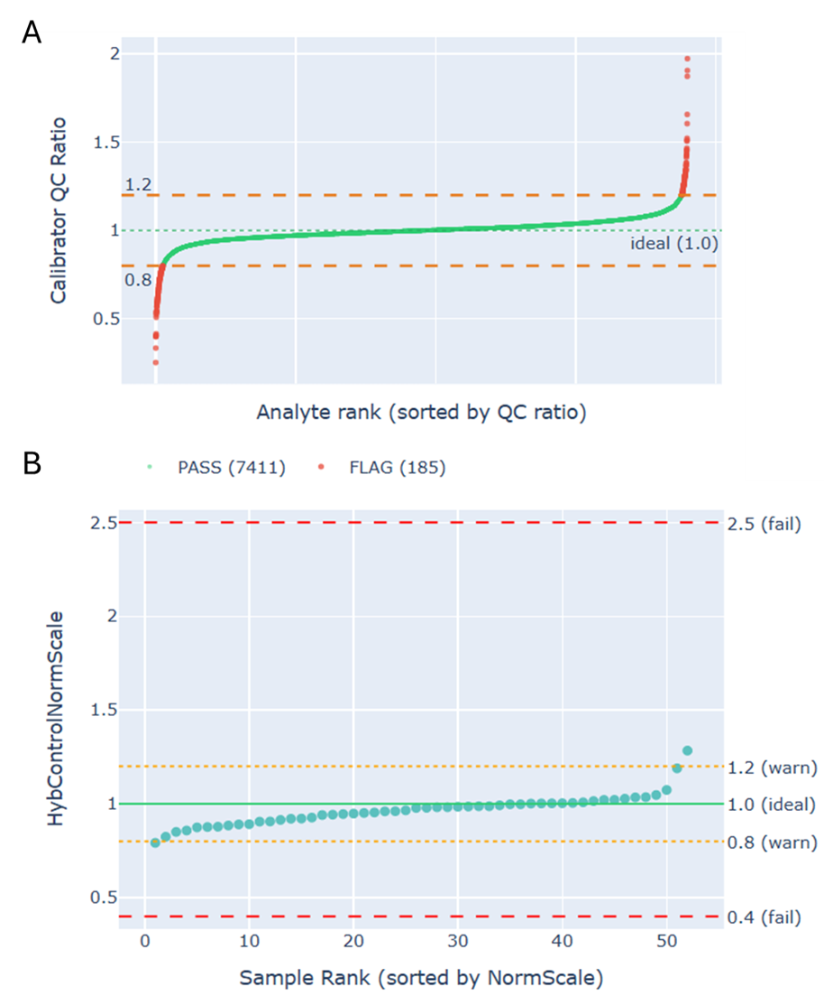

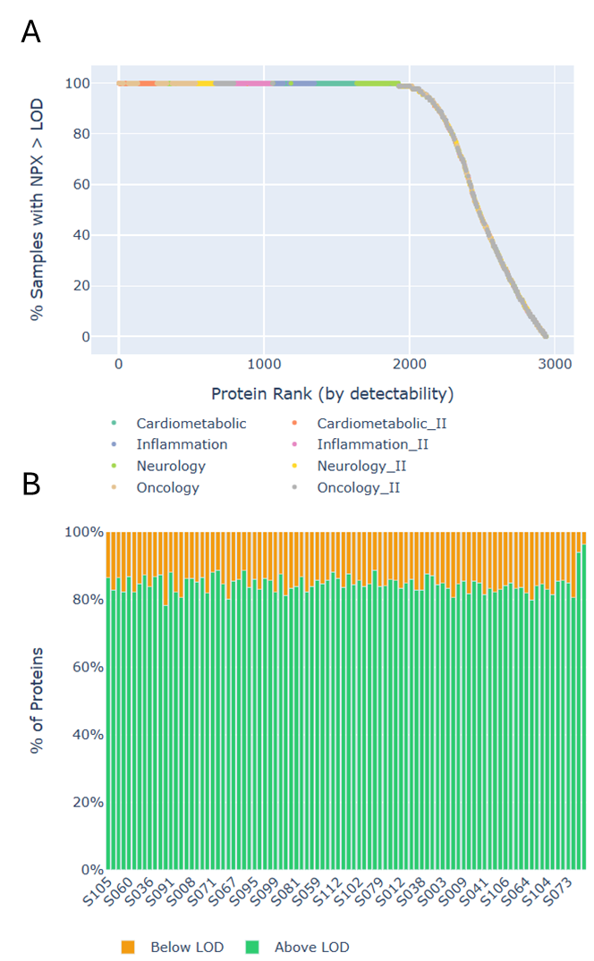
Supplementary Figure 4: SomaScan quality control metrics across analytes and samples. Assessment of key SomaScan QC metrics highlighting calibration performance and hybridization efficiency. A) Calibrator QC ratio for each analyte, plotted against analyte rank (sorted by QC ratio). This metric reflects how well each analyte’s calibration matches the reference (ideal value = 1.0). Analytes within the acceptance range [0.8, 1.2] (orange dashed lines) pass QC (green points), whereas those outside this range are flagged (red points). Flagged analytes may indicate poor calibration reproducibility and should be interpreted with caution; a high proportion of flagged analytes may suggest plate-level calibration issues. B) Hybridization Control Normalization Scale Factor (HybControlNormScale) for each sample, sorted by value. This metric reflects deviations in hybridization signal relative to the reference (ideal value = 1.0, green line). Values outside 0.8–1.2 (orange lines) indicate moderate deviation, while values outside 0.4–2.5 (red lines) indicate potentially poor hybridization that may compromise data quality. Samples failing these thresholds should be flagged for potential exclusion.

Supplementary Figure 5: Olink quality control metrics assessing protein detectability and sample completeness. Overview of data quality based on signal detection relative to the limit of detection (LOD) and per-sample measurement completeness. A) Proportion of samples with detectable signal for each protein, ranked accordingly. Proteins are colored by panel where applicable. This representation highlights the distribution of protein detectability across the dataset, with a subset of proteins showing consistently low detection rates, which may limit their reliability in downstream analyses. B) Per-sample distribution of measurements above and below the LOD, shown as stacked bars. Values above the LOD represent reliable signals, whereas those below indicate measurements with reduced confidence. Control samples are excluded. Samples with an unexpectedly higher proportion of measurements below LOD compared to the rest of the study population may reflect reduced data quality or technical variation and should be interpreted with caution.

Supplementary Note 5: Linking affinity proteomics and mass spectrometry datasets in PRIDE
The integration of affinity proteomics (AP) data within the PRIDE Archive enables cross-technology dataset linking within a single study framework. Through the PRIDE-AP extension, researchers can submit AP datasets alongside mass spectrometry (MS)-based proteomics data and explicitly connect them when they originate from the same biological study. This unified submission and linking mechanism facilitates multimodal data integration and enhances the interpretability of complementary proteomics approaches.
As illustrated in Supplementary Figure 6, related datasets are displayed within the “Other Omics Links” section of a PRIDE-AP dataset entry (e.g., PAD000019). This panel provides direct access to associated datasets generated using different technologies, allowing users to seamlessly navigate between AP and MS experiments. Each linked dataset redirects to its respective project page, where detailed metadata, quality control metrics, and raw data files are available for exploration.
This functionality is particularly valuable for studies involving complex biological matrices such as plasma or serum, where combining AP and MS approaches can provide complementary coverage of the proteome. Furthermore, datasets submitted to PRIDE-AP are indexed in the Omics Discovery Index, enabling their integration into a broader ecosystem of omics resources and facilitating cross-domain data discovery.

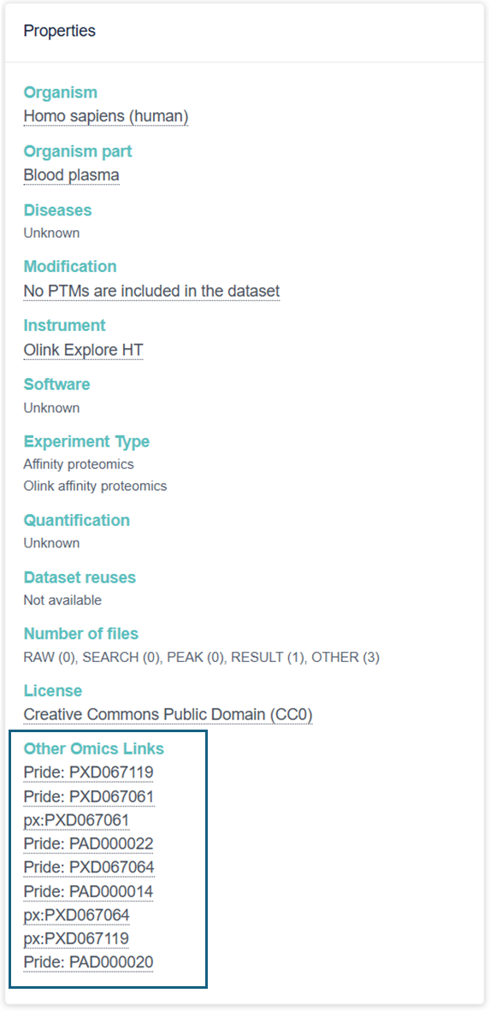

Supplementary Figure 6: Linking related datasets across technologies in PRIDE. The screenshot shows the Properties section of a PRIDE-AP dataset (PAD000019). The highlighted Other Omics Links panel displays related datasets from the same study, including both AP and MS experiments.

Supplementary Note 6: Protein-centric exploration and UniProt integration in PRIDE-AP
PRIDE provides a protein-centric interface that enables exploration of proteomics evidence across MS and AP experiments via https://www.ebi.ac.uk/pride/archive/proteins. This view complements dataset-centric access by allowing users to start from a protein of interest and navigate to the associated experimental evidence across technologies. Proteins can be queried using UniProt accessions or identifiers. This overview provides a technology-aware summary of protein detectability across PRIDE resources.
For AP datasets, proteins displayed in the PRIDE protein-centric view are derived following standardized parsing and QC procedures. Submitted Olink and SomaScan data files are processed to extract protein measurements, excluding technology-specific control and calibration analytes. Proteins failing technology-recommended QC criteria are removed, including measurements flagged as low quality or with abundance values below assay-specific limits of detection (LOD or eLOD, where applicable). For Olink datasets, normalized protein expression (NPX) values are evaluated, while SomaScan datasets use technology-specific intensity measures. After quality filtering, unique protein identifiers are aggregated across datasets and indexed for inclusion in the protein-centric interface, ensuring that displayed proteins are supported by high-confidence affinity measurements.
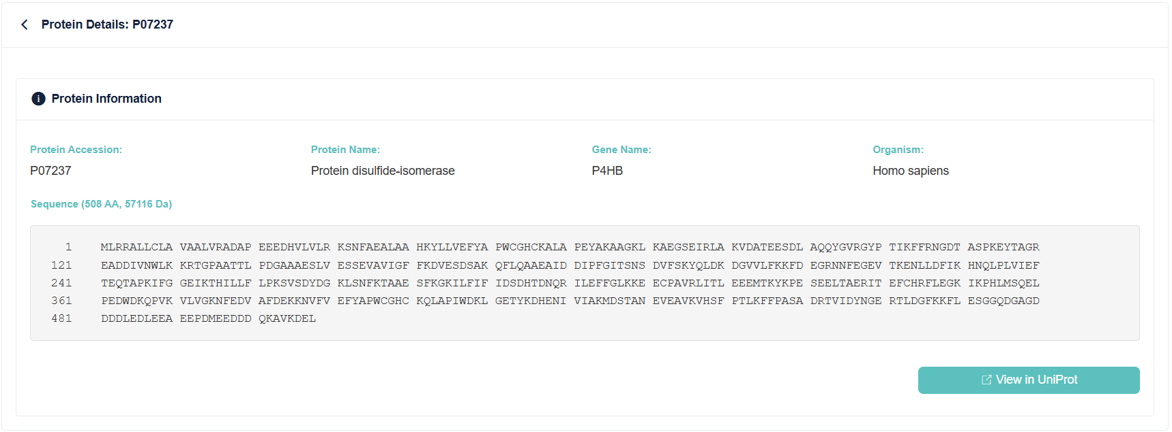
Searching for a protein (for example, UniProt accession P07237) returns a summary table reporting the protein name, gene name, and the number of PRIDE projects in which the protein has been detected, stratified by technology (MS and AP; Supplementary Figure 7).

Supplementary Figure 7: Protein details page in PRIDE. The screenshot shows the PRIDE protein page that opens after selecting View details from the protein search interface. In this example, the UniProt accession P07237 is displayed. The Protein Information panel provides the protein accession, protein name, gene name, organism, amino acid sequence, and a direct link to the corresponding UniProt entry.
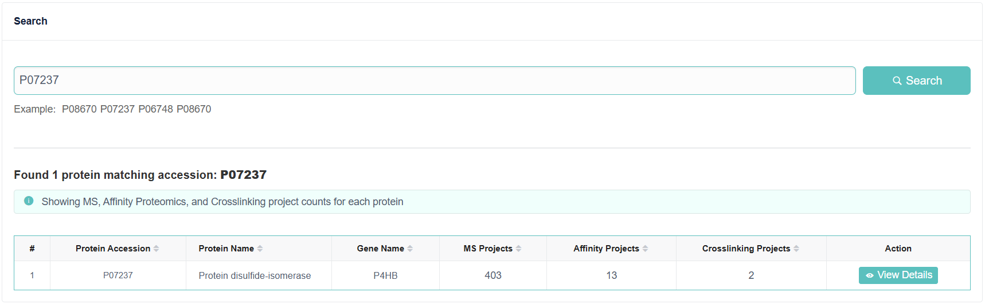
Selecting View details opens a dedicated protein page aggregating all available information for the queried protein. The Protein information panel displays the UniProt accession, protein name, gene name, organism, and amino acid sequence, together with a direct link to the corresponding UniProt entry (Supplementary Figure 8).

Supplementary Figure 8: Protein search and overview table in PRIDE. The screenshot shows the PRIDE protein search interface (https://www.ebi.ac.uk/pride/archive/proteins), which allows users to query proteins using UniProt accessions or identifiers. In this example, the UniProt accession P07237 is searched, returning a summary table that reports the protein accession, protein name, gene name, and the number of projects in which the protein has been detected, stratified by technology (MS, AP, and crosslinking).

The PRIDE Archive Projects (MS) panel lists all MS-based datasets in which the protein has been identified, including project (dataset) accession, title, description, and direct links to the dataset pages (Supplementary Figure 9A). A corresponding Affinity Proteomics Projects panel lists PRIDE-AP datasets in which the protein has been detected using affinity-based technologies, reporting the project accession, title, number of proteins identified in the study, and links to the dataset pages (Supplementary Figure 9B).

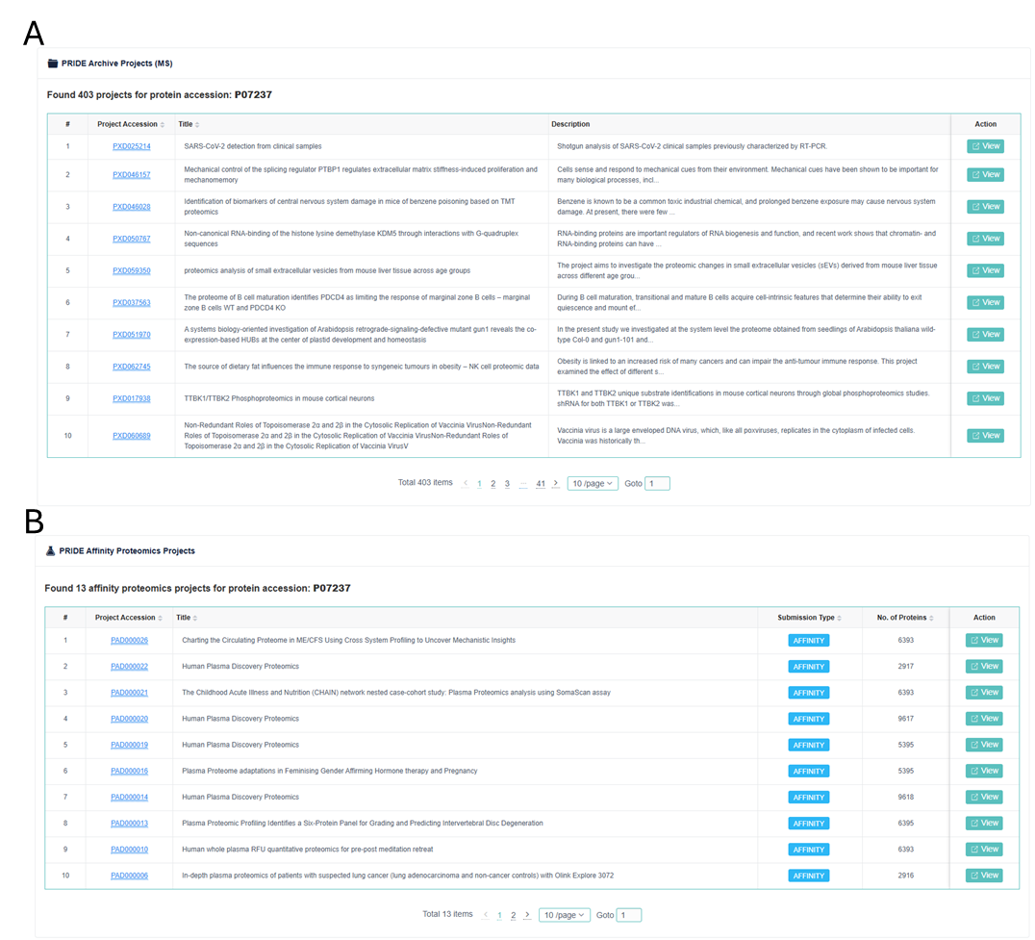

Supplementary Figure 9: Protein-associated datasets in PRIDE. The screenshot shows the protein page for UniProt accession P07237, displaying all datasets in which this protein has been identified. A) PRIDE Archive Projects (MS). List of the MS-based datasets, including project accession, title, description, and direct links to the dataset pages. B) PRIDE Affinity Proteomics Projects. List of the affinity proteomics datasets, showing the project accession, title, number of proteins identified in the dataset, and links to the corresponding dataset pages.

Integration with UniProt is bidirectional. From PRIDE, users can directly access the UniProt entry for a protein (e.g., https://www.uniprot.org/uniprotkb/P07237/entry), which provides curated functional annotations and cross-references. Conversely, UniProt entries include links back to PRIDE under the “Proteomic databases” section, directing users to the corresponding PRIDE protein-centric view (Supplementary Figure 10). This bidirectional linking enables navigation from curated protein knowledge to the underlying experimental datasets and vice versa.
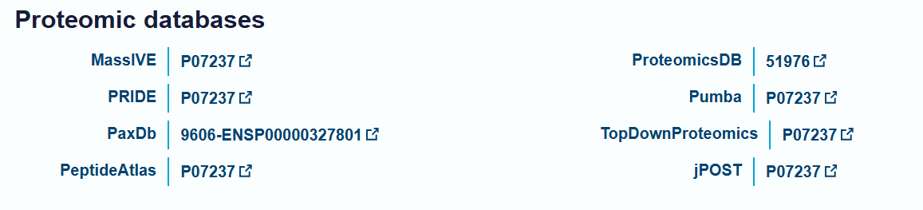

Supplementary Figure 10: Bidirectional integration between PRIDE and UniProt. The screenshot shows the Proteomic databases section of the UniProt entry for P07237, highlighting links to external resources. Among these the link to PRIDE provides direct access to the protein-centric view in PRIDE, allowing users to explore all associated MS and AP datasets.

Supplementary Note 7: RESTful API
File-level metadata associated with affinity-based proteomics datasets were retrieved using the PRIDE Archive REST API v3 via the Swagger interface available at:
https://www.ebi.ac.uk/pride/ws/archive/v3/webjars/swagger-ui/index.html#/.
All queries were performed using HTTP GET requests through the Affinity-Projects → files endpoints. The overall workflow for programmatic retrieval and organization of file metadata is illustrated in Supplementary Figure 11.
Retrieval of individual file metadata
The endpoint GET /files/{fileAccession} was used to obtain metadata for specific files associated with affinity-based projects. Queries were performed by supplying the file accession identifier, and the returned information included file name, file type, associated project accession, and file location.
Retrieval of SDRFs
Experimental design information was retrieved using GET /files/sdrf/{projectAccession}. This endpoint returns the SDRF file describing the relationships between biological samples, experimental conditions, and associated data files for a given project.
Determination of file counts by type
Dataset composition was summarised using GET /files/getCountOfFilesByType/{projectAccession}, which returns the number of files grouped by file type within a specified project.
Archive-level file statistics
The endpoint GET /files/count was used to determine the total number of file records available through the Affinity-Projects file service.
Retrieval of all file metadata records
Comprehensive file metadata was obtained using GET /files/all, which returns metadata for all files associated with affinity-based proteomics projects.
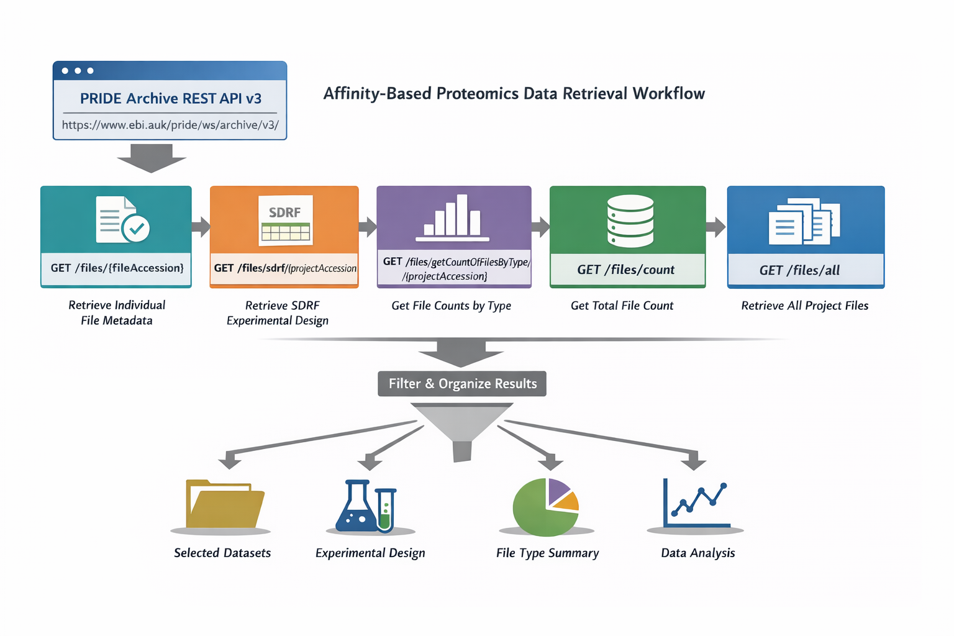
Supplementary Figure. 11: Retrieval of AP-based proteomics data from PRIDE-AP Archive. Workflow illustrating programmatic retrieval of file-level metadata using the PRIDE Archive REST API v3. Individual file records were obtained using GET /files/{fileAccession}, while experimental design metadata were accessed through SDRF files using GET /files/sdrf/{projectAccession}. Project-level dataset composition was summarised using GET /files/getCountOfFilesByType/{projectAccession}, and archive-level statistics were retrieved using GET /files/count. Comprehensive file metadata was obtained using GET /files/all. Retrieved records were subsequently filtered to identify relevant datasets, reconstruct experimental design, summarise file types, and support downstream analysis.

