Supplementary material
SOFA-2 versus SOFA for mortality risk assessment in ICU patients with acute cholangitis
Table S1. MIMIC-IV first-admission phenotype by TG18-like grade
Variable | Overall | Grade I | Grade II | Grade III | P value
N | 1562 | 440 | 316 | 806
Age, years | 69.0 (57.0, 80.0) | 63.0 (53.0, 70.2) | 78.5 (67.8, 86.0) | 70.0 (58.0, 81.0) | <0.001
Hospital LOS, days | 5.7 (3.6, 9.8) | 4.6 (2.8, 6.9) | 5.3 (3.5, 8.3) | 6.8 (4.2, 11.7) | <0.001
Female, n (%) | 689 (44.1) | 204 (46.4) | 159 (50.3) | 326 (40.4) | 0.006
WBC, K/uL | 12.4 (9.1, 16.8) | 10.9 (7.6, 13.6) | 13.6 (11.3, 17.3) | 13.1 (8.8, 18.8) | <0.001
Platelet, K/uL | 186.5 (129.0, 263.8) | 220.0 (161.8, 290.0) | 215.0 (164.8, 291.0) | 156.0 (96.0, 236.0) | <0.001
Creatinine, mg/dL | 0.9 (0.7, 1.3) | 0.8 (0.7, 1.0) | 0.9 (0.7, 1.1) | 1.1 (0.8, 1.8) | <0.001
Total bilirubin, mg/dL | 3.3 (1.7, 5.8) | 2.0 (0.9, 3.3) | 4.8 (2.2, 7.2) | 3.9 (2.1, 7.0) | <0.001
ICU admission during hospitalization, n (%) | 644 (41.2) | 71 (16.1) | 101 (32.0) | 472 (58.6) | <0.001
In-hospital death, n (%) | 118 (7.6) | 7 (1.6) | 10 (3.2) | 101 (12.5) | <0.001
28-day mortality, n (%) | 199 (12.7) | 21 (4.8) | 25 (7.9) | 153 (19.0) | <0.001
Acute kidney injury, n (%) | 487 (31.2) | 55 (12.5) | 63 (19.9) | 369 (45.8) | <0.001
Sepsis, n (%) | 695 (44.5) | 111 (25.2) | 101 (32.0) | 483 (59.9) | <0.001
Liver disease, n (%) | 374 (23.9) | 77 (17.5) | 43 (13.6) | 254 (31.5) | <0.001
Malignant cancer, n (%) | 537 (34.4) | 144 (32.7) | 96 (30.4) | 297 (36.8) | 0.084

Table S2. eICU intensive care mortality across SOFA-2 strata
SOFA-2 stratum | N | ICU deaths | ICU mortality
0-2 | 80 | 1 | 1.2%
3-5 | 93 | 1 | 1.1%
6-8 | 68 | 4 | 5.9%
>=9 | 48 | 11 | 22.9%

Table S3. Availability of eICU score-component inputs
Component input | Available/N | Availability
Time-matched PaO2/FiO2 | 91/289 | 31.5%
Platelets | 282/289 | 97.6%
Bilirubin | 272/289 | 94.1%
Mean arterial pressure | 289/289 | 100.0%
Glasgow Coma Scale | 195/289 | 67.5%
Creatinine | 281/289 | 97.2%
Urine output | 253/289 | 87.5%

Table S4. Discrimination of SOFA-2 organ components
Database | SOFA-2 component | N | ICU deaths | AUROC | 95% CI lower | 95% CI upper | Median in survivors | Median in deaths
MIMIC-IV | Total SOFA-2 | 644 | 71 | 0.834 | 0.777 | 0.883 | 6.0 | 13.0
MIMIC-IV | Brain | 644 | 71 | 0.781 | 0.728 | 0.834 | 1.0 | 3.0
MIMIC-IV | Respiratory | 644 | 71 | 0.714 | 0.651 | 0.776 | 0.0 | 2.0
MIMIC-IV | Cardiovascular | 644 | 71 | 0.71 | 0.644 | 0.778 | 1.0 | 3.0
MIMIC-IV | Liver | 644 | 71 | 0.638 | 0.565 | 0.708 | 2.0 | 3.0
MIMIC-IV | Kidney | 644 | 71 | 0.715 | 0.65 | 0.776 | 1.0 | 3.0
MIMIC-IV | Haemostasis | 644 | 71 | 0.583 | 0.512 | 0.653 | 0.0 | 1.0
eICU | Total SOFA-2 | 289 | 17 | 0.833 | 0.713 | 0.934 | 4.0 | 10.0
eICU | Brain | 289 | 17 | 0.738 | 0.591 | 0.867 | 0.0 | 2.0
eICU | Respiratory | 289 | 17 | 0.726 | 0.591 | 0.847 | 0.0 | 2.0
eICU | Cardiovascular | 289 | 17 | 0.722 | 0.627 | 0.822 | 1.0 | 1.0
eICU | Liver | 289 | 17 | 0.68 | 0.54 | 0.815 | 1.0 | 2.0
eICU | Kidney | 289 | 17 | 0.719 | 0.589 | 0.837 | 1.0 | 2.0
eICU | Haemostasis | 289 | 17 | 0.659 | 0.515 | 0.797 | 0.0 | 1.0

Table S5. Exploratory MIMIC-IV subgroup analyses
Subgroup | Level | N | ICU deaths | SOFA-2 AUROC | SOFA AUROC | AUROC difference | 95% CI lower | 95% CI upper | P value | Analysis status
Age | <65 | 204 | 25 | 0.818 | 0.823 | -0.005 | -0.021 | 0.011 | 0.531 | Exploratory
Age | 65-74 | 151 | 17 | 0.878 | 0.863 | 0.015 | -0.013 | 0.053 | 0.401 | Exploratory
Age | >=75 | 289 | 29 | 0.812 | 0.833 | -0.021 | -0.056 | 0.002 | 0.089 | Exploratory
Sex | F | 284 | 22 | 0.806 | 0.813 | -0.007 | -0.025 | 0.009 | 0.386 | Exploratory
Sex | M | 360 | 49 | 0.839 | 0.844 | -0.005 | -0.026 | 0.015 | 0.66 | Exploratory
TG18-like severity | Grade I-II | 172 | 8 | 0.833 | 0.839 | -0.006 | -0.023 | 0.007 | 0.353 | Exploratory
TG18-like severity | Grade III | 472 | 63 | 0.805 | 0.806 | -0.001 | -0.02 | 0.017 | 0.926 | Exploratory

Table S6. Calibration estimates with bootstrap uncertainty
Database | Model | N | ICU deaths | Calibration intercept (95% CI) | Calibration slope (95% CI) | Brier score (95% CI) | Validation
MIMIC-IV | SOFA-2 | 644 | 71 | -0.020 (-0.511 to 0.521) | 0.989 (0.788 to 1.244) | 0.081 (0.066 to 0.096) | 10-fold cross-validated
MIMIC-IV | SOFA | 644 | 71 | -0.019 (-0.492 to 0.486) | 0.989 (0.787 to 1.236) | 0.079 (0.065 to 0.095) | 10-fold cross-validated
eICU | SOFA-2 | 289 | 17 | 0.475 (-0.805 to 1.777) | 1.200 (0.761 to 1.812) | 0.045 (0.026 to 0.065) | MIMIC-IV risk mapping transported to eICU
eICU | SOFA | 289 | 17 | 0.316 (-0.771 to 1.468) | 1.137 (0.739 to 1.729) | 0.045 (0.026 to 0.066) | MIMIC-IV risk mapping transported to eICU

Table S7. eICU component-completeness sensitivity analyses
Analysis | N | ICU deaths | SOFA-2 AUROC | SOFA AUROC | Difference (95% CI)
Primary analysis: all patients | 289 | 17 | 0.833 | 0.835 | -0.002 (-0.034 to 0.037)
At least 5 of 6 organ components observed | 206 | 15 | 0.857 | 0.873 | -0.017 (-0.044 to 0.006)
All 6 organ components observed | 72 | 10 | 0.802 | 0.815 | -0.013 (-0.059 to 0.029)
Diagnosis-defined broader cohort | 558 | 22 | 0.858 | 0.857 | 0.001 (-0.032 to 0.037)

Table S8. Primary and 24-hour landmark analyses
Analysis | Type | N | ICU deaths | SOFA-2 AUROC (95% CI) | SOFA AUROC (95% CI) | Difference (95% CI); P
MIMIC-IV primary first-day analysis | Primary | 644 | 71 | 0.834 (0.777-0.883) | 0.838 (0.784-0.886) | -0.005 (-0.020 to 0.010); p=0.514
eICU primary first-day analysis | Primary | 289 | 17 | 0.833 (0.709-0.933) | 0.835 (0.712-0.936) | -0.002 (-0.033 to 0.036); p=0.896
MIMIC-IV alive and still in ICU at 24 h | 24-h landmark | 520 | 44 | 0.787 (0.714-0.855) | 0.793 (0.724-0.859) | -0.006 (-0.031 to 0.016); p=0.644
eICU alive and still in ICU at 24 h | 24-h landmark | 211 | 15 | 0.831 (0.687-0.943) | 0.838 (0.702-0.945) | -0.007 (-0.024 to 0.008); p=0.363

Table S9. eICU strict-phenotype and hospital-cluster analyses
Analysis | Uncertainty method | N | ICU deaths | Hospitals | SOFA-2 AUROC | SOFA AUROC | Difference (95% CI); P
Strict diagnosis-supported phenotype excluding acute pancreatitis and cholangiocarcinoma | Patient bootstrap | 144 | 15 |  | 0.783 | 0.787 | -0.004 (-0.044 to 0.045); p=0.780
Ambiguous surgical-label-only cohort | Patient bootstrap | 128 | 2 |  | 0.946 | 0.952 | -0.006 (-0.031 to 0.016); p=0.705
eICU hospital-cluster bootstrap | Hospital-cluster bootstrap | 289 | 17 | 105.0 | 0.833 | 0.835 | -0.002 (-0.044 to 0.039); p=0.879
Strict eICU phenotype hospital-cluster bootstrap | Hospital-cluster bootstrap | 144 | 15 | 69.0 | 0.783 | 0.787 | -0.004 (-0.058 to 0.064); p=0.803

Table S10. Component availability according to ICU outcome
database | component | outcome_group | available | n | availability | missingness
MIMIC-IV | Brain | Survived ICU | 571 | 573 | 99.7% | 0.3%
MIMIC-IV | Brain | Died in ICU | 70 | 71 | 98.6% | 1.4%
MIMIC-IV | Respiratory | Survived ICU | 140 | 573 | 24.4% | 75.6%
MIMIC-IV | Respiratory | Died in ICU | 47 | 71 | 66.2% | 33.8%
MIMIC-IV | Cardiovascular | Survived ICU | 572 | 573 | 99.8% | 0.2%
MIMIC-IV | Cardiovascular | Died in ICU | 71 | 71 | 100.0% | 0.0%
MIMIC-IV | Liver | Survived ICU | 554 | 573 | 96.7% | 3.3%
MIMIC-IV | Liver | Died in ICU | 69 | 71 | 97.2% | 2.8%
MIMIC-IV | Kidney | Survived ICU | 572 | 573 | 99.8% | 0.2%
MIMIC-IV | Kidney | Died in ICU | 70 | 71 | 98.6% | 1.4%
MIMIC-IV | Haemostasis | Survived ICU | 566 | 573 | 98.8% | 1.2%
MIMIC-IV | Haemostasis | Died in ICU | 70 | 71 | 98.6% | 1.4%
eICU | Brain | Survived ICU | 181 | 272 | 66.5% | 33.5%
eICU | Brain | Died in ICU | 14 | 17 | 82.4% | 17.6%
eICU | Respiratory | Survived ICU | 79 | 272 | 29.0% | 71.0%
eICU | Respiratory | Died in ICU | 12 | 17 | 70.6% | 29.4%
eICU | Cardiovascular | Survived ICU | 272 | 272 | 100.0% | 0.0%
eICU | Cardiovascular | Died in ICU | 17 | 17 | 100.0% | 0.0%
eICU | Liver | Survived ICU | 257 | 272 | 94.5% | 5.5%
eICU | Liver | Died in ICU | 15 | 17 | 88.2% | 11.8%
eICU | Kidney | Survived ICU | 271 | 272 | 99.6% | 0.4%
eICU | Kidney | Died in ICU | 17 | 17 | 100.0% | 0.0%
eICU | Haemostasis | Survived ICU | 266 | 272 | 97.8% | 2.2%
eICU | Haemostasis | Died in ICU | 16 | 17 | 94.1% | 5.9%

Table S11. Patient-level agreement between SOFA-2 and SOFA
database | n | pearson_r | spearman_rho | delta_median | delta_q1 | delta_q3 | sofa2_higher_n | equal_n | sofa2_lower_n | exact_agreement | within_one_point
MIMIC-IV | 644 | 0.96383260428596 | 0.9470876226891092 | 0.0 | -1.0 | 0.0 | 120 | 263 | 261 | 0.4083850931677019 | 0.7732919254658385
eICU | 289 | 0.9718233967133972 | 0.9632785780946984 | 0.0 | -1.0 | 0.0 | 30 | 159 | 100 | 0.5501730103806228 | 0.8546712802768166

Table S12. Direction and frequency of organ-component changes
database | component | n | changed_n | sofa2_higher_n | sofa2_lower_n | mean_change | median_change
MIMIC-IV | Brain | 644 | 20 | 0 | 20 | -0.031055900621118 | 0.0
MIMIC-IV | Respiratory | 644 | 85 | 0 | 85 | -0.1319875776397515 | 0.0
MIMIC-IV | Cardiovascular | 644 | 178 | 26 | 152 | -0.281055900621118 | 0.0
MIMIC-IV | Liver | 644 | 125 | 0 | 125 | -0.1940993788819875 | 0.0
MIMIC-IV | Kidney | 644 | 185 | 105 | 80 | 0.1614906832298136 | 0.0
MIMIC-IV | Haemostasis | 644 | 99 | 99 | 0 | 0.1537267080745341 | 0.0
eICU | Brain | 289 | 9 | 0 | 9 | -0.0311418685121107 | 0.0
eICU | Respiratory | 289 | 54 | 0 | 54 | -0.1868512110726643 | 0.0
eICU | Cardiovascular | 289 | 15 | 0 | 15 | -0.0657439446366782 | 0.0
eICU | Liver | 289 | 41 | 0 | 41 | -0.1418685121107266 | 0.0
eICU | Kidney | 289 | 60 | 29 | 31 | 0.0692041522491349 | 0.0
eICU | Haemostasis | 289 | 18 | 18 | 0 | 0.0622837370242214 | 0.0

Table S13. Total, non-liver and liver-only discrimination
Database | N | ICU deaths | Total SOFA-2 AUROC | Non-liver SOFA-2 AUROC | Liver component AUROC | Total minus non-liver (95% CI); P
MIMIC-IV | 644 | 71 | 0.834 | 0.826 | 0.638 | 0.008 (-0.008 to 0.023); p=0.326
eICU | 289 | 17 | 0.833 | 0.844 | 0.68 | -0.010 (-0.044 to 0.020); p=0.536

Table S14. Coded therapeutic biliary-procedure proxy analyses in MIMIC-IV
Result type | Group | N | ICU deaths | ICU mortality | SOFA-2 AUROC | SOFA AUROC | Difference (95% CI); P
Timing summary | After ICU admission date | 139 | 8 | 5.8%
Timing summary | Before ICU admission date | 34 | 6 | 17.6%
Timing summary | No coded therapeutic biliary-procedure proxy | 233 | 44 | 18.9%
Timing summary | On ICU admission date | 238 | 13 | 5.5%
Performance | No coded therapeutic biliary-procedure proxy | 233 | 44 |  | 0.868 | 0.865 | 0.003 (-0.011 to 0.021); p=0.762
Performance | Any coded therapeutic biliary-procedure proxy | 411 | 27 |  | 0.801 | 0.822 | -0.021 (-0.055 to 0.004); p=0.116

Table S15. Decision-curve estimates with bootstrap uncertainty
Database | Threshold | SOFA-2 net benefit (95% CI) | SOFA net benefit (95% CI) | Difference (95% CI)
MIMIC-IV | 5% | 0.079 (0.056 to 0.104) | 0.080 (0.056 to 0.104) | -0.000 (-0.006 to 0.007)
MIMIC-IV | 10% | 0.066 (0.044 to 0.089) | 0.066 (0.044 to 0.089) | -0.000 (-0.007 to 0.006)
MIMIC-IV | 15% | 0.053 (0.033 to 0.075) | 0.054 (0.033 to 0.075) | -0.001 (-0.008 to 0.006)
MIMIC-IV | 20% | 0.037 (0.017 to 0.057) | 0.043 (0.022 to 0.064) | -0.005 (-0.014 to 0.001)
eICU | 5% | 0.032 (0.010 to 0.057) | 0.038 (0.015 to 0.064) | -0.006 (-0.014 to -0.002)
eICU | 10% | 0.020 (0.002 to 0.044) | 0.022 (0.002 to 0.047) | -0.002 (-0.010 to 0.003)
eICU | 15% | 0.016 (-0.000 to 0.037) | 0.016 (-0.001 to 0.038) | 0.000 (-0.009 to 0.006)
eICU | 20% | 0.011 (-0.004 to 0.030) | 0.013 (-0.004 to 0.033) | -0.002 (-0.010 to 0.004)

Table S16. Exploratory data-defined SOFA-2 trajectory groups
Trajectory group | N | ICU deaths | ICU mortality | Day-1 median | Day-2 median | Day-3 median | Delta day-3 median | Database | ICU mortality 95% CI | Analysis status
high_persistent | 18 | 3 | 16.7% | 14.0 | 14.0 | 14.5 | -1.0 | MIMIC-IV | 5.8%-39.2% | Exploratory; data-defined groups
improving | 102 | 9 | 8.8% | 11.5 | 8.0 | 7.0 | -4.0 | MIMIC-IV | 4.7%-15.9% | Exploratory; data-defined groups
low_stable | 30 | 0 | 0.0% | 4.0 | 3.0 | 3.0 | -0.5 | MIMIC-IV | -0.0%-11.4% | Exploratory; data-defined groups
stable | 17 | 1 | 5.9% | 7.0 | 7.0 | 7.0 | 0.0 | MIMIC-IV | 1.0%-27.0% | Exploratory; data-defined groups
worsening | 26 | 12 | 46.2% | 9.5 | 12.0 | 12.0 | 2.0 | MIMIC-IV | 28.8%-64.5% | Exploratory; data-defined groups
high_persistent | 12 | 3 | 25.0% | 12.0 | 10.5 | 12.0 | 0.0 | eICU | 8.9%-53.2% | Exploratory; data-defined groups
improving | 35 | 3 | 8.6% | 8.0 | 6.0 | 5.0 | -5.0 | eICU | 3.0%-22.4% | Exploratory; data-defined groups
low_stable | 24 | 1 | 4.2% | 4.0 | 2.0 | 2.0 | -1.0 | eICU | 0.7%-20.2% | Exploratory; data-defined groups
stable | 2 | 0 | 0.0% | 7.0 | 7.0 | 6.5 | -0.5 | eICU | 0.0%-65.8% | Exploratory; data-defined groups
worsening | 6 | 1 | 16.7% | 6.0 | 7.0 | 8.0 | 2.0 | eICU | 3.0%-56.4% | Exploratory; data-defined groups

Table S17. Additional MIMIC-IV phenotype and clinical sensitivity analyses
Analysis | N | ICU deaths | SOFA-2 AUROC (95% CI) | SOFA AUROC (95% CI) | Difference (95% CI); P
Primary ICU cohort | 644 | 71 | 0.834 (0.777-0.883) | 0.838 (0.784-0.886) | -0.005 (-0.020 to 0.010); p=0.514
Explicit cholangitis-code sensitivity (K80.4x/K83.1 sole-code rule; no patients excluded) | 644 | 71 | 0.834 (0.777-0.883) | 0.838 (0.784-0.886) | -0.005 (-0.020 to 0.010); p=0.514
Non-bilirubin hepatobiliary-criterion sensitivity | 575 | 65 | 0.824 (0.763-0.880) | 0.830 (0.770-0.884) | -0.006 (-0.023 to 0.009); p=0.452
No recorded chronic liver disease | 478 | 37 | 0.825 (0.736-0.897) | 0.840 (0.755-0.910) | -0.015 (-0.041 to 0.009); p=0.222
No invasive ventilation/ECMO in first-day score window | 445 | 24 | 0.818 (0.687-0.925) | 0.820 (0.702-0.921) | -0.002 (-0.030 to 0.030); p=0.809

Table S18. Audit of potentially non-specific biliary diagnosis co-codes in MIMIC-IV
ICD-code audit item | N
Explicit cholangitis code | 644
K80.4x co-code | 5
K83.1 co-code | 76
K80.4x or K83.1 without explicit cholangitis code | 0

Table S19. Hour-resolved ERCP workflow records relative to ICU admission
ERCP workflow timing | N | ICU deaths | ICU mortality (95% CI) | Median day-1 SOFA-2 | ERCP done-in-unit records | Generic percutaneous-drain records
0-12 h | 122 | 7 | 5.7% (2.8%-11.4%) | 6.5 | 1 | 6
12-24 h | 56 | 2 | 3.6% (1.0%-12.1%) | 7.0 | 0 | 4
>24 h | 24 | 1 | 4.2% (0.7%-20.2%) | 7.5 | 2 | 2
No exact ERCP workflow record | 442 | 61 | 13.8% (10.9%-17.3%) | 7.0 | 0 | 15

Table S20. Early blood-culture findings and exploratory score performance
Early blood-culture group | N | ICU deaths | ICU mortality (95% CI) | SOFA-2 AUROC | SOFA AUROC | Difference (95% CI)
No blood culture in window | 182 | 21 | 11.5% (7.7%-17.0%) | 0.938 | 0.922 | 0.016 (-0.006 to 0.045)
Gram-negative blood culture positive | 57 | 6 | 10.5% (4.9%-21.1%) | 0.853 | 0.866 | -0.013 (-0.051 to 0.023)
Blood culture negative | 386 | 42 | 10.9% (8.2%-14.4%) | 0.798 | 0.814 | -0.015 (-0.038 to 0.002)
Other blood culture positive | 19 | 2 | 10.5% (2.9%-31.4%) | 0.544 | 0.529 | 0.015 (0.000 to 0.067)

Table S21. Admission and first-ICU context in MIMIC-IV
Context type | Context group | N | ICU deaths | ICU mortality
Admission type | DIRECT OBSERVATION | 1 | 0 | 0.0%
Admission type | URGENT | 139 | 13 | 9.4%
Admission type | OBSERVATION ADMIT | 78 | 12 | 15.4%
Admission type | EU OBSERVATION | 3 | 1 | 33.3%
Admission type | ELECTIVE | 4 | 1 | 25.0%
Admission type | DIRECT EMER. | 27 | 6 | 22.2%
Admission type | SURGICAL SAME DAY ADMISSION | 8 | 0 | 0.0%
Admission type | EW EMER. | 384 | 38 | 9.9%
First ICU care unit | Medical Intensive Care Unit (MICU) | 93 | 16 | 17.2%
First ICU care unit | Surgical Intensive Care Unit (SICU) | 61 | 2 | 3.3%
First ICU care unit | Coronary Care Unit (CCU) | 10 | 3 | 30.0%
First ICU care unit | Trauma SICU (TSICU) | 44 | 7 | 15.9%
First ICU care unit | Medical/Surgical Intensive Care Unit (MICU/SICU) | 430 | 43 | 10.0%
First ICU care unit | Neuro Intermediate | 1 | 0 | 0.0%
First ICU care unit | Cardiac Vascular Intensive Care Unit (CVICU) | 5 | 0 | 0.0%
Surgical-service flag | 0 | 536 | 66 | 12.3%
Surgical-service flag | 1 | 108 | 5 | 4.6%

Table S22. Sensitivity analysis restricted to emergency or urgent admissions without a surgical-service flag
Sensitivity cohort | N | ICU deaths | SOFA-2 AUROC (95% CI) | SOFA AUROC (95% CI) | Difference (95% CI); P
Emergency/urgent admission without surgical-service flag | 463 | 54 | 0.842 (0.774-0.900) | 0.840 (0.773-0.897) | 0.002 (-0.011 to 0.017); p=0.814

Table S23. Reconstructed APACHE II contextual comparison
Outcome | Events/N | SOFA-2 AUROC (95% CI) | Reconstructed APACHE II AUROC (95% CI) | Difference (95% CI); P
ICU mortality | 71/644 | 0.834 (0.777-0.883) | 0.857 (0.813-0.898) | -0.024 (-0.066 to 0.015); p=0.238
In-hospital mortality | 102/644 | 0.786 (0.734-0.833) | 0.797 (0.747-0.845) | -0.012 (-0.054 to 0.030); p=0.548
28-day mortality | 133/644 | 0.760 (0.714-0.804) | 0.759 (0.711-0.803) | 0.001 (-0.035 to 0.039); p=0.962

Table S24. APACHE II reconstruction component availability
APACHE II component | Available/N | Availability
Temperature | 638/644 | 99.1%
Mean arterial pressure | 643/644 | 99.8%
Heart rate | 643/644 | 99.8%
Respiratory rate | 643/644 | 99.8%
Oxygenation | 349/644 | 54.2%
Arterial pH or bicarbonate | 637/644 | 98.9%
Sodium | 636/644 | 98.8%
Potassium | 636/644 | 98.8%
Creatinine | 636/644 | 98.8%
Haematocrit | 636/644 | 98.8%
White blood cell count | 636/644 | 98.8%
Glasgow Coma Scale | 641/644 | 99.5%

Table S25. APACHE II reconstruction summary
Reconstruction item | Value
N | 644
ICU deaths | 71
Median APACHE II | 19
IQR lower | 15
IQR upper | 27
High-FiO2 ABG pairs with PaCO2 available | 142
High-FiO2 ABG rows lacking PaCO2 | 0

Table S26. Exploratory dynamic SOFA-2 analyses in landmark cohorts
Database | Landmark cohort | Score | N | ICU deaths | ICU mortality | AUROC (95% CI) | Analysis status
MIMIC-IV | 24-hour landmark | Day-1 SOFA-2 | 520 | 44 | 8.5% | 0.787 (0.714-0.855) | Exploratory
MIMIC-IV | 24-hour landmark | Day-2 SOFA-2 | 521 | 45 | 8.6% | 0.832 (0.765-0.895) | Exploratory
MIMIC-IV | 24-hour landmark | Delta day 2 | 521 | 45 | 8.6% | 0.681 (0.582-0.775) | Exploratory
MIMIC-IV | 72-hour landmark | Day-1 SOFA-2 | 193 | 25 | 13.0% | 0.654 (0.540-0.754) | Exploratory
MIMIC-IV | 72-hour landmark | Day-2 SOFA-2 | 193 | 25 | 13.0% | 0.765 (0.668-0.850) | Exploratory
MIMIC-IV | 72-hour landmark | Day-3 SOFA-2 | 193 | 25 | 13.0% | 0.809 (0.730-0.873) | Exploratory
MIMIC-IV | 72-hour landmark | Delta day 3 | 193 | 25 | 13.0% | 0.726 (0.605-0.837) | Exploratory
MIMIC-IV | 72-hour landmark | Maximum SOFA-2, 72 h | 193 | 25 | 13.0% | 0.746 (0.643-0.832) | Exploratory
MIMIC-IV | 72-hour landmark | Mean SOFA-2, 72 h | 193 | 25 | 13.0% | 0.766 (0.671-0.845) | Exploratory
eICU | 72-hour landmark | Day-1 SOFA-2 | 79 | 8 | 10.1% | 0.789 (0.603-0.930) | Exploratory
eICU | 72-hour landmark | Day-2 SOFA-2 | 79 | 8 | 10.1% | 0.818 (0.621-0.951) | Exploratory
eICU | 72-hour landmark | Day-3 SOFA-2 | 79 | 8 | 10.1% | 0.846 (0.686-0.959) | Exploratory
eICU | 72-hour landmark | Delta day 3 | 79 | 8 | 10.1% | 0.614 (0.399-0.818) | Exploratory
eICU | 72-hour landmark | Maximum SOFA-2, 72 h | 79 | 8 | 10.1% | 0.782 (0.582-0.930) | Exploratory
eICU | 72-hour landmark | Mean SOFA-2, 72 h | 79 | 8 | 10.1% | 0.834 (0.654-0.959) | Exploratory

Table S27. Secondary outcome head-to-head comparison
Outcome | SOFA-2 AUROC (95% CI) | SOFA AUROC (95% CI) | Difference (95% CI); P
ICU mortality | 0.834 (0.777-0.883) | 0.838 (0.784-0.886) | -0.005 (-0.020 to 0.010); p=0.514
In-hospital mortality | 0.786 (0.734-0.833) | 0.784 (0.731-0.831) | 0.002 (-0.012 to 0.015); p=0.821
28-day mortality | 0.760 (0.714-0.804) | 0.756 (0.711-0.801) | 0.005 (-0.010 to 0.020); p=0.524

Figure S1. Exploratory dynamic SOFA-2 analyses
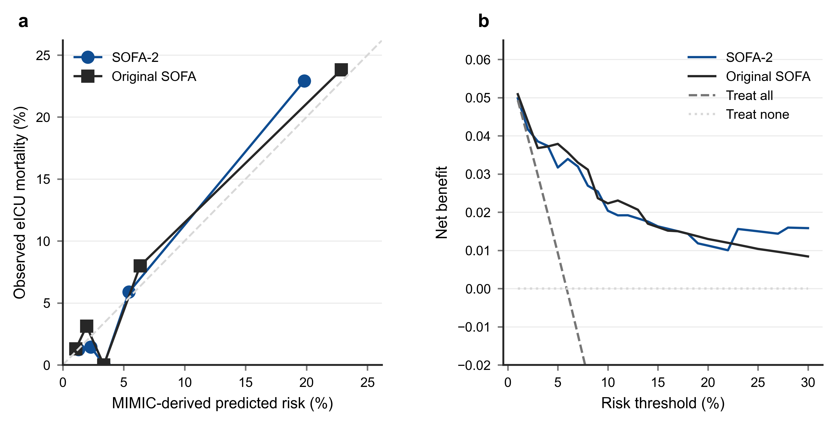
Day-specific, delta, maximum, mean and simple trajectory analyses are shown for landmark cohorts.

Figure S2. Extended sensitivity and component analyses
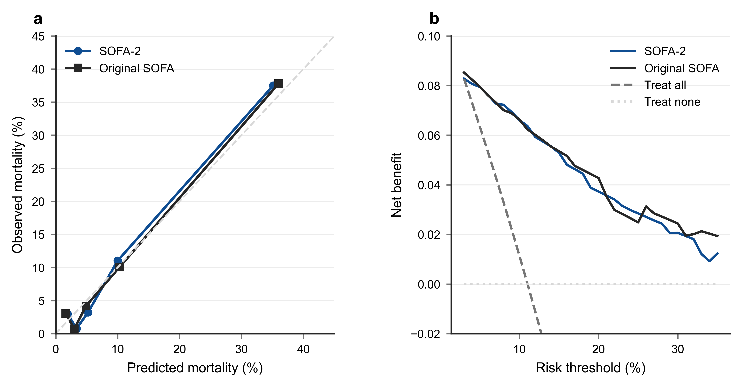
Additional sensitivity, component and agreement analyses are shown for the primary and cross-database cohorts.

Figure S3. Time-dependent cumulative AUC analyses in MIMIC-IV
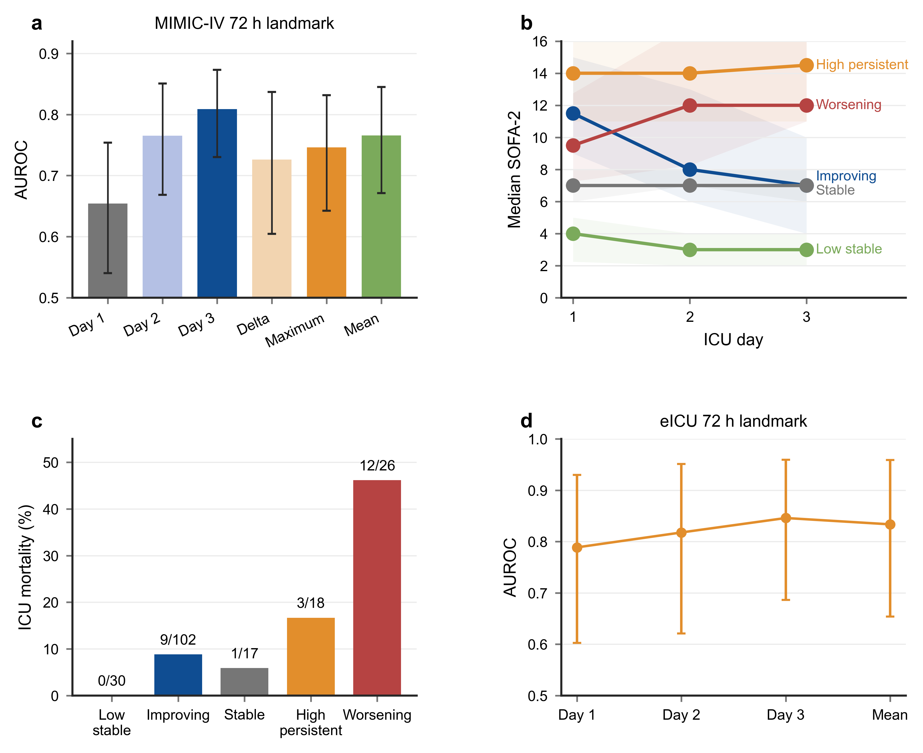
Cumulative AUC curves compare day-1 SOFA-2 with SOFA from day 1 to day 28, and exploratory 72-hour landmark curves compare maximum 72-hour SOFA-2 with day-1 SOFA-2 from day 4 to day 28. Shaded areas show 95% bootstrap confidence intervals.

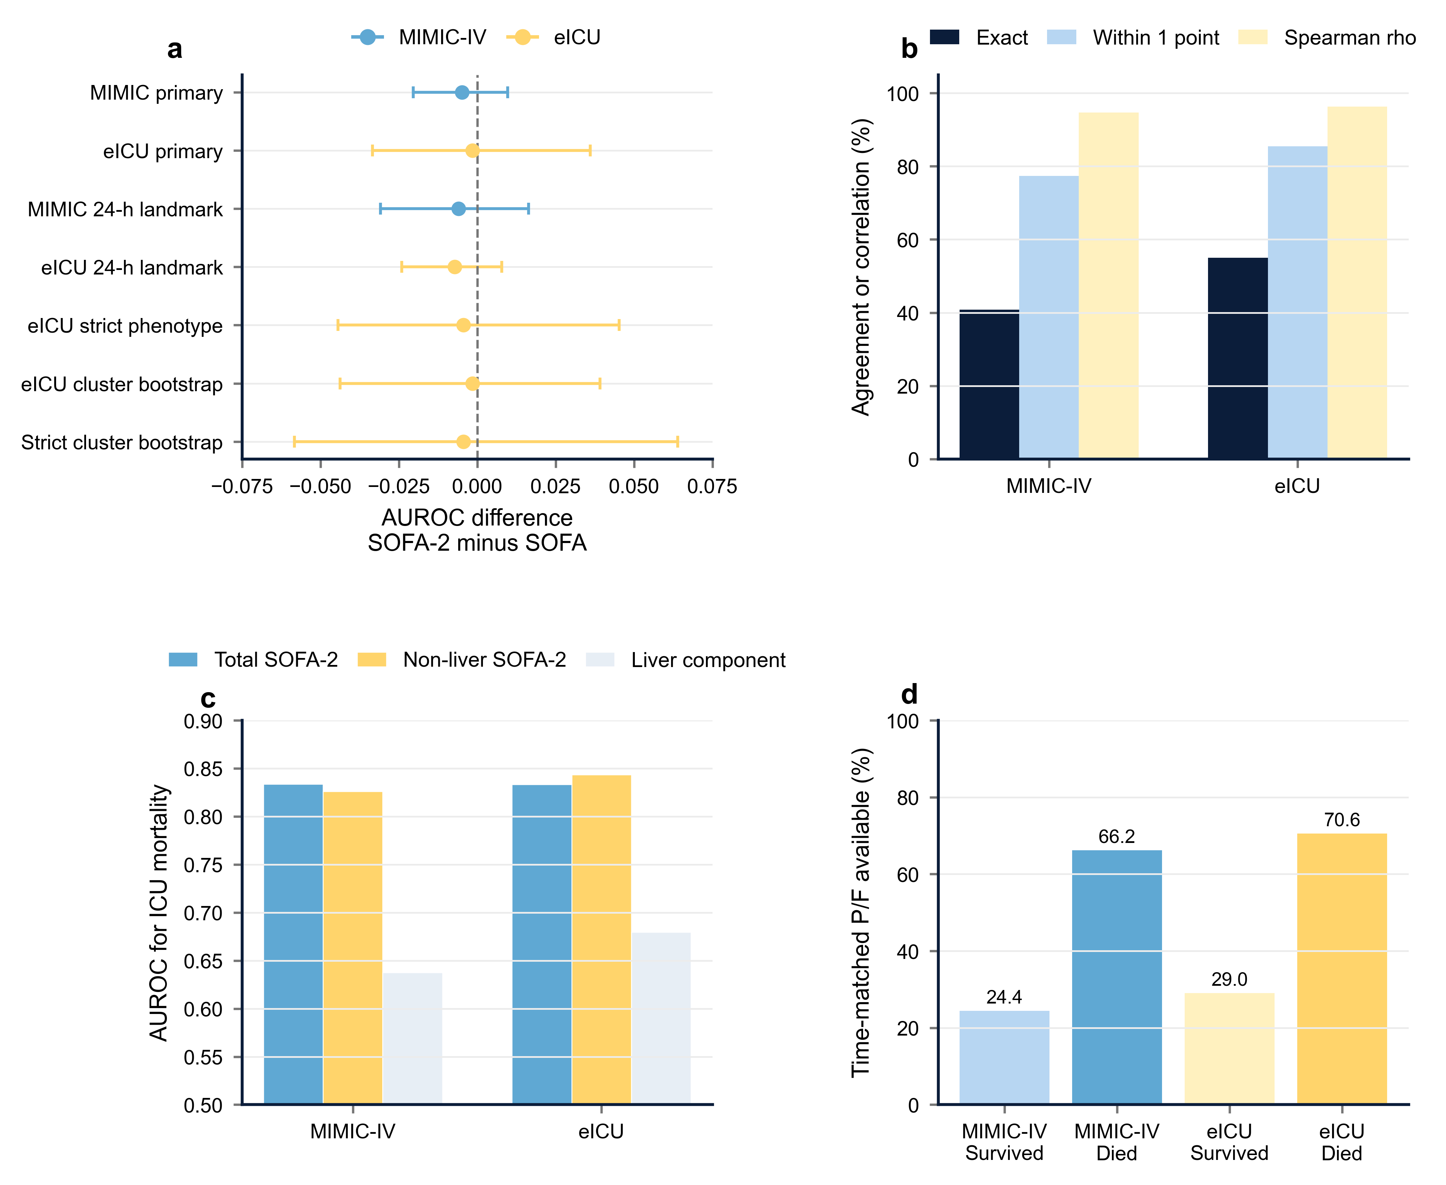

For Table S17, the K80.4x/K83.1 sole-code exclusion rule removed no patients because no patient qualified solely through these codes.

