Title: Seasonality of water temperature and conductivity regulates phytoplankton richness dynamics by changing turnovers rates in a freshwater shallow lake
Tab. S1 The information of sampling sites in Baiyangdian lake
Label | Area | Year of sampling | Latitude (°) | longitude (°)
S1 | Zaozhadian | 2022+2023 | 38.97 | 116.00
S2 | Baodaoleyuan | 2022+2023 | 38.92 | 116.00
S3 | Shaochedian | 2022+2023 | 38.92 | 115.84
S4 | Daguanyuan | 2022+2023 | 38.91 | 115.96
S5 | Guangdian | 2022+2023 | 38.90 | 116.03
S6 | Zaolinzhuang | 2022+2023 | 38.89 | 116.07
S7 | Hupidian | 2022+2023 | 38.85 | 116.03
S8 | Guancheng | 2022+2023 | 38.84 | 115.95
S9 | Duancun | 2022+2023 | 38.83 | 115.89
S10 | Caiputai | 2022+2023 | 38.81 | 116.01

Fig. S1 Annual mean total nitrogen (TN; a), total phosphorus (TP; b), N:P ratios (c), conductivity (EC; d), turbidity (e), and water temperature (WT; f) at all the sampling sites in Baiyangdian Lake over the two years (means ± 1SE). Different lowercase letters above the error bars indicate statistical significances at P < 0.05 based on the Duncan’s multiple range test
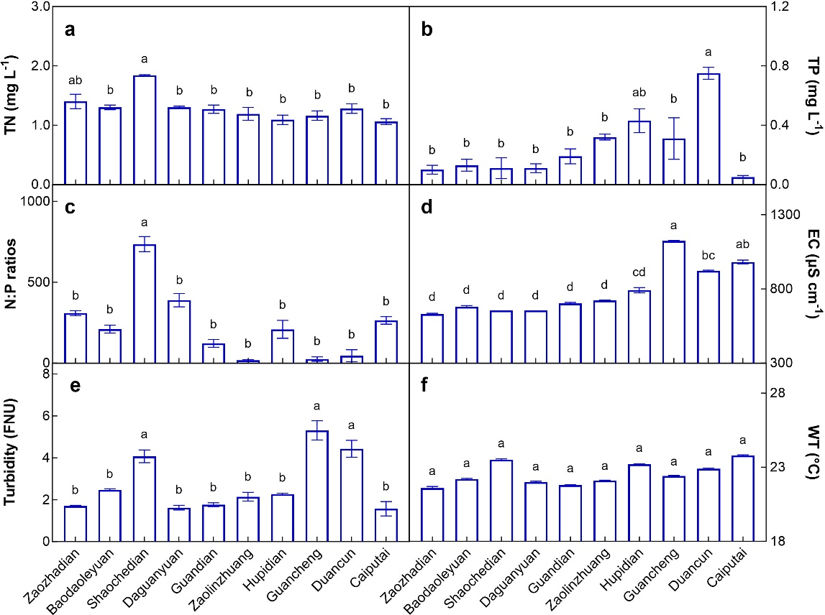

Fig. S2 Seasonal variations in phytoplankton richness during the two years
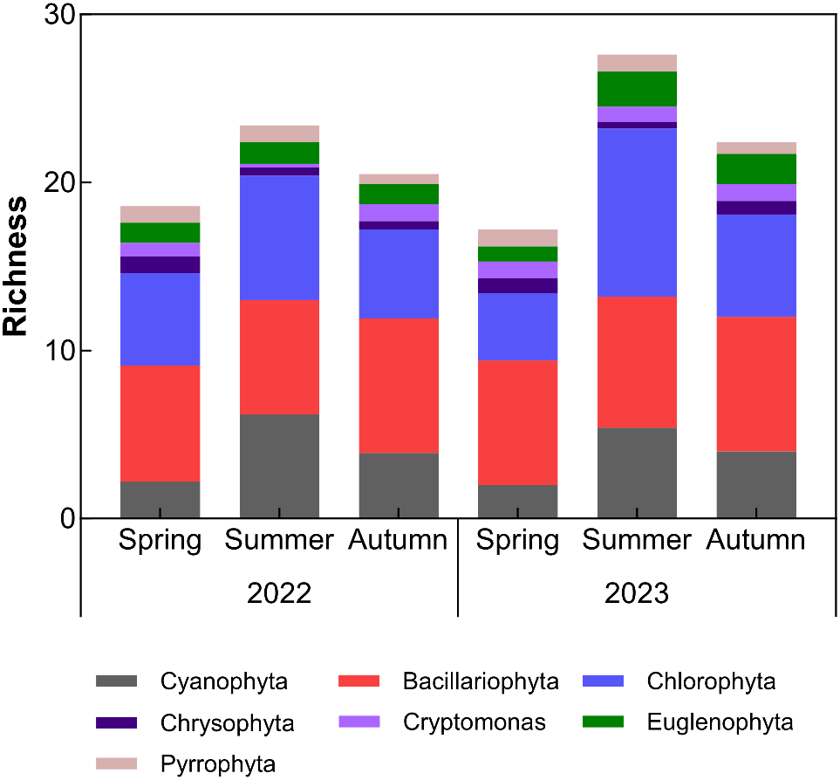

Fig. S3 Relationships of phytoplankton richness with total nitrogen (TN; a), total phosphorus (TP; b), N:P ratios (c), conductivity (EC; d), turbidity (e), and water temperature (WT; f) in 2022 and 2023. Each data point represents the value at each site of each sampling date over the two years
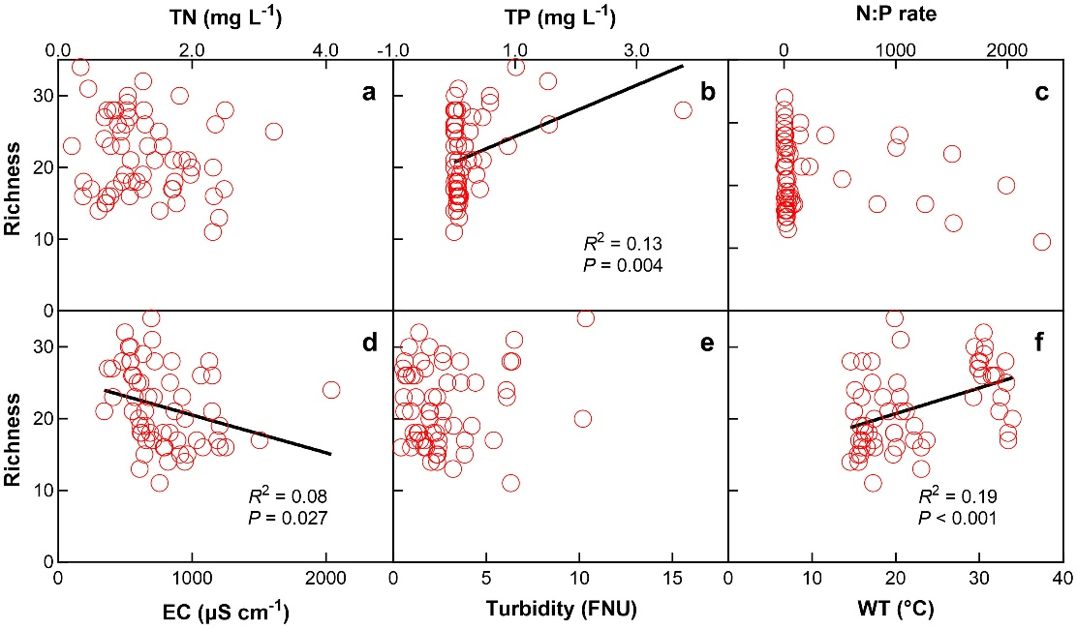

Fig. S4 Relationships of phytoplankton gain and loss rates with the changes in water temperature (ΔWT) in 2022 and 2023. Each date point represents the value between two adjacent seasons at each sampling site. P-value represents the statistical significance of the slope difference between gain and loss rates
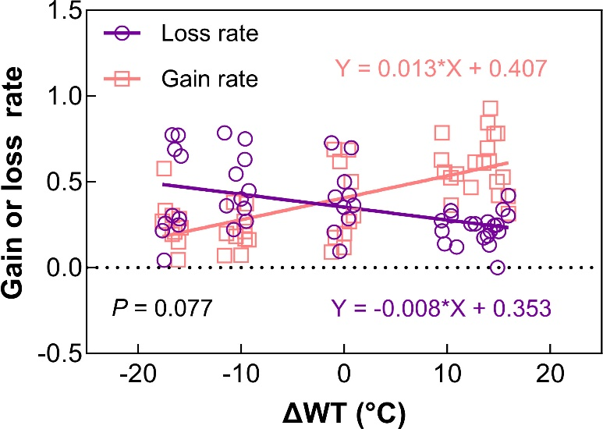

Fig. S5 Dependences of the coefficient variation of Jaccard dissimilarity on the changes in total nitrogen (ΔTN; a), total phosphorus (ΔTP; b), N:P ratios (ΔN:P ratios; c), conductivity (ΔEC; d), turbidity (ΔTurbidity; e), and water temperature (ΔWT; f). Each date point represents the value between two adjacent seasons at each sampling site
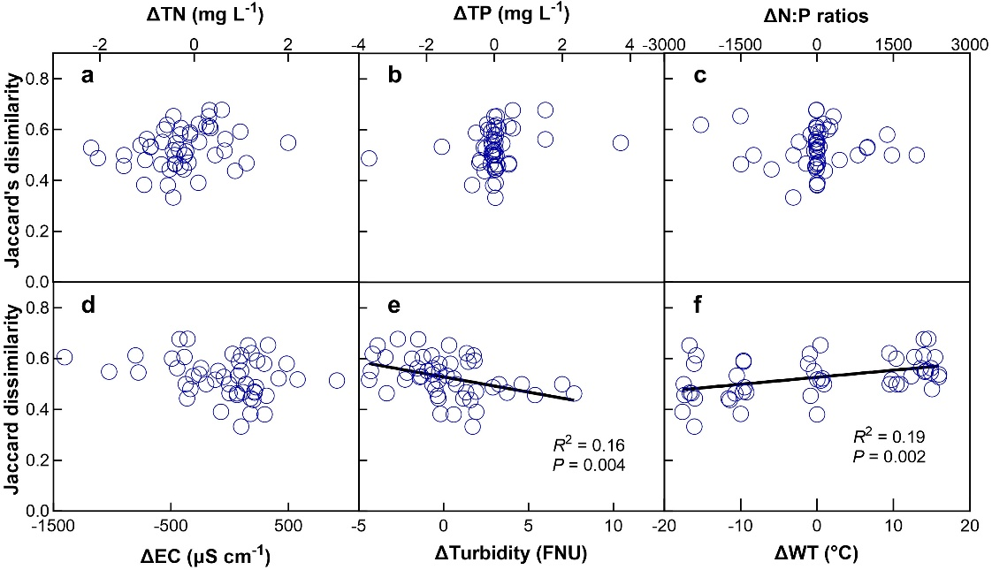

Fig. S6 The replacement- and nestedness- component distribution ternary diagram of the Jaccard similarity index at the 10 sampling sites in Baiyangdian Lake over the two years
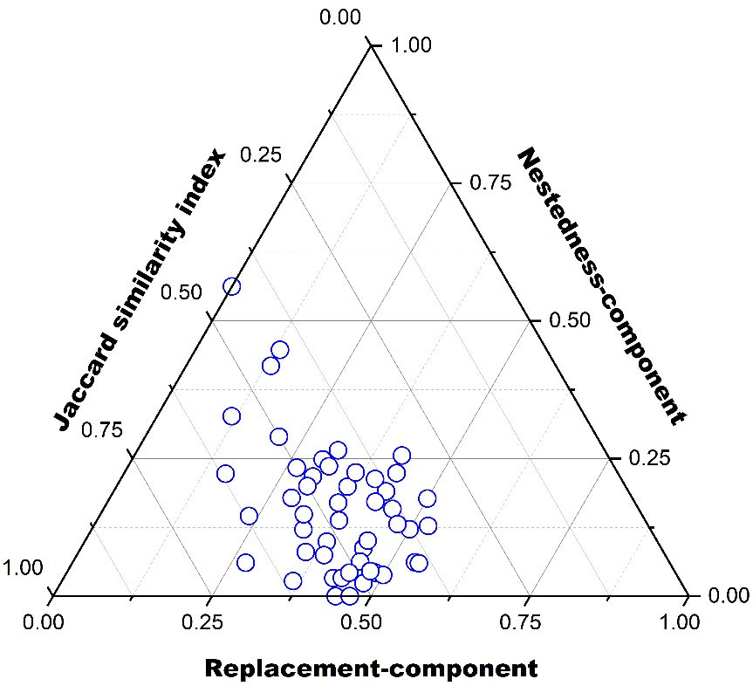

Fig. S7 Relationships of replacement- component (a, b, c, d, e, f) and nestedness-component (g, h, i, j, k, l) of Jaccard dissimilarity index with the changes in total nitrogen (ΔTN; a, g), total phosphorus (ΔTP; b, h), N:P rate (ΔN:P rate; c, i), conductivity (ΔEC; d, j), turbidity (ΔTurbidity; e, k), and water temperature (ΔWT; f, l) in 2022 and 2023. Each date point represents the value between two adjacent seasons at each sampling site
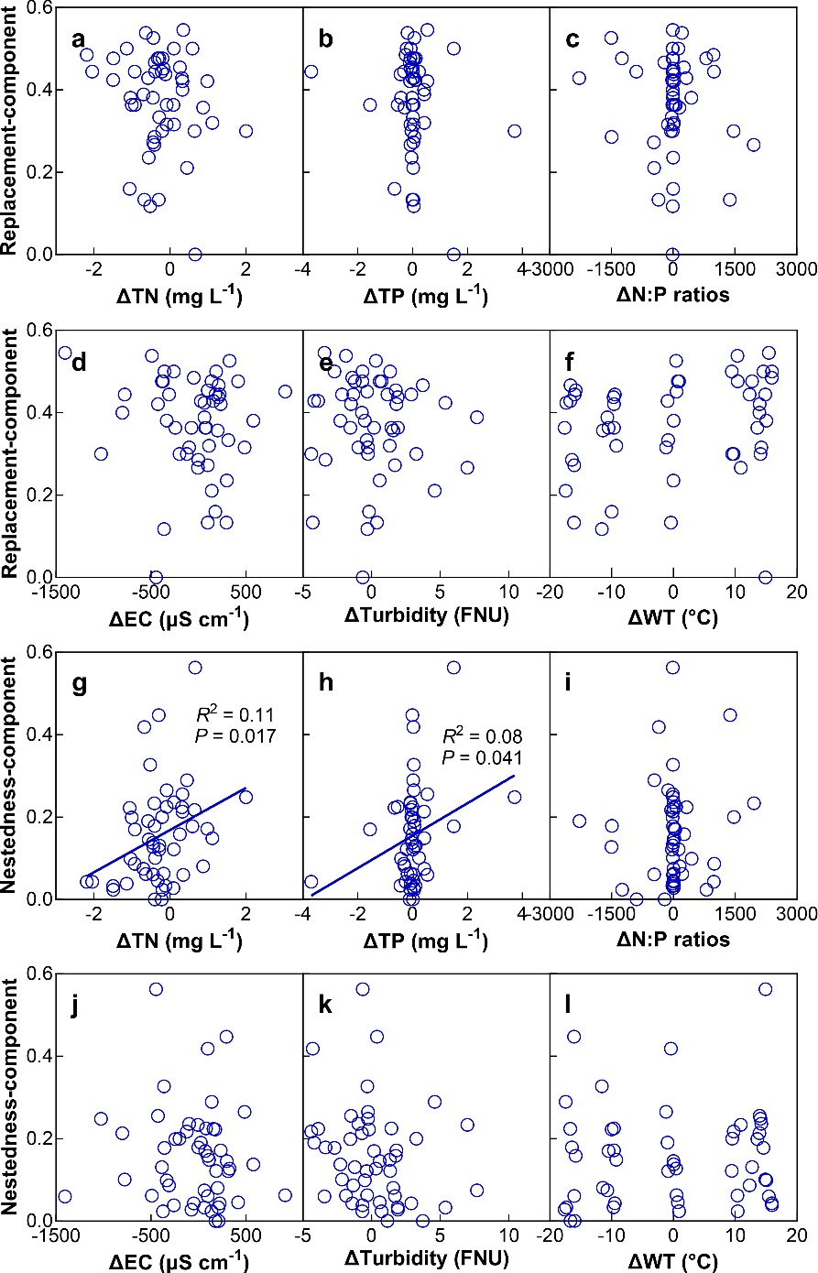
Fig. S8 Relationships of Cyanophyta gain, loss, and turnover rates with the changes in total nitrogen (ΔTN; a, g, m), total phosphorus (ΔTP; b, h, n), N:P ratios (ΔN:P ratios; c, i, o), conductivity (ΔEC; d, j, p), turbidity (ΔTurbidity; e, k, q), and water temperature (ΔWT; f, l, r) over the two years. Each date point represents the value between two adjacent seasons at each sampling site
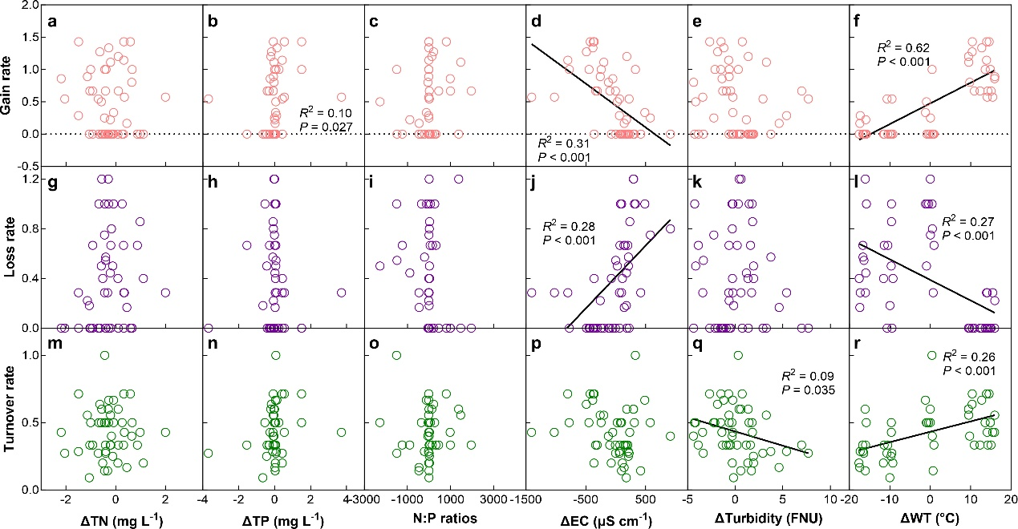

Fig. S9 Relationships of Chlorophyta gain, loss, and turnover rates with the changes in total nitrogen (ΔTN; a, g, m), total phosphorus (ΔTP; b, h, n), N:P ratios (ΔN:P ratios; c, i, o), conductivity (ΔEC; d, j, p), turbidity (ΔTurbidity; e, k, q), and water temperature (ΔWT; f, l, r) over the two years. Each date point represents the value between two adjacent seasons at each sampling site
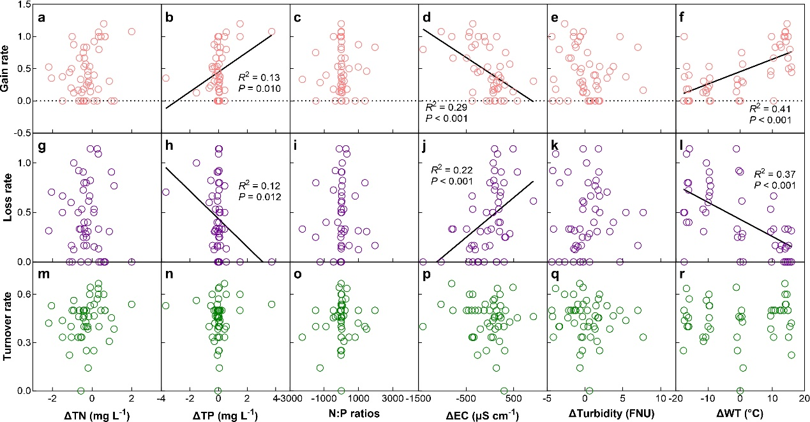

Fig. S10 Relationships of Euglenophyta gain, loss, and turnover rates with the changes in total nitrogen (ΔTN; a, g, m), total phosphorus (ΔTP; b, h, n), N:P ratios (ΔN:P ratios; c, i, o), conductivity (ΔEC; d, j, p), turbidity (ΔTurbidity; e, k, q), and water temperature (ΔWT; f, l, r) over the two years. Each date point represents the value between two adjacent seasons at each sampling site
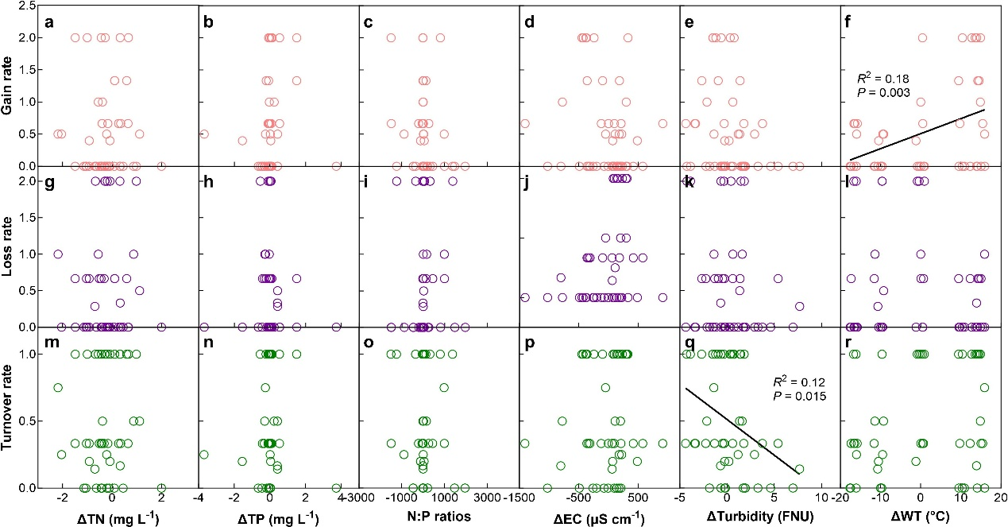

Fig. S11 Relationships of gain, loss, and turnover rates of other phyla (Chrysophyta, Cryptophyta and Pyrrophyta) with the changes in total nitrogen (ΔTN; a, g, m), total phosphorus (ΔTP; b, h, n), N:P ratios (ΔN:P ratios; c, i, o), conductivity (ΔEC; d, j, p), turbidity (ΔTurbidity; e, k, q), and water temperature (ΔWT; f, l, r) over the two years. Each date point represents the value between two adjacent seasons at each sampling site
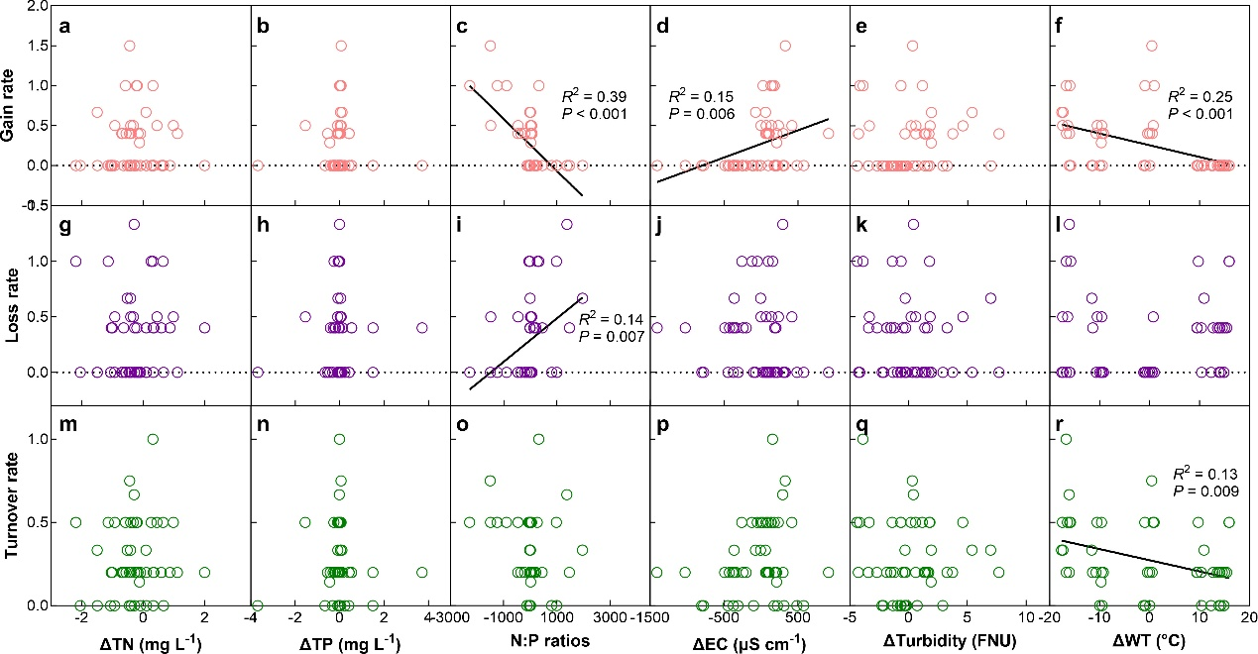

Fig. S12 Relationships of Bacillariophyta gain, loss, and turnover rates with the changes in total nitrogen (ΔTN; a, g, m), total phosphorus (ΔTP; b, h, n), N:P ratios (ΔN:P ratios; c, i, o), conductivity (ΔEC; d, j, p), turbidity (ΔTurbidity; e, k, q), and water temperature (ΔWT; f, l, r) over the two years. Each date point represents the value between two adjacent seasons at each sampling site
