Supplementary Material 1

1.Materials and Methods
1.1 Materials and Reagents
Bulk orthorhombic black phosphorus crystalline powder was purchased from XFNANO Materials Tech Co., Ltd. (Nanjing, China). Bufalin (HPLC purity ≥98%, Cat. No. M0021) was obtained from MedChemExpress (USA) as the core anti-fibrotic small-molecule therapeutic agent for myocardial infarction therapy. Sodium hyaluronate (Mw = 1.0 MDa) and anhydrous N-methylpyrrolidone (≥99.5% analytical grade) were supplied by Aladdin Biochemical Technology Co., Ltd. and Macklin Biochemical Co., Ltd., respectively. Type A porcine gelatin, methacrylic anhydride, EDC·HCl and NHS were analytical-grade chemicals without further purification. 3-Aminophenylboronic acid (3-PBA) was utilized to synthesize ROS-responsive boronate ester crosslinked HA-PBA hydrogel. Lithium phenyl-2,4,6-trimethylbenzoylphosphinate (LAP photoinitiator) and high-molecular polyvinyl alcohol (Mw = 145000) were purchased from domestic biochemical suppliers. Cy5.5-NHS ester near-infrared fluorescent dye was sourced from Thermo Fisher Scientific for ex vivo myocardial retention imaging of microneedle patches. Primary antibodies targeting TOMM20, α-SMA, Collagen I, Collagen III and CX43 were obtained from Thermo Fisher Scientific and Abcam. Alexa Fluor 488-conjugated WGA, FITC/Cy3-labeled goat anti-rabbit secondary antibodies, DAPI nuclear staining solution, DCFH-DA intracellular ROS probe, MitoSOX Red mitochondrial superoxide probe, JC-1 mitochondrial membrane potential and EdU cell proliferation assay kit were all supplied by Beyotime Biotechnology. CCK-8 cell viability kit, TTC infarct staining kit, Masson’s trichrome staining kit, Sirius Red collagen staining kit, MDA, SOD and CAT biochemical detection kits were purchased from Solarbio Science & Technology Co., Ltd. Recombinant TGF-β1 and TNF-α/IL-6 ELISA kits were acquired from R&D Systems. High-glucose DMEM, MEM-α and sugar-free EBSS buffer, fetal bovine serum (FBS), 100× penicillin-streptomycin mixture and 0.25% trypsin-EDTA digestion solution were Gibco products. The H9C2 rat cardiomyoblast cell line was purchased from the American Type Culture Collection (ATCC). Primary neonatal mouse cardiomyocytes (NMCMs) and neonatal mouse cardiac fibroblasts (NMCFs) were isolated from 1–3-day-old SPF-grade C57BL/6 suckling mice in our laboratory. Six-to-eight-week-old male SPF C57BL/6 mice were purchased from the Animal Center of the Fourth Military Medical University. Sodium pentobarbital for intraperitoneal injection anesthesia, 6-0 polypropylene surgical sutures, PDMS microneedle female molds and resin male molds were prepared for cardiac surgery and microneedle fabrication. 4% paraformaldehyde, glutaraldehyde-osmium tetroxide double fixative, paraffin wax and gradient ethanol were supplied by Servicebio. Concentrated hydrochloric acid, sodium hydroxide, anhydrous ethanol and all other inorganic analytical reagents were purchased from Sinopharm Chemical Reagent Co., Ltd. Dialysis bags with molecular weight cutoffs of 3500 Da and 12–14 kDa were sourced from Spectrum Laboratories. TRIzol reagent was purchased from Invitrogen.
1.2 Preparation of Few-Layer BPNs
Bulk orthorhombic black phosphorus crystals were used as starting materials, and few-layer BPNs were fabricated via a standardized argon-shielded liquid-phase exfoliation protocol as previously reported [1]. Briefly, 100 mg bulk BP crystals were ground into uniform fine powder under dark anaerobic conditions to avoid spontaneous oxidation, then fully dispersed in oxygen-free anhydrous N-methylpyrrolidone (NMP). The suspension was pre-sonicated for 30 min in an ultrasonic cleaner to eliminate large BP aggregates. Afterwards, continuous probe sonication (650 W) was performed for 48 h under ice-bath cooling and continuous high-purity argon bubbling protection to prevent oxidative degradation of exfoliated nanosheets. Stepwise gradient centrifugation was carried out to separate BPNs with different thickness fractions: the crude suspension was first centrifuged at 5000 rpm for 10 min to precipitate unexfoliated bulk BP; the recovered supernatant was re-centrifuged at 8000 rpm for another 10 min to discard thick multilayer flakes. The remaining supernatant was further centrifuged at 12,000 rpm for 60 min to collect purified BPN precipitates. The harvested sediments were washed three times with anhydrous ethanol, followed by three rounds of rinsing with deoxygenated ultrapure water to completely remove residual NMP solvent impurities. Purified BPN solids were vacuum-dried away from light at room temperature and sealed and stored at 4 °C for subsequent microneedle fabrication and material characterizations. This mild purification strategy fully preserved the intrinsic broad-spectrum radical-scavenging antioxidant capacity of BPNs, which laid a solid material foundation for subsequent alleviation of myocardial oxidative injury.
1.3 TEM and EDS Elemental Mapping of BPNs
Diluted aqueous suspension of purified BPNs was drop-cast onto carbon-coated copper grids and dried naturally at room temperature prior to characterization. TEM coupled with high-angle annular dark-field scanning transmission electron microscopy was performed on an FEI Tecnai G2 F20 instrument with an acceleration voltage of 200 kV to observe the lamellar morphology and lateral dimension distribution of exfoliated BPN nanosheets. EDS elemental mapping was synchronously acquired under the same TEM mode to visualize the spatial distribution of constituent elements including phosphorus, carbon, nitrogen and oxygen across individual nanosheets, verifying uniform elemental composition without local aggregation of BP fragments.
1.4 DLS and Zeta Potential Measurement
Purified BPNs were dispersed in deoxygenated ultrapure water to prepare homogeneous dilute suspensions. DLS and zeta potential measurements were performed on a Malvern Zetasizer Ultra instrument at room temperature to analyze the hydrodynamic size distribution and surface electrical characteristics of BPNs, and the colloidal stability of nanosheet dispersions was assessed based on the obtained surface potential data.
1.5 Raman Spectroscopy Analysis
Dry powder of purified BPNs was uniformly spread onto clean glass slides for spectral acquisition. Raman spectra were recorded using a Horiba LabRAM spectrometer equipped with a 532 nm excitation laser. Characteristic lattice vibration peaks of orthorhombic black phosphorus at A1 g, B_{2g} and A2 g vibration modes were identified from the spectra to evaluate the crystallinity and structural integrity of exfoliated few-layer nanosheets.
1.6 XPS
XPS measurements were carried out on a Thermo Nexsa X spectrometer with Al Kα radiation. Full-survey scanning was performed to identify surface elemental composition, while high-resolution fine spectra of C 1s, N 1s, O 1s and P 2p were acquired for chemical state analysis. The P 2p spectrum exhibited intrinsic spin-orbit double peaks at 129.9 eV and 130.8 eV, alongside broad phosphorus oxide peaks originating from mild surface oxidation. All spectral data were calibrated against the C 1s peak at 284.8 eV.
1.7 XRD of BPN Powder
Dry powder of purified BPNs was compacted flat on glass sample holders prior to testing. XRD patterns were collected using an X-ray diffractometer with Cu Kα radiation source. The diffraction peaks of orthorhombic black phosphorus were matched with standard crystal diffraction data to confirm the crystal phase purity of as-prepared few-layer BPNs and exclude impurity generation during exfoliation and purification.
1.8 Synthesis of ROS-Responsive HA-PBA Precursor
Sodium hyaluronate (HA) was fully dissolved in deionized water to form a homogeneous aqueous solution. After pH adjustment to neutral, 3-aminophenylboronic acid (3-PBA) and EDC/NHS coupling agents were sequentially added into the HA solution under continuous magnetic stirring to initiate amide condensation reaction. The reaction system was kept stirring at room temperature for sufficient time to complete grafting between boronic acid groups and HA carboxyl sites. Afterwards, the crude reaction solution was transferred into dialysis bags (MWCO 3500 Da) and dialyzed against deionized water to remove unreacted small molecular monomers and catalysts. The purified HA-PBA solution was lyophilized to obtain white solid powder for subsequent core-shell microneedle fabrication.
1.9 Synthesis of GelMA
Type A porcine gelatin was completely dissolved in preheated PBS under constant stirring. Methacrylic anhydride was slowly dropped into the gelatin solution to initiate methacrylation reaction, and the mixture was continuously stirred at constant temperature for a scheduled duration. After reaction termination, the mixed solution was transferred into dialysis bags with a molecular weight cutoff of 12-14 kDa and dialyzed against deionized water to eliminate residual unreacted methacrylic anhydride and small byproducts. The dialyzed aqueous solution was frozen and lyophilized to yield white porous GelMA solid, which was stored for subsequent core hydrogel fabrication of microneedles.
1.10 Fabrication of ROS-Responsive Core-Shell BPNs/Buf@MNs
HA-PBA and LAP photoinitiator were dissolved in deoxygenated deionized water to prepare the shell precursor solution, into which predetermined amounts of pre-synthesized BPN nanosheets were homogeneously dispersed by vortex mixing and ultrasonication. For the core precursor, bufalin powder was fully dissolved in GelMA aqueous solution containing LAP. The core-shell microneedles were fabricated via a two-step molding strategy. Briefly, the shell precursor solution was first filled into PDMS microneedle female molds and subjected to partial UV crosslinking. Subsequently, the core precursor solution was loaded onto the partially cured shell layer followed by full ultraviolet irradiation to complete dual-layer photocuring. After solidification, the core-shell microneedle patches were carefully demolded and vacuum-dried at room temperature for further characterization and in vitro & in vivo experiments.
1.11 SEM and EDS Characterization of Microneedles
Microneedle samples were fixed on conductive adhesive and gold-sputtered for 90 s. A JSM-6700F scanning electron microscope operating at 30 kV was used to observe overall array morphology, tip sharpness and cross-sectional core-shell structure. Corresponding EDS elemental mapping was performed to confirm uniform phosphorus distribution within needle cores, demonstrating successful BPNs loading.
1.12 Mechanical Performance Test of Microneedles
Intact microneedle patches were mounted on a horizontal compression test platform. An indenter compressed needle tips vertically at a constant speed of 0.1 mm/min, and force-displacement curves were recorded in real time. The maximum breaking force of a single microneedle was approximately 1.1 N, which was adopted as the index for evaluating penetration mechanical capacity.
1.13 In Vitro ROS-Triggered Sequential Drug Release
Microneedle patches were sealed in dialysis bags and immersed in PBS supplemented with 10 μM or 100 μM H₂O₂ to mimic pathological oxidative microenvironments. Supernatants were collected at predetermined time points with equivalent fresh PBS replenished each time. Inductively coupled plasma mass spectrometry (ICP-MS) was used to quantify cumulative BPN release, while ultraviolet spectrophotometry was employed to measure bufalin concentrations for generating release profiles.
1.14 In Vitro Biocompatibility of Microneedle Extract
Intact microneedles were immersed in complete medium at a solid-liquid ratio of 0.1 g/mL and incubated at 37 °C for 24 h to prepare extraction medium. H9C2 cells were treated with serially diluted extracts for 24, 48 and 72 h. CCK-8 assay and live/dead double staining were performed to assess cellular viability and survival status.
1.15 Isolation and Culture of Primary Cardiomyocytes and Cardiac Fibroblasts
Primary cardiac cells were isolated following the previously reported differential adhesion method [2]. Heart tissues were harvested from 1-3-day-old SPF-grade C57BL/6 suckling mice under sterile conditions, rinsed repeatedly with pre-cooled PBS to remove residual blood, and minced into tiny tissue fragments. The cardiac tissue pieces were digested repeatedly using trypsin solution, and the cell suspension was collected after each digestion step. Mixed primary cells were seeded onto culture dishes and incubated for a short period to separate adherent cardiac fibroblasts from suspended cardiomyocytes. The unattached cardiomyocytes were transferred to new culture plates for incubation, while adherent cardiac fibroblasts were continuously cultured separately. All primary cells were maintained in complete medium supplemented with fetal bovine serum, penicillin and streptomycin, and incubated at 37 °C with 5% CO₂ for subsequent cellular functional experiments.
1.16 Intracellular ROS Detection in Cardiomyocytes
Primary cardiomyocytes were subjected to OGD injury after different treatments with microneedle extracts. The culture medium was discarded, and cells were washed with PBS before incubation with DCFH-DA working solution at 37 °C away from light. After sufficient staining, the probe solution was replaced with fresh PBS, and cellular fluorescence intensity was captured under a laser scanning confocal microscope to quantify intracellular ROS accumulation.
1.17 Mitochondrial Function and Ultrastructural Observation
For mitochondrial membrane potential measurement, cardiomyocytes were incubated with JC-1 probe at 37 °C for 15 min. Laser scanning confocal microscopy captured red and green fluorescent signals, and the red/green intensity ratio was calculated to evaluate mitochondrial damage. For ultrastructural analysis, OGD-treated cardiomyocytes were double-fixed with glutaraldehyde and osmium tetroxide, dehydrated, resin-embedded and ultrathin-sectioned for TEM observation of mitochondrial swelling, rupture and myofibril lesions.
1.18 Immunofluorescence Staining of Fibrosis Markers
Treated cardiac fibroblasts were fixed with 4% paraformaldehyde, permeabilized with Triton X-100 and blocked with BSA solution. Primary antibodies against α-SMA and Collagen III were incubated overnight at 4 °C. Corresponding fluorescent secondary antibodies and DAPI nuclear counterstain were applied, and laser confocal microscopy was used to acquire images and quantify relative fluorescence intensity.
1.19 EdU Cell Proliferation Assay
EdU working solution was added to fibroblast culture medium and incubated for 2 h. Cells were fixed and permeabilized, stained with Apollo fluorochrome and counterstained with DAPI. The percentage of EdU-positive proliferative cells was counted under fluorescence microscopy.
1.20 Transwell Migration Assay
Serum-free cell suspension was loaded into upper Transwell chambers, while complete medium containing 10% FBS was added to lower chambers as a chemoattractant. After 24 h incubation, residual cells on the upper membrane were wiped away. Migrated cells were fixed and stained with crystal violet, and five random visual fields were counted under light microscopy.
1.21 Wound Scratch Healing Assay
Primary cardiac fibroblasts were cultured to full confluence to form intact monolayers. Uniform linear scratches were created using sterile 200 μL pipette tips, and detached cell debris was washed away with PBS. The cells were cultured in serum-free medium with corresponding interventions, and cellular images were acquired at 0 h and 12 h post-scratching. Image J software was used to calculate wound closure rates.
1.22 Animal Ethics and Group Assignment
All animal experiments were performed in strict accordance with the Guidelines for the Care and Use of Laboratory Animals issued by the Institutional Animal Care and Use Committee (IACUC) of Fourth Military Medical University. The animal experimental protocols were reviewed and approved by the local ethics committee (Approval Number: IACUC-20200602). Six-to-eight-week-old male SPF-grade C57BL/6 mice were adopted to establish the myocardial infarction model. The experimental animals were randomly divided into six groups: Sham, MI, MNs, BPNs@MNs, Buf@MNs and BPNs/Buf@MNs, with sufficient biological replicates set for subsequent in vivo functional detection and histological analysis.
1.23 Construction of Myocardial Infarction Model and Epicardial Microneedle Implantation
Model establishment and epicardial implantation were conducted as previously reported[3]. Mice were anesthetized by intraperitoneal injection of pentobarbital sodium and fixed on a sterile operating platform. Thoracotomy was performed to expose the heart, and the left anterior descending coronary artery was permanently ligated to establish the myocardial infarction model. For the Sham, the suture was threaded through the myocardium without ligation. After successful model construction, the corresponding microneedle patches were conformably attached onto the epicardium of infarcted myocardium in each treatment group, while the Sham and MI received no microneedle implantation. The thoracic cavity and skin were sutured layer by layer, and all mice were placed on a heating pad for recovery until complete wakefulness.
1.24 Kaplan-Meier Survival Curve Analysis
Mouse survival status was recorded daily for 28 days post-MI surgery. Kaplan-Meier survival curves were plotted, and the Log-rank test was employed to assess intergroup survival differences.
1.25 Transthoracic Echocardiography
Echocardiographic examinations were performed on day 7 and day 28 after surgery. Mice were anesthetized with 2% isoflurane inhalation and subjected to non-invasive transthoracic echocardiography using a VisualSonics Vevo 2100 system as previously described [4]. LVEF and LVFS were measured to evaluate systolic cardiac function, with each parameter averaged across three consecutive cardiac cycles.
1.26 TTC Staining of Cardiac Tissue
Mouse heart tissues were harvested at 3 days after myocardial infarction surgery, rinsed with pre-cooled PBS, and briefly frozen for slicing. Serial transverse myocardial slices with uniform thickness were prepared and incubated in 1% TTC staining solution at 37 °C under dark conditions. After sufficient staining, the tissue slices were fixed with 4% paraformaldehyde. Clear field images of each section were acquired, and the pale infarcted area and total myocardial cross-sectional area were quantitatively analyzed using Image J software to calculate the relative myocardial infarct ratio.
1.27 Histopathological Staining of Cardiac Tissue
Mouse cardiac tissues were collected 28 days after myocardial infarction operation and rinsed thoroughly with pre-cooled PBS to remove residual blood and impurities. The tissue samples were fixed in 4% paraformaldehyde, dehydrated through a graded ethanol series, and embedded in paraffin wax. The embedded tissues were cut into continuous ultrathin sections with uniform thickness. Subsequently, H&E staining was performed to observe myocardial morphological changes, inflammatory cell infiltration and tissue damage conditions. In addition, Masson’s trichrome staining was carried out to visualize myocardial collagen deposition and fibrotic tissue distribution. All stained sections were observed and photographed under an optical microscope, and pathological characteristics of each group were comprehensively compared and analyzed.
1.28 Laser Speckle Contrast Imaging
Laser speckle contrast imaging detection was performed as previously reported[5]. Myocardial blood perfusion was evaluated via laser speckle contrast imaging at 28 days after myocardial infarction surgery. Mice were anesthetized and fixed in a supine position to fully expose the cardiac tissue. The real-time myocardial blood flow signals of each group were continuously collected by a laser speckle imaging system under consistent shooting parameters. The perfusion images were processed and analyzed using supporting professional software to calculate the myocardial blood perfusion index, so as to quantitatively evaluate the blood supply recovery of infarcted and border zone myocardium in different groups.
1.29 CX43 and WGA Dual Immunofluorescence Co-Staining
Antigen-retrieved paraffin slices were blocked and co-incubated with primary antibodies targeting CX43 and WGA for double immunofluorescence labeling. DAPI solution was used for nuclear counterstaining, and laser confocal microscopy was applied to acquire images and quantify relative fluorescence intensity.
1.30 TEM Observation of Myocardial Mitochondrial Ultrastructure
1 mm³ myocardial tissue blocks were excised from the infarct marginal zone, double-fixed with glutaraldehyde and osmium tetroxide, dehydrated, resin-embedded and ultrathin-sectioned. Transmission electron microscopy was used to observe mitochondrial swelling, rupture and myofibril damage in cardiomyocytes.
1.31 SEM and AFM Detection of Cardiac Extracellular Matrix
Fresh myocardial marginal tissues were fixed, dehydrated and processed via critical-point drying for SEM to visualize collagen fiber networks. Partial tissue samples were subjected to AFM measurements following our laboratory’s standard protocols, as previously described [6]. Briefly, microindentation assays were conducted on 20-μm-thick mouse heart tissue sections. Data were acquired over a 5 × 5 μm scanning area to generate surface roughness profiles, which were further analyzed with Nanoscope Analysis software. A spherical-tipped Novascan probe with a tip diameter of 5 μm and nominal spring constant of ~60 pN/nm was used. The cantilever spring constant was calibrated and verified via the thermal fluctuation method. Indentations were performed at a scanning rate of 20 mm/s with an applied force of approximately 16 nN. The surface roughness parameter was automatically calculated by the software, and three-dimensional (3D) height topographies were directly reconstructed from raw scanning data.
1.32 Collagen I / Collagen III Dual Immunofluorescence
Paraffin cardiac slices were co-incubated with fluorophore-conjugated primary antibodies against Collagen I and Collagen III, followed by DAPI nuclear counterstaining. Confocal microscopy imaging was performed to quantify the relative expression ratio of the two collagens for assessment of myocardial remodeling.
1.33 Gross and Histological Observation of Epicardial-Thoracic Adhesion
The evaluation of epicardial-thoracic adhesion was conducted as previously reported [7]. All mice were sacrificed 28 days after myocardial infarction surgery, and the thoracic cavity was carefully opened to observe and record the gross conditions of intra-thoracic and epicardial adhesions. Subsequently, cardiac tissues containing adhesion tissues were harvested, fixed, dehydrated, and embedded to prepare paraffin sections. H&E staining was performed to observe the histological characteristics of epicardial hyperplasia and fibrous adhesion formation. The tissue morphological differences of thoracic-epicardial adhesion in each group were comparatively analyzed.
1.34 Myocardial Tissue Bulk RNA Extraction and Bulk RNA-seq Data Analysis
Total RNA extraction and transcriptome sequencing analysis of myocardial tissues were performed. Cardiac tissues from the infarct border zone of each group were collected 7 days after surgery and fully ground into powder in liquid nitrogen. Total RNA was isolated using Trizol reagent following standard protocols. RNA concentration and purity were determined using a Nanodrop spectrophotometer, and RNA integrity was verified via agarose gel electrophoresis. Only RNA samples with an OD260/280 ratio of 1.8-2.1 and intact electrophoretic bands were retained for subsequent library preparation and bulk RNA-seq sequencing. Bulk RNA sequencing of mouse myocardial samples was performed using the LC Sciences reference-transcriptome analysis workflow, and the sequenced species was confirmed as Mus musculus. Raw reads were filtered with Cutadapt to eliminate adapter-contaminated and low-quality sequences. The processed clean reads were aligned to the official mouse reference genome and corresponding gene annotation database using HISAT2 software. Transcript reconstruction and gene/transcript abundance quantification were accomplished with StringTie, yielding raw read counts and FPKM matrices at both gene and transcript levels. Initial differential expression analysis was conducted by the sequencing vendor based on raw read counts. DESeq2 was applied for differential comparison of biological replicates, while edgeR was adopted appropriately for multi-group and sample-level comparisons. All P values were corrected via the Benjamini-Hochberg false discovery rate method. DEGs were defined by the thresholds of |log2(fold change)| ≥ 1 and FDR-adjusted q < 0.05. For manuscript plotting and further screening, a 3-versus-3 comparison was strictly performed, including three control samples and three treatment samples. Raw read counts of six samples were transformed to log2(CPM + 1), and genes with a minimum of 10 raw counts in at least two samples were reserved for downstream analysis. Welch’s two-sample t-test was used to evaluate differential expression, and log2FC was calculated as the mean expression of the BPNs/Buf@MNs group relative to the control group. Genes with nominal P < 0.05 and |log2FC| ≥ 0.58 were screened for visualization and pathway exploration. Pearson correlation coefficients calculated from the filtered log2(CPM + 1) matrix were used to evaluate sample similarity, and principal-coordinate analysis (PCoA) was performed based on the distance matrix of sqrt(2 × (1 - r)). Functional annotation and over-representation analysis were implemented based on GO, KEGG, and Reactome databases, with hypergeometric distribution tests and Benjamini-Hochberg multiple correction applied for enrichment significance evaluation. Ranked gene-set enrichment analysis (GSEA) was performed according to Welch’s statistics of all filtered genes, and gene sets with 5-500 members were included for enrichment calculation. Furthermore, curated gene modules associated with fibrosis/extracellular matrix, reactive oxygen species, and inflammation were systematically analyzed. Module-level scores were calculated based on Z-score normalized gene expression, and permutation tests were used to verify intergroup differences. Protein-protein interaction (PPI) analysis was performed using STRING v11.5 forMus musculus (species ID: 10090), and chord diagrams were plotted to visualize the correlation between representative DEGs and significantly enriched functional pathways.
1.35 In Vivo Systemic Biosafety Detection
To evaluate the in vivo biosafety of BPNs/Buf@MNs microneedles, systemic biosafety assessments including histological staining, serum biochemical detection, and routine blood analysis were performed at predetermined time points. Mice were sacrificed 28 days after treatment, and major organs (heart, liver, spleen, lung, kidney) were harvested for H&E histological staining to observe organ morphological integrity. Peripheral blood samples were collected at days 3, 7, 14, and 28 after treatment for the detection of liver function indexes (ALB, ALT, AST, γGT, TBA, TTBIL), renal function indexes (BUN, creatinine), and multiple hematological parameters (WBC, GRAN, GRAN%, Lymph, Lymph%, Mon, Mon%, RBC, HGB, PLT).
1.36 Statistical Analysis
All experimental quantitative data in this study were acquired from no fewer than three independent biological replicates and presented as mean ± SD. Statistical analysis was performed using GraphPad Prism software. For multiple-group comparison, one-way ANOVA followed by Tukey’s multiple comparisons test was utilized to evaluate statistical differences among groups. Welch’s t-test was applied for comparative analysis of gene expression data. Benjamini-Hochberg method was used for FDR correction in high-throughput sequencing data analysis. A value of p < 0.05 was considered statistically significant.
- He Z, Chen W, Hu K, Luo Y, Zeng W, He X, et al. Resolvin D1 delivery to lesional macrophages using antioxidative black phosphorus nanosheets for atherosclerosis treatment. Nat Nanotechnol. 2024 Sep;19(9):1386-1398.
- Jiang MY, Man WR, Zhang XB, Zhang XH, Duan Y, Lin J, et al. Adipsin inhibits Irak2 mitochondrial translocation and improves fatty acid β-oxidation to alleviate diabetic cardiomyopathy. Mil Med Res. 2023 Dec 11;10(1):63.
- Wang F, Xu Z, Zheng F, Yang D, Xu K, Ke M, et al. Cardiac Organoid Model Inspired Micro-Robot Smart Patch to Treat Myocardial Infarction. Adv Mater. 2025 Jul;37(26):e2417327.
- Ge W, Zhang X, Lin J, Wang Y, Zhang X, Duan Y, et al. Rnd3 protects against doxorubicin-induced cardiotoxicity through inhibition of PANoptosis in a Rock1/Drp1/mitochondrial fission-dependent manner. Cell Death Dis. 2025 Jan 4;16(1):2.
- Lin J, Zhang X, Ge W, Duan Y, Zhang X, Zhang Y, et al. Rnd3 Ameliorates Diabetic Cardiac Microvascular Injury via Facilitating Trim40-Mediated Rock1 Ubiquitination. Diabetes. 2025 Apr 1;74(4):569-584.
- Haak AJ, Kostallari E, Sicard D, Ligresti G, Choi KM, Caporarello N, et al. Selective YAP/TAZ inhibition in fibroblasts via dopamine receptor D1 agonism reverses fibrosis. Sci Transl Med. 2019 Oct 30;11(516):eaau6296.
- Lv Y, Zhou X, Wang M, Qi M, Xie W, Liu C, et al. Mitochondria-Loaded Janus Cardiac Patch for Myocardial Infarction Repair and Prevention of Tissue Adhesions. ACS Nano. 2026 Jan 13;20(1):1462-1480.

Figure S1
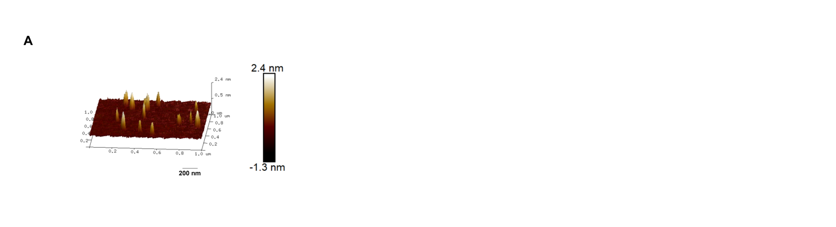
Figure S1. (A) 3D AFM image of BPNs. Scale bar = 200 nm.
Figure S2
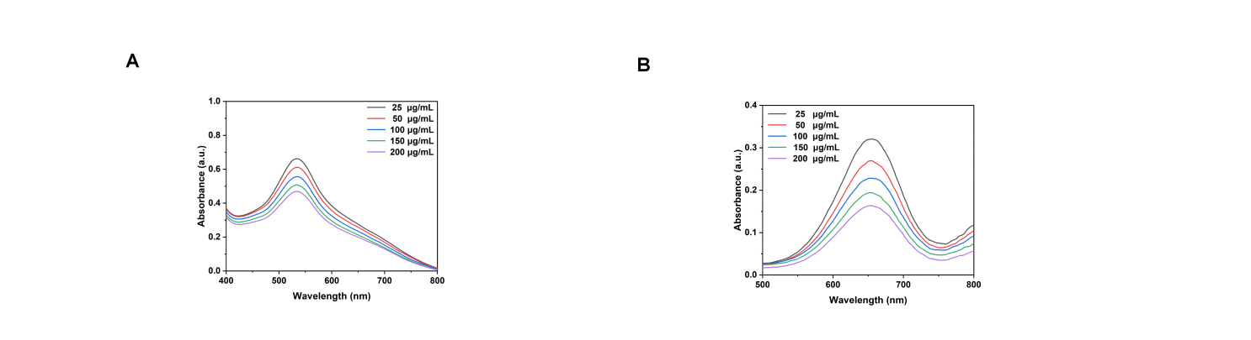
Figure S2. (A) UV-Vis absorption curves of systems treated with BPNs at various concentrations. (B) UV-Vis absorption curves of BPNs-incubated systems at various concentrations.
Figure S3
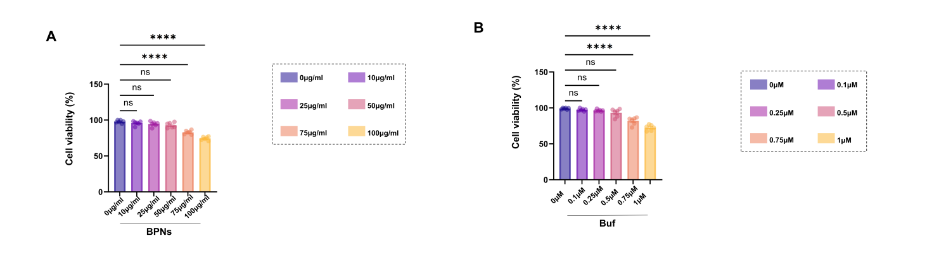
Figure S3. (A) CCK-8 cell viability of H9C2 cardiomyocytes incubated with gradient concentrations of BPNs for 24 h (n = 6). (B) CCK-8 cell viability of H9C2 cardiomyocytes treated with serial concentrations of bufalin for 24 h (n = 6). Statistical analysis was performed via one-way ANOVA with Tukey’s multiple comparison test. All data are expressed as mean ± SD; *p < 0.05, **p < 0.01, ***p < 0.001, ****p < 0.0001, n.s. = no significant difference (p > 0.05).
Figure S4
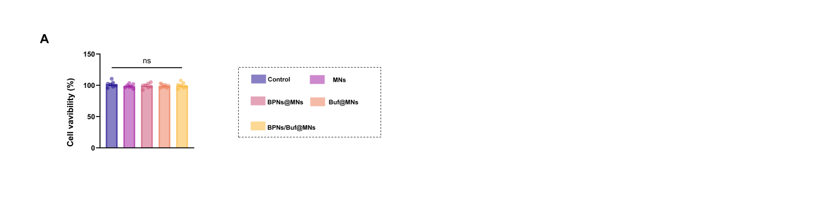
Figure S4. (A) Relative cell viability of H9C2 after incubation with extracts derived from blank MNs, BPNs@MNs, Buf@MNs and BPNs/Buf@MNs for 24 h (n = 6). Statistical analysis was performed via one-way ANOVA with Tukey’s multiple comparison test. All data are expressed as mean ± SD; *p < 0.05, **p < 0.01, ***p < 0.001, ****p < 0.0001, ns = no significant difference (p > 0.05).
Figure S5
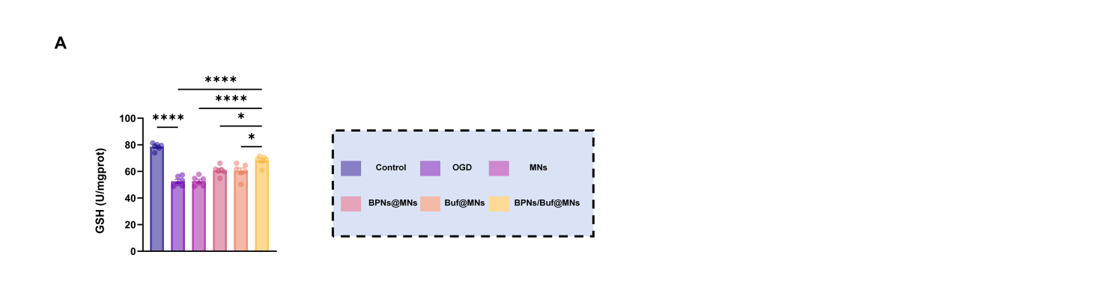
Figure S5. (A) ELISA quantitative detection of intracellular SOD activity and MDA content in H9C2 cells (n = 6). All data are expressed as mean ± SD; *p < 0.05, **p < 0.01, ***p < 0.001, ****p < 0.0001, ns = no significant difference (p > 0.05).
Figure S6
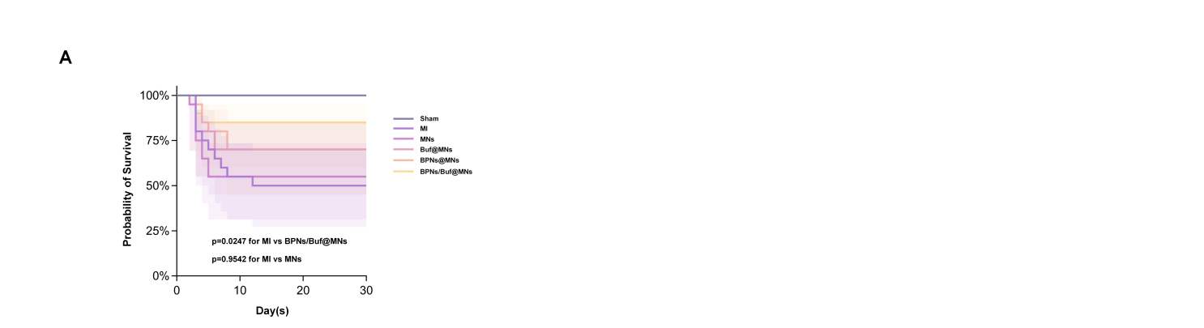
Figure S6. (A) Kaplan-Meier survival curves of MI mice within 28 days after different treatments (n=30). Log-rank test was used for survival statistical analysis.

Figure S7
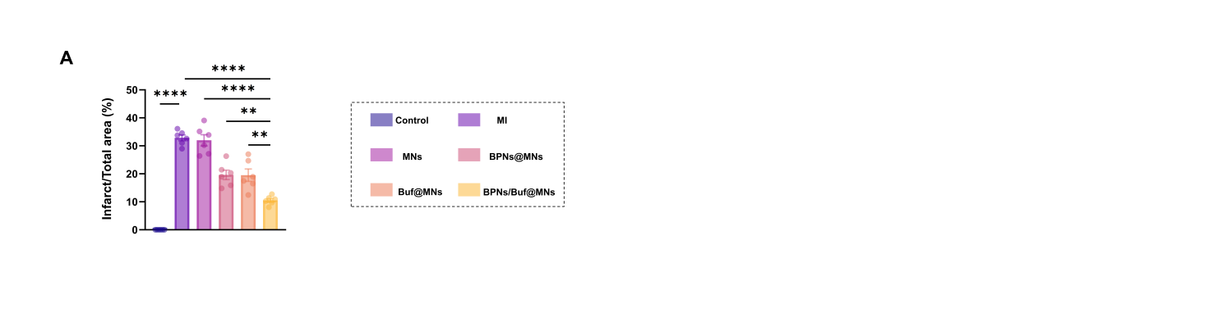
Figure S7. (A) Quantitative statistical analysis of infarct size based on TTC staining in Fig. 5B (n=6). Statistical analysis was performed via one-way ANOVA with Tukey’s multiple comparison test. All data are expressed as mean ± SD; *p < 0.05, **p < 0.01, ***p < 0.001, ****p < 0.0001, n.s. = no significant difference (p > 0.05).
Figure S8
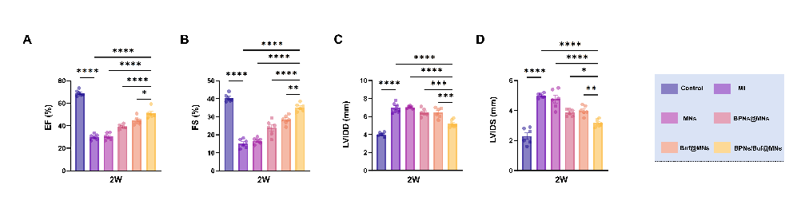
Figure S8. Quantitative statistical analysis of week 2 echocardiographic parameters derived from echocardiography images in Fig. 5C, including EF (A), FS (B), LVIDD (C) and LVIDS (D) (n=6). Statistical analysis was performed via one-way ANOVA with Tukey’s multiple comparison test. All data are expressed as mean ± SD; *p < 0.05, **p < 0.01, ***p < 0.001, ****p < 0.0001, ns = no significant difference (p > 0.05).

Figure S9
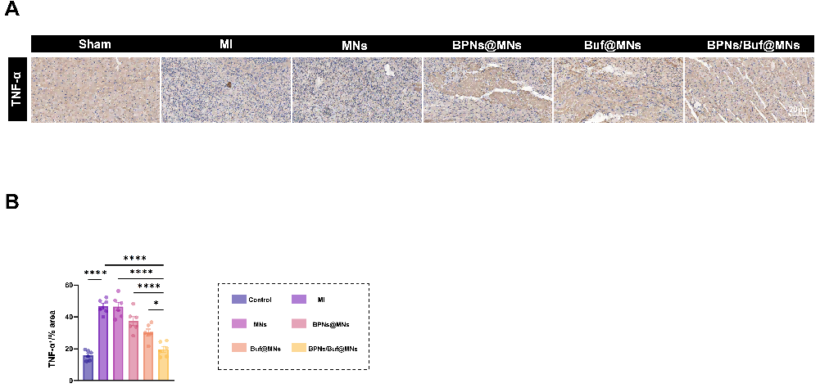
Figure S9. (A) Representative immunohistochemical staining images of pro-inflammatory cytokine TNF-α in myocardial border tissues at day 3 post-MI. Scale bar = 50 μm. (B) Quantitative statistical analysis of TNF-α positive expression intensity based on (A) (n = 6). Statistical analysis was performed via one-way ANOVA with Tukey’s multiple comparison test. All data are expressed as mean ± SD; *p < 0.05, **p < 0.01, ***p < 0.001, ****p < 0.0001, ns = no significant difference (p > 0.05)
Figure S10
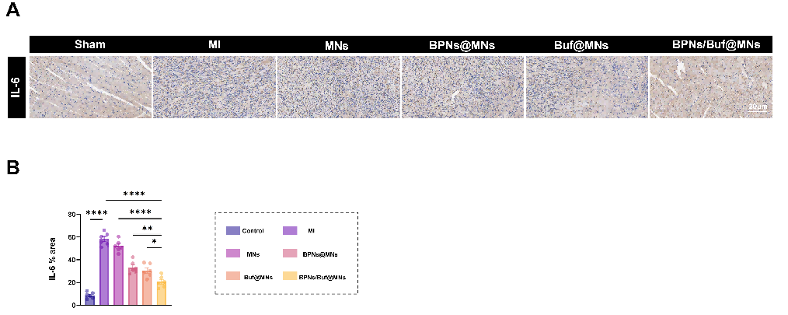
Figure S10. (A) Representative immunohistochemical staining images of pro-inflammatory cytokine IL-6 in myocardial border tissues at day 3 post-MI. Scale bar = 50 μm. (B) Quantitative statistical analysis of IL-6 positive expression intensity based on (A) (n = 6). Statistical analysis was performed via one-way ANOVA with Tukey’s multiple comparison test. All data are expressed as mean ± SD; *p < 0.05, **p < 0.01, ***p < 0.001, ****p < 0.0001, ns = no significant difference (p > 0.05).
Figure S11
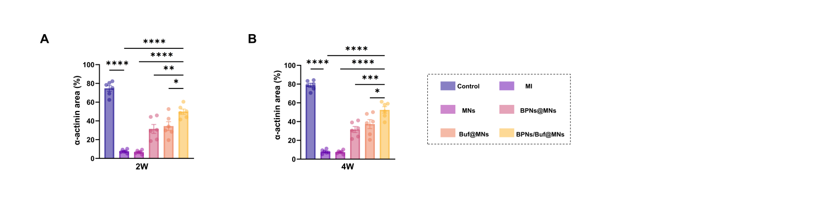
Figure S11. (A) Quantitative statistics of α-actinin fluorescence intensity at week 2 derived from panel (G) (n = 6). (B) Quantitative statistics of α-actinin fluorescence intensity at week 4 derived from panel (G) (n = 6). Statistical analysis was performed via one-way ANOVA with Tukey’s multiple comparison test. All data are expressed as mean ± SD; *p < 0.05, **p < 0.01, ***p < 0.001, ****p < 0.0001, ns = no significant difference (p > 0.05).

