Supplementary
Figure S1. Gating strategy for the identification of alveolar macrophages in mouse lung tissue. Representative flow cytometry plots demonstrating the hierarchical gating strategy used to define and quantify alveolar macrophages (AMs) from murine lung myeloid cell populations using an 8-color antibody panel. (A) Total cells were initially identified based on their size and complexity. (B, C) Doublets were sequentially excluded to isolate single cell populations. (D) Viable cells were identified by gating on the L/D BV510 negative/low population against SSC-A ("Live" gate). (E) Total leukocytes were selected based on the expression of the pan-leukocyte marker CD45 (CD45 APC-Cy7 vs. SSC-A, "CD45⁺" gate). (F) Neutrophils (Ly6G⁺) were separated from the CD45⁺ population, and the remaining Ly6G⁻ non-neutrophil myeloid cells were gated for subsequent analysis (Ly6G percp5.5 vs. CD11b PE-Cy7). (G) Total macrophages were identified within the Ly6G⁻ gating lineage by the co-expression of F4/80 and CD64 (F4/80 BV421 vs. CD64 BV605). (H) Alveolar macrophages (AMs) were finally defined from the macrophage pool as the distinct Siglec-F^{high} CD11b^{low} population (CD11b PE-Cy7 vs. Siglec-F APC).
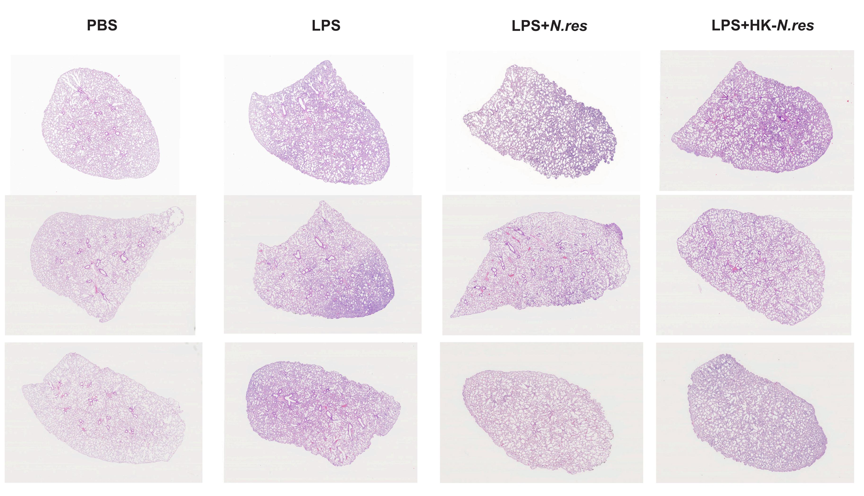
Figure S2. Representative lung histopathology. Representative hematoxylin and eosin (H&E)-stained lung tissue sections from corresponding experimental groups.

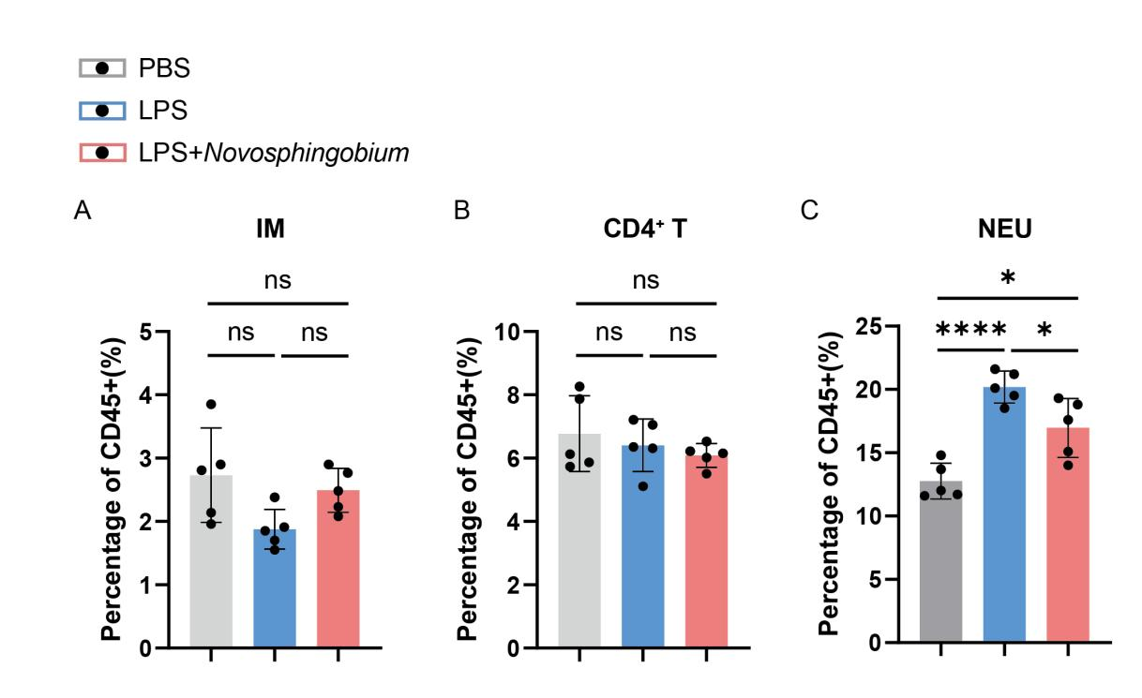
Figure S3. Flow cytometric analysis of pulmonary immune cell populations.
The proportions of various immune cell subsets in lung tissues were determined by flow cytometry following PBS, LPS, or LPS + Novosphingobium treatment. Data are presented as the percentage of total CD45+ leukocytes. (A–B) Infiltration of interstitial macrophages and T cells. (C) Neutrophils

