Supplementary Material
Interpretable task-evoked and resting-state EEG signatures of threat-focused and self-focused processing in high social anxiety
This file contains supplementary EEG result figures, feature-screening diagnostics, model-performance plots and SHAP dependence plots.

Task-evoked ERP and time-frequency results
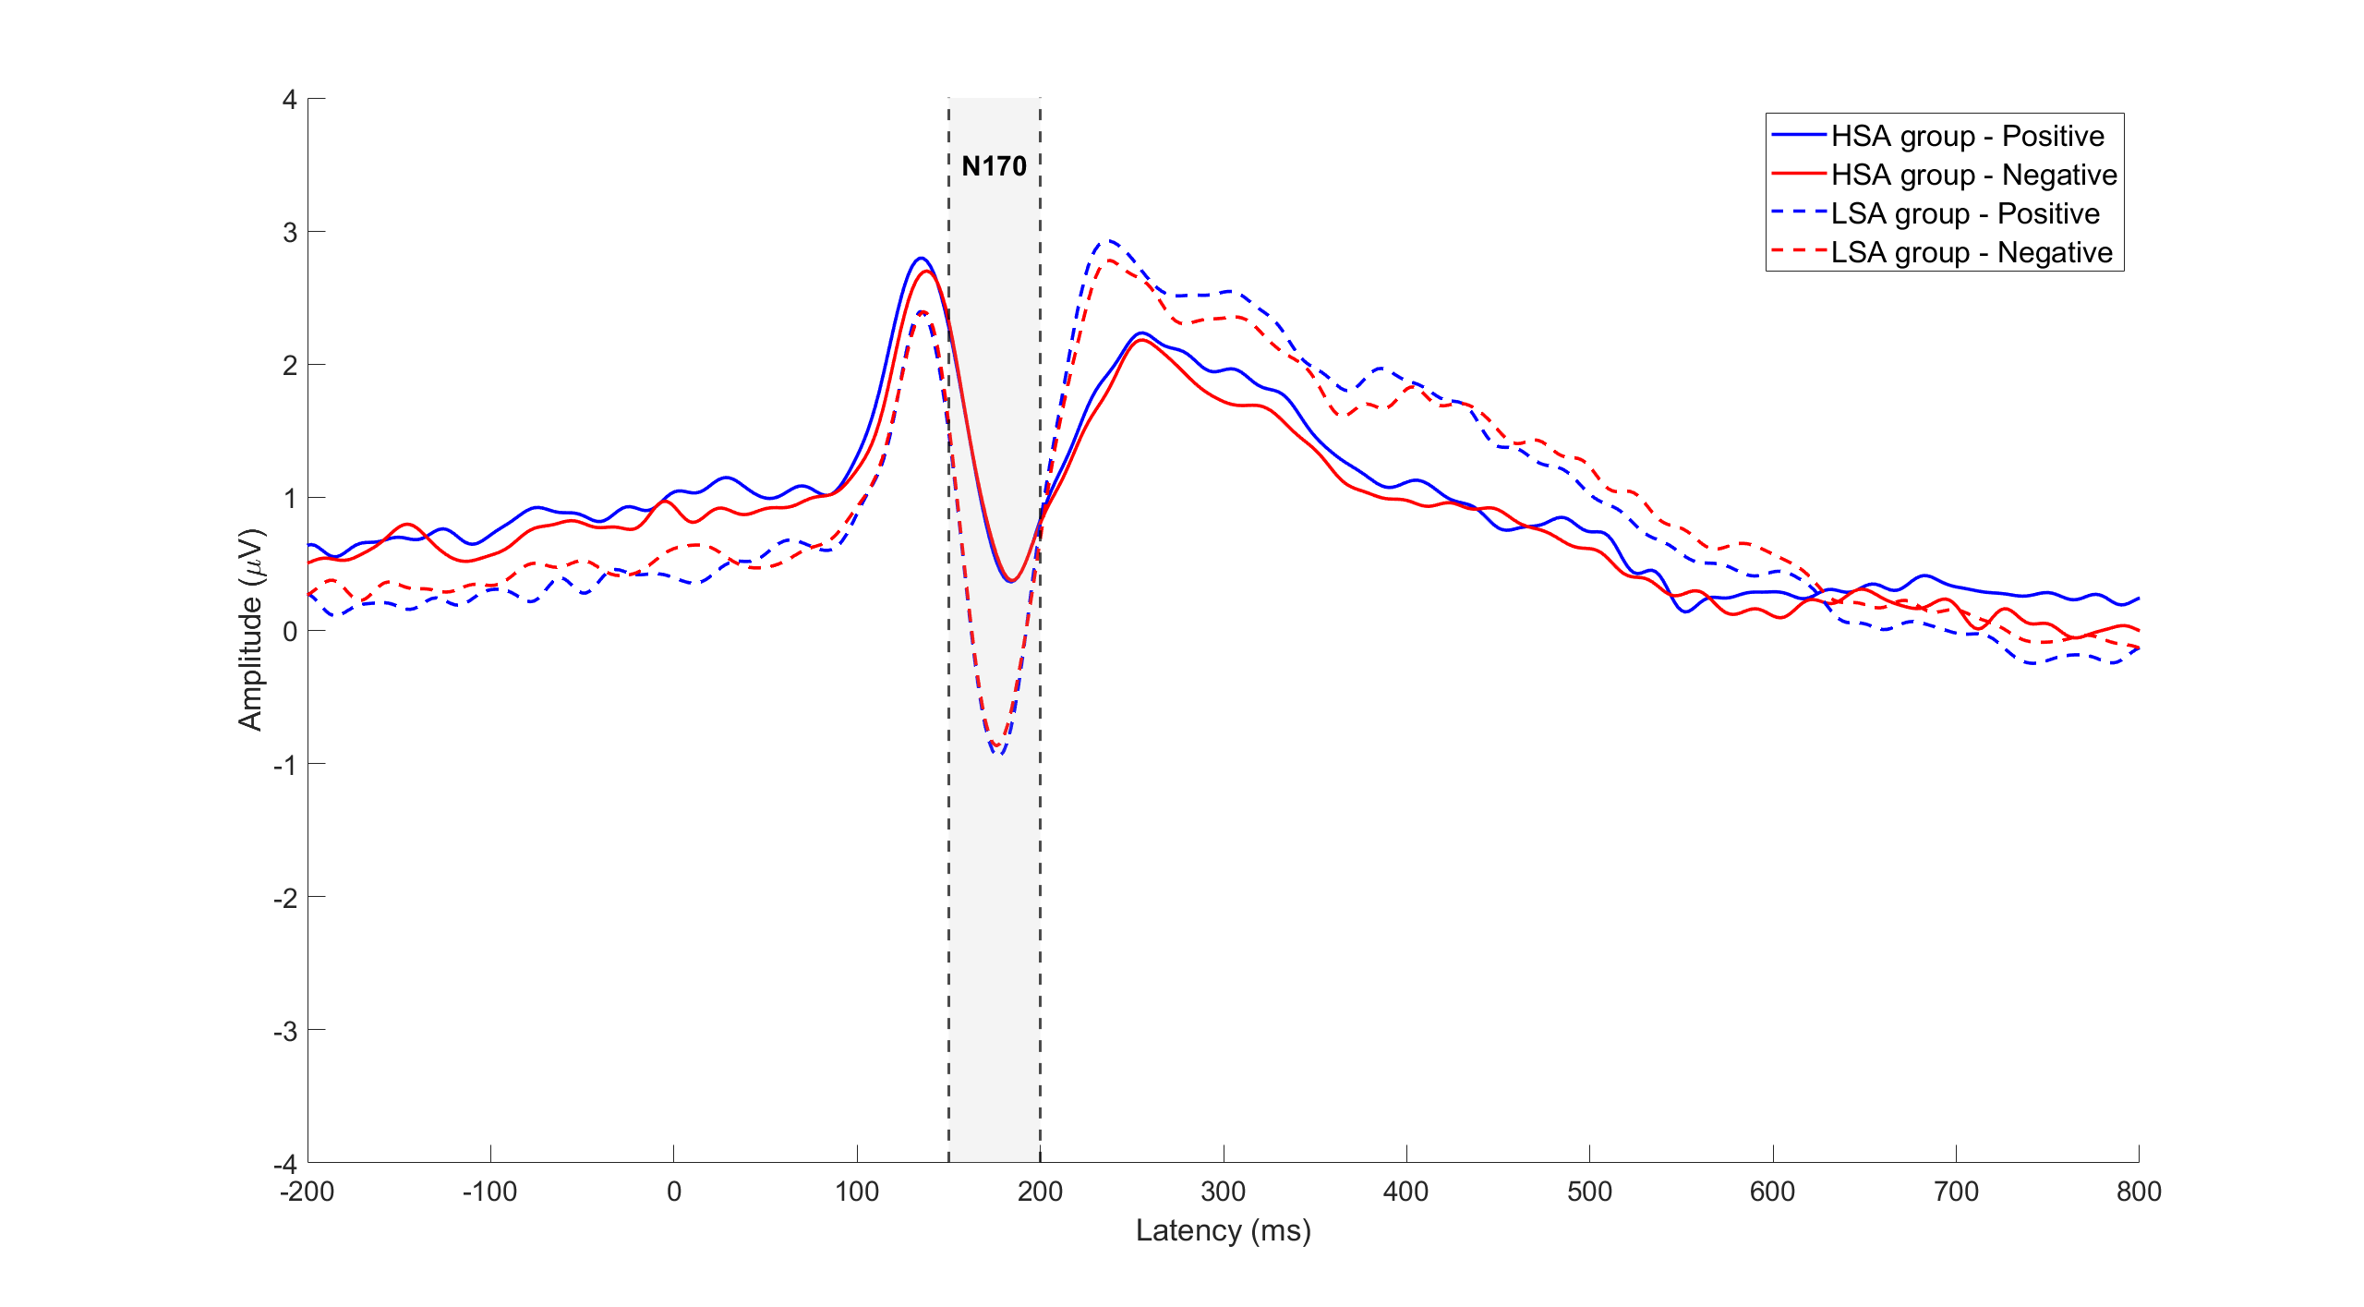
Supplementary Fig. S1. N170 waveform results.

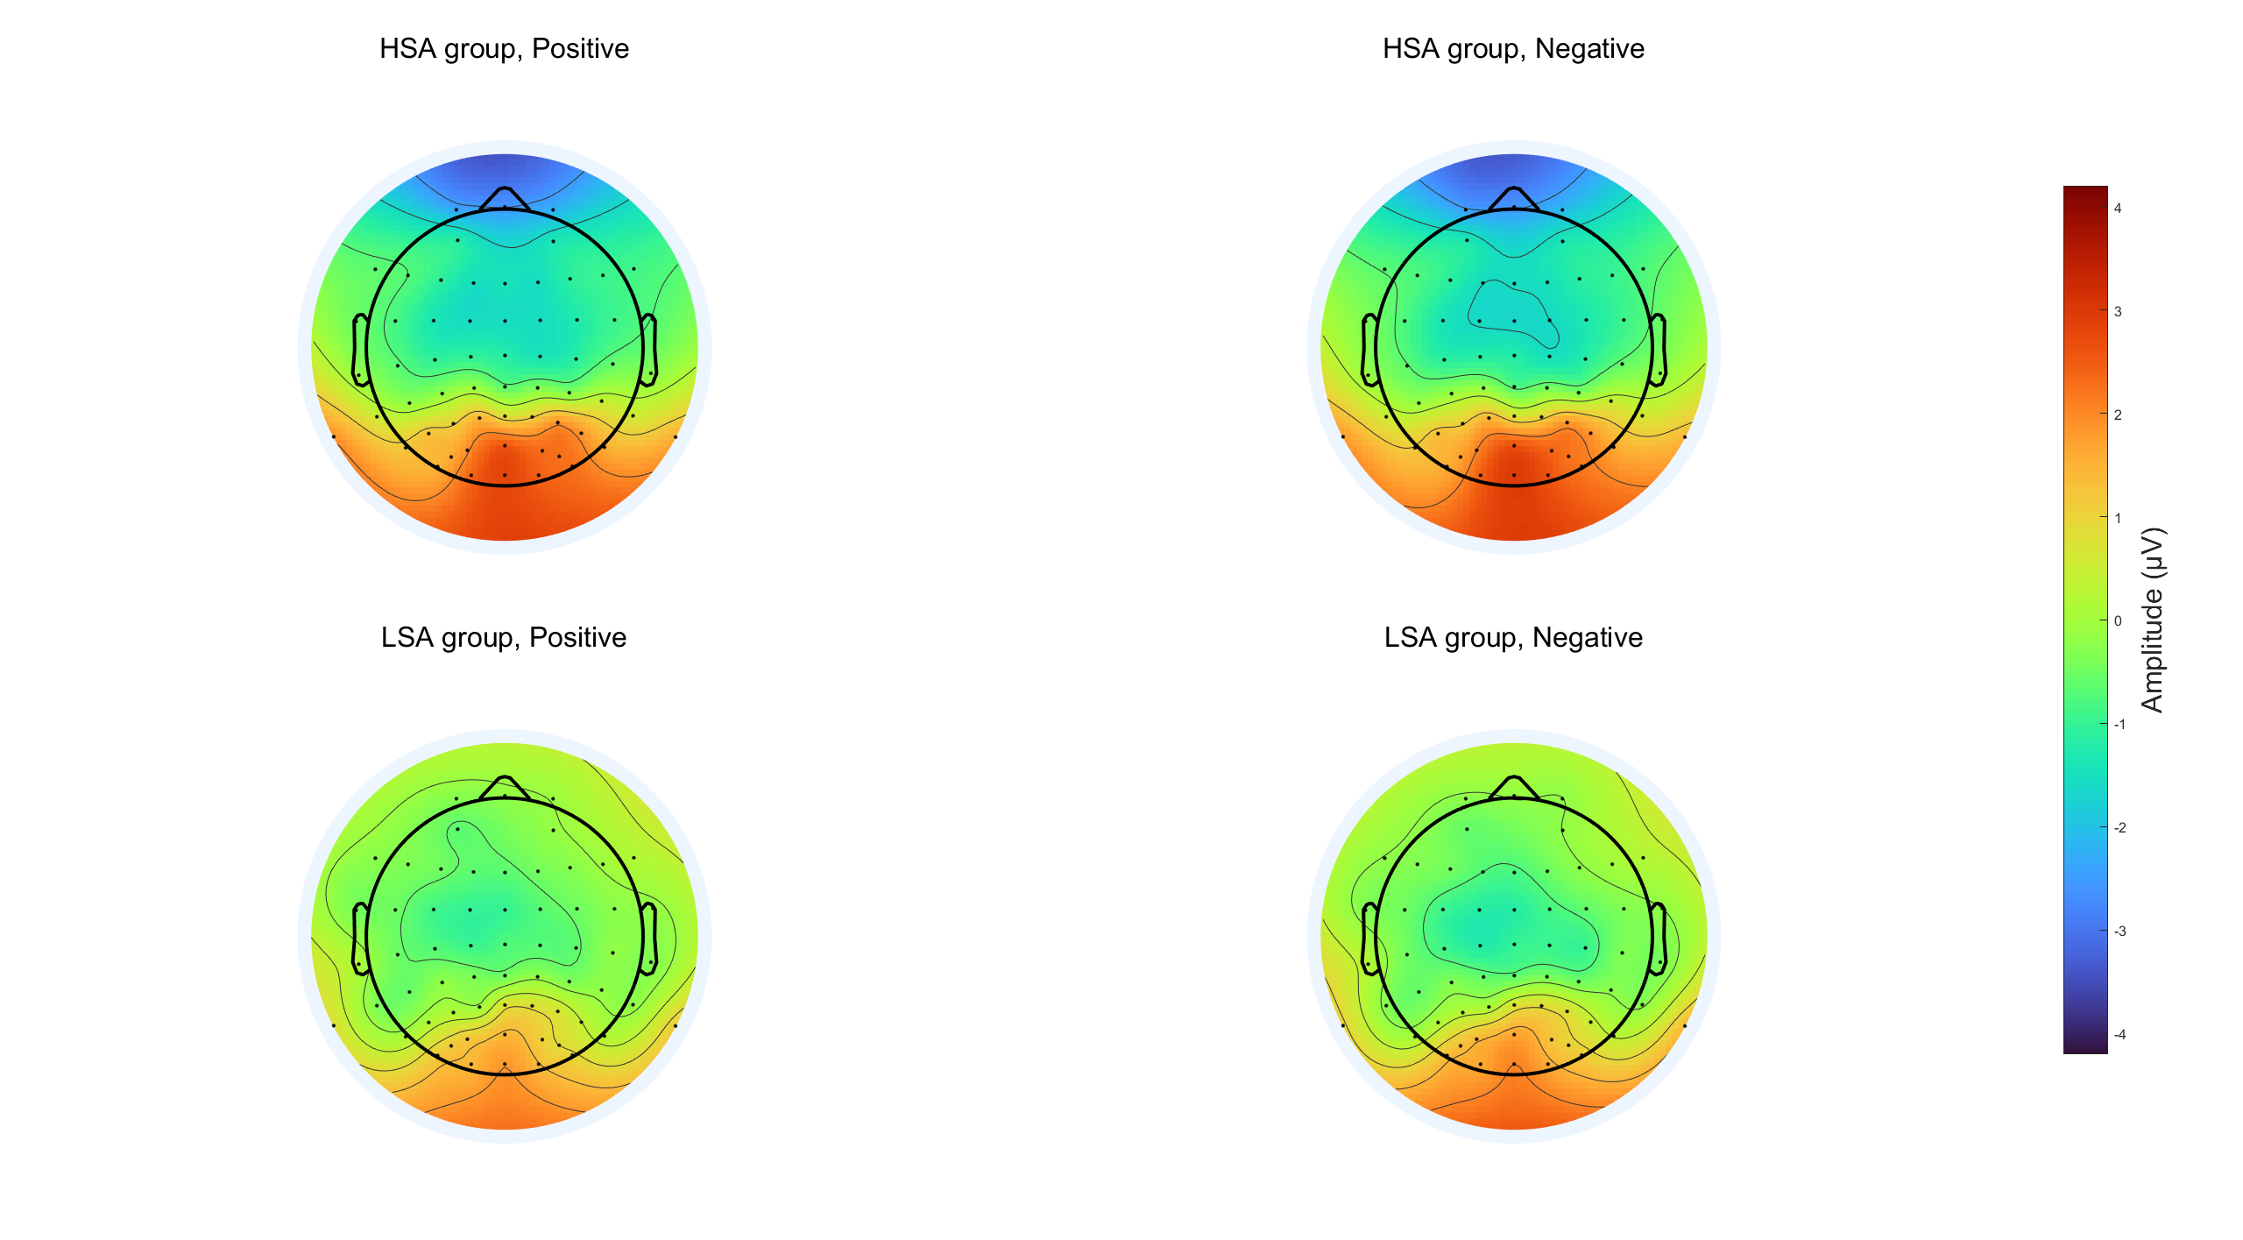
Supplementary Fig. S2. N170 topographic map.

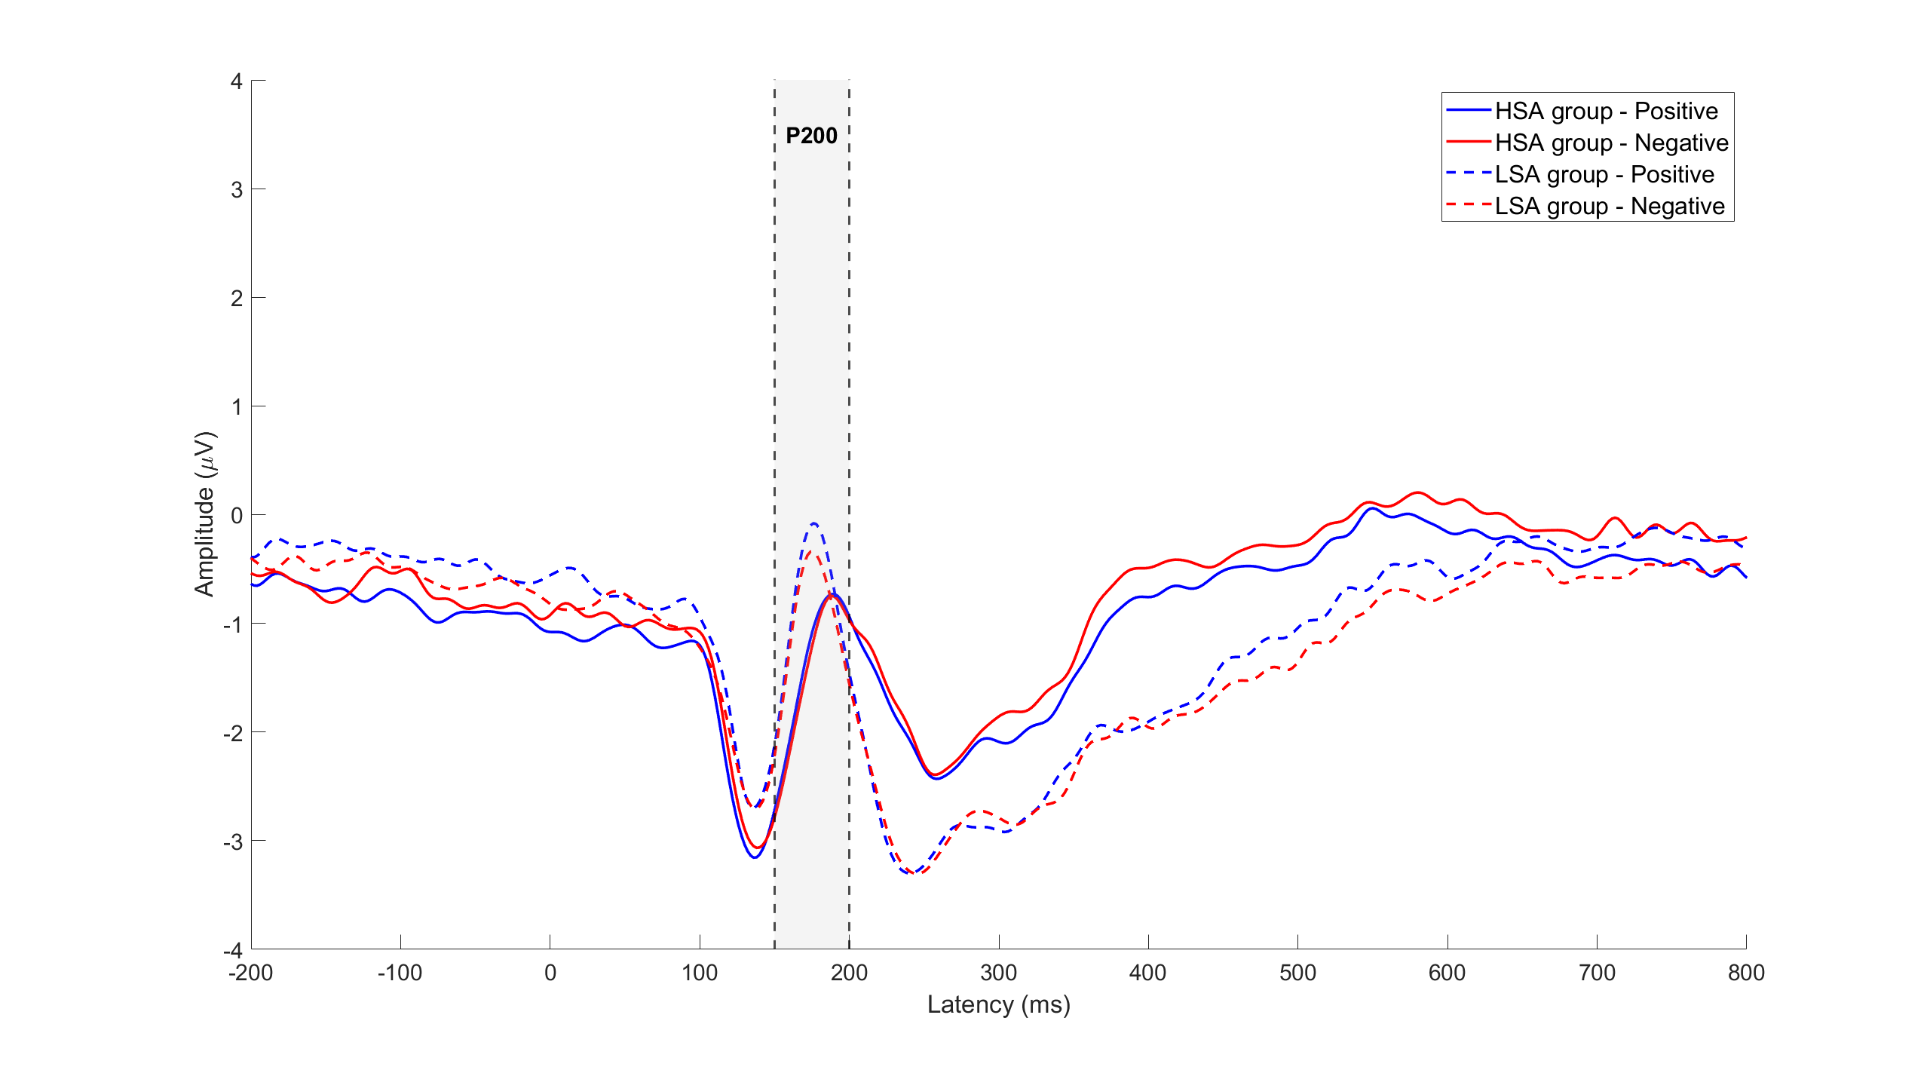
Supplementary Fig. S3. P200 waveform results.

Supplementary Fig. S4. P200 topographic map.

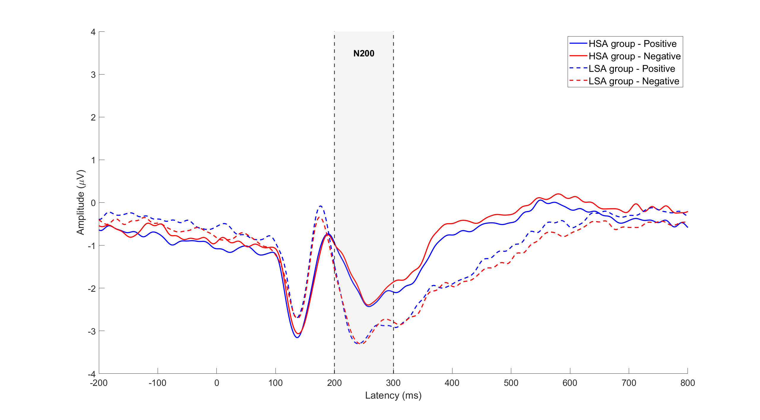
Supplementary Fig. S5. N200 waveform results.

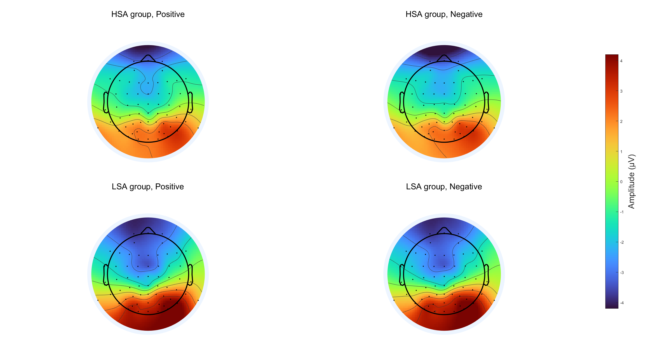
Supplementary Fig. S6. N200 topographic map.

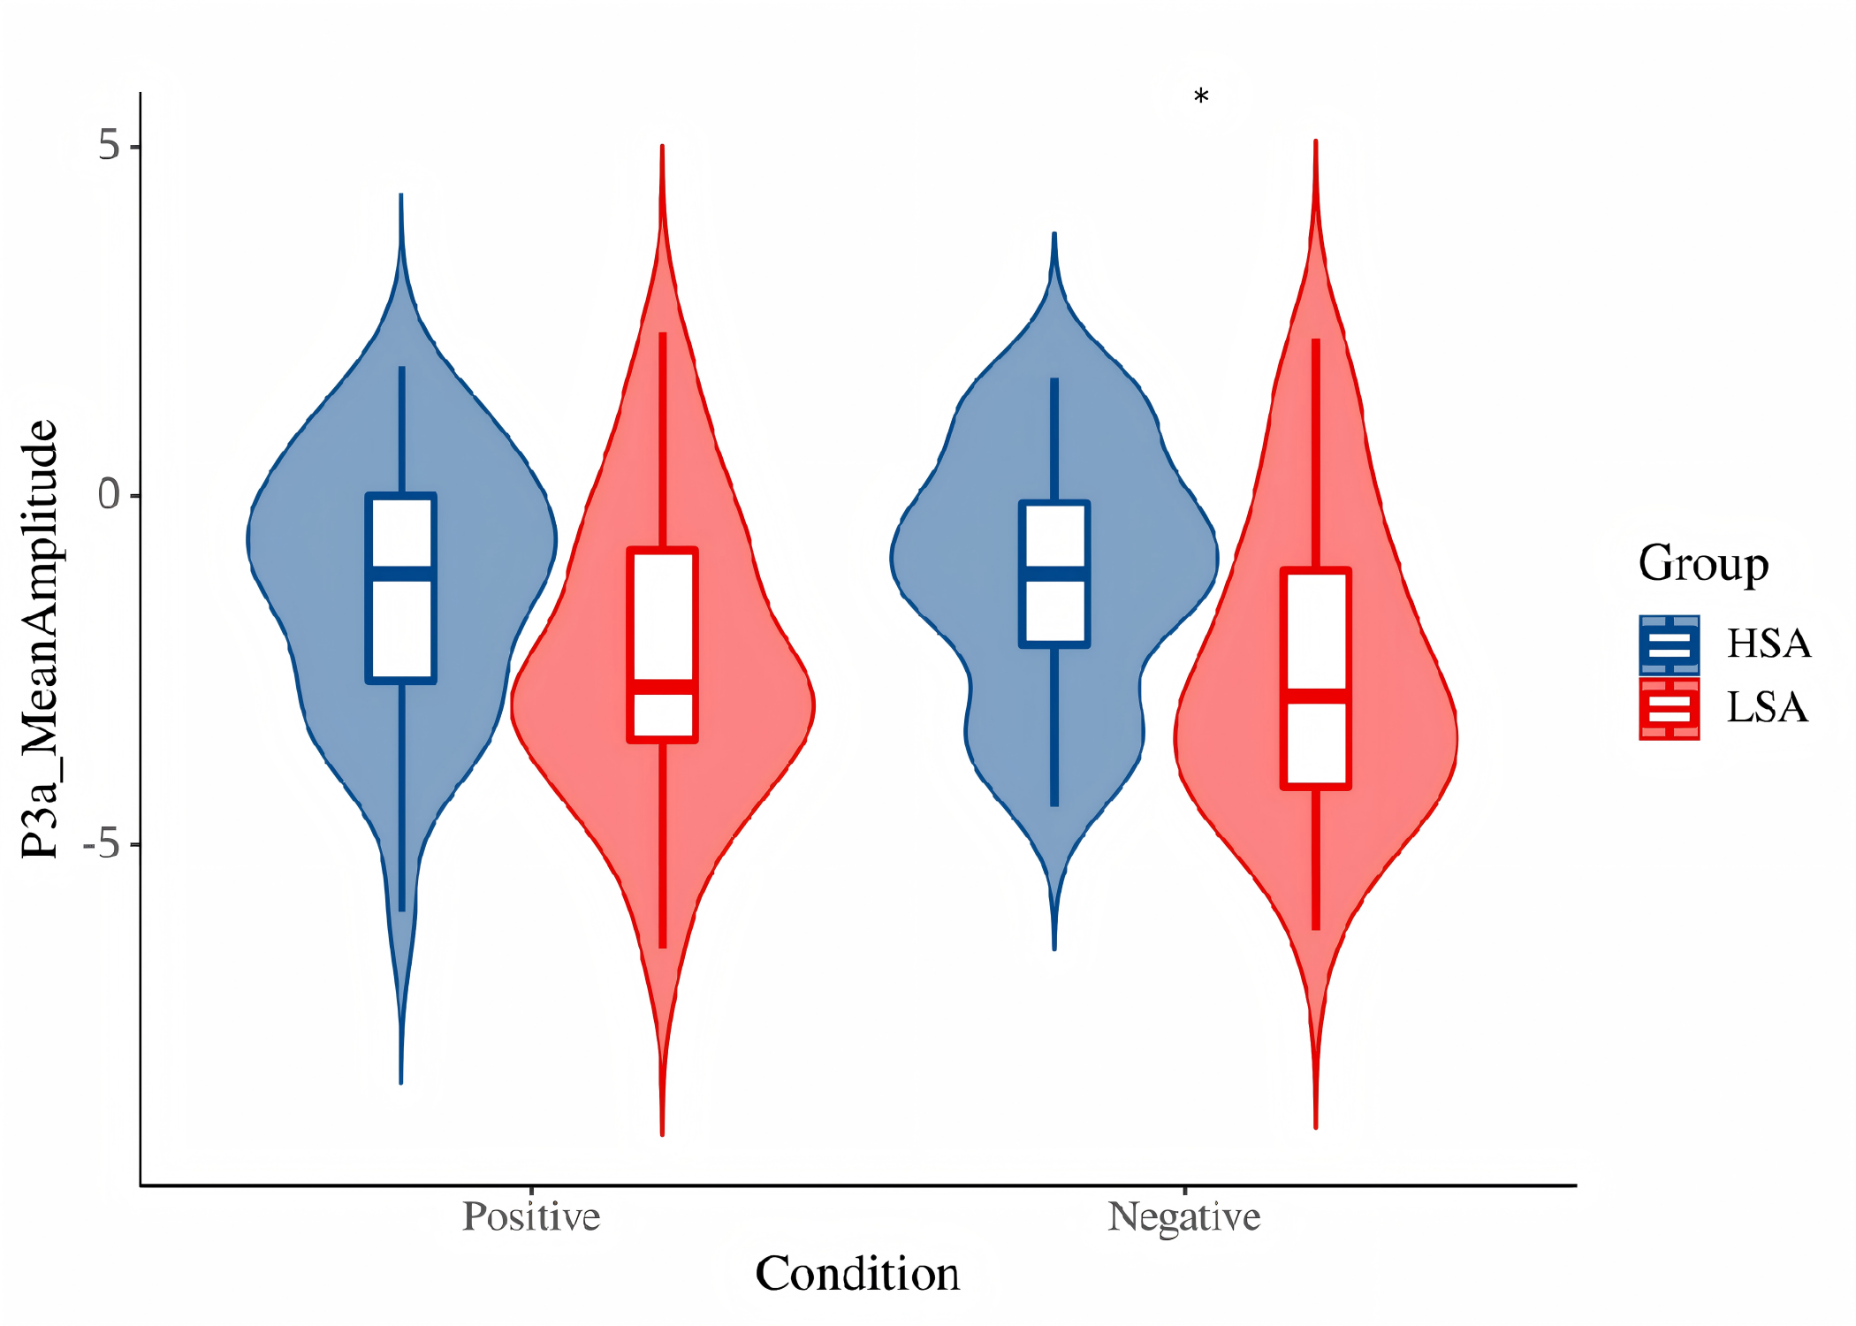
Supplementary Fig. S7. Box-violin plot of P3a mean amplitude.

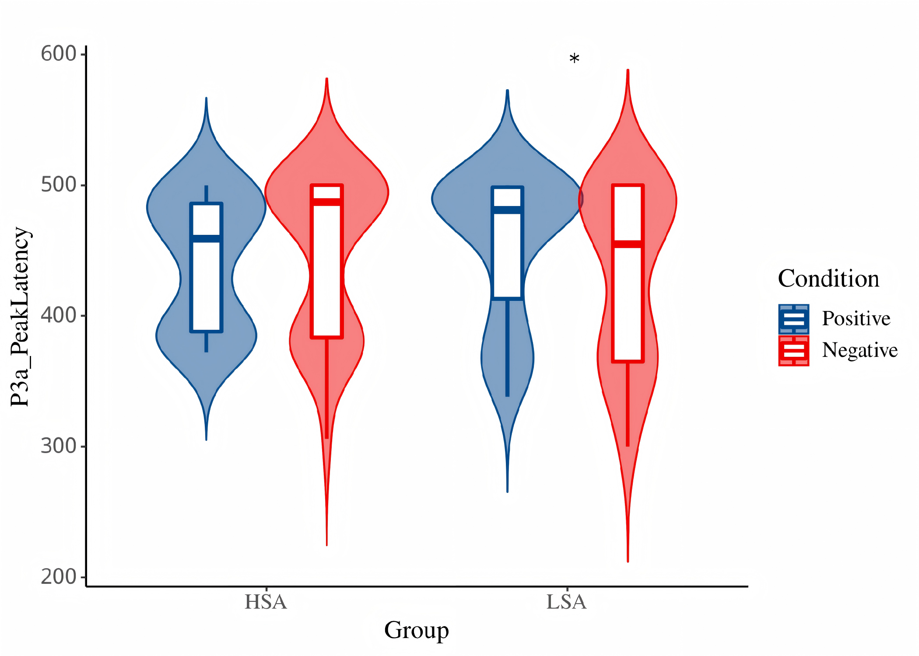
Supplementary Fig. S8. Box-violin plot of P3a latency.

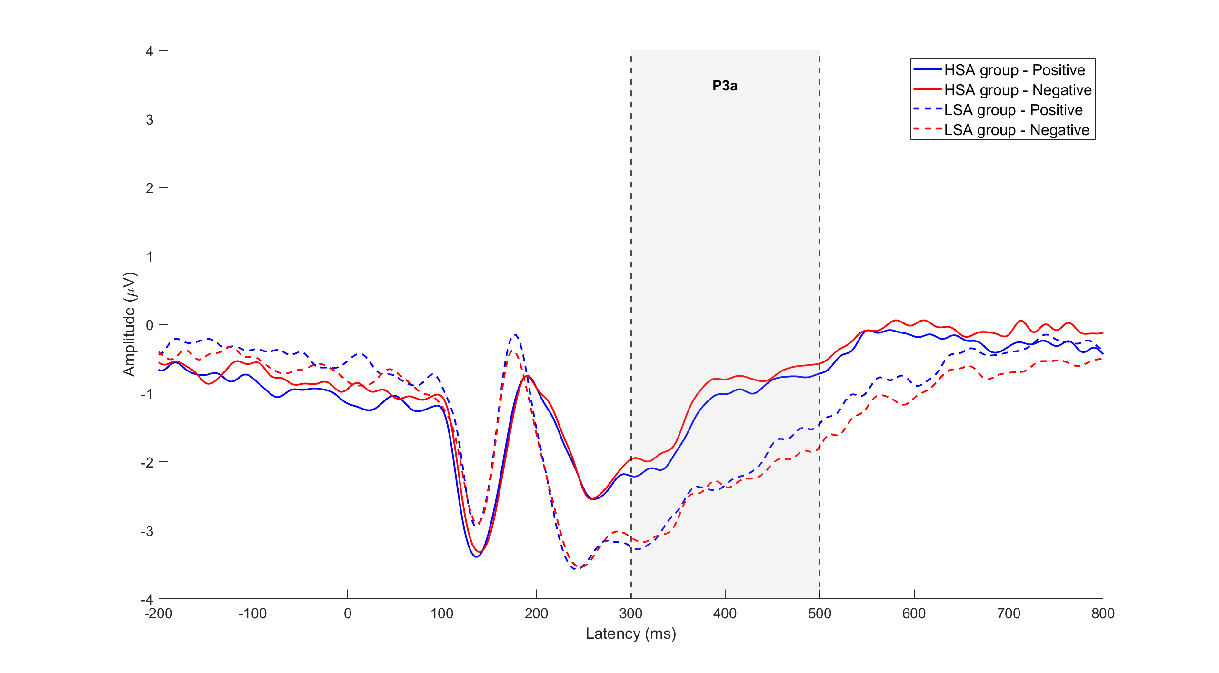
Supplementary Fig. S9. P3a waveform results.

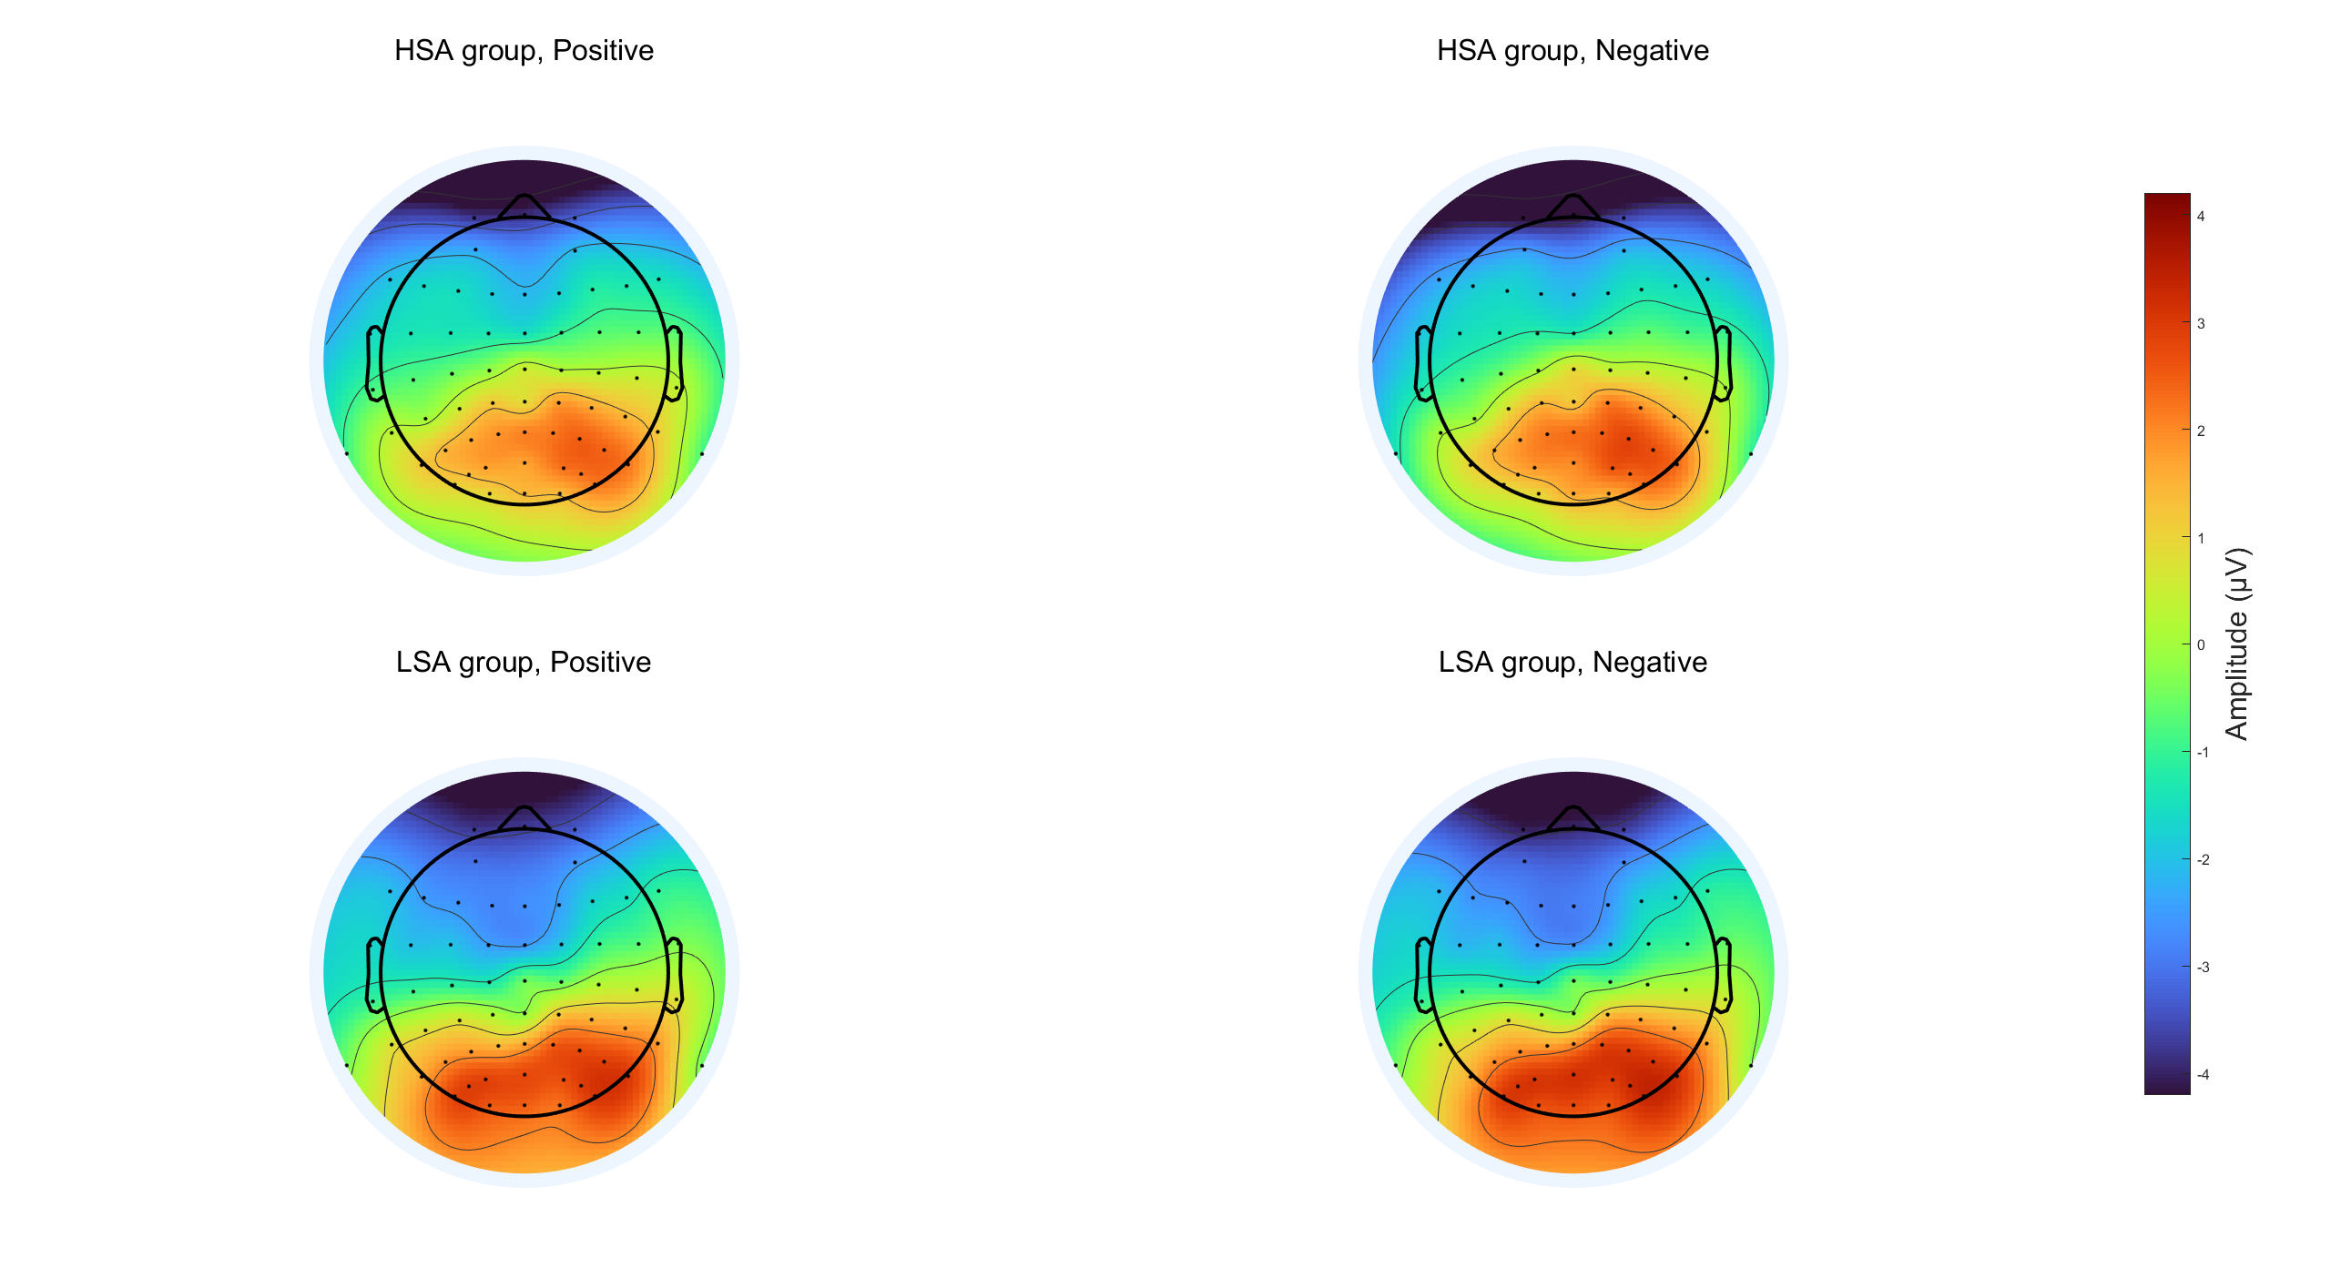
Supplementary Fig. S10. P3a topographic map.

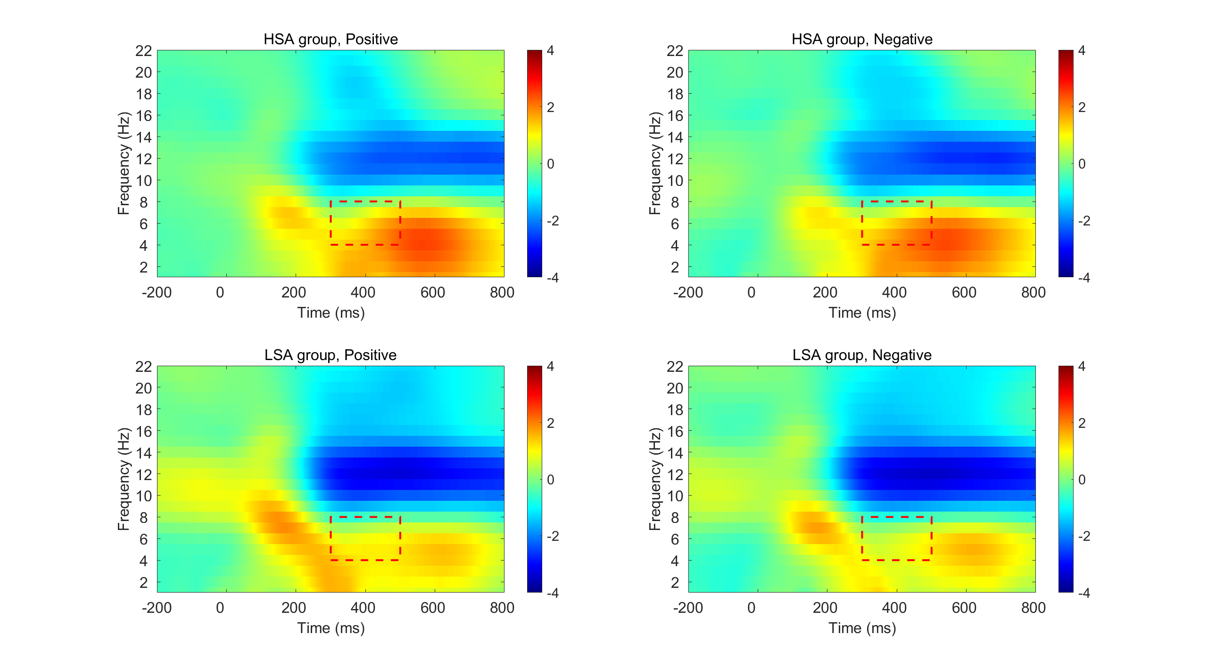
Supplementary Fig. S11. Time-frequency map of theta-band ERS from 300 to 500 ms.

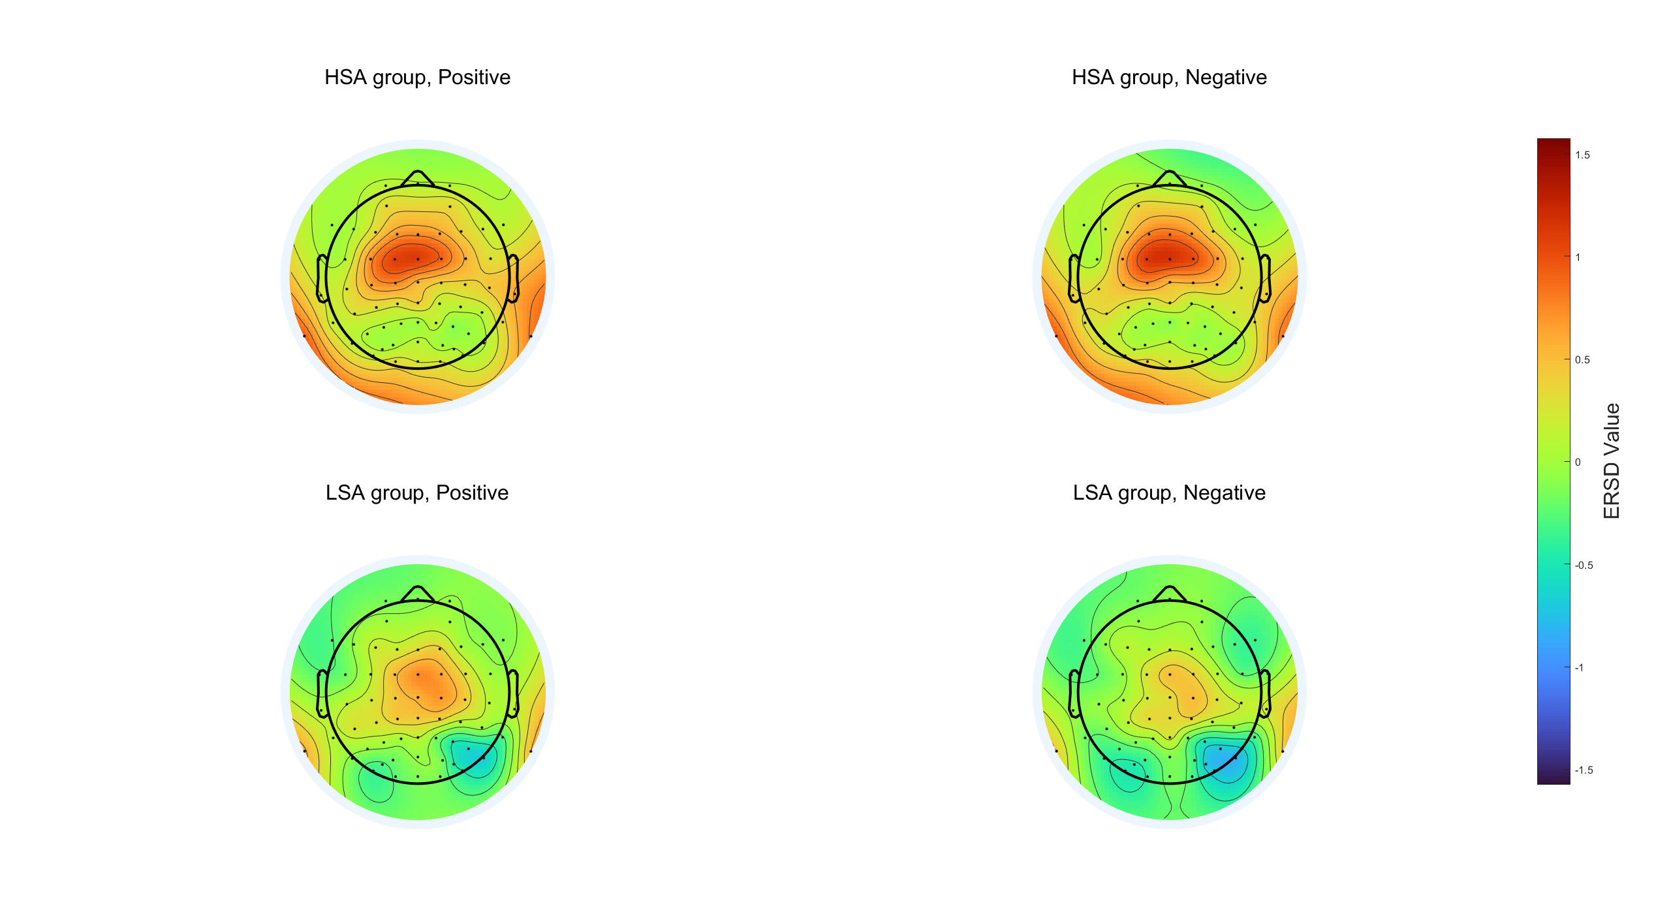
Supplementary Fig. S12. Topographic map of theta-band ERS from 300 to 500 ms.

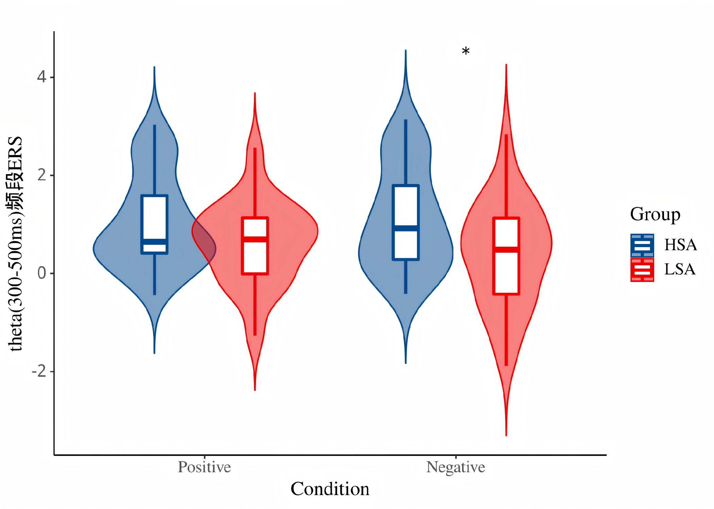
Supplementary Fig. S13. Box-violin plot of theta-band ERS from 300 to 500 ms.

Resting-state microstate results
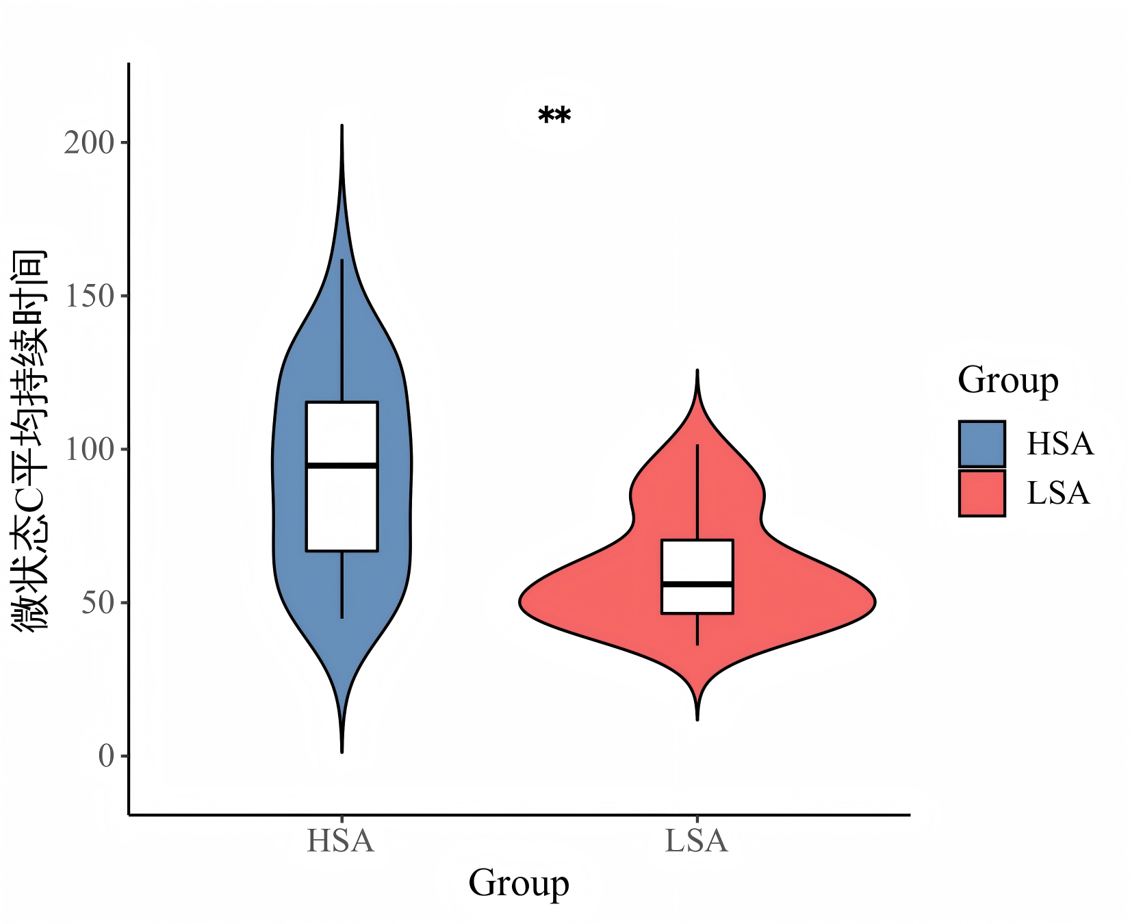
Supplementary Fig. S14. Box-violin plot of mean duration of microstate C.

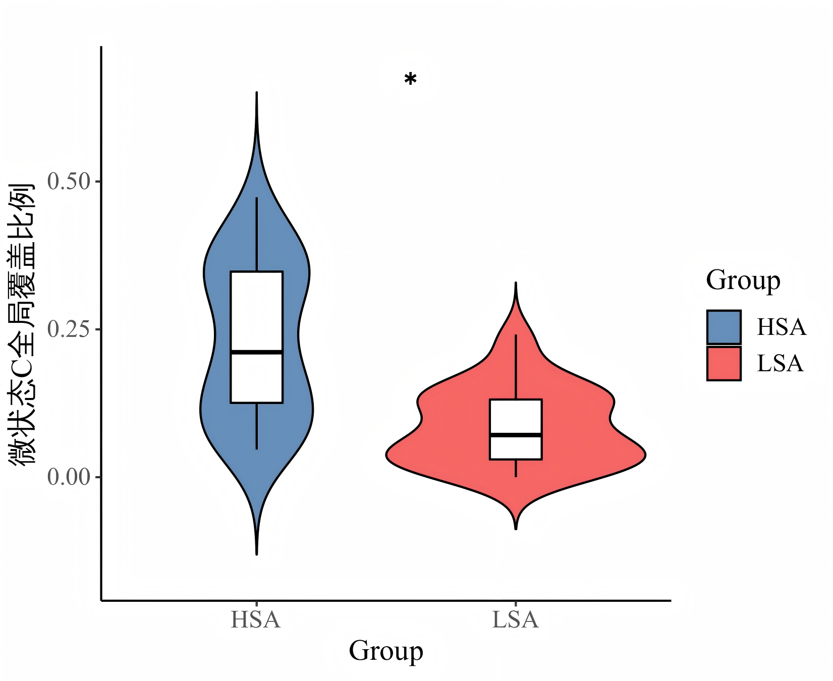
Supplementary Fig. S15. Box-violin plot of global coverage proportion of microstate C.

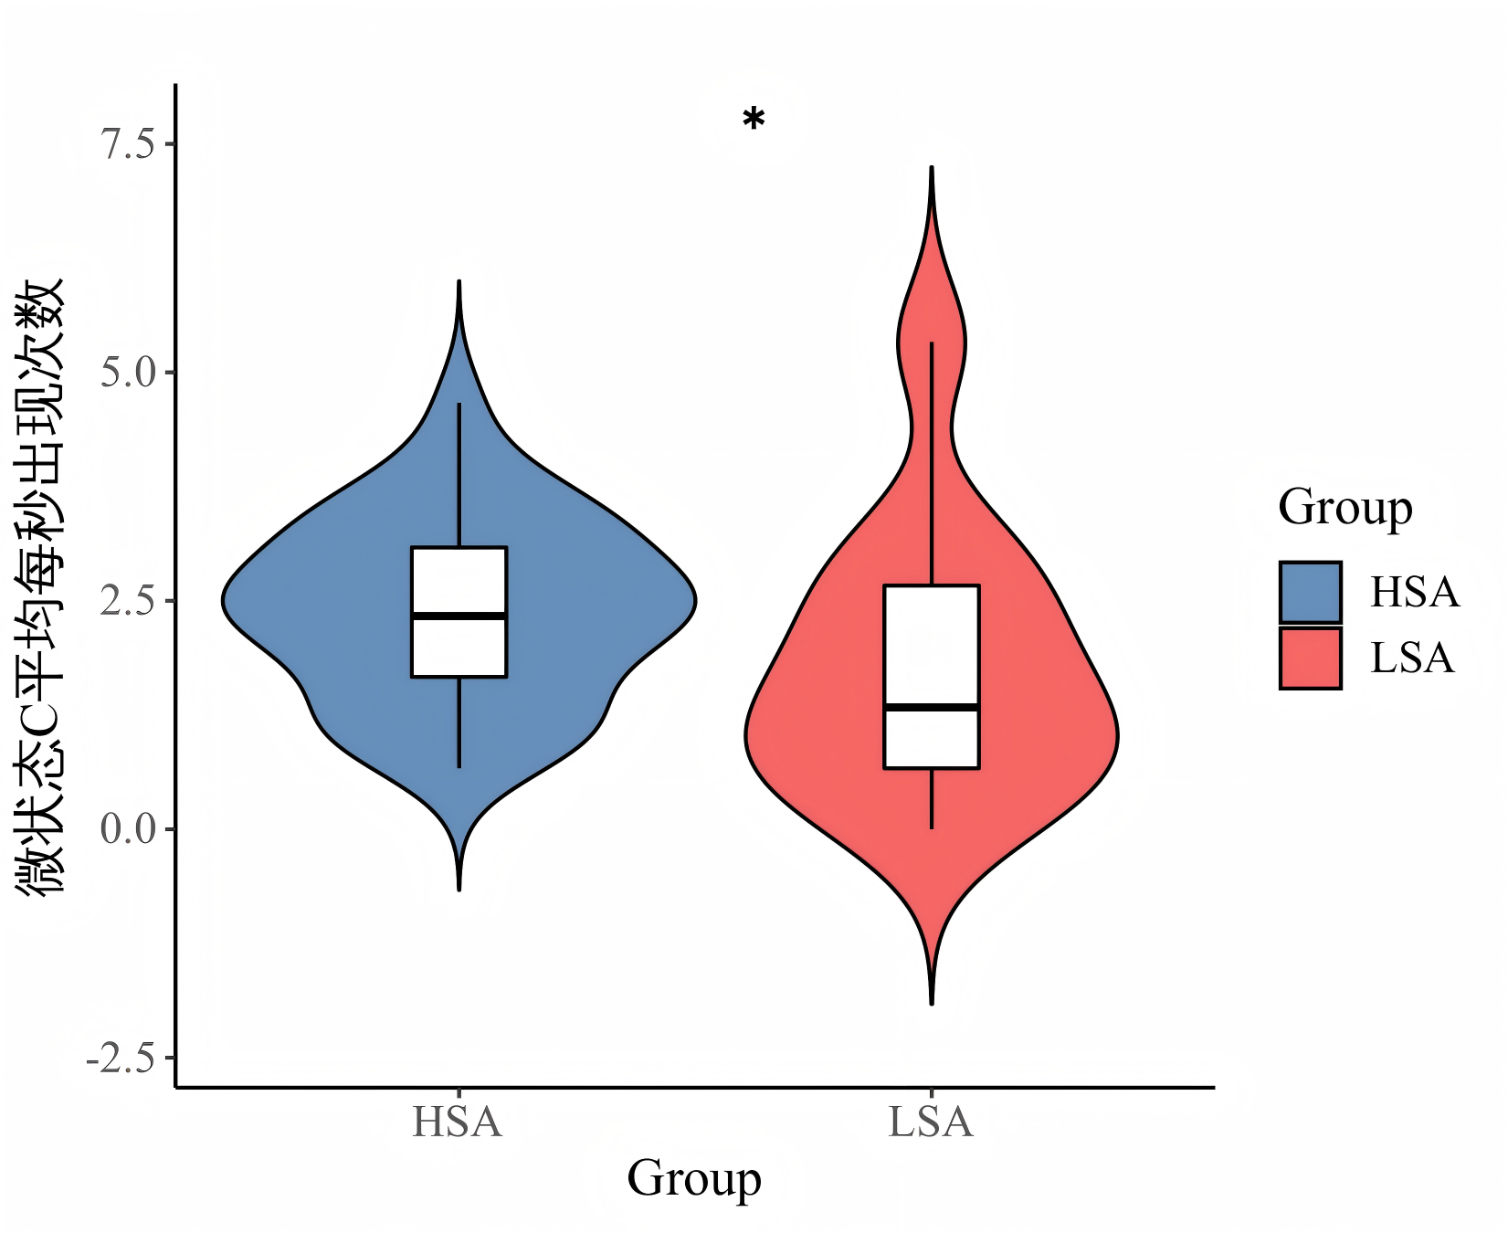
Supplementary Fig. S16. Box-violin plot of occurrence rate per second of microstate C.

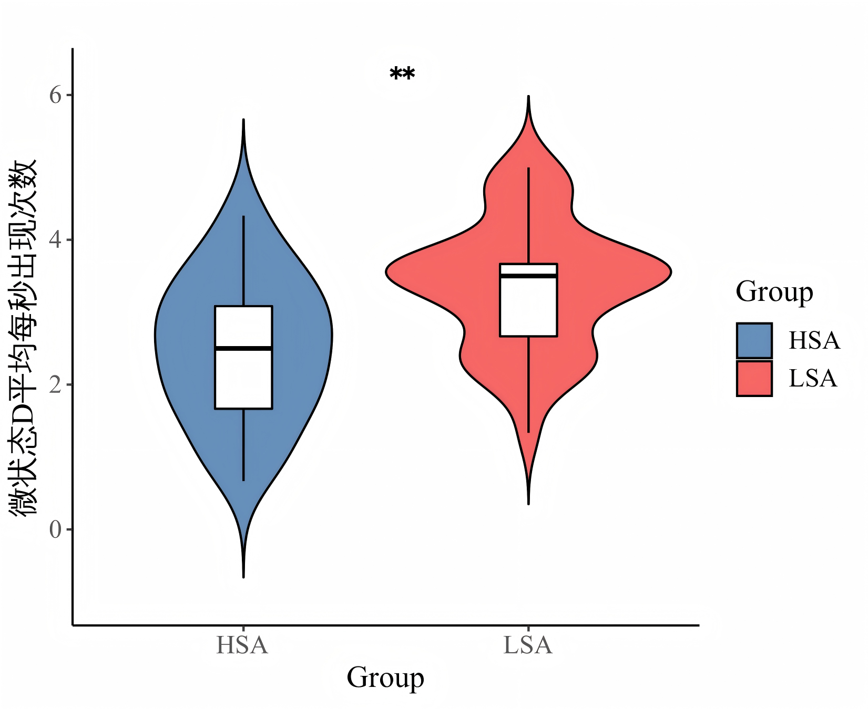
Supplementary Fig. S17. Box-violin plot of mean occurrence rate per second of microstate D.

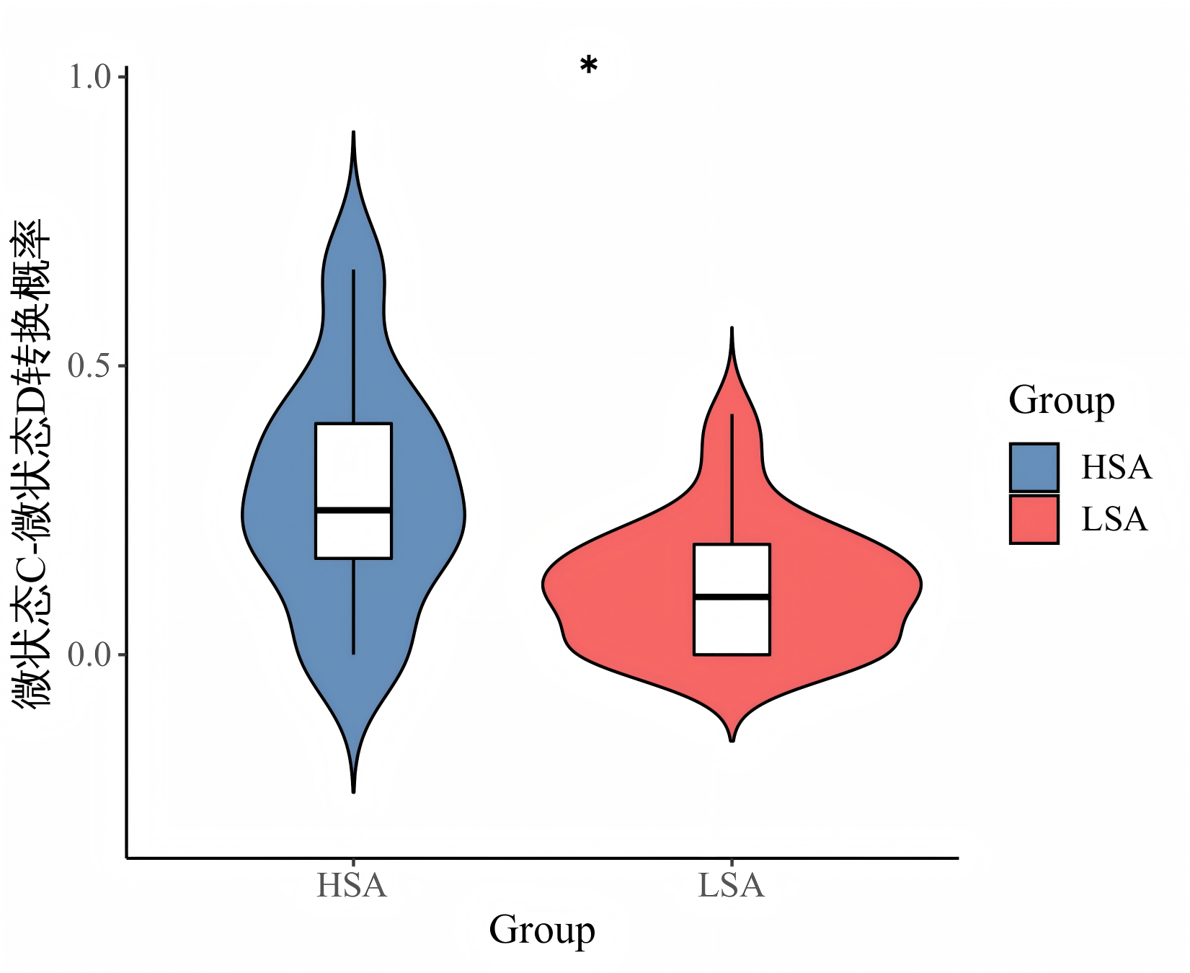
Supplementary Fig. S18. Box-violin plot of transition probability from microstate C to microstate D.

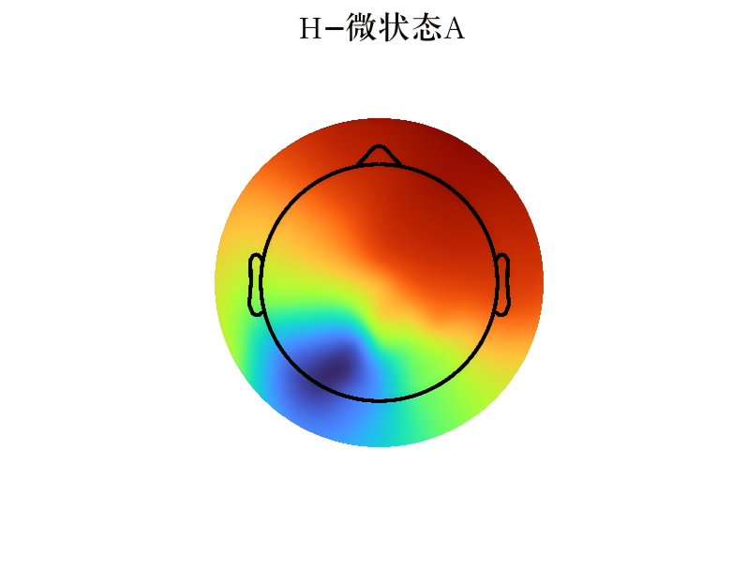
Supplementary Fig. S19. Microstate A topography in the high social anxiety group.

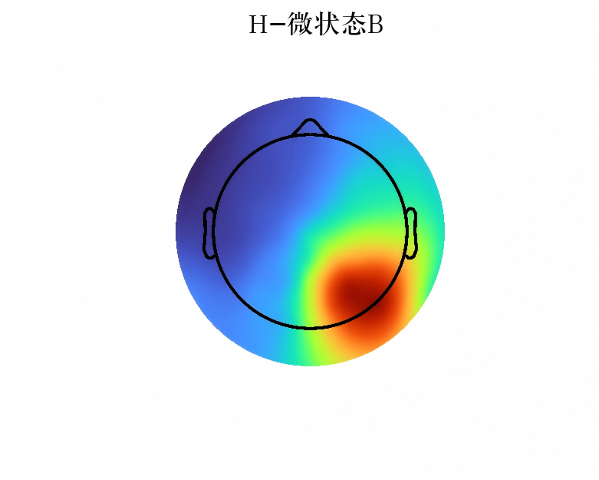
Supplementary Fig. S20. Microstate B topography in the high social anxiety group.

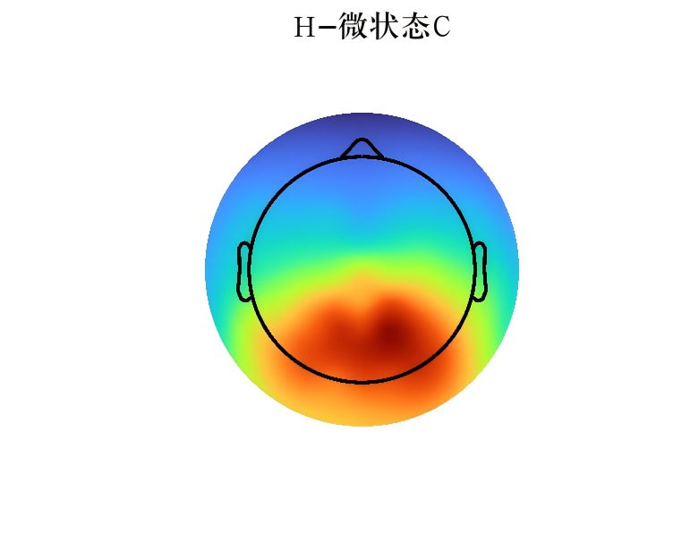
Supplementary Fig. S21. Microstate C topography in the high social anxiety group.

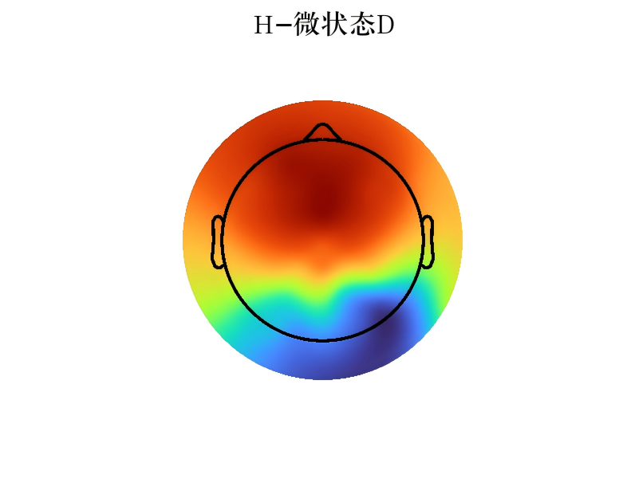
Supplementary Fig. S22. Microstate D topography in the high social anxiety group.

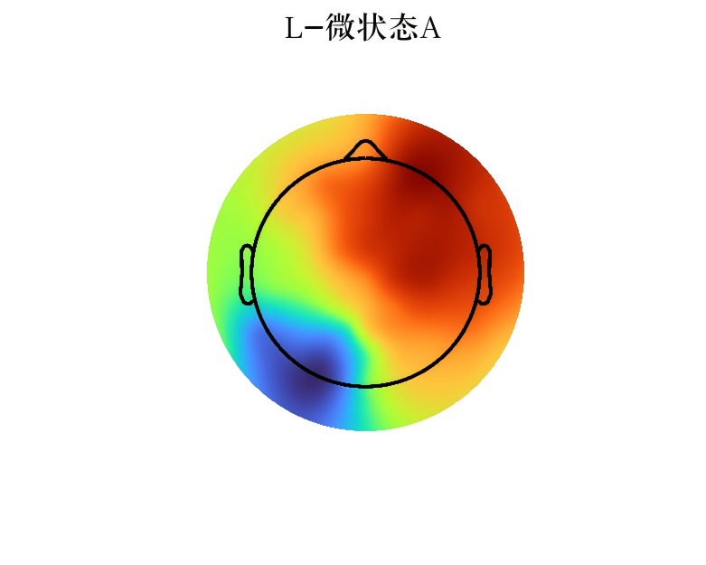
Supplementary Fig. S23. Microstate A topography in the healthy control group.

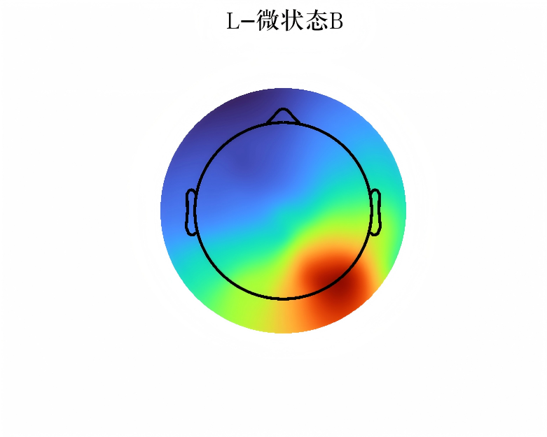
Supplementary Fig. S24. Microstate B topography in the healthy control group.

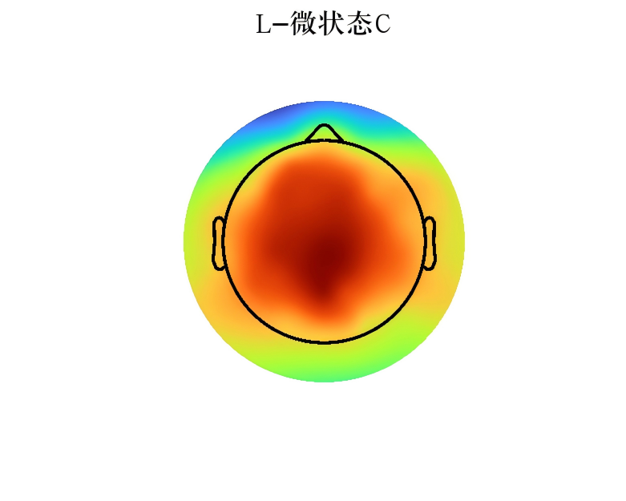
Supplementary Fig. S25. Microstate C topography in the healthy control group.

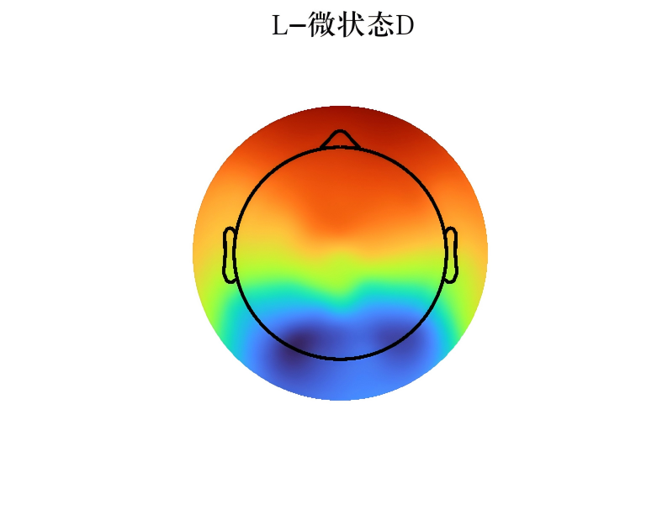
Supplementary Fig. S26. Microstate D topography in the healthy control group.

Resting-state alpha, entropy and network results
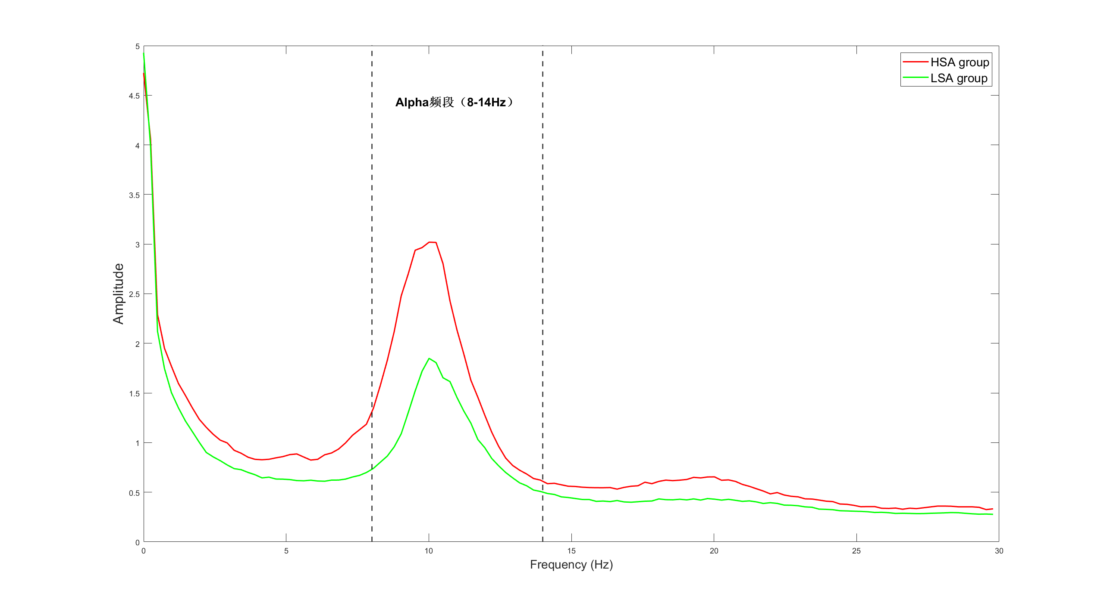
Supplementary Fig. S27. Power map of the alpha band.

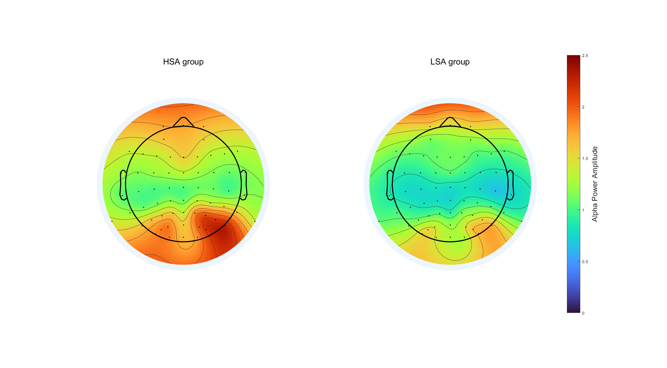
Supplementary Fig. S28. Topographic map of the alpha band.

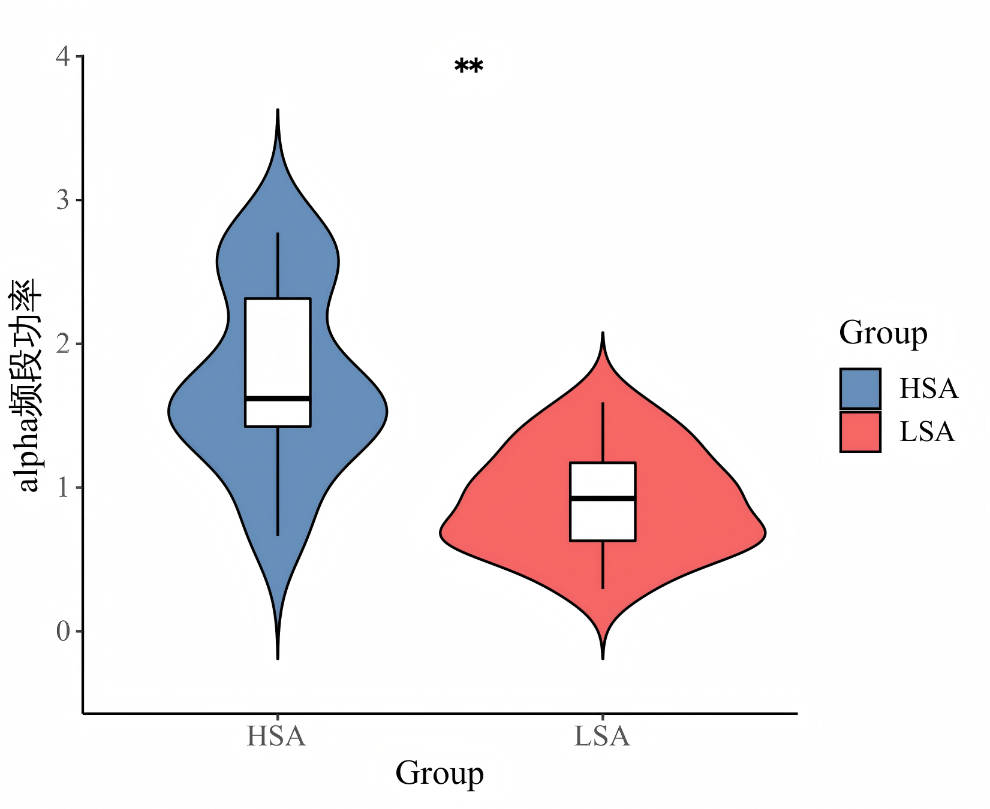
Supplementary Fig. S29. Box-violin plot of alpha-band power.

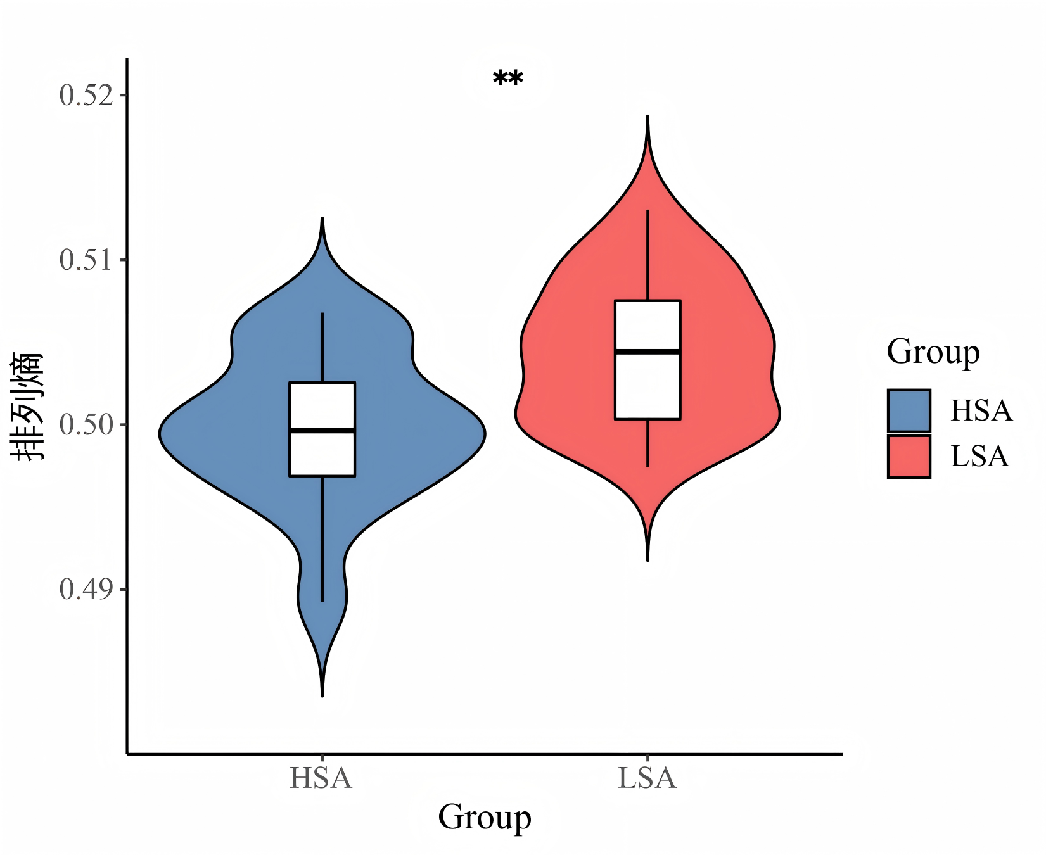
Supplementary Fig. S30. Box-violin plot of permutation entropy in the alpha band.

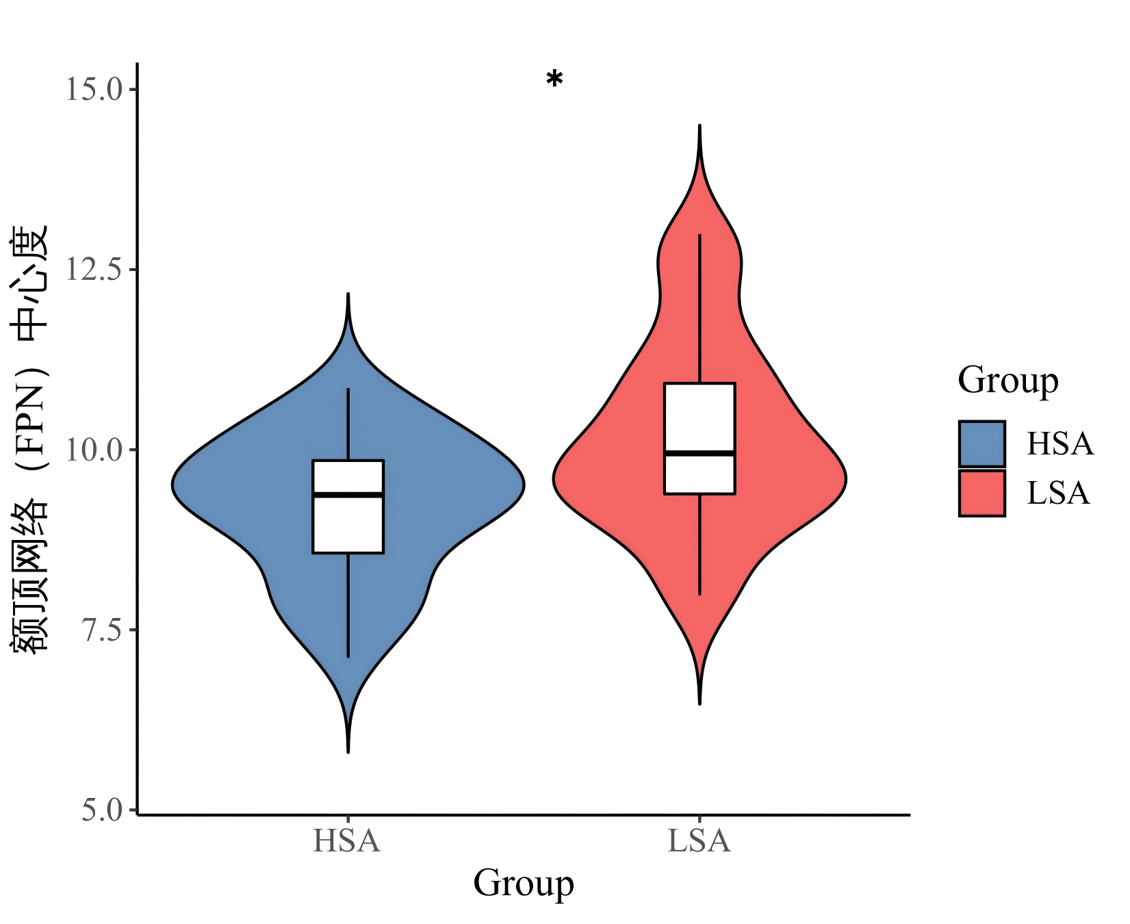
Supplementary Fig. S31. Box-violin plot of frontoparietal network centrality in the alpha band.

Feature-screening diagnostics
Supplementary Fig. S32. Multicollinearity diagnostics for the initial task-state feature set.

Supplementary Fig. S33. Multicollinearity diagnostics for the task-state feature set after removing redundant features.

Supplementary Fig. S34. Multicollinearity diagnostics for the initial resting-state feature set.

Supplementary Fig. S35. Multicollinearity diagnostics for the resting-state feature set after removing redundant features.

Supplementary Fig. S36. Multicollinearity diagnostics for the fused feature set.

Model-performance results
Supplementary Fig. S37. Comparative performance of the Naive Bayes model across feature modalities.

Supplementary Fig. S38. Comparative performance of the logistic regression model across feature modalities.

Supplementary Fig. S39. Comparative performance of the XGBoost model across feature modalities.

Supplementary Fig. S40. Comparative performance of the random forest model across feature modalities.

Supplementary Fig. S41. Comparative performance of four models on the fused feature set.

Machine-learning interpretability
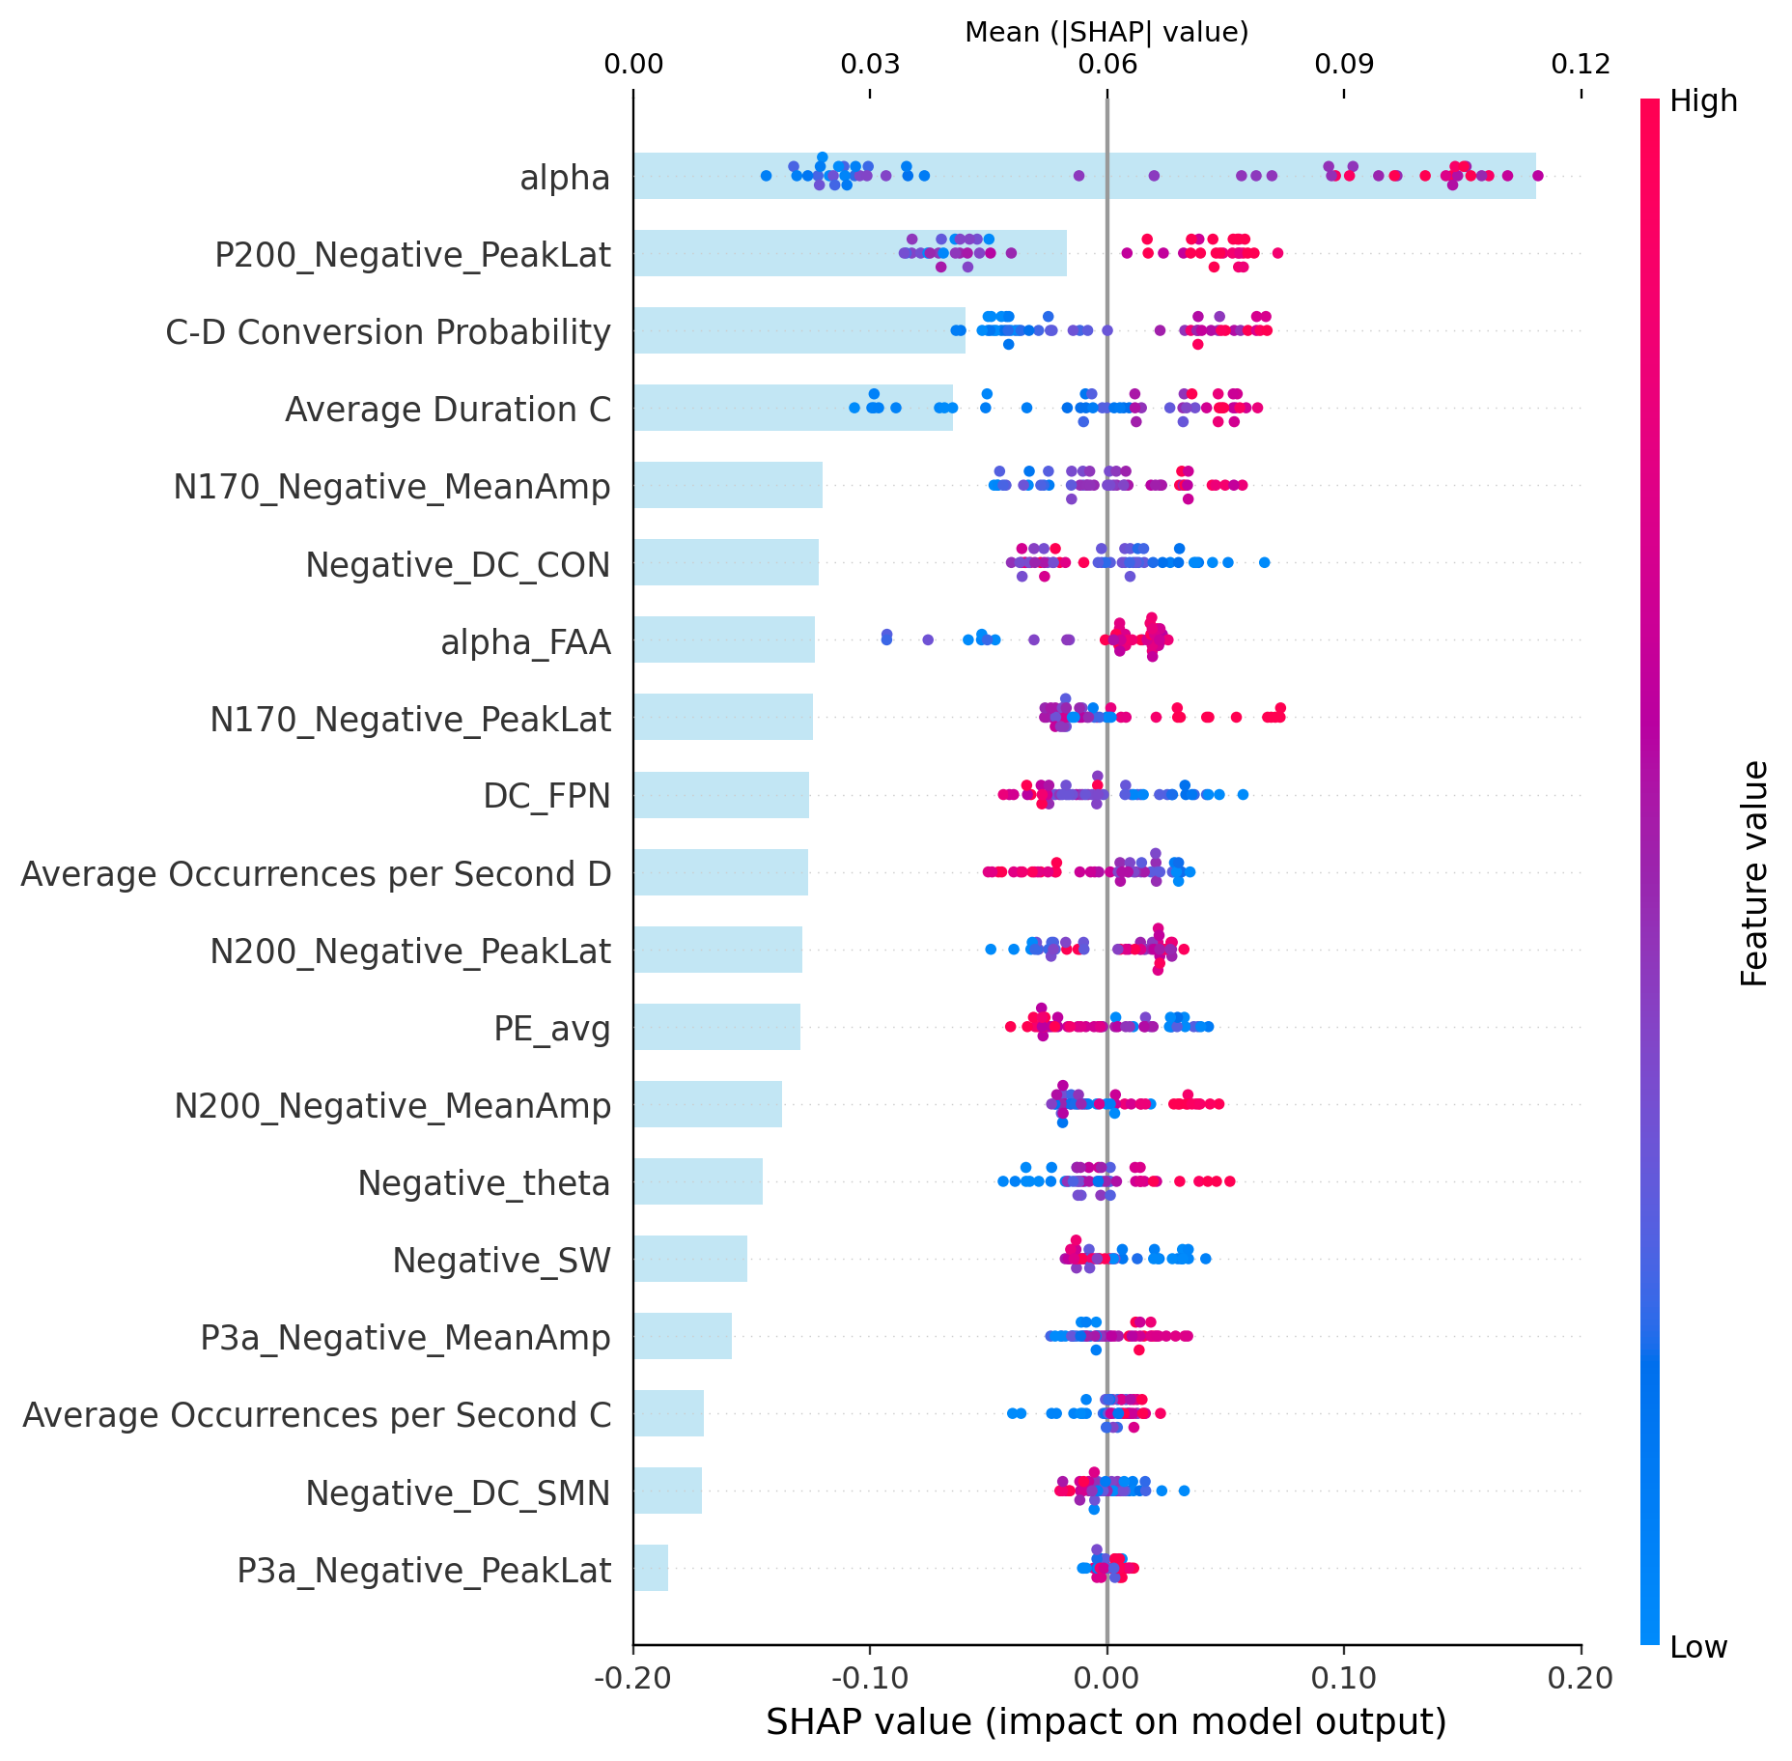
Supplementary Fig. S42. SHAP summary bar and dot plots for the fused random forest model.

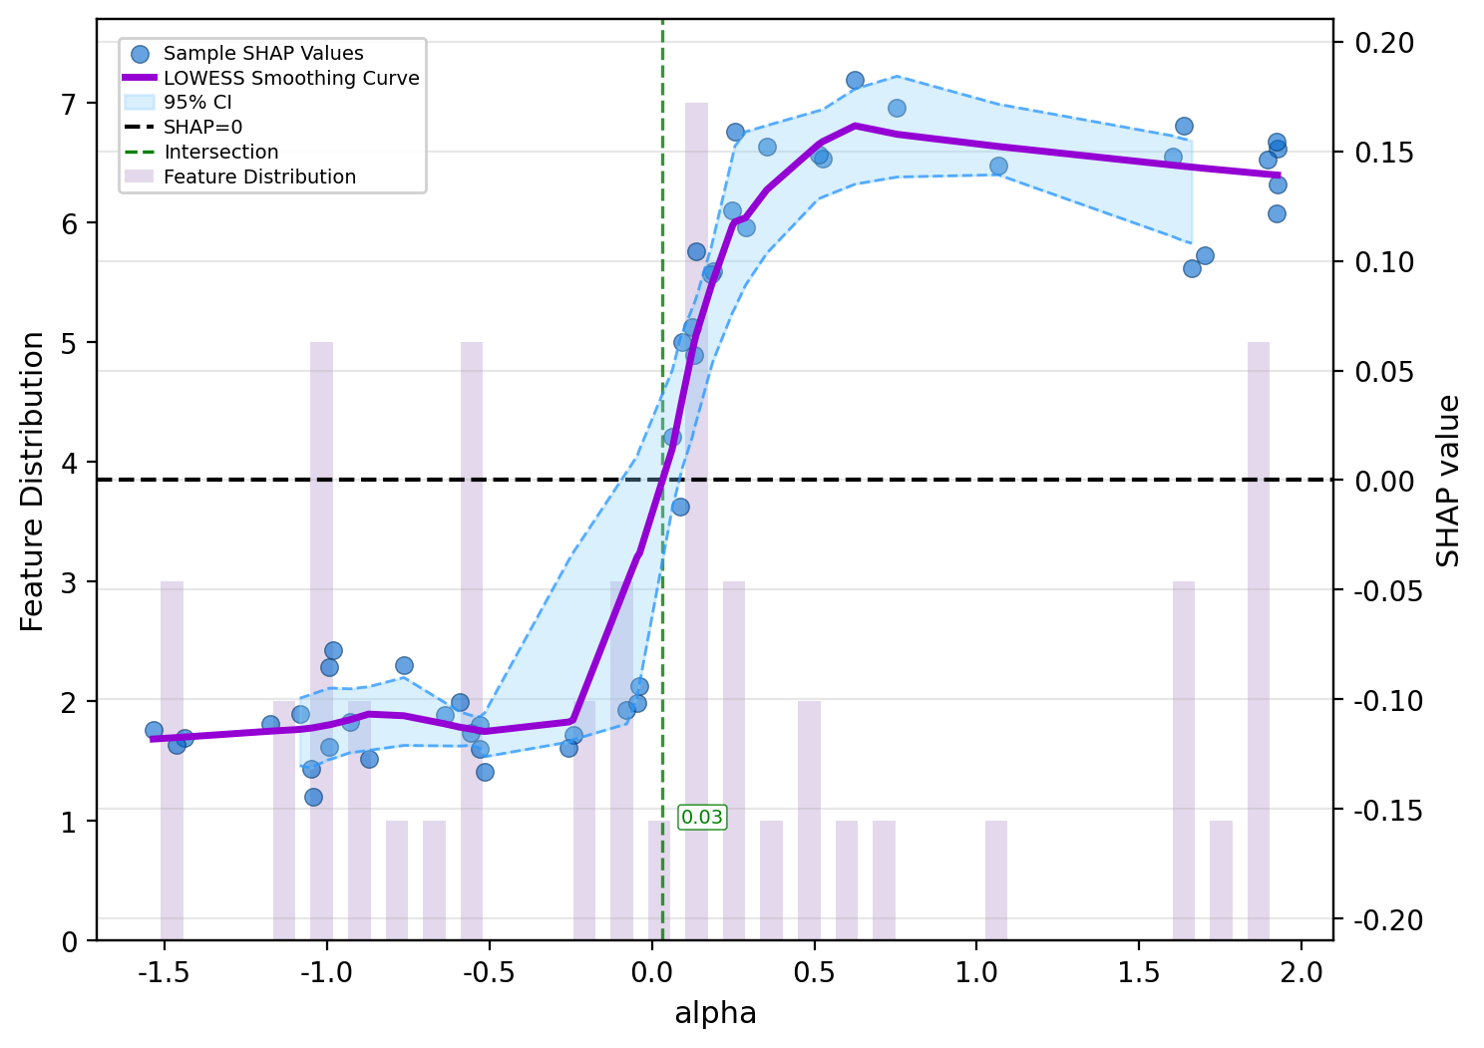
Supplementary Fig. S43. SHAP dependence plot for resting-state alpha-band power.

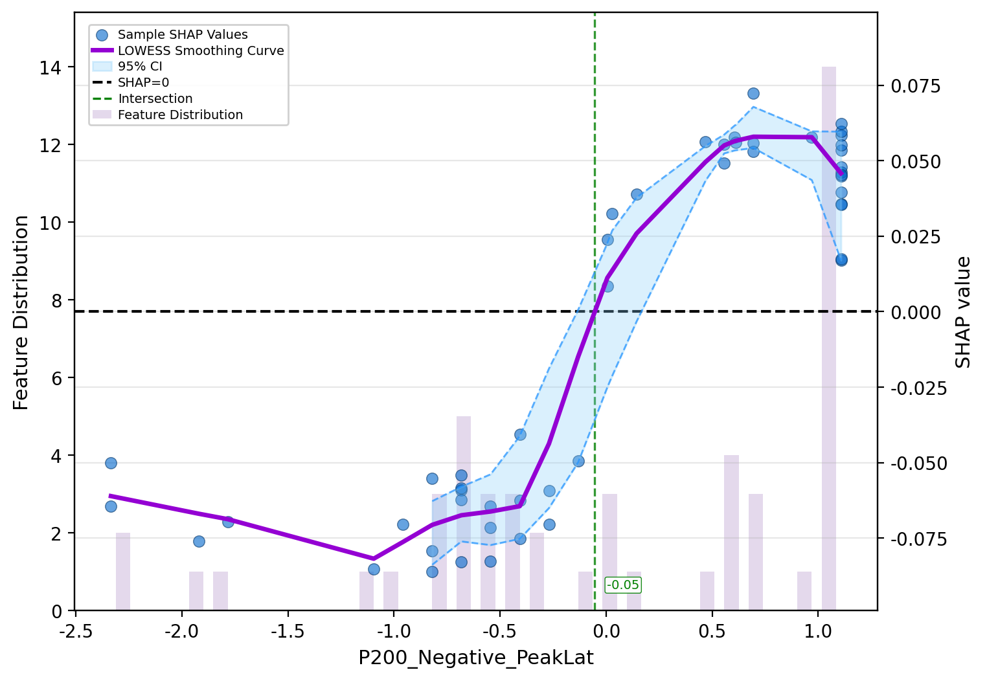
Supplementary Fig. S44. SHAP dependence plot for P200 latency under negative emotional faces.

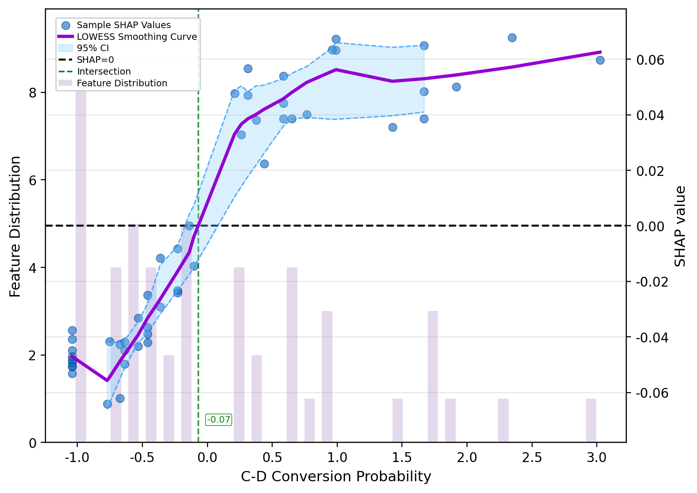
Supplementary Fig. S45. SHAP dependence plot for resting-state microstate C-D transition probability.

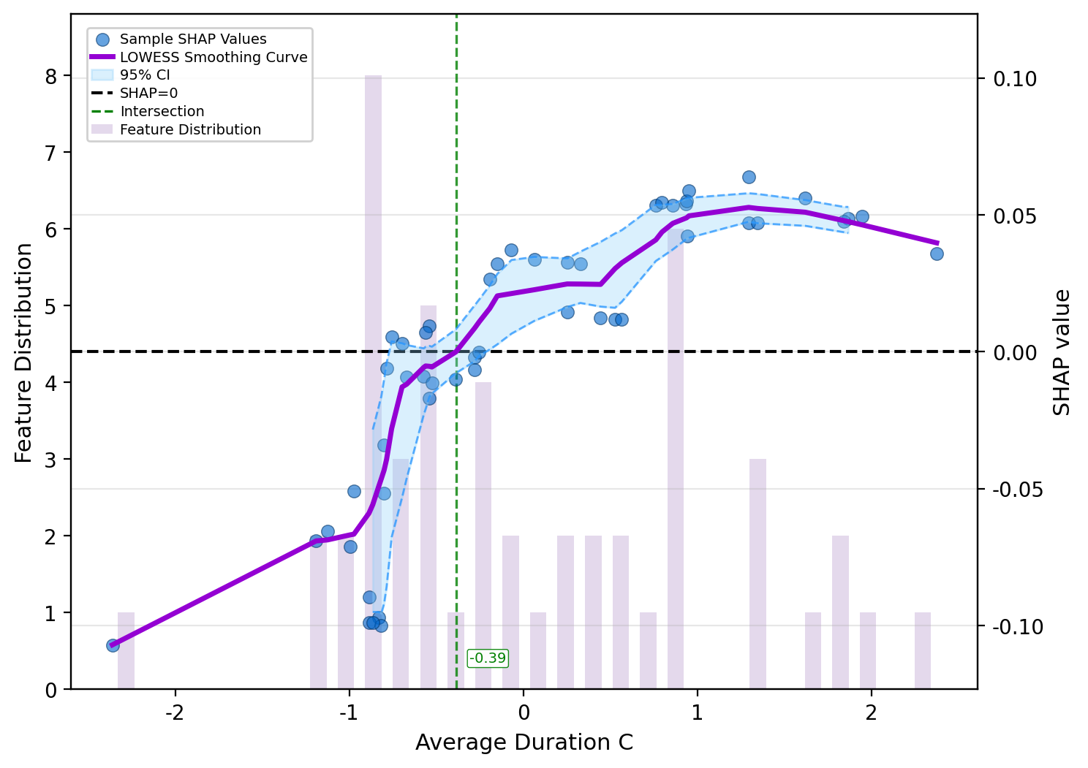
Supplementary Fig. S46. SHAP dependence plot for resting-state microstate C average duration.

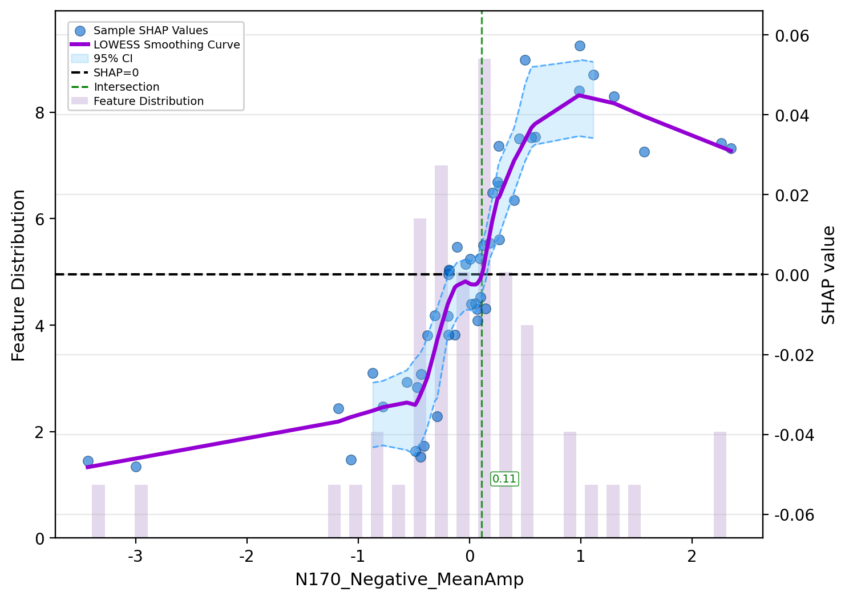
Supplementary Fig. S47. SHAP dependence plot for N170 mean amplitude under negative emotional faces.

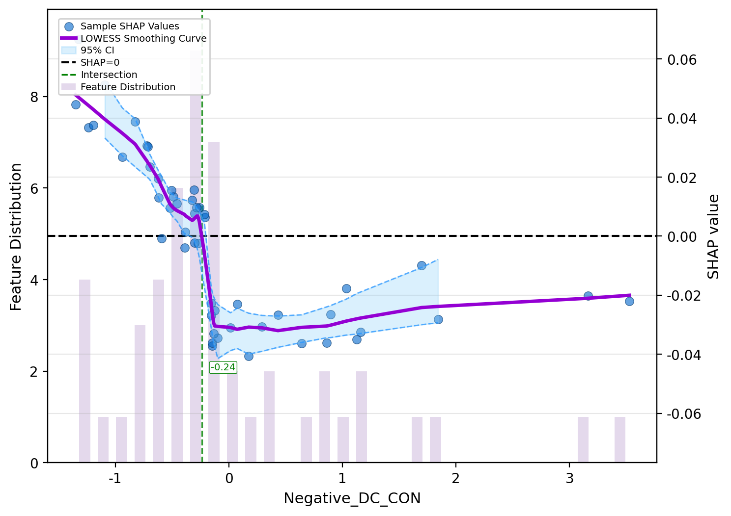
Supplementary Fig. S48. SHAP dependence plot for cingulo-opercular network degree centrality under negative emotional faces.

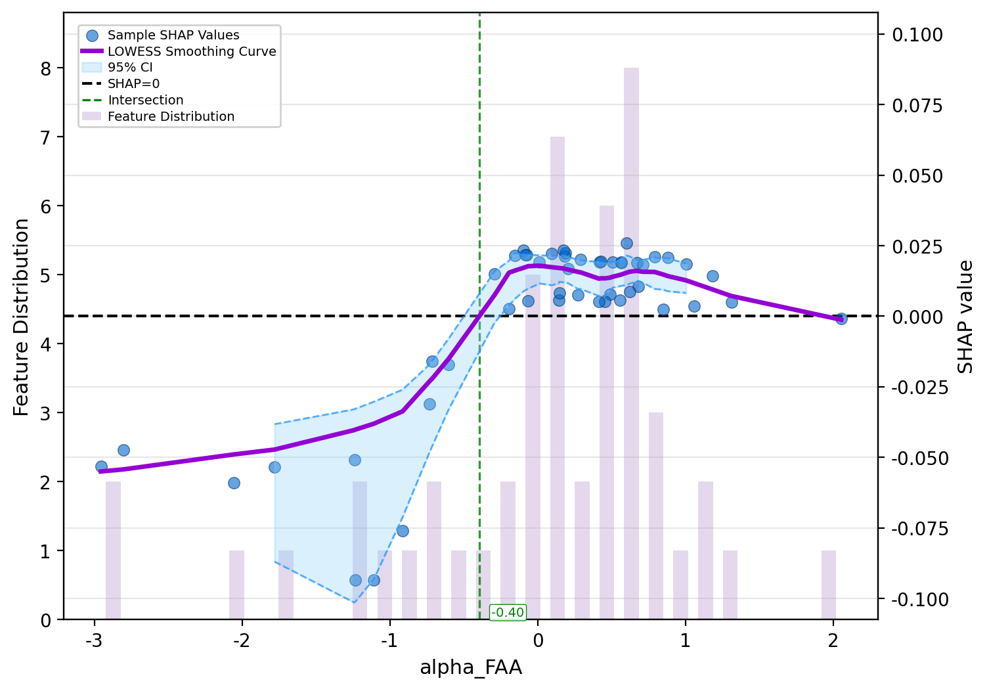
Supplementary Fig. S49. SHAP dependence plot for resting-state frontal alpha asymmetry.

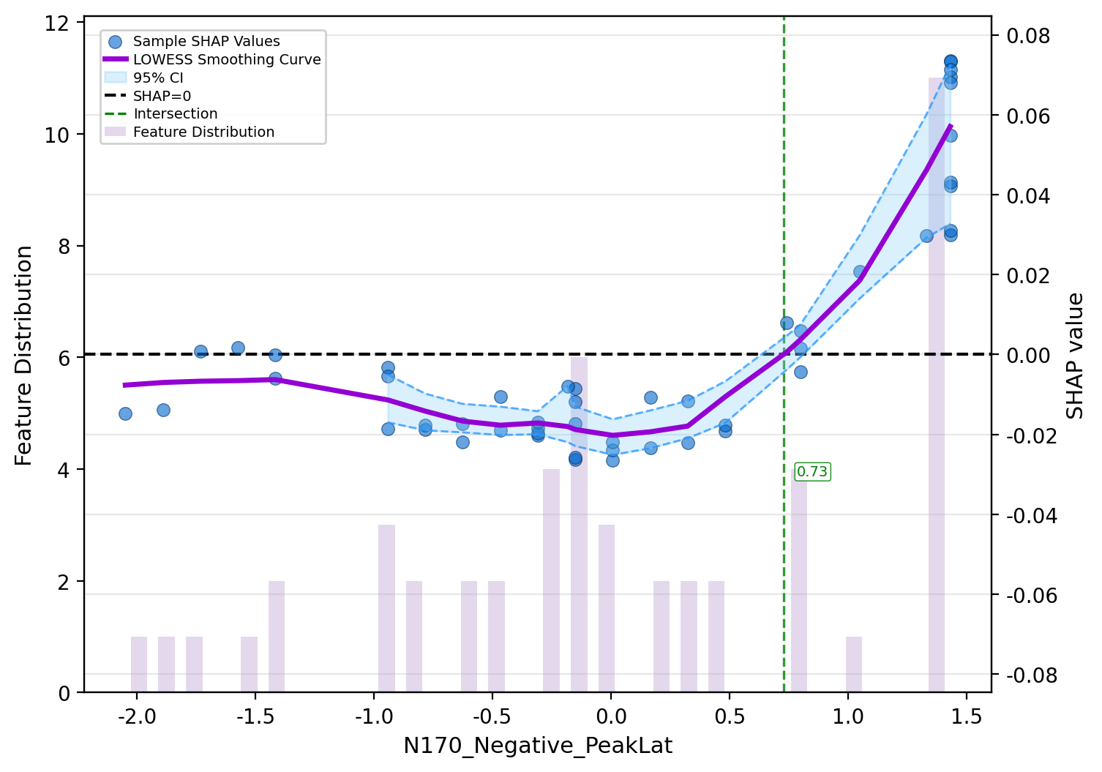
Supplementary Fig. S50. SHAP dependence plot for N170 latency under negative emotional faces.

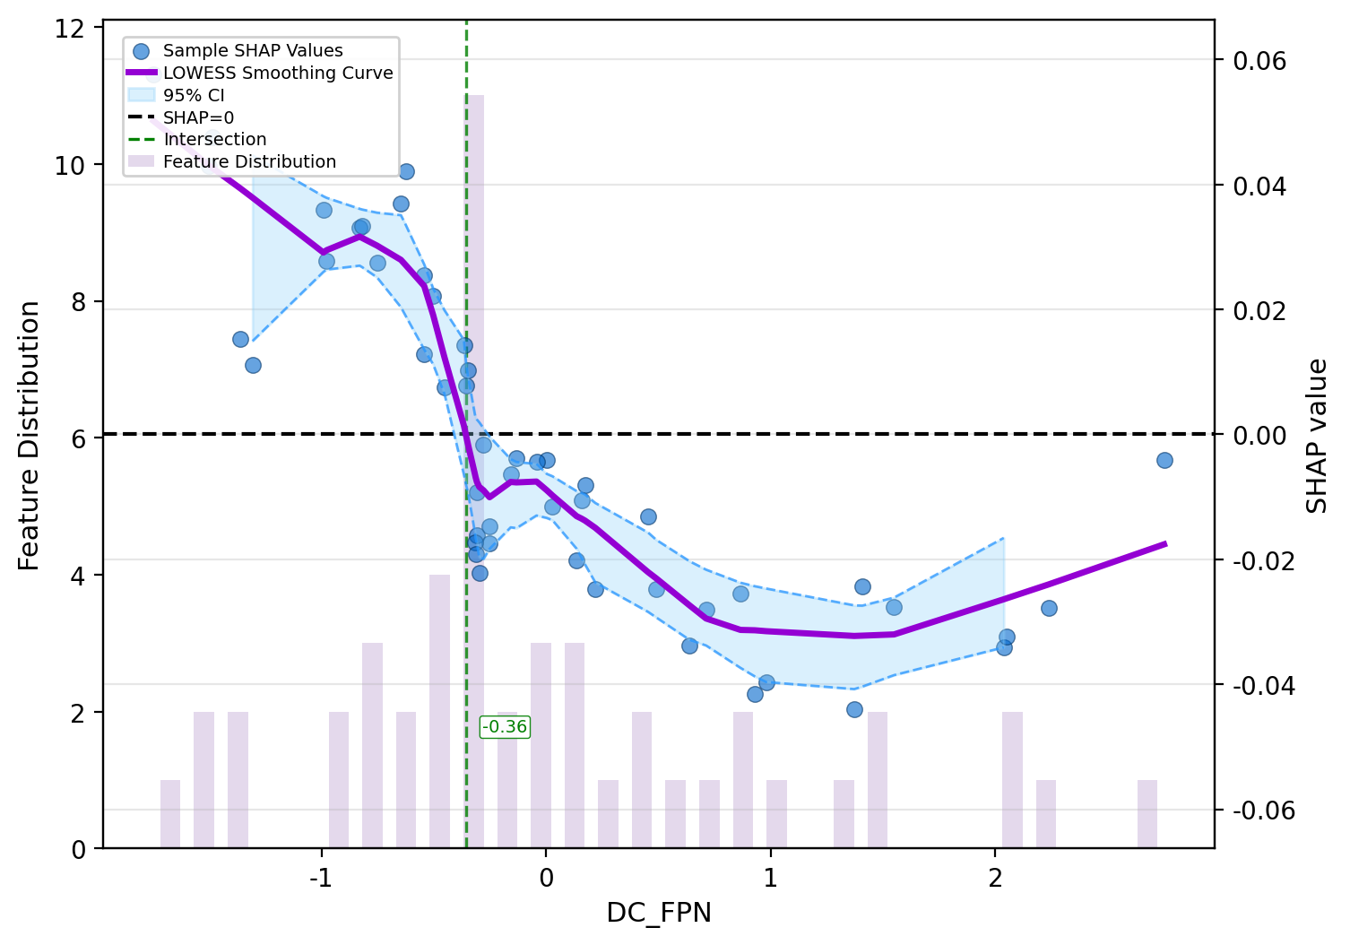
Supplementary Fig. S51. SHAP dependence plot for resting-state frontoparietal network degree centrality.

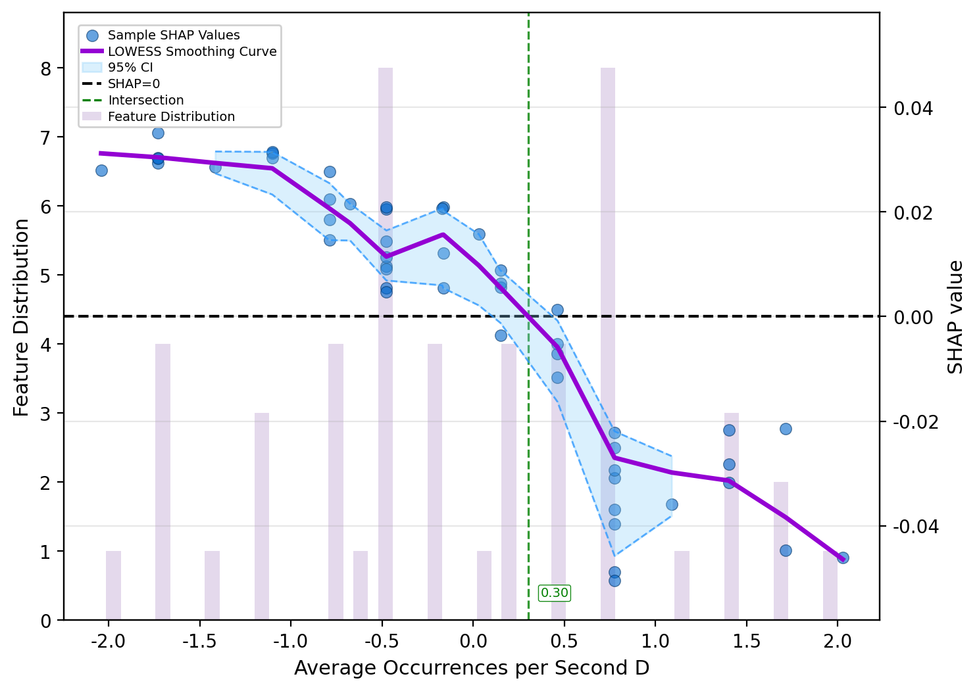
Supplementary Fig. S52. SHAP dependence plot for resting-state microstate D average occurrences per second.

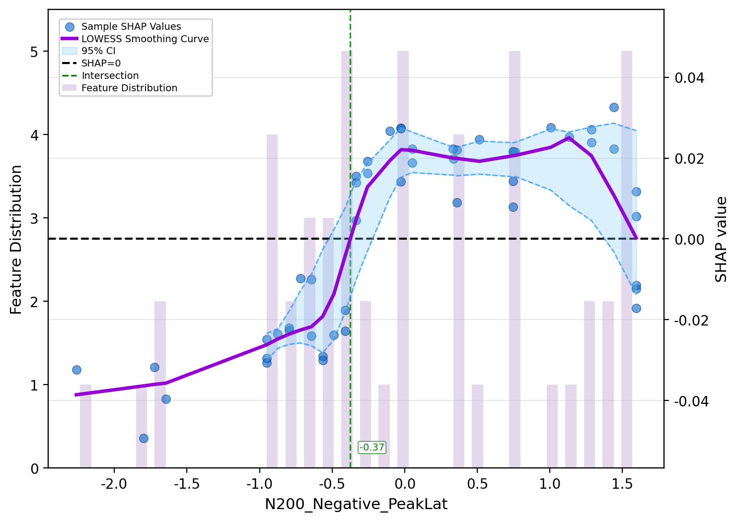
Supplementary Fig. S53. SHAP dependence plot for N200 latency under negative emotional faces.

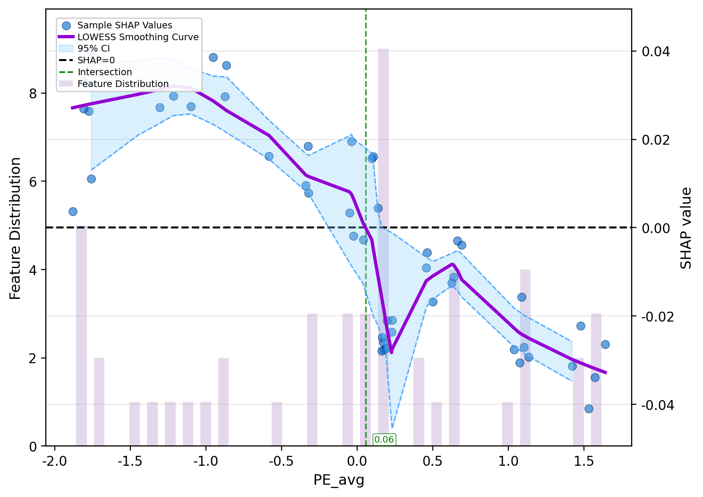
Supplementary Fig. S54. SHAP dependence plot for resting-state global average permutation entropy.

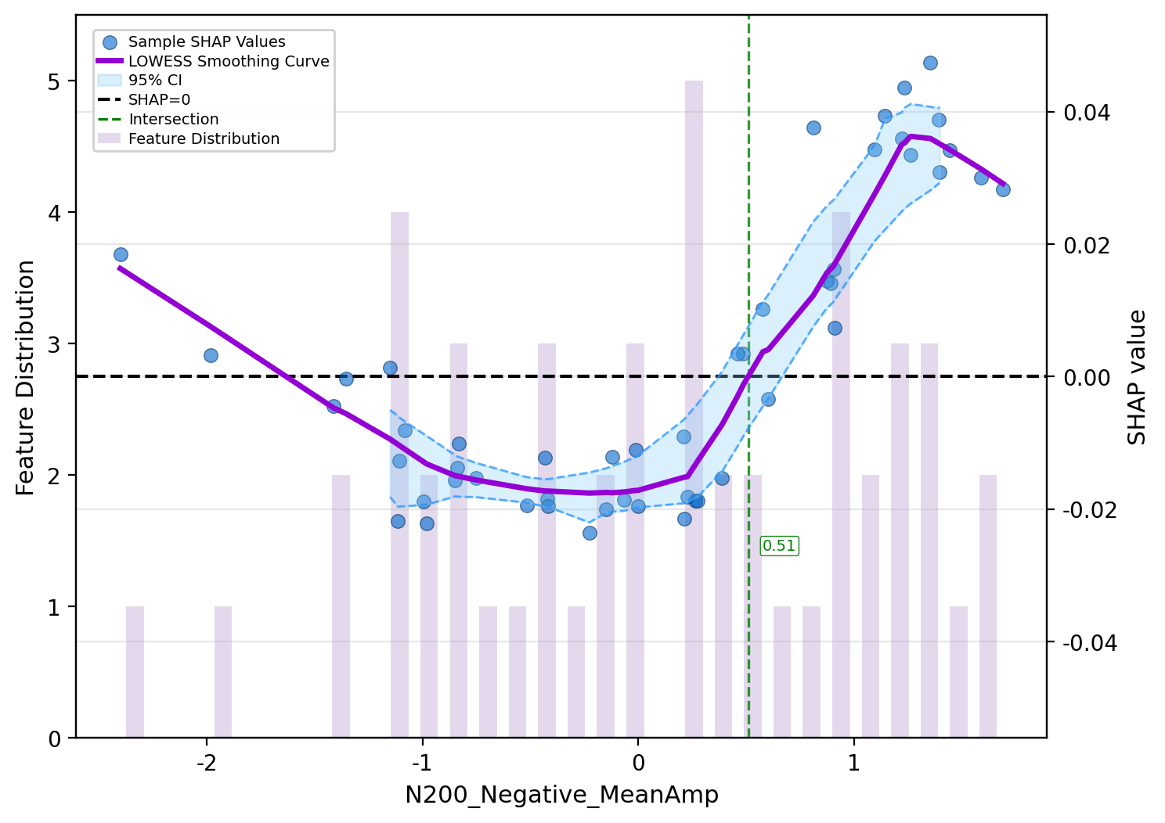
Supplementary Fig. S55. SHAP dependence plot for N200 mean amplitude under negative emotional faces.

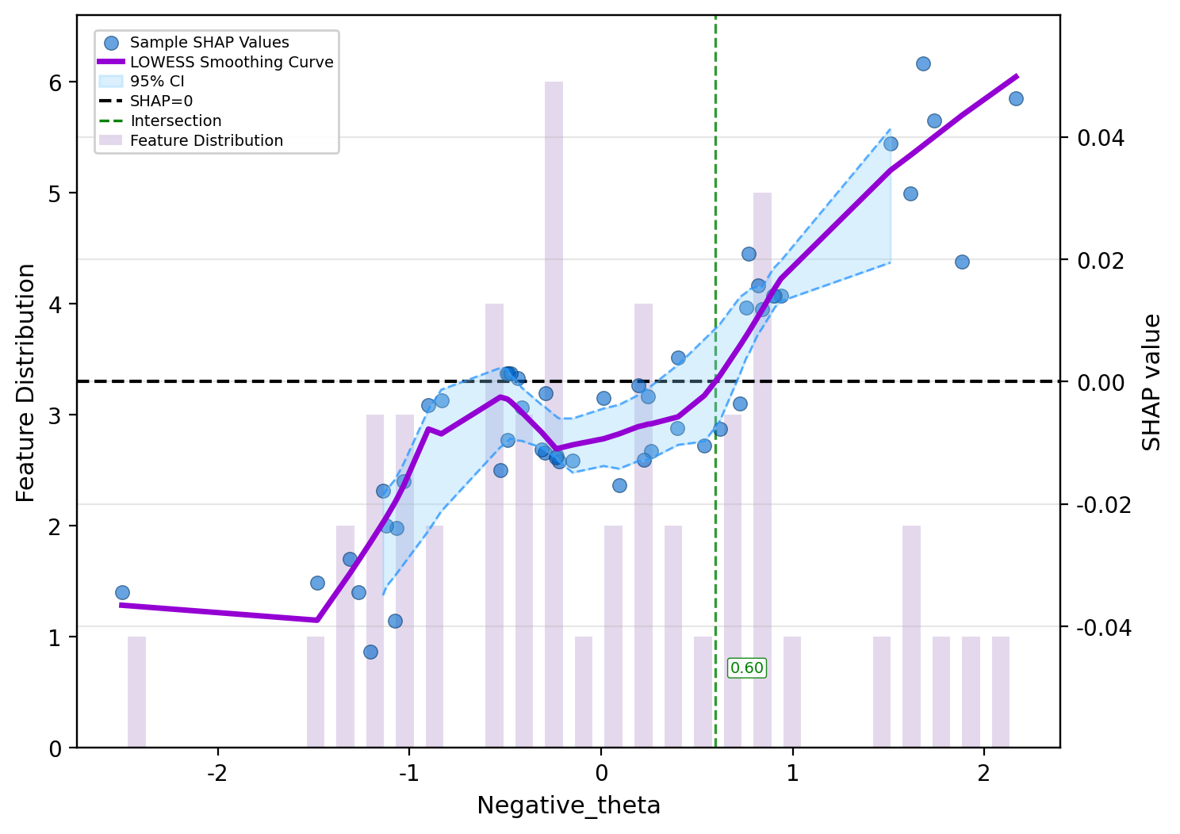
Supplementary Fig. S56. SHAP dependence plot for theta-band ERS under negative emotional faces.

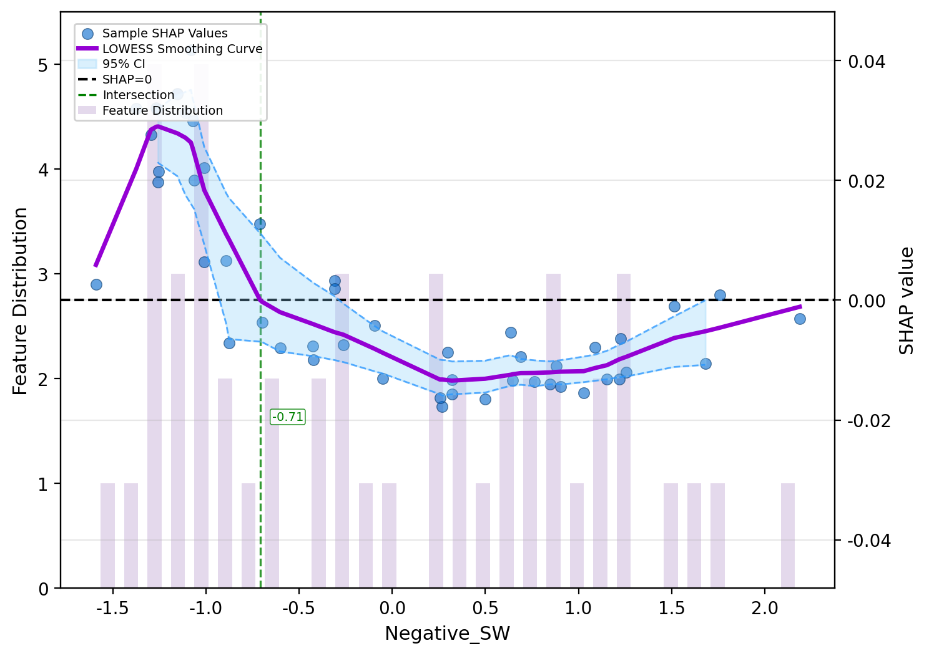
Supplementary Fig. S57. SHAP dependence plot for small-worldness under negative emotional faces.

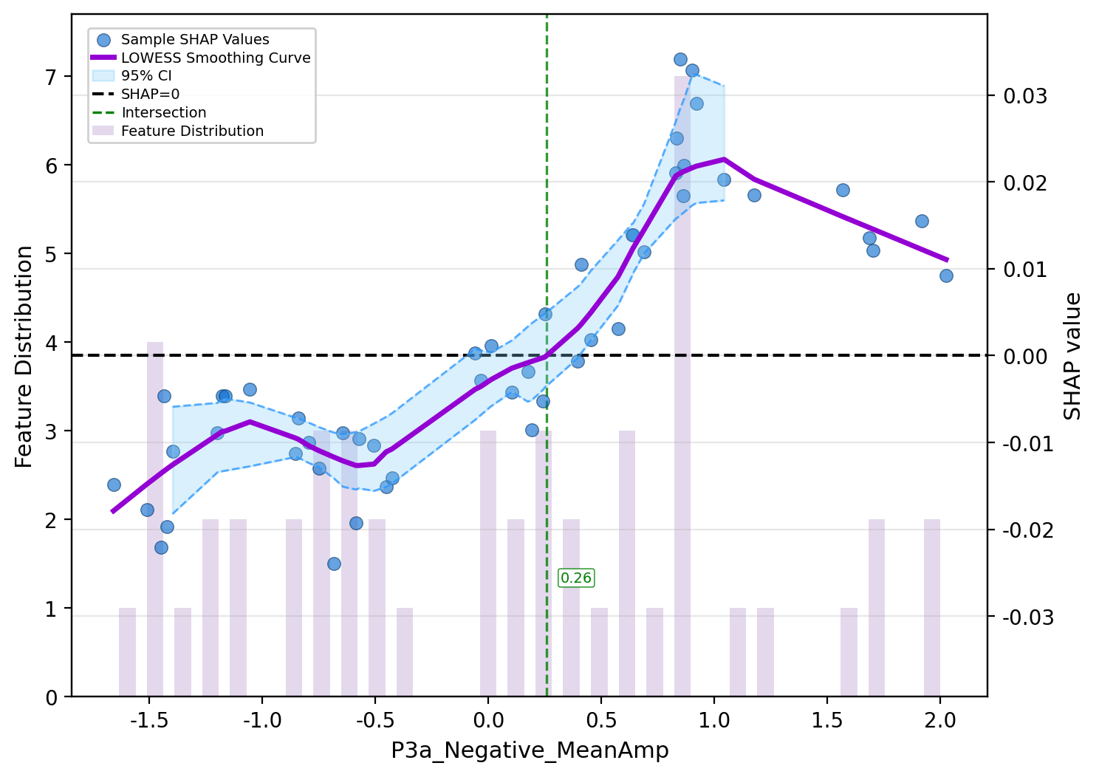
Supplementary Fig. S58. SHAP dependence plot for P3a mean amplitude under negative emotional faces.

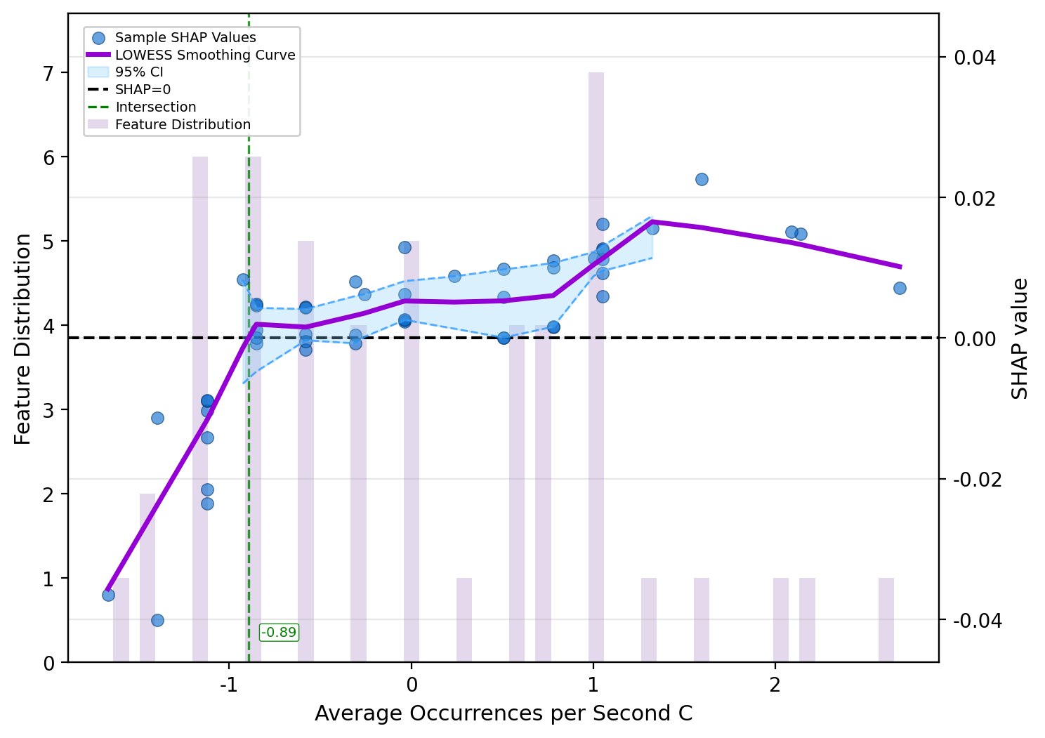
Supplementary Fig. S59. SHAP dependence plot for resting-state microstate C average occurrences per second.

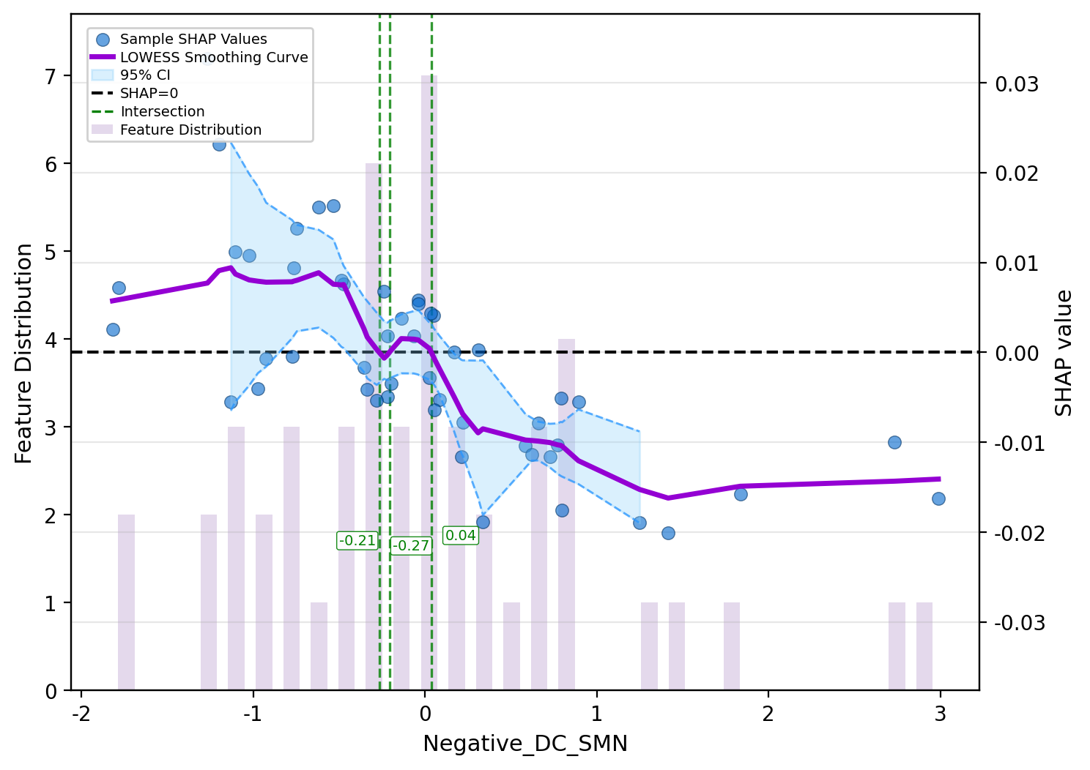
Supplementary Fig. S60. SHAP dependence plot for sensorimotor network degree centrality under negative emotional faces.

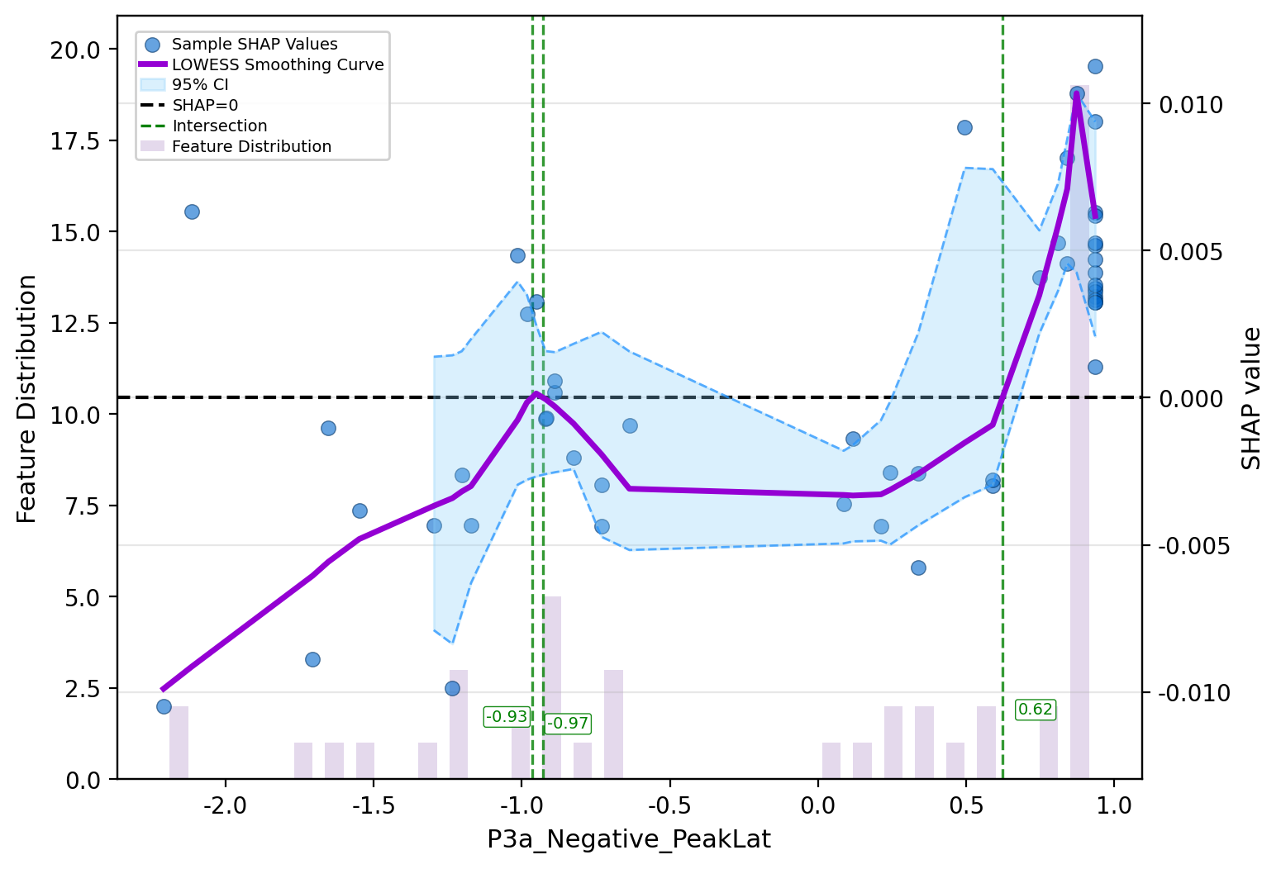
Supplementary Fig. S61. SHAP dependence plot for P3a latency under negative emotional faces.

