Supplementary material for
Global controls on flood expansion and socioeconomic vulnerability

Tuhin Mukherjee ª, N. K. Goel ^{a,b}, D. S. Arya ^{a,} Manohar Arora ^{b}
ª Department of Hydrology, Indian Institute of Technology Roorkee, Roorkee - 247667, Uttarakhand, India
^{b} International Centre of Excellence for Dams, Indian Institute of Technology Roorkee, Roorkee- 247667, Uttarakhand, India

Corresponding author: N. K. Goel; goelhy@gmail.com

Prof. N. K. Goel,
International Centre of Excellence for Dams,
Indian Institute of Technology Roorkee,
Roorkee- 247667,
Uttarakhand, India

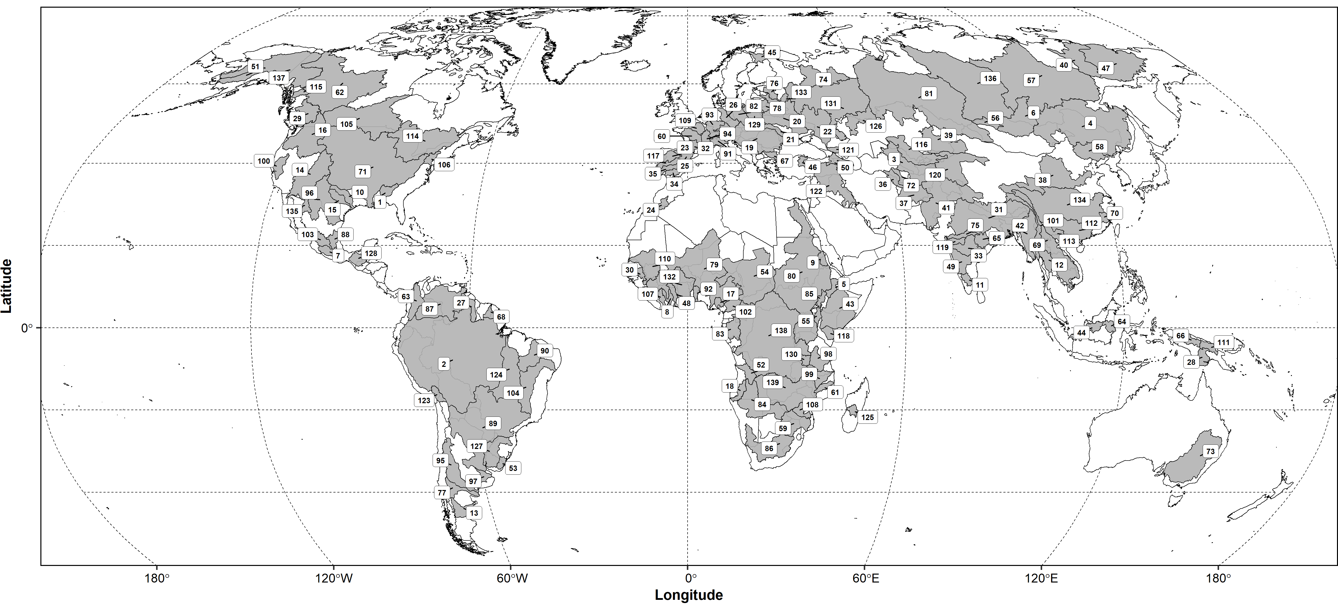
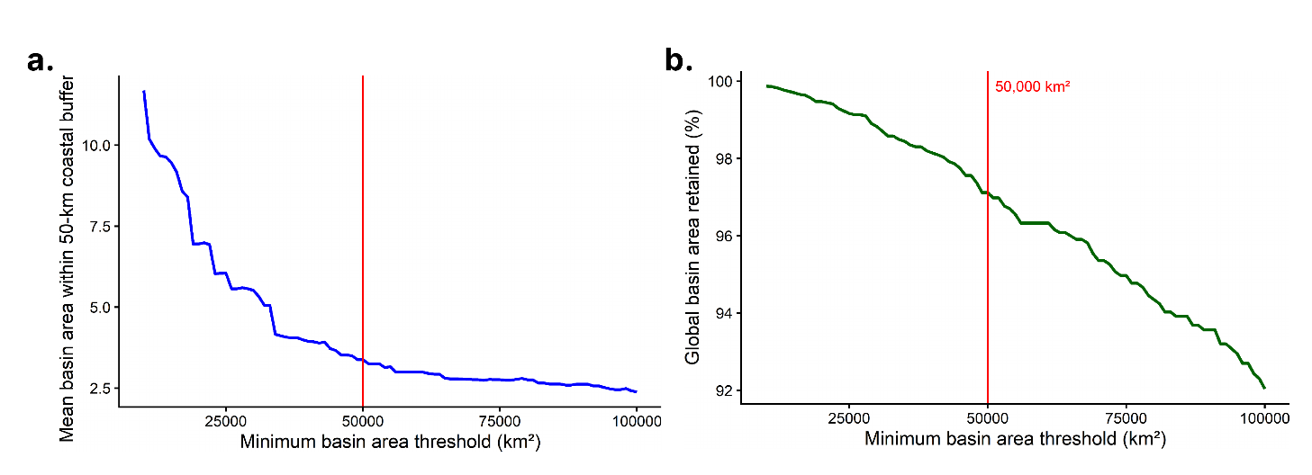
Fig Supplementary_1: Location of analysed river basins
Fig Supplementary_2: Basin-area threshold analysis. a. Sensitivity of the mean basin area located within the 50-km coastal buffer to the minimum basin area threshold. b. Percentage of the global basin area retained as the minimum basin area threshold increases.

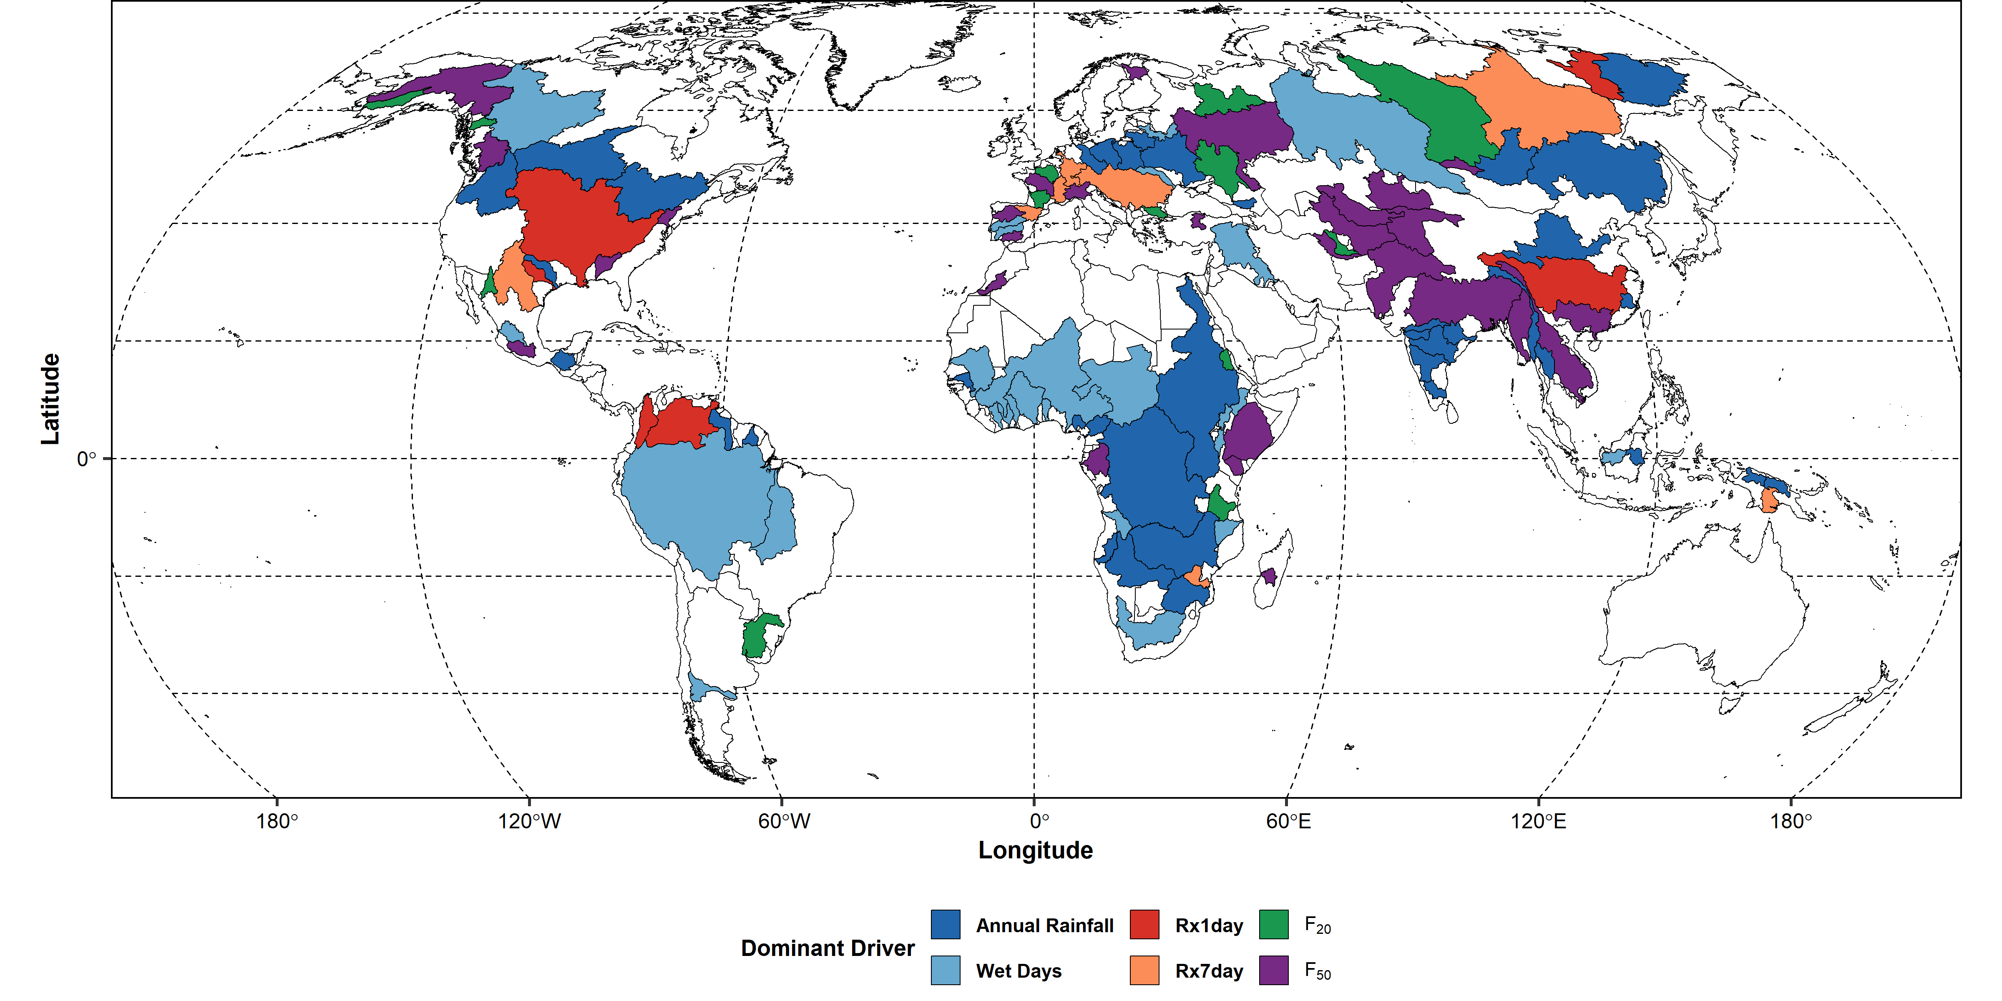
Fig Supplementary_3: Global distribution of the dominant rainfall driver classes: annual rainfall & wet days: Rainfall Regime, maximum 1-day rainfall (Rx1day) & maximum consecutive 7-day rainfall (Rx7day): Extreme Rainfall, Precipitation frequency greater than 50 mm/hr (F₅₀) & 20 (F₂₀) mm/hr: High-frequency rainfall.

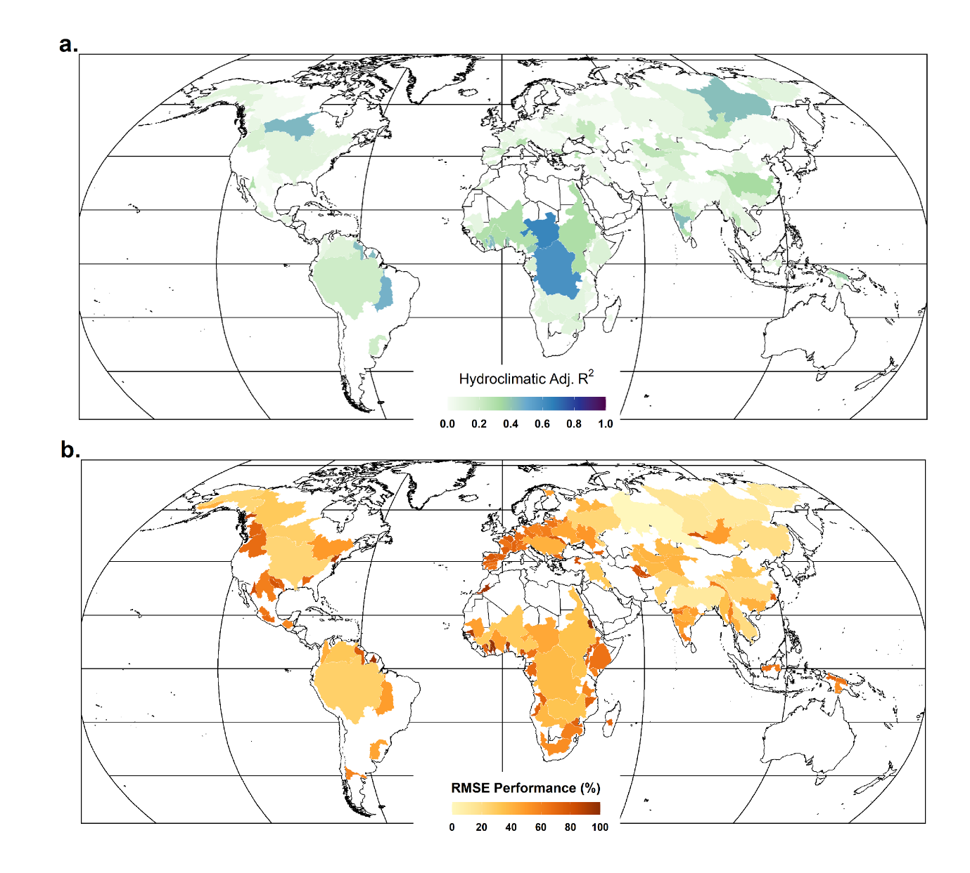
Fig Supplementary_4: Outcome of multiple linear regression analysis between AMFE and hydro-climatic variables: rainfall & snowmelt. a. Spatial distribution of the adjusted coefficient of determination (Adjusted R²) for combined hydro-climatic regression. b. The percentage reduction in root mean square error (RMSE) achieved by taking rainfall and snowmelt simultaneously.

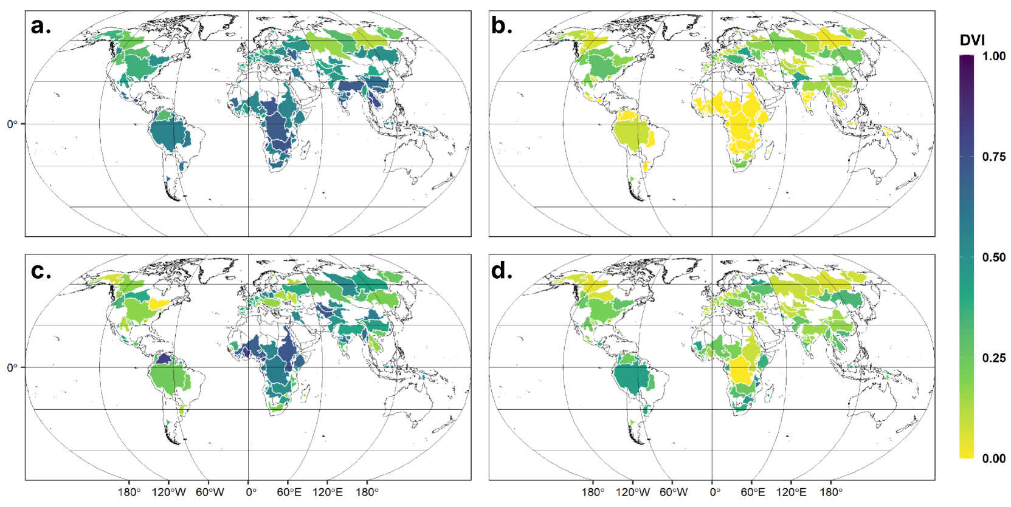
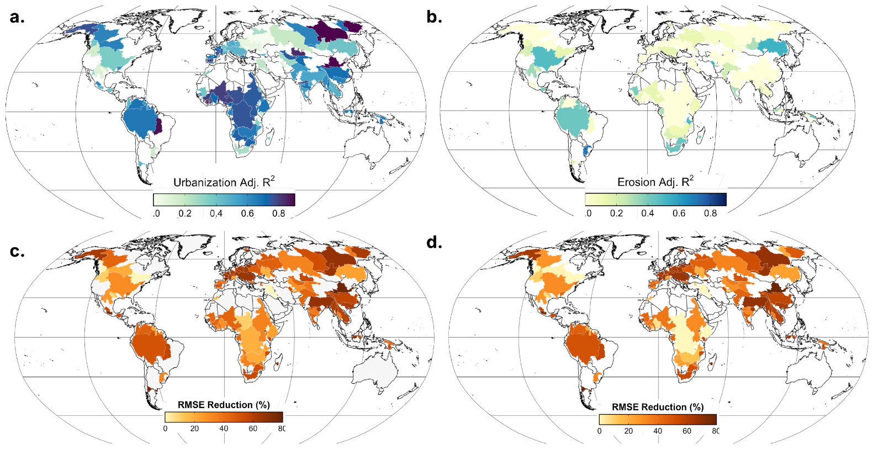

Fig Supplementary_6: Spatial distribution of the DVI for a. rainfall, b. snowmelt, c. urbanization, and d. floodplain erosion across the river basins.

Fig Supplementary_5: Basin-wise performance attribution of multiple regression analysis between AMFE and impervious area, floodplain erosion. Spatial distribution of the adjusted coefficient of determination (Adjusted R²) for a. urbanization-based regression model. b. floodplain erosion-based. Percentage reduction in root mean square error (RMSE) achieved by including c. urbanization in the regression analysis d. long-term erosion within the floodplains.

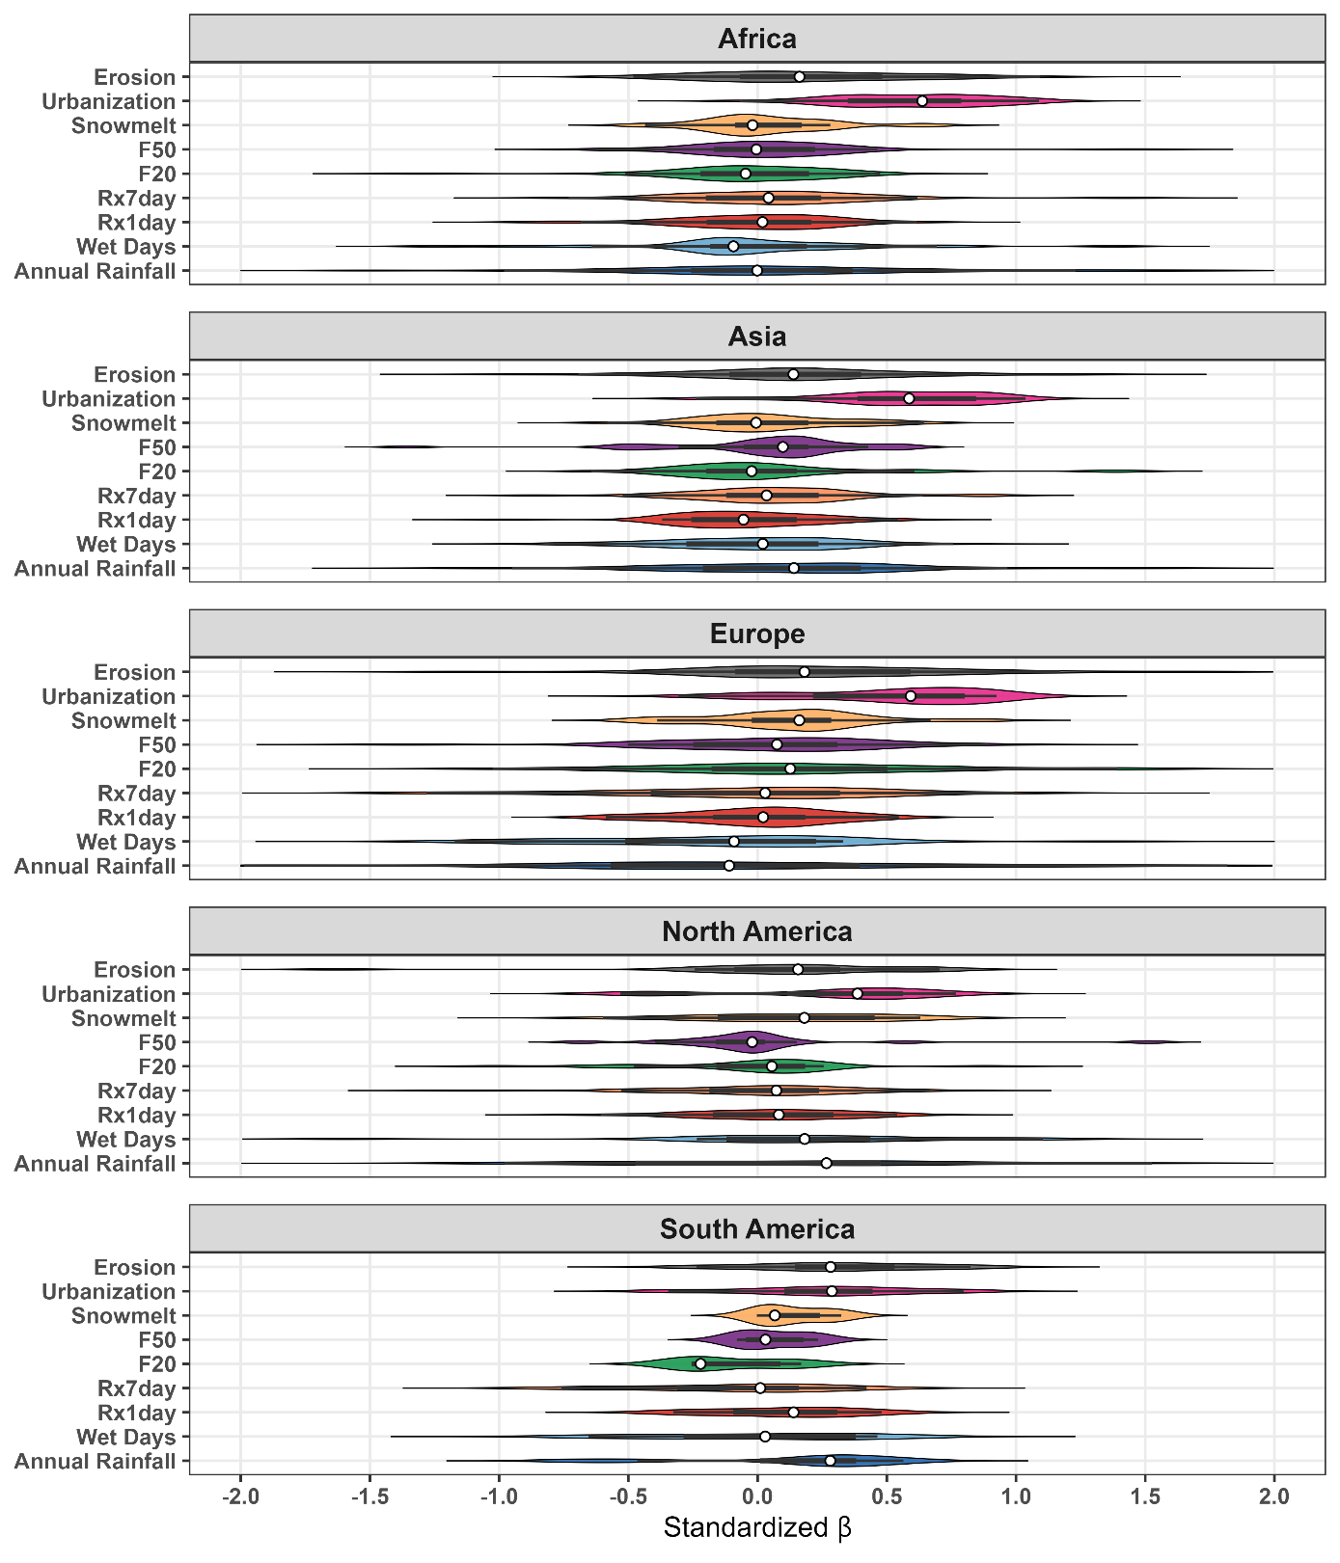
Fig Supplementary_7: Sensitivity of AMFE to the drivers analyzed in this study with Continental variation: Violin plots show the distribution of standardized regression coefficients (β) for all the drivers using a common scale (−2 to 2) to facilitate comparison of driver sensitivity among continents. Here, positive β values indicate a positive association between the particular driver and flood extent, whereas negative values indicate an inverse association.

Supplementary Table_1: Basin-wise basic information with normalized Theil-Sen slope values
SL. No. | Basin | Country | Continent | Basin Area | AMFE Trend (Normalized)
1 | Alabama | United States of America | North America | 113851.748 | 1.1
2 | Amazon | Brazil | South America | 6035836.59 | 0.977
3 | Amu_Darya | Uzbekistan | Asia | 611455.044 | 1.712
4 | Amur | China | Asia | 2214942.78 | 1.35
5 | Awash | Ethiopia | Africa | 91536.2543 | 3.715
6 | Baikal | Russian Federation | Asia | 588895.504 | 4.283
7 | Balsas | Mexico | North America | 119007.819 | 1.373
8 | Bandama | Côte d'Ivoire | Africa | 65965.6672 | 6.043
9 | Baraka | Eritrea | Africa | 68421.0321 | 6.976
10 | Brazos | United States of America | North America | 121188.026 | 1.181
11 | Cauvery | India | Asia | 91055.9064 | 3.229
12 | Chao_Phraya | Thailand | Asia | 151454.497 | 3.868
13 | Colorado_River | United States of America | North America | 112243.398 | 0.621
14 | Columbia | United States of America | North America | 670165.232 | 0.362
15 | Cross | Nigeria | Africa | 53928.489 | 6.699
16 | Cunene | Angola | Africa | 109645.612 | 4.346
17 | Danube | Romania | Europe | 801830.229 | 2.224
18 | Dnieper | Ukraine | Europe | 534766.621 | 0.7
19 | Dniester | Moldova, Republic of | Europe | 75005.2722 | 0.984
20 | Don | Russian Federation | Europe | 487409.781 | 0.801
21 | Douro_Duero | Spain | Europe | 97320.371 | 4.973
22 | Dra | Morocco | Africa | 93077.0132 | 4.036
23 | Ebro | Spain | Europe | 86178.7192 | 5.748
24 | Elbe | Germany | Europe | 115016.688 | 2.724
25 | Essequibo | Guyana | South America | 164853.141 | 2.534
26 | Fly | Papua New Guinea | Asia | 133141.699 | 3.642
27 | Fraser | Canada | North America | 240935.03 | 0.506
28 | Gambia | Senegal | Africa | 69573.4134 | 2.939
29 | Ganges_Brahmaputra | India | Asia | 1662309.01 | 2.273
30 | Garonne | France | Europe | 81441.1879 | 3.765
31 | Godavari | India | Asia | 319822.737 | 3.582
32 | Guadalquivir | Spain | Europe | 55890.1226 | 5.273
33 | Guadiana | Spain | Europe | 71183.4168 | 6.028
34 | Hari_Rud | Iran (Islamic Republic of) | Asia | 126308.486 | 0.859
35 | Hwang_Ho | China | Asia | 881193.03 | 4.421
36 | Ili | Kazakhstan | Asia | 478989.649 | 5.202
37 | Indigirka | Russian Federation | Asia | 330454.656 | 6.813
38 | Indus | Pakistan | Asia | 1030602.33 | 3.756
39 | Irrawaddy | Myanmar | Asia | 386956.718 | 3.693
40 | Jubba_Shebelle | Ethiopia | Africa | 799531.426 | 6.225
41 | Kapuas | Indonesia | Asia | 102481.262 | 3.469
42 | Kemijoki | Finland | Europe | 52270.0093 | 0.424
43 | Kizil | Turkey | Asia | 50999.2037 | 6.885
44 | Kolyma | Russian Federation | Asia | 750966.176 | 6.832
45 | Komoe | Côte d'Ivoire | Africa | 77884.3556 | 4.373
46 | Krishna | India | Asia | 251616.092 | 2.63
47 | Kuskokwim | United States of America | North America | 118428.059 | 4.949
48 | Kwanza | Angola | Africa | 140895.234 | 4.905
49 | Lake_Chad | Chad | Africa | 1496451.3 | 5.475
50 | Lake_Turkana | Kenya | Africa | 72008.3663 | 5.194
51 | Lake_Ubsa | Mongolia | Asia | 91906.1875 | 3.346
52 | Lena | Russian Federation | Asia | 2418594.7 | 5.944
53 | Limpopo | South Africa | Africa | 413588.226 | 3.944
54 | Loire | France | Europe | 114546.432 | 5.019
55 | Mackenzie | Canada | North America | 1537734.04 | 0.538
56 | Magdalena | Colombia | South America | 232210.975 | 2.734
57 | Mahakam | Indonesia | Asia | 80154.0778 | 4.985
58 | Mahanadi | India | Asia | 149124.307 | 2.754
59 | Mamberamo | Indonesia | Asia | 81441.1374 | 4.031
60 | Maritsa | Bulgaria | Europe | 55913.0732 | 5.105
61 | Maroni | Suriname | South America | 67384.0319 | 3.313
62 | Mekong | Lao People's Democratic Republic | Asia | 801871.257 | 3.01
63 | Min | China | Asia | 61075.0561 | 4.023
64 | Mississippi | United States of America | North America | 3228837.76 | 1.034
65 | Murghab | Turkmenistan | Asia | 86114.5017 | 1.166
66 | N._Dvina | Russian Federation | Europe | 361612.307 | 1.717
67 | Narmada | India | Asia | 95805.0854 | 4.872
68 | Negro | Argentina | South America | 160593.28 | 2.16
69 | Neman | Lithuania | Europe | 99990.6505 | 1.046
70 | Niger | Niger | Africa | 2197201.53 | 4.687
71 | Nile | Sudan | Africa | 3057386.04 | 4.087
72 | Ob | Russian Federation | Asia | 3085473.8 | 2.541
73 | Oder | Poland | Europe | 164966.703 | 2.148
74 | Ogooue | Gabon | Africa | 221215.356 | 6.728
75 | Okavango | Angola | Africa | 692212.694 | 3.893
76 | Omo_Wenz | Ethiopia | Africa | 68814.7705 | 6.627
77 | Orange | South Africa | Africa | 620400.699 | 2.057
78 | Orinoco | Colombia | South America | 934462.154 | 3.912
79 | Po | Italy | Europe | 97029.2198 | 5.551
80 | Queme | Benin | Africa | 54663.1444 | 6.27
81 | Rhine | Germany | Europe | 151484.36 | 1.9
82 | Rhone | France | Europe | 94619.3771 | 4.42
83 | Rio_Grande | United States of America | North America | 641609.343 | 0.782
84 | Rufiji | United Republic of Tanzania | Africa | 203543.858 | 2.674
85 | Ruvuma | Mozambique | Africa | 152338.566 | 2.591
86 | Salween | China | Asia | 249040.745 | 3.598
87 | Sanaga | Cameroon | Africa | 133894.783 | 6.272
88 | Santiago_Lerma_Chapala | Mexico | North America | 126031.083 | 2.746
89 | Saskatchewan_Nelson | Canada | North America | 1138155.18 | 1.61
90 | Sasquehanna | United States of America | North America | 68059.4892 | 0.337
91 | Sassandra | Côte d'Ivoire | Africa | 69140.8712 | 5.922
92 | Save | Zimbabwe | Africa | 113497.196 | 3.328
93 | Seine | France | Europe | 79680.4413 | 4.321
94 | Senegal | Mali | Africa | 434749.168 | 4.446
95 | Sepik | Papua New Guinea | Asia | 99824.7014 | 5.316
96 | Si | China | Asia | 459249.348 | 3.246
97 | St._Lawrence | Canada | North America | 1055492.84 | 0.156
98 | Stikine | Canada | North America | 52500.3996 | 0.827
99 | Syr_Darya | Kazakhstan | Asia | 429848.119 | 3.287
100 | Tagus | Spain | Europe | 78836.1631 | 4.447
101 | Tana | Norway | Europe | 95030.4395 | 0.486
102 | Tapti | India | Asia | 73779.6053 | 2.577
103 | Tarim_(Yarkand) | China | Asia | 580935.359 | 4.096
104 | Terek | Russian Federation | Europe | 50623.5647 | 1.912
105 | Tigris_Euphrates | Iraq | Asia | 600308.756 | 2.578
106 | Tocantins | Brazil | South America | 776767.438 | 2.303
107 | Tsiribihina | Madagascar | Africa | 61668.2296 | 1.263
108 | Uruguay | Brazil | South America | 343285.084 | 0.92
109 | Usumacinta | Mexico | North America | 126435.883 | 2.216
110 | Vistula | Poland | Europe | 183927.728 | 2.244
111 | Volga | Russian Federation | Europe | 1393845.1 | 0.982
112 | Volta | Ghana | Africa | 412484.575 | 5.408
113 | W._Dvina | Russian Federation | Europe | 83871.1955 | 0.63
114 | Yangtze | China | Asia | 1709103.86 | 3.541
115 | Yaqui | Mexico | North America | 78883.9737 | 2.294
116 | Yenisey | Russian Federation | Asia | 1926905.32 | 3.523
117 | Yukon | United States of America | North America | 834934.967 | 3.386
118 | Zaire | Democratic Republic of the Congo | Africa | 3679282.33 | 3.487
119 | Zambezi | Zambia | Africa | 1381196.25 | 4.446

Supplementary Table_2: Socio-economic characteristics of the analyzed river basins in this study
SL. No. | Basin | Mean Population Density per km2 (2020) | Mean Population Density Trend (%/ yr) | Average GDP in Dollars per Capita (2024)
1 | Alabama | 41.2 | -0.8 | 47214.5
2 | Amazon | 5.9 | -0.8 | 14217.7
3 | Amu_Darya | 54.3 | 1.4 | 7169.4
4 | Amur | 30.2 | -1.8 | 22430.3
5 | Awash | 239.3 | 2.5 | 2752.5
6 | Baikal | 5.9 | -1.5 | 14052
7 | Balsas | 115.1 | 0.4 | 13455.9
8 | Bandama | 70.3 | 2.2 | 6082.7
9 | Baraka | 25.8 | 1.8 | 1150.7
10 | Brazos | 28.4 | -0.8 | 47461.8
11 | Cauvery | 512.7 | 2.3 | 15895.4
12 | Chao_Phraya | 192.2 | 1.1 | 10869.5
13 | Colorado_River | 22.5 | -1.3 | 80276.6
14 | Columbia | 13 | -1.6 | 52391.2
15 | Cross | 261.5 | 2.3 | 4989.9
16 | Cunene | 35.2 | 4.7 | 6511.4
17 | Danube | 94.4 | -0.8 | 35314.8
18 | Dnieper | 54.3 | -1.2 | 17521.1
19 | Dniester | 85.9 | -0.9 | 11185
20 | Don | 38.5 | -0.3 | 19277.1
21 | Douro_Duero | 52.3 | -0.9 | 8336.2
22 | Dra | 11.3 | -1.1 | 8336.2
23 | Ebro | 42.2 | -0.1 | 62406.4
24 | Elbe | 152.6 | -0.6 | 47691.6
25 | Essequibo | 1.3 | -0.6 | 19252.8
26 | Fly | 5.2 | 2 | 4724
27 | Fraser | 6 | -2.4 | 37043
28 | Gambia | 36.7 | 3 | 2920
29 | Ganges_Brahmaputra | 489.1 | 1.4 | 9970.4
30 | Garonne | 67.7 | 0.7 | 46706.6
31 | Godavari | 280.8 | 2.2 | 11282.4
32 | Guadalquivir | 82 | 0.6 | 42120.5
33 | Guadiana | 25.2 | -0.1 | 46276.8
34 | Hari_Rud | 71.6 | 2.5 | 8960
35 | Hwang_Ho | 196.8 | 1 | 27517.8
36 | Ili | 21.2 | -0.2 | 29783.6
37 | Indigirka | 0.1 | -2.3 | 58328.8
38 | Indus | 234.6 | 0.7 | 8036.2
39 | Irrawaddy | 91.2 | 1.3 | 5494.9
40 | Jubba_Shebelle | 33.7 | 3.5 | 2748.6
41 | Kapuas | 20.4 | 1.6 | 9830
42 | Kemijoki | 2.3 | -1.5 | 59282.4
43 | Kizil | 39.6 | -0.2 | 28899
44 | Kolyma | 0.1 | -3.3 | 63888.7
45 | Komoe | 50.3 | 3.2 | 4996.3
46 | Krishna | 364.6 | 2.2 | 13115.8
47 | Kuskokwim | 0.1 | -1.1 | 58949.9
48 | Kwanza | 27.2 | 2.1 | 5095.6
49 | Lake_Chad | 34.3 | 3.3 | 2291.3
50 | Lake_Turkana | 29.5 | 1.9 | 2682
51 | Lake_Ubsa | 1.6 | -1.3 | 10171.8
52 | Lena | 0.5 | -2.1 | 66767.7
53 | Limpopo | 50.7 | 2.4 | 9911.6
54 | Loire | 69.8 | 0.4 | 48363.8
55 | Mackenzie | 0.3 | -2.8 | 78240.1
56 | Magdalena | 116.1 | 2.5 | 14159.2
57 | Mahakam | 28.2 | 2.8 | 28012.4
58 | Mahanadi | 308.1 | 2.2 | 7484.4
59 | Mamberamo | 9.7 | 5.5 | 12221.1
60 | Maritsa | 87.6 | -0.6 | 31565
61 | Maroni | 1.2 | 2.9 | 17163.3
62 | Mekong | 79.2 | 0.8 | 8318.7
63 | Min | 160.3 | -0.1 | 33268.9
64 | Mississippi | 25.3 | -1.6 | 55024.8
65 | Murghab | 30.1 | 3.3 | 11196.3
66 | N._Dvina | 4.9 | -2.4 | 34845.2
67 | Narmada | 253.8 | 2.9 | 8744.7
68 | Negro | 7.4 | 2.1 | 36479.5
69 | Neman | 47.3 | -0.5 | 33896.7
70 | Niger | 68.7 | 2.8 | 4794.2
71 | Nile | 90.1 | 2.8 | 2957.7
72 | Ob | 8.9 | -0.8 | 88990.9
73 | Oder | 135.8 | -0.5 | 41258.5
74 | Ogooue | 4.4 | 3.7 | 18026.1
75 | Okavango | 5.5 | 1.2 | 10408
76 | Omo_Wenz | 218.2 | 3.9 | 2812.4
77 | Orange | 25.1 | -0.4 | 11537.9
78 | Orinoco | 25.3 | 2.9 | 8441.4
79 | Po | 204.9 | -1 | 66437.3
80 | Queme | 141.8 | 3.5 | 3639.1
81 | Rhine | 314.1 | -0.1 | 63686.8
82 | Rhone | 118.9 | 0.5 | 51704.8
83 | Rio_Grande | 25.1 | -1.2 | 56519.1
84 | Rufiji | 28 | 0.7 | 3241.2
85 | Ruvuma | 22.7 | 3.1 | 1568.3
86 | Salween | 28.3 | 1.2 | 9750.7
87 | Sanaga | 37.5 | 3.1 | 4380.1
88 | Santiago_Lerma_Chapala | 169.1 | 0.9 | 19654.8
89 | Saskatchewan_Nelson | 6.7 | -1.8 | 49591.5
90 | Sasquehanna | 57.1 | -0.8 | 58210.2
91 | Sassandra | 80.2 | 2.7 | 5908.7
92 | Save | 35.4 | 3.3 | 2324.5
93 | Seine | 218.4 | 0.3 | 50747.7
94 | Senegal | 18.7 | 1.3 | 3324.3
95 | Sepik | 27.2 | 1.7 | 3345.3
96 | Si | 278.4 | 0.6 | 17839.9
97 | St. Lawrence | 61.2 | -0.8 | 50836.8
98 | Stikine | 0 | -2.9 | 31972.5
99 | Syr_Darya | 61.8 | 1 | 11834.6
100 | Tagus | 143.7 | -0.5 | 48167.9
101 | Tana | 54.3 | 1.2 | 23642
102 | Tapti | 372.7 | 2.7 | 12570.6
103 | Tarim_(Yarkand) | 19.3 | -1.5 | 13289
104 | Terek | 81.9 | 0.7 | 13043.3
105 | Tigris_Euphrates | 97.6 | 1.1 | 14110.1
106 | Tocantins | 7.8 | -1.4 | 23826.4
107 | Tsiribihina | 72 | 2.7 | 1513.7
108 | Uruguay | 16 | 0 | 27770.3
109 | Usumacinta | 79.1 | 2.2 | 8851.5
110 | Vistula | 135.6 | -0.2 | 34626.7
111 | Volga | 44.4 | -0.9 | 25907.4
112 | Volta | 78.8 | 3.5 | 3585.4
113 | W._Dvina | 26.3 | -1.1 | 21793.7
114 | Yangtze | 234.2 | 0.7 | 18981
115 | Yaqui | 8.9 | -1.8 | 31118.5
116 | Yenisey | 2.4 | -1.7 | 37099.5
117 | Yukon | 0.2 | -2.9 | 66500.8
118 | Zaire | 33 | 2.7 | 2002.6
119 | Zambezi | 38 | 3.1 | 3700.1

Supplementary Table_3: Dominant rainfall and overall AMFE drivers
SL. No. | Basin | Rainfall Driver | Dominant Driver
1 | Alabama | F₅₀ | Rainfall
2 | Amazon | Wet Days | Erosion
3 | Amu_Darya | F₅₀ | Urbanization
4 | Amur | Annual Rainfall | Erosion
5 | Awash | Wet Days | Urbanization
6 | Baikal | Annual Rainfall | Erosion
7 | Balsas | F₅₀ | Rainfall
8 | Bandama | Wet Days | Urbanization
9 | Baraka | F₂₀ | Urbanization
10 | Brazos | Annual Rainfall | Rainfall
11 | Cauvery | Annual Rainfall | Rainfall
12 | Chao_Phraya | Annual Rainfall | Rainfall
13 | Colorado_River | Rx1day | Rainfall
14 | Columbia | Annual Rainfall | Urbanization
15 | Cross | Annual Rainfall | Urbanization
16 | Cunene | Annual Rainfall | Rainfall
17 | Danube | Rx7day | Snow
18 | Dnieper | Annual Rainfall | Snow
19 | Dniester | Wet Days | Rainfall
20 | Don | F₂₀ | Rainfall
21 | Douro_Duero | F₅₀ | Urbanization
22 | Dra | F₅₀ | Snow
23 | Ebro | Rx7day | Urbanization
24 | Elbe | Annual Rainfall | Urbanization
25 | Essequibo | Annual Rainfall | Erosion
26 | Fly | Rx7day | Urbanization
27 | Fraser | F₅₀ | Rainfall
28 | Gambia | Annual Rainfall | Rainfall
29 | Ganges_Brahmaputra | F₅₀ | Rainfall
30 | Garonne | F₂₀ | Urbanization
31 | Godavari | Annual Rainfall | Urbanization
32 | Guadalquivir | F₅₀ | Urbanization
33 | Guadiana | Wet Days | Urbanization
34 | Hari_Rud | F₅₀ | Erosion
35 | Hwang_Ho | Annual Rainfall | Urbanization
36 | Ili | F₅₀ | Urbanization
37 | Indigirka | Rx1day | Snow
38 | Indus | F₅₀ | Urbanization
39 | Irrawaddy | F₅₀ | Urbanization
40 | Jubba_Shebelle | F₅₀ | Urbanization
41 | Kapuas | Wet Days | Urbanization
42 | Kemijoki | F₅₀ | Erosion
43 | Kizil | F₅₀ | Urbanization
44 | Kolyma | Annual Rainfall | Urbanization
45 | Komoe | Wet Days | Urbanization
46 | Krishna | Annual Rainfall | Rainfall
47 | Kuskokwim | F₂₀ | Snow
48 | Kwanza | Wet Days | Rainfall
49 | Lake_Chad | Wet Days | Urbanization
50 | Lake_Turkana | Wet Days | Urbanization
51 | Lake_Ubsa | F₅₀ | Rainfall
52 | Lena | Rx7day | Urbanization
53 | Limpopo | Annual Rainfall | Erosion
54 | Loire | F₅₀ | Urbanization
55 | Mackenzie | Wet Days | Urbanization
56 | Magdalena | Rx1day | Rainfall
57 | Mahakam | Annual Rainfall | Urbanization
58 | Mahanadi | Annual Rainfall | Urbanization
59 | Mamberamo | Annual Rainfall | Urbanization
60 | Maritsa | F₂₀ | Urbanization
61 | Maroni | Annual Rainfall | Urbanization
62 | Mekong | F₅₀ | Rainfall
63 | Min | Annual Rainfall | Urbanization
64 | Mississippi | Rx1day | Snow
65 | Murghab | F₂₀ | Urbanization
66 | N._Dvina | F₂₀ | Erosion
67 | Narmada | Annual Rainfall | Urbanization
68 | Negro | Wet Days | Rainfall
69 | Neman | Annual Rainfall | Urbanization
70 | Niger | Wet Days | Urbanization
71 | Nile | Annual Rainfall | Urbanization
72 | Ob | Wet Days | Urbanization
73 | Oder | Annual Rainfall | Urbanization
74 | Ogooue | F₅₀ | Urbanization
75 | Okavango | Annual Rainfall | Urbanization
76 | Omo_Wenz | Wet Days | Rainfall
77 | Orange | Wet Days | Rainfall
78 | Orinoco | Rx1day | Urbanization
79 | Po | F₅₀ | Rainfall
80 | Queme | Wet Days | Urbanization
81 | Rhine | Rx7day | Urbanization
82 | Rhone | Rx7day | Rainfall
83 | Rio_Grande | Rx7day | Rainfall
84 | Rufiji | F₂₀ | Erosion
85 | Ruvuma | Wet Days | Erosion
86 | Salween | Annual Rainfall | Urbanization
87 | Sanaga | Annual Rainfall | Urbanization
88 | Santiago_Lerma_Chapala | Wet Days | Urbanization
89 | Saskatchewan_Nelson | Annual Rainfall | Urbanization
90 | Sasquehanna | F₅₀ | Rainfall
91 | Sassandra | Wet Days | Urbanization
92 | Save | Rx7day | Rainfall
93 | Seine | F₂₀ | Urbanization
94 | Senegal | Wet Days | Rainfall
95 | Sepik | Annual Rainfall | Erosion
96 | Si | F₅₀ | Rainfall
97 | St. Lawrence | Annual Rainfall | Rainfall
98 | Stikine | F₂₀ | Urbanization
99 | Syr_Darya | F₅₀ | Urbanization
100 | Tagus | Wet Days | Snow
101 | Tana | F₅₀ | Urbanization
102 | Tapti | Annual Rainfall | Urbanization
103 | Tarim_(Yarkand) | F₅₀ | Urbanization
104 | Terek | Annual Rainfall | Urbanization
105 | Tigris_Euphrates | Wet Days | Urbanization
106 | Tocantins | Wet Days | Rainfall
107 | Tsiribihina | F₅₀ | Rainfall
108 | Uruguay | F₂₀ | Erosion
109 | Usumacinta | Annual Rainfall | Rainfall
110 | Vistula | Annual Rainfall | Urbanization
111 | Volga | F₅₀ | Urbanization
112 | Volta | Wet Days | Urbanization
113 | W._Dvina | Wet Days | Urbanization
114 | Yangtze | Rx1day | Urbanization
115 | Yaqui | F₂₀ | Urbanization
116 | Yenisey | F₂₀ | Urbanization
117 | Yukon | F₅₀ | Rainfall
118 | Zaire | Annual Rainfall | Urbanization
119 | Zambezi | Annual Rainfall | Rainfall

Calculation of floodplain soil erosion
We have used the Revised Universal Soil Loss Equation (RUSLE) equation to estimate average-annual soil erosion potential within the floodplains of the selected river basins,

A = R *K *LS *C *P (1)
where A is represented as the average SE potential (t ha⁻¹ yr⁻¹), R is the rainfall erosivity factor (MJ mm ha⁻¹ h⁻¹ yr⁻¹), K is the soil erodibility factor (t h MJ⁻¹ mm⁻¹), LS is the dimensionless slope length and steepness factor, C is the cover-management factor, and P is the support-practice factor. After calculating RUSLE soil erosion potential, these maps were delineated using the recent GFPLAIN250m dataset floodplain extent for each river basin, and the spatial mean soil erosion was calculated to derive annual basin-scale erosion time series.
The R factor is often calculated from the kinetic energy of rainfall and its maximum 30-min intensity (EI₃₀) ^{1–3}. But these data are rarely available in large geographical regions ⁴. Therefore, some alternative methods have been applied to calculate the R factor using more readily available data, such as daily, monthly, or annual rainfall ^{1,5–7}. ⁸ used the RWm model with monthly precipitation data from 112 stations to derive rainfall erosivity (R), computed as follows.
R = 17.35 × 10 ^{(1.5 log10(MFI) − 0.8188)} (2)
MFI = $\sum_{μ=1}^{12}{\left(\frac{{Pi}^{2}}{P}\right)}$, (3)
where P_{i} is the monthly rainfall, and P is the total annual rainfall.
The remaining RUSLE factors (K, LS, C, and P) were adopted from the global RUSLE database developed by Borrelli et al 2017. Authors validated the evaluated potential soil erosion (“A” in t ha⁻¹ yr⁻¹) using independent field observations of soil erosion collected from multiple climatic and physiographic regions worldwide. Hence, this study used the published RUSLE dataset (for the years 2001 and 2012) as an independent benchmark to evaluate the consistency of the potential erosion estimates.
Mean floodplain erosion was calculated for each of the 119 major river basins by averaging erosion values within mapped floodplain areas. After that, corresponding basin-averaged soil loss values for the were independently extracted from the published global RUSLE dataset for the reference years 2001 and 2012 using the same basin boundaries. For comparing these dataset Spearman rank correlation coefficients (ρ) was estimated separately for 2001 and 2012 using 119 major river basins.

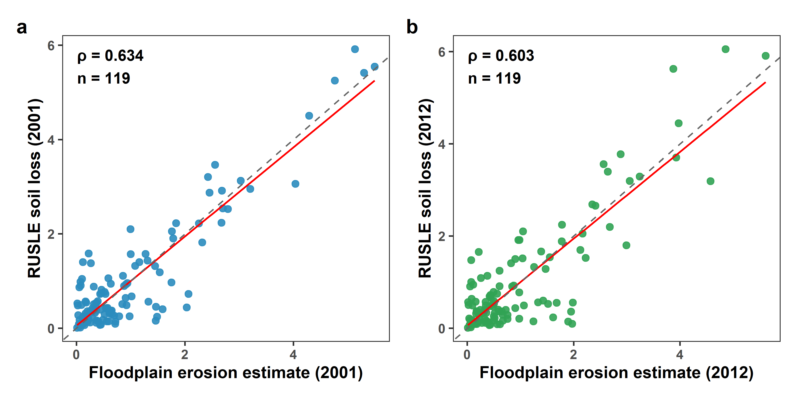
Fig Supplementary_8: Validation of floodplain erosion. Scatterplots comparing basin-scale global potential floodplain erosion estimated in this study with independent RUSLE-derived soil loss estimates for (a) 2001 and (b) 2012. Here, each point represents an individual river basin (n = 119), with the red solid line indicating the least-squares linear regression. Spearman's correlation coefficients were estimated, supporting the reliability of the potential floodplain soil erosion estimates derived in this study (r = 0.634 for 2001 and r = 0.603 for 2012).

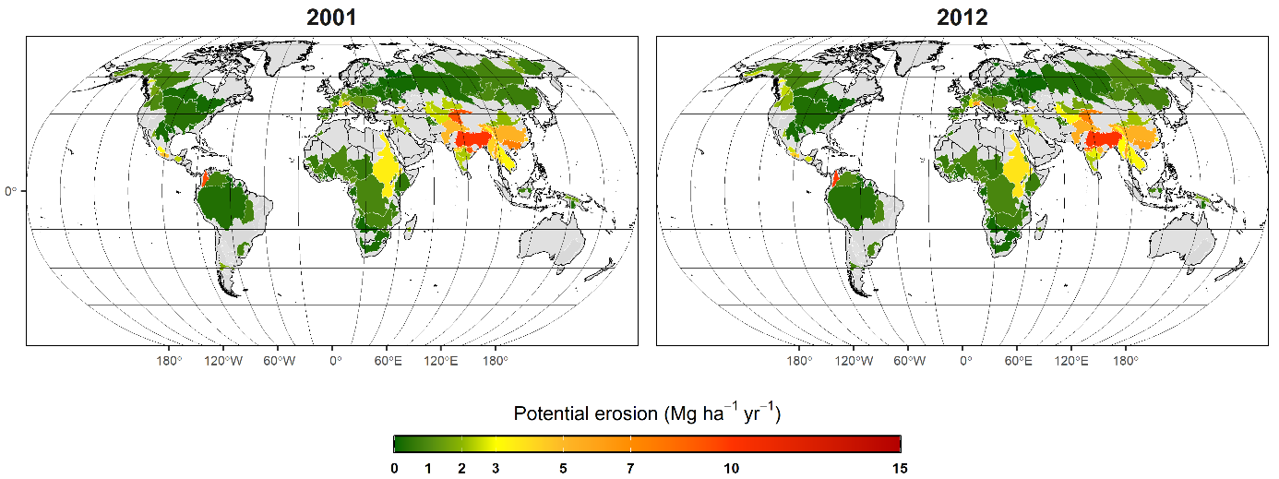
Fig Supplementary_9: Spatial distribution of estimated floodplain potential erosion (t ha⁻¹ yr⁻¹) across major river basins.

References
1. Renard, K. G. ., Foster, G. R. ., Weesies, G. A. ., McCool, D. K. . & Yoder, D. C. . Predicting Soil Erosion by Water : A Guide to Conservation Planning with the Revised Universal Soil Loss Equation (RUSLE). (U.S. Department of Agriculture, Agricultural Research Service ; U.S. Government Printing Office, 1997).
2. De, N., Loureiro, S., De, M. & Coutinho, A. A New Procedure to Estimate the RUSLE EI 30 Index, Based on Monthly Rainfall Data and Applied to the Algarve Region, Portugal. www.elsevier.com/locate/jhydrol.
3. Shamshad, A., Azhari, M. N., Isa, M. H., Hussin, W. M. A. W. & Parida, B. P. Development of an appropriate procedure for estimation of RUSLE EI30 index and preparation of erosivity maps for Pulau Penang in Peninsular Malaysia. Catena (Amst). 72, 423–432 (2008).
4. Panagos, P. et al. Global rainfall erosivity assessment based on high-temporal resolution rainfall records. Sci. Rep. 7, (2017).
5. Li, P. et al. Determining the drivers and rates of soil erosion on the Loess Plateau since 1901. Science of the Total Environment 823, (2022).
6. Xiong, M. & Leng, G. Global soil water erosion responses to climate and land use changes. Catena vol. 241 Preprint at https://doi.org/10.1016/j.catena.2024.108043 (2024).
7. Pan, J. & Wen, Y. Estimation of soil erosion using RUSLE in Caijiamiao watershed, China. Natural Hazards 71, 2187–2205 (2014).
8. Arnoldus. A 1.76 537 1 1 8 8 2 PREDICTING RAINFALL EROSION LOSSES A GUIDE TO CONSERVATION PLANNING UNIVERSITY OF VIRGINIA LIBRARY I N I A X001754985 UNITED STATES DEPARTMENT OF AGRICULTURE AGRICULTURE. (1977).

