Supplementary Information

Supplementary Tables

Table S3. 3D reconstruction performance (mean/sd) of different methods across different scenario in mouse visual cortex data
Methods | Spearman Correlation | RMSE | 3D SSIM
NTF (Scenario 1) | 0.48(0.02) | 1.00(0.26) | 0.86(0.06)
SpatialZ (Scenario 1) | 0.42(0.04) | 1.23(0.33) | 0.82(0.06)
FEAST (Scenario 1) | 0.32(0.05) | 1.76(0.21) | 0.69(0.04)
NTF (Scenario 2) | 0.44(0.04) | 0.96(0.27) | 0.94(0.04)
SpatialZ (Scenario 2) | 0.38(0.06) | 1.08(1.33) | 0.93(0.05)
FEAST (Scenario 2) | 0.23(0.03) | 1.85(0.22) | 0.82(0.04)
NTF (Scenario 3) | 0.52(0.04) | 1.01(0.24) | 0.89(0.07)
NTF (Scenario 4) | 0.40(0.05) | 0.99(0.25) | 0.97(0.02)
NTF (Scenario 5) | 0.38(0.02) | 1.01(0.23) | 0.92(0.04)

Supplementary Figures
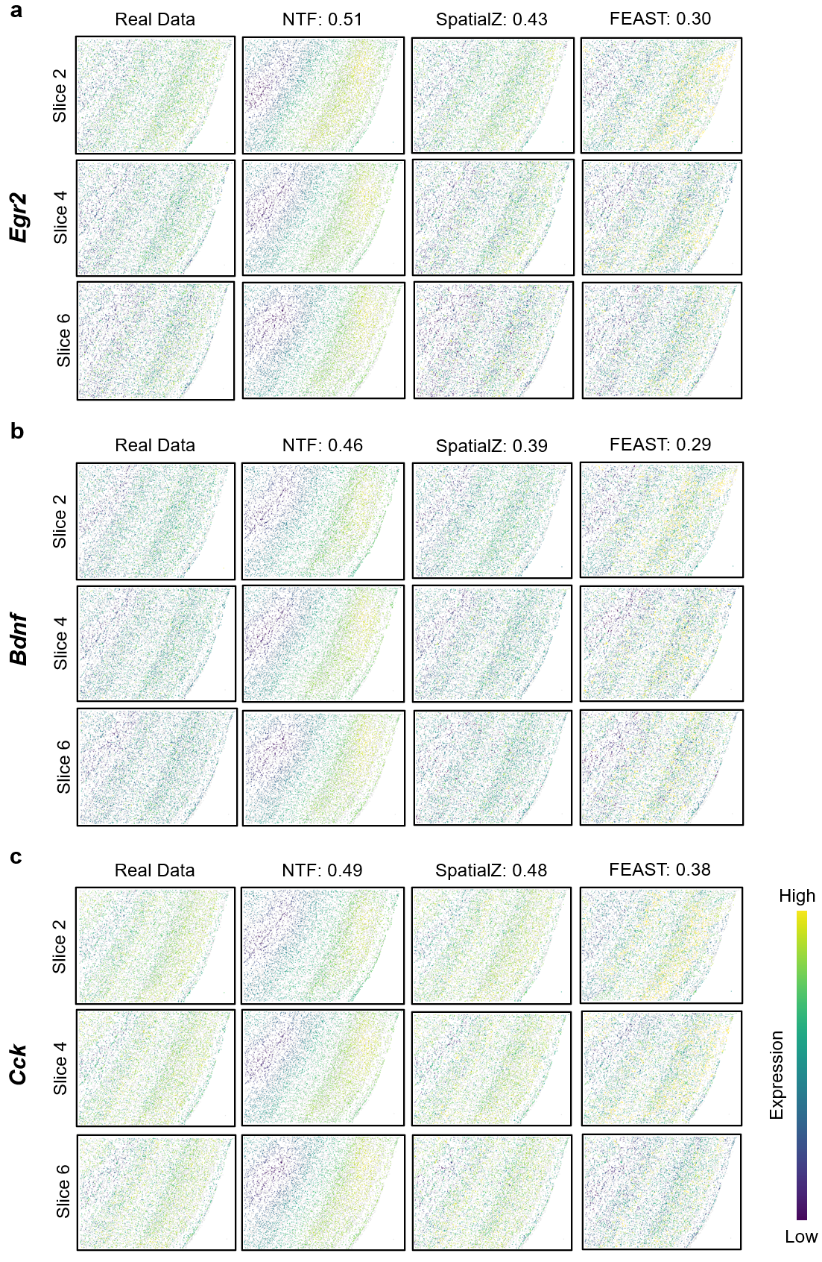

SFig. 1 | Visualization of additional genes in intermediate-slice prediction setting on mouse visual cortex data. In the first setting, we trained on slices 1, 3, 5 and 7 and reconstructed the held-out intermediate slices 2, 4 and 6. a, Ground truth and reconstruction results of gene Egr2. b, Ground truth and reconstruction results of gene Bdnf. c, Ground truth and reconstruction results of gene Cck.

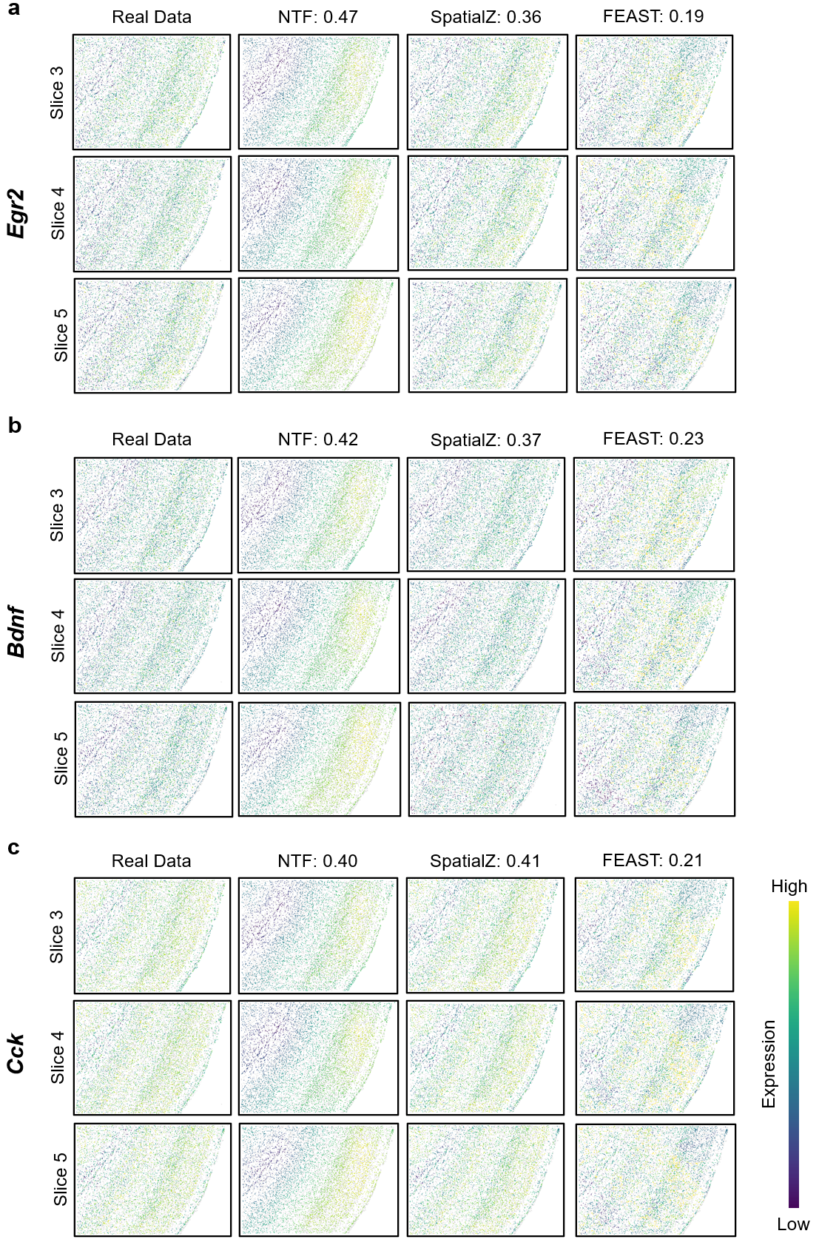

SFig. 2 | Visualization of additional genes in large-block prediction setting on mouse visual cortex data. Wider-gap held-out strategy in which slices 1, 2, 6 and 7 are used for training and slices 3, 4 and 5 are reconstructed. a, Ground truth and reconstruction results of gene Egr2. b, Ground truth and reconstruction results of gene Bdnf. c, Ground truth and reconstruction results of gene Cck.

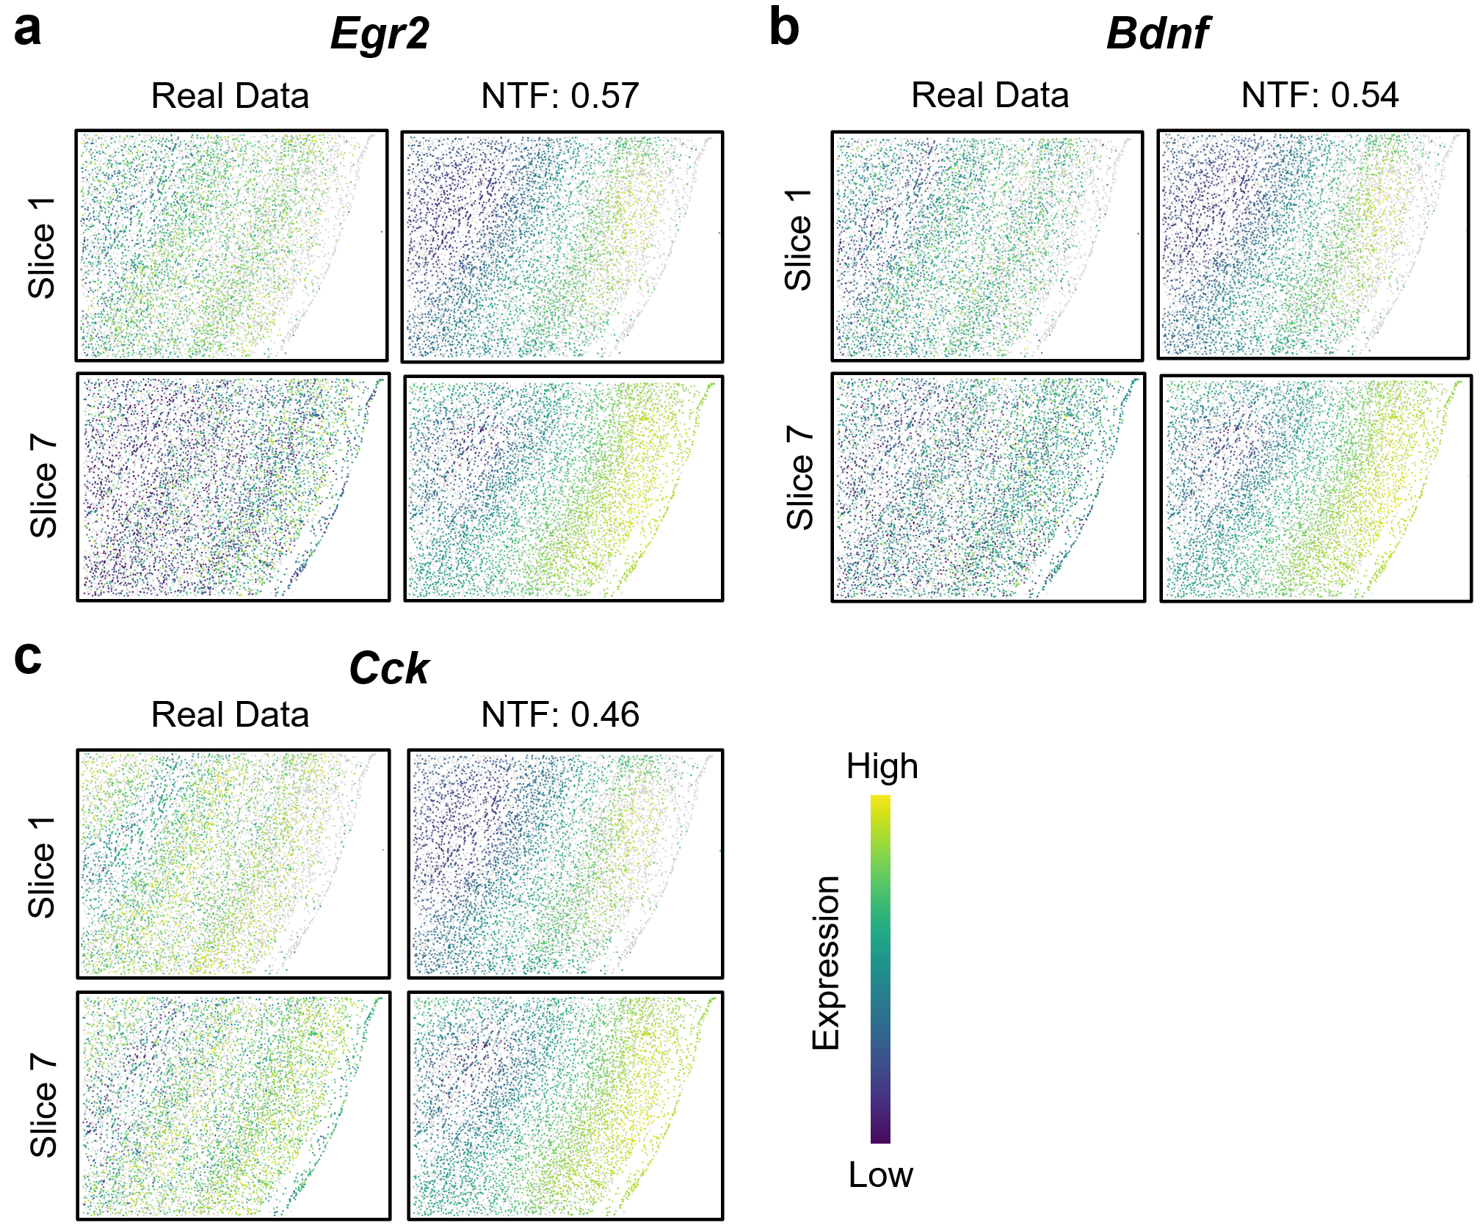

SFig. 3 | Visualization of additional genes in two-side prediction setting on mouse visual cortex data. This is extrapolative next-slice prediction setting in which slices 2-6 are used for training and slices 1 and 7 are predicted. a, Ground truth and reconstruction results of gene Egr2. b, Ground truth and reconstruction results of gene Bdnf. c, Ground truth and reconstruction results of gene Cck.

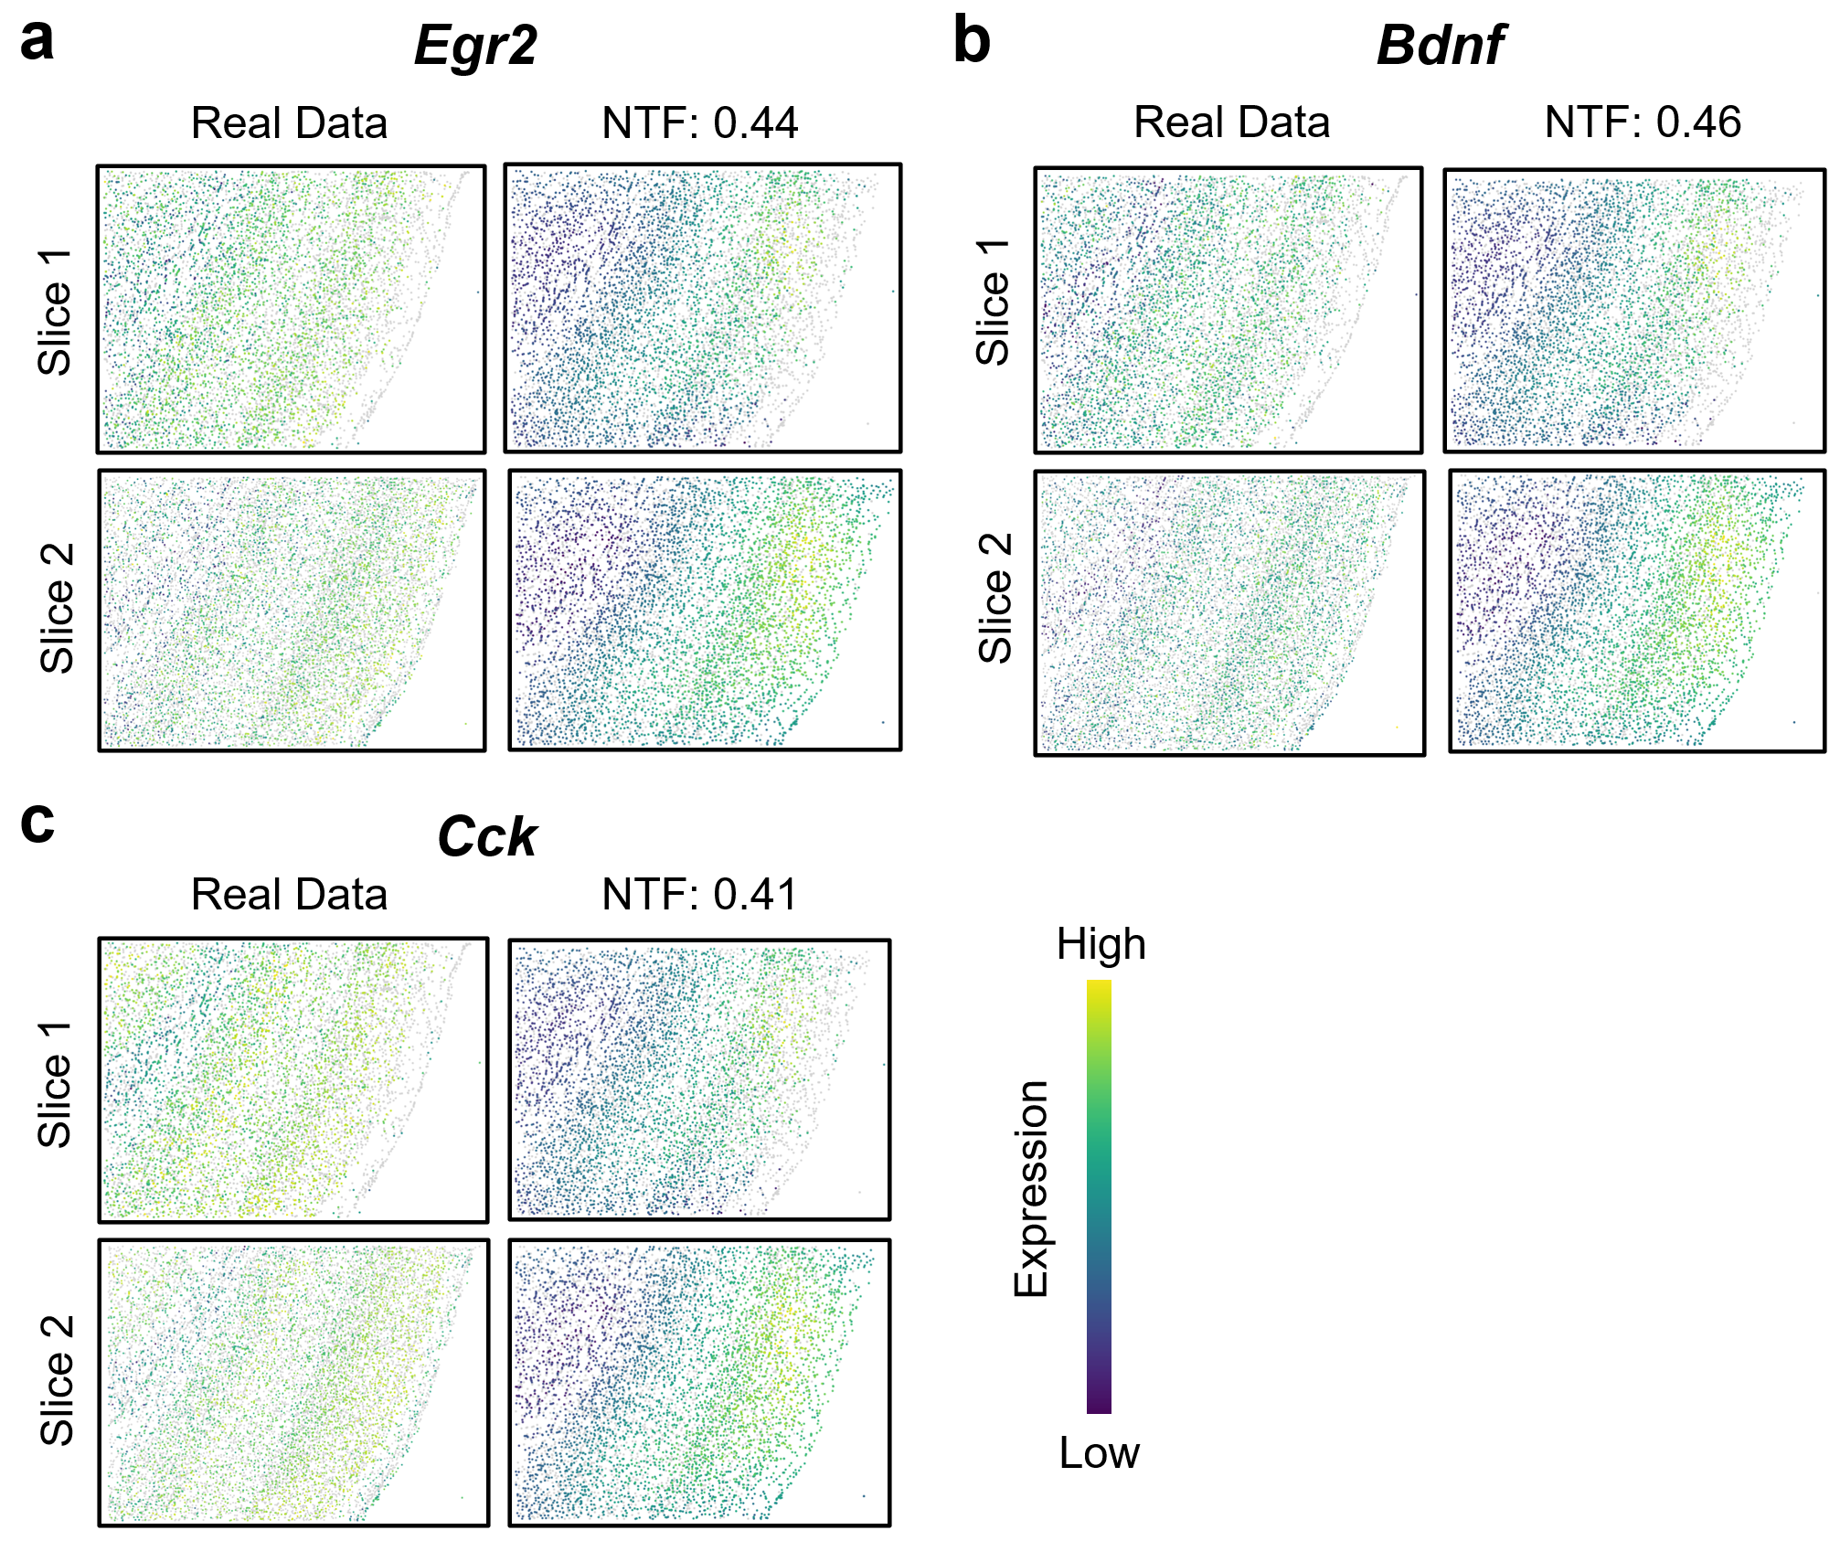

SFig. 4 | Visualization of additional genes in head slice prediction setting on mouse visual cortex data. This is backward extrapolation: NTF predicts the expression patterns of slices 1 and 2 using only slices 3–7 as training input. a, Ground truth and reconstruction results of gene Egr2. b, Ground truth and reconstruction results of gene Bdnf. c, Ground truth and reconstruction results of gene Cck.

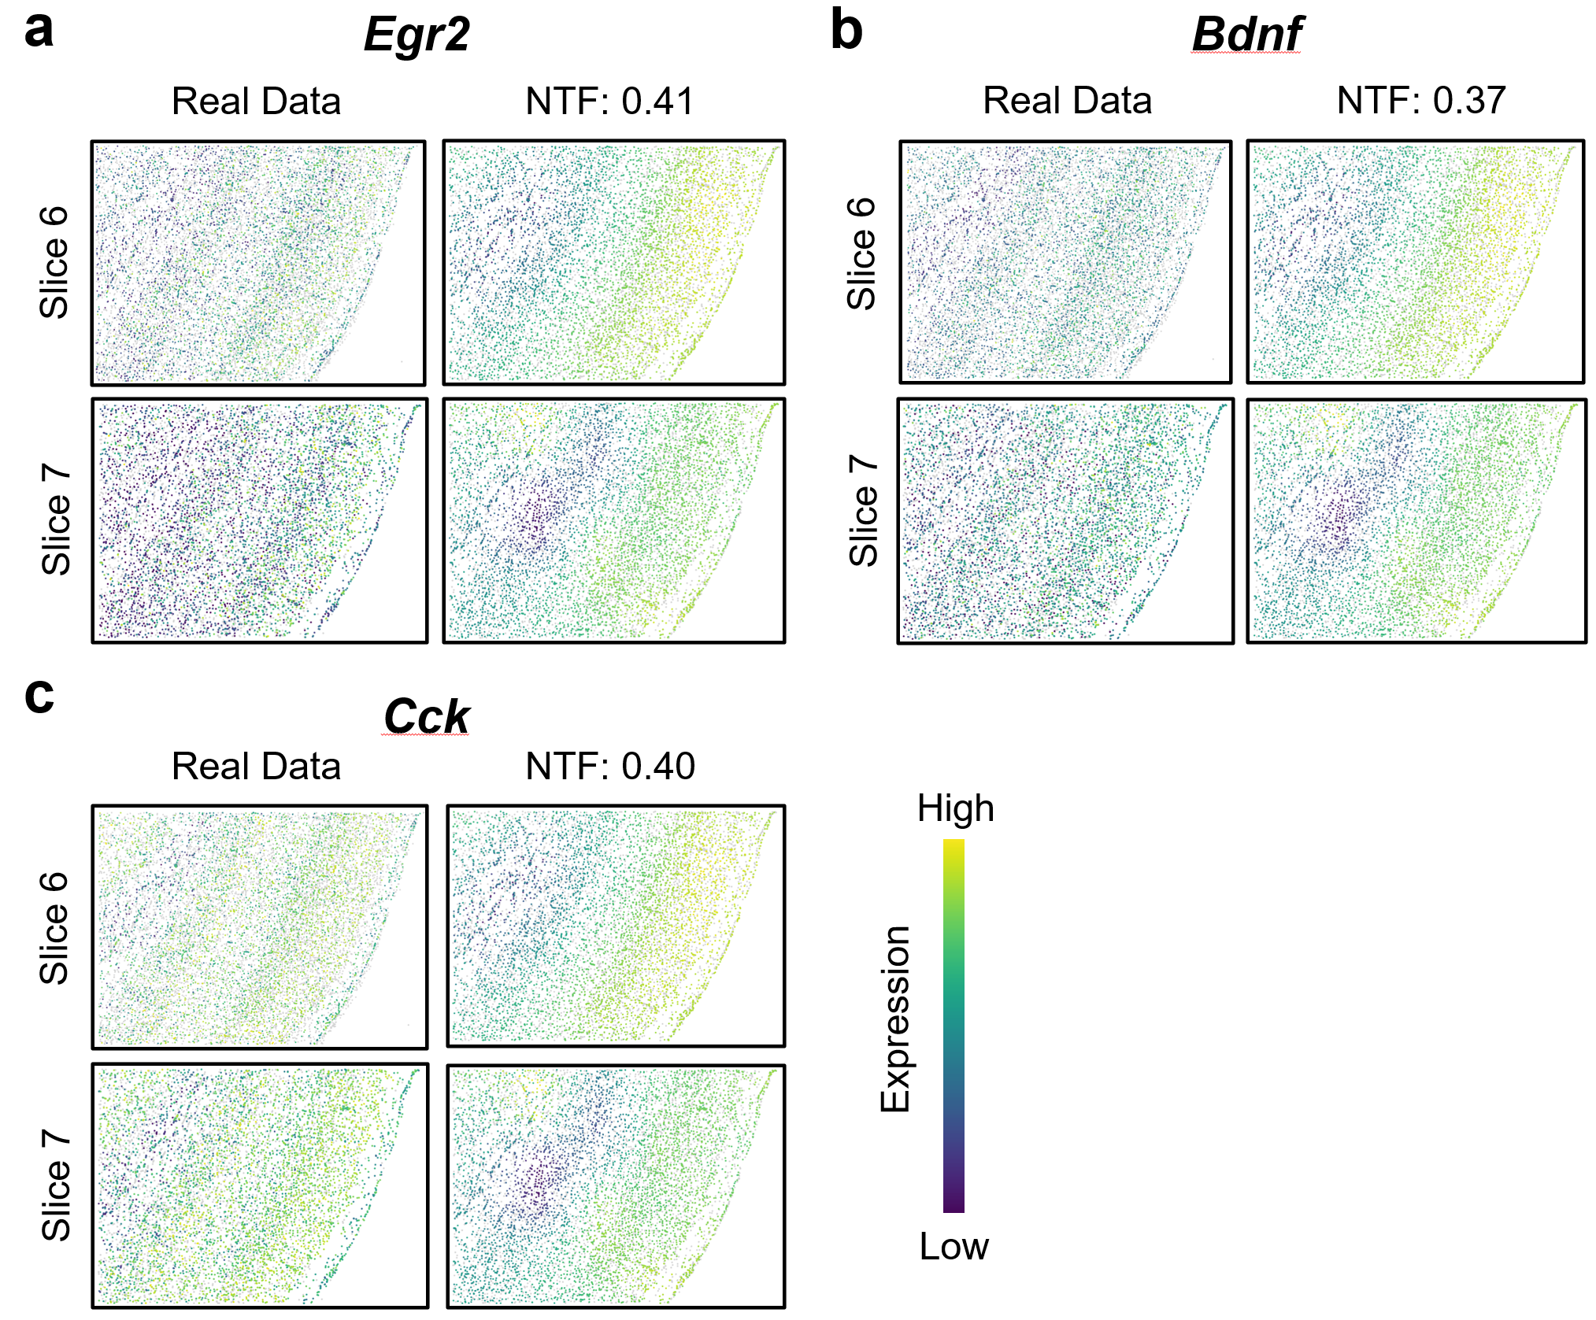

SFig. 5 | Visualization of additional genes in tail slice prediction setting on mouse visual cortex data. This is forward extrapolation: NTF predicts slices 6 and 7 using only slices 1–5 as training input. a, Ground truth and reconstruction results of gene Egr2. b, Ground truth and reconstruction results of gene Bdnf. c, Ground truth and reconstruction results of gene Cck.

