Additional files
Additional file 1. Figure S1. Directional classification flow and misclassification breakdown.
(A) Directional classification flow and misclassification breakdown. The Sankey diagram (top) visualizes the flow of 8,387 variant classifications from VCEP Ground Truth (left) to AIVA Predictions (right), color-coded by directional class (red: P/LP; gold: VUS; blue: B/LB). (B) The stacked bar chart (top left) quantifies classification distribution by true class, showing correct predictions and misclassification destinations using the same color scheme. (C) The pie chart (top right) provides a proportional breakdown of misclassification modes, with slice colors derived from the source class, confirming that conservative adjacent-category shifts dominate (Benign to VUS: 34.5%, VUS to P/LP: 29.7%) while binary clinical misclassification (Pathogenic↔Benign) remains <1.3%.

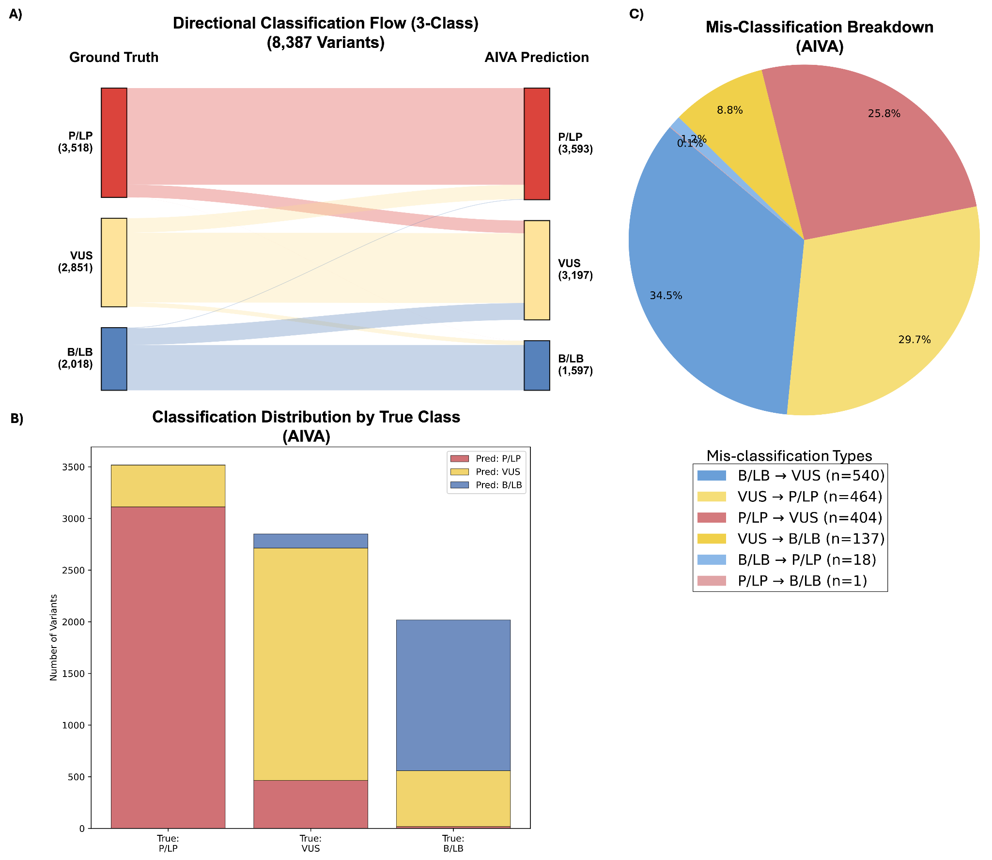

Additional file 2. Supplementary Methods S1. Variant prioritization prompt template.

To improve reproducibility, we provide the exact instruction template used for AIVA inference. In implementation, the model received one concatenated prompt containing (i) patient context, (ii) task instruction, and (iii) output-schema constraints.
“
You are a clinical genetic variant analyst for Mendelian disease triage. Given phenotype terms and candidate genes/variants, rank candidate genes by likelihood of causality. Prioritize phenotype-gene consistency and known disease mechanisms. Return structured JSON only.

Age of Onset: {age_of_onset}
Positive Phenotypes (present):
{positive_hpo_terms_with_labels}
Negative Phenotypes (absent):
{negative_hpo_terms_with_labels}
Disease ID: {disease_id_optional}
Candidate Genes with observed genomic positions (provided as gene-prioritization context only and do not perform variant classification):
{candidate_gene_variant_lines}
- Please identify and rank the most likely causal gene(s) based on the provided information. Prioritize literature review over open web search.
- Return ONLY valid JSON in this exact format (no markdown, no explanation):
{"Rationale": "Brief explanation of reasoning (optional)", "predicted_genes": [{"gene": "GENE1", "score": 0.95}, {"gene": "GENE2", "score": 0.87}, ...]}
Where:
- "predicted_genes" is a list of gene predictions, each with a "gene" name and a "score" (confidence between 0 and 1).
- The list should be ordered from most likely to least likely gene.
- If no genes can be predicted, return {"predicted_genes": []}
- Include all genes from the Candidate Genes list; put non-causal ones last with low scores.
“
Additional file 3. Supplementary Methods S2: Variant Classification Prompt Template

To ensure reproducibility of the variant classification task, we detail the exact inference specifications used for AIVA. Classification was executed via structured API calls rather than free-text prompts. The inference payload provided the model with explicit fields for variant representation (e.g., HGVS or genomic coordinates), baseline analysis settings (ACMG/AMP protocol and genome assembly), and specific clinical context (patient phenotype terms, target gene symbol, and mode of inheritance). The response structure was strictly enforced by the API endpoint contract, standardizing the model output into discrete fields for the final classification label, confidence level, applied ACMG criteria, and a detailed evidence summary. Below is the prompt template:

“{
"variant_data": {
"hgvs": "<variant_hgvs_expression>"
},
"classification_type": "acmg",
"assembly": "GRCh37",
"model": "google/gemini-3-pro-preview",
"phenotype_terms": "<disease_name>",
"description": "Gene: <target_gene_symbol>",
"additional_context": "Mode of inheritance: <mode_of_inheritance>"
}
“

Additional file 4. Table S1: Disease Categories and Expert Panels (VCEPs) in the Benchmark Dataset: A total of 8,387 variants curated by 35 ClinGen Variant Curation Expert Panels (VCEPs) were retained after HGVS-based filtering and matching against the ClinVar dataset and broadly classified into 11 disease categories.

Disease Category | Expert Panel | Variants (n) | AIVA  Macro F1 (%) | BIAS-2015  Macro F1 (%) | InterVar  Macro F1 (%)
Cancer Predisposition | Myeloid Malignancy | 1,387 | 75.9% | 72.2% | 65.0%
Cancer Predisposition | CDH1 | 284 | 71.8% | 72.7% | 58.1%
Cancer Predisposition | PTEN | 186 | 78.7% | 82.1% | 65.9%
Cancer Predisposition | DICER1 & miRNA-Processing | 133 | 77.8% | 66.5% | 64.1%
Cancer Predisposition | TP53 | 121 | 48.0% | 59.4% | 33.0%
Cancer Predisposition | Hereditary Breast, Ovarian & Pancreatic | 116 | 87.7% | 74.8% | 63.7%
Cancer Predisposition | InSiGHT Hereditary Colorectal | 87 | 71.5% | 74.6% | 51.4%
Cancer Predisposition | ENIGMA BRCA1 & BRCA2 | 39 | 66.6% | 57.4% | 51.1%
Cancer Predisposition | VHL | 29 | 77.5% | 67.4% | 59.2%
Cancer Predisposition | Subtotal | 2,382 | 78.2% | 77.9% | 64.9%
Metabolic Disorders | Monogenic Diabetes | 825 | 67.1% | 63.9% | 52.1%
Metabolic Disorders | Phenylketonuria | 593 | 85.4% | 70.4% | 60.8%
Metabolic Disorders | Familial Hypercholesterolemia | 415 | 79.8% | 76.2% | 50.1%
Metabolic Disorders | Lysosomal Diseases | 334 | 86.3% | 75.5% | 64.8%
Metabolic Disorders | Cerebral Creatine Deficiency | 266 | 79.9% | 71.0% | 56.9%
Metabolic Disorders | ACADVL | 199 | 79.7% | 64.5% | 60.7%
Metabolic Disorders | Mitochondrial Diseases | 45 | 88.5% | 86.2% | 86.6%
Metabolic Disorders | Subtotal | 2,677 | 80.2% | 72.3% | 58.9%
Cardiovascular | Cardiomyopathy | 169 | 85.6% | 82.2% | 60.1%
Cardiovascular | FBN1 | 106 | 71.0% | 64.7% | 29.9%
Cardiovascular | Pulmonary Hypertension | 66 | 69.8% | 46.2% | 37.4%
Cardiovascular | Subtotal | 341 | 81.5% | 72.7% | 50.5%
Hematologic | Platelet Disorders | 473 | 81.0% | 76.2% | 60.5%
Hematologic | Coagulation Factor Deficiency | 87 | 74.7% | 53.6% | 55.7%
Hematologic | Thrombosis | 70 | 90.1% | 63.0% | 61.9%
Hematologic | von Willebrand Disease | 65 | 91.2% | 63.4% | 43.0%
Hematologic | Subtotal | 695 | 84.7% | 71.6% | 59.3%
Immunodeficiency | Severe Combined Immunodeficiency | 379 | 85.6% | 81.2% | 71.4%
Immunodeficiency | Subtotal | 379 | 85.6% | 81.2% | 71.4%
Neurodevelopmental | Rett & Angelman-like Disorders | 387 | 71.9% | 73.8% | 52.9%
Neurodevelopmental | Subtotal | 387 | 71.9% | 73.8% | 52.9%
Neuromuscular | Malignant Hyperthermia Susceptibility | 323 | 78.8% | 70.2% | 51.4%
Neuromuscular | Limb Girdle Muscular Dystrophy | 115 | 61.4% | 64.2% | 44.5%
Neuromuscular | Congenital Myopathies | 86 | 84.6% | 68.4% | 67.6%
Neuromuscular | Subtotal | 524 | 81.7% | 73.2% | 61.7%
Ophthalmologic | Glaucoma | 207 | 83.8% | 84.2% | 52.6%
Ophthalmologic | Leber Congenital Amaurosis / EORD | 125 | 77.0% | 61.7% | 43.8%
Ophthalmologic | Subtotal | 332 | 85.3% | 79.2% | 49.8%
Hearing | Hearing Loss | 196 | 77.5% | 78.5% | 56.9%
Hearing | Subtotal | 196 | 77.5% | 78.5% | 56.9%
RASopathies | RASopathy | 365 | 86.5% | 83.3% | 65.5%
RASopathies | Subtotal | 365 | 86.5% | 83.3% | 65.5%
Other | Brain Malformations | 42 | 97.3% | 97.2% | 59.5%
Other | Hereditary Hemorrhagic Telangiectasia | 36 | 93.3% | 71.4% | 62.2%
Other | Epilepsy Sodium Channel | 31 | 66.7% | 58.5% | 52.2%
Other | Subtotal | 109 | 88.0% | 77.3% | 58.7%
OVERALL TOTAL |  | 8,387 | 80.5% | 75.3% | 60.6%

