Harnessing Post-excitation Evolution of Radical Clusters via Spatially Coherent Vacuum Ultraviolet Irradiation for Enhanced Chemical Transformations
Yanei Xueª, Wenjun Sun^{a,#}, Che Liu^{b}, Guoqing Jiangª, Ranlong Xuª, Yuanna Zhangª

ª School of Environment
Tsinghua University
Beijing, 100084, China
E-mail: wsun@tsinghua.edu.cn

^{b} China Electronics Engineering Design Institute Co., Ltd.,
Beijing, 100840, China

contents
Tab. 1 The chain reaction between the various free radicals. 3
Tab. 2 Available performance and conditions for reactions of PFAS in related VUV₁₈₅ reactors. 5
Tab. 3 Optical properties of CaF₂ lens. 6
Tab. 4 Water quality parameters of the collected actual water samples. 7
Tab. 5 The changes of pH of PFAS solution in the process of VUV_CCB reactions. 8
Text 1 The quantitative quantum yield detection methods for HO• and e_{aq}⁻ 9
HO• 9
e_{aq}⁻ 10
Text 2 Calculation method of the contribution ratios of the three reaction pathways to TOC and PFAS removal. 11
Text 3 Calculated Mulliken charges and spin density data of hydroxyl radical clusters((HO•)_{n}): A comparison of systems with and without a light field. 12
Text 4 Determination of the FR-Dependent Apparent Barrier (E_{a}) 19
Text 5 Calculation of the defluorination ratio. 20
Text 6 Life Cycle Analyses and Techno-Economic Assessment of the various types of PFAS disposal techniques. 21
Text 7 Detailed Information on Materials and Methods 24
Text 8 Measurement of PFAS Parent Compound. 25
Fig. 1 Experimentally validated FR quantum yield ($ΦFRexp$). 26
Fig. 2 The fluorescence emission spectra in the presence of TA in VUV based systems. (inset: mechanism diagram of TA capturing HO•). 27
Fig. 3 DFT-calculated VUV absorption spectra of PFOA, highlighting characteristic peaks within the vacuum ultraviolet(100-200nm) range. 28
Fig. 4 Contribution ratios of the three reaction pathways to TOC and PFAS removal in ultrapure water within the VUV_CCB system. 29
Fig. 5 Comparative degradation kinetics and rate constants of TOC in H₂O and D₂O under the VUV_CCB system. 30
Fig. 6 Performance of an on-site VUV_CCB pilot system for the continuous production of electronic-grade ultrapure water. 31
Fig. 7 Schematic configuration of the pilot-scale circulating VUV_CCB system for on-site PFAS remediation. 32
Fig. 8 Traditional E-UPW process flow and VUV_CCB upgrade plan 33
References 34

Tab. 1 The chain reaction between the various free radicals.
 | Reaction | Constant
R1 | $${\text{H}}_{\text{2}}\text{O}\text{+}{\text{hv}}_{\text{185nm}}\text{→}{\text{HO}}^{\text{•}}\text{+}{\text{H}}^{\text{•}}$$ | $${\text{Φ}}_{1}\text{=0.33}$$
R2 | $${\text{H}}_{\text{2}}\text{O}\text{+}{\text{hv}}_{\text{185}}\text{→}{\text{H}\text{O}}^{\text{•}}\text{+}{\text{H}}^{\text{+}}\text{+}{\text{e}}_{\text{aq}}^{\text{-}}$$ | $${\text{Φ}}_{2}\text{=0.045}$$
R3 | $${\text{H}}_{\text{2}}{\text{O}}_{\text{2}}\text{+}{\text{hv}}_{\text{185}}\text{→}\text{2}{\text{HO}}^{\text{•}}$$ | $${\text{Φ}}_{3}\text{=0.5}$$
R4 | $${\text{H}}_{\text{2}}{\text{O}}_{\text{2}}\text{+}{\text{hv}}_{\text{254}}\text{→}\text{2}{\text{HO}}^{\text{•}}$$ | $${\text{Φ}}_{4}\text{=0.5}$$
R5 | $${\text{O}}_{\text{2}}\text{+}{\text{H}}^{\text{•}}\text{→}{\text{HO}}_{\text{2}}^{\text{•}}$$ | $$k_{5}\text{=2.1×}{\text{10}}^{\text{10}}M^{-1}s^{-1}$$
R6 | $${\text{O}}_{\text{2}}\text{+}{\text{e}}_{\text{aq}}^{\text{-}}\text{→}{\text{O}}_{\text{2}}^{\text{•}\text{-}}$$ | $$k_{6}\text{=2.0×}{\text{10}}^{\text{10}}M^{-1}s^{-1}$$
R7 | $${\text{H}}_{\text{2}}{\text{O}}_{\text{2}}\text{+}{\text{HO}}^{\text{•}}\text{→}{\text{HO}}_{\text{2}}^{\text{•}}\text{+}{\text{H}}_{\text{2}}\text{O}$$ | $$k_{7}\text{=2.7×}{\text{10}}^{7}M^{-1}s^{-1}$$
R8 | $${\text{H}}_{\text{2}}{\text{O}}_{\text{2}}\text{+}{\text{HO}}_{\text{2}}^{\text{•}}\text{→}{\text{HO}}^{\text{•}}\text{+}{\text{O}}_{\text{2}}\text{+}{\text{H}}_{\text{2}}\text{O}$$ | $$k_{8}\text{=5.3×}{\text{10}}^{2}M^{-1}s^{-1}$$
R9 | $${\text{H}}_{\text{2}}{\text{O}}_{\text{2}}\text{+}{\text{O}}_{\text{2}}^{\text{•}\text{-}}\text{→}{\text{HO}}^{\text{•}}\text{+}{\text{O}}_{\text{2}}\text{+}{\text{HO}}^{\text{-}}$$ | $$k_{9}\text{=1.6×}{\text{10}}^{1}M^{-1}s^{-1}$$
R10 | $${\text{H}}_{\text{2}}\text{+}{\text{HO}}^{\text{•}}\text{→}{\text{H}}_{\text{2}}\text{O}\text{+}{\text{H}}^{\text{•}}$$ | $$k_{10}\text{=6.0×}{\text{10}}^{7}M^{-1}s^{-1}$$
R11 | $${\text{HO}}^{\text{•}}\text{+}{\text{HO}}^{\text{•}}\text{→}{\text{H}}_{\text{2}}{\text{O}}_{\text{2}}$$ | $$k_{11}\text{=4.0×}{\text{10}}^{9}M^{-1}s^{-1}$$
R12 | $${\text{HO}}_{\text{2}}^{\text{•}}{\text{+}\text{HO}}_{\text{2}}^{\text{•}}\text{→}{\text{H}}_{\text{2}}{\text{O}}_{\text{2}}\text{+}{\text{O}}_{\text{2}}$$ | $$k_{12}\text{=2.6×}{\text{10}}^{6}M^{-1}s^{-1}$$
R13 | $${\text{H}}^{\text{•}}\text{+}{\text{H}}^{\text{•}}\text{→}{\text{H}}_{\text{2}}$$ | $$k_{13}\text{=1.0×}{\text{10}}^{10}M^{-1}s^{-1}$$
R14 | $${\text{HO}}^{\text{•}}\text{+}{\text{H}}^{\text{•}}\text{→}{\text{H}}_{\text{2}}\text{O}$$ | $$k_{14}\text{=7.0×}{\text{10}}^{9}M^{-1}s^{-1}$$
R15 | $${\text{HO}}^{\text{•}}\text{+}{\text{O}}_{\text{2}}^{\text{•}\text{-}}\text{→}{\text{O}}_{\text{2}}\text{+}{\text{HO}}^{\text{-}}$$ | $$k_{15}\text{=7.0×}{\text{10}}^{9}M^{-1}s^{-1}$$
R16 | $${\text{HO}}^{\text{•}}\text{+}{\text{HO}}_{\text{2}}^{\text{•}}\text{→}{\text{H}}_{\text{2}}\text{O}\text{+}{\text{O}}_{\text{2}}$$ | $$k_{16}\text{=6.6×}{\text{10}}^{9}M^{-1}s^{-1}$$
R17 | $${\text{HO}}_{\text{2}}^{\text{•}}\text{+}{\text{O}}_{\text{2}}^{\text{•}\text{-}}\text{→}{\text{O}}_{\text{2}}\text{+}{\text{HO}}_{\text{2}}^{\text{-}}$$ | $$k_{17}\text{=9.7×}{\text{10}}^{7}M^{-1}s^{-1}$$
R18 | $${\text{e}}_{\text{aq}}^{\text{-}}\text{+}{\text{HO}}^{\text{•}}\text{→}{\text{HO}}^{\text{-}}$$ | $$k_{18}\text{=3.0×}{\text{10}}^{10}M^{-1}s^{-1}$$
R19 | $$\text{2}{\text{O}}_{\text{2}}^{\text{•}\text{-}}\text{+}\text{2}{\text{H}}_{\text{2}}\text{O}\text{→}{\text{O}}_{\text{2}}\text{+}{\text{H}}_{\text{2}}{\text{O}}_{\text{2}}\text{+2}{\text{HO}}^{\text{-}}$$ | $$k_{19}\text{=3.0×}{\text{10}}^{-1}M^{-1}s^{-1}$$
R20 | $${\text{e}}_{\text{aq}}^{\text{-}}\text{+}{\text{H}}^{\text{•}}\text{+}{\text{H}}_{\text{2}}\text{O}\text{→}{\text{H}}_{\text{2}}\text{+}{\text{HO}}^{\text{-}}$$ | $$k_{20}\text{=2.5×}{\text{10}}^{10}M^{-1}s^{-1}$$
R21 | $${\text{HO}}^{\text{•}}\text{+}{\text{HO}}_{\text{2}}^{\text{-}}\text{→}{\text{HO}}_{\text{2}}^{\text{•}}\text{+}{\text{HO}}^{\text{-}}$$ | $$k_{21}\text{=7.5×}{\text{10}}^{9}M^{-1}s^{-1}$$
R22 | $${\text{HO}}^{\text{•}}\text{+}{\text{HO}}^{\text{-}}\text{→}{\text{O}}^{\text{•}\text{-}}\text{+}{\text{H}}_{\text{2}}\text{O}$$ | $$k_{22}\text{=3.9×}{\text{10}}^{8}M^{-1}s^{-1}$$
R23 | $${\text{H}}^{\text{•}}\text{+}{\text{HO}}^{\text{-}}\text{→}{\text{e}}_{\text{aq}}^{\text{-}}\text{+}{\text{H}}_{\text{2}}\text{O}$$ | $$k_{23}\text{=3.6×}{\text{10}}^{8}M^{-1}s^{-1}$$
R24 | $${\text{H}}_{\text{2}}{\text{O}}_{\text{2}}\text{+}{\text{e}}_{\text{aq}}^{\text{-}}\text{→}{\text{HO}}^{\text{•}}\text{+}{\text{HO}}^{\text{-}}$$ | $$k_{24}\text{=1.1×}{\text{10}}^{10}M^{-1}s^{-1}$$
R25 | $${\text{e}}_{\text{aq}}^{\text{-}}\text{+}{\text{H}}^{\text{+}}\text{→}{\text{H}}^{\text{•}}$$ | $$k_{25}\text{=2.3×}{\text{10}}^{10}M^{-1}s^{-1}$$
R26 | $${\text{e}}_{\text{aq}}^{\text{-}}\text{+}{\text{H}}_{\text{2}}\text{O}\text{→}{\text{H}}^{\text{•}}\text{+}{\text{HO}}^{\text{-}}$$ | $$k_{26}\text{=1.9×}{\text{10}}^{1}M^{-1}s^{-1}$$
R27 | $${\text{H}}^{\text{•}}\text{+}{\text{HO}}_{\text{2}}^{\text{-}}\text{→}{\text{HO}}_{\text{2}}^{\text{•}}\text{+}{\text{HO}}^{\text{-}}$$ | $$k_{27}\text{=1.0×}{\text{10}}^{10}M^{-1}s^{-1}$$
R28 | $${\text{H}}^{\text{•}}\text{+}{\text{H}}_{\text{2}}{\text{O}}_{\text{2}}\text{→}{\text{H}}_{\text{2}}\text{O}\text{+}{\text{HO}}^{\text{•}}$$ | $$k_{28}\text{=9.0×}{\text{10}}^{7}M^{-1}s^{-1}$$
R29 | $${\text{e}}_{\text{aq}}^{\text{-}}\text{+}{\text{HO}}_{\text{2}}^{\text{-}}\text{+}{\text{H}}_{\text{2}}\text{O}\text{→2}{\text{HO}}^{\text{-}}\text{+}{\text{HO}}^{\text{•}}$$ | $$k_{29}\text{=3.5×}{\text{10}}^{9}M^{-1}s^{-1}$$
R30 | $${\text{H}}^{\text{•}}\text{+}{\text{O}}_{\text{2}}^{\text{•}\text{-}}\text{→}{\text{HO}}_{\text{2}}^{\text{-}}$$ | $$k_{30}\text{=2.0×}{\text{10}}^{10}M^{-1}s^{-1}$$
R31 | $${\text{H}}_{\text{2}}\text{O↔}{\text{H}}^{\text{+}}\text{+}{\text{HO}}^{\text{-}}$$ | $$k_{{\text{H}}_{\text{2}}\text{0}}\text{=}{10}^{-14}$$
R32 | $${\text{H}}_{\text{2}}{\text{O}}_{\text{2}}\text{↔}{\text{H}}^{\text{+}}\text{+}{\text{HO}}_{\text{2}}^{\text{-}}$$ | $$k_{{\text{H}}_{\text{2}}{\text{O}}_{\text{2}}}\text{=}{2.23\text{×10}}^{-12}$$

Tab. 2 Available performance and conditions for reactions of PFAS in related VUV₁₈₅ reactors.
PFAS | deC%  (k_{ros}, min⁻¹) | DeF%  (VOF) | TOC% | Reaction conditions | Ref
PFOA | 62%  (0.0018) | 27% | -- | pH 12, 480min, light sources(LS): 8.0 mW/cm², closed quartz tubes, 40mL | ¹
PFOA | 99%  (0.012) | 20% | -- | pH (original), 180min, SEN Light Corporation:20.73 mW/cm², glass reactor, 1.5L | ²
PFOA | 88%  (0.0045) | 15% | -- | pH 10, 360min, Sankyo Electric Corporation, closed Pyrex glass reactor, 2L | ³
PFOA | 80%  (0.025) | 25% | -- | pH (original), 120min, Cnlight Corporation: 62–69 mW/cm², tubular glass reactor,0.8L | ⁴
PFOA | -- | 43.2% | -- | pH 5, 360min, Shanghai Jiguang Special Lighting Appliance Factory, China, cylindrical glass reactor, 250mL | ⁵
PFOA | 61.7%  (0.0558) | 17.1% | -- | pH 3.7, 120min, LS, tubular glass reactor, 800mL | ⁶
C7 HFPO-TA | 58%  (0.0021) | 27% | 30% | pH 12, 480min, LS: 8.0 mW/cm², closed quartz tubes, 40mL | ¹
HFPO-DA | 40%  (0.016) | 56%  (40%) | -- | pH 6, 180min, Sankyo Electric Corporation:0.65mW/cm², batch-type photoreactor, 1.2L |  | ⁷
PFAS | 2%–100%  (0-0.299) | 3–54%  (0–26%) | 6–63% | pH(original), 180min, LS:0.095mW/cm², stainless steel chamber photoreactor, dynamic irradiation, 0.237L | this article
PFAS | 100%  (0.039–0.715) | 46−81%  (4–15%) | 56−88% | pH(original), 80min, LS:0.095mW/cm², stainless steel chamber photoreactor, CI, 0.237L | this article
PFAS | 100%  (0.0738–0.914) | 100%  (3.5–15%) | 87−100% | pH(original), 55min, LS: 0.13mW/cm², VUV_CB,80 mL | this article

Tab. 3 Optical properties of CaF₂ lens.
Refractive Indices at 185nm VUV | 1.51052
Curvature | 51.96
185VUV Transmittance | 94%
Dispersion Coefficient *4 | 0.24774543
 | 0.10320260
 | 0.10323473
 | 0.37323234
Conditions:
Temperature:22.5 ℃
Humidity:50%
Atmospheric pressure:1013.25hPa

Tab. 4 Water quality parameters of the collected actual water samples.
Actual Water Sample | Electrical  conductivity μmhos/cm | pH | DO  mg/L | NO₃⁻  mg/L | COD_{Mn}  mg/L | TOC mg/L
Ultrapure Water# | 0.072 | 6.8 | 0.045 | ND ^{c} | -- | 0.05
Tap Water# | 812 | 7.2 | 4.7 | ND | 3.27 | 1.46
Ground Water^{*3} | 2690 | 8.8 | 6.6 | 34.8 | 10.94 | 7.82
 | 1808 | 8.3 | 6.7 | 10.9 | 10.32 | 6.17
 | 1462 | 7.8 | 4.5 | 23.5 | 9.09 | 4.31
Surface Water^{*5} | 3408 | 8.6 | 7.4 | 4.04 | 19.82 | 9.35
 | 2870 | 7.9 | 6.8 | 3.42 | 12.31 | 7.01
 | 2134 | 7.8 | 5.9 | 1.67 | 15.67 | 5.82
 | 1675 | 7.6 | 5.3 | 1.06 | 10.02 | 4.77
 | 1543 | 7.5 | 5.5 | 1.94 | 8.36 | 4.19
ROC ^{a *2} | 4890 | 7.6 | 6.3 | 19.90 | 42.03 | 15.17
 | 4084 | 7.6 | 5.7 | 16.37 | 21.26 | 12.09
Wastewater ^{b} ^{*3} | 3267 | 7.6 | 6.5 | 7.61 | 20.29 | 14.30
 | 2908 | 7.5 | 6.3 | 6.83 | 17.84 | 13.27
 | 2164 | 7.3 | 6.1 | 7.01 | 19.04 | 12.22
 | 1671 | 7.3 | 5.2 | 5.20 | 18.45 | 11.96
# The average value was obtained from continuous monitoring over a period of 15 days.
^{*n} The number of water samples from different sources. Dissolved Oxygen (DO) and NO₃⁻ are regarded as the capture agents for free radicals (FR) and are specifically detected. COD_{Mn} represents the concentration of reducible substances in water that are oxidizable by potassium permanganate.
ª Reverse osmosis concentrate, derived from high-concentration nitrate-containing drinking water remediation practice.
^{b} The secondary effluent from a sewage treatment plant.
^{c} Not detected

Tab. 5 The changes of pH of PFAS solution in the process of VUV_CCB reactions.
PFAS  10mg/L | before | after
6:2 FTS | 5.10 | 3.40
GenX | 5.46 | 6.51
HFPO-TA | 4.95 | 4.11
PFNA | 4.98 | 4.07
PFOA | 4.98 | 6.72
PFHxA | 4.42 | 4.14
PFPrA | 4.45 | 4.14
PFOS | 4.67 | 4.02
LiTFSI | 6.39 | 4.62
PFBS | 4.98 | 7.78

Text 1 The quantitative quantum yield detection methods for HO• and e_{aq}⁻

HO•
HO•generated from the VUV-induced homolysis of water were quantified using Terephthalic Acid (TA) as a chemical probe. TA reacts with HO• to specifically form 2-hydroxyterephthalic acid (HTA), a highly fluorescent product⁸. The fluorescence signals originating from TA-radical adducts in the traditional VUV_CB and the proposed VUV_CCB systems are show in Supplementary Fig. 2.
Reagent Preparation: A stock solution of TA (2-5 mM) was prepared in a phosphate buffer (pH 7.0–8.2) to ensure complete dissolution and to stabilize the fluorescence yield of HTA.
Irradiation: Aliquots were collected at predetermined time intervals (0, 2, 5, 10 min) during VUV irradiation.
Detection: The concentration of HTA was determined using a fluorescence spectrophotometer (e.g., Hitachi F-7000). The excitation wavelength was set at 310 nm, and the emission spectra were recorded at 425 nm.
Calibration: A standard curve was established using pure HTA to correlate fluorescence intensity (I_{FL}) with molar concentration (C_{HTA}). The concentration of HO•(C_{HO•}) was subsequently derived using the established hydroxylation yield (η), where C_{HTA}=η•C_{HO•} (with ≈0.35 under neutral conditions, subject to validation).
The primary quantum yield of HO• (Φ_{HO•}) was calculated based on the initial linear rate of HTA formation (R_{HTA}, mol• L⁻¹•s⁻¹):
$$Φ_{HO•}=\frac{R_{HTA}}{{η•E}_{avg}}$$
Where E_{avg}, W·m^{–2} is the average irradiance in collimated light, which is calculated as E_{avg} = E₀×PF×RF×DF⁹, where E₀ represents the central point irradiance (W·m^{–2}). The Petri factor (PF), defined as the ratio of the spatial average irradiance across the container surface to the central point irradiance, ranges from 0.90–0.91. The reflection factor (RF, 0.973) characterizes the reflectance of the medium (N₂) at a wavelength of 185nm. The divergence factor (DF, 0.9245) accounts for the distance between the upper surface of the Petri dish and the axial centerline of the UV lamp.

e_{aq}⁻
The primary quantum yield of e_{aq}⁻ was determined by exploiting the stoichiometric conversion of e_{aq}⁻ into HO• in the presence of N₂O. Under N₂O-saturated conditions, e_{aq}⁻ reacts rapidly with N₂O (k=9.1×10⁹ M⁻¹•s⁻¹)¹⁰ to produce an equivalent molar amount of HO• through the following reaction:
$$e_{aq}^{-}+N_{2}O+ H_{2}O→N_{2}+ HO•+ {OH}^{-}$$
To isolate the contribution of e_{aq}⁻ from the intrinsic HO• production, a comparative kinetic analysis was performed:
Intrinsic Φ_{HO•}: The system was first purged with high-purity N₂O to create an anaerobic environment. The formation rate of HTA was measured using the TA-trapping fluorescence method as described previously, representing the radicals generated solely from the direct homolysis of water.
Total Radical Yield (Φ_{HO•,Total}): The same reaction matrix was subsequently saturated with high-purity N₂O (≈25 mM at 25℃). The concentration of TA was maintained in excess to ensure that both the intrinsic and the N₂O-derived HO• were quantitatively scavenged.
The quantum yield of e_{aq}⁻ was calculated by determining the difference in the initial formation rates of HTA between the N₂O-saturated and N₂-saturated systems:
$$Φ_{e_{aq}^{-}}=\frac{R_{HTA,N_{2}O}-R_{HTA,N_{2}}}{η•E_{avg}}$$

Text 2 Calculation method of the contribution ratios of the three reaction pathways to TOC and PFAS removal.
The contribution rates are quantified based on the degradation rates of the three respective pathways. Specifically, the radical reaction rate (k_{FR}, pathway ⅲ) for TOC decomposition is determined using the solvent isotope effect (SIE) and Dual-model competitive kinetic method¹¹. For PFAS decomposition, the radical reaction rate (k_{FR,PFAS}) is calculated based on the difference before and after N₂O quenching, while the photolysis rate(k_{ph}, pathway ⅱ) is derived from established photolysis kinetic equations: k_{ph}= $\frac{{2.303I}_{0}Φε}{U}$×C, where C is the concentration of PFAS, I₀ is the incident fluence rate (mW cm⁻²), Φ is the unitless quantum yield, ε is the molar absorption coefficient (M⁻¹ cm⁻¹, which was obtained via simulation to exclude absorption interference from water molecules, show in Supplementary Fig.3) and U is the energy associated with an einstein of photons (J einstein⁻¹) of 185 nm VUV light. The final data are presented in Supplementary Fig. 4.
Experimental verification of TOC degradation pathways via SIE and Dual-model competitive kinetic method.
To quantify the contribution of the radical pathway, the following comparative kinetic studies should be performed under identical irradiation intensity (P_{VUV}):
H-System: Conduct TOC degradation in tap water to determine the observed pseudo-first-order rate constant, k_{obs,H}, as show in Supplementary Fig. 5a.
D-System: Conduct the same experiment in D₂O to determine k_{obs,D}, as show in Supplementary Fig. 5b.

The observed rate constant can be expressed as the sum of individual pathways:
$$k_{obs}=k_{direct}+k_{radical}$$
Under the assumption that k_{direct,H}≈k_{direct,D}, we define the isotope effect factor α as:
$$α=\frac{k_{radical,H}}{k_{radical,D}}$$
The value of a was obtained by using an adequate amount of parachlorobenzoic-acid (pCBA , 300 mM) as the hydroxyl radical(•OH) probe substrate^{12, 13}.

By substituting these into the kinetic equations:
- $k_{obs,H}=k_{direct}+k_{radical,H}$
- $k_{obs,D}=k_{direct}+\frac{k_{radical,H}}{α}$
The relative contribution of the radical pathway (P_{VUV}) to the total TOC degradation in the H-system is calculated as¹⁴:
$$P_{radical}=\frac{k_{radical,H}}{k_{obs,H}}=\frac{k_{obs,H}-k_{obs,D}}{k_{obs,H} (1-\frac{1}{α})}$$

Text 3 Calculated Mulliken charges and spin density data of hydroxyl radical clusters((HO•)_{n}): A comparison of systems with and without a light field.
Mulliken charges and spin densities: n=3
1 O -0.435279 1.033854
2 H 0.435211 -0.033852
3 O -0.434934 1.033884
4 H 0.435407 -0.033847
5 O -0.435667 1.033832
6 H 0.435262 -0.033872
Under VUV-field
Mulliken charges and spin densities: n=3
1 O -0.431682 1.034164
2 H 0.436985 -0.033747
3 O -0.440024 1.033590
4 H 0.436352 -0.033887
5 O -0.434292 1.033837
6 H 0.432662 -0.033958

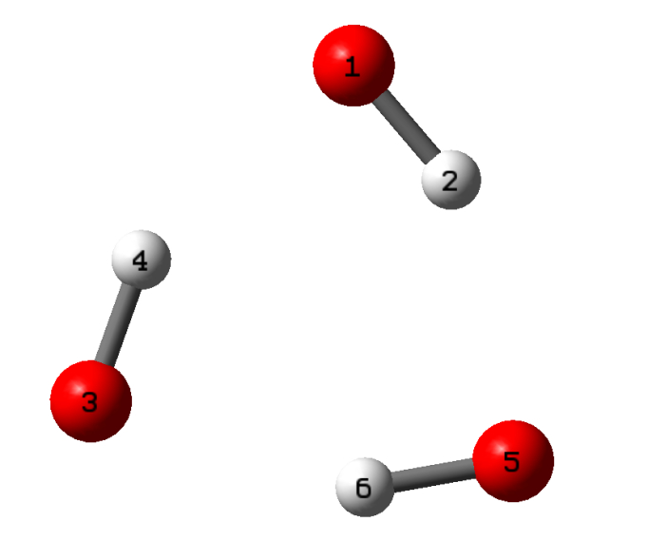

Mulliken charges and spin densities: n=5
1 O -0.448759 1.034253
2 O -0.449624 1.034891
3 O -0.448668 1.034657
4 O -0.450529 1.032960
5 O -0.450162 1.033536
6 H 0.449896 -0.033899
7 H 0.448691 -0.034281
8 H 0.448280 -0.034147
9 H 0.451124 -0.033845
10 H 0.449751 -0.034123
Under VUV-field
Mulliken charges and spin densities: n=5
1 O -0.449953 1.033895
2 O -0.446807 1.035125
3 O -0.446761 1.034287
4 O -0.453816 1.032700
5 O -0.450808 1.034223
6 H 0.449240 -0.033875
7 H 0.449480 -0.034180
8 H 0.447599 -0.034015
9 H 0.451021 -0.033949
10 H 0.450804 -0.034211

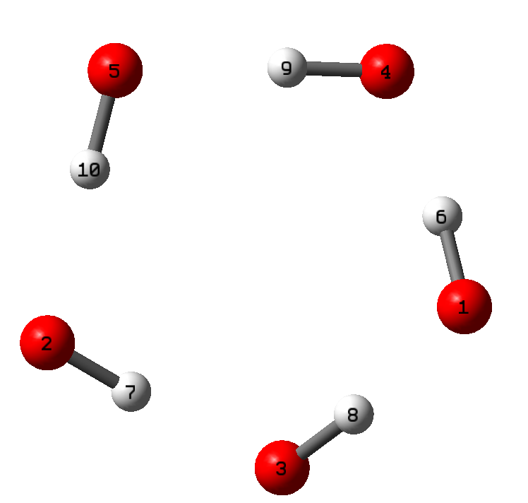

Mulliken charges and spin densities: n=10
1 O -0.497365 0.959655
2 O -0.445788 1.043503
3 O -0.439098 1.035346
4 O -0.421980 1.052906
5 O -0.428004 1.045371
6 O -0.536624 0.876503
7 O -0.462614 1.057841
8 O -0.460734 1.033757
9 O -0.437754 1.032559
10 O -0.368416 1.179166
11 H 0.449682 -0.033709
12 H 0.466314 -0.033640
13 H 0.446484 -0.032826
14 H 0.448012 -0.030118
15 H 0.443253 -0.030746
16 H 0.457196 -0.029925
17 H 0.443815 -0.034172
18 H 0.456950 -0.030457
19 H 0.434345 -0.028886
20 H 0.452325 -0.032130
Under VUV-field
Mulliken charges and spin densities: n=10
1 O -0.057658 1.887558
2 O -0.414439 1.046848
3 O -0.704574 0.357738
4 O -0.452150 1.043506
5 O -0.549092 0.825861
6 O -0.465904 1.012546
7 O -0.531141 0.909250
8 O -0.446421 1.041988
9 O -0.440447 1.033867
10 O -0.413668 1.130271
11 H 0.450711 -0.034400
12 H 0.464222 -0.033215
13 H 0.453545 -0.034844
14 H 0.448889 -0.033846
15 H 0.439863 -0.016210
16 H 0.443759 -0.039201
17 H 0.442733 -0.017065
18 H 0.437784 -0.029091
19 H 0.460945 -0.028482
20 H 0.433044 -0.023079

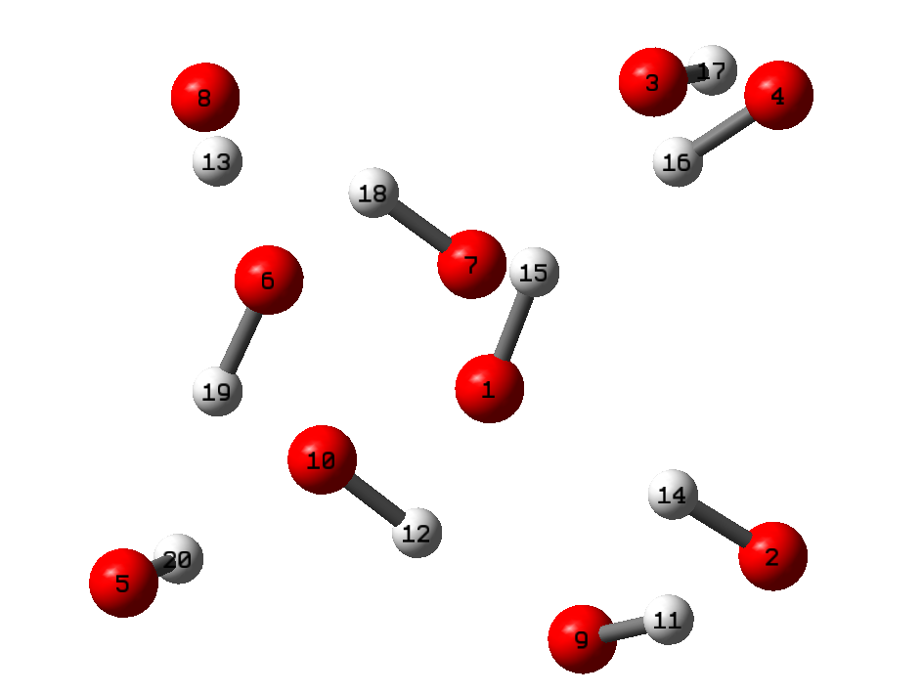

Mulliken charges and spin densities: n=20
1 O -0.534349 0.879184
2 O -0.450857 1.039396
3 O -0.508439 0.927456
4 O -0.377414 1.198400
5 O -0.522392 0.865216
6 O -0.496279 1.018906
7 O -0.358061 1.189808
8 O -0.377115 1.208440
9 O -0.494899 0.987583
10 O -0.529060 0.900159
11 O -0.468910 1.029717
12 O -0.449909 1.043869
13 O -0.390595 1.091667
14 O -0.429819 1.042805
15 O -0.489696 1.018811
16 O -0.473145 0.989292
17 O -0.289500 1.304451
18 O -0.502185 1.018941
19 O -0.574778 0.774536
20 O -0.432953 1.081134
21 H 0.448508 -0.034409
22 H 0.482200 -0.034760
23 H 0.464923 -0.032724
24 H 0.469875 -0.030328
25 H 0.456351 -0.032716
26 H 0.477034 -0.028881
27 H 0.459238 -0.024943
28 H 0.455292 -0.036162
29 H 0.445492 -0.028595
30 H 0.457561 -0.030437
31 H 0.471677 -0.032741
32 H 0.458849 -0.038822
33 H 0.453852 -0.026998
34 H 0.444015 -0.025306
35 H 0.466226 -0.031574
36 H 0.444708 -0.030993
37 H 0.452167 -0.032863
38 H 0.425713 -0.025160
39 H 0.465738 -0.027249
40 H 0.450936 -0.024108
Under VUV-field
Mulliken charges and spin densities: n=20
1 O -0.533693 0.882833
2 O -0.447179 1.039985
3 O -0.505623 0.927068
4 O -0.375672 1.206001
5 O -0.530794 0.852600
6 O -0.510394 1.005403
7 O -0.367746 1.184240
8 O -0.390456 1.191343
9 O -0.491348 0.995580
10 O -0.524026 0.911210
11 O -0.470588 1.026597
12 O -0.443578 1.049774
13 O -0.383246 1.094318
14 O -0.428209 1.042927
15 O -0.483157 1.025093
16 O -0.477734 0.985228
17 O -0.289629 1.305051
18 O -0.500097 1.018723
19 O -0.572361 0.781842
20 O -0.429484 1.083997
21 H 0.447057 -0.034424
22 H 0.483189 -0.034716
23 H 0.466084 -0.032655
24 H 0.469435 -0.030354
25 H 0.458405 -0.032507
26 H 0.476216 -0.028879
27 H 0.457833 -0.025346
28 H 0.452702 -0.035798
29 H 0.449054 -0.028694
30 H 0.459519 -0.030732
31 H 0.469837 -0.032792
32 H 0.458618 -0.039051
33 H 0.453916 -0.026525
34 H 0.444354 -0.024788
35 H 0.468681 -0.031836
36 H 0.446293 -0.030812
37 H 0.450702 -0.032891
38 H 0.423970 -0.025422
39 H 0.466112 -0.027228
40 H 0.453039 -0.024363

Text 4 Determination of the FR-Dependent Apparent Barrier (E_{a})
To evaluate the system’s global reactivity, a Kinetic Ensemble (K_{ens}) was established by integrating the experimental degradation rates of PFAS and TOC with the theoretical reaction limits of primary radicals (HO• and eaq-). The ensemble represents the degree of kinetic utilization relative to the theoretical maximum:
$$K_{ens}=\frac{1}{N}\sum_{i=0}^{N}{\frac{k_{exp,i}}{\sum{(k_{theory,j}•Φ_{j})}}}$$
where k_{exp, i} is the observed pseudo-first-order rate constant for species i, k_{theory, j} is the theoretical second-order rate constant for specific radical-target reactions (e.g., k_{theory, HO•+PFOA}, and Φ_{j} is the experimentally determined quantum yield of the corresponding radical species (j = HO•, e_{aq}⁻). The radical reaction rate (k_{FR},_{TOC}) for TOC decomposition is determined using the solvent isotope effect (SIE) method. For PFAS decomposition, the radical reaction rate (k_{FR,PFAS}) is calculated based on the difference before and after N₂O quenching,

The apparent kinetic barrier (E_{a}), which characterizes the energy requirement for electronic reshaping under the VUV field, was quantified by the logarithmic divergence between the theoretical potential and the experimental kinetic output:
$E_{a}$ = ln($\frac{Φ_{FR}^{exp}}{K_{ens}}$)

Text 5 Calculation of the defluorination ratio.
$ReF\%=\frac{Observed concentration of F^{-}(mg/L)}{Theoretical concentration of F^{-}(mg/L )}$×100%
It should be noted that ReF% exclusively accounts for the release of fluoride ions into the aqueous phase, excluding volatile organic fluorine compounds generated during the experiment. Given that organic fluorine species have been documented in VUV-based system, the theoretical total defluorination rate is expected to be higher than the measured ReF%.

Text 6 the determination of COD_{Mn} using the acidic permanganate method.
Chemical Oxygen Demand (COD_{Mn}) was determined via the KMnO₄ titration method. Briefly, the water sample was acidified with H₂SO₄ and boiled in a water bath with a known excess of KMnO₄ for 30 min to oxidize organic matter. The remaining KMnO₄ was then reduced by adding a fixed amount of standard Na₂C₂O₄ solution. Finally, the excess oxalate was back-titrated with the standard KMnO₄ solution until a faint, persistent pink color appeared. The concentration of COD_{Mn} was calculated based on the total consumption of permanganate.

Text 7 Life Cycle Analyses and Techno-Economic Assessment of the various types of PFAS disposal techniques.
Pyrolysis:
Phelecia et al.¹⁵ demonstrates electrothermal mineralization of PFOA and PFOS-GAC via flash Joule heating, a scalable and efficient process. Heating PFAS-GAC with sodium or calcium salts converts PFAS into inert fluoride salts with >90% fluorine conversion and >99% PFOA and PFOS removal. Simultaneously, the spent carbon is upcycled into flash graphene, offsetting treatment costs by US$60–100 per kg, and CO₂ emissions by 350−400 (CO₂ eq, the greenhouse gas emissions for each process in the form of global warming potential or the kg of CO₂ released to produce 1 kg of treated GAC for each method. Abou-Khalil et al.¹⁶ investigates the use of common alkali and alkaline-earth metal additives to enhance the mineralization of PFOS adsorbed onto GAC. When treated at 800 °C without an additive, only 49% of PFOS was mineralized to HF. All additives tested (Ca(OH)₂, CaO, Ca₅(PO₄)₃(OH), CaCl₂, CaCl₂⁺, NaOH (i.e., mixture of CaCl₂ and NaOH in powder form), Mg(OH)₂, MgO, NaOH, NaCl, NH₄OH/H₂O (i.e., NH₄OH in solution), and HCl/H₂O (i.e., HCl in solution)) demonstrated improved mineralization, and Ca(OH)₂ had the best performance, achieving a mineralization efficiency of 98% in air or N₂. Its ability to increase the reaction rate and shift the byproduct selectivity suggests that its role may be catalytic. Moreover, additives reduced HF in the flue gas by instead reacting with the additive to form inorganic fluorine (e.g., CaF₂) in the starting waste material. For the life cycle assessment (LCA), only electrical energy consumption and CO₂ emissions were considered.
UV/S:
Gu et al.¹⁷ investigated the degradability of GenX by typical advanced redox technologies (UV/persulfate and UV/sulfate). Results demonstrate that <5% GenX is oxidized after 3 h in UV/persulfate system, which is much lower than ∼27% for PFOA. In comparison, GenX can be readily degraded and defluorinated by e_{aq}⁻ generated by UV/sulfite system. Specifically, GenX is not detectable after 2 h, and >90% of fluoride ion is recovered 6 h later. Life Cycle and Techno-Economic are analyzed based on the following parameters: a photon intensity of 3.8 μE/L/s in the reactor chamber. The sulfite (113.4 mg Na₂SO₃ in 45 mL solution) and persulfate concentration (243 mg K₂S₂O₈ in 45 mL solution) in all experiments were fixed at 20 mM. Song et al.¹⁸ established reductive degradation of PFOA by using a sulfite/UV process. This process led to a PFOA removal of 100% at about 1 h and a defluorination ratio of 88.5% at reaction time of 24 h under N₂ atmosphere, whereas the use of either UV irradiation or SO₃²⁻ alone induced little defluorination of PFOA under the same conditions. It was confirmed that the reductive defluorination of PFOA was achieved by hydrated electrons being generated from the photo-conversion of SO₃²⁻ as a mediator. Life Cycle and Techno-Economic are analyzed based on the following parameters: A 10 W low-pressure mercury lamp (Philips) with emission at 254 nm was used to provide UV irradiation. sulfuric acid (0.1 mol L⁻¹), 200 mL of 20.0 μmol L⁻¹ PFOA aqueous solution was used in the reaction. The reaction solution was purged with N₂ gas for 30 min to achieve oxygen-free condition.
HER:
Marek et al.¹⁹ investigated the radiolytic methods of PFOS decomposition in aqueous solutions based on the use of gamma rays or a beam of accelerated electrons (EB) under different chemical conditions in irradiated solutions. In the presence of formate and 2-propanol in irradiated solutions, the reductive radicals derived from them (CO₂•⁻, (CH₂)₂C•-OH) are able to induce reductive decomposition of PFOS. In the presence of tert-butanol, the radicals derived from the alcohol and PFOS dimerize forming alkyl-substituted derivatives. The most favorable conditions for irradiation were achieved in neutral deaerated solutions and aerated solutions containing 10 mM 2-propanol. In γ-irradiation processes the pseudo-first order rate-constants of PFOS decomposition are 0.0197 min⁻¹(0.310 kGy⁻¹), and 0.0060 min⁻¹ (0.0947 kGy⁻¹), respectively, under both conditions. Due to a big difference in the dose-rate between the two employed types of radiation (gamma and EB), the values of pseudo-first order rate constants of PFOS decomposition are different, namely 0.0197 min⁻¹ (0.310 kGy⁻¹) and 0.368 s⁻¹ (0.0184 kGy⁻¹), respectively, for γ and EB radiation used for decomposition of 0.1 mg L⁻¹ PFOS in neutral, deaerated solution. The gamma irradiation based PFOS decomposition requires smaller absorbed doses and it does not require any external energy input because of the use of the isotope source of radiation.
EO:
Niu et al.²⁰ used an Ce-doped modified porous nanocrystalline PbO₂ film electrode prepared by electrodeposition technology for electrochemical mineralization of perfluorinated carboxylic acids (PFCAs) (∼C4−C8), i.e., perfluorobutanoic acid (PFBA), perfluopentanoic acid (PFPeA), perfluorohexanoic acid (PFHxA), perfluoheptanoic acid (PFHpA), and perfluorooctanoic acid (PFOA) in aqueous solution (100 mL of 100 mg L⁻¹). The degradation of PFCAs follows pseudo-firstorder kinetics, and the values of the relative rate constant (k) depend upon chain length k_{PFHpA} (4.1×10⁻² min⁻¹; corresponding half-life 16.8 min)≈1.1 k_{PFOA}≈ 2.5k PFHxA≈6.9 kPFPeA≈9.7k PFBA. The carbon mineralization indices were 0.49, 0.70, 0.84, 0.91, and 0.95 for PFBA, PFPeA, PFHxA, PFHpA, and PFOA, respectively, after 90min electrolysis. The electrochemical cells were made of organic glass. The Ce-doped modified porous nanocrystalline PbO₂ film electrode and Ti electrodes (dimension 15 cm×6.5 cm; thickness 1 mm) were used as the anode and cathode, respectively, with a 1 cm gap and a working area of 97.5 cm². A typical PFOA concentration from fluoropolymer manufacturing wastewater is 140.8−1386.9 mg L⁻¹. In each run, a 100 mL PFCA solution (PFBA, PFPeA, PFHxA, PFHpA, or PFOA; 100 mg L⁻¹) was degraded in aqueous medium containing 10 mmol L⁻¹ NaClO₄ as supporting electrolyte. The whole system was operated in a batch mode at a constant current density of 20 mA cm⁻².

Text 8 Detailed Information on Materials and Methods
The four PFCAs (PFPrA, PFHxA, PFOA, PFNA, ≥96%) and two PFECA (GenX and HFPO-TA, ≥96%) and 6:2 FTS (≥96%) were purchased from Macklin Reagent and ANPEL-TRACE Stard Technical Services Co., Ltd. (Shanghai, China). Three PFISA (LiTFSI, PFBS and PFOS) (≥96%), 4-Chlorobenzoic acid (pCBA, ≥99.0%) were obtained from Macklin Reagent Co., Ltd. Individual PFAS were dissolved in deionized water (produced by a Milli-Q system) as 10 mM stock solutions. All stock solutions were stored on benchtop at room temperature (20°C).

Text 9 Measurement of PFAS Parent Compound.
The concentrations of individual PFAS during the reaction were measured using a high performance liquid chromatography coupled with a tripe-stage quadrupole mass spectrometer (HPLC-MS/MS, API3200; Applied Biosystems). The HPLC separation was performed with a HPLC BEH C18 column (2.1 mm × 50 mm, 1.7 μm) at 40 °C, A in-line filter column(2μm) and a Eclipse XDB-C18 protective column(4.6×12.5mm, 5μm ) should be placed before the column to filter out the micro-particle catalysts that may be present in the sample; In the detection process, the mobile phase needs to cross the mobile phase degassing device of high performance liquid chromatography, and the mobile phase was degassed by non-on-line degassing device; Mobile phase was a gradient composition of solvent A(ammonium acetate methanol solution, 10mM) and solvent B (ammonium acetate aqueous solution, 10 mM). The gradient expressed as the concentration of solvent A was as follows: 0−7.5 min, a linear increase from 60% to 100%; 7.5−11 min, held at 100% A; 11−16.5 min, a linear decrease from 100% to 75%; 16.5−17 min, hold at 60% A. The flow rate was 0.3 mL min⁻¹. An electrospray negative ionization mode was used to identify the products in the liquid phase. The pressure of sheath gas (N₂) was 0.4 MPa. The capillary potential was −4.5 kV. The source temperature was 120 °C, and the desolvation temperature was 450 °C. The analysis was carried out in multiple reaction monitoring (MRM) mode.

Fig. 1 Experimentally validated FR quantum yield ($Φ_{FR}^{exp}$).
The quantitative quantum yield detection methods for HO• and e_{aq}⁻ are described in the Supplementary Text 1.

Fig. 2 The fluorescence emission spectra in the presence of TA in VUV based systems. (inset: mechanism diagram of TA capturing HO•).

Fig. 3 DFT-calculated VUV absorption spectra of PFOA, highlighting characteristic peaks within the vacuum ultraviolet(100-200nm) range.
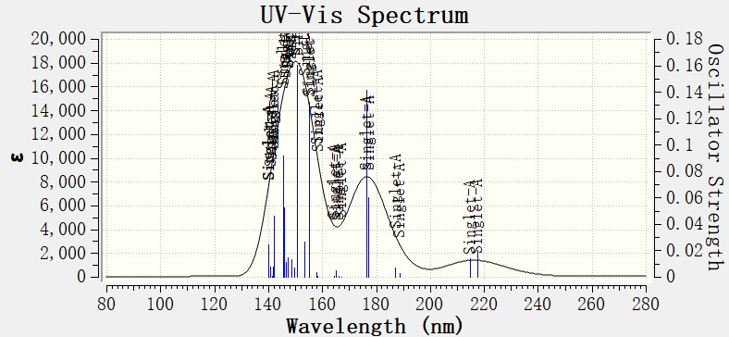
Computational Methods: VUV Absorption Spectrum Simulation
To elucidate the electronic transitions and spectral response of perfluorooctanoic acid (PFOA) in the VUV region, theoretical absorption spectra were simulated using Density Functional Theory (DFT).
1. Geometry Optimization
The ground-state molecular structure of PFOA was fully optimized in the gas phase (or specify: using the Polarizable Continuum Model (PCM) to simulate an aqueous environment) at the B3LYP/6-311+G(d,p) level of theory. Frequency calculations were subsequently performed at the same level to ensure that the optimized stationary point corresponded to a true local minimum, confirmed by the absence of imaginary frequencies.
2. Excited State Calculations
The vertical excitation energies and oscillator strengths (f) were computed using TD-DFT at the ωB97X-D/6-311+G(d,p) level. The range-separated functional ωB97X-D was specifically selected to accurately account for long-range exchange-correlation effects, which are critical for describing high-energy Rydberg states and charge-transfer transitions characteristic of the VUV region.
3. Spectral Post-processing
The first 50–100 excited states were calculated to ensure sufficient coverage of the VUV spectrum (100–200 nm). The discrete transitions were broadened using a Gaussian line-shape function with a full width at half maximum (FWHM) of 0.2 eV to generate the final absorption curve. The molecular orbitals involved in the primary VUV characteristic peaks, specifically the HOMO→LUMO and transitions originating from the oxygen lone pairs (n) to π* antibonding orbitals of the carboxyl group, were visualized and analyzed to determine the transition nature.

Fig. 4 Contribution ratios of the three reaction pathways to TOC and PFAS removal in ultrapure water within the VUV_CCB system.

Fig. 5 Comparative degradation kinetics and rate constants of TOC in H₂O and D₂O under the VUV_CCB system.

Fig. 6 Performance of an on-site VUV_CCB pilot system for the continuous production of electronic-grade ultrapure water.

Fig. 7 Schematic configuration of the pilot-scale circulating VUV_CCB system for on-site PFAS remediation.

Fig. 8 Long-term operational stability of TOC mineralization(a) and Techno-economic analysis and process reconfiguration(b).
Violin plots depict the distribution of effluent TOC over a 20-day continuous run. Each violin integrates the median (white dot), interquartile range (blue bar), and 1.5×IQR (whiskers). The inset provides a comparative baseline of the inflow water (45–65 μg/L). All measurements were obtained using an online Sievers M500 analyzer to ensure real-time precision. The exploded pie chart details the cost breakdown of the standard E-UPW production sequence. The lower bar chart quantifies the 45% reduction in production costs enabled by the VUV_CCB upgrade. The data originate from a collaborative pilot-scale study involving Tsinghua University and industrial designers, conducted under the framework of a National Key R&D International Cooperation Project.

Fig. 9 Matrix-dependent kinetic response (k_{PFAS} and ReF%)(a), Representative aqueous environments and PFAS occurrence(b), Multidimensional sustainability benchmark(c).
Dual-axis plots correlate reaction rates (left) and DeF% (right) across five representative matrices: DI W, Tap W, Surface W, ROC, and Waste W. The inset highlights the sensitivity of the system in the low-concentration regime ([TF] in μg/L). High-resolution photographs characterize the tested water types, including Surface Water, Secondary Effluent, Clean Well, and RO Concentrate. Note: The concentration ranges provided represent ubiquitous levels reported in current literature and do not imply universal detection at these specific values in every location. A five-axis radar chart compares VUV_CCB (blue stars) against Pyrolysis, UV/S, HER, and EO. Evaluation metrics include Cost (US$), GWP (CO₂ eq), reagent consumption, and energy consumption. Further details regarding the analytical approach and supporting references are provided in Supplementary Text 5.

Fig. 8 Traditional E-UPW process flow and VUV_CCB upgrade plan
The TOC concentration falls within the accessible range of existing technologies, but it is susceptible to the coupled influences of influent fluctuations, operational conditions, and raw material specifications.

References
1. Gu, M., Liu, L., Yu, G. & Huang, J. Deeper Defluorination and Mineralization of a Novel PFECA (C7 HFPO-TA) in Vacuum UV/Sulfite: Unique Mechanism of H/OCF3 Exchange. Environmental Science & Technology 57, 15288-15297 (2023).
2. Giri, R.R., Ozaki, H., Guo, X., Takanami, R. & Taniguchi, S. Oxidative–reductive photodecomposition of perfluorooctanoic acid in water. International Journal of Environmental Science and Technology 11, 1277-1284 (2013).
3. Park, H. et al. Reductive degradation mechanism of perfluorooctanoic acid (PFOA) during vacuum ultraviolet (VUV) reactions combining with sulfite and iodide. Chemosphere 348 (2024).
4. Cao, M.H. et al. Photochemical decomposition of perfluorooctanoic acid in aqueous periodate with VUV and UV light irradiation. Journal of Hazardous Materials 179, 1143-1146 (2010).
5. Li, Y. et al. The defluorination of perfluorooctanoic acid by different vacuum ultraviolet systems in the solution. Water Environment Research 93, 455-463 (2020).
6. Chen, J., Zhang, P.-y. & Liu, J. Photodegradation of perfluorooctanoic acid by 185 nm vacuum ultraviolet light. Journal of Environmental Sciences 19, 387-390 (2007).
7. Kim, J. et al. Kinetics and proposed mechanisms of hexafluoropropylene oxide dimer acid (GenX) degradation via vacuum-UV (VUV) photolysis and VUV/sulfite processes. Journal of Hazardous Materials 463 (2024).
8. Su, L. et al. Colorimetric Detection of Urine Glucose Based ZnFe2O4 Magnetic Nanoparticles. Analytical Chemistry 84, 5753-5758 (2012).
9. Yin, R., Anderson, C.E., Zhao, J., Boehm, A.B. & Mitch, W.A. Controlling contaminants using a far-UVC-based advanced oxidation process for potable reuse. Nature Water 1, 555-562 (2023).
10. Xue, Y., Sun, W., Shi, W., Huang, C.-H. & Santoro, D. Prehydrated Electrons Activated by Continuous Electron Transfer Stemmed from Peracetic Acid Homolysis Mediated by Diamond Surface Defects for Enhanced PFOA Destruction. Environmental Science & Technology 58, 11152-11161 (2024).
11. Stephen P. Mezyk, T.H., Kirkham Cole, William J. Cooper, Robert V. Fox, Piero R. Gardinali,|and Bruce J. Mincher Free Radical Chemistry of Disinfection-Byproducts. 1. Kinetics of Hydrated Electron and Hydroxyl Radical Reactions with Halonitromethanes in Water. J. Phys. Chem. A 110, 2176-2180 (2006).
12. Shao, P. et al. Revisiting the Graphitized Nanodiamond-Mediated Activation of Peroxymonosulfate: Singlet Oxygenation versus Electron Transfer. Environmental Science & Technology 55, 16078-16087 (2021).
13. Liu, X., Shao, P., Gao, S., Bai, Z. & Tian, J. Benzoquinone-assisted heterogeneous activation of PMS on Fe3S4 via formation of active complexes to mediate electron transfer towards enhanced bisphenol A degradation. Water Research 226 (2022).
14. Stephen P. Mezyk, T.H., Kirkham Cole, William J. Cooper, Robert V. Fox, Piero R. Gardinali, and Bruce J. Mincher Free Radical Chemistry of Disinfection-Byproducts. 1. Kinetics of Hydrated Electron and Hydroxyl Radical Reactions with Halonitromethanes in Water. J. Phys. Chem. A 110, 2176-2180 (2006).
15. Scotland, P. et al. Mineralization of captured perfluorooctanoic acid and perfluorooctane sulfonic acid at zero net cost using flash Joule heating. Nature Water 3, 486-496 (2025).
16. Abou-Khalil, C. et al. Enhancing the Thermal Mineralization of Perfluorooctanesulfonate on Granular Activated Carbon Using Alkali and Alkaline-Earth Metal Additives. Environmental Science & Technology 58, 11162-11174 (2024).
17. Bao, Y. et al. Degradation of PFOA Substitute: GenX (HFPO–DA Ammonium Salt): Oxidation with UV/Persulfate or Reduction with UV/Sulfite? Environmental Science & Technology (2018).
18. Song, Z., Tang, H., Wang, N. & Zhu, L. Reductive defluorination of perfluorooctanoic acid by hydrated electrons in a sulfite-mediated UV photochemical system. Journal of Hazardous Materials 262, 332-338 (2013).
19. Trojanowicz, M. et al. Application of ionizing radiation in decomposition of perfluorooctane sulfonate (PFOS) in aqueous solutions. Chemical Engineering Journal 379 (2020).
20. Niu, J., Lin, H., Xu, J., Wu, H. & Li, Y. Electrochemical Mineralization of Perfluorocarboxylic Acids (PFCAs) by Ce-Doped Modified Porous Nanocrystalline PbO2 Film Electrode. Environmental Science & Technology 46, 10191-10198 (2012).

