Supplementary File 1. Study Instruments Used for Data Collection
Effectiveness of Structured Cardiotocography Training on Maternity Nurses’ Performance and Fetal Trace Interpretation Competency.

Tool I: Structured CTG Knowledge Questionnaire
 | Part 1: General data of the participants:
 | Department | - DR  - OBG  - OPD
 | Age per year | - 21≤30 ( )  - 30≤40 ( )  - 40≤50 ( )  - ≥50 ( )
 | Clinical midwifery experience per year | - 6 months ( )  - 6 months ≤ 5 years ( )  - 5 ≤ 10 years ( )  - More than 10 years ( )
 | Level of education | - Diploma  - BSN  - MSN

Tool II: Performance Assessment Using Observational Checklist and Fetal Trace Interpretation skills
Part I: CTG Procedure Observational Checklist: Preparation stage Performance stage Post procedure
 | Action | met | Not met
Preparation stage
 | Wash hands and dry it well to prevent cross infection
 | Prepare the equipment
 | Explain procedure for mothers, and offer the opportunity to ask any questions
 | Record mother identification at beginning of the monitor strip
 | determine fetal position and locate fetal back.
 | undress to put a wide elastic belt around her back to secure the transducer in place maintain privacy
 | Put mother in comfortable position
Performance stage
 | Assess fetal heart tone
 | Place monitor belts under the mother back
 | Confirm the presence of fetal heart tone with fetoscope before applying fetal monitor
 | Connect the CTG transducer and the Toc transducer to the fetal monitor
 | Place the Toc transducer on the fundus of the uterus so that the pressure sensitive button is flush against the maternal abdomen
 | Place the ultrasound transducer on the maternal abdomen over the fetal back
Post procedure
 | record fetal heart rate
 | Evaluate the FHR strip
 | Remove electronic fetal monitor
 | Clear mother’s abdomen from gel
 | cover the mother & assess her
 | Record the procedure in nurses’ notes
 | Inform the doctor to review the strip
 | wash hand & return equipment’s
 | explain finding to the mother

Part 2: Fetal Trace Interpretation:
 | Strip | Identify | Correct | Not correct
 | 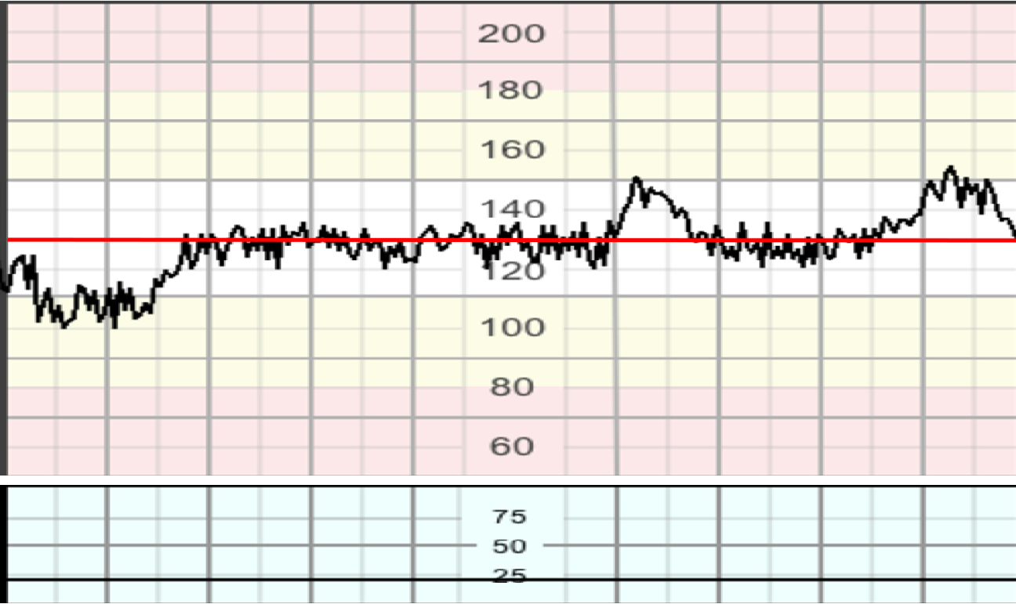 | - Baseline Fetal Heart Rate  - Acceleration.
 | 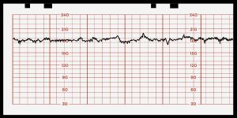 | - Fetal Tachycardia  - Decrease variability
 | 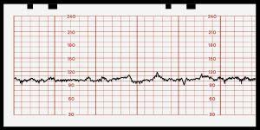 | - Fetal bradycardia  - Decrease variability
 | 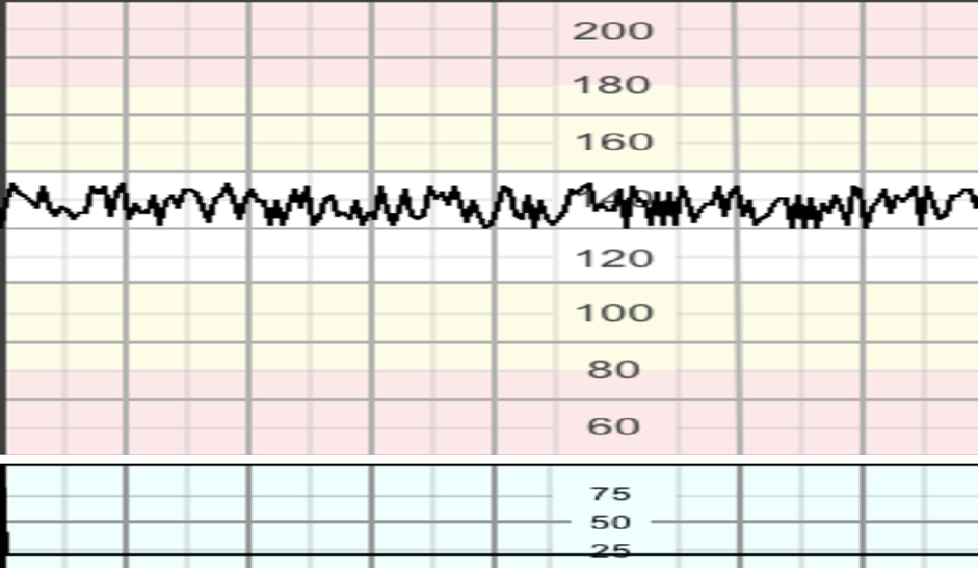 | - Severe bradycardia in the second stage of labor  - Baseline Fetal Heart Rate
 | 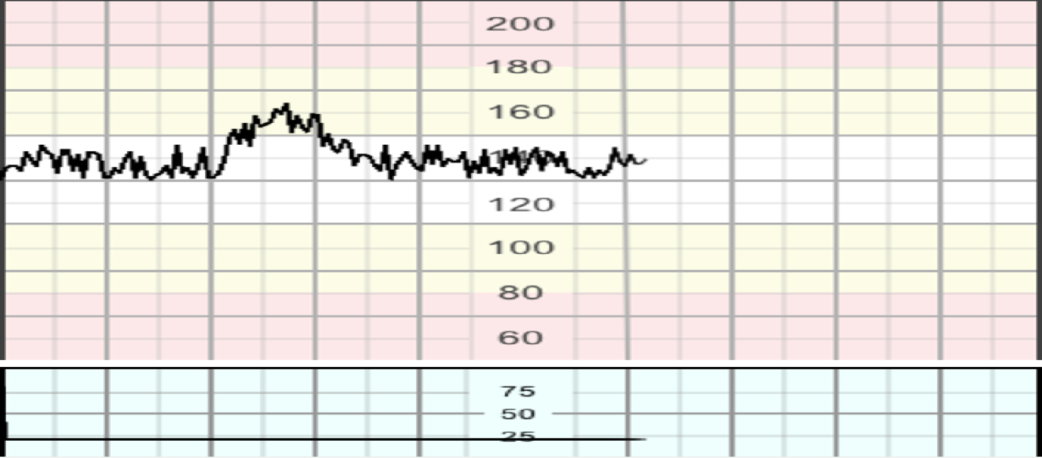 | - Baseline variability  - Acceleration.
 | 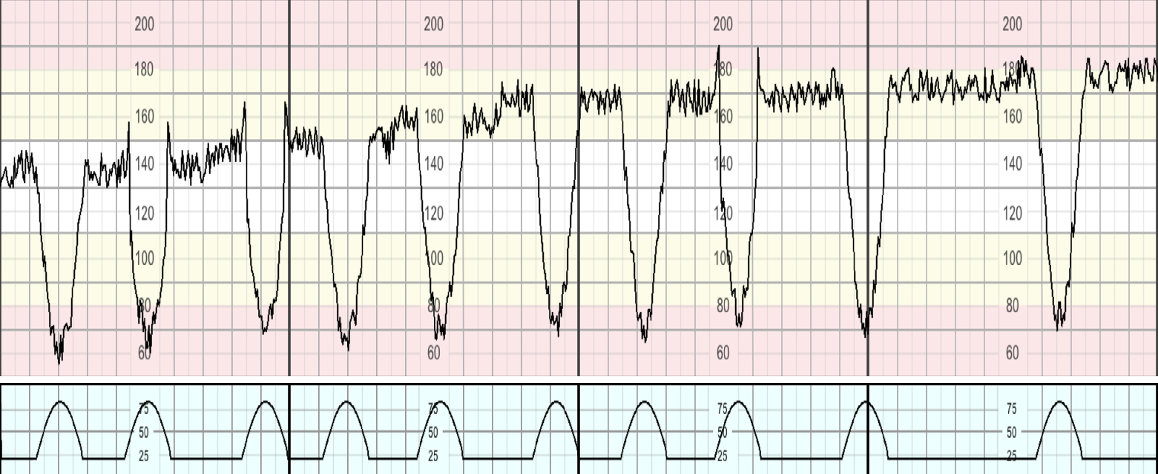 | - Acceleration  - Decrease variability
 | 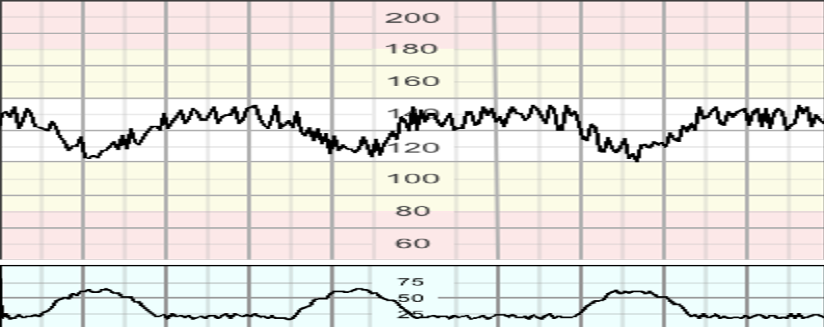 | - Deceleration  - Baseline Fetal Heart Rate
 | 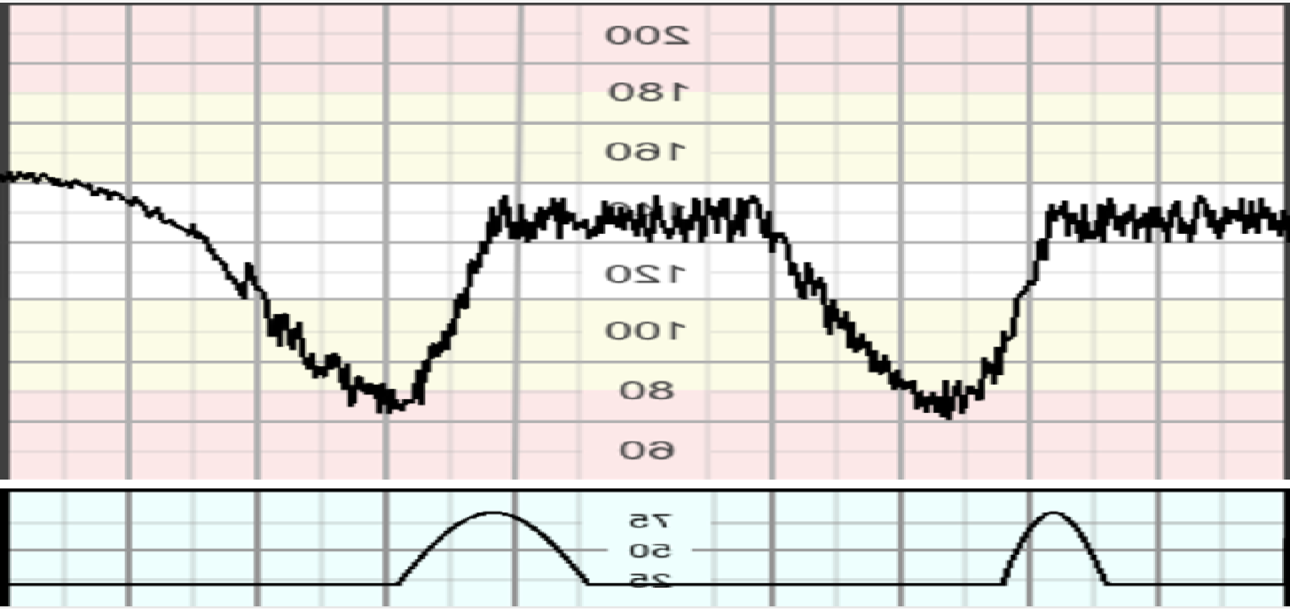 | - Late deceleration  - Deceleration
 | 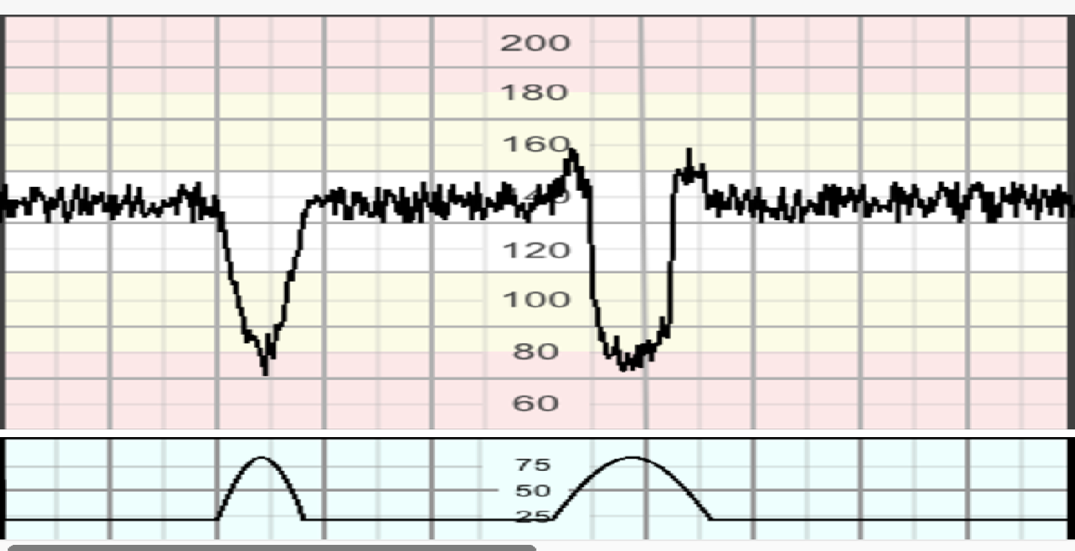 | - Variable deceleration  - Late deceleration
 | 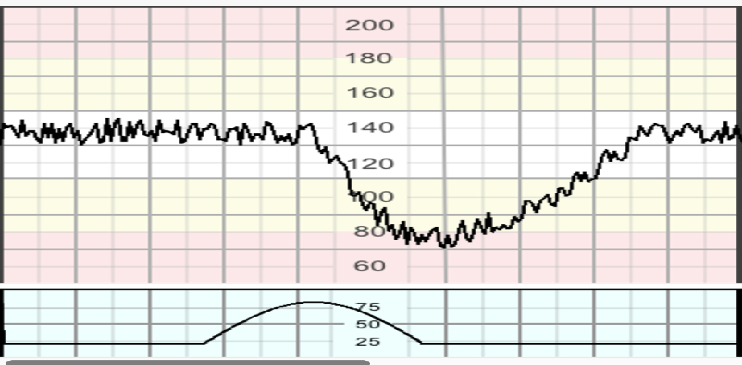 | - Prolonged deceleration  - Decrease variability
 | 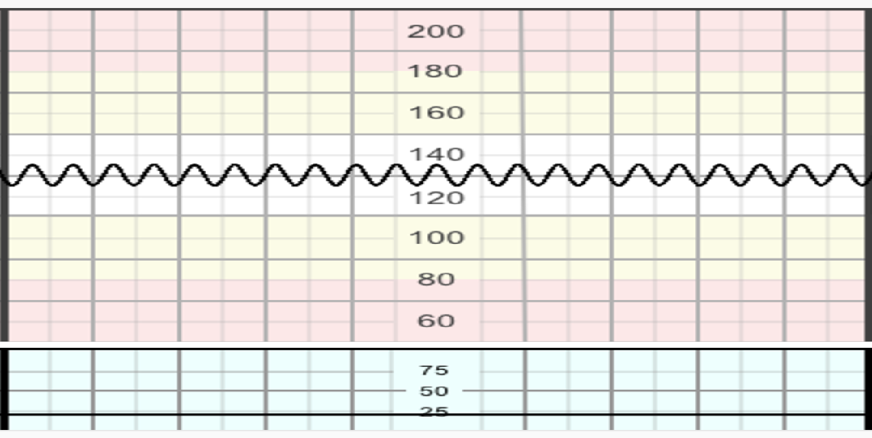 | - Sinusoidal pattern  - Severe bradycardia in the second stage of labor

