Effects of Different Fermented Fertilizer Formulations on Soil Nutrient Status and Microbial Communities in Morchella sextelata Cultivation
Yongmei Miao^{a,}*,†,Wangyang Wu^{b,†}, Qiong Wu^{b}, Tao Han^{b} and Huaqi He^{b}
a College of Biomedicine and Health, Anhui Science and Technology University, Chuzhou, 233100, China;
b College of Agriculture, Anhui Science and Technology University, Chuzhou, 233100, China;
* rrespondence: mym416@163.com
† These authors contributed equally to this work.

A
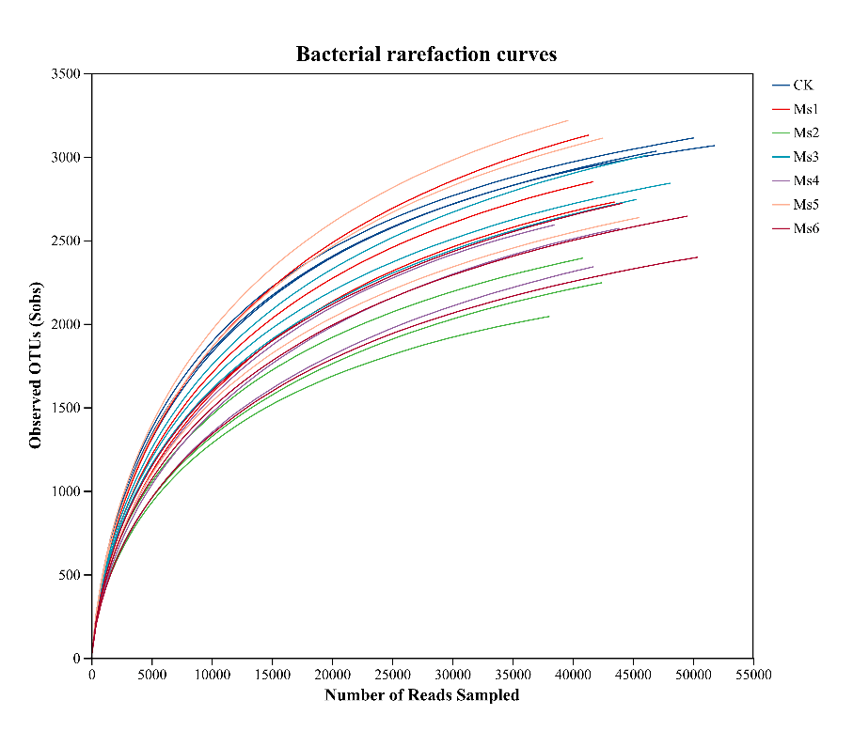
B
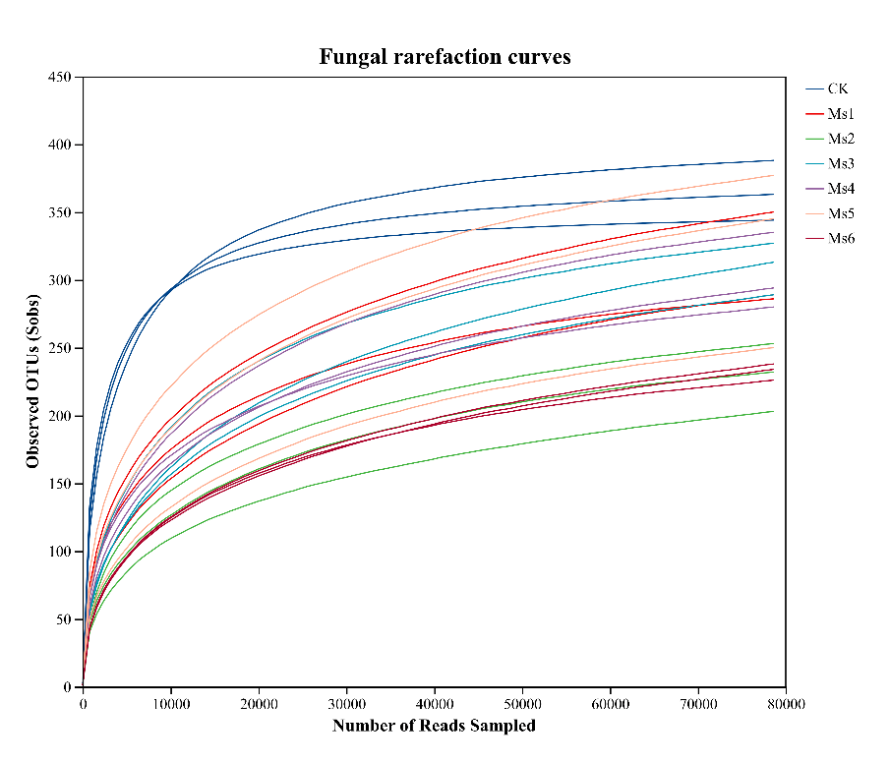
Figure S1. Rarefaction curves of bacterial and fungal communities based on the Sobs index at the OTU level.
Note:A, bacterial communities; B, fungal communities.

