Supplementary Materials for
Framework Zn Modulation of Confined Cu_{x}O_{y} Species for Photothermal Methane to Methanol
Jinchen Han^{1,2}†, Haonan Zhang^{3†}, Yan Sun⁴, Yue Zhao^{1,2}, Chunlei Sun^{1,2}, Lei Liu^{2*}, Qiwen Sun^{4*}, Wenting Wu^{5*}, Zhijun Zuo^{1,2*}
¹ State Key Laboratory of Clean and Efficient Coal Utilization, Taiyuan University of Technology, Taiyuan 030024, PR China
² College of Chemistry and Chemical Engineering, Taiyuan University of Technology, Taiyuan 030024, PR China
³ Department of Applied Chemistry, School of Engineering, University of Toyama, Toyama 9308555, Japan
⁴ State Key Laboratory of Coal Liquification, Gasification and Utilization with High, Efficiency and Low Carbon Technology, Shanghai 200237, PR China
⁵ College of Chemistry and Chemical Engineering, China University of Petroleum (East China), Qingdao 266580, PR China
*Corresponding author. E-mail: zuozhijun@tyut.edu.cn (Z. J. Z.); wuwt@upc.edu.cn (W. T. W.); yetech_lab@163.com (Q. W. S.)
†Jinchen Han and Haonan Zhang contributed equally to this work.

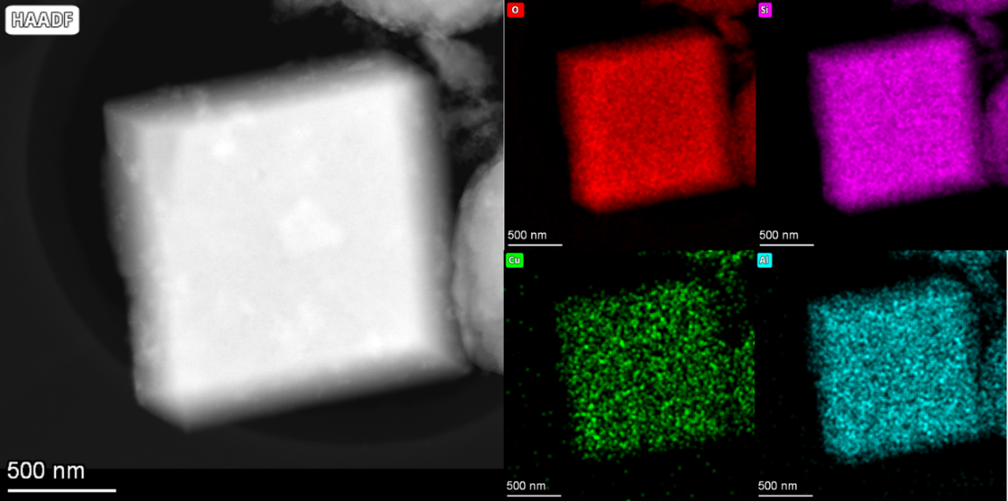
Figure S1. HAADF-STEM images and corresponding mapping images of Cu/Zn-SSZ-13.

Figure S2. FT-IR spectra of SSZ-13, Cu/SSZ-13, Zn-SSZ-13, and Cu/Zn-SSZ-13.

Figure S3. Uv-vis spectra of SSZ-13, Cu/SSZ-13, Zn-SSZ-13, and Cu/Zn-SSZ-13.

Figure S4. N₂ adsorption and desorption isothermal curves of SSZ-13, Cu/SSZ-13, Zn-SSZ-13, and Cu/Zn-SSZ-13.
All samples display combined Type I and Type IV isothermal, characteristics of microporous mesoporous composite materials (Figure S4 and Table S1) ¹. The specific surface area of SSZ-13 is 451 m²/g. A sharp N₂ uptake occurs at low relative pressure (P/P₀ < 0.1), corresponds to the filling of the intrinsic 0.38 nm micropores of SSZ-13. A Type H1 hysteresis loop appears at high relative pressure (P/P₀ > 0.8), which is attributed to N₂ desorption from intercrystallite agglomerated pores. The specific surface area of Cu/SSZ-13 is 396 m²/g, which is smaller than that of SSZ-13. This decrease is due to the partial occupation of SSZ-13 pores by Cu specie ²⁻³. In contrast, Zn-SSZ-13 exhibits an increased specific surface area of 550 m²/g compared to 451 m²/g for SSZ-13. This increase results from lattice expansion following Zn incorporation into the framework ⁴. Consequently, surface roughness also increases, as confirmed by scanning electron microscopy images (Figure S5).

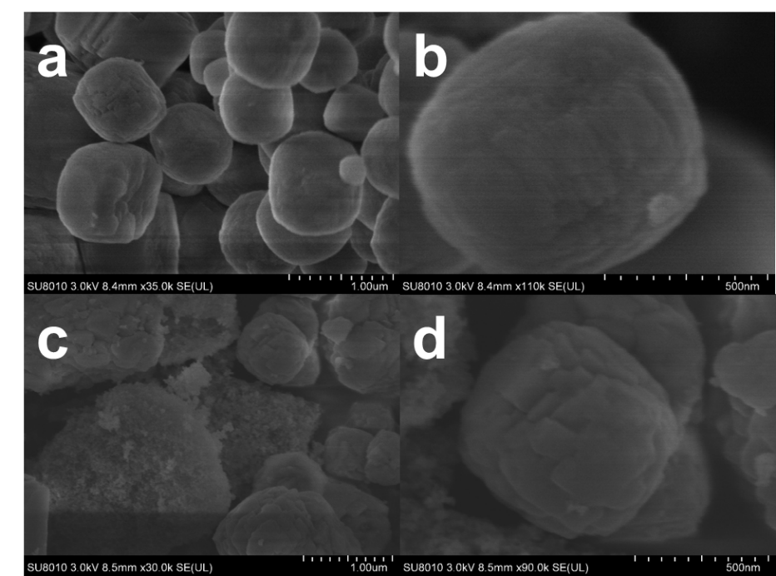
Figure S5. SEM images of Cu/SSZ-13 (a, b) and Cu/Zn-SSZ-13 (c, d).

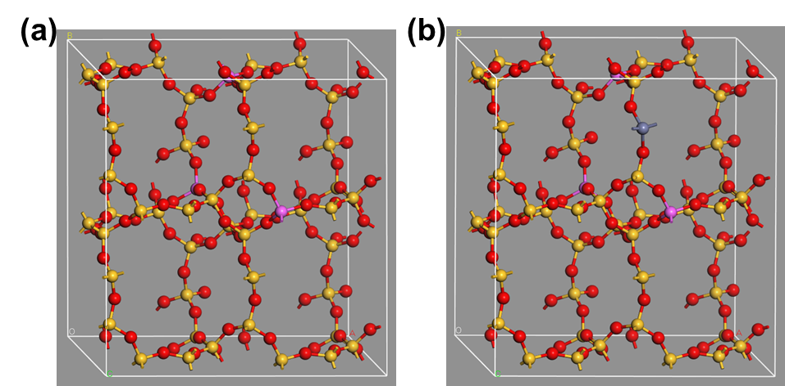
Figure S6. The models of Si₄₈O₉₆ (a) and ZnAl₃Si₄₄O₉₆ (b).

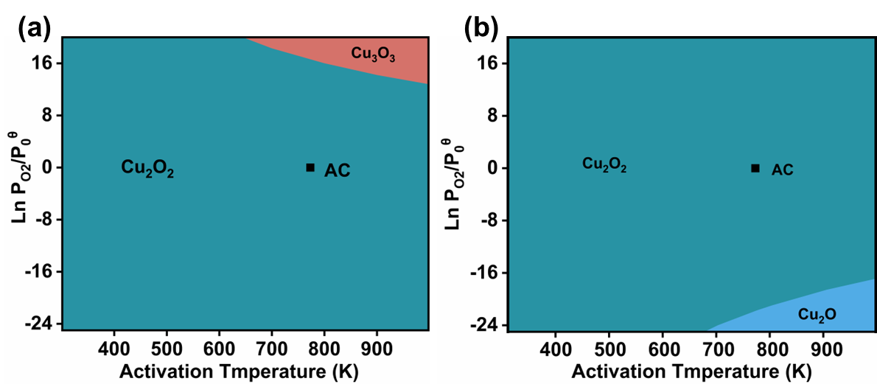
Figure S7. Phase diagram comparison of Cu/SSZ-13-6R (a), and Cu/SSZ-13-8R (b) (AC: activation conditions).

Figure S8. Catalytic oxidation of methane to methanol by Cu/Zn-SSZ-13 at different temperatures.

Figure S9. Catalytic oxidation of methane to methanol by Cu/Zn-SSZ-13 at different CH₄ flow rate.

Figure S10. Catalytic oxidation of methane to methanol by Cu/Zn-SSZ-13 at different O₂ flow rate.

Figure S11. Catalytic oxidation of methane to methanol by Cu/Zn-SSZ-13 at different H₂O flow rate.

Figure S12. Catalytic oxidation of methane to methanol by Cu/Zn-SSZ-13 with different Zn/Si.

Figure S13. Catalytic oxidation of methane to methanol by Cu/Zn-SSZ-13 with different Si/Al.

Figure S14. Catalytic oxidation of methane to methanol by Cu/Zn-SSZ-13 with different Cu ion exchange concentration.

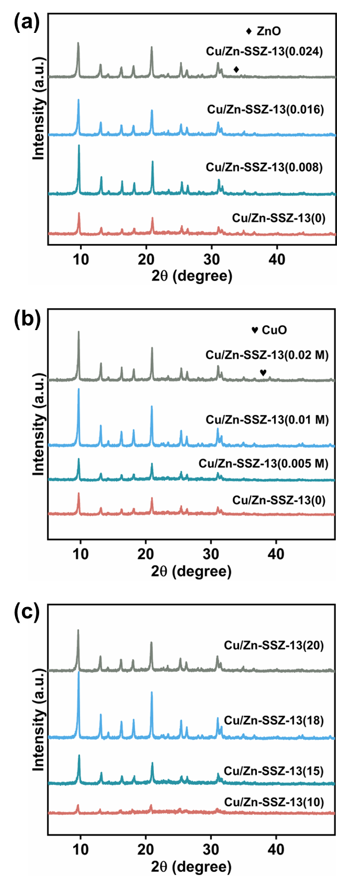
Figure S15. XRD patterns of Cu/Zn-SSZ-13 with different Zn/Si (a), Cu loadings (b) and Si/Al (c).
XRD results of different Zn/Si ratio and Cu loading on SSZ-13 further confirming that Zn species were doped into the SSZ-13 framework, while Cu species were uniformly distributed in the pores (Figure S15a and S15b). However, at excessive Zn or Cu loadings, aggregated ZnO and CuO phases formed, blocking pore channels and diminishing the catalytic activities of Cu/SSZ-13 and Cu/Zn-SSZ-13. At low Si/Al ratios, the crystallinity of the zeolite framework was compromised (Figure S15c), leading to reduced catalytic activity. Increasing the Si/Al ratio improved framework crystallinity, but excessively high ratios diminished the number of acidic sites, ultimately lowering catalytic performance. Additionally, as the Si/Al ratio increases, the peaks shift towards higher angles, because the radius of Si is smaller than that of Al ⁵. The high methanol production rate observed with Zn doped Cu-SSZ-13, compared to Zn incorporated samples, confirms the doping induced activity enhancement.

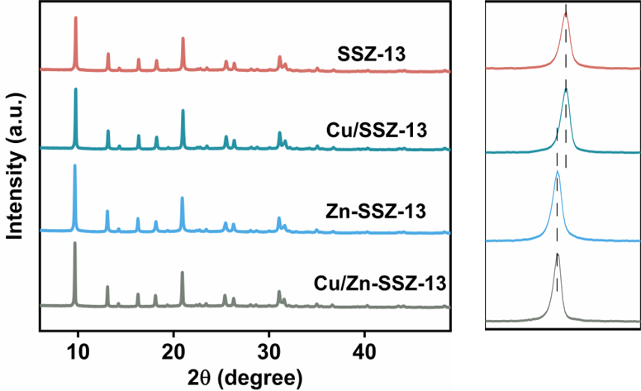
Figure S16. XRD patterns of SSZ-13, Cu/SSZ-13, Zn-SSZ-13, and Cu/Zn-SSZ-13 after reaction

Figure S17. XPS spectra of Cu/Zn-SSZ-13 before and after the reaction

Figure S18. CH₃OH yield on Cu/Zn-SSZ-13 by photothermal catalysis. Reaction conditions: 0.1 g catalyst, 425 ℃, 300 W Xe lamp (200-400 nm), CH₄/O₂/H₂O = 6.75/18/48 mL min⁻¹, N₂ balance, 225 mL min⁻¹ in total.

Figure S19. PL spectra of Zn-SSZ-13 and Cu/Zn-SSZ-13.

Figure S20. EIS plots (f) of Zn-SSZ-13 and Cu/Zn-SSZ-13.

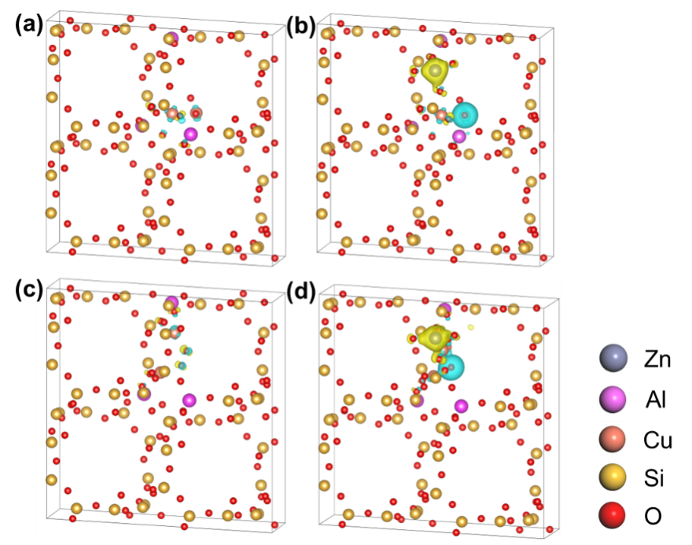
Figure S21. Charge density differential plots for Cu/SSZ-13 and Cu/Zn-SSZ-13 in 6R (a, c) and 8R (b, d).

Figure S22. NH₃-TPD curves of SSZ-13, Cu/SSZ-13, Zn-SSZ-13, and Cu/Zn-SSZ-13
The NH₃-TPD profiles of the four samples are shown in Figure S22, with detailed acidic site information summarized in Table S7. The peak between 180-200 ℃ is attributed to physiosorbed NH₃ on the zeolite surface or framework, as well as weak chemisorption on weak Lewis acid sites. The region between 250-350 ℃ is assigned to NH₃ stored on medium-strength acid sites, which likely associate with Cu and/or Zn ions. The peak above 350 ℃ arises from NH₃ desorbing from strong Brønsted acid site (BASs) ⁶⁻⁸. The introduction of Cu through light assisted ion exchange and framework incorporation of Zn significantly increases the number of weak acid sites in SSZ-13. Moreover, the strong interfacial interaction between Cu and Zn leads to a more pronounced increase in the number of strong BAS.

Figure S23. CH₄-TPD of Cu/SSZ-13 and Cu/Zn-SSZ-13
The results indicate that Cu/SSZ-13 exhibits only a weak CH₄ desorption peak between 300-400 ℃, suggesting a limited number of active sites. In contrast, Cu/Zn-SSZ-13 exhibits significantly stronger low temperature desorption peaks in the 100-200 ℃ range, while also maintaining pronounced high temperature desorption signals between 250-400 ℃, thus broadening the overall adsorption temperature window.

Figure S24. In situ DRIFT spectra of Cu/Zn-SSZ-13 in the atmosphere of reaction gas at 250 in dark for 20 min and under irradiation for the following.

Figure S25. PDOS plots of the d orbitals of Cu at 6R and 8R in Cu/SSZ-13, Cu/Zn-SSZ-13.
Table S1 Specific surface area and pore volume of the catalysts
Catalyst | Specific surface area (m²/g) | Micropore pore Volume (cm³/g) | Average Pore size (nm)
SSZ-13 | 451 | 0.14 | 8.15
Zn-SSZ-13 | 550 | 0.18 | 6.21
Cu/SSZ-13 | 396 | 0.11 | 12.26
Cu/Zn-SSZ-13 | 543 | 0.17 | 5.54

Table S2 Fitting parameters for Cu K-edge EXAFS for the samples.
Catalyst | Shell | CNª | R(Å)^{b} | σ²(Å)^{c} | ΔE₀(eV)^{d} | S₀² | R factor
Cu/Zn-SSZ-13  N₂-treated | Cu-O | 3.6 | 1.92±0.01 | 0.040±0.002 | 3.52±1.03 | 0.9 | 0.017
Cu/Zn-SSZ-13  Reaction | Cu-O | 3.2 | 1.93±0.02 | 0.006±0.004 | 2.21±1.49 | 0.6 | 0.02
Cu/Zn-SSZ-13  Reaction | Cu-Cu | 0.88 | 2.93±0.02 | 0.009±0.001 | 2.45±1.49 | 0.6 | 0.02
Cu/SSZ-13  Reaction | Cu-O | 3.0 | 1.89±0.001 | 0.003±0.001 | 2.79±1.27 | 0.6 | 0.02
Cu/SSZ-13  Reaction | Cu-Cu | 0.78 | 2.85±0.03 | 0.009±0.001 | 2.39±1.07 | 0.6 | 0.02
Note: ª CN, coordination number; ^{b} R, the distance to the neighboring atom; ^{c} σ², the Mean Square Relative Displacement (MSRD); ^{d}ΔE₀, inner potential correction; R factor indicates the goodness of the fit. S₀² was fixed to 0.8461, according to the experimental EXAFS fit of the sample foil by fixing CN as the known crystallographic value. This value was fixed during EXAFS fitting, based on the known structure of Cu foil. Data range 3.0 ≤ k ≤ 11.0 Å⁻¹, 1.0 ≤ R ≤ 3.0 Å. The Debye-Waller factors and ΔRs are based on the guessing parameters and constrained for paths.

Table S3 The average bond length (d, Å) of Cu/Zn-SSZ-13 in 6R and 8R
 | 6R | 8R
d_{Cu-O} | 1.93 | 1.85
d_{Cu-Cu}¹ | 2.57 | ---
d_{Cu-Cu}² | --- | 3.02
¹ first shell; ² second shell

Table S4 CH₃OH yield on SSZ-13, Zn-SSZ-13, Cu/SSZ-13 and Cu/Zn-SSZ-13 by photothermal catalysis
Catalyst | Methanol yield (μmol g⁻¹ h⁻¹) |  | Cu content (wt %)
Catalyst | Thermal | Photothermal | Cu content (wt %)
SSZ-13 | 0 | 0 | 0
Zn-SS-Z13 | 0 | 0 | 0
Cu/SSZ-13 | 299.8 | 303.1 | 1.5
Cu/Zn-SSZ-13 | 408.1 | 466.8 | 1.7

Catalyst | Reactant | Temperature  (℃) |  |  | Yield  (μmol g⁻¹ h⁻¹) | Selectivity  (%) | Reference
Cu-MOR/g-C₃N₄ ª | CH₄, O₂, H₂O |  |  | 200 | 3.09 | -- | 9
Cu-Na-SSZ-13 | CH₄, O₂, H₂O |  |  | 210 | 3.12 | 70.6 | 10
0.5Cu-SSZ-13(12) | CH₄, O₂, H₂O |  | 200 |  | 8.24 | 93 | 11
Cu/Ti-ZSM-5ª | CH₄, O₂, H₂O |  | 300 |  | 67.41 | 92 | 2
Cu_{1.4}-CHA_{6.5} | CH₄, O₂, H₂O |  | 300 |  | 157.25 | 97 | 12
Cu/SAPO-34 | CH₄, O₂, H₂O |  | 400 |  | 178.3 | 47 | 13
Cu-SSZ-13 | CH₄, H₂O |  | 350 |  | 189.9 | 91 | 14
Cu-CHA | CH₄, O₂, H₂O |  | 300 |  | 195 | 91 | 15
Cu1/SSZ-13 | CH₄, H2O |  | 400 |  | 218 | 93 | 16
Cu-KFI | CH₄, O₂, H₂O |  | 450 |  | 280.58 | 83 | 17
Cu/Zn-SSZ-13ª | CH₄, O₂, H₂O |  | 425 |  | 466.8 | 79.1 | This work
Table S5 Comparison of methanol activity and selectivity with other catalysts

Table S6 The average Bader charge of Cu and Zn (Δq, |e|) of Cu/SSZ-13, Zn-SSZ-13 and Cu/Zn-SSZ-13
Catalyst | Atom | Δq
Cu/SSZ-13 | Cu | 1.04
Zn-SSZ-13 | Zn | 1.43
Cu/Zn-SSZ-13 | Cu | 1.10
Cu/Zn-SSZ-13 | Zn | 1.31

Table S7 Statistics on the number of acidic sites of SSZ-13, Zn-SSZ-13, Cu/SSZ-13 and Cu/Zn-SSZ-13
Catalyst | Acid amount (mmol g⁻¹)
Catalyst | Weak | Medium strength | Strong | Total
SSZ-13 | 0.26 | \ | 0.14 | 0.40
Zn-SSZ-13 | 0.39 | 0.09 | \ | 0.48
Cu/SSZ-13 | 0.82 | 0.07 | \ | 0.89
Cu/Zn-SSZ-13 | 0.66 | 0.06 | 0.28 | 1.01

References
1. Aydani, A. et al. Silica Sol Gel Assisted Defect Patching of SSZ-13 Zeolite Membranes for CO2/CH4 Separation. Sep. Purif. Technol. 277, 119518, (2021).
2. Wang, W. et al. Photothermal Catalytic Methane Oxidation to Methanol on Cu/Ti-ZSM-5. Fuel 376, 132720, (2024).
3. Wang, W. et al. Preparation of Bifunctional Core-shell Structured Cu/TS-1@MCM-41 Molecular Sieves for Synthesis of Aniline by Benzene in One Step Amination. Microporous Mesoporous Mater. 277, 163-170, (2019).
4. Huo, J.-M. et al. High-Valence Metal Doping Induced Lattice Expansion for M-FeNi LDH toward Enhanced Urea Oxidation Electrocatalytic Activities. Small 20, 2305877, (2024).
5. Lin, H. et al. Dealumination-Controlled Strategy Mediates Ti-Y Zeolite with Cooperative Active Sites for Selective Oxidations. Catal. Sci. Technol. 12, 4837-4850, (2022).
6. Xu, R. et al. Understanding Zn Functions on Hydrothermal Stability in a One-Pot-Synthesized Cu&Zn-SSZ-13 Catalyst for NH₃ Selective Catalytic Reduction. ACS Catal. 10, 6197-6212, (2020).
7. Zhao, Z. et al. Rare-Earth Ion Exchanged Cu-SSZ-13 Zeolite from Organotemplate-Free Synthesis with Enhanced Hydrothermal Stability in NH₃-SCR of NOx. Catal. Sci. Technol. 9, 241-251, (2019).
8. Zhou, C. et al. Methane-Selective Oxidation to Methanol and Ammonia Selective Catalytic Reduction of NOx over Monolithic Cu/SSZ-13 Catalysts: Are Hydrothermal Stability and Active Sites Same? Fuel 309, 122178, (2022).
9. Chen, Y. Q. et al. Photo-Assisted Thermal Catalysis for Methanol Synthesis from Methane Oxidation on Cu-MOR/g-C₃N₄. Fuel 340, 127525, (2023).
10. Narsimhan, K. et al. Catalytic Oxidation of Methane into Methanol over Copper-Exchanged Zeolites with Oxygen at Low Temperature. ACS Cent. Sci. 2, 424-429, (2016).
11. Pappas, D. K. et al. Methane to Methanol: Structure Activity Relationships for Cu-CHA. J. Am. Chem. Soc. 139, 14961-14975, (2017).
12. Brenig, A. et al. Redox and Kinetic Properties of Composition-Dependent Active Sites in Copper-Exchanged Chabazite for Direct Methane-to-Methanol Oxidation. Angew. Chem. Int. Ed. 63, e202411662, (2024).
13. Jiang, Y. et al. The Impact of Cu Distribution in Cu/SAPO-34 Catalyst on the Continuous Direct Conversion of Methane to Methanol. Microporous Mesoporous Mater. 391, 113607, (2025).
14. Zhou, C. et al. Temperature-Dependant Active Sites for Methane Continuous Conversion to Methanol over Cu-zeolite Catalysts Using Water as the Oxidant. Fuel 329, 125483, (2022).
15. Sun, L. et al. Water-Involved Methane-Selective Catalytic Oxidation by Dioxygen over Copper Zeolites. Chem 7, 1557-1568, (2021).
16. Zhang, H. et al. Confined Cu-OH Single Sites in SSZ-13 Zeolite for the Direct Oxidation of Methane to Methanol. Nat. Commun. 14, 7705, (2023).
17. Zhang, H. et al. Continuous Selective Conversion of Methane to Methanol over a Cu-KFI Zeolite Catalyst Using a Water-O₂ Mixture as the Oxygen Source. Chem. Commun. 60, 228-231, (2023).

