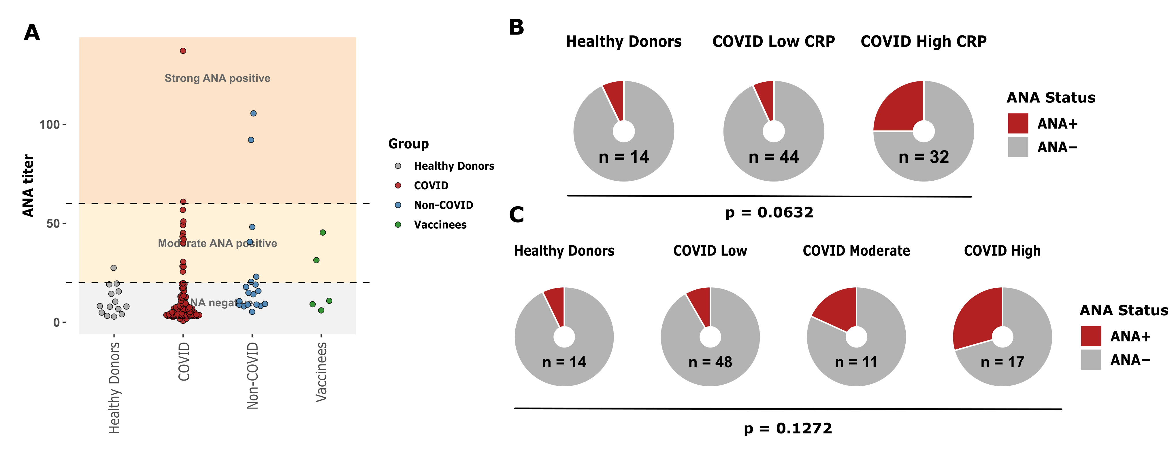
Supplemental Figure 1. Healthy donor and patient group comparisons within clinical parameters. (A) Anti-nuclear antibody ELISA results for COVID-19 patients (COVID) (n = 76), healthy donors (n= 14), non-COVID (n = 20), and vaccinated healthy donors (n = 5). Thresholds were drawn at ≥ 20 ANA score as moderate and > 60 as strong positive. (B) Comparison of ANA status in patients with low versus high C-reactive protein (CRP) to healthy donors. Patients were stratified by CRP concentration (≤10 mg/L versus >10 mg/L), and ANA status (ANA+ = ANA score > 20; ANA- = ANA score < 20). Statistical significance was assessed by Fisher’s exact test. (B) Comparison of ANA status in patients with low (COVID low; scores 5-6), moderate (COVID moderate; scores 7-8), and high (COVID high; scores 9-10) disease severity scores. Statistical significance was assessed by Fisher’s exact test.
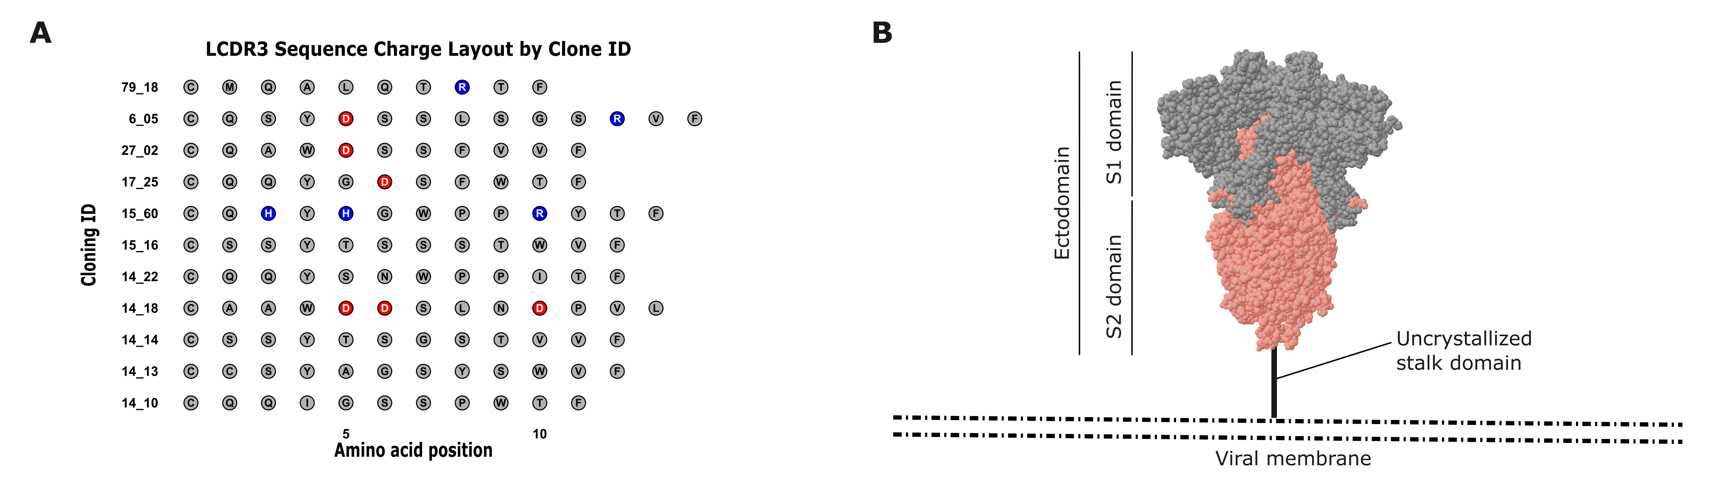
Supplemental Figure 2. Light chain amino acid distribution and model of the SARS-CoV-2 spike protein. (A) Amino acid composition of light chain CDR3 (LCDR3) regions from polyreactive antibodies. Each row represents an individual clone, with residues plotted by position along the LCDR3. Positively charged residues (arginine, histidine, and lysine) are blue, and negatively charged residues (aspartic acid and glutamic acid) are red. (B) Representative image of the spike protein on the viral membrane. The S1 and S2 domains form the crystallizable ectodomain, while the stalk domain cannot be crystallized and thus is missing from the PDB file. The stalk domain is roughly 10nM in length and anchors the ectodomain to the membrane.
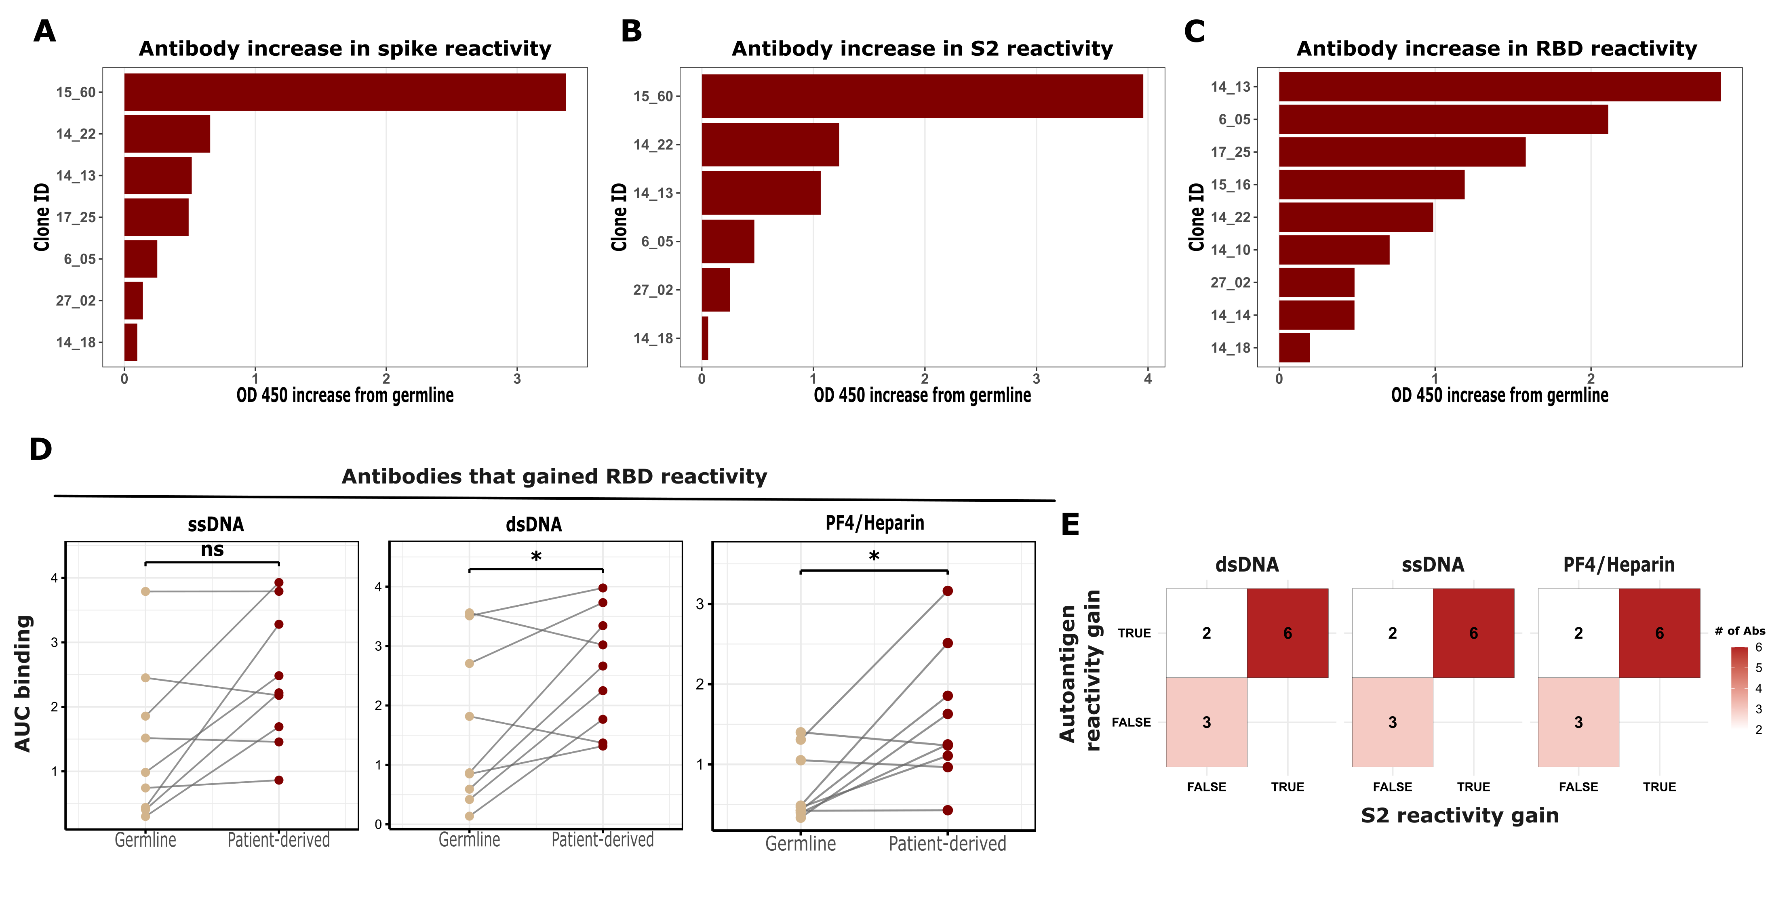Supplemental Figure 3. Anti-viral antibody breakdown and germline versus patient-derived comparisons. ELISA AUC binding gain from germline to patient-derived clones (germline OD450 minus patient-derived OD450). Plots show clones that gained reactivity for (A) spike, (B) S2 domain, and (C) RBD. (D) Autoreactivity pairwise comparison of germline versus patient-derived antibodies that gained RBD reactivity (n = 9). ELISA AUC values are shown for autoantigens: single stranded DNA (ssDNA), double stranded DNA (dsDNA), and platelet factor-4(PF4)/Heparin complexes. Statistical significance was assessed using a paired Wilcoxon signed-rank test. *p < 0.05. (E) Autoreactivity and S2 reactivity change heatmap. Clones were classified based on increases in AUC binding from germline to patient-derived antibodies (ΔAUC > 0 = True, ΔAUC < 0 = False). Counts of antibody clones gaining or not gaining reactivity to dsDNA, ssDNA, or PF4/Heparin are shown stratified by S2 reactivity gain. Color represents the number of antibodies (red = high; white = low).
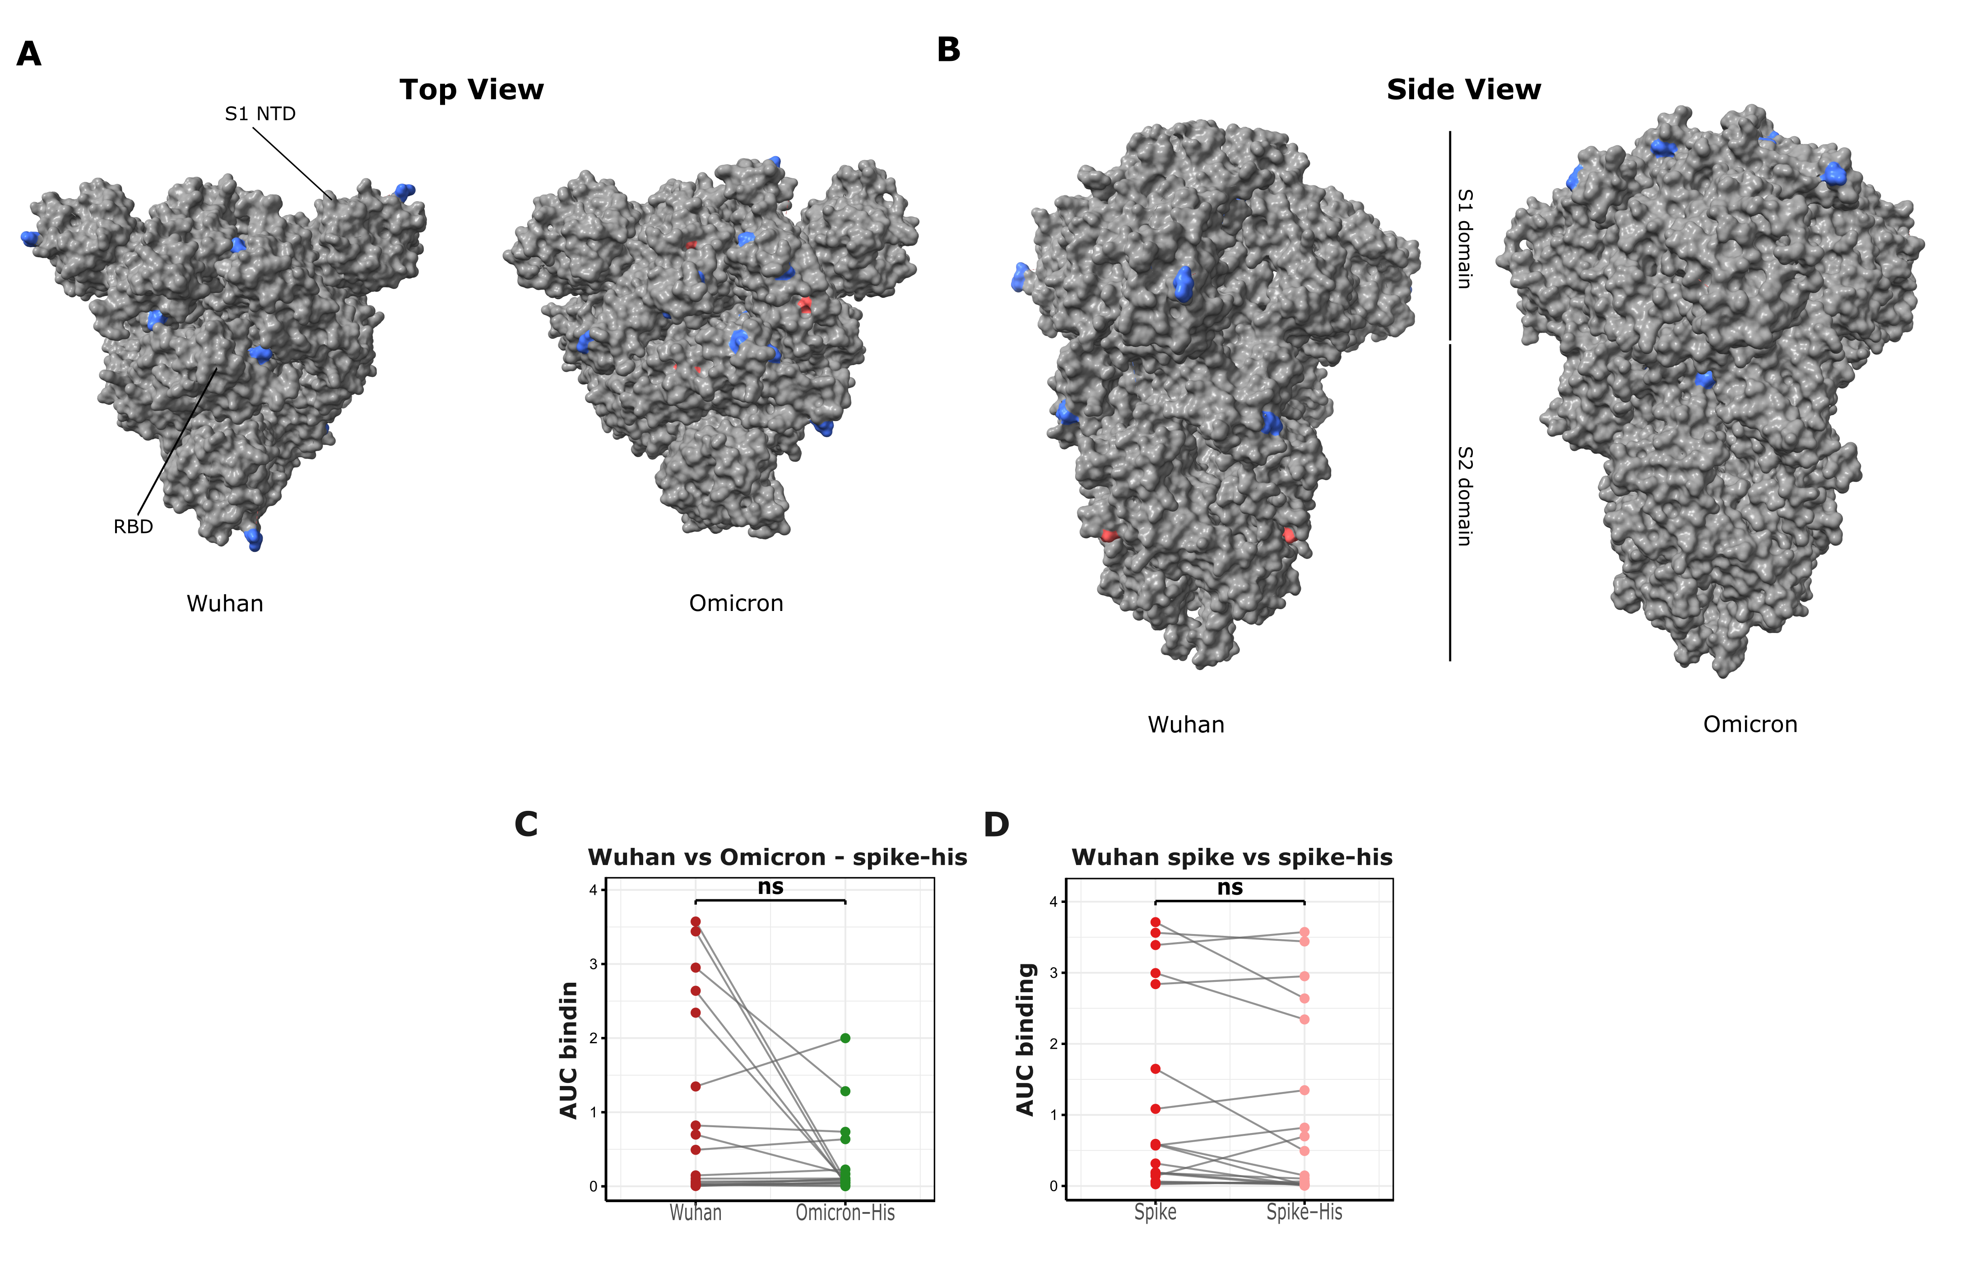
Supplemental Figure 4. Wuhan versus Omicron mutations and spike-his ELISA comparisons. (A, B) Crystallized ectodomains of the Wuhan (PBD:6VXX) and Omicron (PDB:7WP9) variant spike proteins. Mutation differences between the variants are either blue (positive charge), red (negative charge), or gray (neutral charge). Color changes represent the charge of the changed residue in each variant. (C) ELISA AUC pairwise binding comparisons for 19 monoclonal antibodies between the His-tagged spike for both the Wuhan and Omicron spike proteins. Lines indicate matched pairs. (D) ELISA AUC pairwise binding comparisons for 19 monoclonal antibodies between Wuhan-His spike and untagged spike proteins. Lines indicate matched pairs. Statistical significance was assessed using a Wilcoxon rank-sum test.

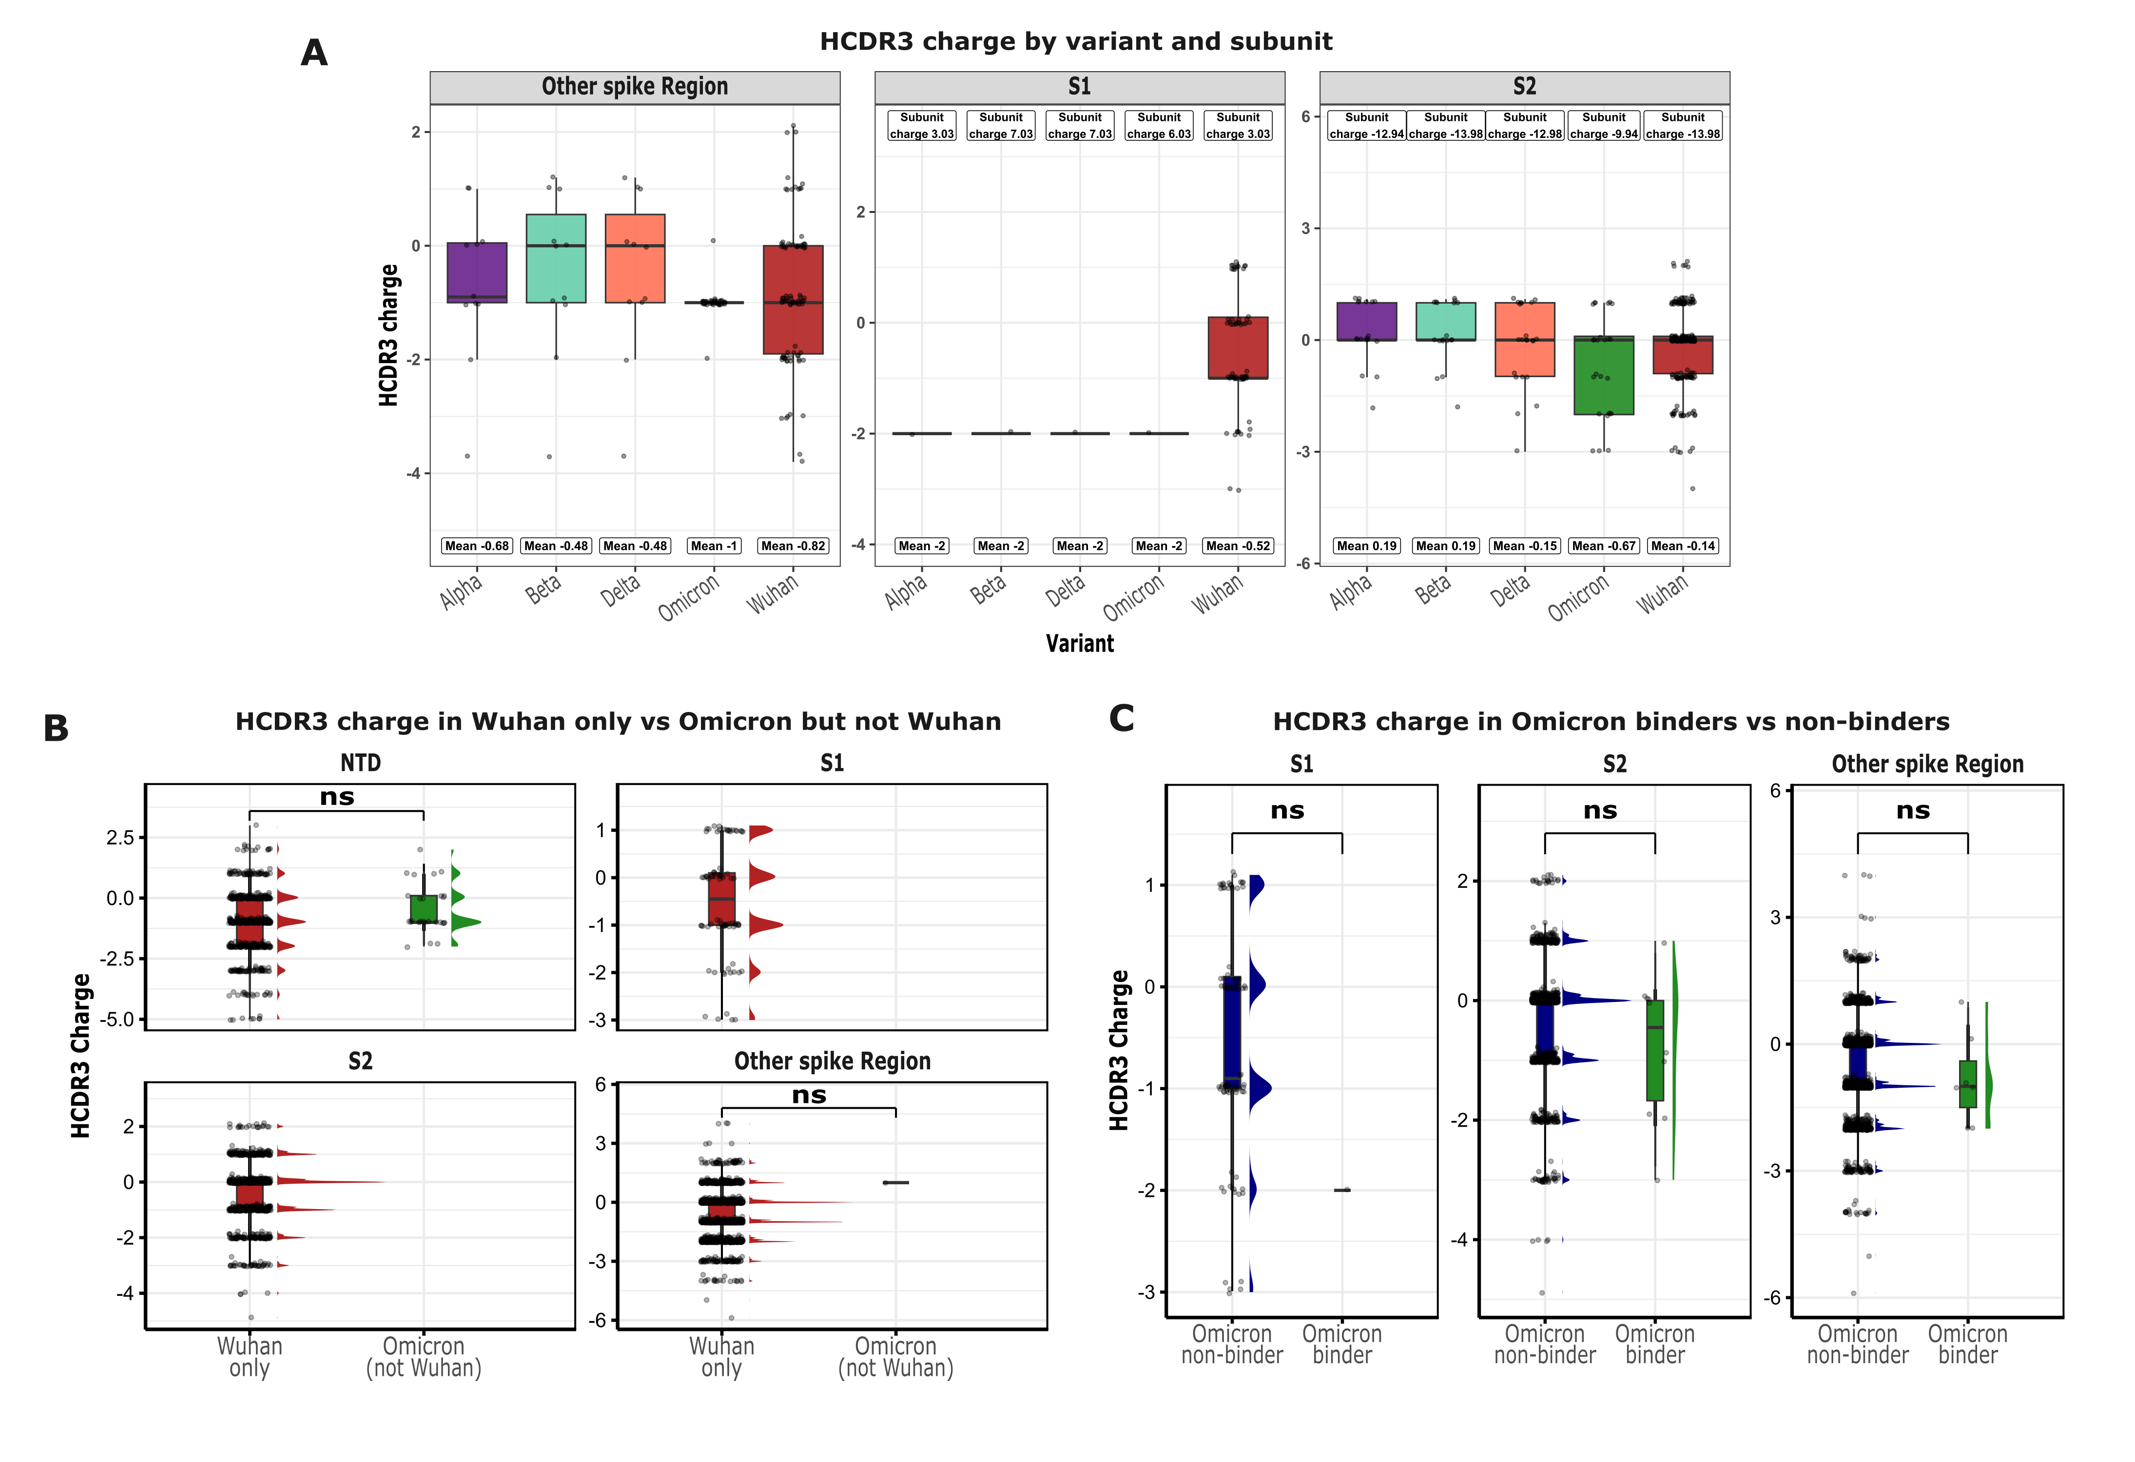
Supplemental Figure 5. HCDR3 comparisons for SARS-CoV-2 variants. (A) HCDR3 charge comparison of antibodies that bound subunits of each SARS-CoV-2 variant. Top boxes indicate the charge of each subunit for each variant, and bottom boxes indicate the mean HCDR3 charge of the antibody repertoire. For panels without top boxes, no specific region was indicated to calculate the charge (Other spike Region n values left to right; 11, 11, 11, 43, 90; S1 n values left to right; 1, 1, 1, 1, 67; S2 n values left to right; 18, 18, 22, 25, 221) (B) Spike subunit breakdown of the HCDR3 antibodies responding to Wuhan only versus Omicron (not Wuhan) (NTD n values left to right; 650, 27); S1 n values left to right; 84, 0; S2 n values left to right; 873, 0; Other spike Region n values left to right; 1,811, 1), and (C) Omicron binder versus Omicron non-binder (S1 n values left to right; 85, 1; S2 n values left to right; 895, 10; Other spike Region n values left to right; 1871, 7). Colored peaks parallel to boxplots indicate dot distribution for each group. Statistical significance was assessed using a Wilcoxon rank-sum test.

Patient ID | ANA score | Clone IDs from the patient
COVID03 | 8.68 | 3_04, 3_06
COVID06 | 137.14 | 6_05
COVID14 | 6.58 | 14_10, 14_13, 14_14, 14_18, 14_22
COVID15 | 12.46 | 15_23, 15_06, 15_49, 15_42, 15_16, 15_60
COVID17 | - | 17_25
COVID27 | 6.77 | 27_02
COVID48 | 5.19 | 48_02, 48_07
COVID79 | 17.43 | 79_18
Supplemental Table 1. Patient ANA and clone information. ANA score and Clone ID information for patients that yielded polyreactive antibodies. ANA scores with – indicate patients who did not have sufficient plasma to conduct ANA ELISAs.

