Online Resource 1
Supplementary Information for: Coal accumulation reshapes soil microbial functional profiles involved in carbon, nitrogen and phosphorus cycling
Journal: Journal of Soils and Sediments
Authors: Wenjing Zhang, Xiaoju Nie, Tongqian Zhao and Xuan Liu
Corresponding authors: Xiaoju Nie (niexj2005@hpu.edu.cn); Tongqian Zhao (zhaotq@hpu.edu.cn)
Affiliations: a Yellow River Conservancy Technical University, Surveying and Mapping Engineering School, Kaifeng 475004, China; b Henan Polytechnic University, School of Surveying and Engineering Information, Jiaozuo 454003, China; c Henan Polytechnic University, School of Resources and Environment, Jiaozuo 454003, China
Supplementary Tables
Table S1. Quality-filtered metagenomic sequencing information for coal accumulation soil samples.
Sample ID | Clean reads | Number of Reads | Q20(%) | Contigs. | N50c | Mapped(%) | ORFsb
CFS1 | 10410416492 | 69660070 | 99.61 | 928545 | 560 | 50.16 | 1109797
CFS2 | 11299014324 | 75593726 | 99.53 | 1095429 | 598 | 50.33 | 1327606
CFS3 | 11074055444 | 73115912 | 99.18 | 952411 | 554 | 46.67 | 1125257
CFS4 | 10446856255 | 69309414 | 99.33 | 1004479 | 598 | 49.63 | 1223793
CFS5 | 10833447237 | 71942208 | 99.3 | 1065474 | 557 | 56.16 | 1244763
CCSL1 | 11870984504 | 79373320 | 99.53 | 1185686 | 620 | 52.78 | 1455946
CCSL2 | 15109502693 | 101056392 | 99.64 | 1841619 | 577 | 63.18 | 2213896
CCSL3 | 11139588476 | 74537494 | 99.59 | 1126894 | 597 | 51.82 | 1372338
CCSL4 | 11380193507 | 75231738 | 99.23 | 1058553 | 568 | 50.37 | 1264649
CCSL5 | 10336939231 | 68851360 | 99.42 | 884282 | 558 | 46.08 | 1048287
CCSM1 | 11966819490 | 78416280 | 98.99 | 999273 | 539 | 51.81 | 1186284
CCSM2 | 10739879652 | 71915038 | 99.57 | 911364 | 542 | 46.83 | 1069313
CCSM3 | 11111878419 | 73348866 | 99.21 | 1012206 | 557 | 49.67 | 1195970
CCSM4 | 11511840046 | 75705286 | 99.03 | 1008822 | 573 | 47.72 | 1201655
CCSM5 | 11158468717 | 73367740 | 99.16 | 1064861 | 509 | 52.72 | 1240223
CCSH1 | 11549868419 | 77515164 | 99.62 | 1120575 | 600 | 58.09 | 1362401
CCSH2 | 11245260876 | 74126388 | 99.21 | 1197923 | 578 | 56.95 | 1453658
CCSH3 | 11383105983 | 74743926 | 99.01 | 1078694 | 574 | 53.28 | 1310183
CCSH4 | 11213163192 | 74081228 | 99.19 | 948614 | 543 | 47.48 | 1119805
CCSH5 | 10749369218 | 71194468 | 99.25 | 977546 | 555 | 44.66 | 1153178
CCSEH1 | 10680670368 | 70869294 | 99.3 | 951941 | 565 | 44.99 | 1128423
CCSEH2 | 12830529858 | 85971538 | 99.59 | 1313531 | 617 | 58.21 | 1580983
CCSEH3 | 12328898118 | 80614036 | 98.87 | 1126499 | 569 | 50.9 | 1348723
CCSEH4 | 12864812794 | 86141432 | 99.59 | 1292850 | 597 | 55.82 | 1575073
CCSEH5 | 11180182335 | 74796220 | 99.58 | 1103046 | 602 | 52.7 | 1341291
平均数 | 11456629826 | 76059141.52 | 99.3412 | 1090044.68 | 572.28 | 51.5604 | 1306139.8
Table S2a. Carbon cycling genes used in this study.
Process | Subcategory | KEGG orthology number | Encoded protein (EC) / KO Description | Gene name
C degradation | 1.Starch | K00705 | 2.4.1.25 | malQ
C degradation | 1.Starch | K01176 | 3.2.1.1 | amyA
C degradation | 1.Starch | K01187 | 3.2.1.20 | malZ
C degradation | 1.Starch | K01200 | 3.2.1.41 | pula
C degradation | 1.Starch | K01208 | 3.2.1.135 | nplT
C degradation | 1.Starch | K01214 | 3.2.1.68 | iam
C degradation | 2.Hemicellulose | K01048 | 3.1.1.5 | pldB
C degradation | 2.Hemicellulose | K01191 | 3.2.1.24 | MAN2C1
C degradation | 2.Hemicellulose | K01195 | 3.2.1.31 | uidA, GUSB
C degradation | 2.Hemicellulose | K01198 | 3.2.1.37 | xynB
C degradation | 2.Hemicellulose | K01206 | 3.2.1.51 | FUCA
C degradation | 2.Hemicellulose | K01209 | 3.2.1.55 | abfA
C degradation | 2.Hemicellulose | K01212 | 3.2.1.65 | sacC
C degradation | 2.Hemicellulose | K01218 | 3.2.1.78 | gmuG
C degradation | 2.Hemicellulose | K01710 | 4.2.1.46 | rfbB
C degradation | 2.Hemicellulose | K01805 | 5.3.1.5 | xylA
C degradation | 2.Hemicellulose | K03928 | 3.1.1.1 | yvaK
C degradation | 2.Hemicellulose | K07406 | 3.2.1.22 | melA
C degradation | 2.Hemicellulose | K10543 | D-xylose transporter | xylF
C degradation | 2.Hemicellulose | K10544 | D-xylose transport system permease protein | xylH
C degradation | 2.Hemicellulose | K12308 | 3.2.1.23 | bgaB, lacA
C degradation | 2.Hemicellulose | K15923 | 3.2.1.51 | AXY8, FUC95A, afcA
C degradation | 2.Hemicellulose | K19355 | 3.2.1.78 | MAN
C degradation | 3.Pectin | K01184 | 3.2.1.15 | pgl
C degradation | 3.Pectin | K01728 | 4.2.2.2 | pel
C degradation | 4.Cellulose | K01179 | 3.2.1.4 | celF
C degradation | 4.Cellulose | K01223 | 3.2.1.86 | bglA
C degradation | 4.Cellulose | K05349 | 3.2.1.21 | bglX
C degradation | 4.Cellulose | K05350 | 3.2.1.21 | bglB
C degradation | 4.Cellulose | K19668 | 3.2.1.91 | cbhA
C degradation | 4.Cellulose | K01182 | 3.2.1.10 | malL
C degradation | 5.Chitin | K01183 | 3.2.1.14 | chi
C degradation | 6.Lignin | K00104 | 1.1.3.15 | glcD
C degradation | 6.Lignin | K00432 | 1.11.1.9 | gpx
C degradation | 6.Lignin | K03386 | 1.11.1.24 | Peroxiredoxin
C degradation | 6.Lignin | K03781 | 1.11.1.6 | Catalase
C degradation | 6.Lignin | K03782 | 1.11.1.21 | katG
C degradation | 6.Lignin | K03862 | 1.14.13.82 | vanA
C degradation | 6.Lignin | K03863 | vanillate monooxygenase ferredoxin subunit | vanB
C degradation | 6.Lignin | K11065 | 1.11.1.24 | tpx
C degradation | 6.Lignin | K11517 | 1.1.3.15 | HAO
C fixation | 1.Multiple systems | K01962 | 2.1.3.15;6.4.1.2 | accA
C fixation | 1.Multiple systems | K11263 | 6.3.4.14;6.4.1.2;6.4.1.3 | pccA
C fixation | 2.Reductive tricarboxylic acid cycle (rTCA cycle) | K00031 | 1.1.1.42 | icd
C fixation | 2.Reductive tricarboxylic acid cycle (rTCA cycle) | K00174 | 1.2.7.11 | korA
C fixation | 2.Reductive tricarboxylic acid cycle (rTCA cycle) | K00175 | 1.2.7.11 | korB
C fixation | 3.wood-ljungdahl pathway (WL pathway) | K01938 | 6.3.4.3 | fhs
C fixation | 3.wood-ljungdahl pathway (WL pathway) | K07321 | carbon monoxide dehydrogenase accessory protein | cooC
C fixation | 4.Calvin cycle | K01601 | 4.1.1.39 | rbcL
C fixation | 4.Calvin cycle | K01602 | 4.1.1.39 | rbcS
C fixation | 4.Calvin cycle | K21703 | ruBisCO operon transcriptional regulator | cbbR
C fixation | 6.CO oxidation | K03518 | 1.2.5.3 | coxS
C fixation | 6.CO oxidation | K03519 | 1.2.5.3 | coxM
C fixation | 6.CO oxidation | K03520 | 1.2.5.3 | coxL
Methane metabolism | Methane oxidation | K10944 | 1.14.18.3;1.14.99.39 | pmoA-amoA
Methane metabolism | Methane oxidation | K10945 | methane/ammonia monooxygenase subunit B | pmoB-amoB
Methane metabolism | Methane oxidation | K10946 | methane/ammonia monooxygenase subunit C | pmoC-amoC
Methane metabolism | Methanogen | K00577 | 2.1.1.86 | mtrA
Methane metabolism | Methanogen | K14083 | 2.1.1.250 | mttB
Table S2b. Nitrogen cycling genes used in this study.
Process | KEGG orthology number | Encoded protein (EC) / KO Description | Gene name
Nitrogen fixation | K02588 | nitrogenase iron protein NifH | nifH
Nitrogen fixation | K02591 | 1.18.6.1 | nifK
Nitrification | K10944 | 1.14.18.3;1.14.99.39 | amoA-pmoA
Nitrification | K10945 | ammonia monooxygenase subunit B/methane | amoB-pmoB
Nitrification | K10946 | ammonia monooxygenase subunit C/methane | amoC-pmoC
Nitrification | K10535 | 1.7.2.6 | hao
Denitrification | K00370 | 1.7.5.1;1.7.99.- | narG/nxrA
Denitrification | K00371 | 1.7.5.1;1.7.99.- | narH/nxrB
Denitrification | K00374 | 1.7.5.1;1.7.99.- | narI
Denitrification | K00368 | 1.7.2.1 | nirK
Denitrification | K15864 | 1.7.2.1;1.7.99.1 | nirS
Denitrification | K02305 | nitric oxide reductase subunit C | norC
Denitrification | K00376 | 1.7.2.4 | nosZ
Assimilatory nitrate reduction (ANRA) | K00372 | 1.7.99.- | nasA
Assimilatory nitrate reduction (ANRA) | K00360 | 1.7.99.- | nasB
Assimilatory nitrate reduction (ANRA) | K00366 | 1.7.7.1 | nirA
Assimilatory nitrate reduction (ANRA) | K00367 | 1.7.7.2 | narB
Dissimilatory nitrate reduction (DNRA) | K00362 | 1.7.1.15 | nirB
Dissimilatory nitrate reduction (DNRA) | K00363 | 1.7.1.15 | nirD
Dissimilatory nitrate reduction (DNRA) | K03385 | 1.7.2.2 | nrfA
Dissimilatory nitrate reduction (DNRA) | K15876 | nitrite reductase complex | nrfH
Dissimilatory nitrate reduction (DNRA) | K02567 | 1.9.6.1 | napA
Dissimilatory nitrate reduction (DNRA) | K02568 | Periplasmic nitrate reductase, electron transfer subunit | napB
Dissimilatory nitrate reduction (DNRA) | K02569 | periplasmic nitrate reductase, electron transfer subunit | napC
Nitrogen degradation | K00262 | 1.4.1.4 | GDH1 (gdhA)
Nitrogen degradation | K15371 | 1.4.1.2 | GDH2
Nitrogen degradation | K01430 | 3.5.1.5 | ureA
Nitrogen degradation | K01429 | 3.5.1.5 | ureB
Nitrogen degradation | K01428 | 3.5.1.5 | ureC
Nitrogen degradation | K01915 | 6.3.1.2，5.4.4.3 | glnA
Nitrogen degradation | K00265 | 1.4.1.13 | gltB
Nitrogen degradation | K00266 | 1.4.1.13 | gltD
Nitrogen degradation | k00926 | 2.7.2.2 | arcC
Table S2c. Phosphorus cycling genes used in this study.
Process | KEGG orthology number | Encoded protein (EC) / KO Description | Gene name
Organic P mineralisation | K03788 | 3.1.3.2 | aphA
Organic P mineralisation | K01093 | 3.1.3.2;3.1.3.26 | appA
Organic P mineralisation | K01077 | 3.1.3.1 | phoA
Organic P mineralisation | K01113 | 3.1.3.1 | phoD
Organic P mineralisation | K09474 | 3.1.3.2 | phoN
Organic P mineralisation | K19670 | 3.11.1.2 | phnA
Organic P mineralisation | K06166 | 2.7.8.37 | phnG
Organic P mineralisation | K06165 | 2.7.8.37 | phnH
Organic P mineralisation | K06164 | 2.7.8.37 | phnI
Organic P mineralisation | K06163 | 4.7.1.1 | phnJ
Organic P mineralisation | K05780 | 2.7.8.37 | phnL
Organic P mineralisation | K06162 | 3.6.1.63 | phnM
Organic P mineralisation | K05774 | 2.7.4.23 | phnN
Organic P mineralisation | K09994 | 2.3.1.280 | phnO
Organic P mineralisation | K06167 | 3.1.4.55 | phnP
Organic P mineralisation | K05306 | 3.11.1.1 | phnX
Organic P mineralisation | K03430 | 2.6.1.37 | phnW
Organic P mineralisation | K01083 | 3.1.3.8 | phy
Organic P mineralisation | K00140 | 1.2.1.18 | mmsA
Organic P mineralisation | K00469 | 1.13.99.1 | MIOX
Organic P mineralisation | K01803 | 5.3.1.1 | TPI
Inorganic P solibilisation | K00117 | 1.1.5.2 | gcd
Inorganic P solibilisation | K01507 | 3.6.1.1 | ppa
Inorganic P solibilisation | K01524 | 3.6.1.11;3.6.1.40 | ppx
Inorganic P solibilisation | K06137 | 1.3.3.11 | pqqC
P starvation regulation | K07636 | 2.7.13.3 | phoR
P starvation regulation | K07657 | phosphate regulon response regulator | phoB
P starvation regulation | K02039 | phosphate transport system protein | phoU
P uptake and transport | K02038 | phosphate transport system | pstA
P uptake and transport | K02036 | phosphate transport system | pstB
P uptake and transport | K02037 | 7.3.2.1 | pstC
P uptake and transport | K02040 | phosphate transport system | pstS
P uptake and transport | K02041 | phosphonate transport system | phnC
P uptake and transport | K02044 | 7.3.2.2 | phnD
P uptake and transport | K02042 | phosphonate transport system | phnE
P uptake and transport | K05781 | phosphonate transport system | phnK
P uptake and transport | K02043 | phosphonate transport system | phnF
P uptake and transport | K03306 | inorganic phosphate transporter | pit
P uptake and transport | K05814 | glycerol-3-phosphate transporter subunit | ugpA
P uptake and transport | K05813 | glycerol-3-phosphate transporter subunit | ugpB
P uptake and transport | K05815 | glycerol-3-phosphate transporter subunit | ugpE
P uptake and transport | K05816 | glycerol-3-phosphate transporter subunit | ugpC
Table S3. Effects of coal accumulation on soil physicochemical properties.
Treatment regimes | pH (1:2.5 CaCl₂) | Total phosphorus (g/kg) | Available phosphorus (mg/kg) | AP/TP ratio | Total nitrogen (mg/kg) | Alkaline nitrogen (mg/kg) | AN/TN ratio (%) | Ammonium nitrogen (mg/kg) | NH₄⁺-N/TN ratio (%) | Microbial biomass N (mg/kg) | Microbial biomass C (mg/kg) | MBC/MBN ratio
CFS | 8.31±0.03a | 1.58±0.17a | 40.08±2.23d | 2.55±0.28b | 1285.68±128.10d | 79.13±7.46e | 6.24±1.16a | 5.70±0.23a | 0.44±0.04a | 40.24±5.86e | 295.78±61.37e | 7.54±2.04a
CCSL | 8.25±0.08b | 1.24±0.29ab | 44.95±13.35cd | 3.81±1.56ab | 1507.02±148.16c | 86.32±7.30d | 5.76±0.61a | 5.16±0.37b | 0.35±0.04b | 46.73±5.05d | 312.22±23.92de | 6.75±0.97a
CCSM | 8.24±0.08b | 1.06±0.21b | 48.56±2.91bc | 4.68±0.87a | 1562.52±144.73c | 98.54±8.96c | 6.41±0.27a | 5.53±0.26ab | 0.36±0.03b | 57.87±17.21c | 378.59±147.17d | 6.49±1.16a
CCSH | 8.23±0.03bc | 1.40±0.31ab | 53.39±1.54ab | 4.04±1.28ab | 2143.91±143.91b | 129.39±9.47b | 6.04±0.45a | 4.83±0.42bc | 0.23±0.03c | 89.12±11.18b | 688.21±86.13b | 7.78±1.01a
CCSEH | 8.22±0.02c | 1.26±0.23ab | 59.44±7.93a | 4.83±0.86a | 2326.62±233.07a | 140.21±24.56a | 6.04±0.93a | 4.69±0.23c | 0.21±0.02c | 95.01±6.65a | 753.87±44.16a | 7.97±0.71a
ANOVA p-values | <0.001 | 0.124 | 0.002 | 0.016 | <0.001 | <0.001 | 0.221 | <0.001 | <0.001 | <0.001 | <0.001 | 0.133
Fig. S1. Differential abundance of carbon cycling genes among coal accumulation treatments.
Fig. S2. Differential abundance of nitrogen cycling genes among coal accumulation treatments.
Fig. S3. Differential abundance of phosphorus cycling genes among coal accumulation treatments.
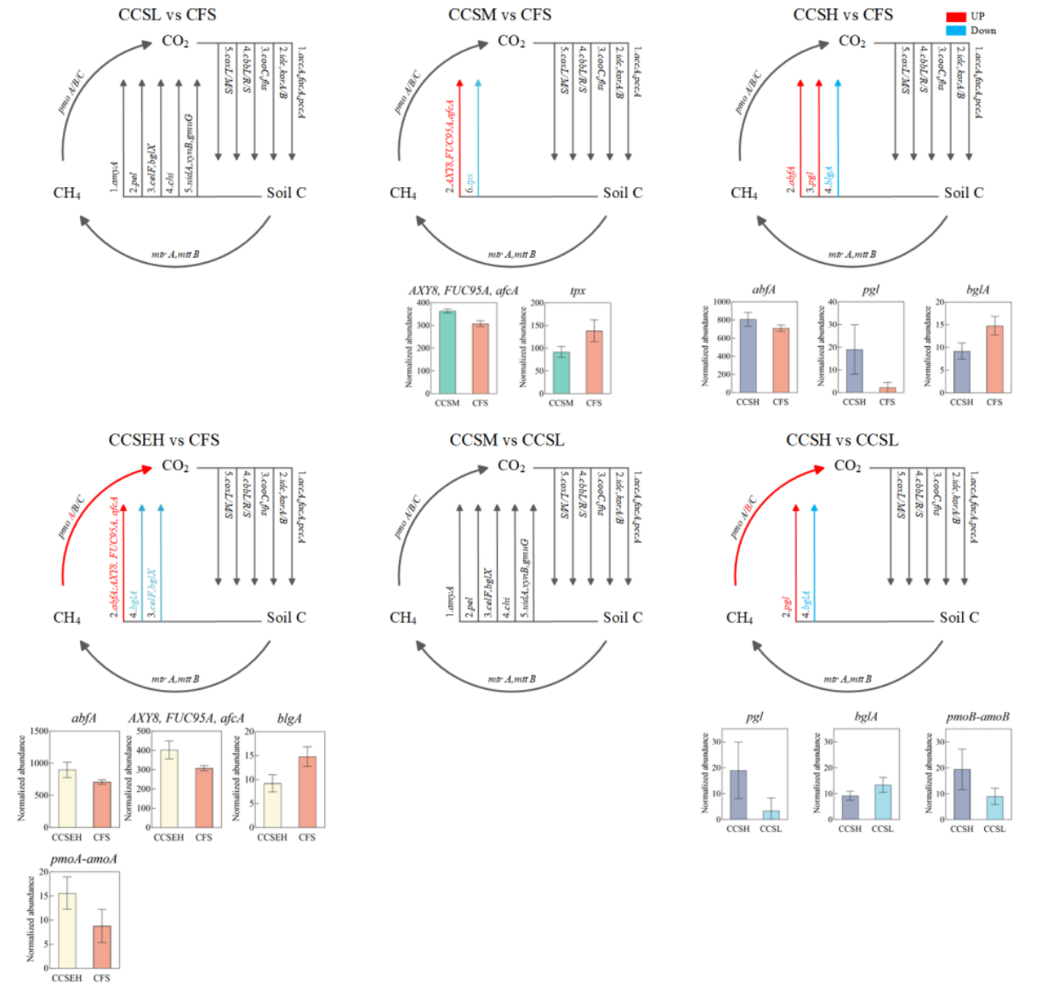
Fig. S4a. Responses of carbon cycling pathways and related functional genes under coal accumulation treatments.
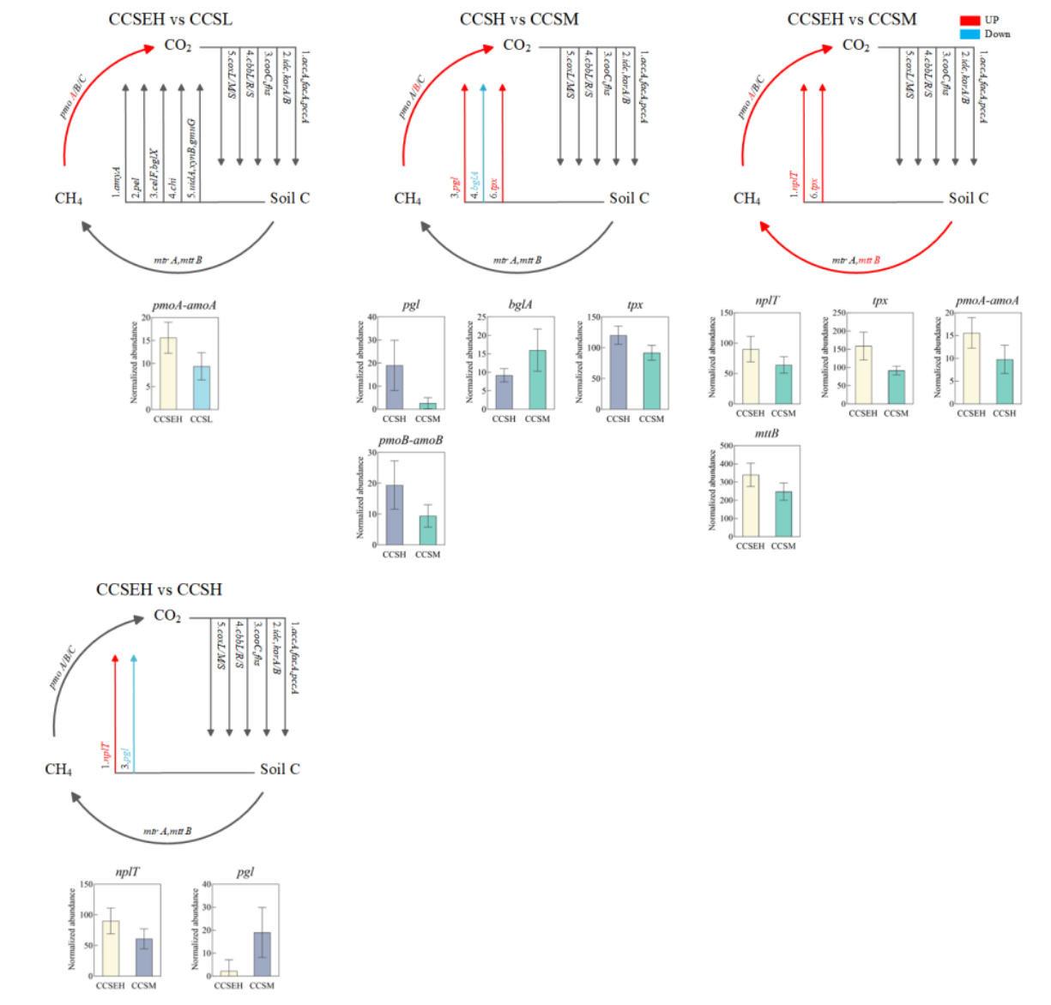
Fig. S4b. Responses of carbon cycling pathways and related functional genes under coal accumulation treatments.

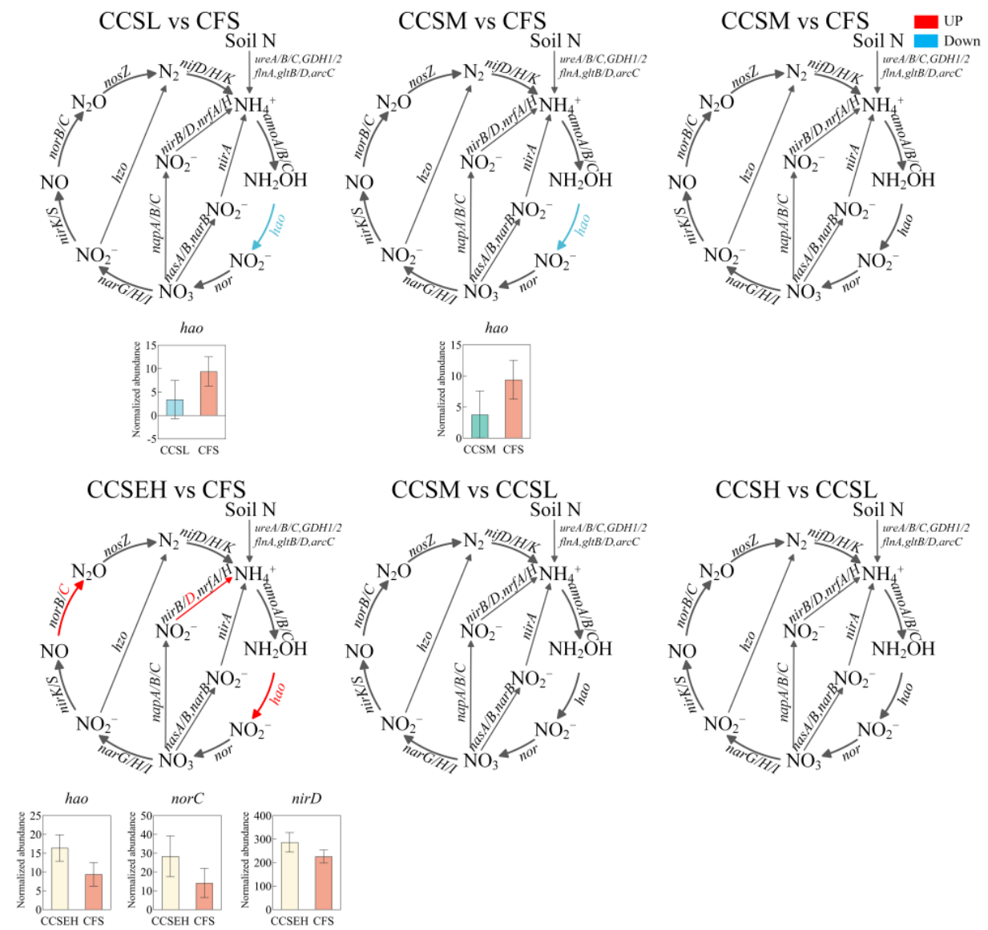
Fig. S5a. Responses of nitrogen cycling pathways and related functional genes under coal accumulation treatments.
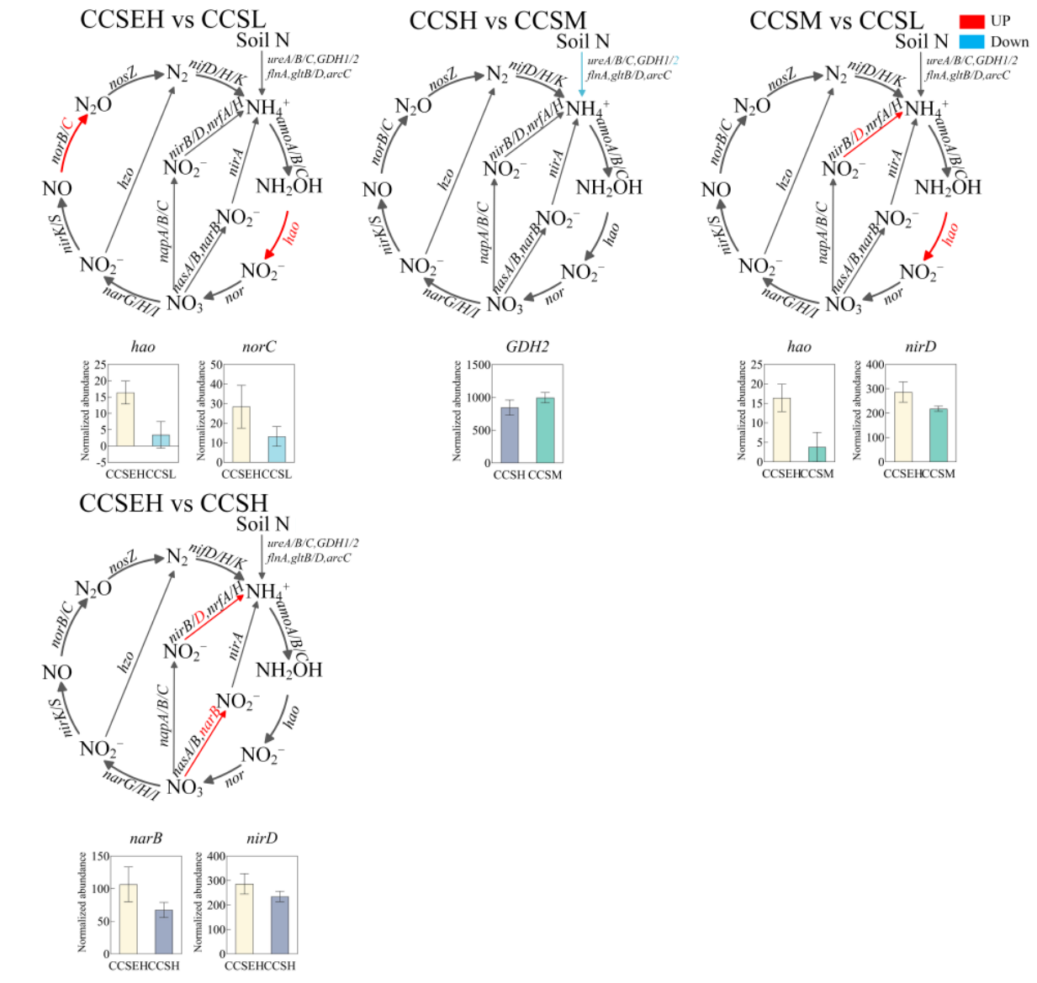
Fig. S5b. Responses of nitrogen cycling pathways and related functional genes under coal accumulation treatments.

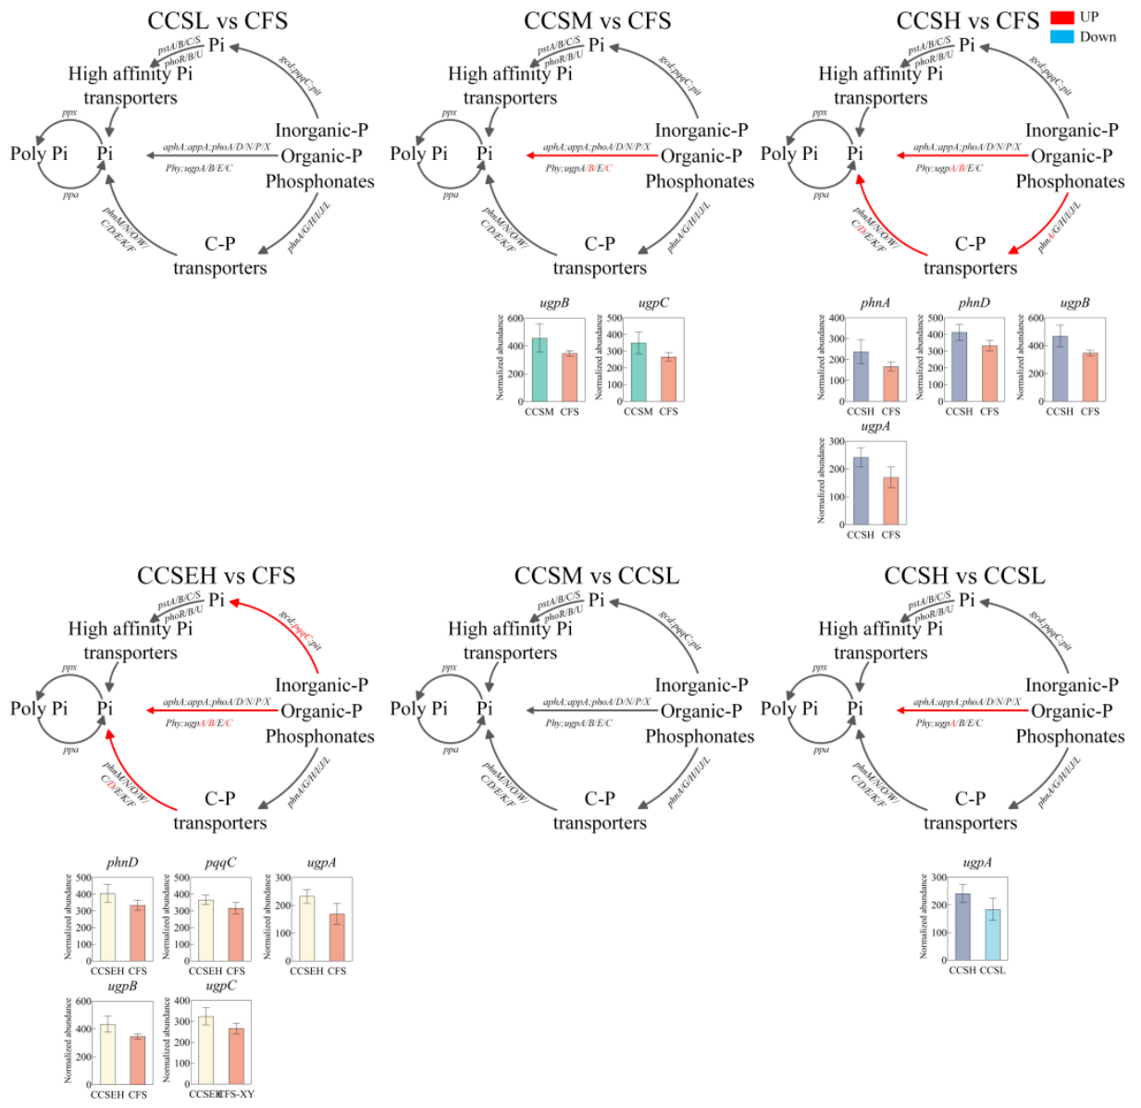
Fig. S6a. Responses of phosphorus cycling pathways and related functional genes under coal accumulation treatments.
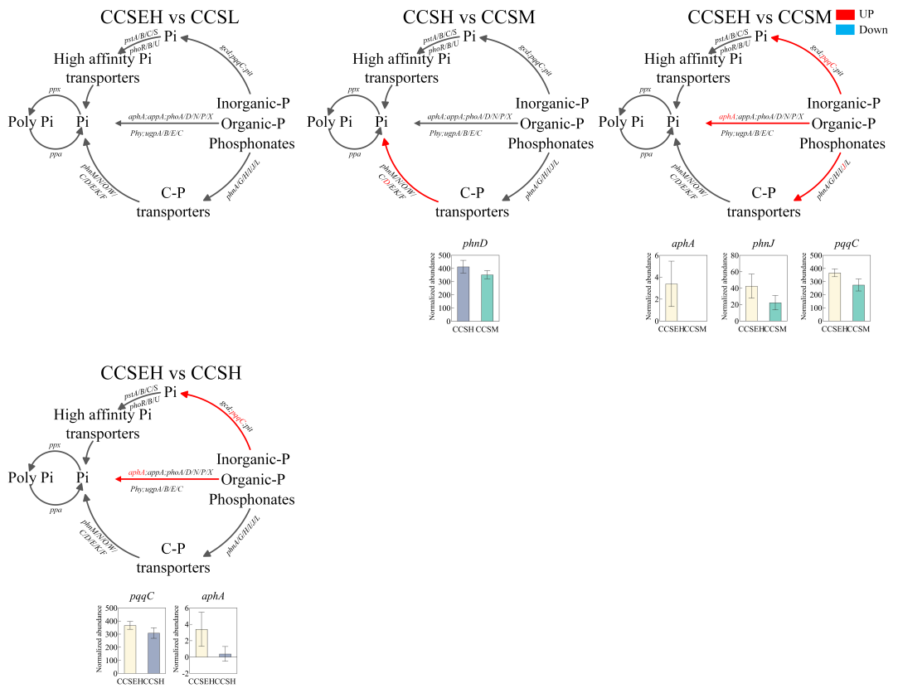
Fig. S6b. Responses of phosphorus cycling pathways and related functional genes under coal accumulation treatments.
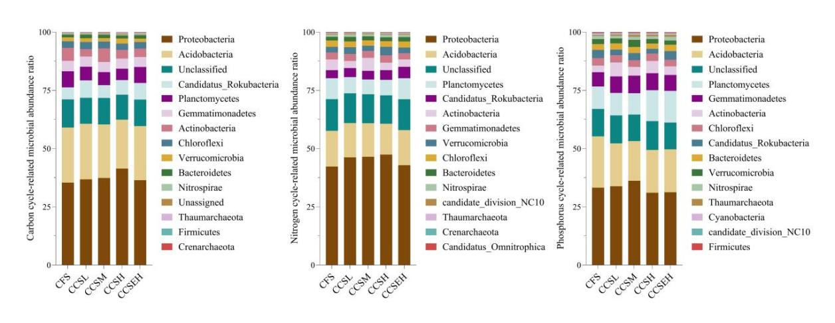
Fig. S7. Taxonomic composition of microorganisms involved in carbon, nitrogen and phosphorus cycling.
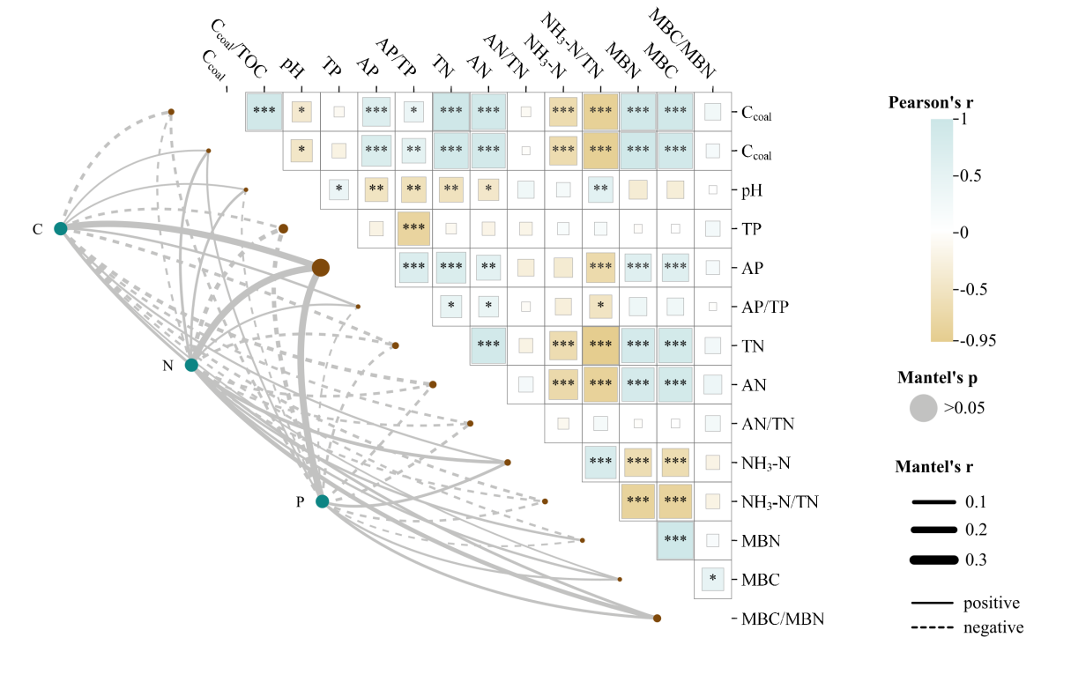
Fig. S8. Relationships between functional gene profiles and soil environmental factors.
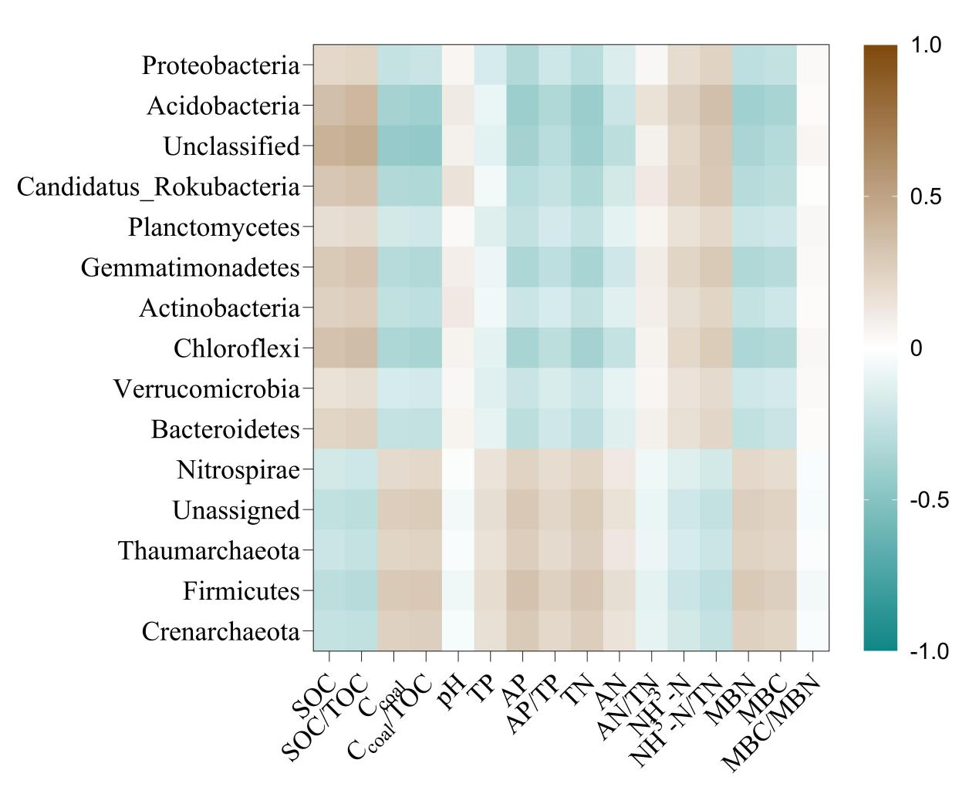
Fig. S9a. Correlations between carbon-cycling functional microbial taxa and soil environmental factors.
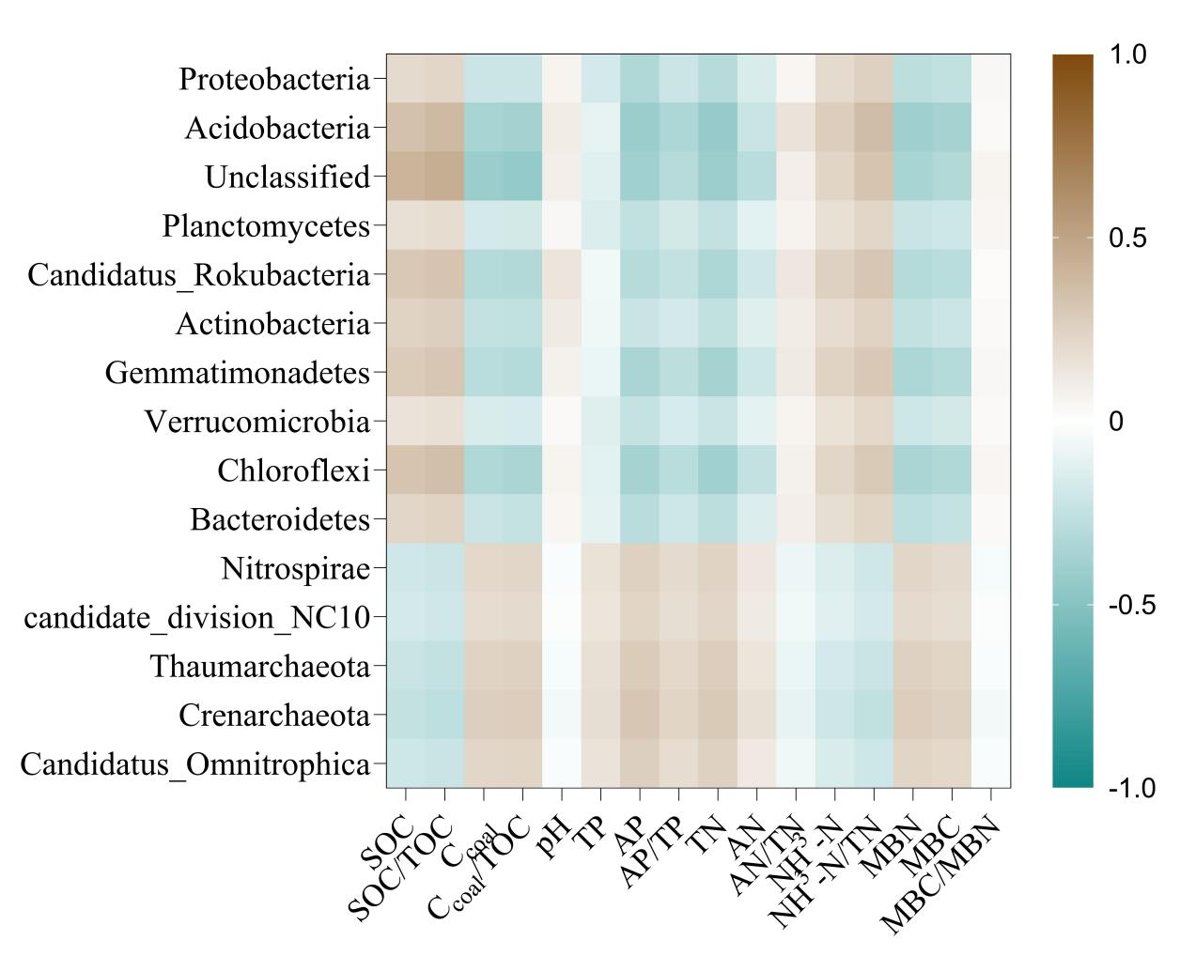
Fig. S9b. Correlations between nitrogen-cycling functional microbial taxa and soil environmental factors.
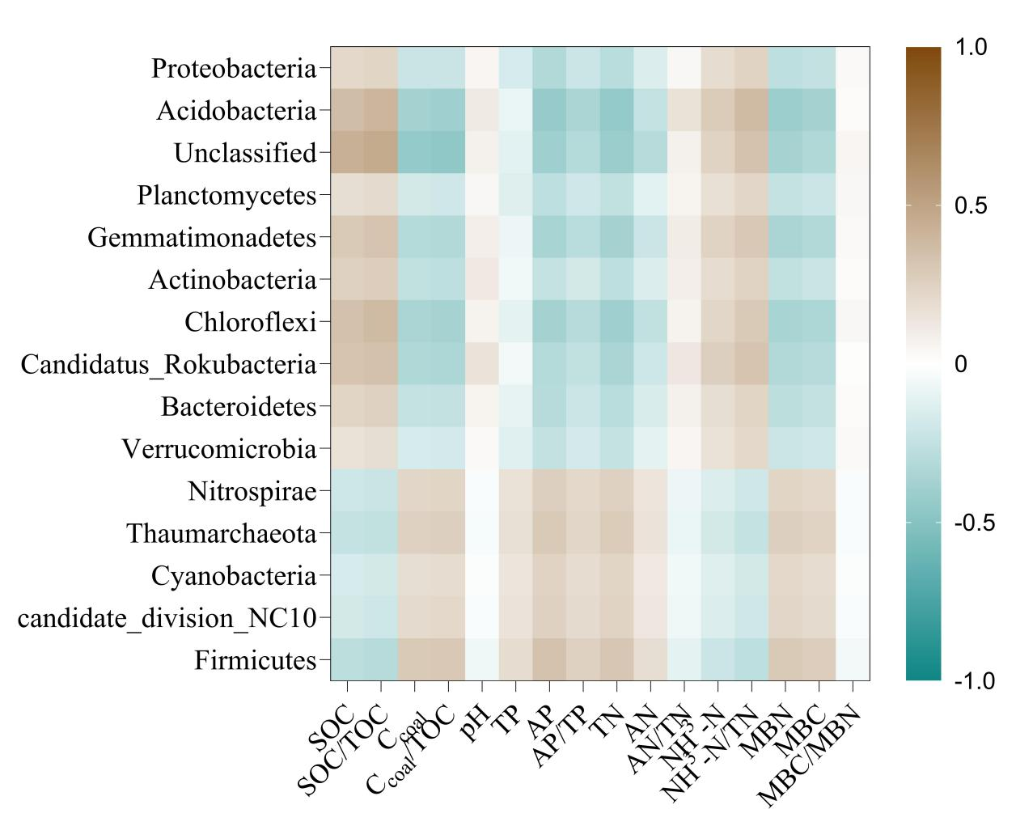
Fig. S9c. Correlations between phosphorus-cycling functional microbial taxa and soil environmental factors.

