Supplemental Materials
Supplemental Figure 1. Enrollment in driving study is shown for individual participant. Resting state functional connectivity (rsfc) was collected at year 0. All individuals contributed at least one year of driving data and exactly one rsfc scan. Individuals with the longest horizontal lines contributed driving data for the longest interval.
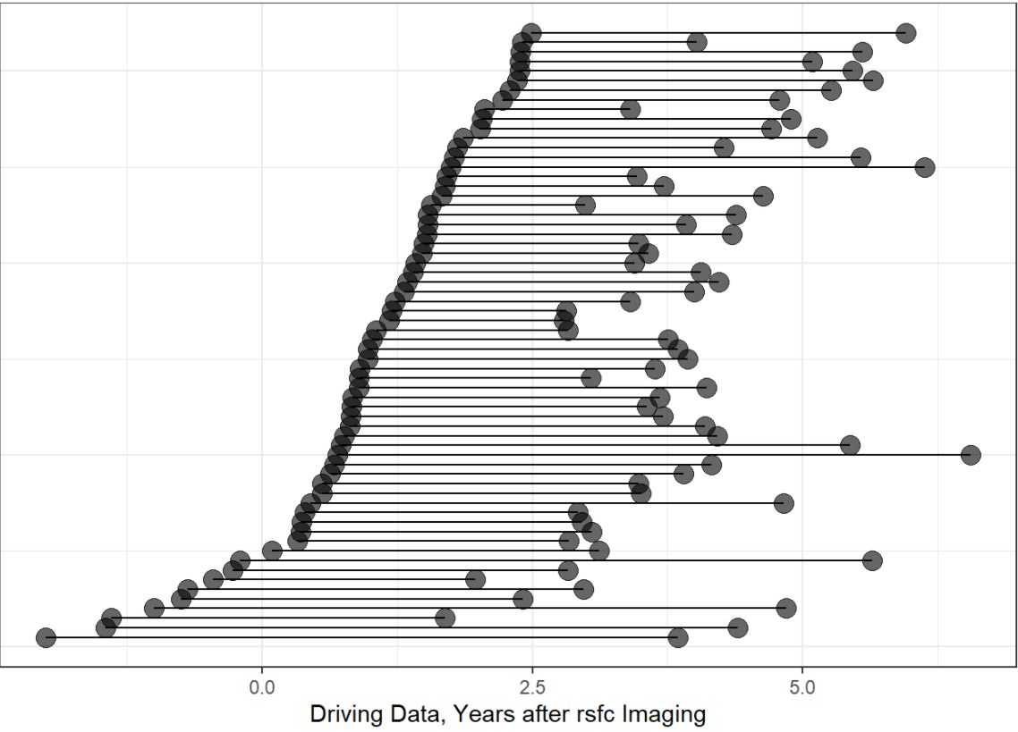

Supplemental Text
MRI Imaging – Structural
We collected MRI using 3T Siemens scanners (Erlangen, Germany) with a standard 12-channel head coil. Structural images were acquired using the Alzheimer’s Disease Neuroimaging Initiative (ADNI) protocol. DICOM files were transferred from the scanners to a local server²³. We applied quality assurance of de-identified data. The study coordinator validated the sequence parameters during scanning, and we performed recapture if the session was corrupted by motion. All MRI scans are examined by a board-certified neuroradiologist at Washington University in St. Louis (WUSTL) for abnormalities.
We processed MRI images with FreeSurfer as detailed previously²⁴. We applied motion correction and intensity normalization prior to segmenting both grey- and white matter structures from a T1 weighted image. We registered images to a spherical atlas and parcellated the cerebral cortex using the Desikan atlas²⁵. We also applied partial volume correction in order to correct for head size²⁶.
MRI Imaging – Resting State Functional Connectivity
We collected resting state functional connectivity (rsfc) scans during the same session as the aforementioned T1 weighted structural MRI scan. Participants were instructed to lie still with their eyes open, and avoid falling asleep. We collected 36 contiguous slices in the sagittal direction²⁷ and processed data consistent with previously published work.^{27,28}.
We corrected for slice intensity differences and corrected for intensity inhomogeneity using FSL FAST. We corrected for echoplanar imaging (EPI) distortion using a mean field map. We registered the EPI mean image to the atlas via MP-RAGE. We compensated for head motion, distortion correction and atlas transformation sequentially in order to produce a volumetric time series.
We classified excessive head motion as either a DVARS > 0.9% root mean square of the frame-to-frame signal change from the entire brain or frame displacement > 0.3 mm. We censored the frames if either of the criterion were exceeded. We applied band pass filtering to retain frequencies between 0.005 Hz and 0.1 Hz. We applied global signal regression and then used FNIRT to non-linearly warped the preprocessed time series data to the Montreal Neurological Institute 152 (3 mm³ voxels) space atlas.

