Spatial proximity heuristics structure the foraging behavior of Callithrix jacchus in the Caatinga: evidence for spatial cognition in a Neotropical primate

Gessica Rafaelly Dantas da Silva
ORCID: 0000-0002-6554-2500 Email: gessica.silva.107@ufrn.edu.br
Igor Eloi
ORCID: 0000-0001-8013-8963 Email: igor.eloi.108@ufrn.edu.br
Arrilton Araújo¹
ORCID: 0000-0002-4804-389X Email: arrilton.aruajo@ufrn.br

¹ Corresponding author
Post-Graduate Program in Psychobiology, Department of Physiology and Behavior, Federal University of Rio Grande do Norte, Natal, Rio Grande do Norte, Brazil.

Material Supplementary

Table S1: Sensitivity analysis of the perceptual range. Prediction error of the mere random walk (MRW = mere random walk, ballistic null model) and the nearest-neighbour (NN) rule across perceptual-range thresholds. N = number of inter-patch displacements; error is the median of ln(|observed − expected| + 1); lower values indicate better fit. Corrects the earlier version (MRW/NN error columns and N were mistranscribed; MRW had been mislabelled 'Mean Resultant Vector'). The NN rule outperformed the null across all thresholds.

Perceptual range | N | MRW error (ln) | NN (ln) | t | dz
15 m | 884 | 3,73 | 3,57 | 5,41 | 0,18
30 m | 884 | 3,87 | 3,28 | 9,77 | 0,33
45 m | 884 | 3,89 | 3,51 | 7,65 | 0,26
60 m | 884 | 3,89 | 3,69 | 4,45 | 0,15

Table S2: Stratified results of the movement-decision models by social group, dietary season, and resource type. For each stratum, the observed inter-patch displacements (N) were compared with those predicted by the mere random walk (MRW, null model) and the nearest-neighbour (NN) rule. Prediction error is the median of ln(|observed − expected| + 1); t and dz (Cohen's d for paired samples) refer to the paired comparison MRW vs NN. Lower error indicates better fit. The NN rule outperformed the null model in every stratum.

Stratum | N | MRW (ln) | NN (ln) | t | dz | p
Overall
Overall | 884 | 5,38 | 3,7 | 34,12 | 1,15 | < 0.001
By social group
G1 (Água) | 194 | 5,79 | 3,67 | 21,12 | 1,52 | < 0.001
G2 (Bosque) | 447 | 5,35 | 4,02 | 20 | 0,95 | < 0.001
G3 (Torre) | 243 | 5,32 | 3,37 | 20,86 | 1,34 | < 0.001
By dietary season
Dry | 616 | 5,41 | 3,8 | 27,21 | 1,1 | < 0.001
Rainy | 268 | 5,35 | 3,49 | 20,98 | 1,28 | < 0.001
By resource type
Gum | 482 | 5,36 | 3,68 | 25,05 | 1,14 | < 0.001
Animal | 356 | 5,4 | 3,69 | 21,49 | 1,14 | < 0.001
Plant | 46 | 5,46 | 3,81 | 8,67 | 1,28 | < 0.001

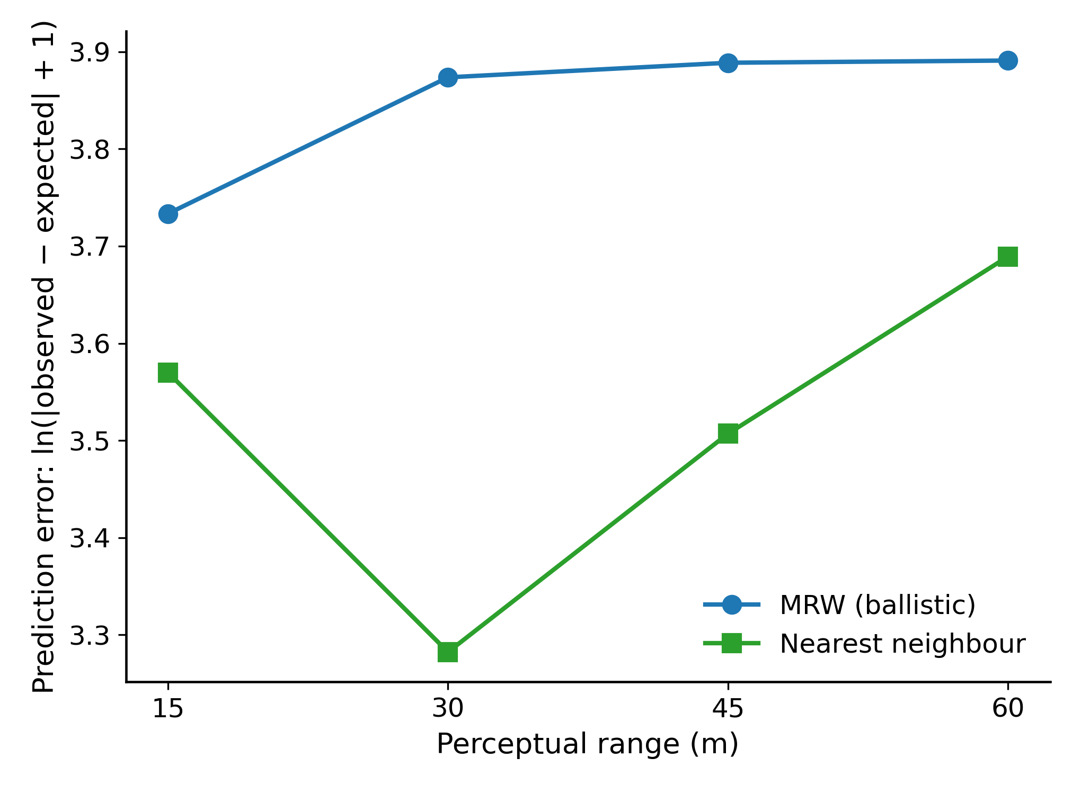

Figure S1: Prediction error of the MRW (ballistic) and Nearest Neighbour (NN) models under different perceptual range thresholds (15–60 m). Error was calculated as ln[|observed − expected| + 1], with lower values indicating better model fit.

