A
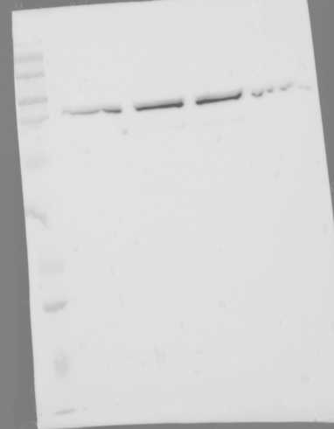

B
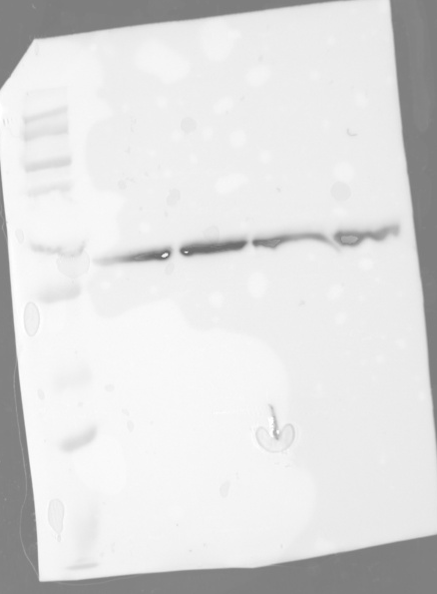
Fig. 1. (A and B) Original gel pictures represent Western blot analysis of BiP and β-actin expression in the presence of Y-27632 alone or in combination with TTNPB, respectively.

A
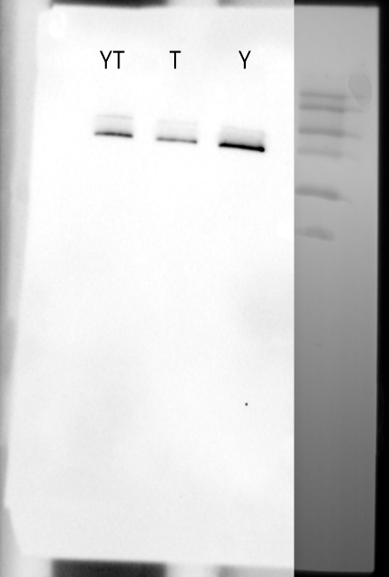
B
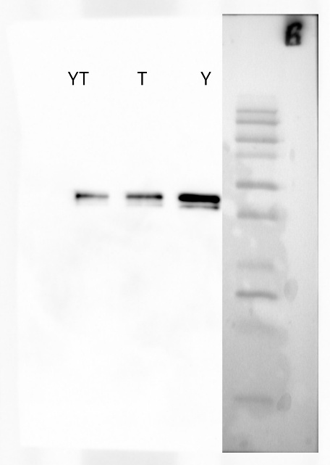
Fig.2. (A and B) Original gel pictures represent Western blot analysis of BiP and β-actin expression at 0, 2, 4, and 24 h after dissociation, respectively.

