Supplementary Information

Table S1. Chi-square test: CNI vs. non-CNI — share in High-High (HH) cluster.
Score | Non-CNI HH (%) | CNI HH (%) | χ² | p-value | Cramér's V
Composite CVI | 17.2 | 70 | 208.14 | <0.001 | 0.106
Socioeconomic Vulnerability | 16.7 | 86.4 | 368.66 | <0.001 | 0.141
Chronic Disease Burden | 17.2 | 54.1 | 99.78 | <0.001 | 0.074
Climate Hazard Exposure | 15.7 | 31.8 | 20.21 | <0.001 | 0.033

Notes: HH cluster membership is defined as census tracts with a statistically significant (simulated p < 0.05) positive local Moran's I for the CVI, surrounded by neighbors of similarly high vulnerability. The chi-square test assesses whether the proportion of tracts classified as HH clusters differs significantly between CNI and non-CNI tracts.

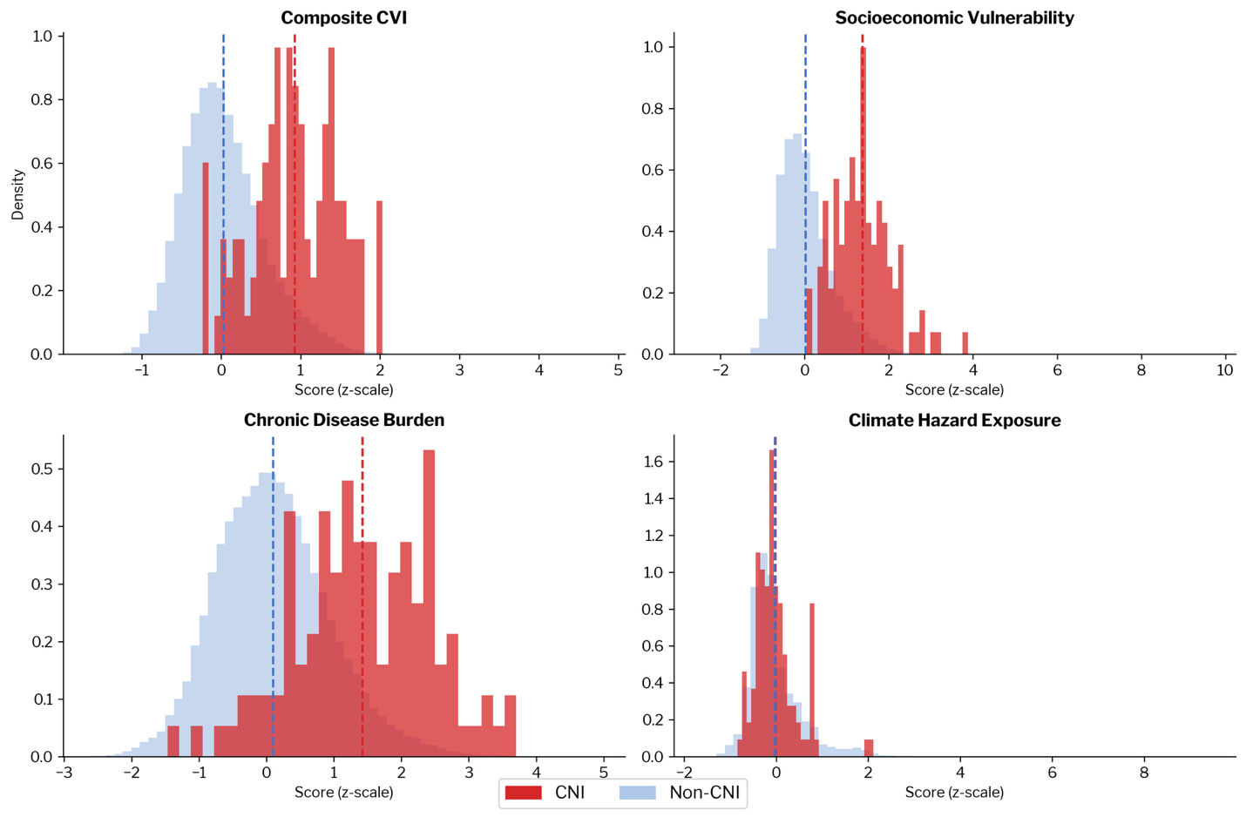

Figure S1. Distribution of CVI and domain scores: CNI vs. non-CNI Tracts. Dashed vertical lines indicate group means. CNI tracts score markedly higher than non-CNI tracts on the Composite CVI, Socioeconomic Vulnerability, and Chronic Disease Burden, with means shifted roughly 1–2 standard deviations above the non-CNI baseline. Climate Hazard Exposure shows a smaller and more compressed difference. All scores are z-scaled relative to the full sample.

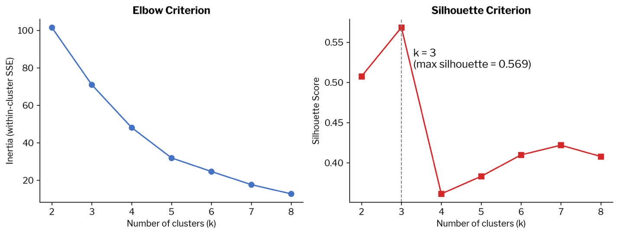

Figure S2. K-means cluster selection diagnostics for CNI site climate hazard typologies (n = 34 sites). Left panel: within-cluster sum of squared errors (inertia) across k = 2–8; the largest marginal reduction occurs at k = 3 (Δ = 30.5), after which gains diminish. Right panel: mean silhouette coefficient across k = 2–8; k = 3 yields the highest silhouette score (0.569), with a pronounced drop at k = 4 (0.361). Both criteria jointly support a three-cluster solution.

