Supplementary material
Table S1 Scoring rubric for the five quality domains
Domain | Construct assessed | Score 1 | Score 3 | Score 5
Accuracy | Scientifically and medically correct | Mostly incorrect | Partially correct | Completely accurate
Completeness | Covers all key points for patient education | Major gaps present | Partly comprehensive | Fully comprehensive
Clarity | Understandable to a non-specialist patient | Very difficult | Moderately clear | Clear and accessible
Safety | Free from harmful or misleading advice | Potentially harmful | Some concern | Clearly safe
Trustworthiness | Aligned with current clinical guidelines | Contradicts guidelines | Partially aligned | Fully aligned
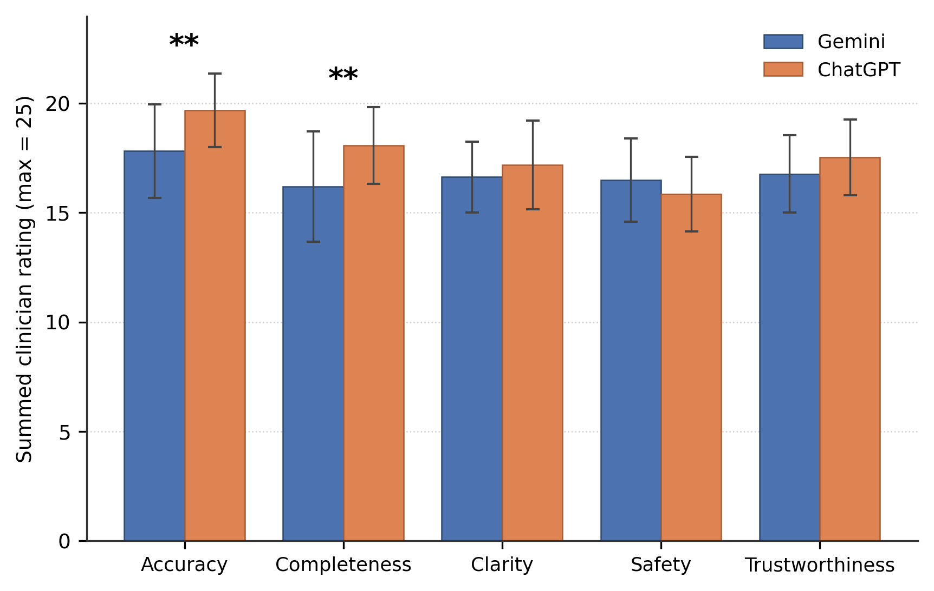
Fig. S1 Quality domain scores: Gemini vs ChatGPT (n = 36 questions per platform). Clustered bar chart of mean summed ratings across the five domains; error bars = SD; ** p < 0.0033 (Bonferroni-corrected); ns = not significant
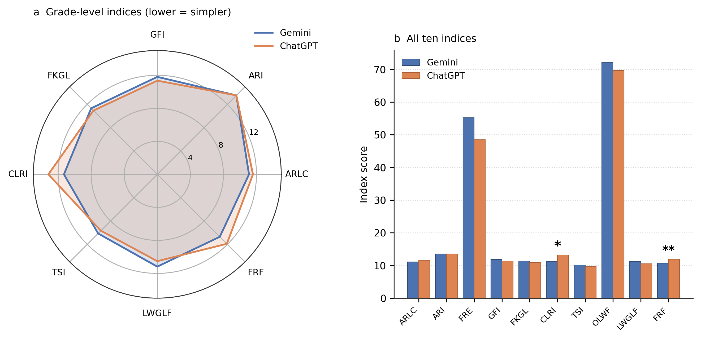
Fig. S2 Readability analysis: Gemini vs ChatGPT. Panel a, radar chart of grade-level indices (lower = simpler); panel b, bar chart of all ten indices. * p < 0.05 (uncorrected); ** p < 0.003 (Bonferroni-corrected, FRF only)

Supplementary Appendix 1. Full list of 36 patient-education questions
The following questions were used as input stimuli for both ChatGPT and Gemini. Each question was entered individually into a new, unprompted chat session.
Table S2 Complete question bank (n = 36) with domain categorisation
No. | Question | Domain
1 | What is wrong with my knee joint? | General Understanding
2 | Is this just “age-related pain,” or osteoarthritis? | General Understanding
3 | What does “knee osteoarthritis” mean in simple terms? | General Understanding
4 | Can you explain what my X-ray or scan shows regarding my knees? | Symptoms & Diagnosis
5 | Will this knee problem continue to worsen over time, or can it be slowed down? | Prognosis
6 | Is my knee problem the same in both knees, or is one side worse? | Symptoms & Diagnosis
7 | Why did I develop this knee problem when some people my age do not have it? | Causes & Risk Factors
8 | Is my weight putting extra stress on my knees and causing pain? | Causes & Risk Factors
9 | Did my past injury, sports, or work (long-standing, squatting, lifting) lead to this? | Causes & Risk Factors
10 | Did my sitting style, use of Indian toilets, or praying on the floor damage my knee? | Causes & Risk Factors
11 | Can my food habits or lifestyle be a reason for my knee osteoarthritis? | Lifestyle & Self-care
12 | Is knee osteoarthritis something that I could have prevented earlier in life? | Causes & Risk Factors
13 | What are all the treatment options available for my knee osteoarthritis? | Pharmacological Tx
14 | How can Unani treatment help with my knee pain and stiffness? | Unani Medicine
15 | What types of Unani treatments are used for the knees (medicines, oils, massage, and others)? | Unani Medicine
16 | How does Unani treatment differ from regular pain tablets, injections, or surgery? | Unani Medicine
17 | Can I safely take Unani medicines along with my current allopathic medicines? | Unani Medicine / Pharmacological Tx
18 | How long should I try Unani treatment before deciding whether it is effective? | Unani Medicine
19 | If I start feeling better, can I reduce or stop my pain medication? | Pharmacological Tx
20 | What can I do, apart from taking tablets, to reduce my knee pain in daily life? | Lifestyle & Self-care
21 | What kind of exercises are safe for my knees, and how often should I perform them? | Exercise & Physio
22 | Will walking, climbing stairs, or using Indian toilets damage my knees more? | Exercise & Physio
23 | Can I safely sit on the floor or perform daily activities like cooking, sweeping, or namaz? | Lifestyle & Self-care
24 | How much activity and rest should I have in a normal day with this condition? | Lifestyle & Self-care
25 | Will I be able to continue my job or household work with this condition? | Prognosis
26 | Are there any foods that can alleviate or worsen my knee pain? | Lifestyle & Self-care
27 | Should I try to lose weight because of my knee problem? If yes, how much? | Lifestyle & Self-care
28 | Can you suggest a simple daily food plan that is good for my joints’ health? | Lifestyle & Self-care
29 | Are there any Unani dietary tips that can help with knee osteoarthritis? | Unani Medicine
30 | What small lifestyle changes at home or work can protect my knees? | Lifestyle & Self-care
31 | What side effects should I watch out for in the medicines I am using? | Pharmacological Tx / Warning Signs
32 | How will I know if I need stronger treatments, such as injections or knee replacement? | Surgical Management / Escalation
33 | For how long is it safe to continue taking pain tablets for knee osteoarthritis? | Pharmacological Tx
34 | Which websites, videos, or pamphlets provide correct information about knee OA? | Health Information & Self-management
35 | Can you provide me with a brief written summary of my knee condition and treatment plan? | Health Information & Self-management
36 | What can I realistically expect in the next few years with this knee problem? | Prognosis
Tx = treatment. Questions 14–16, 18, and 29 were added to capture culturally relevant information-seeking behaviour in South Asian clinical contexts. Questions 10 and 23 addressed activity patterns specific to the target population. All 36 questions were entered verbatim, as stated above

