Supplementary Figure 1. Directed acyclic graph for the association between SUA and incident sepsis
The DAG illustrates the hypothesized causal structure linking SUA to incident sepsis. Age, sex, ethnicity, TDI, education, employment, smoking, alcohol consumption status, BMI, eGFR, diabetes, hypertension, and CVD were considered potential confounders. Solid arrows indicate hypothesized direct causal relationships.
Abbreviations: BMI, body mass index; CVD, cardiovascular disease; DAG, directed acyclic graph; eGFR, estimated glomerular filtration rate; SUA, serum uric acid; TDI, Townsend deprivation index.

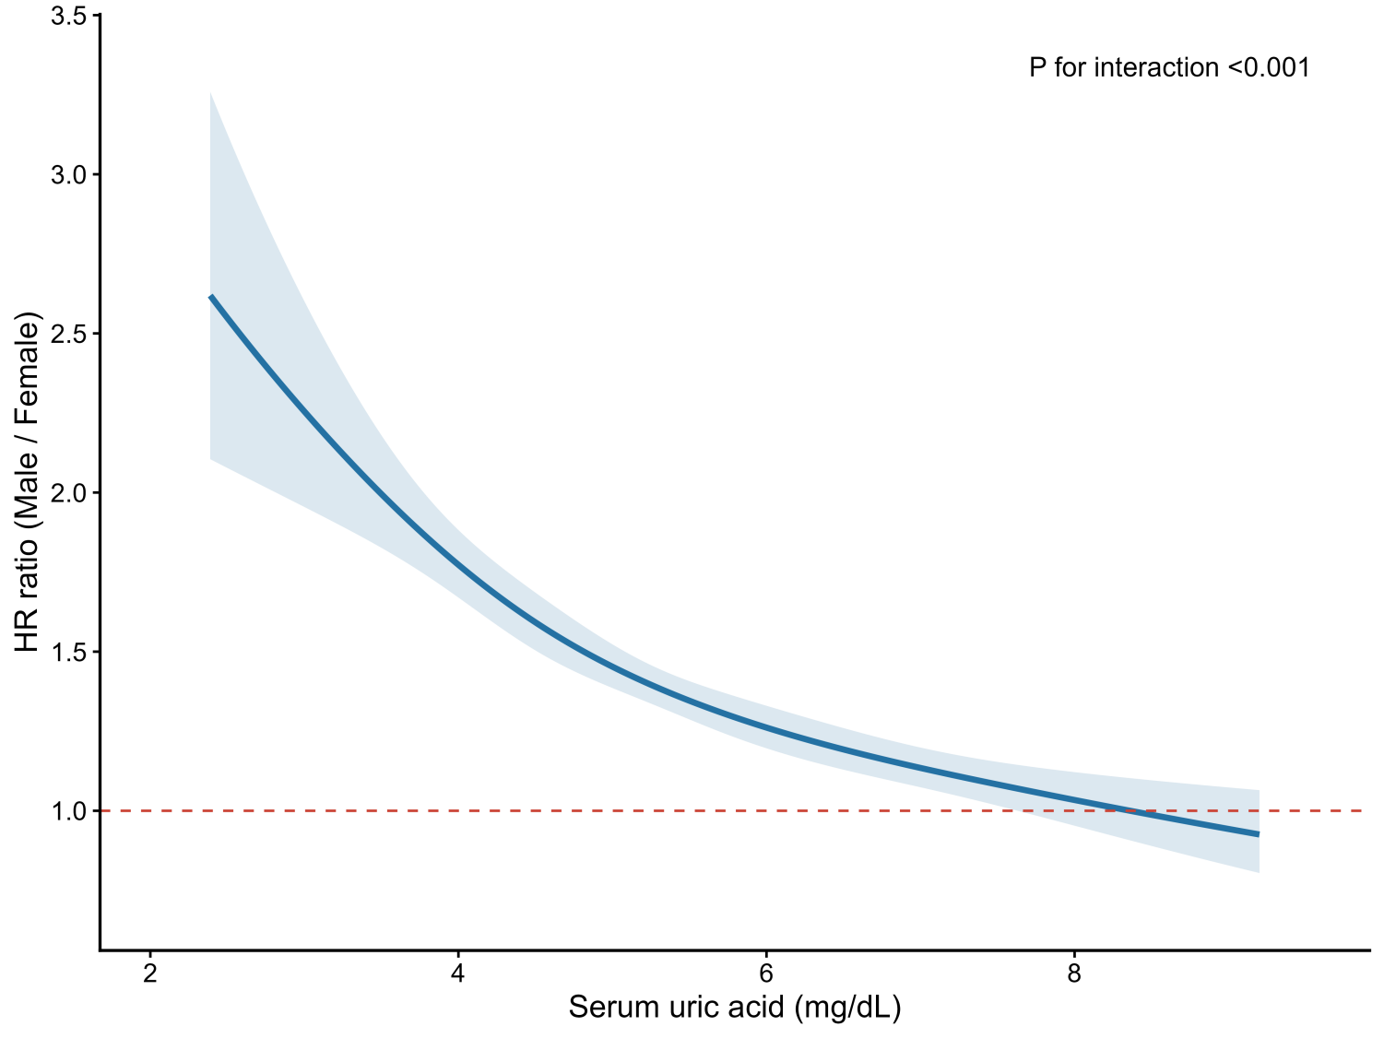
Supplementary Figure 2. Effect modification by sex in the association between serum uric acid and incident sepsis
The curve shows the male-to-female HR ratio for incident sepsis across SUA concentrations, estimated from a fully adjusted Cox model with SUA modeled using cubic splines and sex–SUA interaction terms. The solid line indicates the point estimate; the shaded area represents the 95% CI. The dashed horizontal line denotes an HR ratio of 1.0, indicating no difference between sexes. Values above 1.0 indicate higher relative hazard in males. The overall sex–SUA interaction was significant (P < 0.001).
Abbreviations: CI, confidence interval; HR, hazard ratio; SUA, serum uric acid.

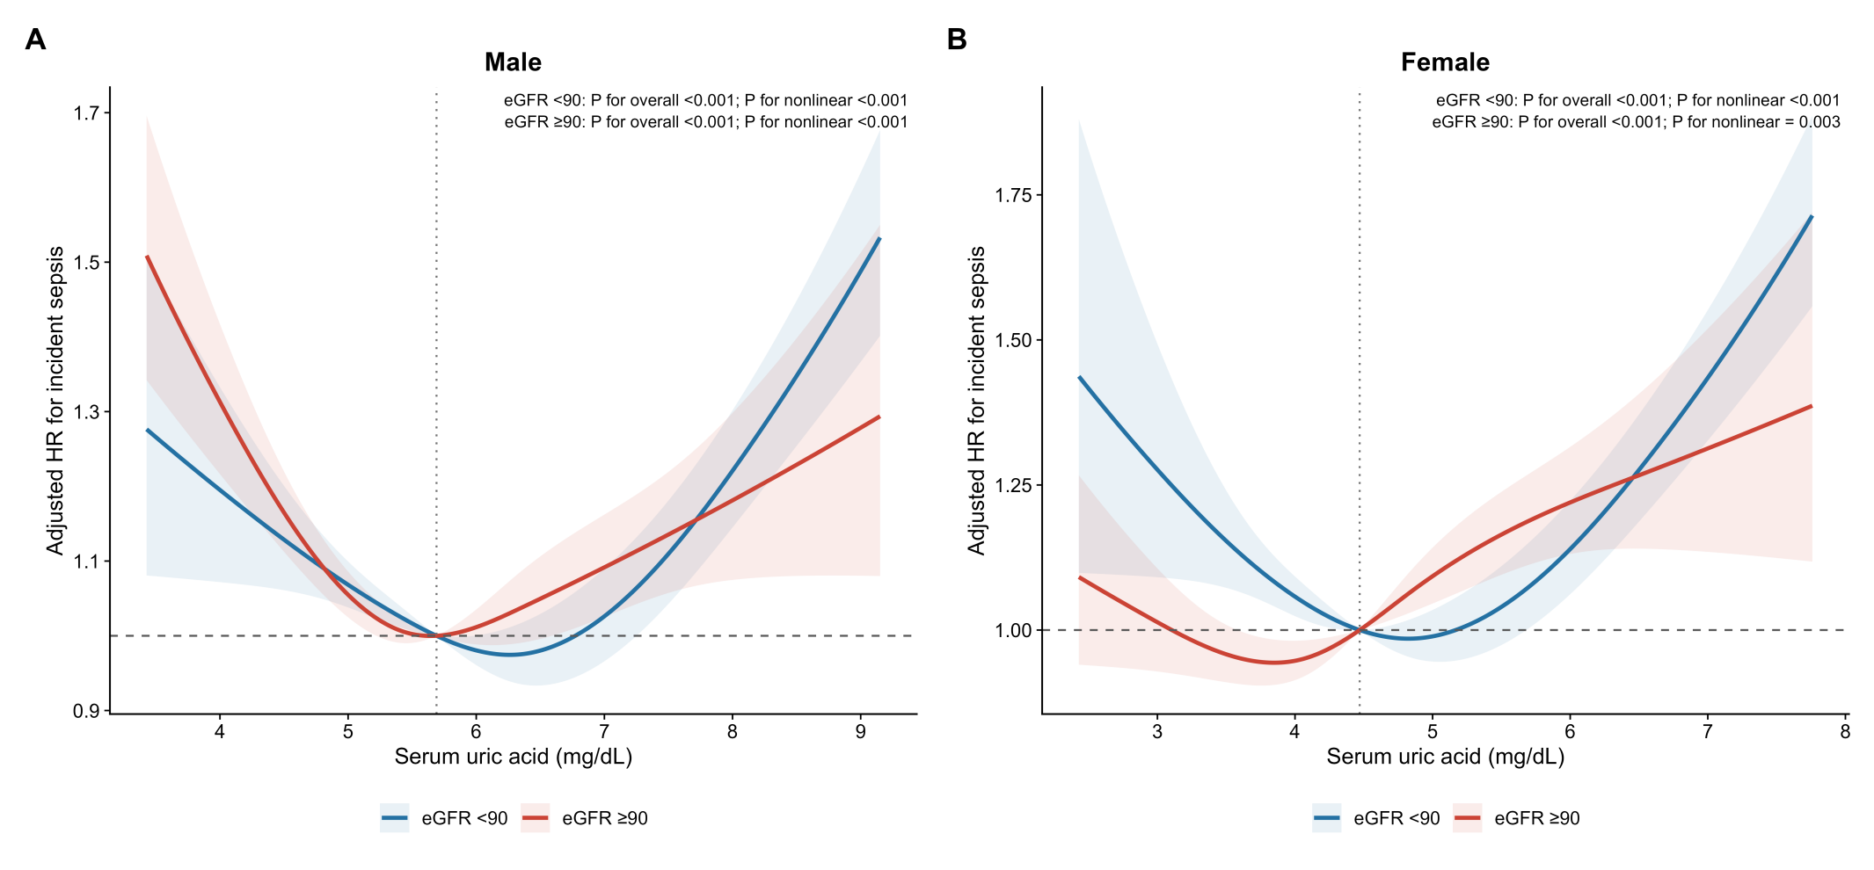Supplementary Figure 3. eGFR-stratified associations between serum uric acid and incident sepsis risk
RCS curves show the association between SUA and adjusted HRs for incident sepsis, stratified by eGFR <90 and ≥90 mL/min/1.73 m², separately in males (A) and females (B). Vertical dotted lines indicate sex-specific SUA inflection points: 5.69 mg/dL in males and 4.47 mg/dL in females. The horizontal dashed line indicates HR = 1. Shaded areas represent 95% CIs. Models were adjusted for age, Townsend deprivation index, employment status, educational attainment, ethnicity, smoking status, alcohol consumption status, BMI, diabetes, hypertension, and CVD. Abbreviations: BMI, body mass index; CI, confidence interval; CVD, cardiovascular disease; eGFR, estimated glomerular filtration rate; HR, hazard ratio; RCS, restricted cubic spline; SUA, serum uric acid.

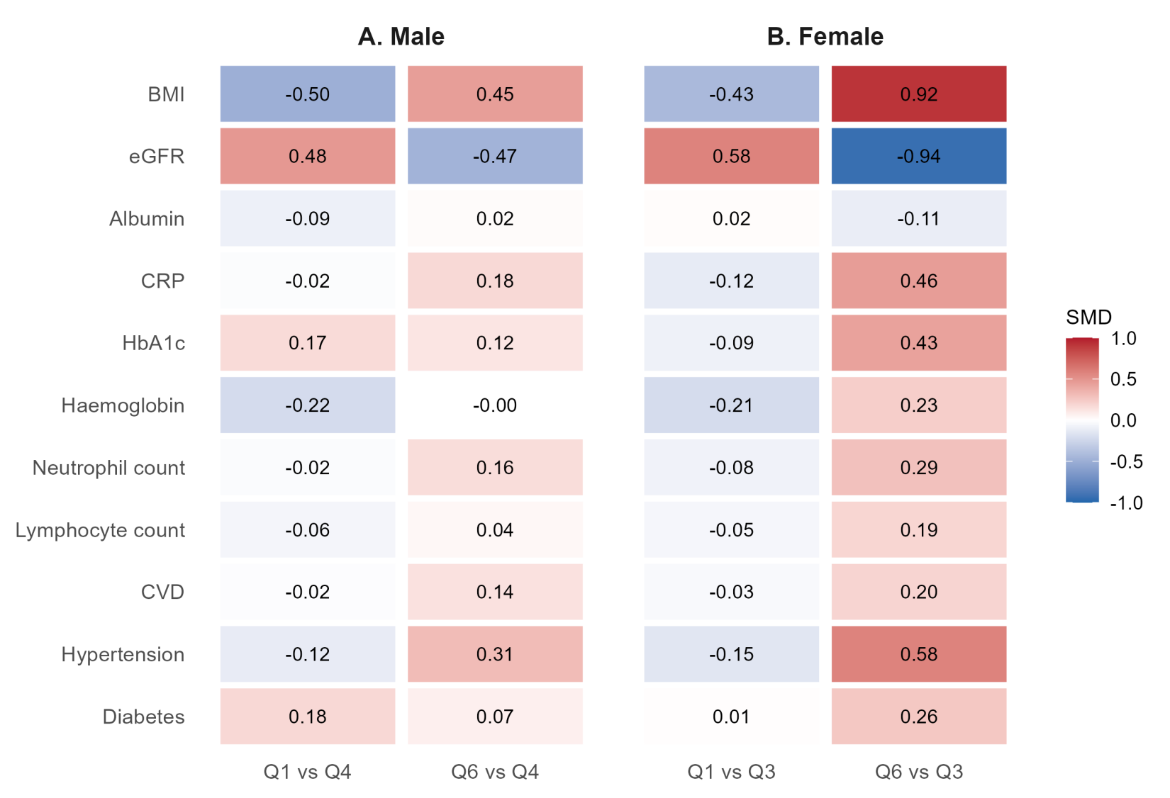

Supplementary Figure 4. Standardized differences in selected baseline characteristics between extreme serum uric acid sextiles and sex-specific reference sextiles

Standardized mean differences in selected baseline characteristics comparing the lowest and highest SUA sextiles with sex-specific reference sextiles. In males, the lowest and highest sextiles were compared with the fourth sextile. In females, the lowest and highest sextiles were compared with the third sextile. Red indicates higher values or prevalence in the extreme sextile; blue indicates lower values or prevalence. Values shown within cells are standardized mean differences.

Abbreviations: BMI, body mass index; CRP, C-reactive protein; CVD, cardiovascular disease; eGFR, estimated glomerular filtration rate; HbA1c, glycated hemoglobin; SMD, standardized mean difference; SUA, serum uric acid.

