Supplementary materials
Table S1. Demographics of the subset with 2-years fMRI-PET time interval
PREVENT-AD sample demographic and clinical characteristics
Sample size | 104
Age in years | 67.44 (4.85)
Female, %(n) | 76.92 (80)
Years of education | 15.28 (3.32)
APOE ε4 carriers, % (n) | 39.42 (41)
Global Aβ SUVR (baseline) | 1.29 (0.27)
Temporal meta-ROI tau SUVR (baseline) | 1.16 (0.11)
Years between fMRI and baseline PET scans | 0.82 (0.50)
Note: The data presented in the table are with the format of the mean (standard deviation) per continuous measures and percentage for categorized variables which the percentage is presented in the parentheses.
Tabel S2. Demographics of the subset with 1-year fMRI-PET time interval
PREVENT-AD sample demographic and clinical characteristics
Sample size | 72
Age in years | 67.47 (4.96)
Female, %(n) | 72 (59)
Years of education | 15.10 (3.28)
APOE ε4 carriers, % (n) | 36.11 (26)
Global Aβ SUVR (baseline) | 1.30 (0.29)
Temporal meta-ROI tau SUVR (baseline) | 1.16 (0.12)
Years between fMRI and baseline PET scans | 0.55 (0.28)
Note: The data presented in the table are with the format of the mean (standard deviation) per continuous measures and percentage for categorized variables which the percentage is presented in the parentheses.
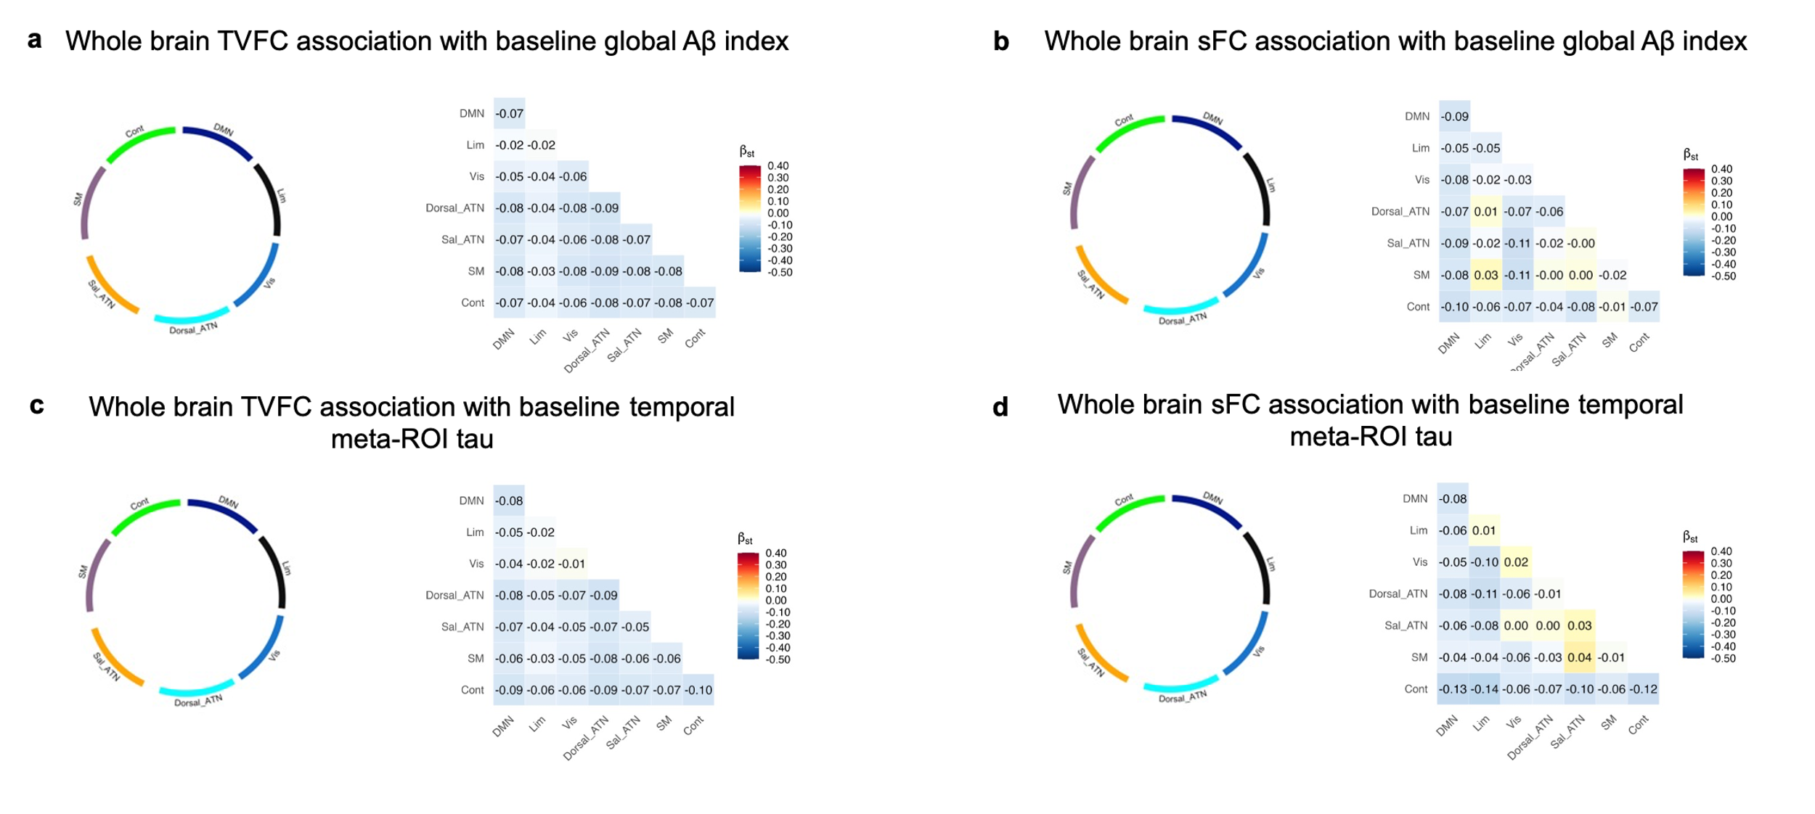
Figure S1. Whole brain networks TVFC and sFC relationships with cross-sectional Aβ and tau PET using Schaefer7-400 parcellation. Null associations between functional connectivity measures and cross-sectional Aβ and tau burden across Schaefer 7-400 networks. a, Chord plot and heatmap depicting associations between TVFC and cross-sectional Aβ. The empty chord plot indicates no significant association (p > 0.05); the heatmap displays corresponding standardized beta coefficients. b, A parallel analysis for sFC, following identical chord plot and heatmap structure as in panel a. c, Chord plot and heatmap depicting associations between TVFC and cross-sectional tau in temporal meta-ROI regions. The empty chord plot indicates no significant association (p > 0.05); the heatmap displays corresponding standardized beta coefficients. d, A parallel analysis for sFC associations with cross-sectional tau, following identical structure as in panel c. Abbreviations in the figure are as follows: DMN = default mode network, Lim = limbic network, Vis = visual network, Sal_ATN = salience/ventral attention network, Dorsal_ATN = dorsal attention network, Cont = control network, and SM = somatomotor network.
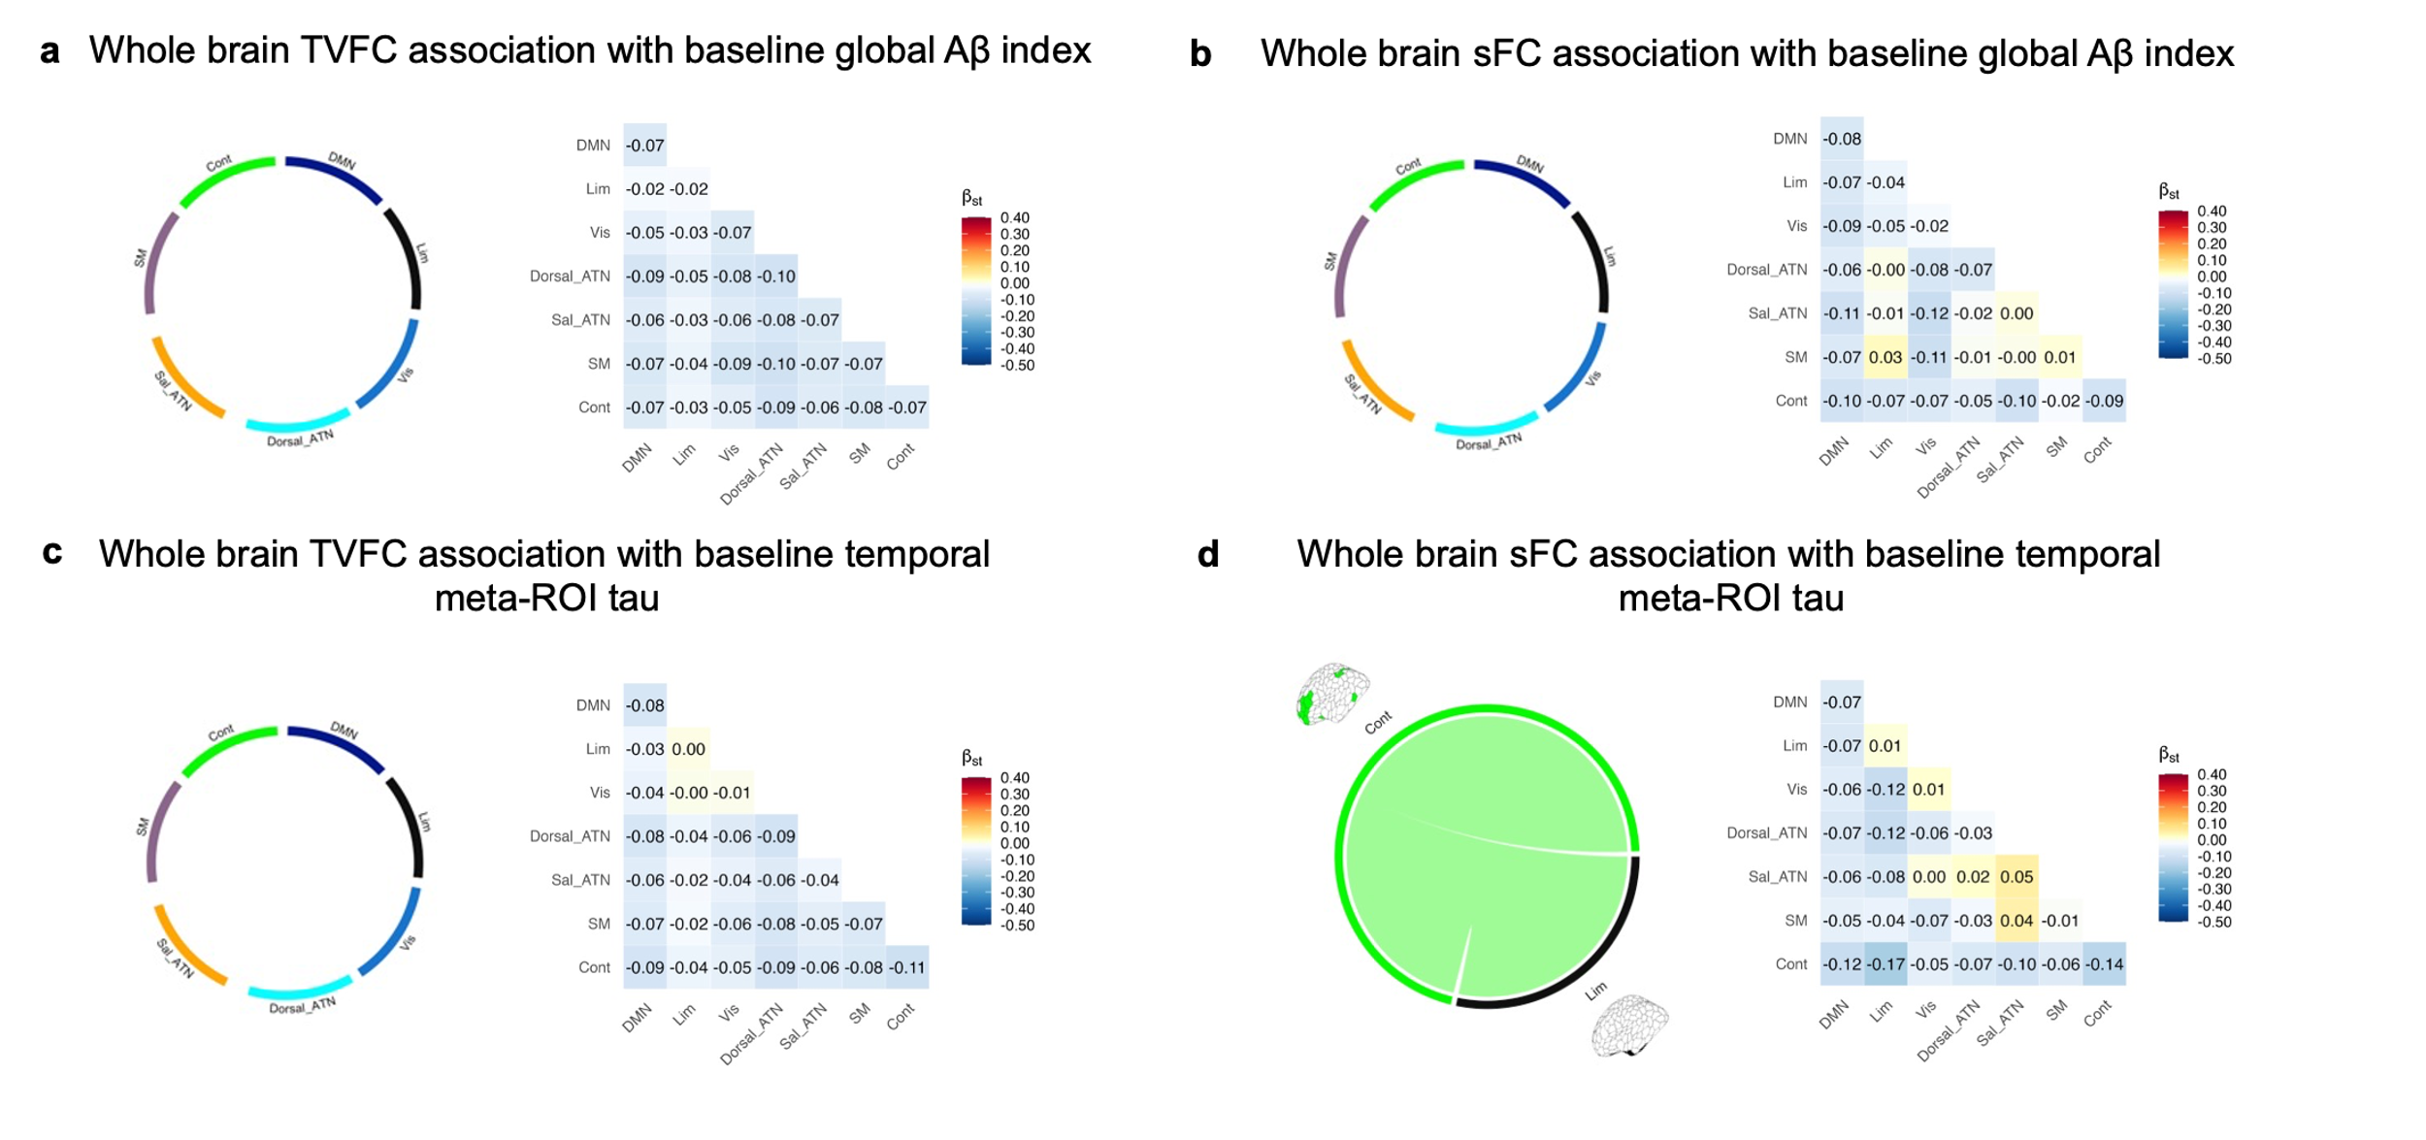
Figure S2. TVFC and sFC relationships with cross-sectional Aβ and tau PET using Schaefer7-200 parcellation. Associations between whole-brain functional connectivity measures and cross-sectional Aβ and tau burden across Schaefer 7-200 networks. a, Chord plot and heatmap depicting associations between TVFC and cross-sectional Aβ. The empty chord plot indicates no significant association (p > 0.05); the heatmap displays corresponding standardized beta coefficients. b, A parallel analysis for sFC, following identical chord plot and heatmap structure as in panel a. c, Chord plot and heatmap depicting associations between TVFC and cross-sectional tau in temporal meta-ROI regions. The empty chord plot indicates no significant association (p > 0.05); the heatmap displays corresponding standardized beta coefficients. d, A parallel analysis for sFC associations with cross-sectional tau, following identical structure as in c, with the chord plot displaying significant associations (p < 0.05). Abbreviations: DMN = default mode network, Lim = limbic network, Vis = visual network, Sal_ATN = salience/ventral attention network, Dorsal_ATN = dorsal attention network, Cont = control network, and SM = somatomotor network.
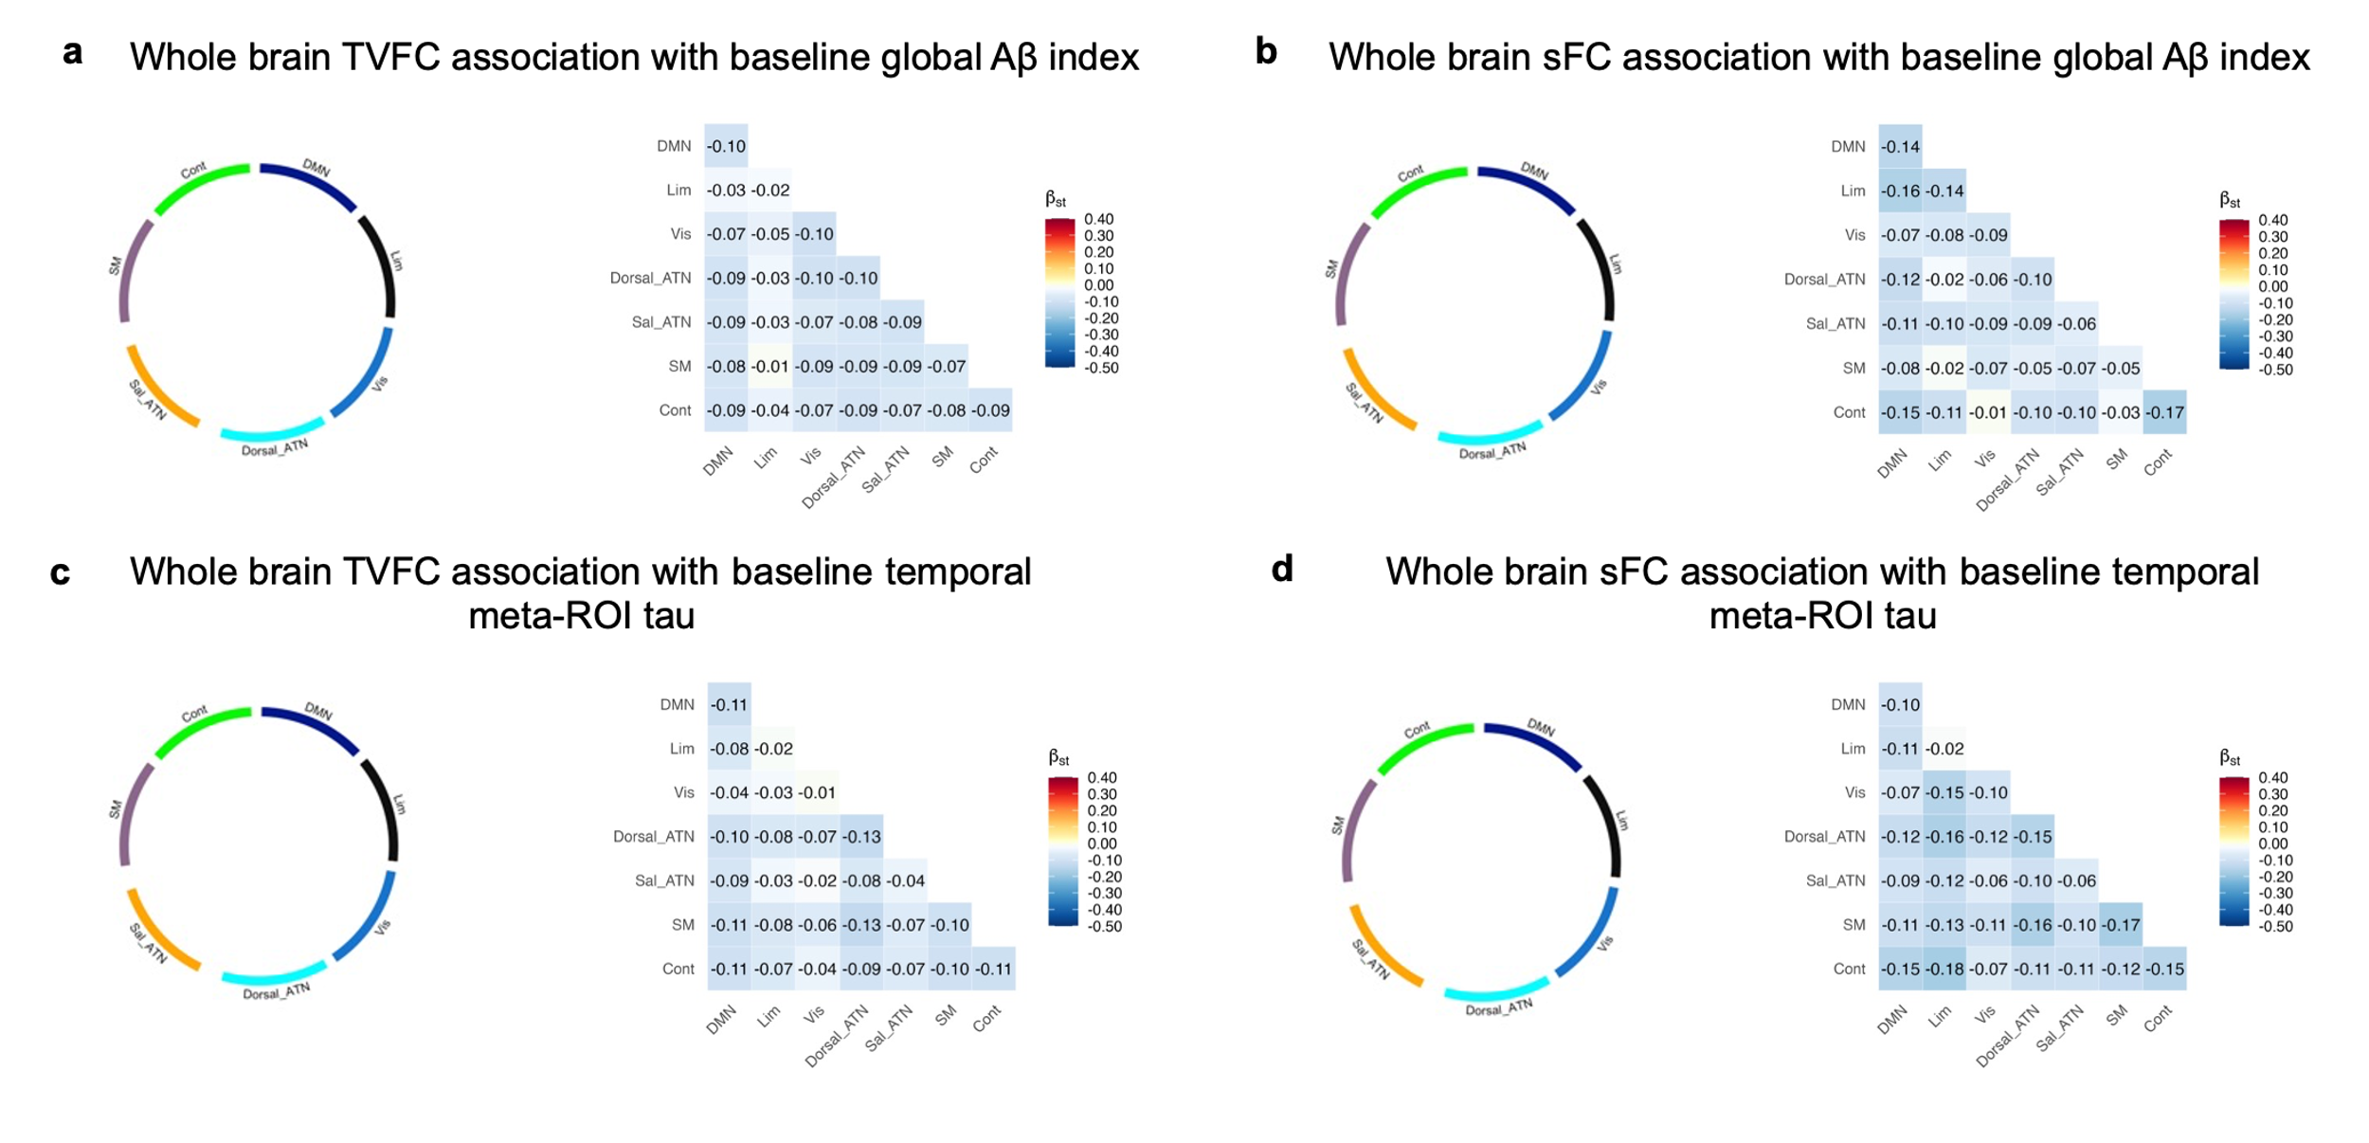
Figure S3. TVFC and sFC relationships with cross-sectional Aβ and tau PET using Schaefer7-400 parcellation while limiting fMRI-PET time interval to 2 years. Associations between whole-brain functional connectivity measures and cross-sectional Aβ and tau burden across Schaefer 7-400 networks, restricted to participants with an fMRI-PET interval of two years or less. a, Chord plot and heatmap depicting associations between TVFC and cross-sectional Aβ. The empty chord plot indicates no significant association (p > 0.05); the heatmap displays corresponding standardized beta coefficients. b, A parallel analysis for sFC, following identical chord plot and heatmap structure as in panel a. c, Chord plot and heatmap depicting associations between TVFC and cross-sectional tau in temporal meta-ROI regions. d, A parallel analysis for sFC associations with cross-sectional tau, following identical structure as in c. Abbreviations: DMN = default mode network, Lim = limbic network, Vis = visual network, Sal_ATN = salience/ventral attention network, Dorsal_ATN = dorsal attention network, Cont = control network, and SM = somatomotor network.
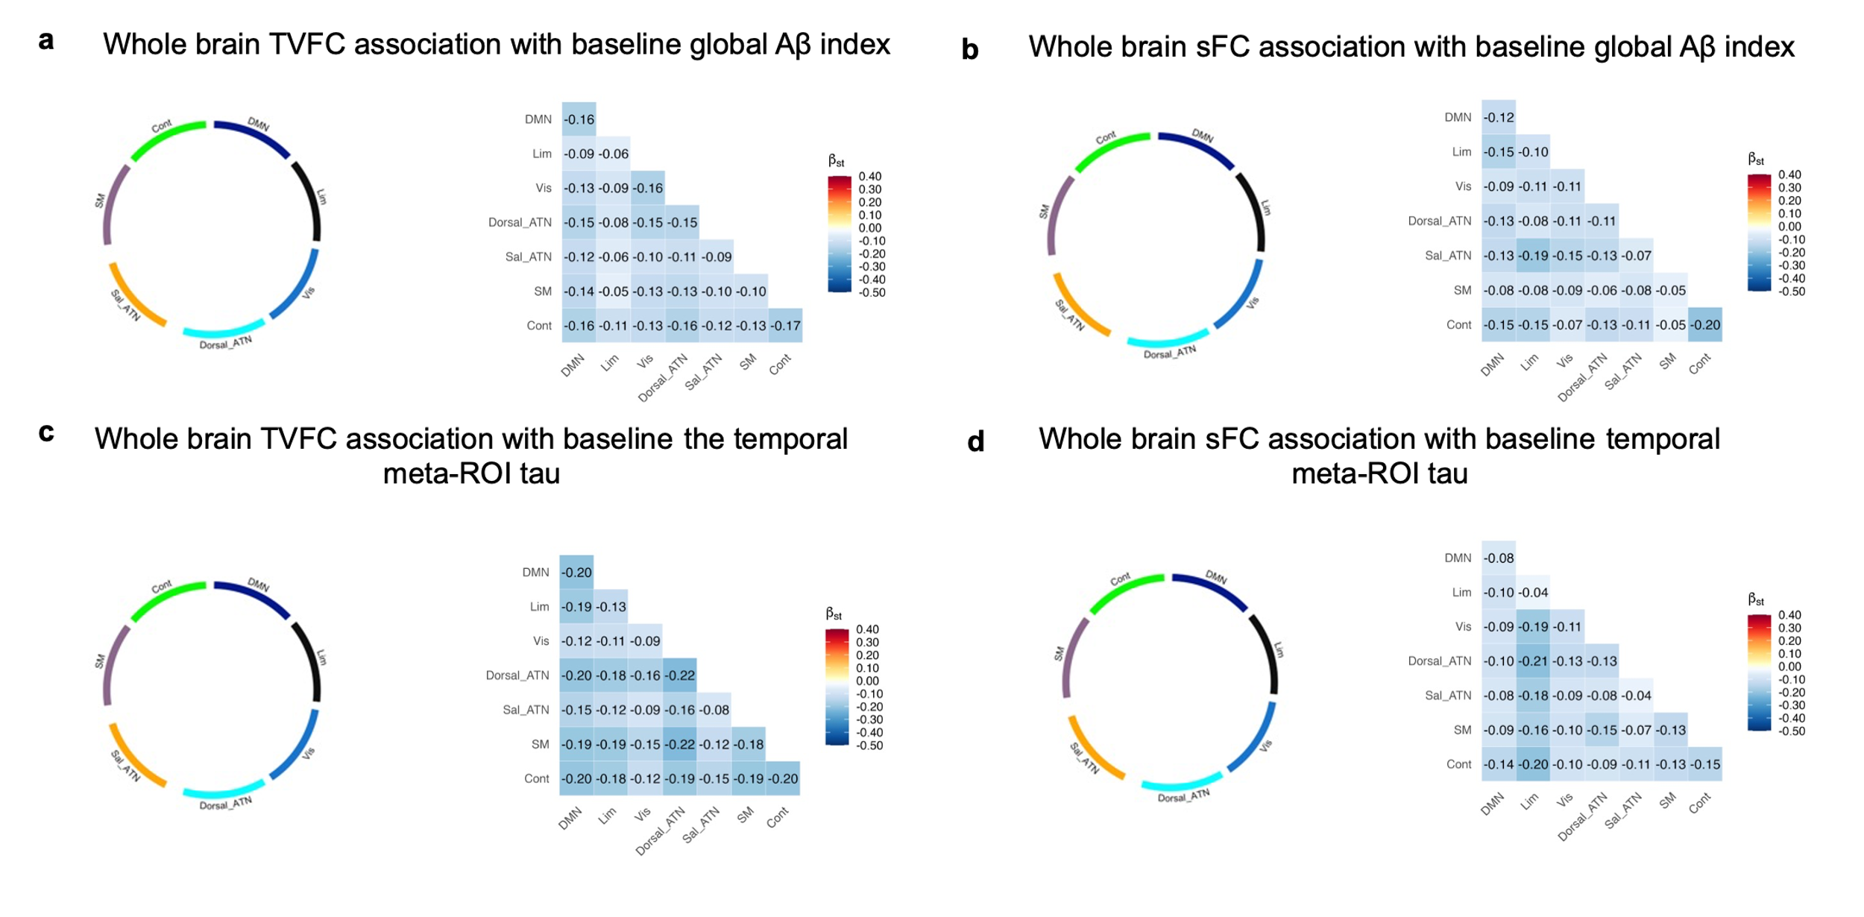
Figure S4. TVFC and sFC relationships with cross-sectional Aβ and tau PET using Schaefer7-400 parcellation while limiting fMRI-PET time interval to 1 year. Associations between whole-brain functional connectivity measures and cross-sectional Aβ and tau burden across Schaefer 7-400 networks, restricted to participants with an fMRI-PET interval of one year or less. a, Chord plot and heatmap depicting associations between TVFC and cross-sectional Aβ. The empty chord plot indicates no significant association (p > 0.05); the heatmap displays corresponding standardized beta coefficients. b, A parallel analysis for sFC, following identical chord plot and heatmap structure as in panel a. c, Chord plot and heatmap depicting associations between TVFC and cross-sectional tau in temporal meta-ROI regions. d, A parallel analysis for sFC associations with cross-sectional tau, following identical structure as in c. Abbreviations: DMN = default mode network, Lim = limbic network, Vis = visual network, Sal_ATN = salience/ventral attention network, Dorsal_ATN = dorsal attention network, Cont = control network, and SM = somatomotor network.
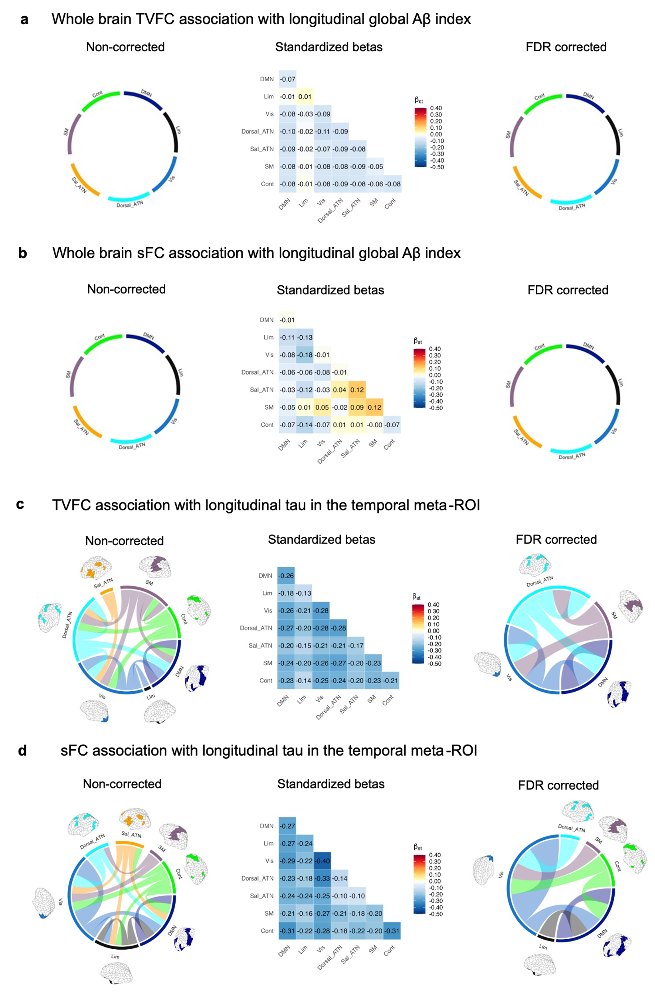
Figure S5. TVFC and sFC relationship with longitudinal Aβ and tau PET using Schaefer7-200 parcellation. Associations between functional connectivity measures and annual changes in Aβ and tau SUVR across Schaefer 7-200 networks. a, Chord plots and heatmap depicting associations between TVFC and longitudinal Aβ change. Both uncorrected and FDR-corrected chord plots show no significant associations (p > 0.05); the heatmap displays corresponding standardized beta coefficients. b, A parallel analysis for sFC associations with longitudinal Aβ change, following identical chord plot and heatmap structure as in panel a. c, Chord plots and heatmap depicting associations between TVFC and longitudinal tau accumulation. Both uncorrected and FDR-corrected chord plots show significant associations (p < 0.05), with line thickness reflecting statistical significance. The heatmap displays corresponding standardized beta coefficients. d, A parallel analysis for sFC associations with longitudinal tau accumulation, following identical structure as in panel c. Abbreviations: DMN = default mode network, Lim = limbic network, Vis = visual network, Sal_ATN = salience/ventral attention network, Dorsal_ATN = dorsal attention network, Cont = control network, and SM = somatomotor network.
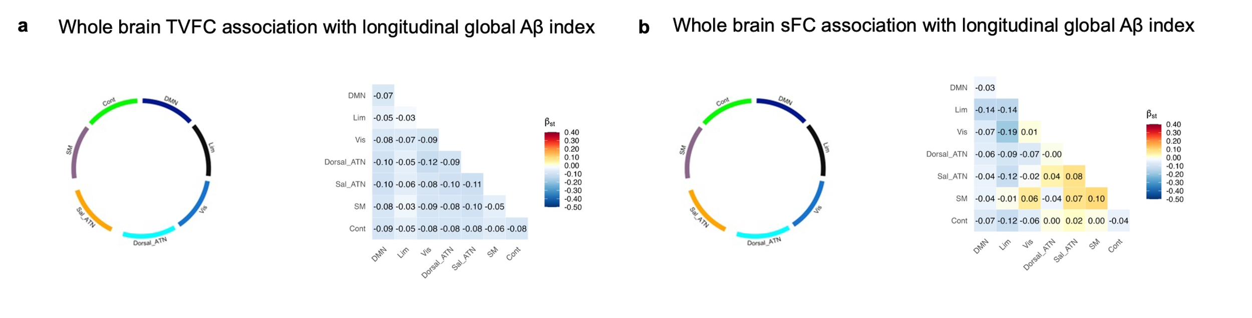
Figure S6. TVFC and sFC relationship with longitudinal Aβ PET, a full network analysis using Schaefer7-400 parcellation. Associations between whole-brain functional connectivity measures and annual Aβ accumulation rate across Schaefer 7-400 networks. a, Chord plot and heatmap depicting associations between TVFC and longitudinal Aβ accumulation. The empty chord plot indicates no significant association (p > 0.05); the heatmap displays corresponding standardized beta coefficients. b, A parallel analysis for sFC, following identical chord plot and heatmap structure as in a. Abbreviations: DMN = default mode network, Lim = limbic network, Vis = visual network, Sal_ATN = salience/ventral attention network, Dorsal_ATN = dorsal attention network, Cont = control network, and SM = somatomotor network.
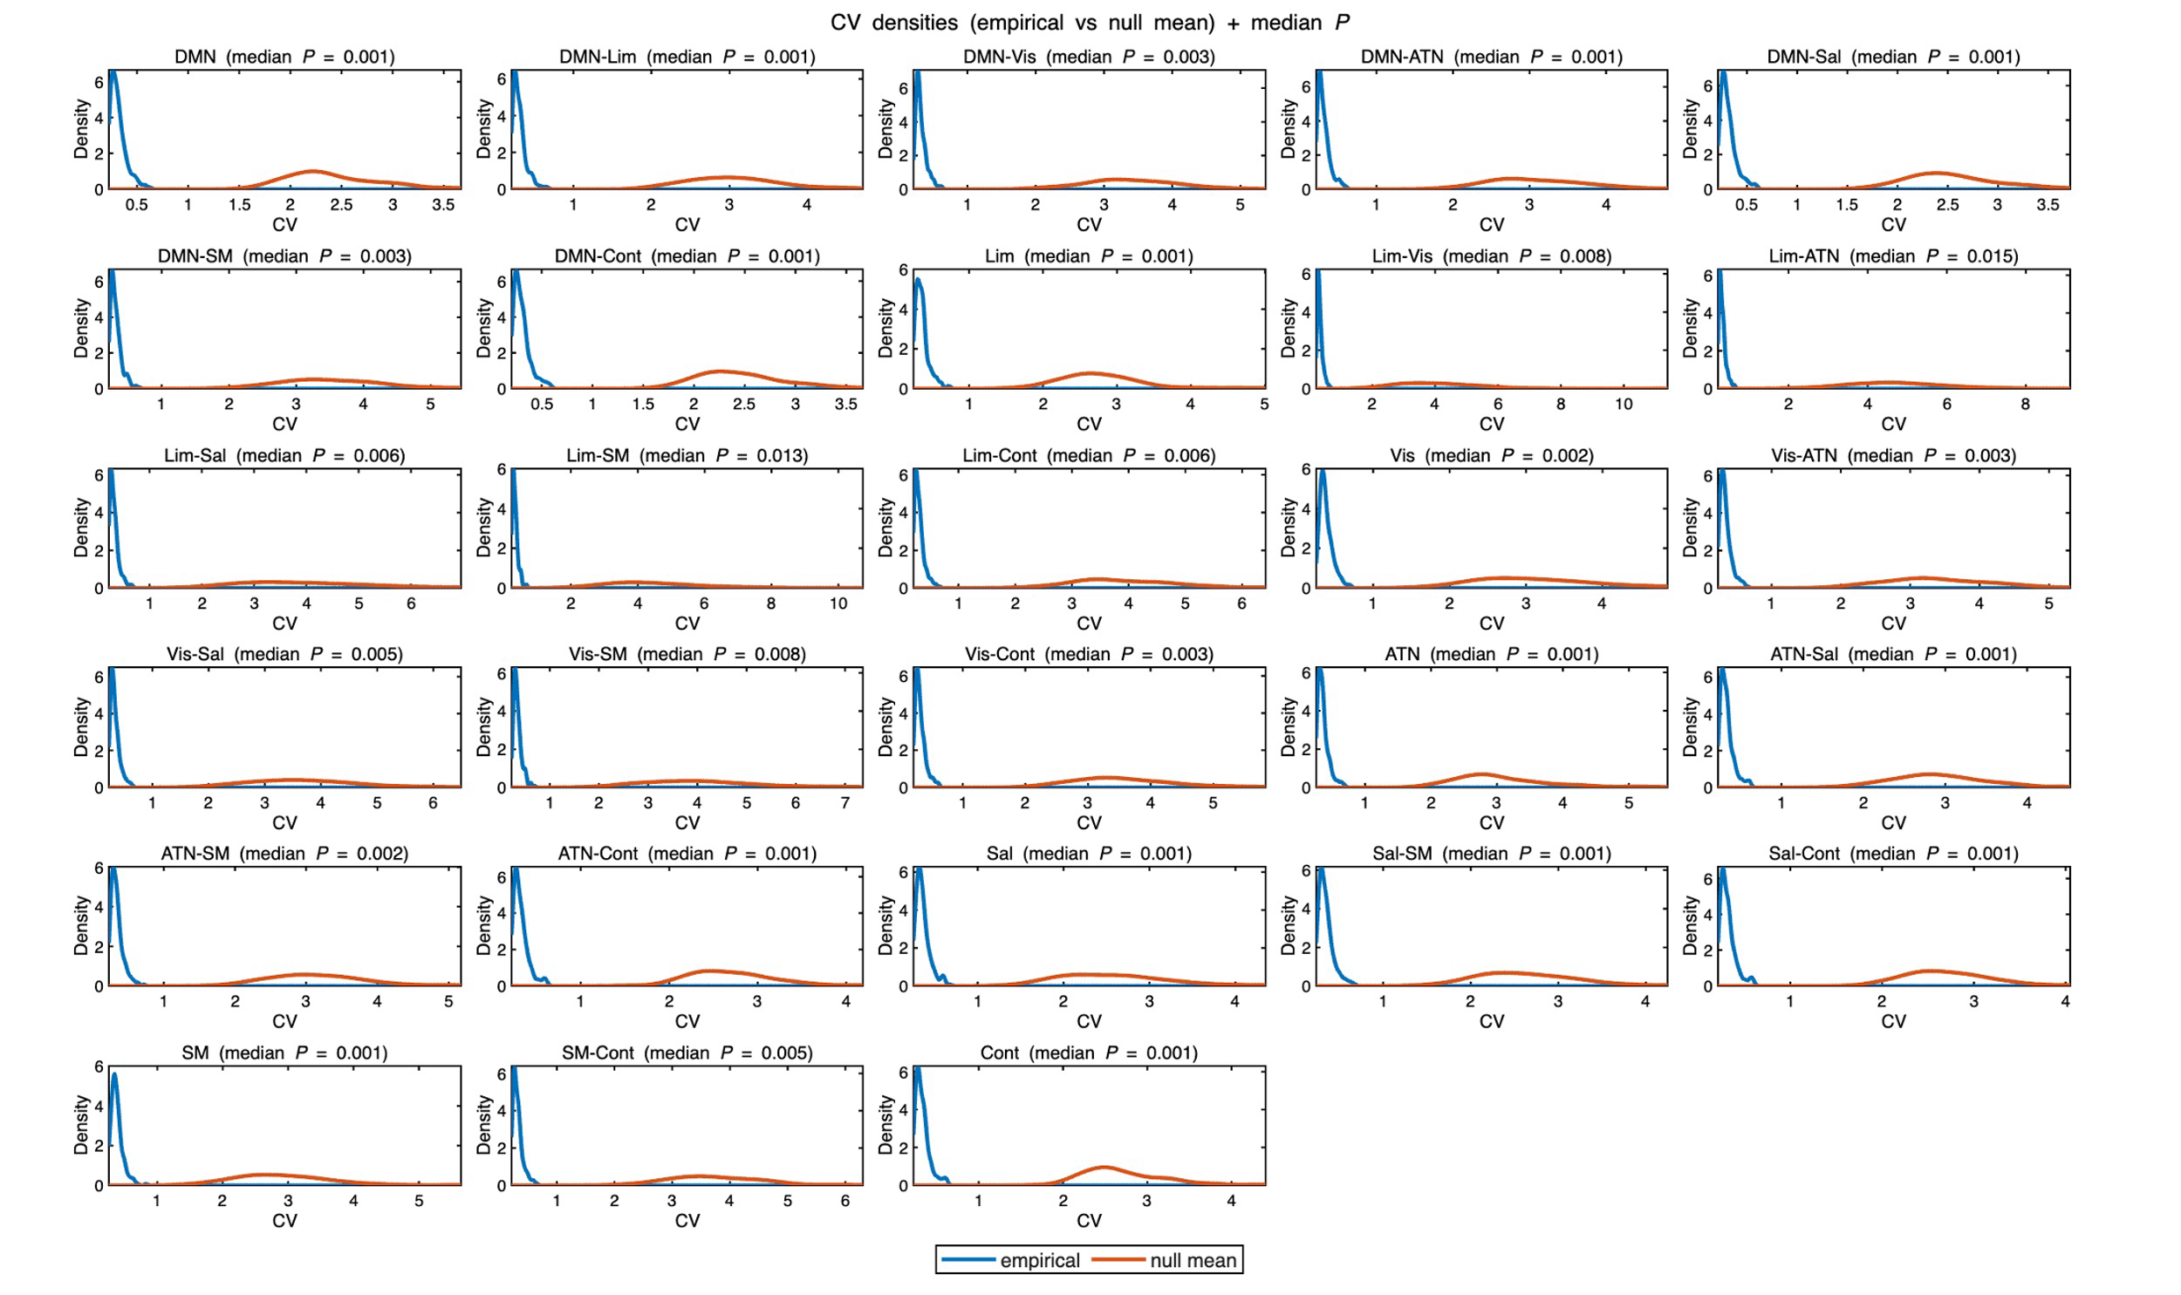
Figure S7. Empirical versus null model TVFC distributions. Distributions of the coefficient of variation (CV) for empirical TVFC (blue) and the corresponding subject-specific null mean derived from surrogate data (orange). Curves represent kernel density estimates across subjects and are shown for visualization purposes only. For each subject and network pair, a two-sided Monte Carlo p-value (P) was computed by comparing the empirical CV to that subject’s surrogate distribution, centered at the null mean. Titles report the median subject-level P across subjects for each pair. Abbreviations: DMN = default mode network, Lim = limbic network, Vis = visual network, Sal_ATN = salience/ventral attention network, Dorsal_ATN = dorsal attention network, Cont = control network, and SM = somatomotor network.

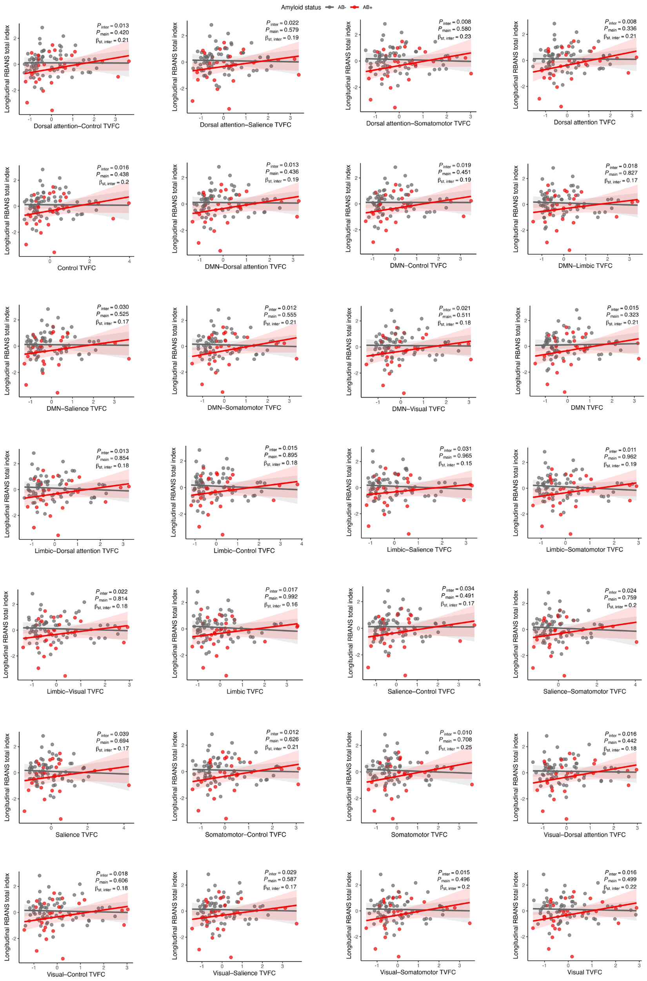
Figure S8. Aβ interaction effect on TVFC relationship with longitudinal total RBANS cognitive score using Schaefer7-400 parcellation. The interaction effect of Aβ on the association between TVFC for all the within and between Schafer7-400 networks and longitudinal RBANS total scale index (dichotomization was only for visualization and the statistical p-values and beta estimates are derived using the continuous Aβ values). P_{inter} is the p-value for the interaction effect and the P_{main} is the p-value of the main effect while β_{st,inter} also represent the beta estimate of the interaction effects. Shaded regions around the fitted line represents the 95% confidence intervals.

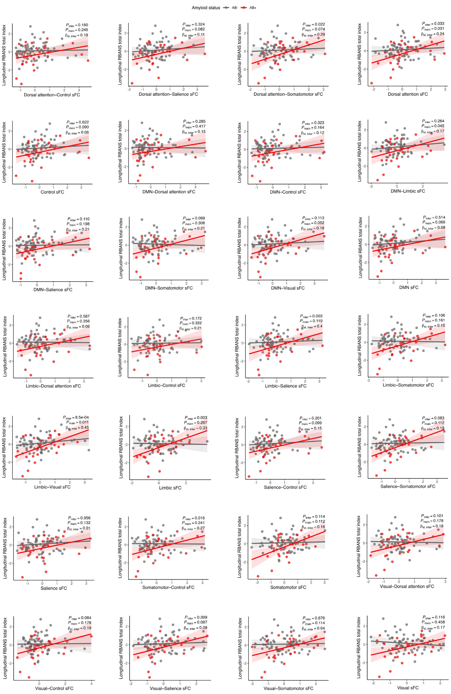
Figure S9. Aβ interaction effect on sFC relationship with longitudinal total RBANS cognitive score using Schaefer7-400 parcellation. The interaction effect of Aβ on the association between sFC for all the within and between Schafer7-400 networks and longitudinal RBANS total scale index (dichotomization was only for visualization and the statistical p-values and beta estimates are derived using the continuous Aβ values). P_{inter} is the p-value for the interaction effect and the P_{main} is the p-value of the main effect while β_{st,inter} also represent the beta estimate of the interaction effects. Shaded regions around the fitted line represents the 95% confidence intervals.

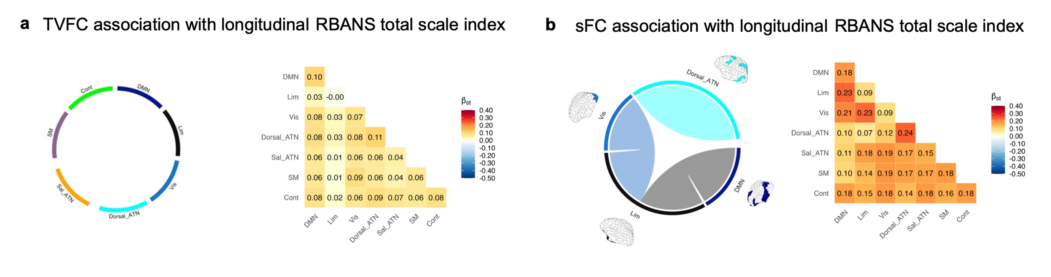
Figure S10. TVFC and sFC relationship with the decade-long longitudinal total RBANS cognitive score using Schaefer7-200 parcellation. Associations between whole-brain functional connectivity measures and longitudinal RBANS total score across Schaefer 7-400 networks. a Chord plot and heatmap depicting associations between TVFC and longitudinal RBANS total score. The empty chord plot indicates no significant association (p > 0.05); the heatmap displays corresponding standardized beta coefficients. b, A parallel analysis for sFC, following identical chord plot and heatmap structure as in a. The chord plot shows significant associations (p < 0.05), with line thickness reflecting statistical significance and colors denoting networks: dark blue, DMN; black, limbic; sky blue, dorsal attention; blue, visual. Abbreviations: DMN = default mode network, Lim = limbic network, Vis = visual network, Sal_ATN = salience/ventral attention network, Dorsal_ATN = dorsal attention network, Cont = control network, and SM = somatomotor network.

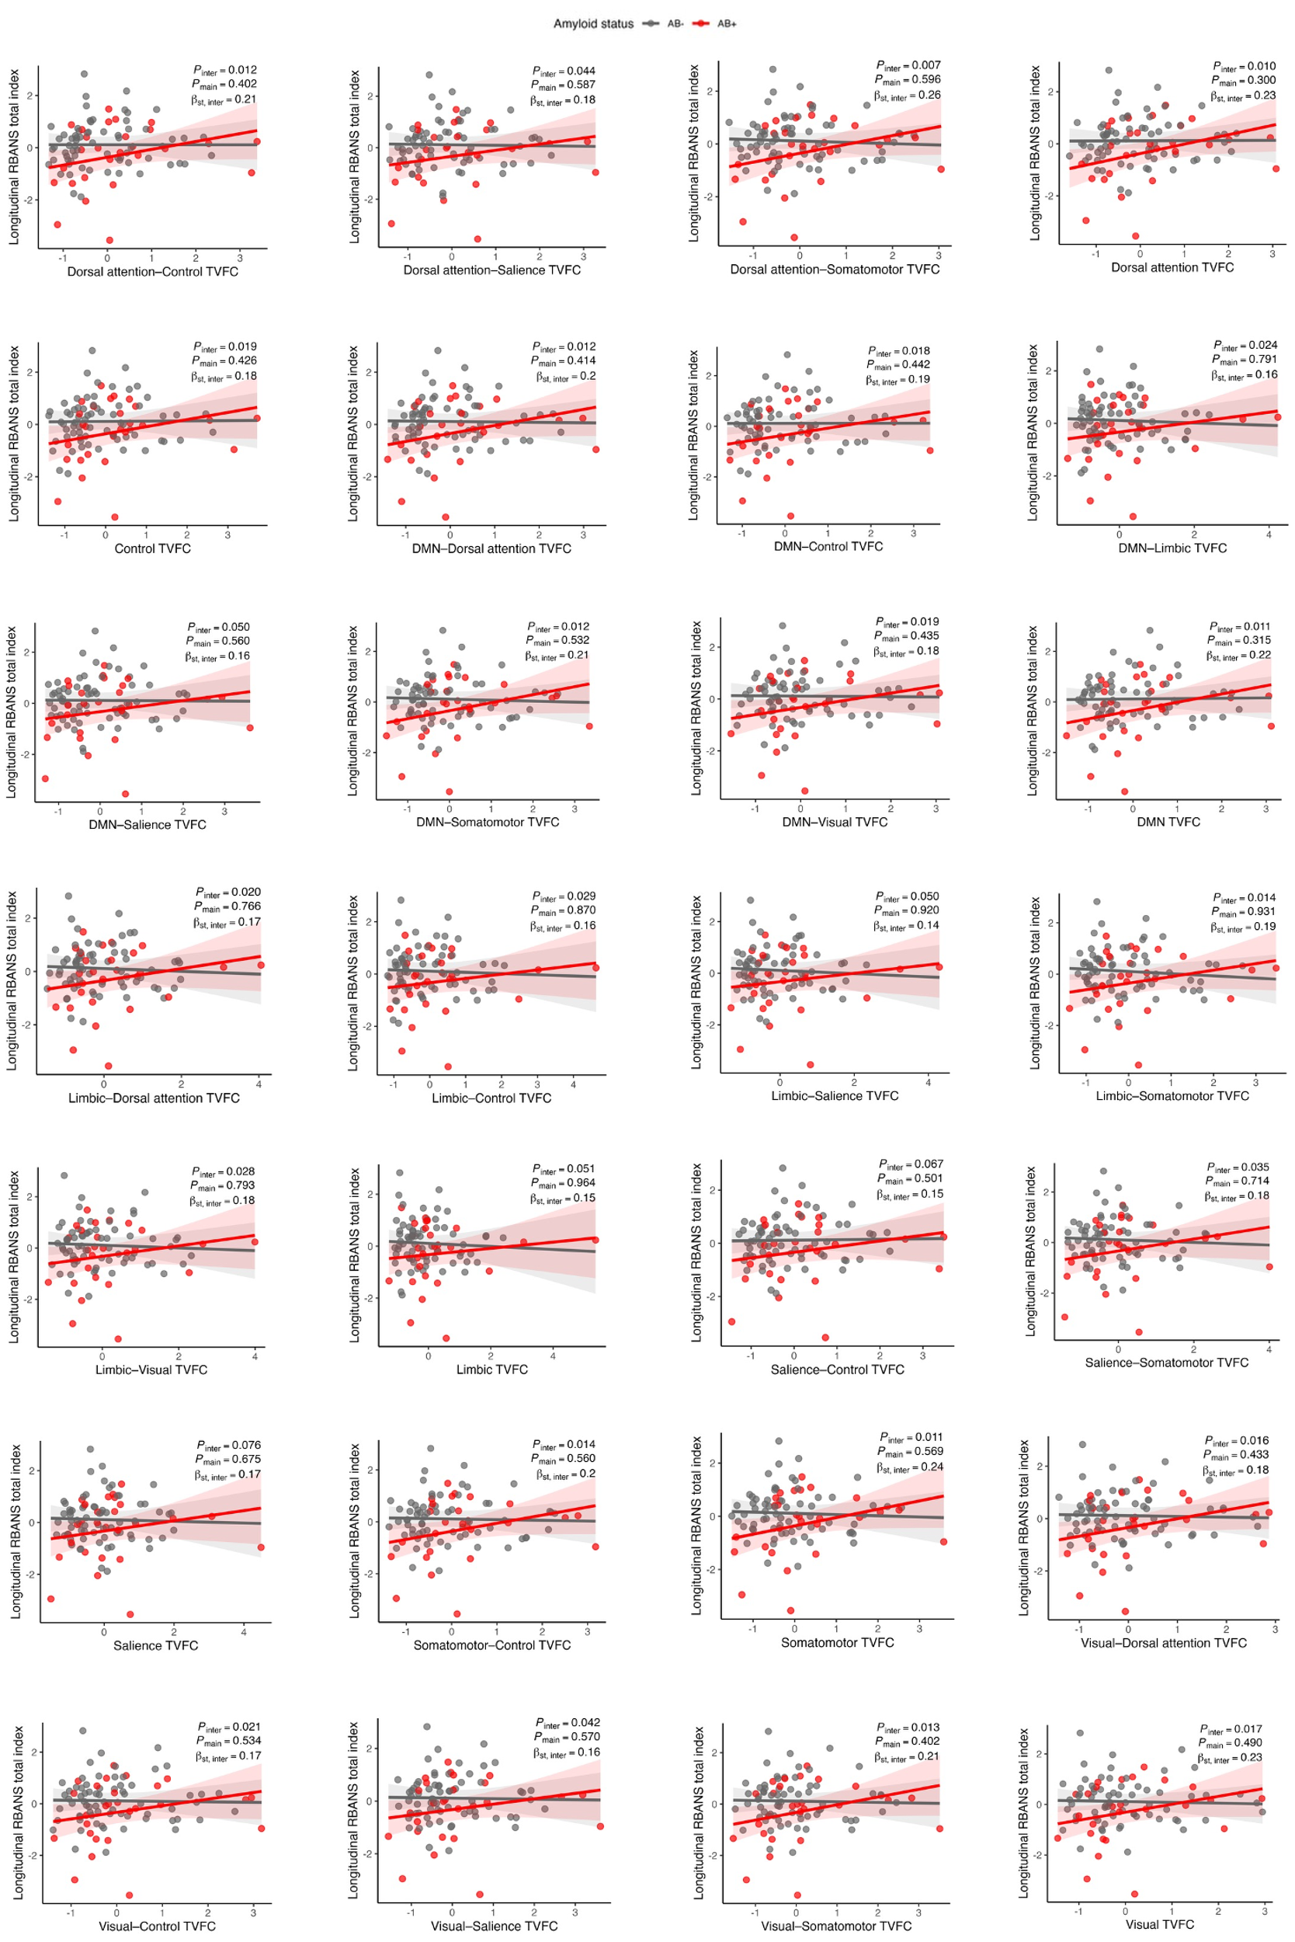
Fig. S11: Aβ interaction effect on TVFC relationship with longitudinal total RBANS cognitive score using Schaefer7-200 parcellation. The interaction effect of Aβ on the association between TVFC for all the within and between Schafer7-200 networks and longitudinal RBANS total scale index (dichotomization was only for visualization and the statistical p-values and beta estimates are derived using the continuous Aβ values). P_{inter} is the p-value for the interaction effect and the P_{main} is the p-value of the main effect while β_{st,inter} also represent the beta estimate of the interaction effects. Shaded regions around the fitted line represents the 95% confidence intervals.

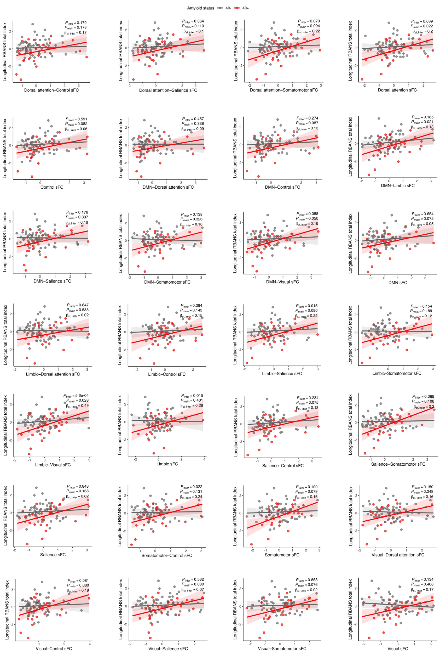
Fig. S12: Aβ interaction effect on sFC relationship with longitudinal total RBANS cognitive score using Schaefer7-200 parcellation. The interaction effect of Aβ on the association between sFC for all the within and between Schafer7-200 networks and longitudinal RBANS total scale index (dichotomization was only for visualization and the statistical p-values and beta estimates are derived using the continuous Aβ values). P_{inter} is the p-value for the interaction effect and the P_{main} is the p-value of the main effect while β_{st,inter} also represent the beta estimate of the interaction effects. Shaded regions around the fitted line represents the 95% confidence intervals.

