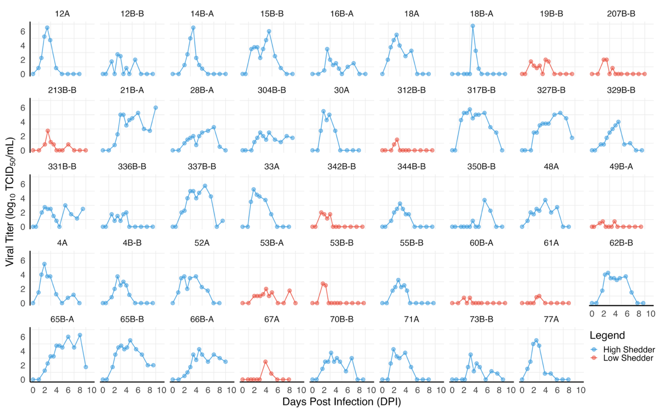
Supplementary Figure 1. Volunteers’ Influenza kinetics. Tissue Culture Infectious Dose (TCID₅₀) kinetics following human challenge in 44 untreated volunteers. Individuals are categorized as high (blue) or low (red)-shedders as defined in the Data Pre-Processing section of Materials and Methods. The title of each panel corresponds to the volunteer’s ID number. A and B denote influenza A or B infection. Solid lines are used to connect data.

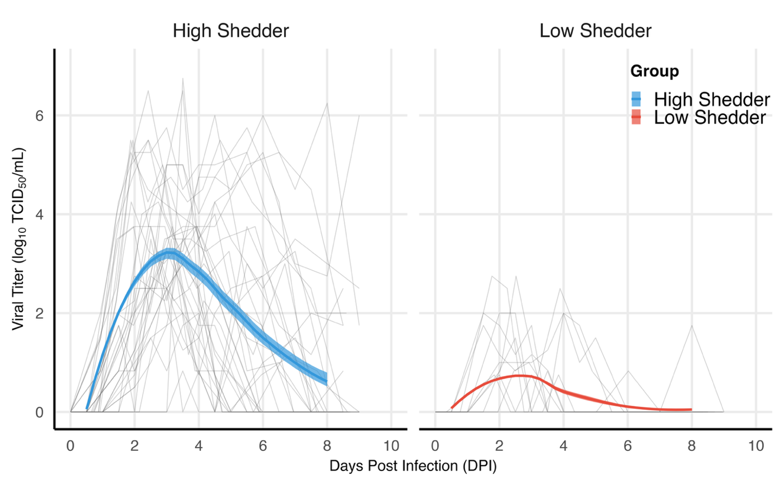
Supplementary Figure 2. Trend lines of the categorized high- and low-shedders. The distinction between the high and low viral load shedders illustrated with LOESS smoothed trend lines in blue and red trajectories, respectively. The bold center line represents the smoothed median with lower and upper edges of the shaded region as the 1st and 3rd quartile, respectively, of each cohort. The median peak viral load for high-shedders and low-shedders were $4.55\log_{10}{({TCID}_{50}}/ml)$ and $1.82\log_{10}{({TCID}_{50}}/ml)$, respectively.
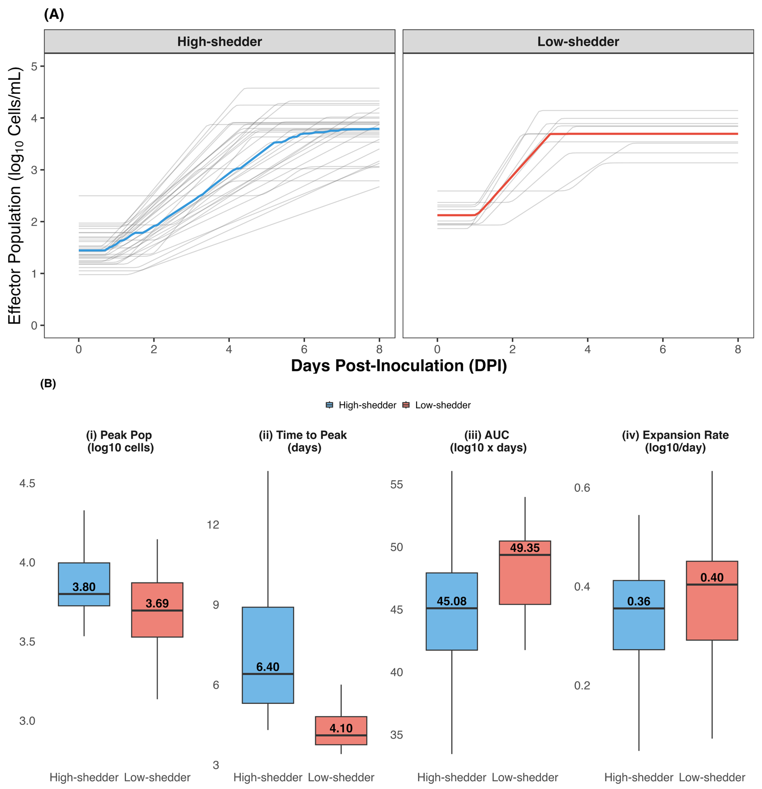
Supplementary Figure 3. More effective and rapid effector responses explain lower viral loads. (A) Effector cells start at a higher level and expand to peak levels more rapidly in low shedders as compared to high shedders shown in the respective red and blue median curves. The median initial effector cell population for high shedders’ is $\log_{10}{(Cells/mL)}=2.49$ cells per day and 1.33 cells per day for low shedders. (B) Box plots of (i) peak effector cell population size, (ii) time to peak, (iii) area under the effector cell curve (AUC), and (iv) effector cell expansion rate for high and low shedders, as simulated by the viral dynamics model.

