APPENDIX 2
Effectiveness of Artificial Intelligence-based Health Education Accurately Linking System (AI-HEALS) for Type 2 diabetes self-management：A Cluster Randomized Clinical Trial

Table S1. Sensitivity Analysis of Primary and Secondary Outcomes with Multiple Imputation
Figure S1. Distribution of AI-Chatbot Interaction Frequency in AI-HEALS Group
Figure S2. Distribution of Average Session Length of AI-Chatbot Interaction in AI-HEALS Group
Figure S3. Distribution of Average Interval of AI-HEALS Usage in AI-HEALS Group
Figure S4. Distribution of AI-HEALS Time Usage in AI-HEALS Group
Figure S5. Total Clicks for Different Types of Health Education Materials in AI-HEALS Group

Table S1. Sensitivity Analysis of Primary and Secondary Outcomes with Multiple Imputation
Outcome | AI |  |  | TAU |  | Treatment effect, mean (95% CI)ª | P value^{b}
Outcome | Mean (SD) | No. of participants |  | Mean (SD) | No. of participants | Treatment effect, mean (95% CI)ª | P value^{b}
Primary outcome
HbA_{1c ,}%
Baseline | 7.20 (1.61) | 202 |  | 7.51 (1.52) | 189
3-mo Follow-up | 7.23(1.49) | 202 |  | 7.35 (1.62) | 189 | -0.10 (-0.41 to 0.21) | 0.534
6-mo Follow-up | 6.96 (1.10) | 202 |  | 7.40 (1.68) | 189 | -0.28 (-0.59 to 0.03) | 0.079
12-mo Follow-up | 6.92 (1.18) | 202 |  | 7.16 (1.55) | 189 | -0.26 (-0.58 to 0.52) | 0.101
18-mo Follow-up | 7.04 (1.13) | 202 |  | 7.40 (1.62) | 189 | -0.25 (-0.57 to 0.07) | 0.130
Overall intervention effect^{b} |  |  |  |  |  | -0.22 (-0.48 to 0.04) | 0.099
Secondary outcomes
Self-Care Activities^{c}
Baseline | 36.06 (14.38) | 202 |  | 35.56 (14.91) | 189
3-mo Follow-up | 42.55 (14.89) | 202 |  | 40.40 (17.08) | 189 | 2.42（-2.35 to 7.20） | 0.319
6-mo Follow-up | 46.06 (16.60) | 202 |  | 44.24 (17.31) | 189 | 2.09（-2.73 to 6.92） | 0.393
12-mo Follow-up | 49.34 (16.11) | 202 |  | 44.84 (15.98) | 189 | 4.80（0.05 to 9.55） | 0.048
18-mo Follow-up | 46.13 (13.23) | 202 |  | 43.07 (16.35) | 189 | 3.36（-2.81 to 9.53） | 0.267
Overall intervention effect |  |  |  |  |  | 3.17 (-0.71 to 7.05) | 0.108
Dietary adherence^{d}
Baseline | 55.88 (16.31) | 202 |  | 56.77 (17.99) | 189
3-mo Follow-up | 82.79 (14.76) | 202 |  | 84.49 (15.32) | 189 | -1.20 (-5.78 to 3.38) | 0.606
6-mo Follow-up | 91.42 (14.57) | 202 |  | 86.81 (15.29) | 189 | 5.07 (0.81 to 9.33) | 0.020
12-mo Follow-up | 93.23 (14.96) | 202 |  | 86.70 (16.33) | 189 | 6.99 (2.96 to 11.01) | 0.001
18-mo Follow-up | 87.69 (15.58) | 202 |  | 86.45 (16.78) | 189 | 1.70 (-2.61 to 6.01) | 0.435
Overall intervention effect |  |  |  |  |  | 3.13 (-0.09 to 6.36) | 0.057
Medication adherence^{e}
Baseline | 5.74 (5.18) | 202 |  | 5.94 (4.94) | 189
3-mo Follow-up | 3.65 (3.45) | 202 |  | 3.25 (3.32) | 189 | 0.38 (-0.52 to 1.28) | 0.403
6-mo Follow-up | 3.53 (3.22) | 202 |  | 3.59 (3.03) | 189 | -0.08(-0.99 to 0.84) | 0.867
12-mo Follow-up | 3.84 (3.56) | 202 |  | 4.21 (3.87) | 189 | -0.38 (-1.30 to 0.54) | 0.416
18-mo Follow-up | 2.41 (3.98) | 202 |  | 3.77 (3.21) | 189 | -1.38 (-2.41 to -0.34) | 0.011
Overall intervention effect |  |  |  |  |  | -0.36 (-0.98 to 0.25) | 189
Diabetes-related skills^{f}
Baseline | 28.11 (9.86) | 202 |  | 30.17 (10.17) | 189
3-mo Follow-up | 31.76 (9.97) | 202 |  | 32.60 (9.28) | 189 | -0.75(-3.55 to 2.06) | 0.601
6-mo Follow-up | 37.40 (10.50) | 202 |  | 33.92 (10.61) | 189 | 3.56 (0.80 to 6.33) | 0.012
12-mo Follow-up | 38.06 (10.29) | 202 |  | 34.53 (10.04 | 189 | 3.63 (0.72 to 6.53) | 0.015
18-mo Follow-up | 34.19 (10.60) | 202 |  | 34.03 (10.48) | 189 | 0.25 (-3.31 to 3.82) | 0.883
Overall intervention effect |  |  |  |  |  | 1.67 (0.02 to 3.66) | 0.045
Self-efficacy^{g}
Baseline | 38.05 (16.11) | 202 |  | 38.06 (15.25) | 189
3-mo Follow-up | 43.05 (14.21) | 202 |  | 45.34 (12.86) | 189 | -2.48 (-6.41 to 1.45) | 0.214
6-mo Follow-up | 47.24 (16.48) | 202 |  | 46.35 (14.59) | 189 | -0.71 (-3.18 to 4.61) | 0.719
12-mo Follow-up | 52.22 (13.73) | 202 |  | 45.36 (13.43) | 189 | 6.70 (2.81 to 10.60) | 0.008
18-mo Follow-up | 47.37 (12.32) | 202 |  | 47.15 (14.07) | 189 | 0.03 (-4.80 to 4.87) | 0.990
Overall intervention effect |  |  |  |  |  | 1.24(-1.54 to 4.02） | 0.376
Sleep quality^{h}
Baseline | 5.54 (3.48) | 202 |  | 4.88 (3.46) | 189
3-mo Follow-up | 4.06 (2.91) | 202 |  | 3.50 (2.53 | 189 | 0.61 (-0.26 to 1.48) | 0.167
6-mo Follow-up | 4.38 (3.24) | 202 |  | 4.54 (2.99) | 189 | -0.07 (-0.96 to 0.81) | 0.869
12-mo Follow-up | 4.04 (3.48) | 202 |  | 4.35 (3.18) | 189 | -0.23 (-1.11 to 0.65) | 0.611
18-mo Follow-up | 4.13 (3.39) | 202 |  | 3.58 (3.02) | 189 | -0.63 (-0.28 to 1.55) | 0.173
Overall intervention effect |  |  |  |  |  | 0.24 (-0.48 to 0.95) | 0.51
Perceived stress^{i}
Baseline | 8.26 (3.03) | 202 |  | 8.31 (3.15) | 189
3-mo Follow-up | 8.31 (3.06) | 202 |  | 7.89 (3.04) | 189 | -1.31 (-2.57 to -0.04) | 0.043
6-mo Follow-up | 6.92 (3.38) | 202 |  | 7.01 (3.36) | 189 | 0.13 (-1.20 to 1.45) | 0.852
12-mo Follow-up | 7.30 (3.68) | 202 |  | 8.06 (3.52) | 189 | 0.00 (-1.35 to 1.34) | 0.998
18-mo Follow-up | 7.64 (3.28) | 202 |  | 8.41 (3.38) | 189 | -0.81 (-2.50 to 0.87) | 0.342
Overall intervention effect |  |  |  |  |  | -0.50 (-1.25 to 0.26) | 0.187
Quality of life (EQ-5D-5L)^{j}
Baseline | 0.93 (0.10) | 202 |  | 0.95 (0.08) | 189
3-mo Follow-up | 0.97 (0.07) | 202 |  | 0.96 (0.13) | 189 | 0.01 (-0.01 to 0.03), | 0.282
6-mo Follow-up | 0.97 (0.07) | 202 |  | 0.97 (0.05) | 189 | -0.01 (-0.03 to 0.01) | 0.512
12-mo Follow-up | 0.97 (0.07) | 202 |  | 0.98 (0.04) | 189 | -0.01 (-0.03 to 0.02) | 0.52
18-mo Follow-up | 0.96 (0.06) | 202 |  | 0.96 (0.08) | 189 | 0.00 (-0.04 to 0.04) | 0.999
Overall intervention effect |  |  |  |  |  | -0.00 (-0.02 to 0.02) | 0.915
Quality of life (0-100)^{k}
Baseline | 77.84 (13.59) | 202 |  | 78.25 (13.14) | 189
3-mo Follow-up | 75.32 (18.38) | 202 |  | 75.94 (17.74) | 189 | -0.21 (-3.85 to 3.44) | 0.911
6-mo Follow-up | 80.45 (13.00) | 202 |  | 77.66 (11.46) | 189 | 3.21 (-0.52 to 6.95) | 0.091
12-mo Follow-up | 82.30 (13.76) | 202 |  | 79.69 (11.96) | 189 | 3.06 (-0.60 to 6.72) | 0.101
18-mo Follow-up | 82.03 (10.27) | 202 |  | 82.40 (12.31) | 189 | 0.08 (-3.78 to 3.94) | 0.966
Overall intervention effect |  |  |  |  |  | 1.54 (-0.86 to 4.03) | 0.222
Note: Data are mean difference (95% CI), unless otherwise specified.
a The average treatment effect was derived from a linear mixed-effects model, which implicitly controlled for baseline values ​​of the outcome and the age.
b P value is from a mixed effects model, comparing between-group differences over the entire 18-mo trial.
c Measures diabetes self-care activities, with scores ranging from 0 to 77. Higher scores indicate stronger self-management ability.
d Measures dietary adherence in diabetes patients, with scores ranging from 22 to 110. Higher scores indicate better adherence.
e Measures medication adherence and refill adherence in diabetes patients, with scores ranging from 0 to 21. Higher scores indicate poorer adherence to medication and refills.
f Measures the ability of diabetes patients to acquire relevant skills, with scores ranging from 0 to 48. Higher scores indicate stronger skills.
g Measures self-efficacy in managing dietary control for diabetes, with scores ranging from 0 to 64. Higher scores indicate greater confidence.
h Measures sleep quality, with scores ranging from 0 to 15. Higher scores indicate poorer sleep quality.
i Measures psychological stress levels over the past month, with scores ranging from 0 to 16. Higher scores indicate higher levels of psychological stress.
j Measures health-related quality of life using the EQ-5D-5L utility index, derived from EQ-5D-5L responses using the Chinese value set. Higher values indicate better health-related quality of life.
k Measures self-rated health on the EQ visual analogue scale, ranging from 0 to 100, with higher scores indicating better perceived health status.
Abbreviations: AI: artificial intelligence. TAU: treatment as usual. HbA_{1c}: glycated haemoglobin.

Results of AI-HEALS System Usage Data

Figure S1. Distribution of AI-Chatbot Interaction Frequency in AI-HEALS Group
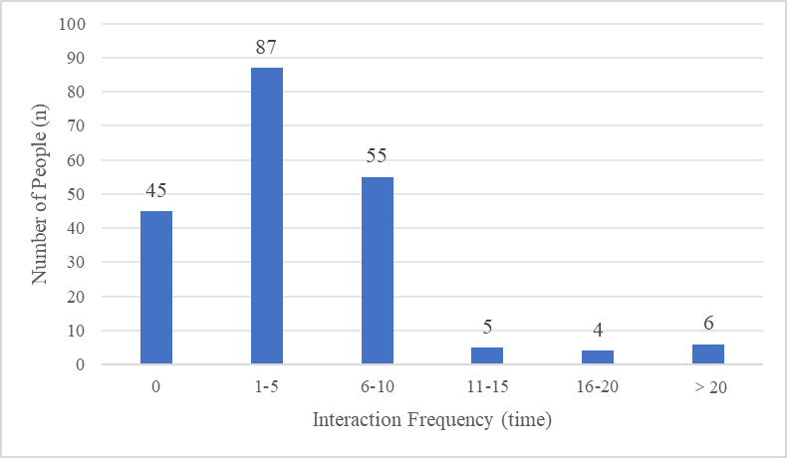
Note: AI-chatbot interaction frequency (time): Number of interactions with the AI chatbot.

Figure S2. Distribution of Average Session Length of AI-Chatbot Interaction in AI-HEALS Group
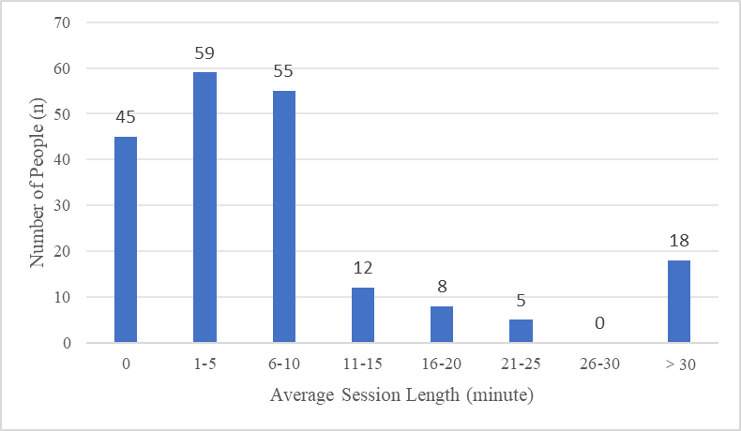
Note: Average session length (minutes):The average time spent interacting with an AI chatbot.

Figure S3. Distribution of Average Interval of AI-HEALS Usage in AI-HEALS Group
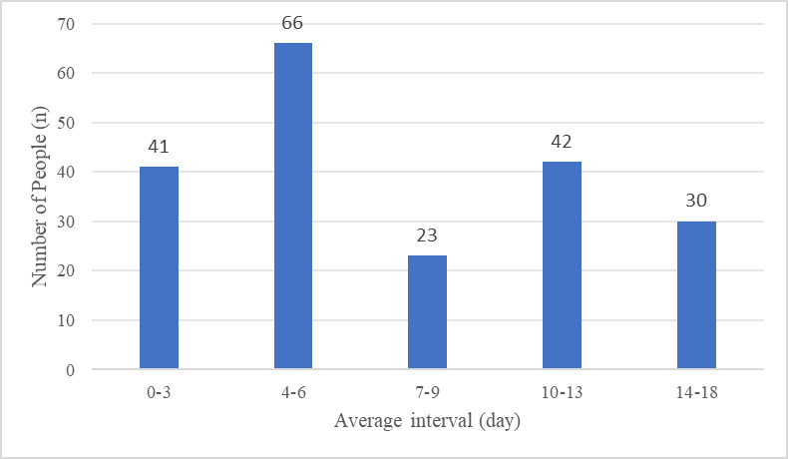

Figure S4. Distribution of AI-HEALS Time Usage in AI-HEALS Group
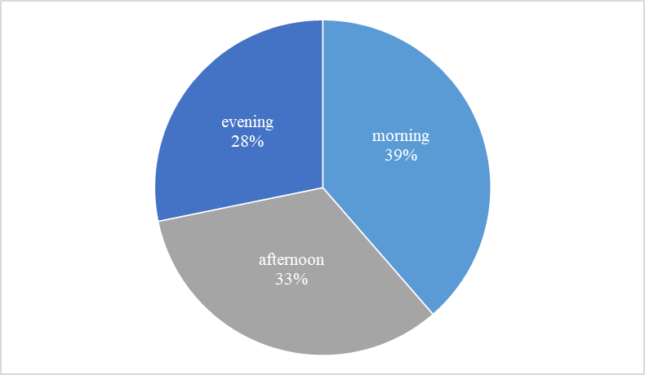

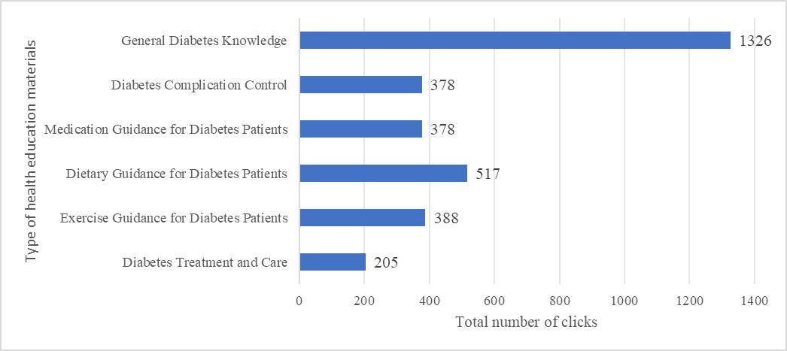
Figure S5.Total Clicks for Different Types of Health Education Materials in AI-HEALS Group

