APPENDIX 1
AI-HEALS DESIGN AND STUDY PROCEDURES
Title：Effectiveness of Artificial Intelligence-based Health Education Accurately Linking System (AI-HEALS) for Type 2 diabetes self-management：A Cluster Randomized Clinical Trial

This supplement includes the following materials:
Functional Overview of the AI-HEALS
Final Study Protocol
Operational Workflow of AI-HEALS

Table of Content
CONTENTS
1.AI-HEALS Detailed Description 3
1.1 System Functionality and Modules 3
1.2 T2DM Knowledge Graph 3
1.3 AI-Chatbot 3
1.4 HEALS Mobile Education System 4
2.Materials and methods 5
2.1 Study Design, Setting, Masking and Ethics 5
2.2 Study Participants 5
2.3 Recruitment, Eligibility Screening, Enrollment and Intervention 6
3.Measures 6
3.1Biochemical analyses 7
3.2 Secondary Outcome Measures 8
4. Patient Process and Features of the "PKU Diabetes Butler" WeChat Service Account 10
Step 1: Service Account Subscription 10
Step 2: Health Education 11
Step 3: Blood Glucose Monitoring 12
Step 4: Scheduled Push Notifications 13
Step 5: AI-Chatbot Integration 14
5.Reference 16

1.AI-HEALS Detailed Description
Artificial Intelligence-based Health Education Accurately Linking System (AI-HEALS) is a mobile health education platform designed for patients with type 2 diabetes mellitus (T2DM). Grounded in the extended theory of Medication Therapy Management (MTM), the system is deployable on mobile devices to enable real-time chat interactions with patients, address their inquiries, and facilitate both active reading and passive reception of educational content. The platform comprises two integrated components: an Artificial Intelligence Chatbot (AI-Chatbot) and HEALS, connected via application programming interfaces (APIs) and accessible through the "PKU Diabetes Butler" WeChat service account. The "T2DM Artificial Intelligence Knowledge Graph Platform V1.0" developed in this study has been granted a software copyright by the National Copyright Administration of China (Registration No. 2024SR1701301, Certificate No. 14105174).

1.1 System Functionality and Modules
The AI-HEALS facilitates diabetes self-management via five interconnected core modules: the Knowledge Graph Module, which consolidates authoritative medical resources into a structured database; the Natural Language Processing (NLP) Engine, designed to analyze patient voice or text inputs in real time and drive context-aware dialogues; the AI-Chatbot, leveraging deep learning and the knowledge graph to deliver evidence-based guidance on diet, exercise, and medication; the Content Management Module, which enforces rigorous quality control and timely updates of educational materials through a multi-tiered editorial review workflow; and the Personalized Push Algorithm, which synthesizes health indicators, user interactions, and content preferences to generate tailored recommendations.

1.2 T2DM Knowledge Graph
A multidisciplinary medical team constructed diabetes knowledge graph (DKG) using knowledge extraction, fusion, and storage technologies. Data sources included Chinese and English biomedical databases and official guidelines from authoritative institutions. A systematic search strategy was employed (keywords: "diabetes health management," "type 2 diabetes," etc.; subcategories: "food types," "exercise modalities," "medication protocols," etc.), followed by literature quality assessment and content analysis. The DKG, optimized through clinical expert consensus, is structured as <entity-relationship-entity> or <entity-attribute-value> triples, encompassing 1,258 entities, 3 domains (diet/exercise/medication), and 34 core attributes.

1.3 AI-Chatbot
Figure 2 shows the AI-Chatbot was initialized using a diabetes-specific question-answering dataset built upon the DKG and trained on the "Emotibot" AI development platform. Machine learning algorithms (e.g., deep learning, regression, random forest) were applied to enhance data accuracy, relevance, and structural coherence. After model validation, the AI-Chatbot was integrated via API into the " PKU Diabetes Butler" WeChat platform, providing 24/7 intelligent health consultation. The system supports natural language interactions to parse patient queries and deliver personalized management advice. Additionally, it integrates basic utility functions (e.g., time inquiry, reminders, calculator, weather forecasts, storytelling, idiom games, jokes) to offer a "medical-life" integrated service.

1.4 HEALS Mobile Education System
The HEALS health education materials were independently developed by the research team based on authoritative guidelines and evidence-based literature, utilizing multimodal formats (text, images, audio, and video). All content undergoes a rigorous three-stage review process: initial screening by medical editors followed by blinded reviews by two diabetes specialists with associate senior professional titles or higher, ensuring scientific accuracy and readability. The system currently hosts a knowledge base of 98 original articles (420,000 Chinese characters) covering six core modules: dietary guidance, exercise guidance, medication management, treatment and care, complication control, and general diabetes education. The delivery strategy, grounded in the MTM, includes two approaches: group-based delivery and personalized delivery. Group-based delivery involves selecting articles from the repository and sending them uniformly to the intervention group or specific user cohorts. Personalized delivery integrates detailed patient data—such as demographics, blood glucose levels, scan timestamps, total articles read, reading duration per article, reading status, unread article count, and effective/non-effective reading metrics—to generate a 3-month tailored delivery plan. This plan ensures at least one daily text/image or video delivery, supplemented by a system operation guide during the first week. Delivery effectiveness is dynamically evaluated across multiple dimensions: engagement metrics (open rate, share rate), behavioral changes (e.g., self-management indicators), and clinical outcomes (e.g., HbA_{1c}). Refer to Figure 1 and 2 for details.

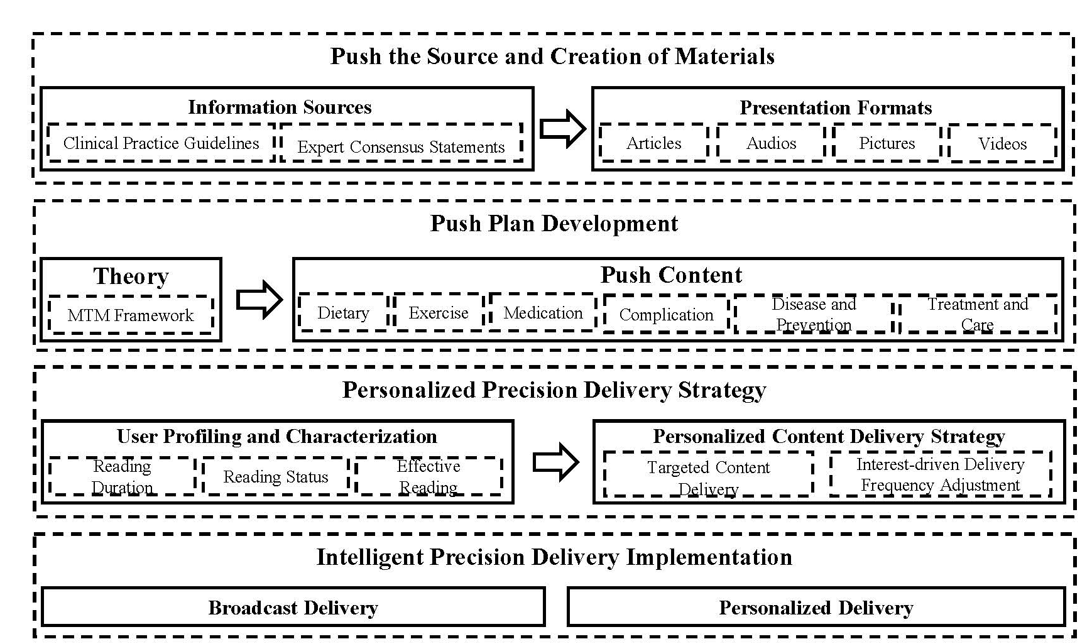
Figure 1. HEALS Design Ideas and Processes

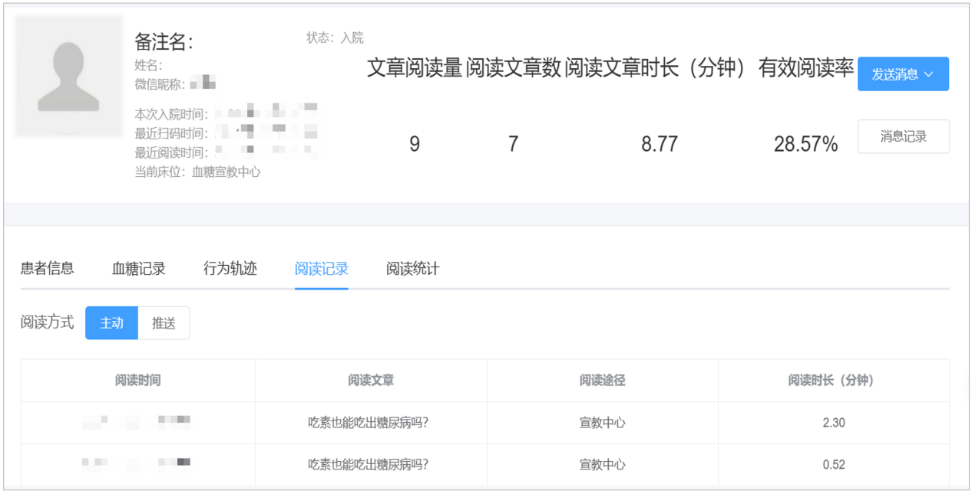
Figure 2. Individual Patient Background Data Situation
Note: The background of AI-HEALS can view the detailed data information of each patient, such as basic information, blood glucose status, scanning time, total number of articles read, total time of reading articles, reading time of each article, reading status of each article, total number of unread articles, total number of validly read articles, and total number of non-validly read articles.

2.Materials and methods

2.1 Study Design, Setting, Masking and Ethics
This 18-month cluster-randomised controlled trial employed a two-arm parallel design, randomizing 45 community health centers (CHCs) in Beijing’s Daxing and Shunyi Districts through simple randomisation (1:1 ratio) to either the AI-HEALS intervention (23 clusters) or treatment-as-usual (TAU) control (22 clusters). Masking procedures were implemented as follows: CHC personnel responsible for patient recruitment and biometric data collection remained unaware of group allocation; field investigators performed standardized data collection without access to allocation information; and analysts processed anonymized datasets labeled as "Group A/B," preventing linkage to intervention types.
The study protocol was approved by the Peking University Biomedical Ethics Committee (No. IRB00001052-22058), registered at the Chinese Clinical Trial Registry (ChiCTR2300068952), and filed in the National Health Security Information Platform Medical Research Registration System (No. HSR-23-000770). All participants provided written informed consent using paper documents.

2.2 Study Participants
Inclusion Criteria:
- Diagnosis of type 2 diabetes: fasting blood glucose ≥7.0 mmol/L, or 2-hour OGTT blood glucose ≥11.1 mmol/L, or HbA_{1c} ≥6.5%¹
- Age 18–75 years
- Permanent resident of Beijing (annual time away from Beijing <1 month)
- No use of psychotropic medications prior to enrollment
- Able to use smartphones and basic WeChat functions
- Voluntarily participated in the study and signed informed consent
Exclusion Criteria
- Type 1 diabetes, gestational diabetes, or secondary diabetes
- Severe complications (proliferative retinopathy, nephropathy stage ≥IV or serum creatinine >2 mg/dL, cardiac function below class III, residual effects of cerebrovascular accidents, diabetic foot Wagner grade I or above)
- Limited mobility, impaired consciousness, or psychiatric disorders
- Concurrent malignancy or history of radiotherapy/chemotherapy within the past 6 months
- Currently participating in other similar research studies
- Unwilling to cooperate

2.3 Recruitment, Eligibility Screening, Enrollment and Intervention
The study completed baseline participant enrollment from July 4 to August 11, 2023. During recruitment, multi-channel outreach was conducted through CHCs, community bulletin boards, and residential activity centers. Community healthcare providers conducted preliminary screenings via telephone, in-person visits, or online platforms. Eligible candidates meeting inclusion criteria (age ≥18 years, confirmed diagnosis of T2DM by medical institutions) had their enrollment intentions confirmed by research staff one day before baseline assessment. On the enrollment day, participants signed informed consent forms after detailed explanations of study procedures, data collection methods (HbA_{1c} testing, BMI measurement, and standardized questionnaires), and benefit guarantees (testing costs covered by the project; participants received daily necessities worth 40 CNY per follow-up).
Participants were assigned to either the AI group or the TAU group based on randomisation results from their respective CHCs (see Section 2.2, Study Design). Investigators guided AI group participants to subscribe to the "PKU Diabetes Butler" WeChat official account and complete training on AI-HEALS functions. For the first 3 months post-enrollment, the AI group received proactive health push notifications (customized education and AI Q&A features) from the AI-HEALS, followed by discontinuation of automated pushes. However, participants retained access to chatbot interactions, health education materials, and blood glucose logging for 18 months. The TAU group continued standard diabetes primary care (SDPC), including routine follow-ups and verbal health education. For all participants, investigators collected HbA_{1c} levels, BMI, and other physical metrics at baseline and the 3, 6, 12 and18 months, while additional data were obtained via questionnaires.

3.Measures
Patients in both the AI and TAU groups underwent physiological and biochemical measurements at baseline and at 3, 6, 12, and 18 months post-enrolment, and completed questionnaires. All self-reported indicators were collected via face-to-face questionnaires. Baseline assessments, including a review of past medical history with a particular focus on chronic respiratory, cardiovascular, cerebrovascular, and renal diseases, were conducted within one week prior to randomisation.
System usage behaviour data were automatically captured during the intervention period. The primary outcome for evaluating intervention efficacy was HbA_{1c} levels, while secondary outcomes included diabetes self-care activities, dietary adherence scores, diabetes-related skill scores, sleep quality scores, self-efficacy scores, perceived stress scores, quality of life scores, medication adherence scores, and physical activity scores. All data sources and specific evaluation metrics are summarised in Table 1.
Table 1. Data Sources and Evaluation Metrics
Data Category | Specific Measures | Type | Data Collector | Data collection time
 |  |  |  | T0 | T1 | T2 | T3
Biochemical and Anthropometric Data | Height (cm), weight (kg), waist circumference (cm) | Quantitative | CHC clinicians | √
Biochemical and Anthropometric Data | Hemoglobin A_{1c} (HbA_{1c}) | Quantitative | CHC clinicians | √ | √ | √ | √
Questionnaire Data | Sociodemographic characteristics | Quantitative | Field investigators | √
Questionnaire Data | Summary of diabetes self-care activities; Dietary adherence scale; Diabetes-related skills scale; Pittsburgh Sleep Quality Index; Diabetes self-efficacy scale; Perceived Stress Scale; Quality of life scale; Medication adherence scale; Physical activity scale | Quantitative | Field investigators | √ | √ | √ | √
System Engagement Data | Total articles read (n); Total article clicks (n); Interaction duration (min); Effective reading rate (%); Chatbot query frequency (n); Chatbot interaction time (s) | Quantitative | Automated system records | √ | √ | √ | √

3.1Biochemical analyses
During participant enrollment and follow-up, blood samples (2 mL of whole blood) were collected using EDTA anticoagulant tubes (purple cap) on the day scheduled for HbA_{1c} measurements. After collection, the samples were transported under cold chain conditions (2-8°C) to KingMed Clinical Laboratory Center (Beijing) for centralized processing. HbA_{1c} levels were measured using high-performance liquid chromatography (HPLC) with the MQ-6000 glycated haemoglobin. (HbA_{1c}) Analyzer. In the laboratory, the process began with the initialization and preheating of the chromatograph, followed by calibration and preparation of glycated hemoglobin standards. Samples were then injected, and the column and mobile phase parameters were set to ensure optimal separation. The detector recorded the HbA_{1c} concentrations, and the results were entered into an electronic database. Any unused blood samples were destroyed within 7 days of completing the analysis.
The height, body weight, and waist circumference of each participant were measured twice with validated instruments. Height and weight measurements were obtained using calibrated electronic devices, with BMI calculated as weight in kilograms divided by the square of height in meters (kg/m²). Waist circumference was measured horizontally at the umbilical level with a non-elastic anthropometric tape.

3.2 Secondary Outcome Measures
Summary of Diabetes Self-Care Activities (SDSCA): This SDSCA evaluates patients' self-management behaviors over the past week across six dimensions (11 items), ² including diabetes-specific diet, general diet, physical activity, blood glucose monitoring, foot care, and medication adherence. Each item is scored based on the number of days a behavior was performed in the past week, ranging from 0 to 7. The total score is 77, with higher scores indicating better self-management behaviors. Cronbach’s α = 0.736 in this study.
Dietary Adherence Behavior Scale for Diabetes Patients: This scale comprises 23 items across five dimensions: dietary self-regulation, carbohydrate and fat adherence, oil and salt adherence, fruit and vegetable adherence, and cooking and dining habits. ³ It uses a 5-point Likert scale (1 = "never" to 5 = "always"), with a total score of 115. Higher scores indicate better adherence to dietary behaviors. Cronbach’s α = 0.915.
Adherence to Refills and Medications Scale (ARMS-7): The 7-item short form of the Adherence to Refills and Medications Scale assesses prescription compliance. ⁴ Items use a 4-point Likert scale, with the final item reverse-coded. Total scores range 0–21; higher scores indicate poorer adherence. Cronbach’s α = 0.700.
Diabetes-related Skills Scale: Developed by Wang et al.⁵, this 12-item tool measures skills in weight assessment, caloric calculation, personalized meal planning, glycemic impact evaluation of foods, dietary/exercise adjustments, hypoglycemia prevention/management, and blood glucose monitoring. Items are rated from 0 ("no proficiency") to 4 ("full proficiency"), with total scores ranging 0–48. Higher scores reflect superior self-management skills. Cronbach’s α = 0.912.
Diabetes Self-Efficacy Scale: This self-designed 16-item scale assesses self-efficacy across four domains: dietary control (5 items), physical activity (7 items), hypoglycemia recognition/management (2 items), and healthcare access (2 items). Using a 5-point Likert scale (0 = "no confidence" to 4 = "full confidence"), total scores range 0–64. Higher scores indicate greater self-efficacy. Cronbach’s α = 0.928.
Brief Pittsburgh Sleep Quality Index (B-PSQI): The B-PSQI assesses seven dimensions: sleep latency, sleep duration, sleep efficiency, sleep disturbances, subjective sleep quality, use of sleep medication, and daytime dysfunction. ⁶ The total score is 15, with higher scores indicating poorer sleep quality. Cronbach’s α = 0.738.
Perceived Stress Scale-4 (PSS-4): This abbreviated scale evaluates psychological stress over the past month using four items from the PSS-10 (items 2, 4, 5, and 10). ⁷ Negative items (2 and 10) are scored positively, while positive items (4 and 5) are reverse scored. The total score ranges from 0 to 16, with higher scores indicating greater perceived stress. Cronbach’s α = 0.556.
The 5-level EuroQoL-5 Dimensions (EQ-5D-5L)：Health-related quality of life (HRQoL) was assessed using the EQ-5D-5L questionnaire, a validated and widely used instrument for measuring subjective health status across clinical populations ⁸. The EQ-5D-5L comprises five core dimensions: mobility, self-care, usual activities, pain/discomfort, and anxiety/depression. Each dimension is rated on a 5-point scale (1 = no problems; 2 = slight problems; 3 = moderate problems; 4 = severe problems; 5 = extreme problems), with higher aggregate scores indicating poorer self-reported health status. Additionally, a visual analog scale (EQ-5D-5L VAS) was administered, where participants rated their overall health on a 0–100 scale (0 = worst imaginable health state; 100 = best imaginable health state). The EQ-5D-5L has demonstrated good internal consistency in patients with T2DM (Cronbach’s α = 0.73).

4. Patient Process and Features of the "PKU Diabetes Butler" WeChat Service Account

Step 1: Service Account Subscription
Participants received an offline User Manual for the "PKU Diabetes Butler"(PKU-DB) containing an educational QR code. Patients were instructed to scan the code via the WeChat "Scan" function, which redirected them to the PKU-DB service account interface. A "Follow" button was prominently displayed for account subscription (Figure 3).
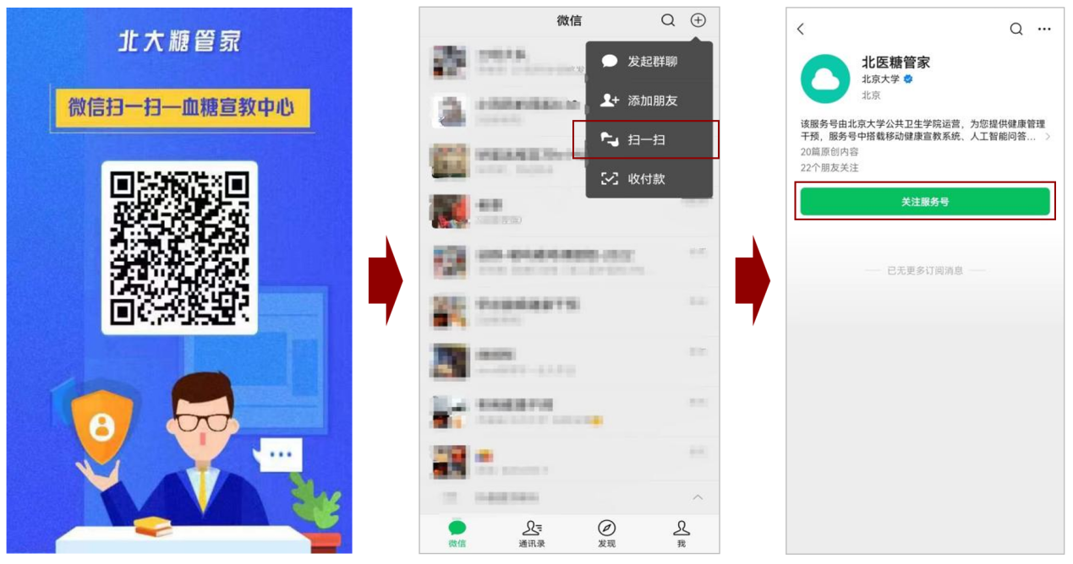
Figure 3. Subscription Workflow for the "PKU Diabetes Butler" Service Account

Upon successful subscription, the system automatically delivered a hyperlink to the "PKU-DB Glycemic Education Center" within the service account chat interface. First-time users received an introductory article titled "AI-HEALS: An Integrated Diabetes Management Platform" through an auto-push notification, outlining the system’s core functionalities and operational guidelines (Figure 4).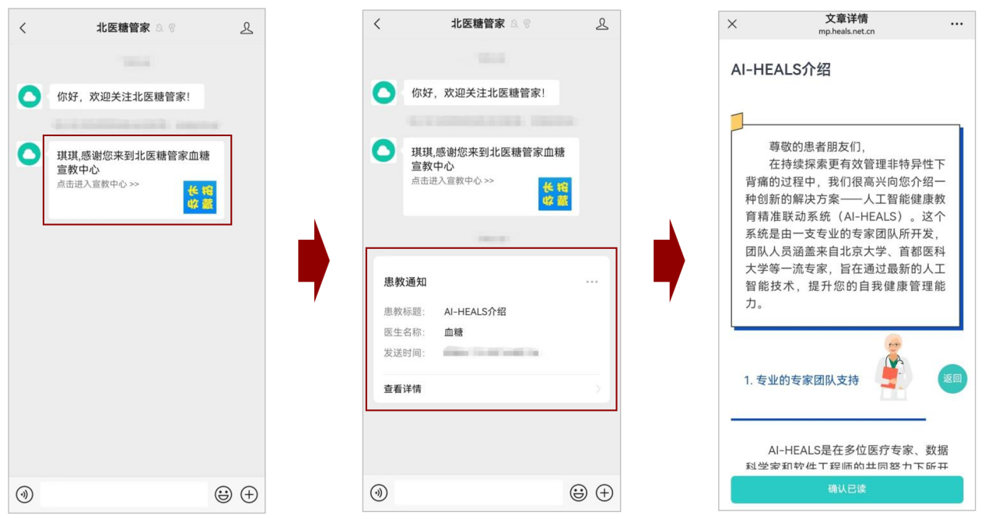Figure 4. Functional Activation Protocol of the "PKU Diabetes Butler" Service Account

Step 2: Health Education
After entering the "PKU Diabetes Butler" Blood Glucose Education Center link mentioned above, users will access the education homepage. The bottom navigation bar has three module options: "Education Center", "Blood Glucose Records", and "My Account".
The "Education Center" is the default module page, containing 7 education categories with displayed article counts:
- "Health Tips from PKU Diabetes Butler" (1 article): Guides patients to disable the "Do Not Disturb" mode of the service account to ensure timely receipt of push notifications.
- "Diabetes Treatment and Care" (23 articles)
- "Dietary Guidance for Diabetes Patients" (26 articles)
- "Exercise Guidance for Diabetes Patients" (15 articles)
- "Medication Guidance for Diabetes Patients" (20 articles)
- "Diabetes Complication Control" (18 articles)
- "General Diabetes Knowledge" (10 articles)
Clicking a category tab allows users to select articles. Each article combines audio, text, and images with appropriately sized fonts for readability. References are appended to enhance credibility. Completed articles are automatically marked as "Read" to distinguish unread content. Details are shown in Figure 5.
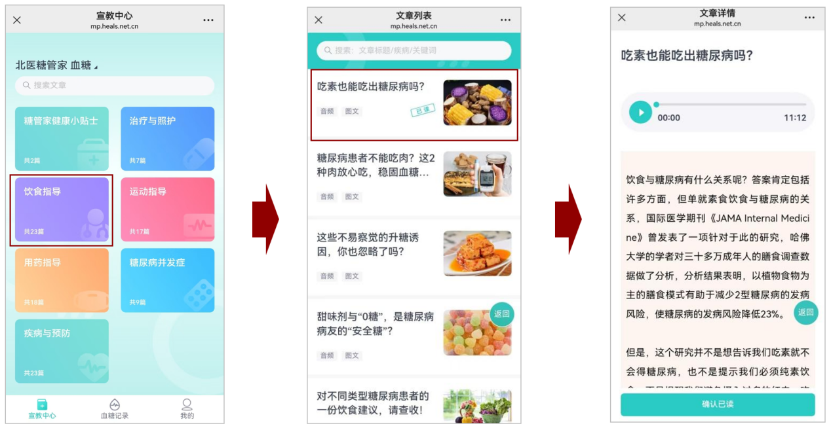Figure 5. Implementation of Content Delivery and Reading Features in the "PKU Diabetes Butler" Service Account

Step 3: Blood Glucose Monitoring
Selecting the "Blood Glucose Records" interface directs users to the monitoring module. The interface features two primary tabs: "Reminder Settings" and "Add New Record" at the top section. Directly below these tabs, the module displays daily measurement frequency and glucose target adherence rate, enabling patients to immediately assess compliance with monitoring protocols and glycemic control status. The "Blood Glucose Records" panel provides retrospective data categorized into "Daily", "7-Day", and "30-Day" intervals, facilitating longitudinal analysis of glycemic trends.
To configure automated monitoring reminders:
- Navigate to the "Reminder Settings" interface.
- Activate the "Add Reminder" function at the bottom of the screen.
- Input a user-defined reminder label.
- Select "Reminder Time" and adjust the scroll wheel to set the target timepoint.
- Toggle the "Enable" switch to the active position (indicated by blue highlighting).
- Modify temporal parameters or deactivate the alert system as clinically indicated. Confirm configurations by selecting "Save".
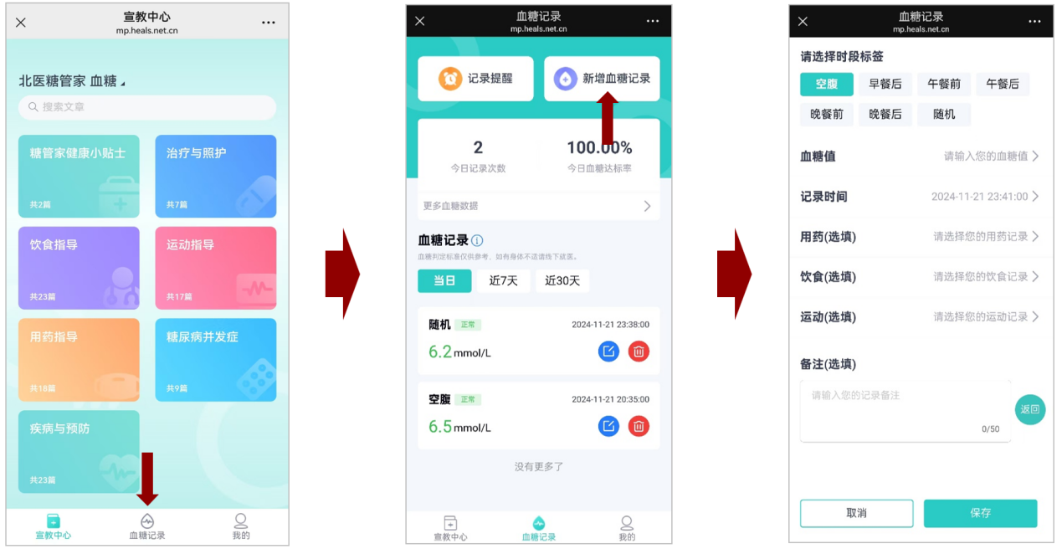Figure 6. Blood Glucose Monitoring Features in the "PKU Diabetes Butler" Service Account

Step 4: Scheduled Push Notifications
The "PKU Diabetes Butler" service account is deployed on the WeChat Official Account platform. System-preset educational materials are delivered as scheduled push notifications within the WeChat message list, utilizing notification mechanisms identical to standard unread messages. This design ensures effective patient attention capture, thereby prompting timely message review and improving information receipt rates and engagement metrics. Implementation details are shown in Figure 7.
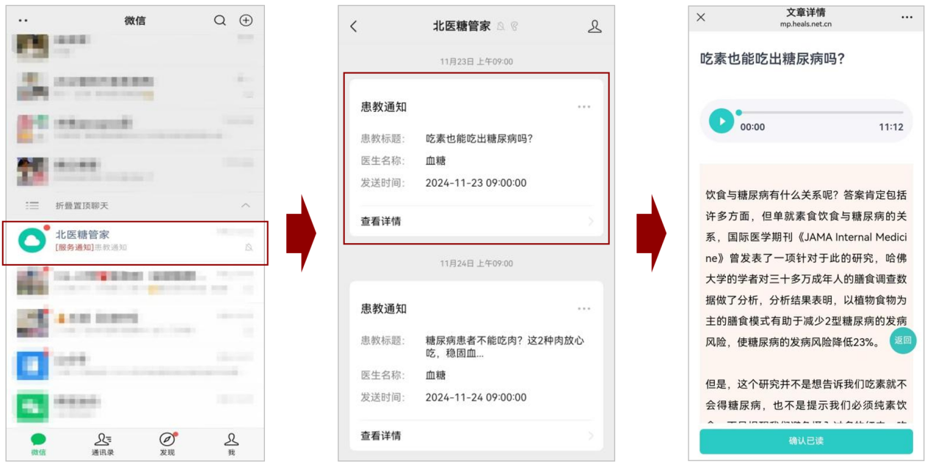Figure 7. Schematic of AI-HEALS scheduled push notification functionality

Step 5: AI-Chatbot Integration
The AI-HEALS is autonomously embedded within the "PKU Diabetes Butler" WeChat service account. Patients may return to the chat interface by pressing the back button on their mobile devices, mirroring standard WeChat navigation. Within the interface, users can type queries in the text input field and select "Send" to initiate real-time interactions with the AI-driven chatbot. The system supports structured dialogue across four clinical domains: Dietary management (Figure 8)；Exercise guidance (Figure 9)；Medication adherence protocols (Figure 10)；General health inquiries (Figure 11).
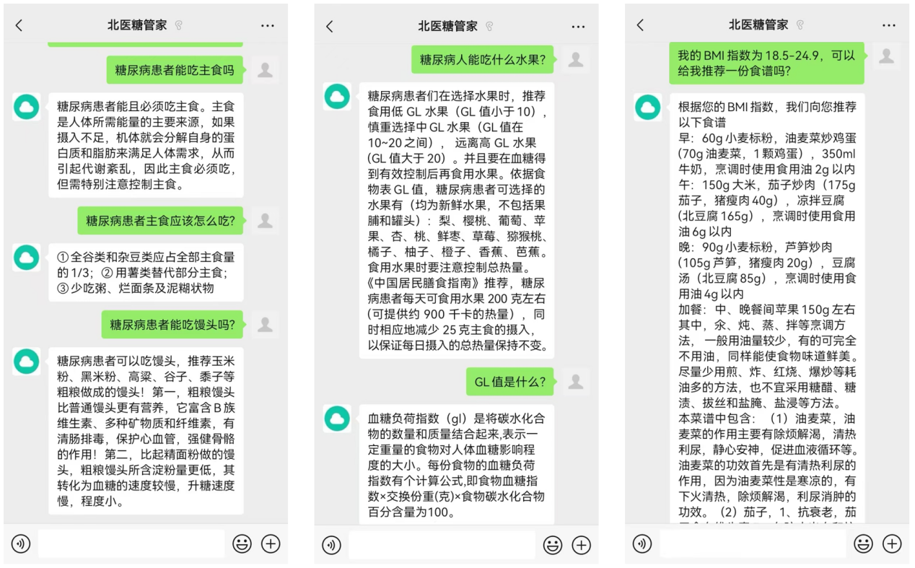
Figure 8. Interaction with the AI chatbot in the "PKU Diabetes Butler" service account regarding diet-related content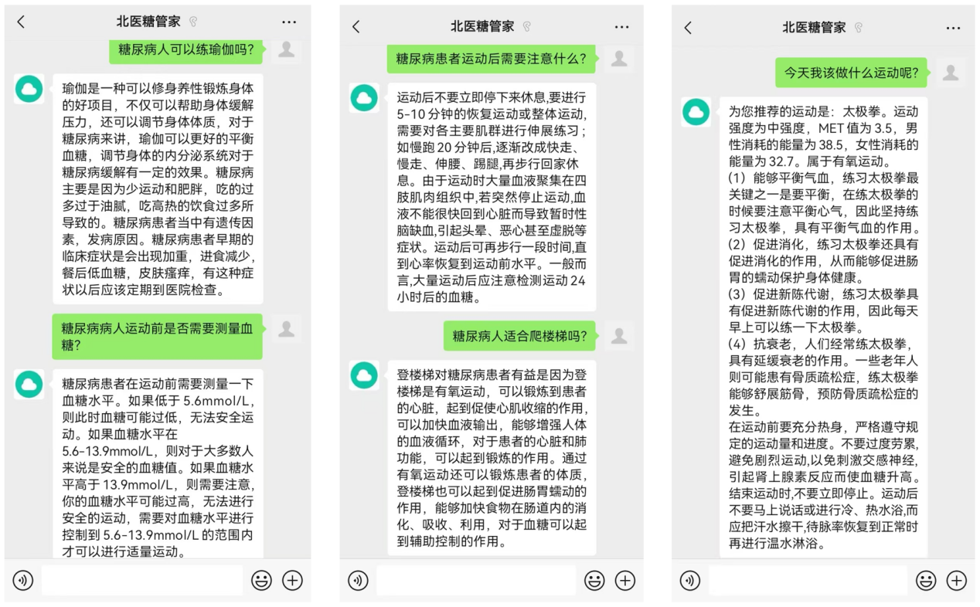
Figure 9. Interaction with the AI chatbot in the "PKU Diabetes Butler" service account regarding exercise-related content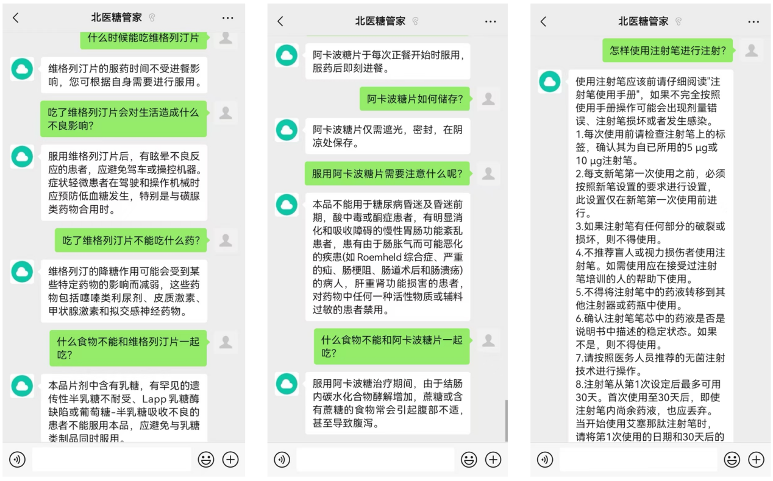
Figure 10. Interaction with the AI chatbot in the "PKU Diabetes Butler" service account regarding medication-related content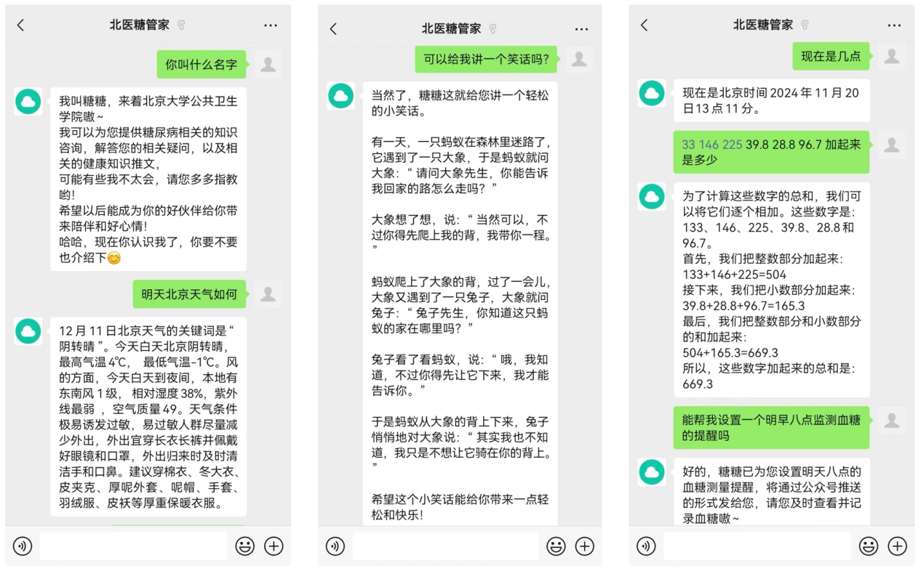
Figure 11. Interaction with the AI chatbot in the "PKU Diabetes Butler" service account regarding other content

5.Reference
1. Guo L, Xiao X. Guideline for the Management of Diabetes Mellitus in the Elderly in China (2024 Edition). Aging Med (Milton). Feb 2024;7(1):5-51. doi:10.1002/agm2.12294
2. Toobert DJ, Hampson SE, Glasgow RE. The summary of diabetes self-care activities measure: results from 7 studies and a revised scale. Diabetes Care. Jul 2000;23(7):943-50. doi:10.2337/diacare.23.7.943
3. Zhao Qiuli, Hou Sai ning, Liang Yan, Zhao Jing, Limin W. Dietary Behavior Compliance Scale for Patients with Type 2 Diabetes Mellitus: development and validation. Journal of Nursing Science. 2017;32(17):4.
4. Kripalani S, Risser J, Gatti ME, Jacobson TA. Development and evaluation of the Adherence to Refills and Medications Scale (ARMS) among low-literacy patients with chronic disease. Value Health. Jan-Feb 2009;12(1):118-23. doi:10.1111/j.1524-4733.2008.00400.x
5. WANG Feng-bin, GAO Min, CHEN Xue-ying, et al. Study on the correlation between family support and dietary behavior in patients with type 2 diabetes mellitus in community. Chinese Journal of Health Education. 2020;(4):5.
6. Cox SD, Benoit JS, Brohard CL, McIntyre TM. Evaluation of sleep quality among nursing faculty: Application of the Pittsburgh Sleep Quality Index-A descriptive correlational study. Nurs Open. Jan 2022;9(1):339-348. doi:10.1002/nop2.1067
7. Ingram PBt, Clarke E, Lichtenberg JW. Confirmatory Factor Analysis of the Perceived Stress Scale-4 in a Community Sample. Stress Health. Apr 2016;32(2):173-6. doi:10.1002/smi.2592
8. Cheng LJ, Tan RL, Luo N. Measurement Properties of the EQ VAS Around the Globe: A Systematic Review and Meta-Regression Analysis. Value Health. Aug 2021;24(8):1223-1233. doi:10.1016/j.jval.2021.02.003

