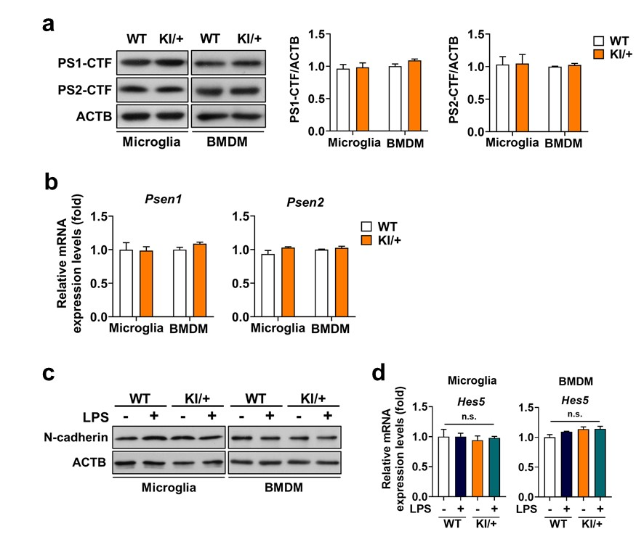
Supplementary Fig. 1 Psen2 N141I mutation does not change the expression levels of Psen1 and Psen2, or γ-secretase activity of PSEN2. a Western blot analysis of the levels of carboxy-terminal fragments (CTF) of PSEN1 and PSEN2 in primary microglia and BMDM from WT and KI/+ mice. Graphs show quantification of the protein levels (n = 3). b Relative mRNA levels of Psen1 and Psen2 measured by qRT-PCR in primary microglia and BMDM from WT and KI/+ mice (n = 4). c, d Representative blots of N-cadherin expression level (c) and relative mRNA expression levels of Hes5 (n = 3) (d) in primary microglia and BMDM from WT and KI/+ mice. mRNA levels were normalized to Actb. The blots shown are representative of 3 experiments with similar results. All data are mean ± SEM. n.s., not significant.
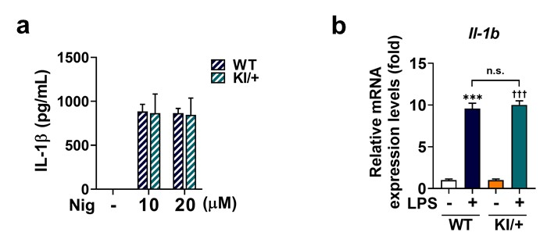
Supplementary Fig. 2 Psen2 N141I mutation does not affect NLRP3 inflammasome activation and IL-1b expression. a ELISA of IL-1β in supernatants from LPS-primed WT and KI/+ microglia after nigericin (10 and 20 μM) treatment (n =3). Microglia were primed with LPS (1 μg/ mL) for 3 h, followed by nigericin treatment for 40 min. b Relative mRNA levels of IL-1b in WT and KI/+ microglia after LPS treatment for 12 h. The mRNA levels were normalized to Actb (n = 3). All data are mean ± SEM. n.s., not significant. ***p < 0.001 vs. untreated WT control. †††p < 0.001 vs. untreated KI/+ control.

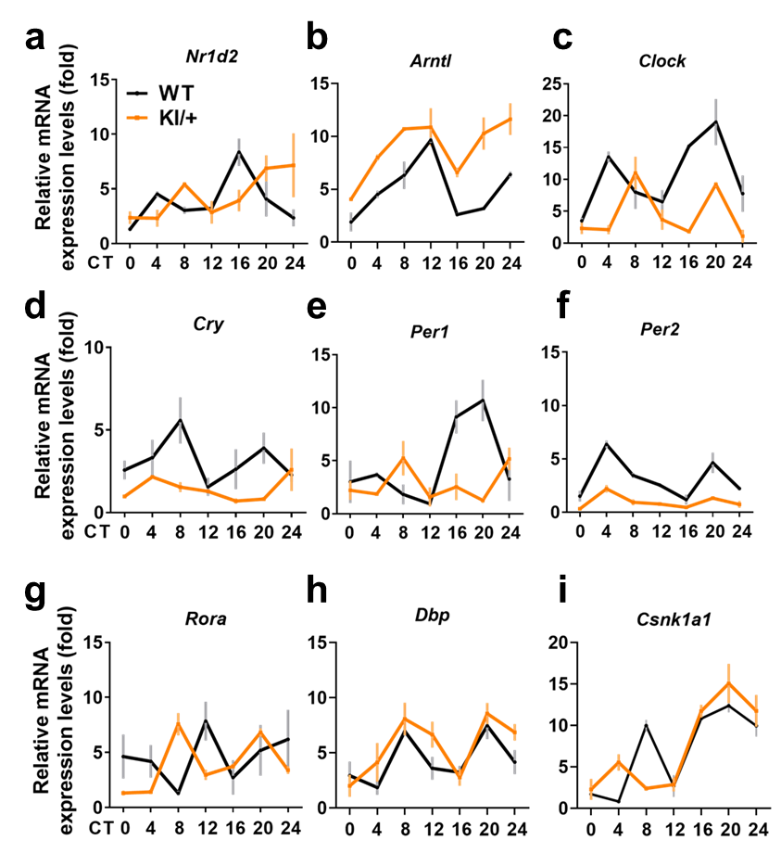
Supplementary Fig. 3. Transcript abundance of the indicated circadian clock genes at different circadian times (CT). a-i Microglia were synchronized with dexamethasone (DEX, 100 nM) treatment for 2 h and harvested every 4 h for RNA extraction and qPCR (n = 4). mRNA levels were normalized to Actb.
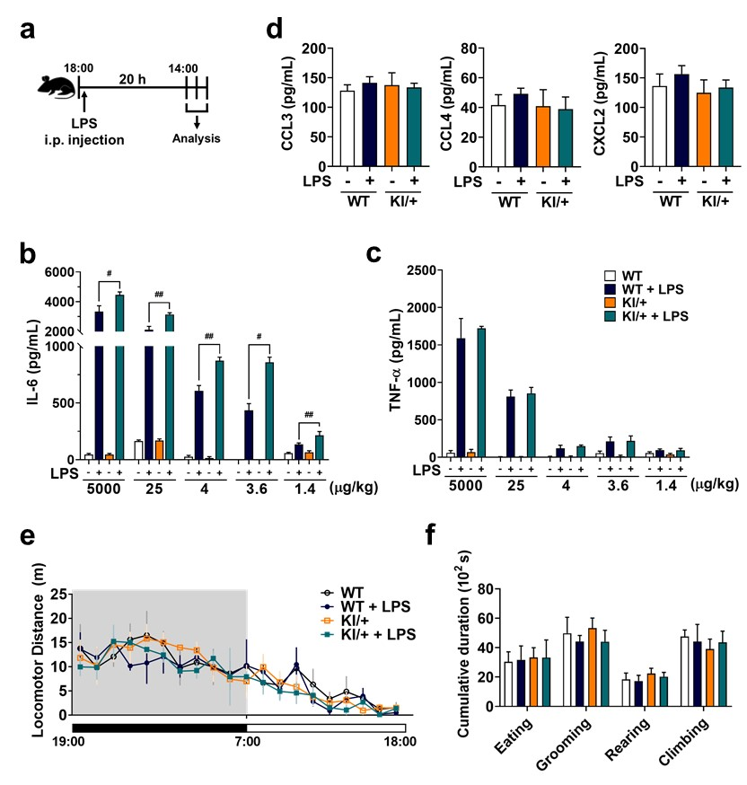
Supplementary Fig. 4 Psen2^{N141I/+} mice show normal locomotor activity and behaviour, but produce more IL-6 than TNF-α in response to LPS. a Schematic illustration of the experimental schedule. b, c ELISA of IL-6 (b) and TNF-α (c) in blood serum from WT and KI/+ mice i.p. injected with various doses of LPS (n = 9). LPS induced more IL-6 secretion in KI/+ mice than in WT in a dose-dependent manner. d ELISA of CCL3, CCL4, and CXCL2 in blood serum from WT and KI/+ mice 20 h after i.p. injection of LPS (0.35 μg/kg). e, f Analyses of locomotor activity and home cage behaviour of WT and KI/+ mice 20 h after i.p. injection of LPS (0.35 μg/kg). WT and KI/+ mice showed normal locomotor activity (e) and general behaviour (f; eating, grooming, rearing, and climbing), when monitored in LABORAS cages for 24 h (n = 8). All data are mean ± SEM. #p < 0.05, ##p < 0.01 and ###p < 0.001 for the indicated comparisons.
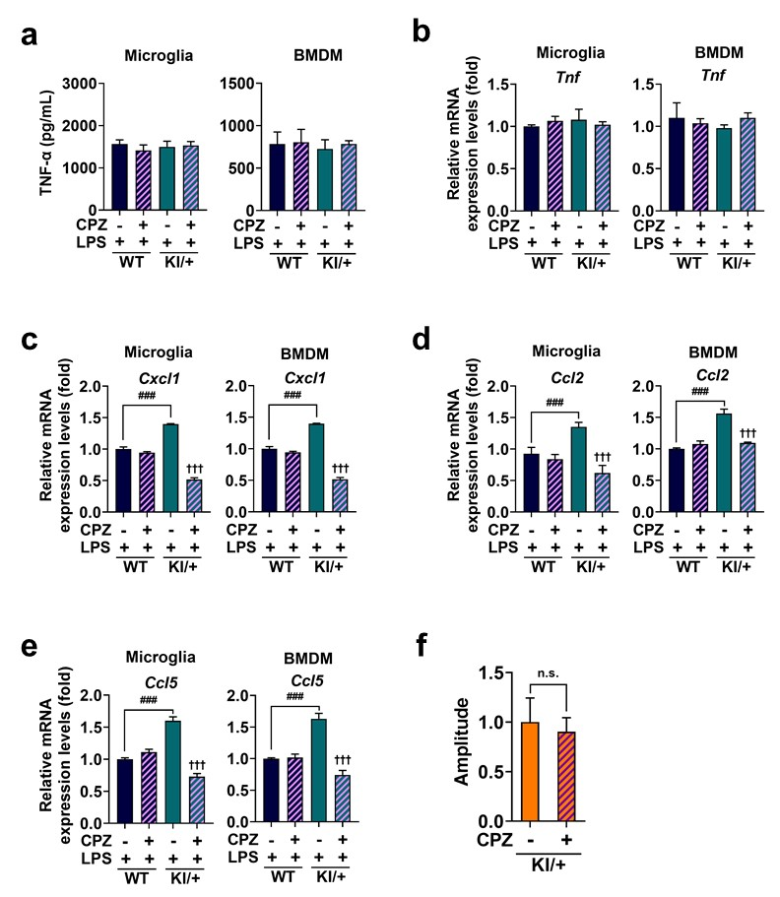
Supplementary Fig. 5 Chlorpromazine selectively reduced expression of clock-controlled cytokines, but does not affect circadian amplitude in Psen2^{N141I/+} microglia and BMDM. a, b Secretion (a) and mRNA level (b) of TNF-α in microglia (0.5 μM, n = 4) and BMDM (1 μM, n = 3) treated with CPZ for 1 h prior to LPS for 12 h. c-e mRNA levels of clock-controlled cytokines in microglia (n = 4) and BMDM (n = 3) treated with CPZ for 1 h prior to LPS for 12 h. f Circadian amplitude were analysed using representative bioluminescence recordings of CPZ-treated KI/+ microglia (n = 4). Data are mean ± SEM. n.s., not significant. †††p < 0.001 vs. untreated KI/+ control. ###p < 0.001 for the indicated comparisons.

