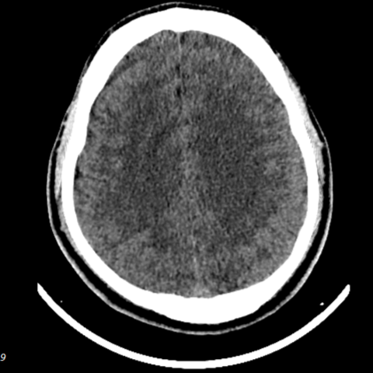
Figure 1 Cerebral Edema
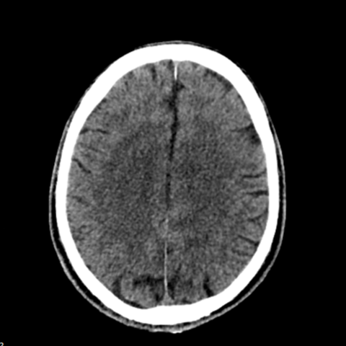
Figure 2 Cerebral Edema
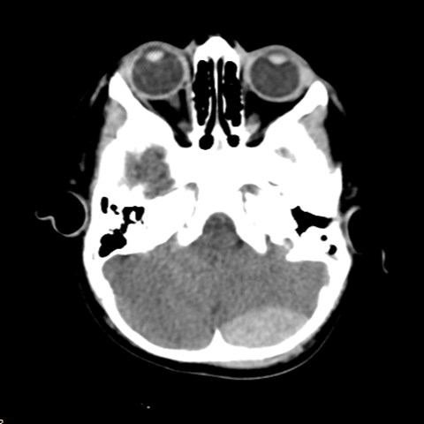
Figure 3 Epidural Hematoma
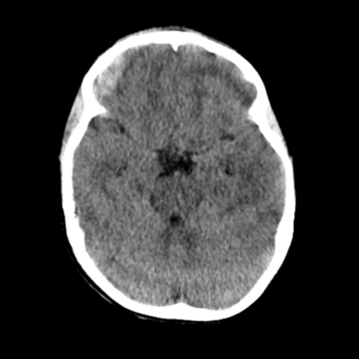
Figure 4 Epidural Hematoma
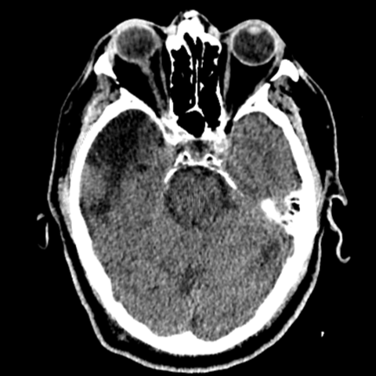
Figure 5 Cerebral Encephalopathy
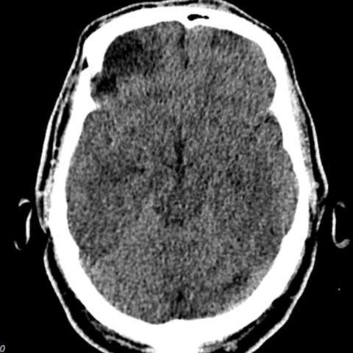
Figure 6 Cerebral Encephalopathy
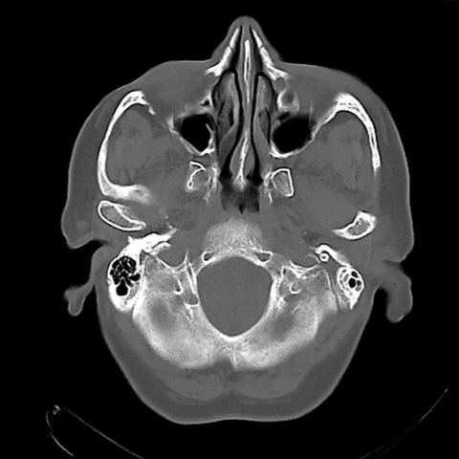
Figure 7 Ethmoid Fracture
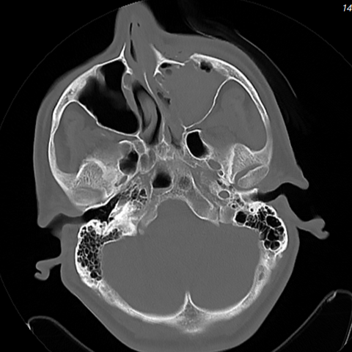
Figure 8 Ethmoid Fracture
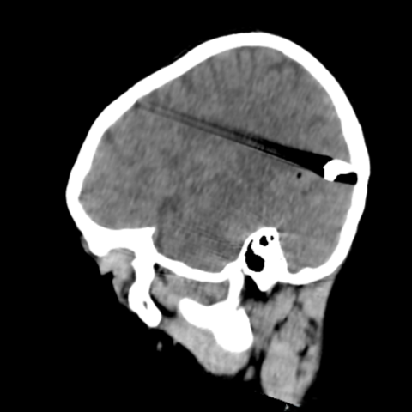
Figure 9 Intracranial Foreign Body
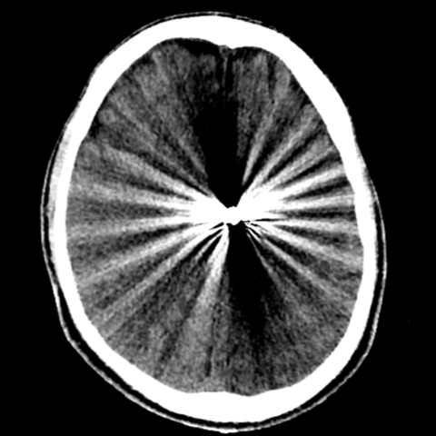
Figure 10 Intracranial Foreign Body
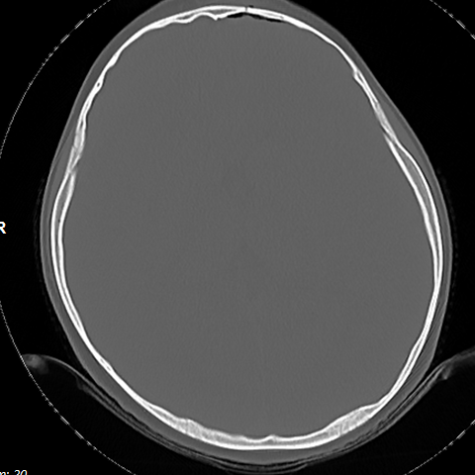
Figure 11 Frontal Fracture
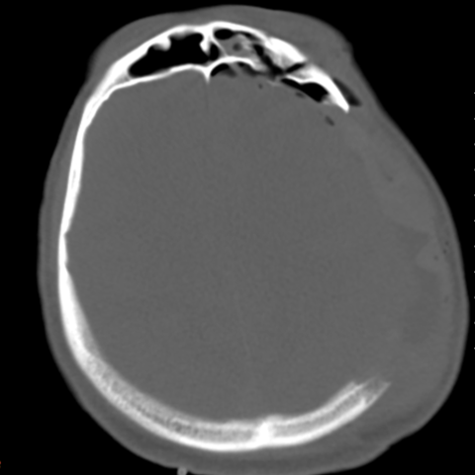
Figure 12 Frontal Fracture
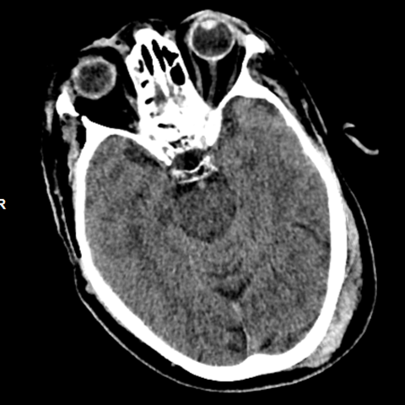
Figure 13 Intracranial Hematoma
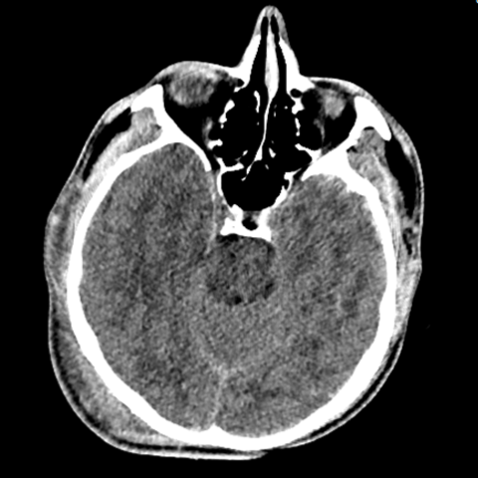
Figure 14 Intracranial Hematoma
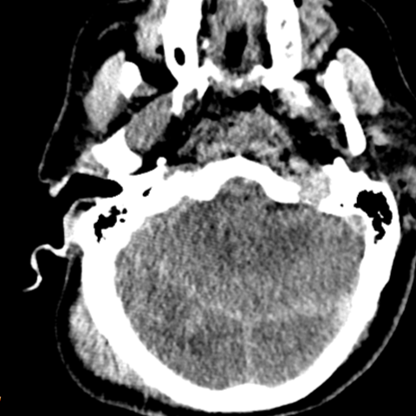
Figure 15 Brain Herniation
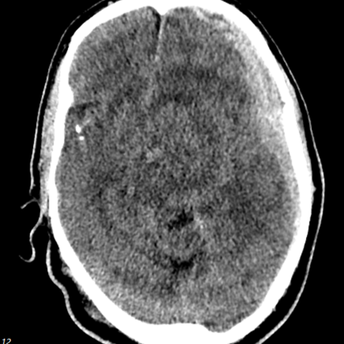
Figure 16 Brain Herniation
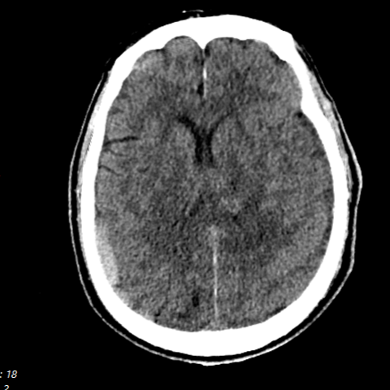
Figure 17 Intraparenchymal Hemorrhage
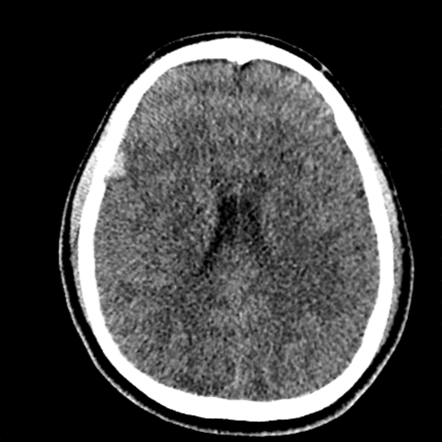
Figure 18 Intraparenchymal Hemorrhage
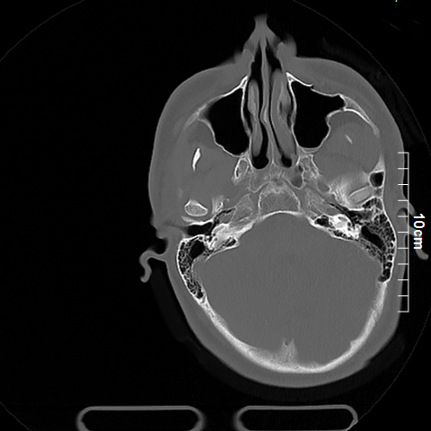
Figure 19 Maxillary Fracture
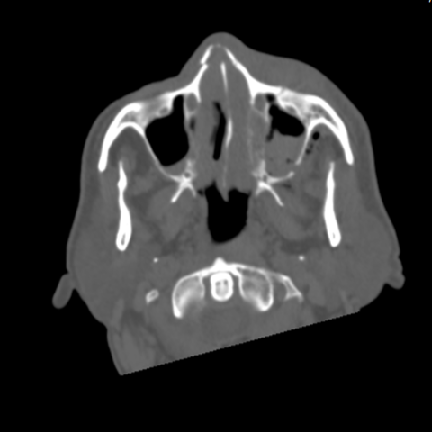
Figure 20 Maxillary Fracture
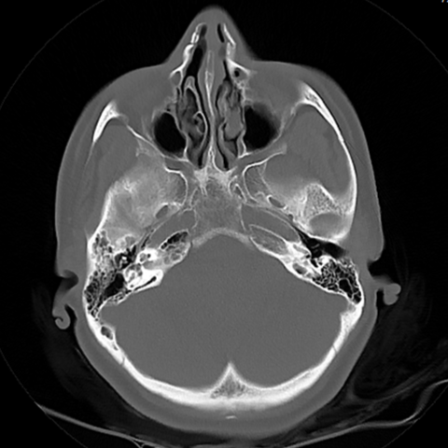
Figure 21 Nasal Fracture
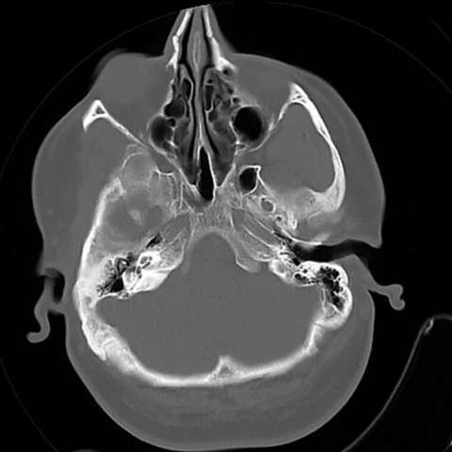
Figure 22 Nasal Fracture
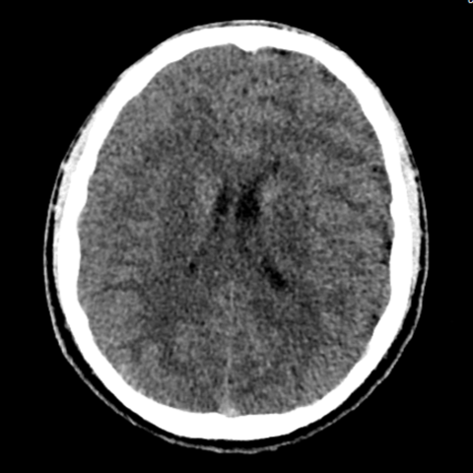
Figure 23 Normal Brain CT Scan
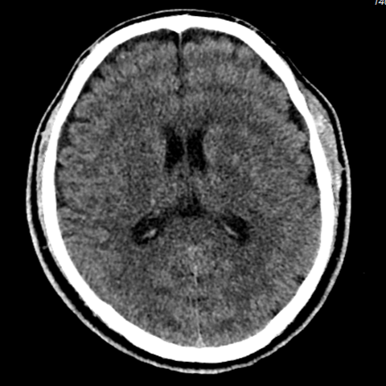
Figure 24 Normal Brain CT Scan
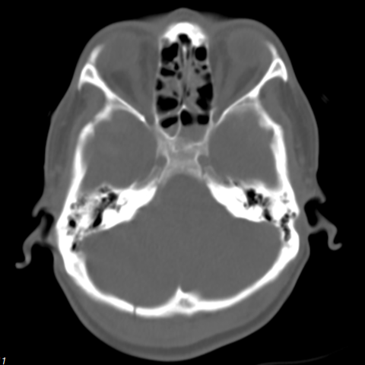
Figure 25 Occipital Fracture
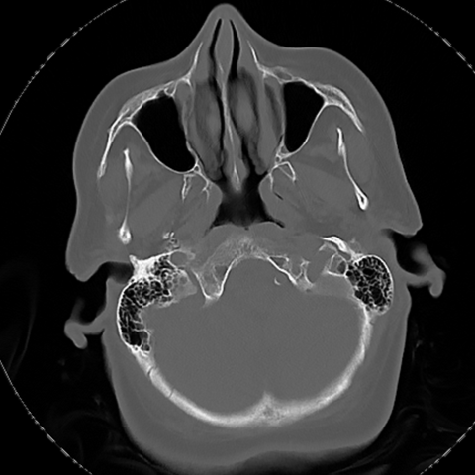
Figure 26 Occipital Fracture
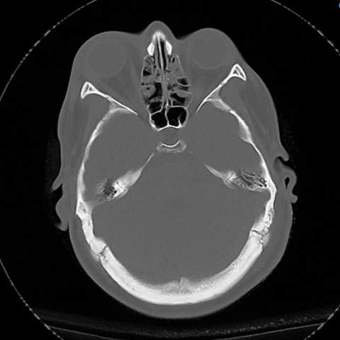
Figure 27 Orbital Fracture
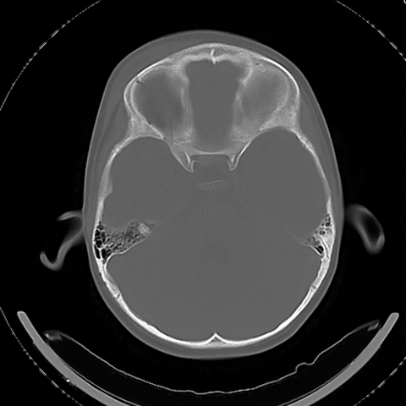
Figure 28 Orbital Fracture
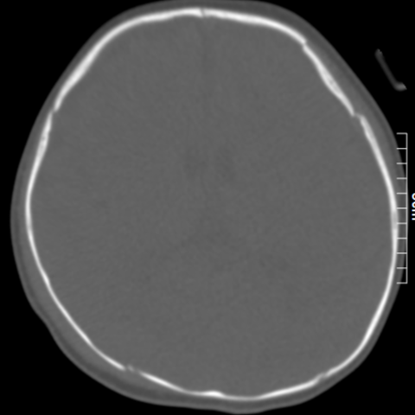
Figure 29 Parietal Fracture
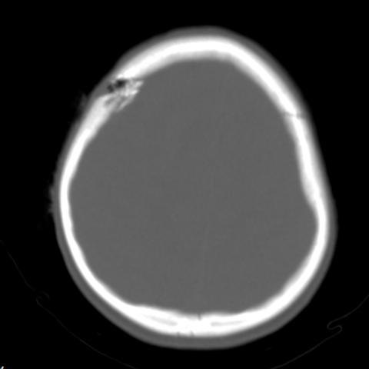
Figure 30 Parietal Fracture
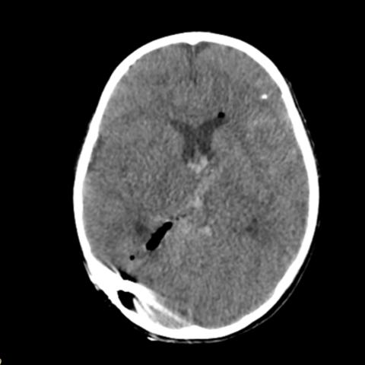
Figure 31 Pneumocephalus
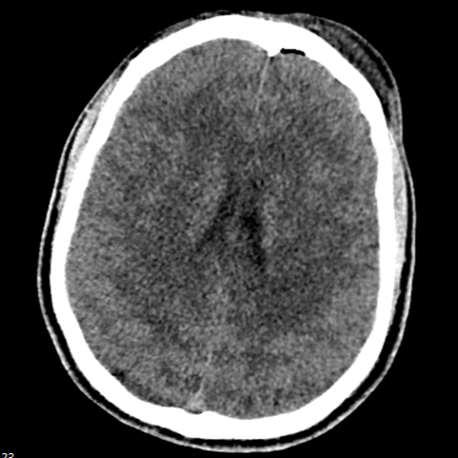
Figure 32 Pneumocephalus
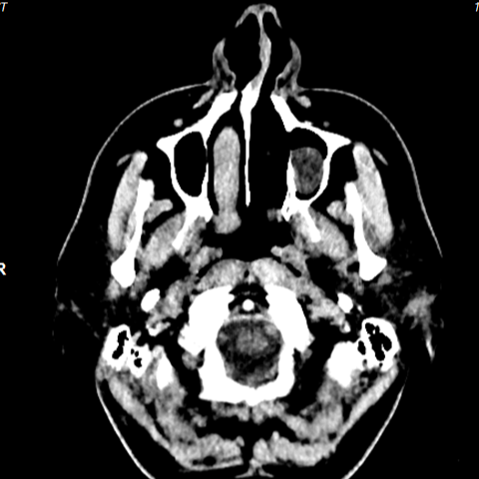
Figure 33 Retention Cyst
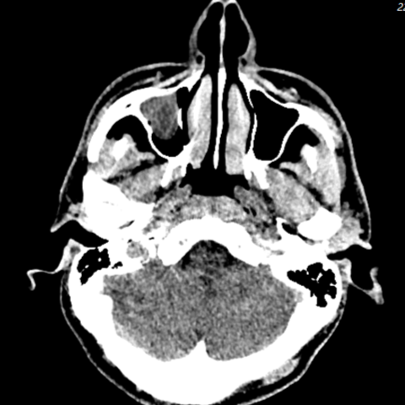
Figure 34 Retention Cyst
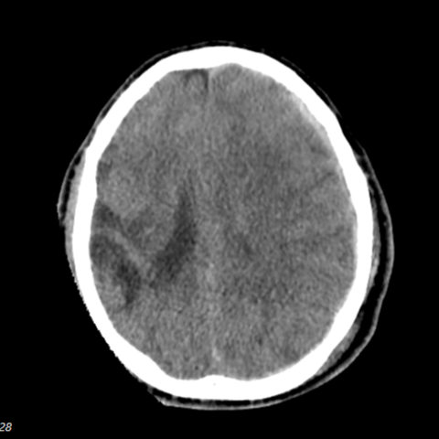
Figure 35 Subarachnoid hemorrhage
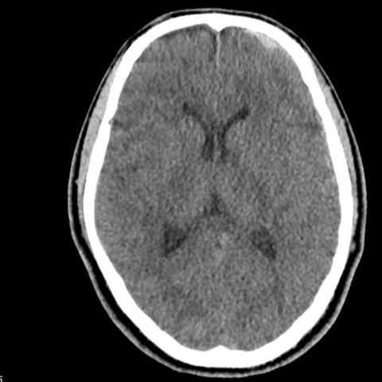
Figure 36 Subarachnoid hemorrhage
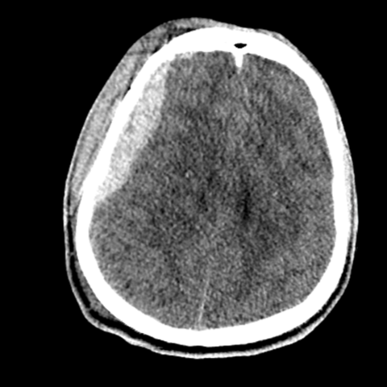
Figure 37 Subdural Hematoma
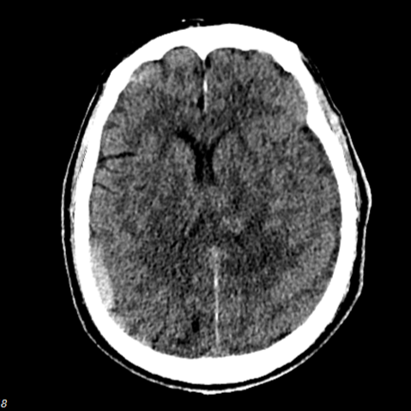
Figure 38 Subdural Hematoma
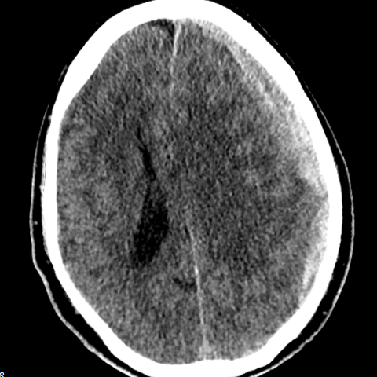
Figure 39 Midline Shift
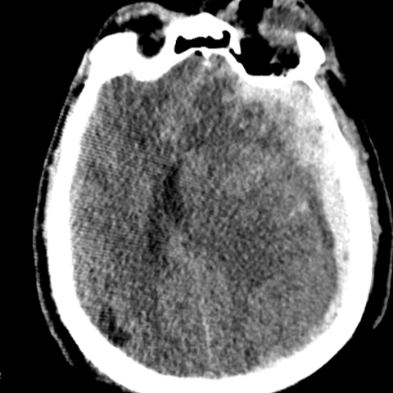
Figure 40 Midline Shift
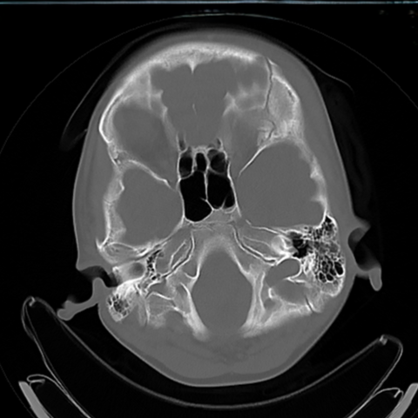
Figure 41 Subpial Hemorrhage
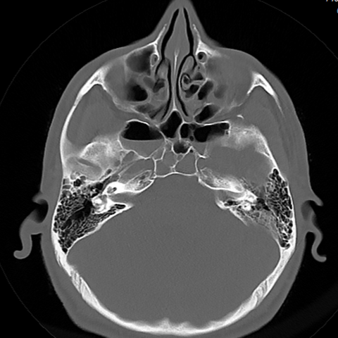
Figure 42 Subpial Hemorrhage
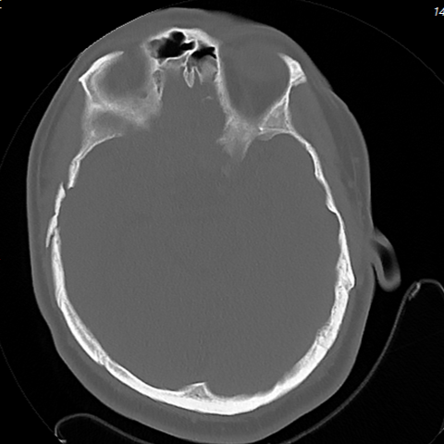
Figure 43 Temporal Fracture
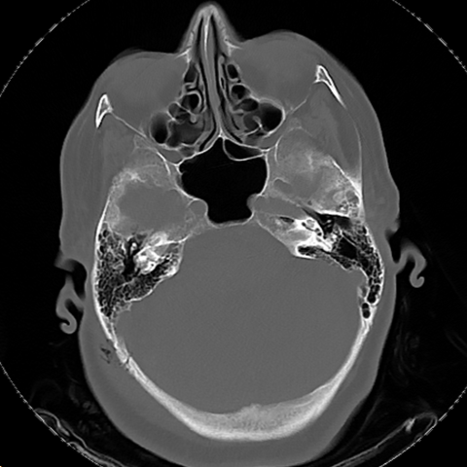
Figure 44 Temporal Fracture
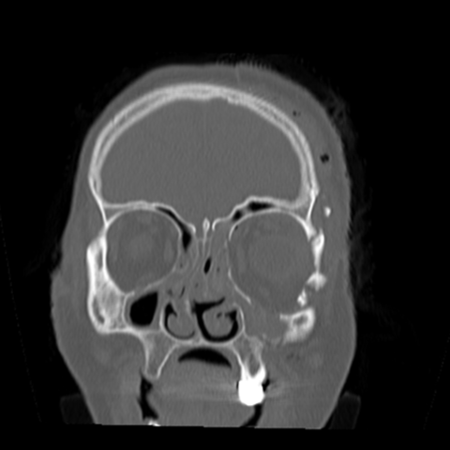
Figure 45 Zygomatic Fracture
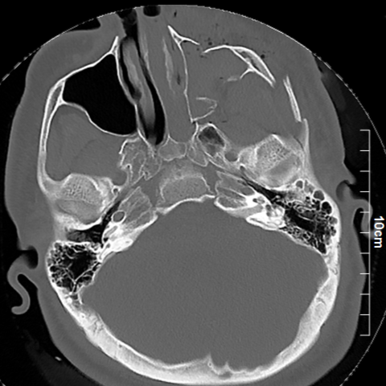
Figure 46 Zygomatic Fracture
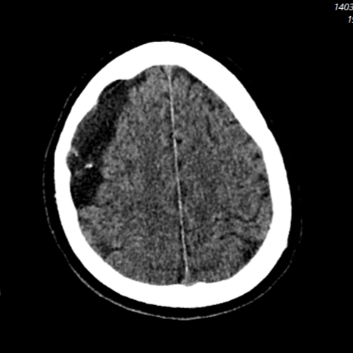
Figure 47 Arachnoid Cyst
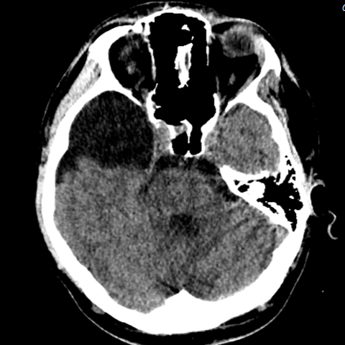
Figure 48 Arachnoid Cyst
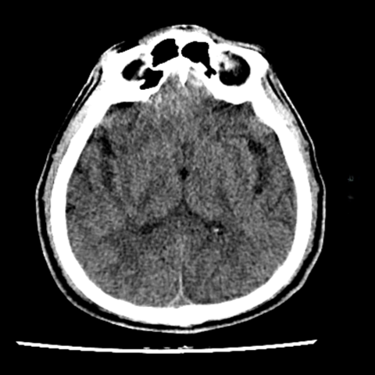
Figure 49 Cerebral Contusion
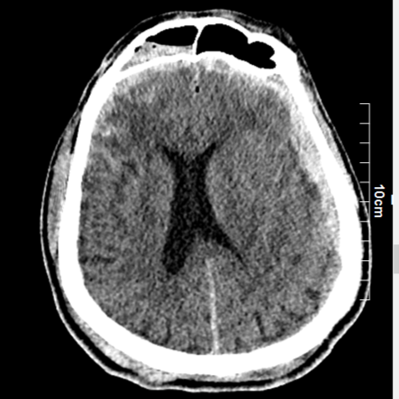
Figure 50 Cerebral Contusion

