Contents
Supplementary notes 1: Study area 2
Supplementary notes 2: Data Assembly 3
2.1. Availability 3
2.1.1. Kenya’s Healthcare system hierarchy 3
2.1.2. Facility inclusion/exclusion 4
2.2. Geographic access 6
2.3. Affordability 6
2.4. Accommodation and Acceptability 7
Supplementary notes 3: Geospatial modelling 10
3.1. Enhanced Two Step Floating Catchment Area (E2SFCA) for Service Availability 10
3.2. Modelling travel time for Geographic Accessibility 10
3.3. Model-based geostatistical (MBG) interpolation for Affordability, Accommodation, and Acceptability 11
3.3.1. Covariates 11
3.3.2. Evidence of spatial autocorrelation 12
3.3.3. MESH 14
3.3.4. Model fitting and interpolation 15
3.3.5. Dasymetric adjustment 15
Supplementary notes 4: Composite score construction 16
4.1. Dimension Outlier Handling and normalisation 16
4.2. Principal Component Analysis 16
4.3. Relationship between travel time, access dimensions and composite access score 17
Supplementary notes 4: Results 18

Supplementary notes 1: Study area
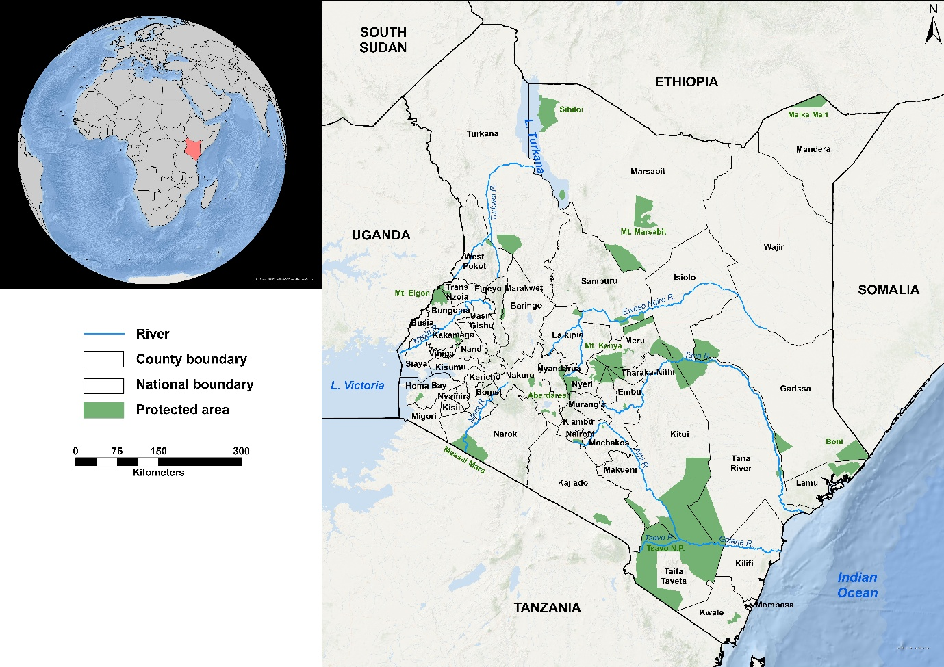
Supplementary Figure 1: Study area map showing the 47 counties in Kenya.

Supplementary notes 2: Data Assembly
This section provides additional details on the data assembly process; data sources and processing steps summarised in the main manuscript.

Availability

Kenya’s Healthcare system hierarchy
Supplementary Table 1: Levels of healthcare service delivery in Kenya
Level | Facility Type | Designated catchments | Services
1 | Community | - | - Promotion of healthier behaviours amongst communities  - Testing services (HIV, Blood sugar, blood pressure, malaria RDT)  - Treatment of minor ailments  - Facilitating referrals
2 | Dispensaries and Clinics | 10,000  population | In addition to all services offered in level 1 facilities  - Basic outpatient diagnostic, medical and rehabilitative services  - Disease prevention and health promotion  - Antenatal and postnatal services  - Pharmacy  - Family Planning
3 | Health Centers | 30,000  population | Offer Basic Emergency obstetric and newborn care (BEmONC) in addition to all services offered in level 2 facilities¹.  Some facilities offer Inpatient services for emergency clients awaiting referral or under observation²
4 | Primary Care facilities | 100,000  population | Offer comprehensive Emergency obstetric and newborn care (CEmONC) and handle referrals from lower-level hospitals¹. Some of the services include²:  - Inpatient services  - Specialised outpatient services  - Blood transfusion services  - Comprehensive inpatient diagnostic, medical, surgical, habilitative and rehabilitative care
5 | Secondary Care facilities | 1,000,000  population
6 | Tertiary Care facilities | National
¹ [1], ² [2]
Health facility data was obtained from a national census of all facilities providing healthcare services in Kenya conducted in August 2023 by the Ministry of Health (MoH) to assess service availability and readiness [3]. The census provides facility‑level data on human resources, equipment, infrastructure, and services.
The complete dataset comprised 12,375 enumerated facilities. Facilities capable of providing inpatient paediatric emergency care based on MoH guidelines were identified [3]. Eligible facilities were required to be public (owned by the government), to have a paediatric ward, a medical officer or paediatrician, a nurse, a paediatric medical or surgical ward, a sluice room, sanitary facilities, inpatient beds (excluding delivery beds), oxygen, and a suction machine. Facilities also had to be classified by the MoH as providing emergency care. Applying these criteria yielded a final analytical sample of 183 public facilities. Supplementary Figure 2 illustrates the inclusion/exclusion process, and Supplementary Figure 3 shows the spatial distribution of the eligible facilities.

Facility inclusion/exclusion
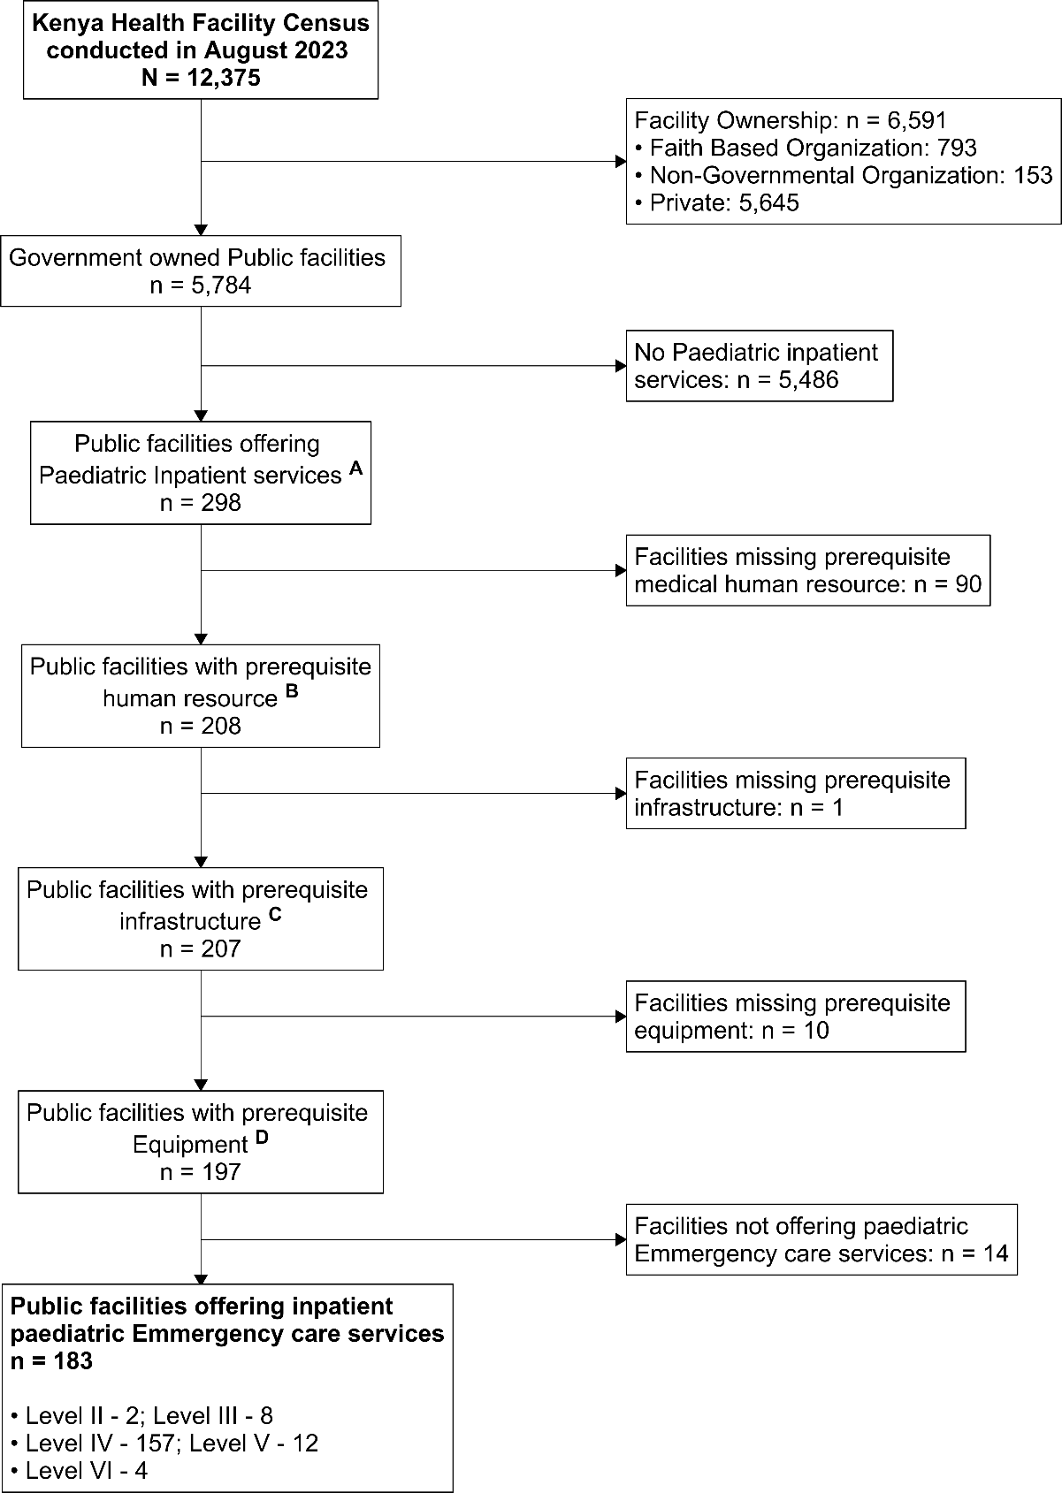
Supplementary Figure 2: Inclusion exclusion criterion.
According to the MoH facility census report, the following are what constitute a facility capable of providing inpatient paediatric care
A – Facilities that have a paediatric ward
B – Facilities that have a medical officer/paediatrician and a nurse
C – Facilities that have either paediatric medical or paediatric surgical ward, sluice room, hand wash basin, toilets/sanitary facilities
D – Facilities with inpatient beds excluding delivery beds, oxygen, suction machine
Facilities were classified based on emergency care provision by MoH using a binary (Yes/No) variable.

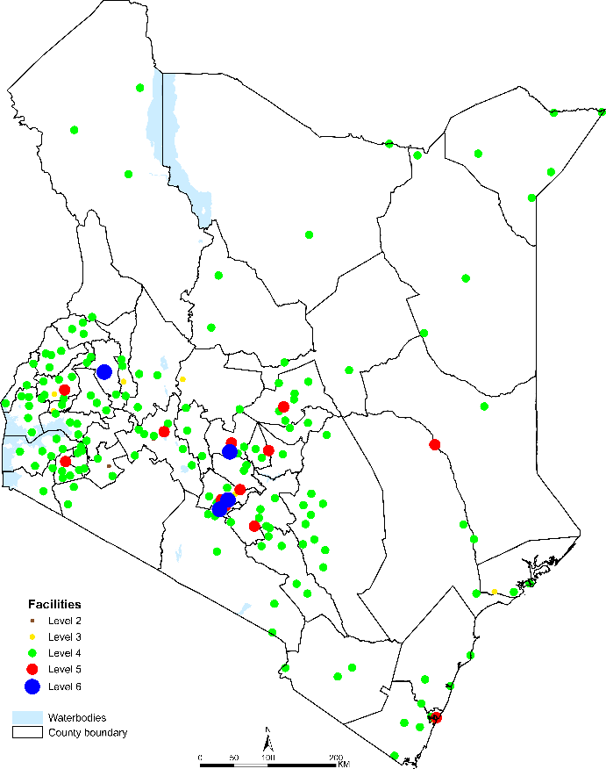
Supplementary Figure 3: Spatial distribution of the 183 eligible public (government-owned) facilities providing inpatient paediatric emergency care in Kenya.

Geographic access
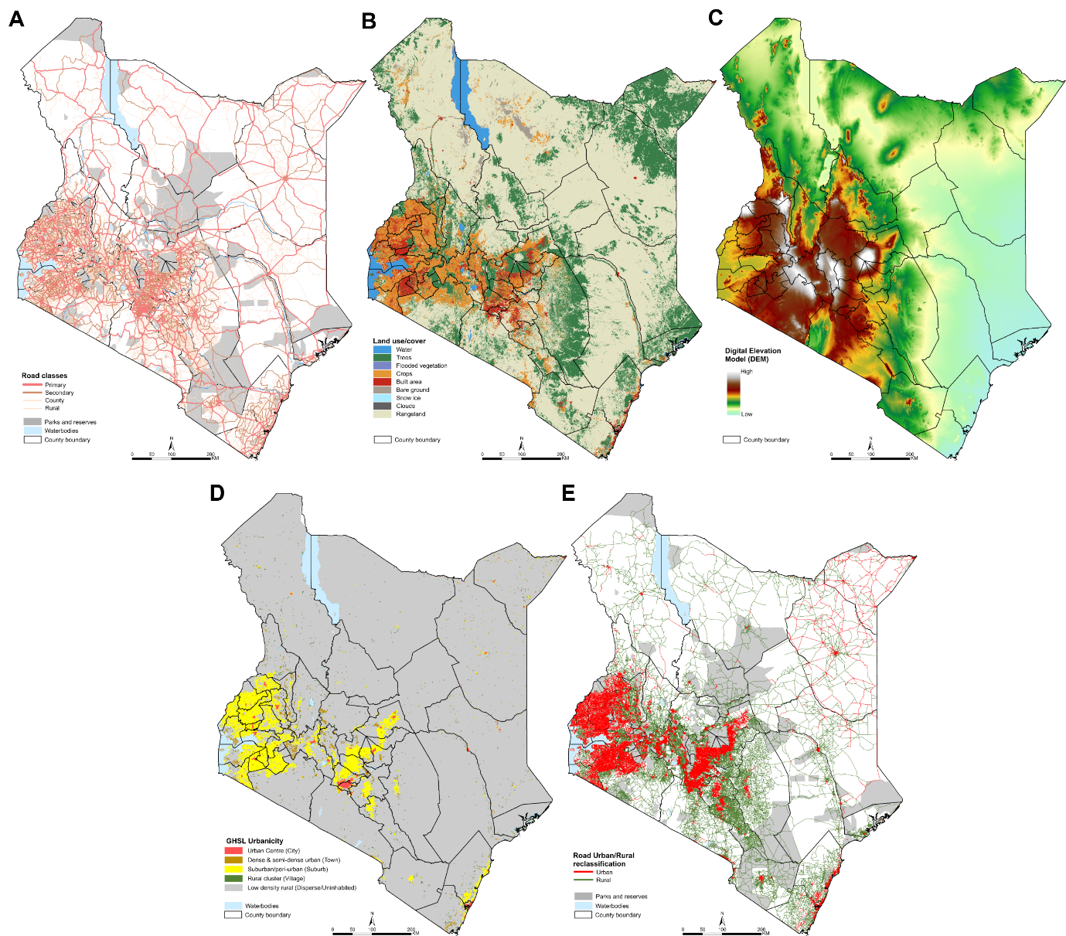
Supplementary Figure 4: Maps showing Panel a) Kenya’s road network and barriers, Panel b) Land use/cover classes across Kenya, Panel c) Elevation across Kenya, Panel d) Global Human Settlement Layer (GHSL) urban/rural index, Panel e) Rural-urban classification of roads.

Affordability
Household survey data on insurance coverage were obtained from the 2022 Kenya Demographic and Health Survey (KDHS) [4]. The KDHS is a nationally representative survey using two‑stage stratified sampling across all 47 counties (1,691 clusters, $≈$25 households per cluster). From the household recode file, a binary indicator of any insurance coverage was created. Cluster‑level summaries (number of insured individuals, total respondents, and proportion insured) were calculated. Cluster geocoordinates were also extracted. Supplementary Figure 5 (Panel a) shows the spatial distribution of clusters and the cluster‑level insurance coverage.

Accommodation and Acceptability
We used the 2010 Kenya Service Provision Assessment (KSPA), a nationally representative survey of facility readiness that also includes caregiver satisfaction exit interviews [5]. For each facility, we extracted caregiver responses on:
- Service organisation (accommodation): satisfaction with waiting times, operation hours, and operation days.
- Service provision (acceptability): satisfaction with privacy, communication, quality of examinations, and staff attitudes.
To bring the 2010 surfaces to more recent levels, we used the 2018 Kenya Household Health Expenditure and Utilisation Survey (KHHEUS), downloaded from the Kenya National Data Archive (KeNADA, https://statistics.knbs.or.ke/nada/index.php/home). The KHHEUS is a nationally representative survey of health‑seeking behaviour, service utilisation, spending, and insurance coverage [6]. It also provides survey‑weighted estimates of satisfaction with service organisation and provision (waiting times, staff courtesy, privacy). Unlike the KDHS, KHHEUS data are released only with cluster identifiers and without cluster coordinates, precluding direct spatial interpolation. Therefore, we obtained county‑level satisfaction summaries. Supplementary Figure 5 maps these county‑level estimates for accommodation and acceptability.
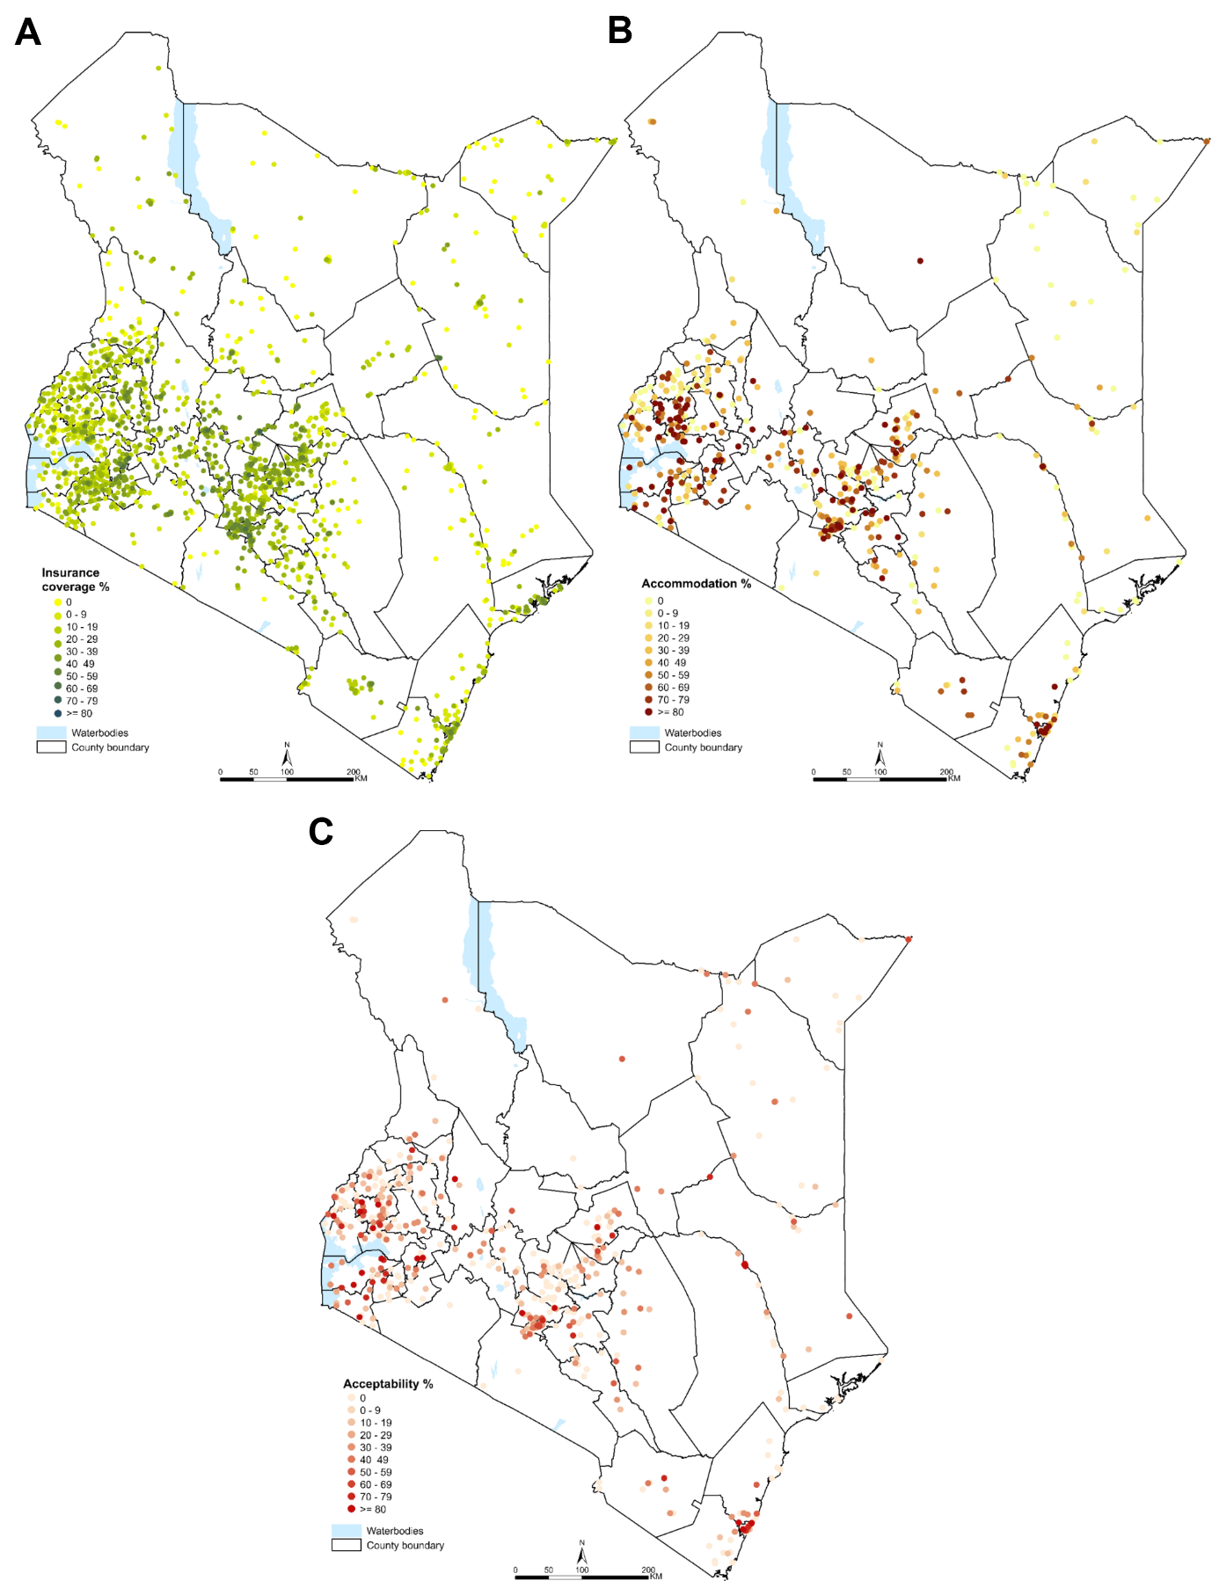
Supplementary Figure 5: Survey data points used for interpolation. Panel a) Affordability - cluster‑level insurance coverage (KDHS 2022). Panel b) Accommodation - facility‑level dissatisfaction with service organisation (KSPA 2010). Panel c) Acceptability - facility‑level dissatisfaction with service provision (KSPA 2010).

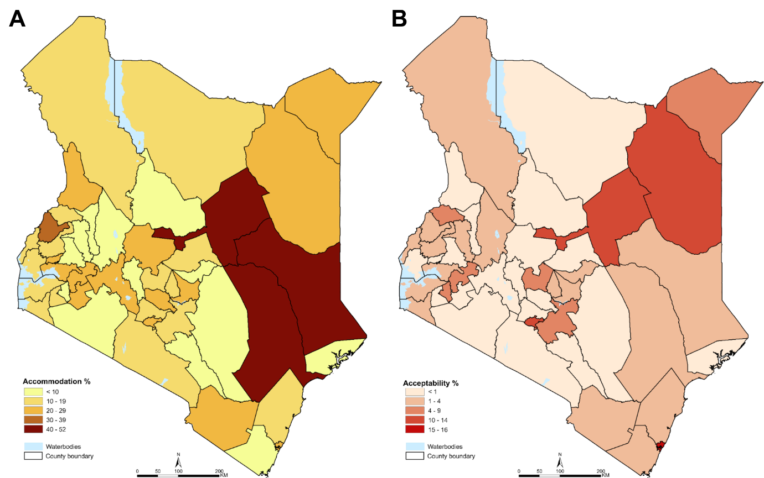
Supplementary Figure 6: County‑level summaries from KHHEUS 2018. Panel a) Satisfaction with service organisation (accommodation). Panel b) Satisfaction with service provision (acceptability).

Supplementary notes 3: Geospatial modelling

Enhanced Two Step Floating Catchment Area (E2SFCA) for Service Availability
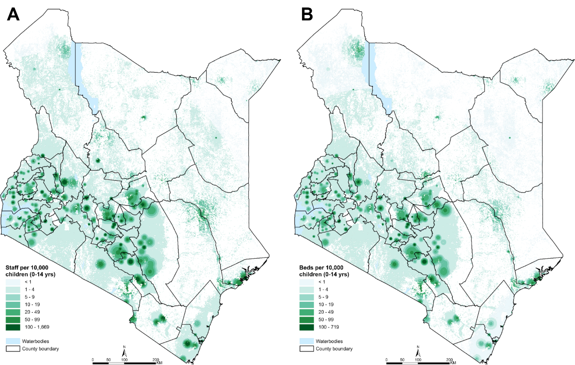
Supplementary Figure 7: Spatial distribution of Panel a) Staff and Panel b) Bed capacity per 10,000 paediatric population (0-14 years).

Modelling travel time for Geographic Accessibility
The following steps were followed to model travel time to the nearest health facility in AccessMod software:
- Friction Surface Creation: The "Merge Land Cover" module in AccessMod was first used to integrate the road, land use/cover, and barriers data into a single friction raster.
- Speed Assignment and Mode-Switching: Travel speeds and modes (walking, cycling, motorcycle, vehicle) were assigned to each road class and land cover type based on established literature [7], as detailed in Supplementary Table 2. To reflect real-world congestion in urban areas, base speeds for roads within urban areas were reduced by 20% [8–11]. The travel scenario assumed a care-seeker follows the pathway of least travel time. On this pathway, the care-seeker’s mode of transport is determined by the underlying land cover (e.g., walking over land use/cover surfaces assigned walking mode, using motorized transport over drivable surfaces), with automatic switching between modes permitted to achieve the fastest route.
- Travel Time Computation and Output: Travel time to the nearest facility was calculated using an anisotropic least-cost path algorithm. This algorithm incorporates the digital elevation model (DEM) to adjust walking speeds for slope according to Tobler's hiking function, while cycling speeds were adjusted using slope-based power correction that limits downhill speed increases to a maximum of twice the flat-surface speed [12,13]. The final output was a raster surface where each pixel value represents the estimated travel time (in minutes) to the closest eligible facility.
Supplementary Table 2: Land cover and road classes and assigned speeds
 | Class | Label | Speed (Km/Hr) | Mode
Land use/cover | 1 | Water | 0.0001 | WALKING
Land use/cover | 2 | Trees | 2.5 | WALKING
Land use/cover | 4 | Flooded vegetation | 0.0001 | WALKING
Land use/cover | 5 | Crops | 2.5 | WALKING
Land use/cover | 7 | Built area | 5 | WALKING
Land use/cover | 8 | Bare ground | 5 | WALKING
Land use/cover | 9 | Snow ice | 0.0001 | WALKING
Land use/cover | 10 | Clouds | 0.0001 | WALKING
Land use/cover | 11 | Rangeland | 4.5 | WALKING
Road classes | 1001 | Primary (rural) | 50 | MOTORIZED
Road classes | 1002 | Secondary (rural) | 30 | MOTORIZED
Road classes | 1003 | County (rural) | 10 | BICYCLING
Road classes | 1004 | Rural (rural) | 5 | WALKING
Road classes | 10012 | Primary (urban) | 40 | MOTORIZED
Road classes | 10022 | Secondary (urban) | 24 | MOTORIZED
Road classes | 10032 | County (urban) | 8 | BICYCLING
Road classes | 10042 | Rural (urban) | 4 | WALKING

Model-based geostatistical (MBG) interpolation for Affordability, Accommodation, and Acceptability
Bayesian Model-based geostatistical interpolation methods were utilised within the stochastic partial differential equations (SPDE) approach and using the Integrated Nested Laplace Approximations in R (R-INLA) [14–16].

Covariates
Covariates known to be associated with insurance coverage and patient satisfaction were assembled (supplementary table 3) [4,5]. For DHS cluster data, covariates were extracted for each cluster in 5km and 2km buffers around rural and urban DHS cluster centroids respectively, as per DHS recommendations [17]. For the KSPA data, the location of the facility was used to extract the urbanisation index whereas data on the caregiver education years were averaged per facility based on the details of the interviewed caregivers.
Supplementary Table 3: Summary of assembled covariates
Covariate | Source | Dimension used for
Urbanisation | Global Human Settlement Layer (GHSL) (Pesaresi et al., 2024) | Affordability  Accommodation  Acceptability
Female population | WorldPop (Tatem, 2017) | Affordability
Nighttime light | Defense Meteorological Satellite Program (DMSP) Operational Linescan System (OLS) | Affordability
Education years | Institute for Health Metrics and Evaluation (IHME) | Accommodation  Acceptability

Evidence of spatial autocorrelation
Prior to MBG interpolation, existence of spatial autocorrelation was first investigated by fitting semi-variograms [18]. Let $y_{i}$ be the observed number of individuals at cluster/facility $i$ with the assembled survey characteristic, $n_{i}$ be the total number of individuals in cluster/facility $i$, and $p_{i}$ the probability of observing the survey characteristic in cluster/facility $i$. The following model was fitted.
$$y_{i}\sim Binomial\left(n_{i},p_{i}\right)$$
$$\begin{aligned}logit\left(p_{i}\right)=β_{0}+βX+ϵ_{i}\#\left(1\right)\end{aligned}$$
where $β_{o}$ is the intercept, $X$ is the vector of covariates, $β$ the corresponding covariate coefficients, and $ϵ_{i}$ are random effects defined as i.i.d Gaussian processes to hypothesize negligible or lack thereof of spatial autocorrelation within the observed data implying no structured patterns would be observed in the model residuals. After model fitting, the model residuals were then used to fit empirical variograms (supplementary figure 8). Evidence of spatial autocorrelation was observed across the models. Notably, for accommodation and acceptability, spatial autocorrelation was weak.

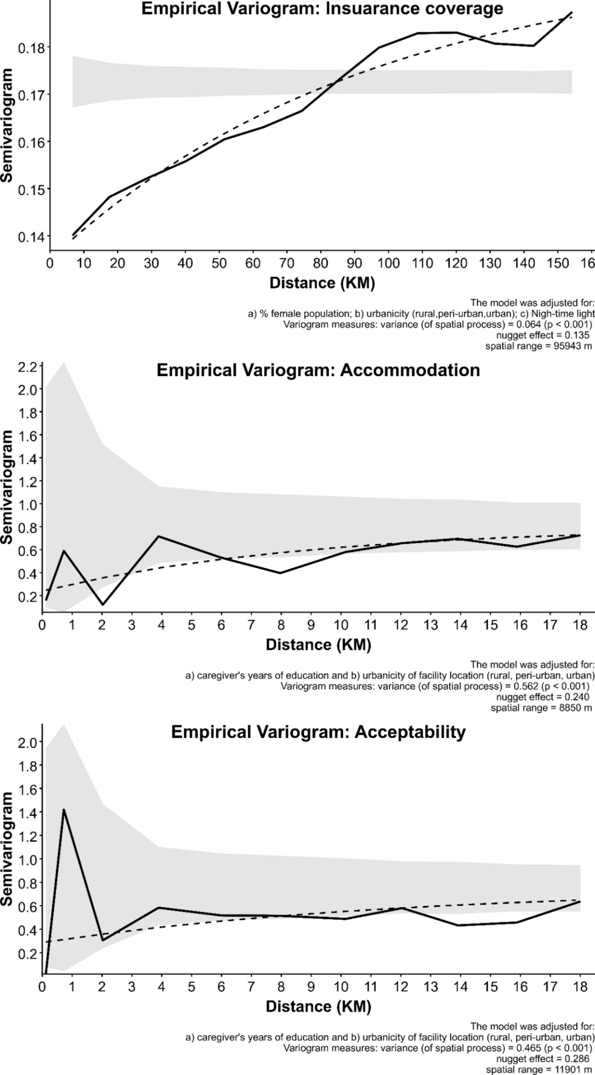
Supplementary Figure 8: Evidence of spatial autocorrelation and related variogram measures Panel a) Insurance coverage, Panel b) Satisfaction with service organization, Panel c) Satisfaction with service provision.

MESH
The stochastic partial differential equations (SPDE) approach requires a finite representation of the underlying continuous Gaussian field, defined by a Matèrn covariance function, using a discretised Gaussian Markov Random Field (GMRF) [19]. This discretization is implemented by constructing a triangulated mesh over the study area, which discretises the spatial process onto the mesh vertices. This discretization allows us to leverage the computational advantages of a GMRF while approximating the desired Matèrn covariance structure [19]. The MESH for each of the point datasets was created based on the theoretical ranges obtained from the variograms with the vertices lengths set within a fifth and tenth of the ranges (Supplementary Figure 9).
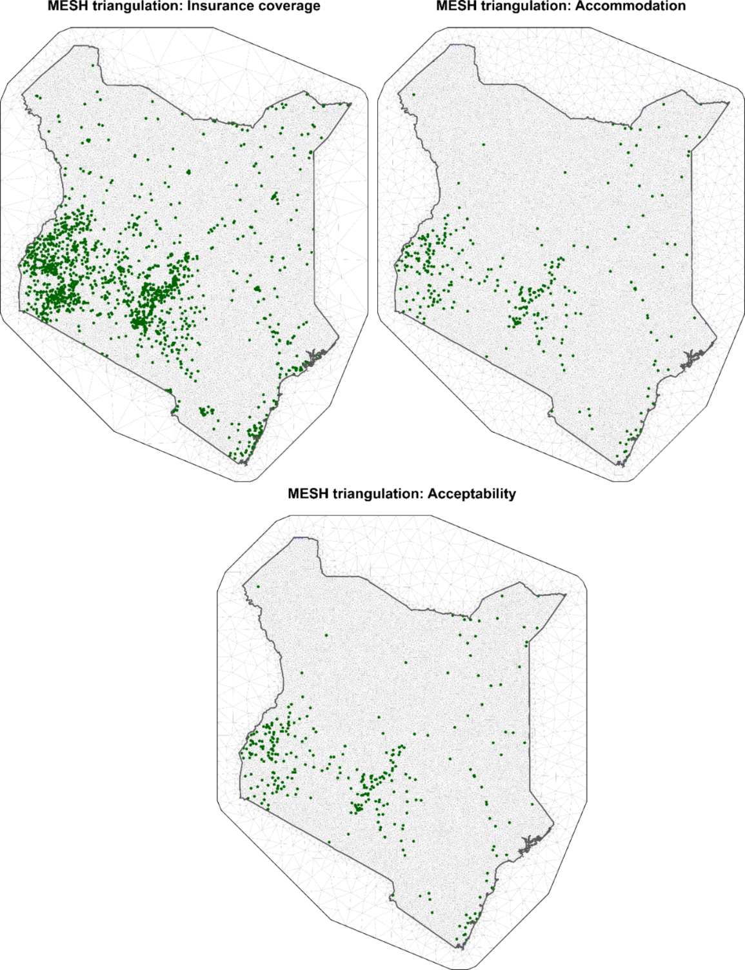
Supplementary Figure 9: MESH used for the Model-Based Geostatistical interpolation. Green dots show location of sampled points.

Model fitting and interpolation
The Matèrn covariance structure was applied to the MESH to define structured spatial random effects. Specifically, Penalized Complexity (PC) priors were specified for the Matèrn covariance structure to regularize the model and prevent overfitting [20]. We set conservative prior probability of 0.9 that the spatial range was less than the ranges defined by the respective variograms (Supplementary Figure 8), which allows for a simpler model favouring shorter-range dependence but is weakly informative enough to be updated by the data should stronger evidence for longer-range correlation exist. Similarly, standard deviation parameter PC prior of the spatial field was set not exceeding those from the respective variograms.

Dasymetric adjustment
To adjust the 2010 KSPA accommodation and acceptability surfaces to 2018 levels, a dasymetric logit-space adjustment using county-level survey-weighted summaries from the 2018 KHHEUS was employed. This method preserves the fine-scale spatial patterns of the original 1 km geostatistical surfaces while ensuring that the county means of the adjusted rasters match the 2018 targets, avoiding the crude approach of assigning uniform county values to all pixels. Simple additive shifts on the probability scale risk violating the [0,1] bounds, and multiplicative shifts distort variance and cannot handle zero values. Working in logit space circumvents these issues: the logit transformation, $logit\left(p\right)=ln\left(\frac{p}{1-p}\right)$, maps probabilities to the real line for natural additive shifts, with logistic back-transformation guaranteeing valid (0,1) output.
For each county $c$ and dimension, we solved for a constant shift $δ_{c}$, such that after adding $δ_{c}$ to the logit of all pixels in the county and back-transforming, the average of the resulting values equals the 2018 target ${\overset{ˉ}{p}}_{c,2018}$:
$$(\frac{1}{n_{c}}) \sum_{i∈c}{\left[\frac{1}{1+e^{-\left(logit\left(p_{i}^{2010}\right)+δ_{c}\right)}}\right]} = {\overline{p}}_{c}^{2018}$$
The left-hand side is strictly increasing in $δ_{c}$, ensuring a unique solution exists. The shifts were computed numerically using R’s uniroot() function over the interval $\left[\text{‑}10 , 10\right]$, which comfortably spans all plausible values (e.g., $\text{logit}({10}^{-4})≈-9.2$, $\text{logit}(0.9999)≈+9.2$), with a tolerance of ${10}^{-6}$ to ensure negligible error in the county means. This approach yields updated 1 km surfaces of accommodation and acceptability dimensions that incorporate the more recent survey information while retaining the original within-county spatial heterogeneity.

Supplementary notes 4: Composite score construction

Dimension Outlier Handling and normalisation
Each of the five access dimensions was extracted as 1 km × 1 km rasters on different scales. Outliers were addressed using robust Weibull winsorisation [21], followed by min‑max normalization with polarity correction, yielding scores where 1 represents optimal access.
Raw dimension values were first winsorised using quantiles from a Weibull distribution fitted robustly for each dimension based on the median and 75th percentile, which are insensitive to outliers [21]. Cutoffs were set at the 3rd and 97th percentiles of the fitted distribution. For each tail, the most extreme values (outliers) were replaced using rank‑preserving Weibull quantiles drawn from a probability grid extending from the cutoff down to the 0.1st percentile (left tail) and up to the 99.9th percentile (right tail). Final winsorised values were capped to each dimension’s original observed range to prevent artificial range expansion. The winsorised values were then normalized using min‑max scaling with polarity adjustment; Equation 1 for dimensions with positive polarity and Equation 2 for dimensions with negative polarity.
$$\begin{aligned}\hat{x_{j}}(u)=\frac{x_{j}(u)-\min\left(x_{j}\right)}{\max\left(x_{j}\right)-\min\left(x_{j}\right)} \#(1\end{aligned})$$
$$\begin{aligned}\hat{x_{j}}(u)=\frac{\max\left(x_{j}\right)- x_{j}\left(u\right)}{\max\left(x_{j}\right)-\min\left(x_{j}\right)} \#(2)\end{aligned}$$
where $\hat{x_{j}}(u)$ and $x_{j}(u)$ denote the normalised and raw scores, respectively, for dimension $j$ at pixel $u$; $\max\left(x_{j}\right)$ and $min⁡(x_{j})$ are the maximum and minimum values of dimension j across the study area.

Principal Component Analysis
For model calibration in the Geographically Weighted Principal Component Analysis (GWPCA), the global PCA was first computed. The winsorised dimension scores were standardised to z‑scores (mean = 0, variance = 1) and utilised in the 'princomp' function in base R. The first two components were selected based on the Kaiser–Guttman criterion (eigenvalue > 1) to construct global PCA weights for use in the sensitivity analysis.
Unlike the global PCA, GWPCA calculates PCA weights for each pixel based on its neighbourhood. Consequently, a neighbourhood specification is required in performing GWPCA [22]. Here, cross validation was done for an adaptive bandwidth selection to balance between capturing local variation (small bandwidths) and over smoothing (large bandwidths) of the estimates [22,23]. The GWPCA was implemented with a gaussian kernel function in R within the GWmodel library package [24]. The results of the GWPCA were a set of five-dimension weights at each 1 km × 1 km pixel.

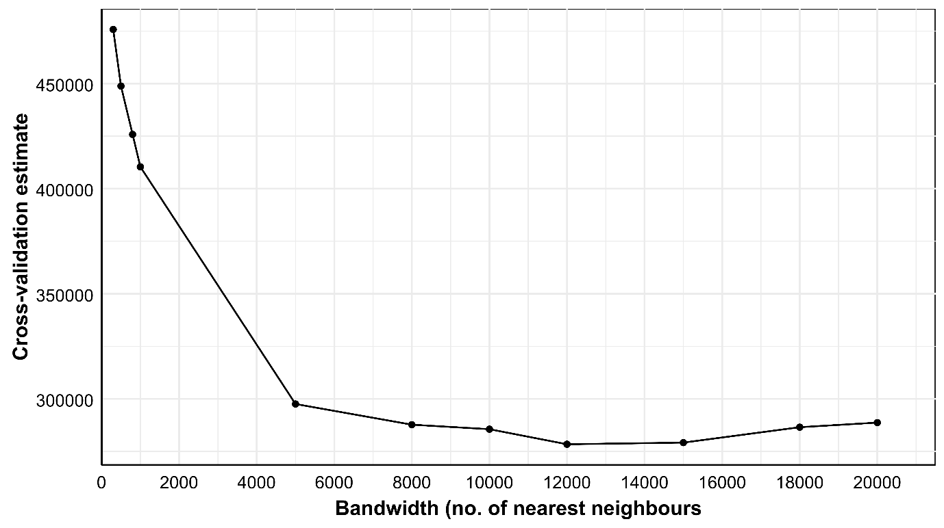
Supplementary Figure 10: Cross-validation results for bandwidth selection. The bandwidth that was selected was 12000 neighbours.

Relationship between travel time, access dimensions and composite access score
Associations between travel time and the four non-geographic dimensions was assessed using generalized additive models (GAMs) with cubic regression splines for travel time. Each dimension was modelled on its normalized [0-1] scale (higher = better access), with smoothness selected via restricted maximum likelihood (REML) and basis dimension $k=10$ to balance flexibility and overfitting risk [25]. The GAM output includes a smooth term (effective degrees of freedom, EDF) interpreted as follows: an EDF of 1 indicates a linear relationship, an EDF less than 2 indicates weak non‑linearity, and an EDF greater than 2 indicates strong non‑linearity. Predicted means and 95% confidence intervals were generated across the observed travel time range.
To quantify the deficits that a travel-time-only approach would overlook, analysis was restricted to pixels with travel time ≤ 60 minutes (the “golden hour”). Within this subset, pixels were divided into lowest (Q1) and highest (Q4) composite access score quartiles. Empirical cumulative distribution functions (ECDFs) compared normalised distributions of each non-geographic dimension between Q1 and Q4. If travel time alone were sufficient, the two groups would show similar distributions; conversely, marked differences would confirm that even among geographically proximate areas, multidimensional access varies widely. In addition, we summarised county‑level travel times and composite scores to investigate how many counties classified as having “good” geographic access would be misclassified as having good overall access when, in fact, they suffer from severe deficits in other dimensions.

Supplementary notes 4: Results
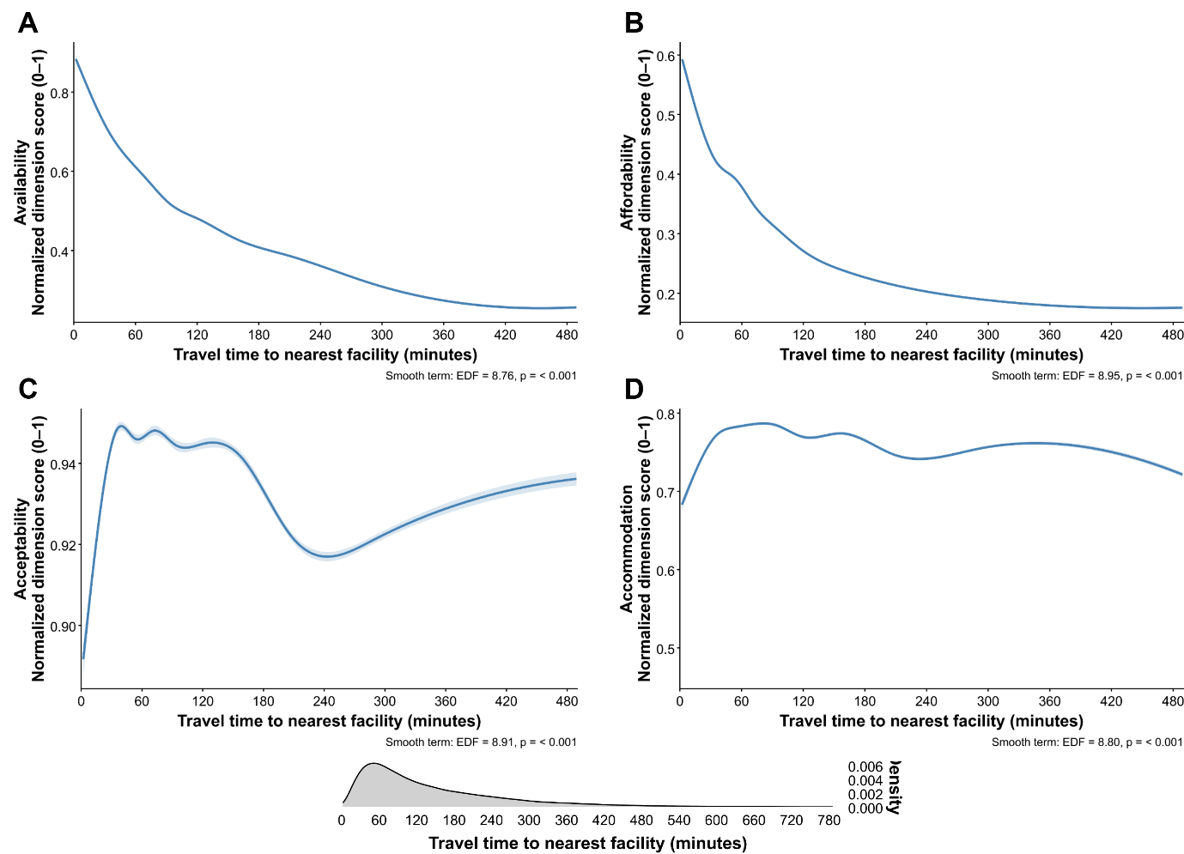
Supplementary Figure 11: Association of the dimensions (normalised scale; 0 = poor, 1 = best) with travel time to the nearest facility from GAM model. The y-axis has been varied across the plots to show small dips/troughs for each dimension. The 95% confidence intervals (shaded ribbons) are extremely narrow due to the large sample size. The density plot shows the sample sizes (number of pixels) across travel time. The plots have been trimmed to 480 minutes as this represent 98% of the pixels.

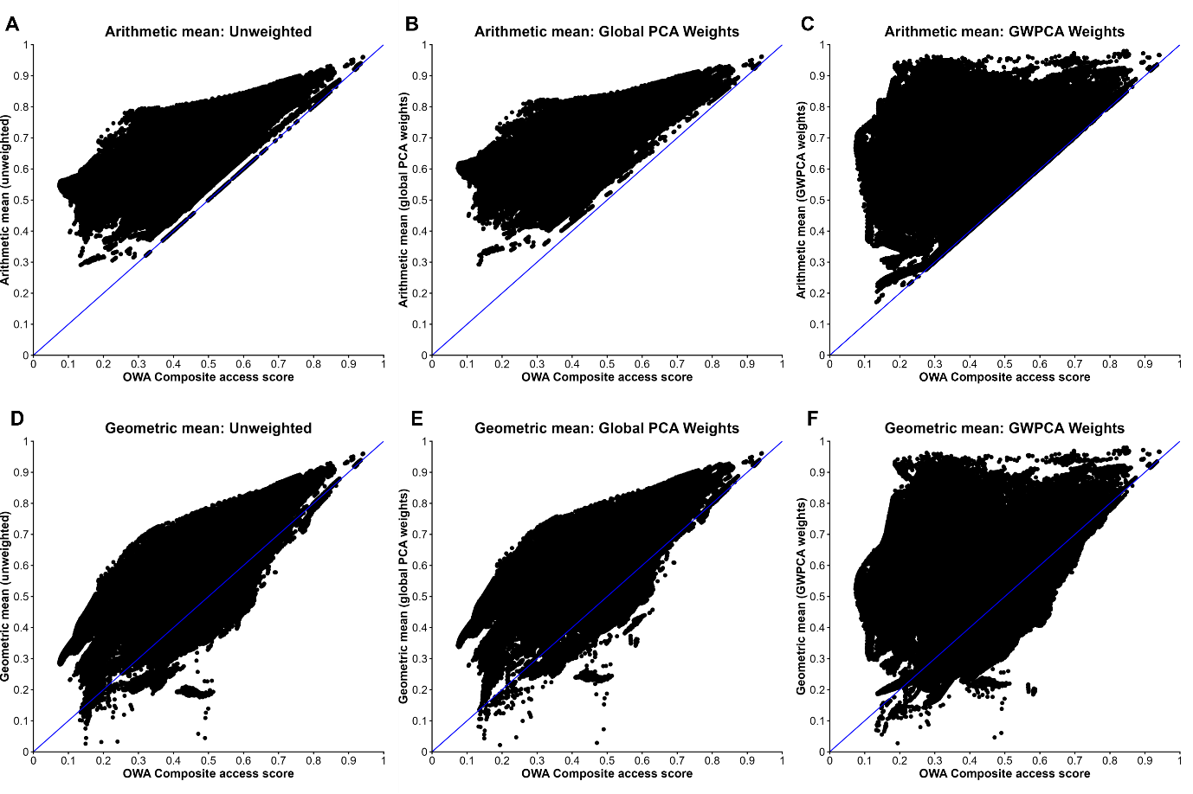
Supplementary Figure 12: Sensitivity analysis. Dot-plots for arithmetic (Panels A-C) and geometric mean (Panels C-D) against Ordered Weighted Averaging (OWA). The blue line represent the line of equality.

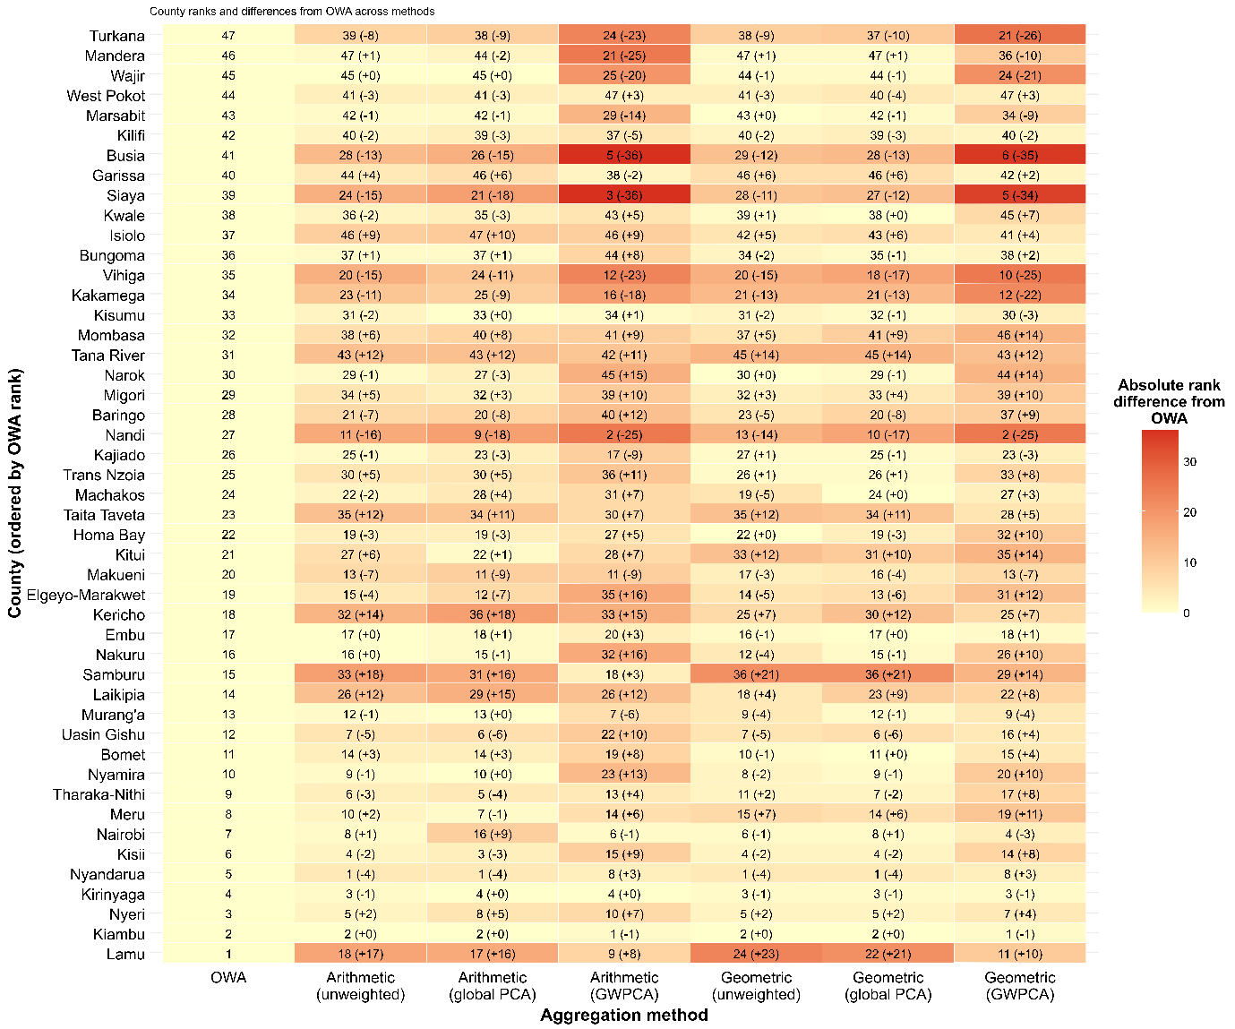
Supplementary Figure 13: Sensitivity analysis on county ranking by the different aggregation-weighting methods. The counties (y-axis) have been sorted according to the OWA composite score; Lamu = highest access and Turkana = lowest access. The shades are as per the difference in ranking of counties by other methods compared to OWA.

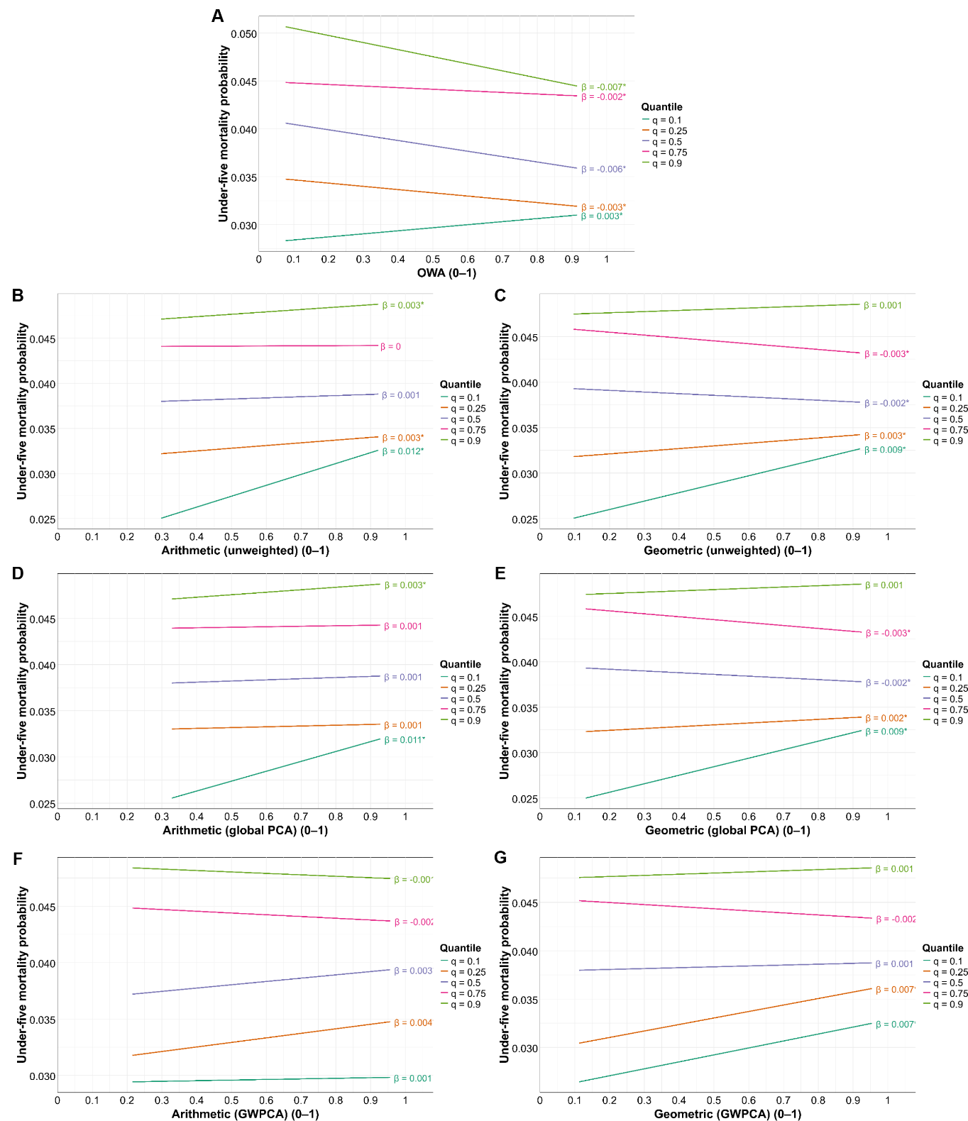
Supplementary Figure 14: Validation analysis. Quantile regression lines and associated coefficient estimates for Ordered Weighted Averaging (OWA) (Panel A), arithmetic (Panels B, D, F) and geometric mean (Panels C, E, G) against under-five mortality probability. Coefficient values with an asterisk were statistically significant at 95% confidence interval.

References
- Ouma PO, Maina J, Thuranira PN, Macharia PM, Alegana VA, English M, et al. Access to emergency hospital care provided by the public sector in sub-Saharan Africa in 2015: a geocoded inventory and spatial analysis. Lancet Glob Health. Elsevier Ltd; 2018;6:e342–50. https://doi.org/10.1016/S2214-109X(17)30488-6
- Ministry of Health (MoH). Kenya Health Sector Strategic Plan. 2018. http://guidelines.health.go.ke:8000/media/Kenya_Health_Sector_Strategic_Plan_July_2018-_June_2023.pdf. Accessed 8 Nov 2025
- Ministry of Health (MoH). Kenya health facility census report. 2023. https://www.health.go.ke/sites/default/files/2024-01/Kenya%20Health%20Facility%20Census%20Report%20September%202023.pdf. Accessed 12 Nov 2025.
- KNBS, ICF. Kenya Demographic and Health Survey 2022: Volume 1. 2023. https://www.knbs.or.ke/download/kenya-dhs-2022-main-report-volume-1/ Accessed 22 Jan 2026
- National Coordinating Agency for Population and Development (NCAPD) [Kenya], Ministry of Medical Services (MOMS) [Kenya], Ministry of Public Health and Sanitation (MOPHS) [Kenya], Kenya National Bureau of Statistics (KNBS) [Kenya], ICF Macro. Kenya Service Provision Assessment Survey 2010 [SPA17]. Nairobi;. 2010. https://dhsprogram.com/pubs/pdf/SPA17/SPA17.pdf Accessed 15 Feb 2026
- Kenya national bureau of statistics (KNBS). Kenya household and health expenditure and utilization survey (KHHEUS) 2018 report. Kenya national bureau of statistics (KNBS). 2018. https://statistics.knbs.or.ke/nada/index.php/catalog/95 Accessed 10 Feb 2026
- Robert BN, Muchiri SK, Kahoro EW, Hindada BH, Kiarie H, Okiro EA, Macharia PM. Impact analysis of flood-induced changes in geographical accessibility and coverage to healthcare in both public and private sector, 2024, Kenya. International Journal of Health Geographics. 2026 Mar 18.
- Ahmed S, Adams AM, Islam R, Hasan SM, Panciera R. Impact of traffic variability on geographic accessibility to 24/7 emergency healthcare for the urban poor: A GIS study in Dhaka, Bangladesh. Wilson FA, editor. PLoS One . Public Library of Science (PLoS); 2019;14:e0222488. https://doi.org/10.1371/journal.pone.0222488b
- Mutono N, Wright JA, Mutunga M, Mutembei H, Thumbi SM. Impact of traffic congestion on spatial access to healthcare services in Nairobi. Frontiers in Health Services. 2022;2:788173. https://doi.org/10.3389/frhs.2022.788173
- Fraser MS, Wachira BW, Flaxman AD, Lee AY, Duber HC. Impact of traffic, poverty and facility ownership on travel time to emergency care in Nairobi, Kenya. African Journal of Emergency Medicine. 2020;10:40-5. https://doi.org/10.1016/j.afjem.2019.12.003
- Macharia PM, Wong KL, Olubodun T, Beňová L, Stanton C, Sundararajan N, et al. A geospatial database of close-to-reality travel times to obstetric emergency care in 15 Nigerian conurbations. Sci Data. 2023;10:736. https://doi.org/10.1038/s41597-023-02651-9
- Ray N, Ebener S. AccessMod 3.0: computing geographic coverage and accessibility to health care services using anisotropic movement of patients. Int J Health Geogr. Springer Nature; 2008;7:63.
- Macharia PM, Mumo E, Okiro EA. Modelling geographical accessibility to urban centres in Kenya in 2019. PLoS One. Public Library of Science (PLoS); 2021;16:e0251624.
- Rue H, Martino S, Chopin N. Approximate Bayesian inference for latent Gaussian models by using integrated nested Laplace approximations. J. R. Statist. Soc. B. 2009; 2:319‑92.
- Rue H, Riebler A, Sørbye SH, Illian JB, Simpson DP, Lindgren FK. Bayesian Computing with INLA: A Review. Annu Rev Stat Appl . Annual Reviews; 2017;4:395–421. https://doi.org/10.1146/annurev-statistics-060116-054045
- Martins TG, Simpson D, Lindgren F, Rue H. Bayesian computing with INLA: New features. Comput Stat Data Anal [Internet]. Elsevier BV; 2013;67:68–83. https://doi.org/10.1016/j.csda.2013.04.014
- Perez-Heydrich C, Warren JL, Burgert CR, Emch ME. Influence of demographic and health survey point displacements on raster-based analyses. Spatial demography. 2016 Jul;4(2):135-53.
- Bohling G. Introduction to geostatistics and variogram analysis. Earth. 2005.
- Lindgren F, Rue H, Lindström J. An explicit link between Gaussian fields and Gaussian Markov random fields: the stochastic partial differential equation approach. J. R. Statist. Soc. B. 2011.
- Fuglstad GA, Simpson D, Lindgren F, Rue H. Constructing Priors that Penalize the Complexity of Gaussian Random Fields. J Am Stat Assoc. 2019;114. https://doi.org/10.1080/01621459.2017.1415907
- Boudt K, Todorov V, Wang W. Robust Distribution-Based Winsorization in Composite Indicators Construction. Soc Indic Res. Springer; 2020;149:375–97. https://doi.org/10.1007/s11205-019-02259-w
- Harris P, Brunsdon C, Charlton M. Geographically weighted principal components analysis. International Journal of Geographical Information Science. 2011;25:1717‑36. https://doi.org/10.1080/13658816.2011.554838
- Harris P, Clarke A, Juggins S, Brunsdon C, Charlton M. Enhancements to a geographically weighted principal component analysis in the context of an application to an environmental data set. Geogr Anal. 2015;47:146‑72. https://doi.org/10.1111/gean.12048
- Gollini I, Lu B, Charlton M, Brunsdon C, Harris P. Gwmodel: An R package for exploring spatial heterogeneity using geographically weighted models. J Stat Softw. 2015;63. https://doi.org/10.18637/jss.v063.i17
- Wood SN. Inference and computation with generalized additive models and their extensions. Test. 2020;29. https://doi.org/10.1007/s11749-020-00711-5

