Electronic Supplementary Material
For submission to Earth Science Informatics
Supporting information for the manuscript

Contents
- Supplementary Figure S1. Elevation and slope maps used for groundwater potential modelling
- Supplementary Figure S2. Geological and lithological maps of Zimbabwe
- Supplementary Figure S3. Drainage density and lineament density maps
- Supplementary Figure S4. Average annual rainfall and Topographic Wetness Index (TWI)
- Supplementary Figure S5. Soil texture and Normalized Difference Vegetation Index (NDVI)
- Supplementary Figure S6. Land Use/Land Cover (LULC) and Evapotranspiration (ET)
- Supplementary Figure S7. Monthly rainfall and terrestrial water storage anomaly time series (2002–2020)
- Supplementary Table S1. Groundwater conditioning factors, data sources and spatial resolution

Supplementary Figure S1
Elevation and slope maps used for groundwater potential modelling.
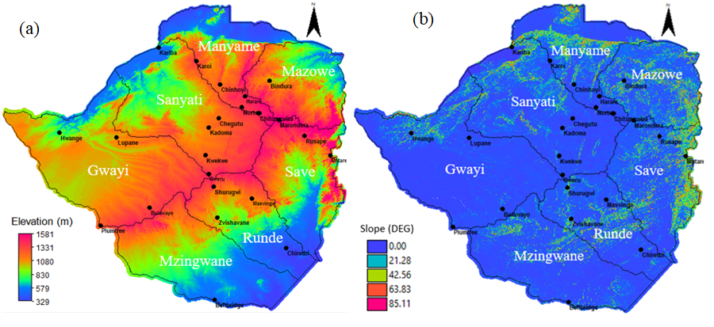

Supplementary Figure S2
Geological and lithological maps of Zimbabwe.
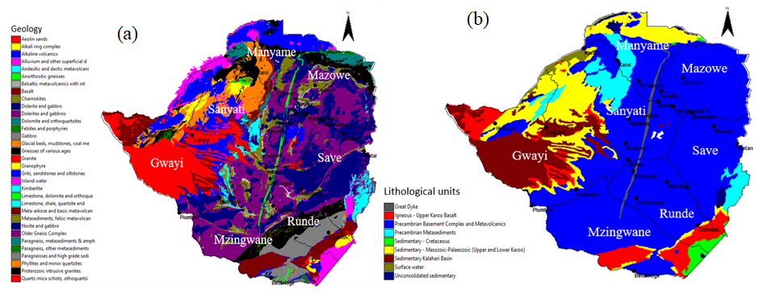

Supplementary Figure S3
Drainage density and lineament density maps.
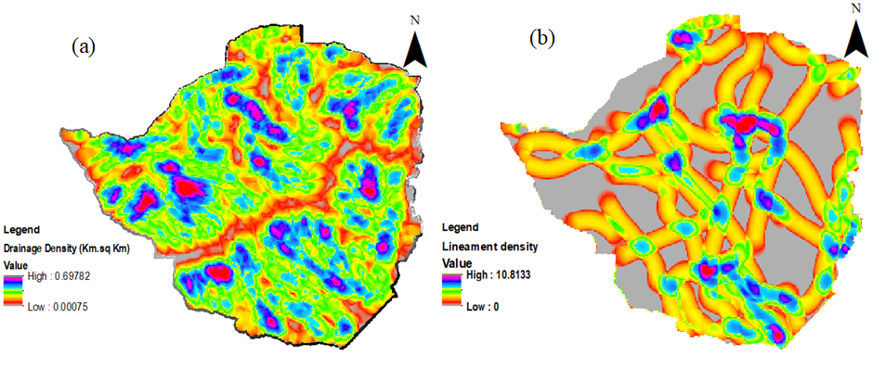

Supplementary Figure S4
Average annual rainfall and Topographic Wetness Index (TWI).
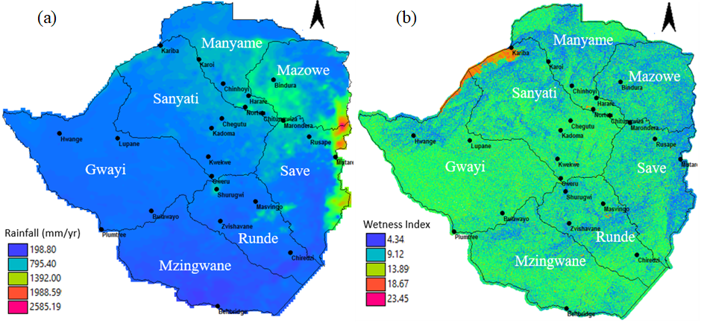

Supplementary Figure S5
Soil texture and NDVI.
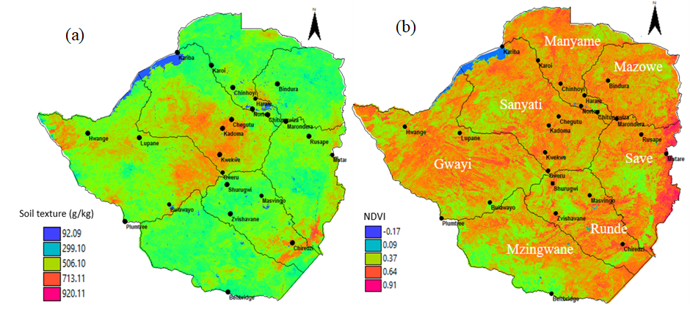

Supplementary Figure S6
Land Use/Land Cover (LULC) and Evapotranspiration (ET).
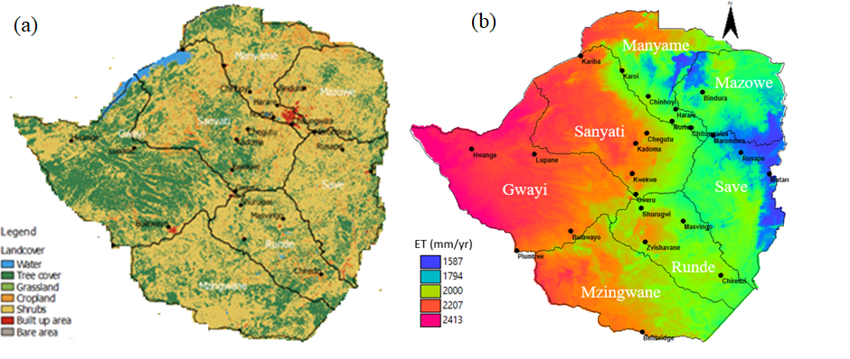

Supplementary Figure S7
Monthly rainfall and terrestrial water storage anomaly time series (2002–2020).
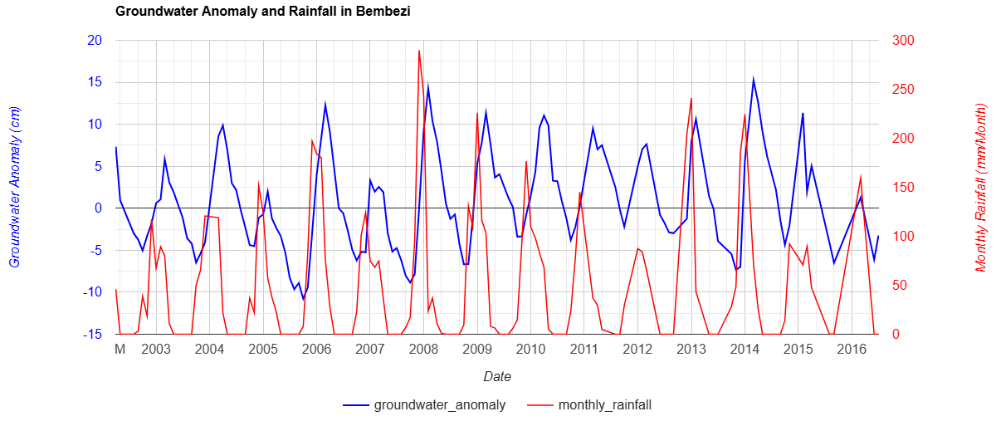
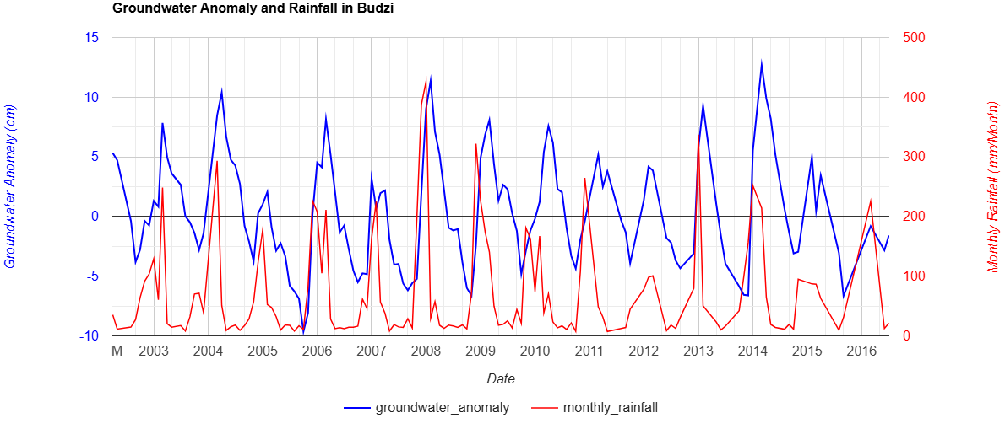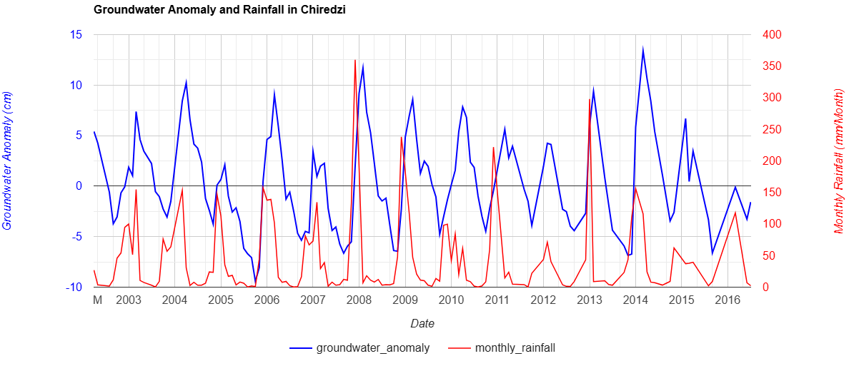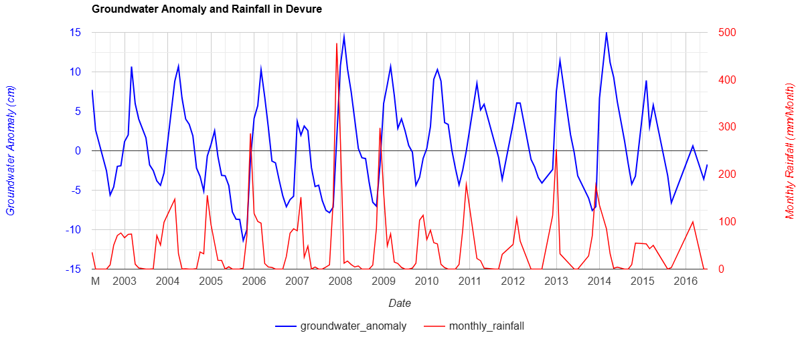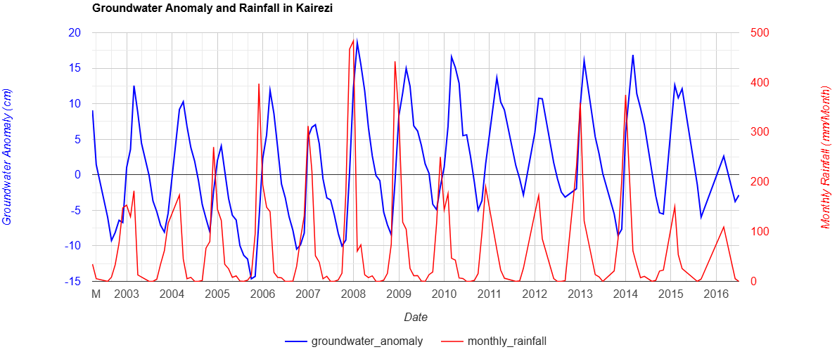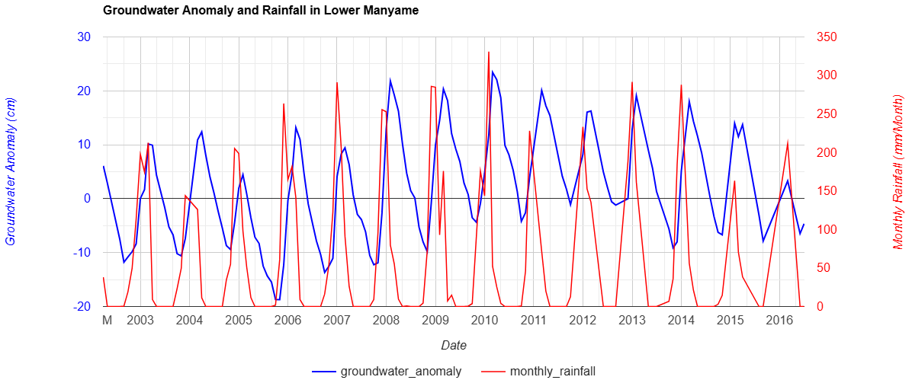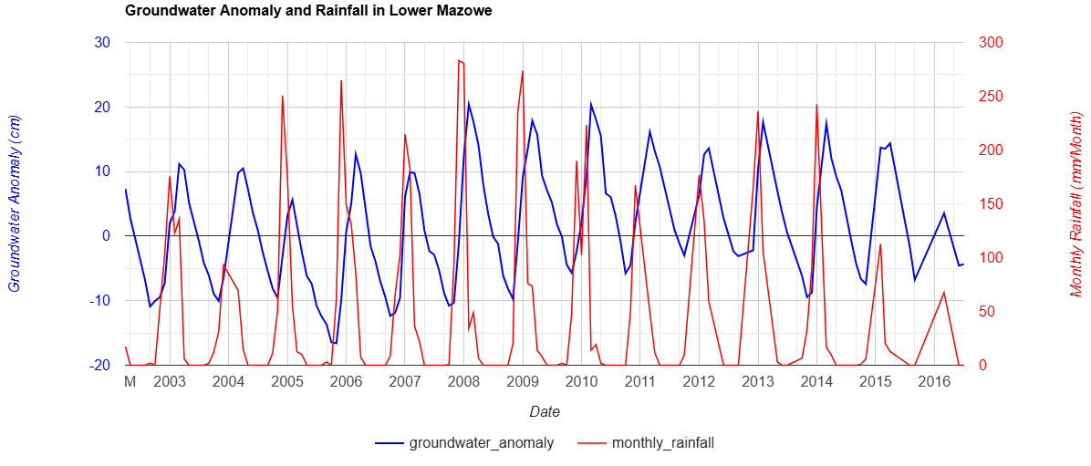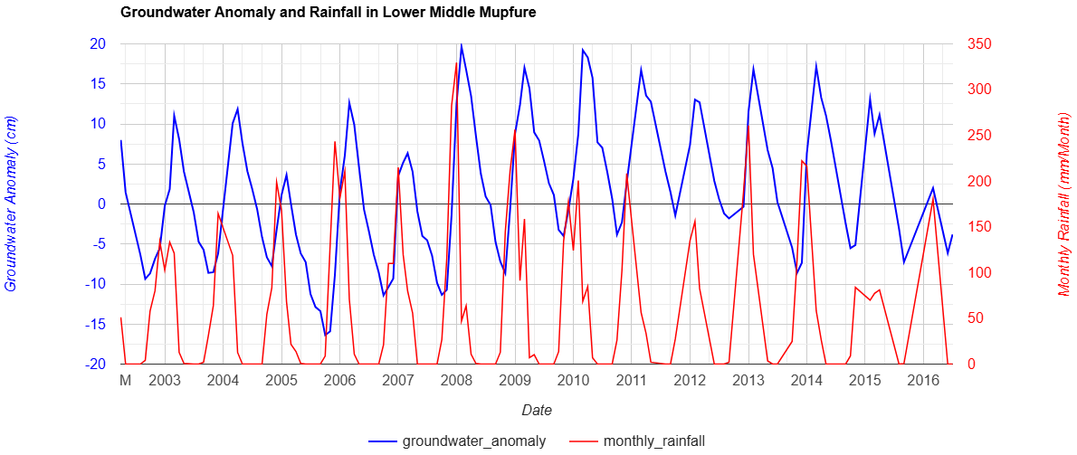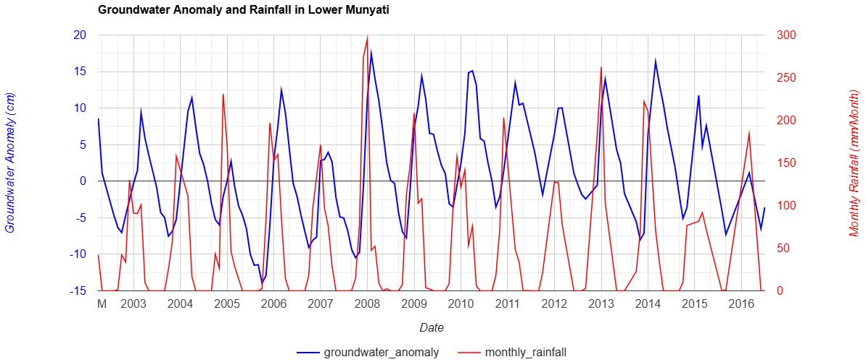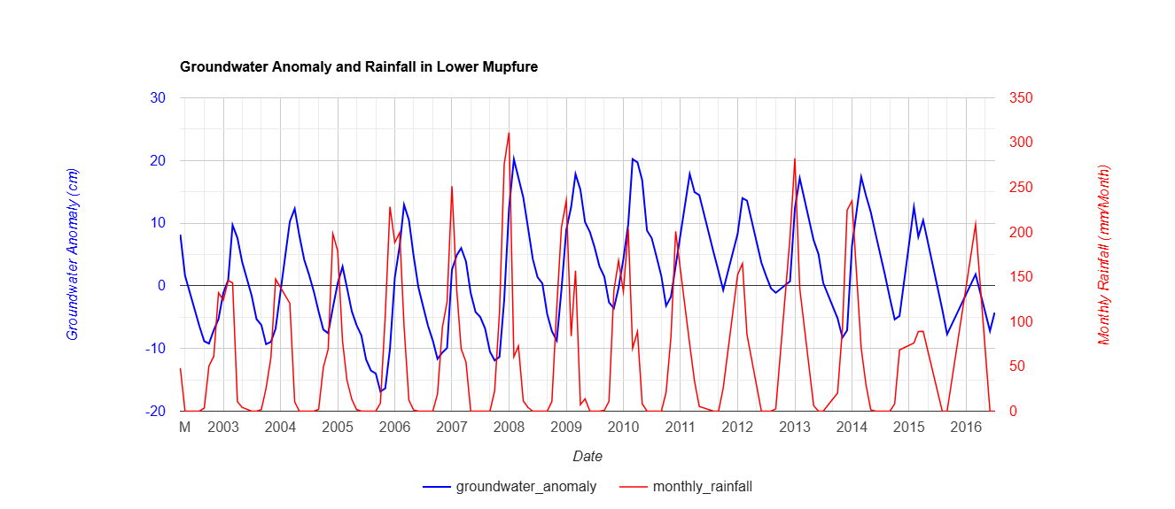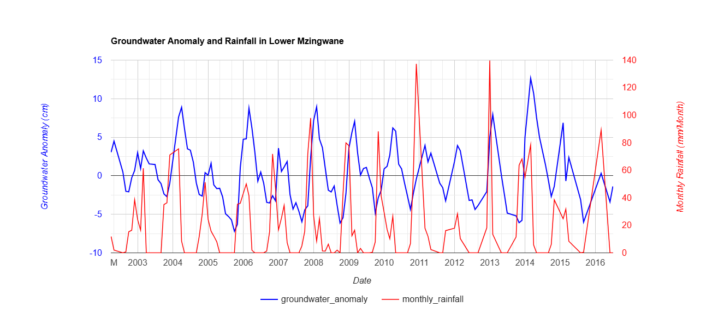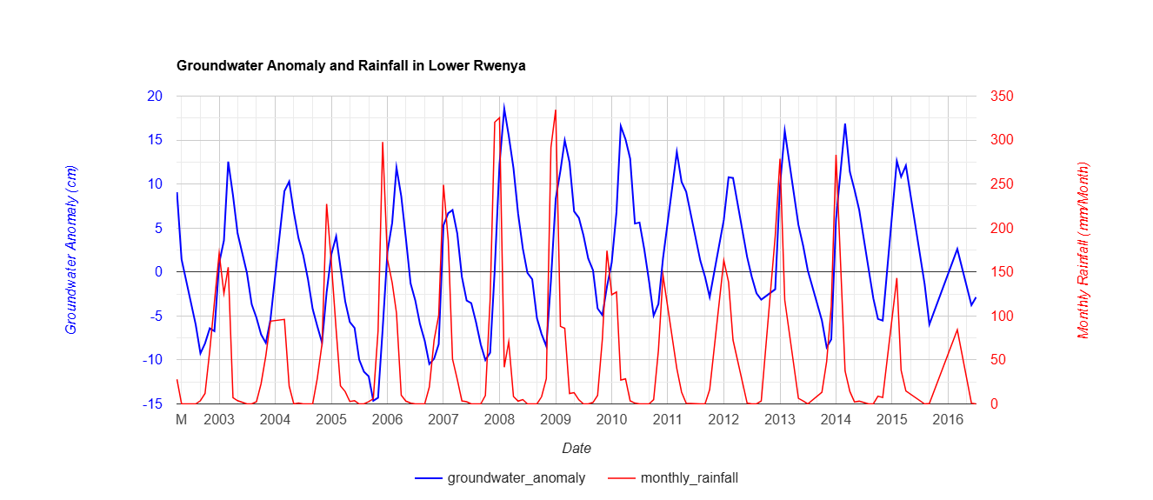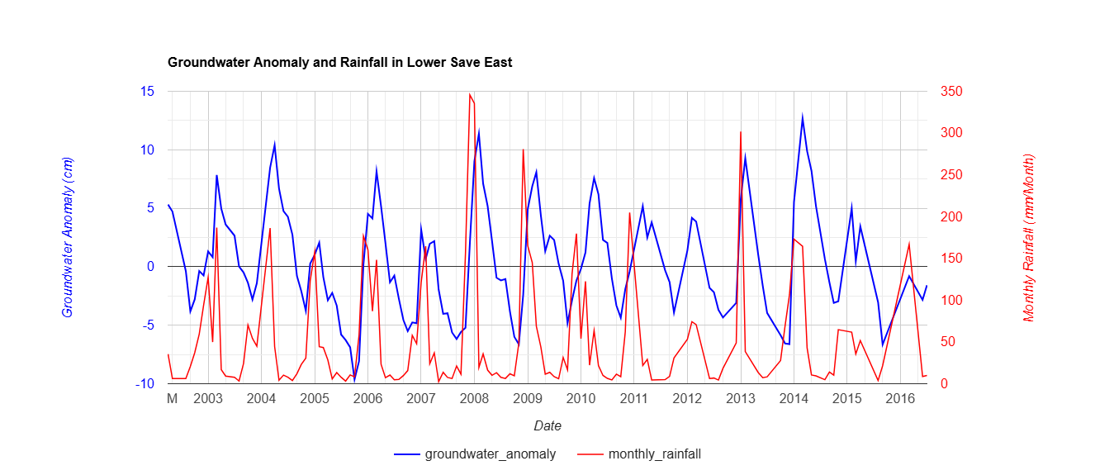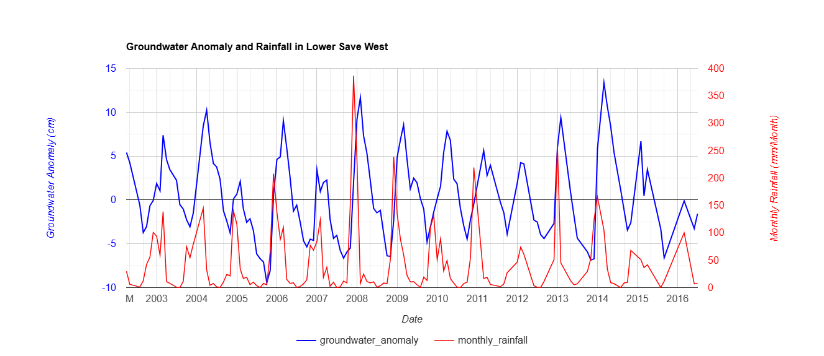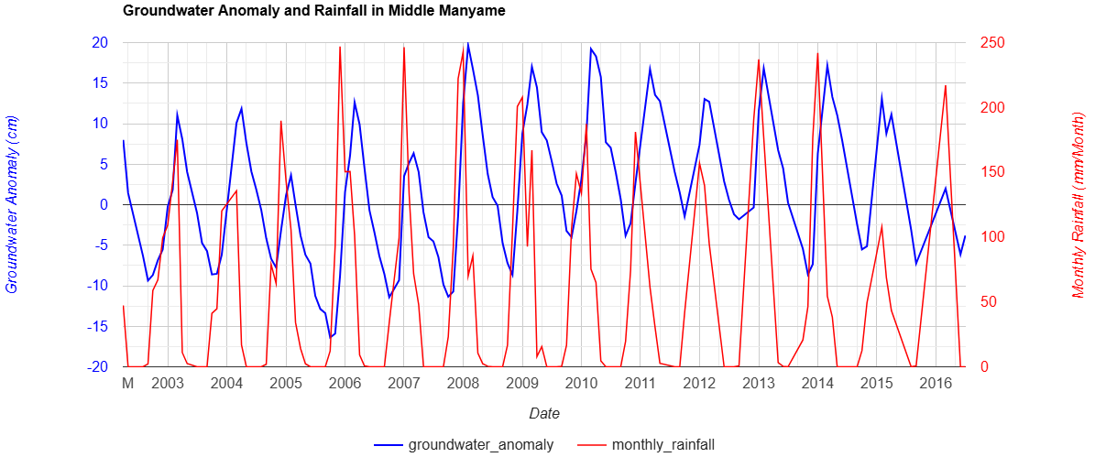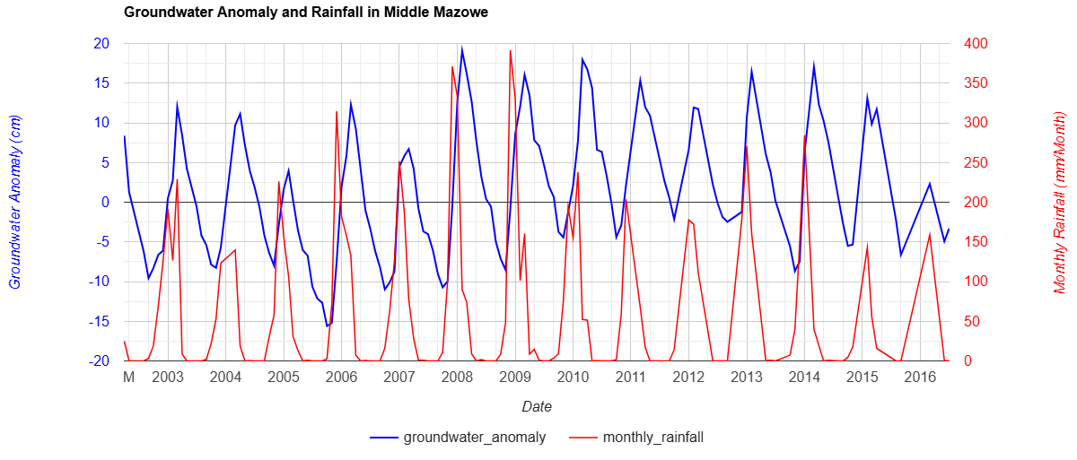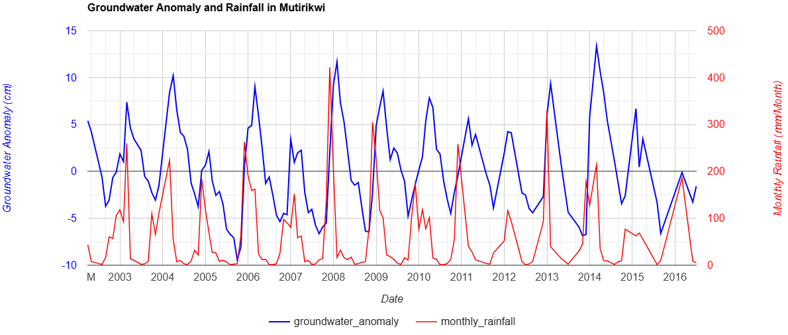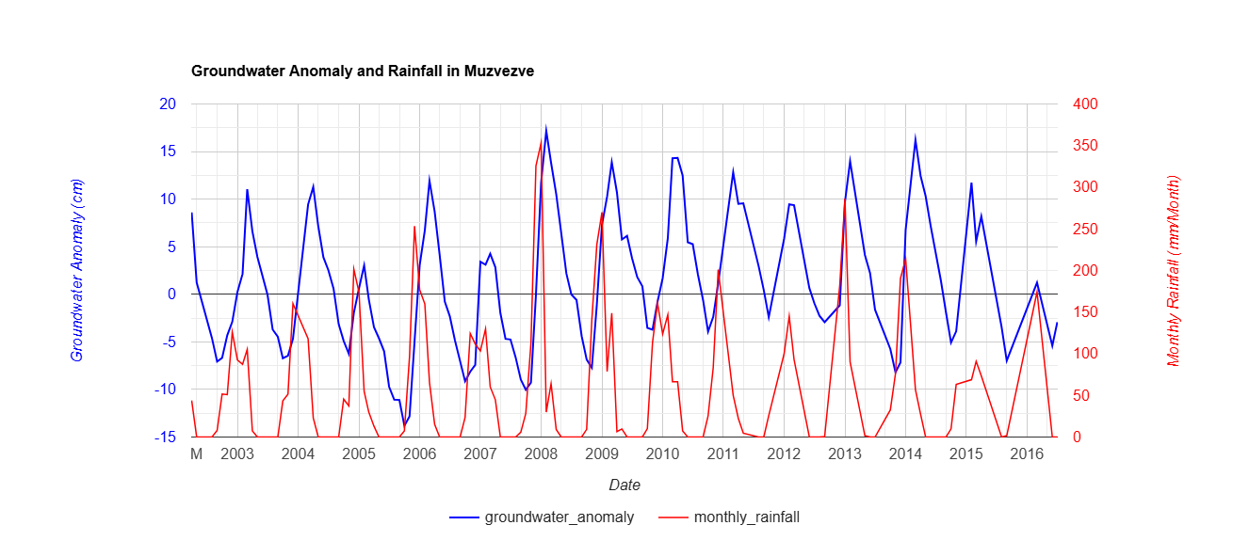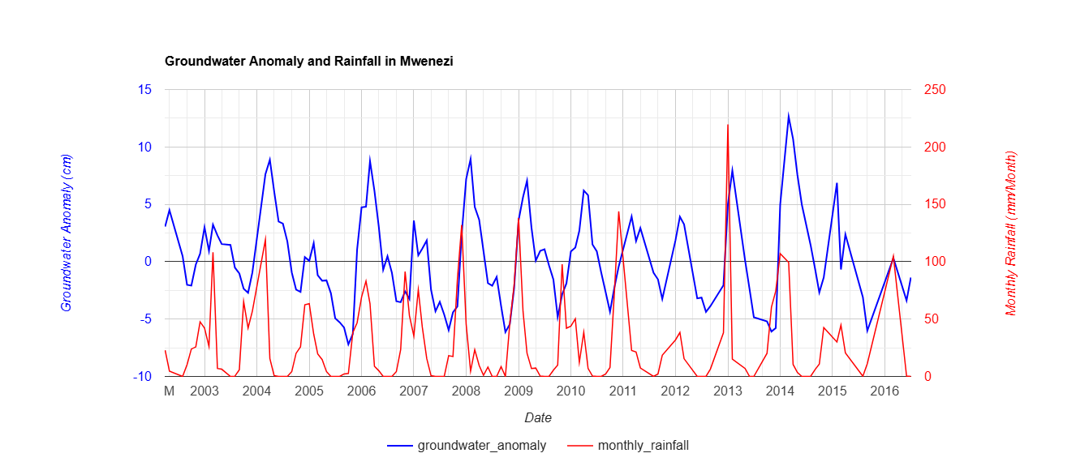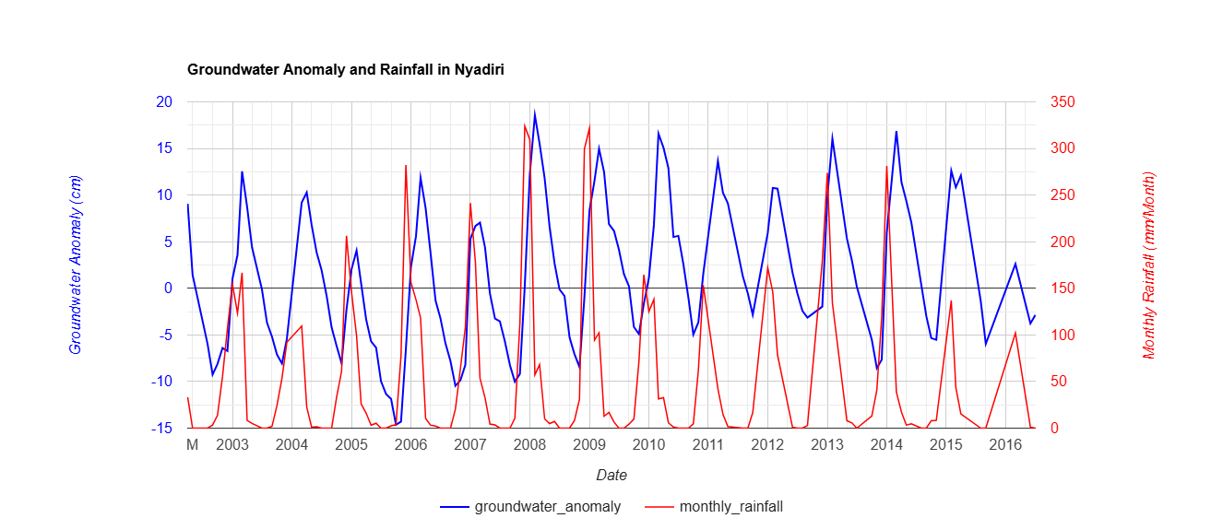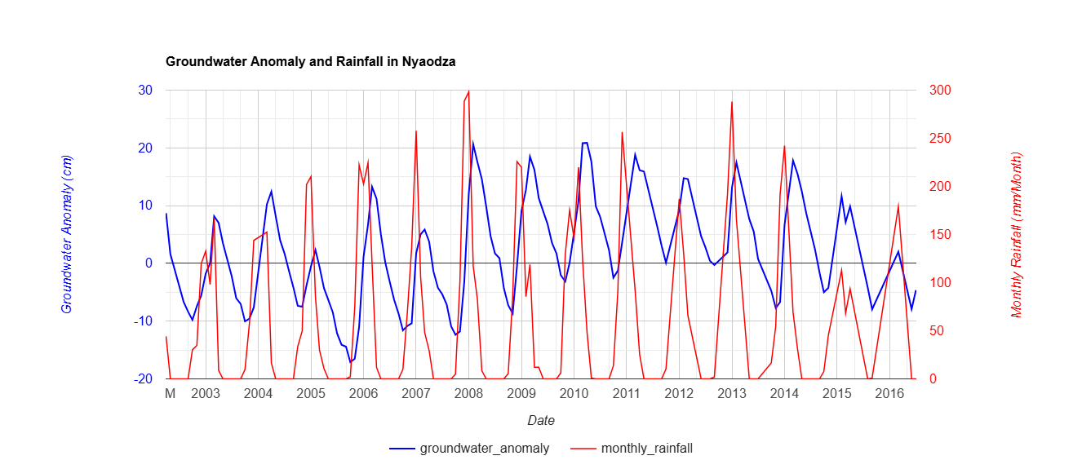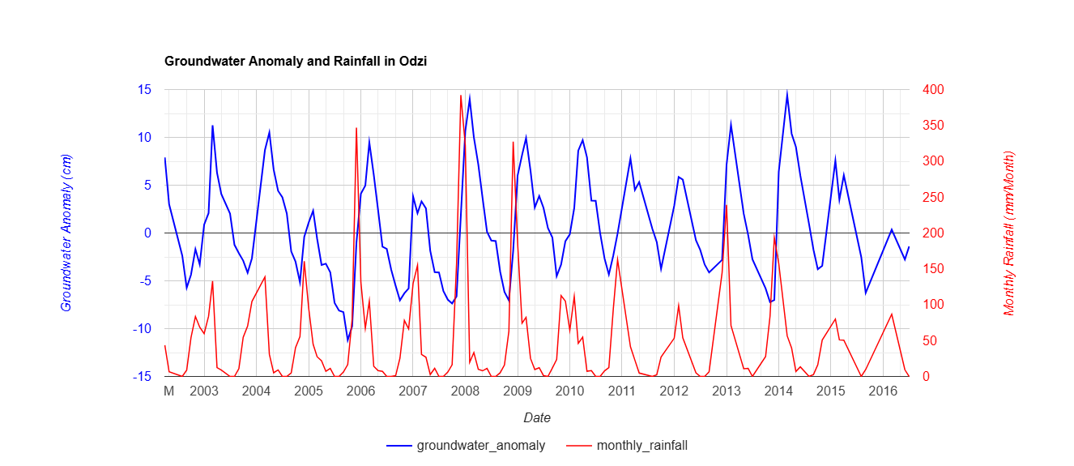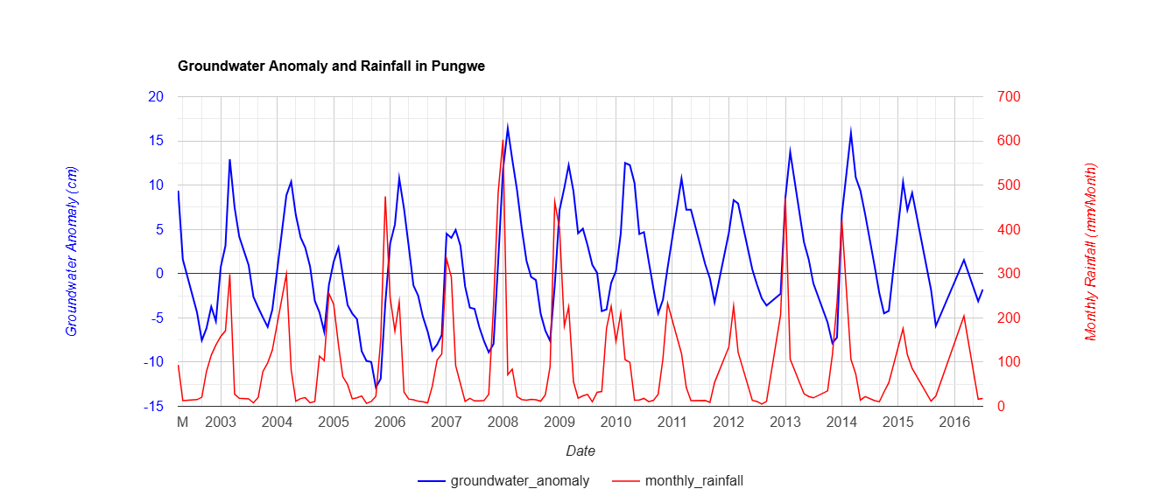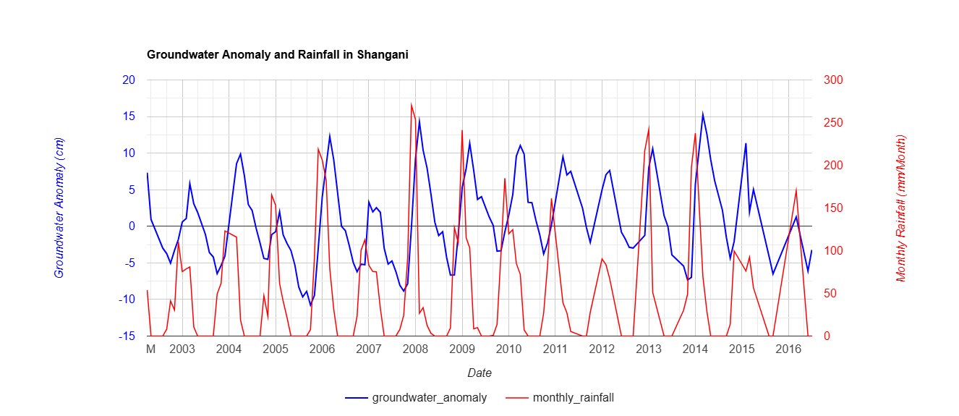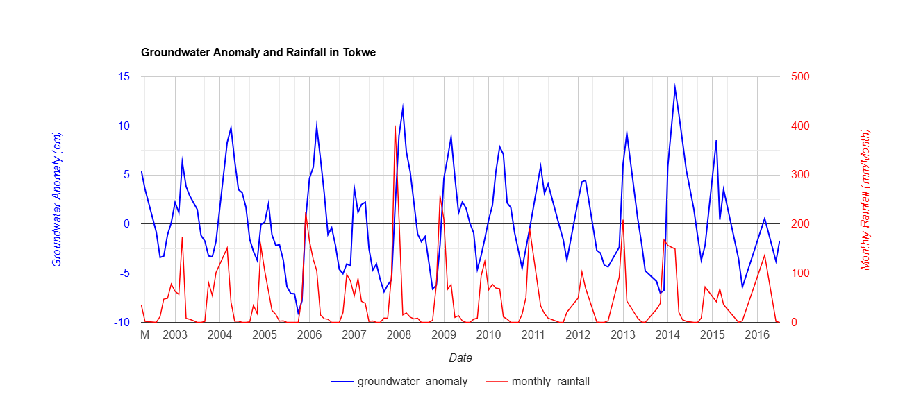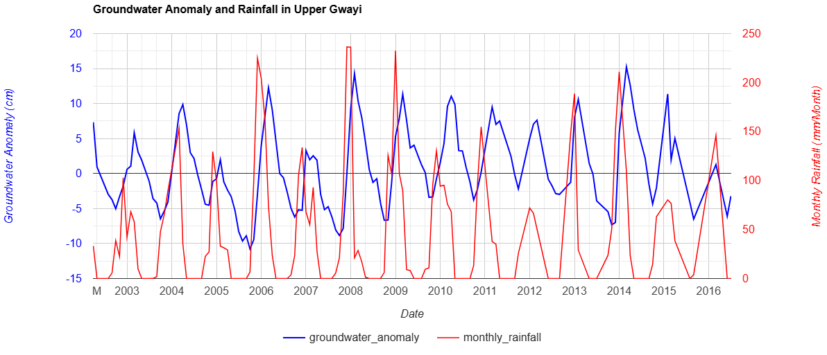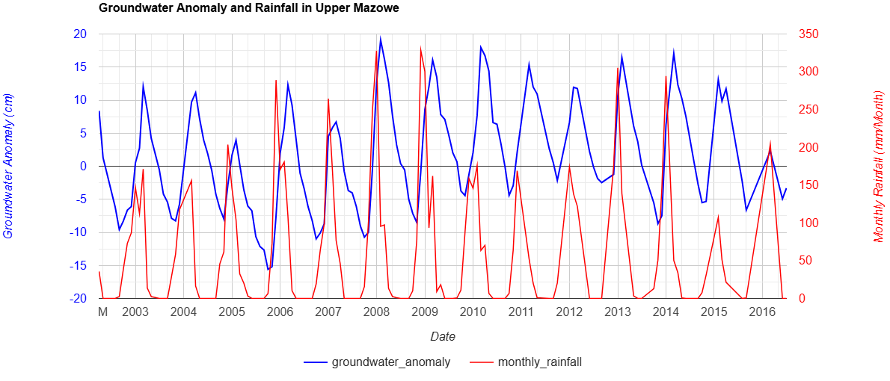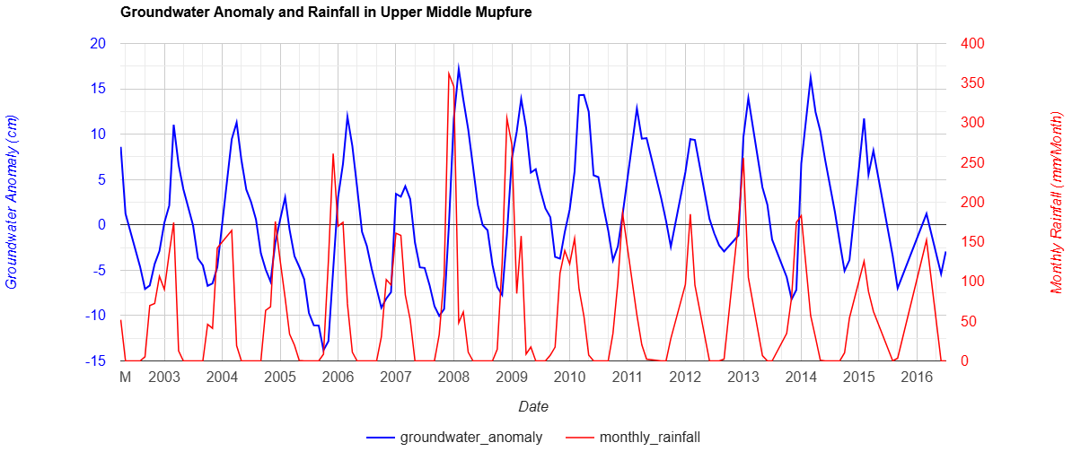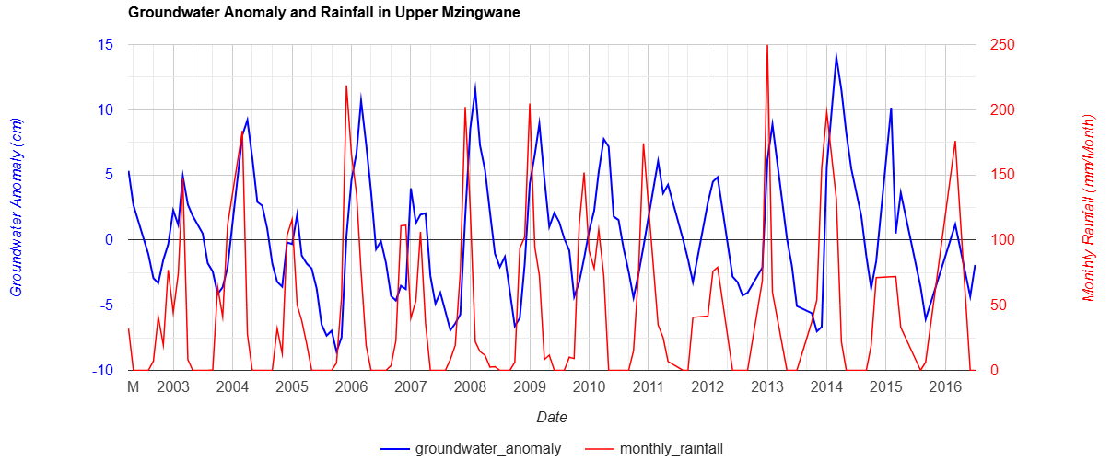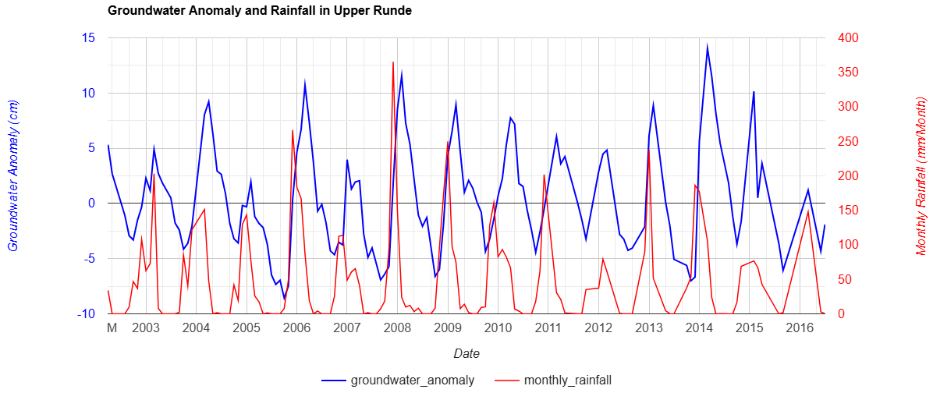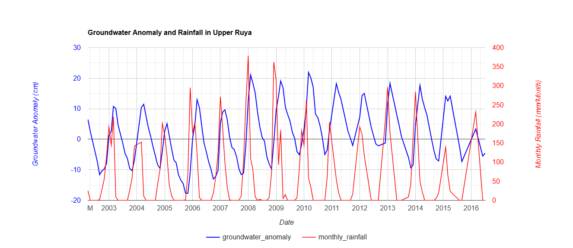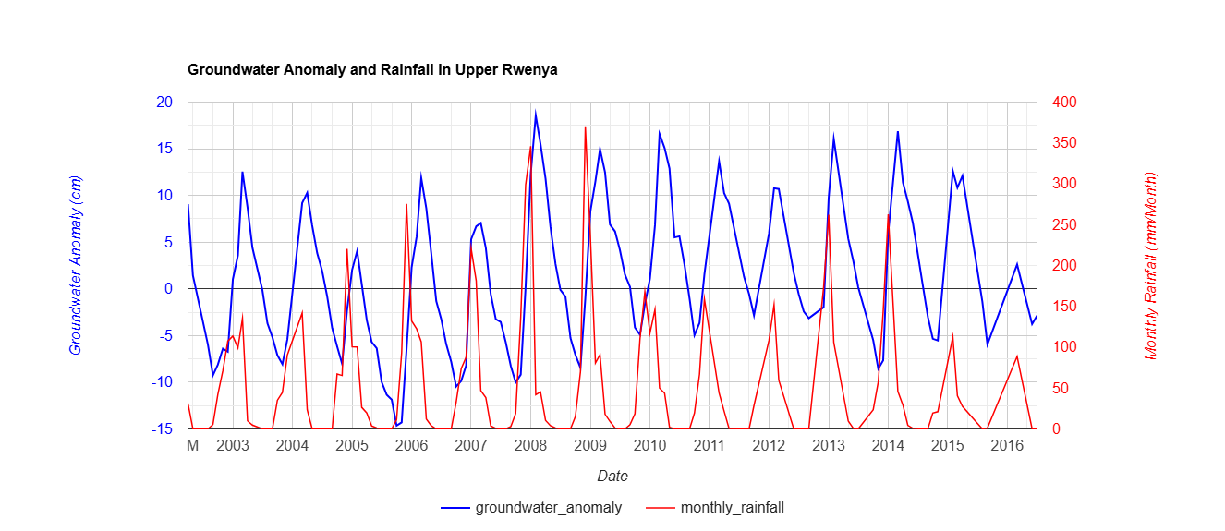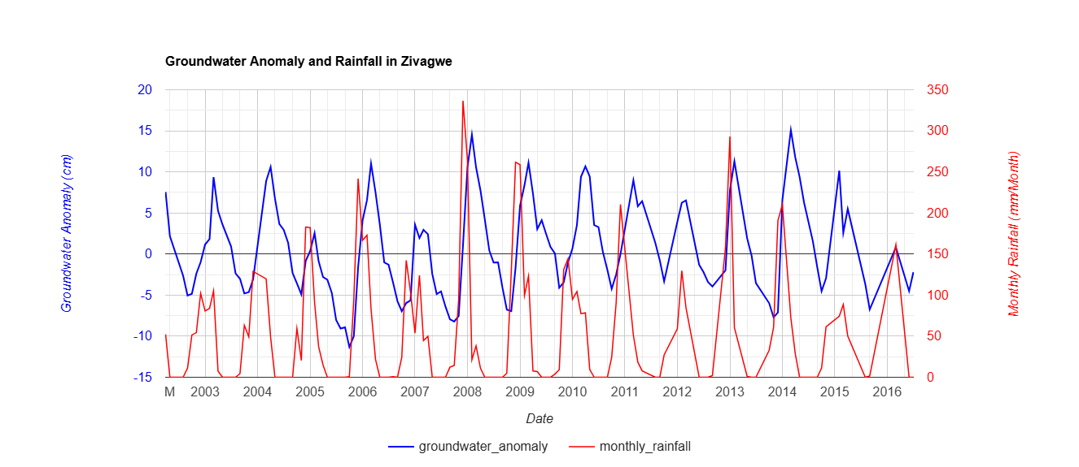

Supplementary Table S1
Groundwater conditioning factors, data sources and spatial resolution.
Class | Slope (°) | Geology | Soil Texture | Rainfall (mm) | NDVI (Vegetation Index) | Borehole Yield (L/s) | Lineament Density (km/km²) | Topographic Wetness Index (TWI) | Landcover | Evapotranspiration (mm/year) | Lithological units | Elevation (m)
1 | > 30° (Steep) | Impermeable (e.g., Granite) | Clayey (Low infiltration) | < 400 | < 0.1 | < 0.5 | < 0.5 | < 3.0 (Very low wetness) | Urban/Bare land | > 1400 | Unweathered Granite | > 1800
2 | 25° - 30° | Fractured Granite | Silty Clay | 400 - 500 | 0.1 - 0.2 | 0.5 - 1 | 0.5 - 1.0 | 3.0 - 4.0 | Shrubland | 1200 – 1400 | Fractured Gneiss | 1600 – 1800
3 | 20° - 25° | Quartzite | Sandy Clay | 500 - 600 | 0.2 - 0.3 | 1-Feb | 1.0 - 1.5 | 4.0 - 5.0 | Mixed Agriculture | 1000 – 1200 | Quartz-rich Schists | 1400 – 1600
4 | 15° - 20° | Dolerite | Loamy Sand | 600 - 700 | 0.3 - 0.4 | 2-Mar | 1.5 - 2.0 | 5.0 - 6.0 | Agroforestry | 900 – 1000 | Weathered Dolerite | 1200 – 1400
5 | 10° - 15° | Sandstone | Sandy Loam | 700 - 800 | 0.4 - 0.5 | 3-Apr | 2.0 - 2.5 | 6.0 - 7.0 | Woodland | 800 – 900 | Ferruginous Sandstones | 1000 – 1200
6 | 7° - 10° | Basalt | Loam | 800 - 900 | 0.5 - 0.6 | 4-May | 2.5 - 3.0 | 7.0 - 8.0 | Bushland | 700 – 800 | Fractured Basalts | 800 – 1000
7 | 4° - 7° | Weathered Basement | Silt Loam | 900 - 1000 | 0.6 - 0.7 | 5-Jul | 3.0 - 3.5 | 8.0 - 9.0 | Cultivated Fields | 600 – 700 | Weathered Schist | 600 – 800
8 | 2° - 4° | Karoo Sediments | Silt | 1000 - 1100 | 0.7 - 0.8 | 7-Sep | 3.5 - 4.0 | 9.0 - 10.0 | Wetlands | 500 – 600 | Fluvial Sediments | 400 – 600
9 | 1° - 2° | Alluvial Deposits | Sandy | 1100 - 1200 | 0.8 - 0.9 | 9-Dec | 4.0 - 4.5 | 10.0 - 11.0 | Riverine Forests | 400 – 500 | Recent Alluvial Sands | 200 – 400
10 | < 1° (Flat) | Unconsolidated Sediments | Coarse Sand | > 1200 | > 0.9 | > 12 | > 4.5 (Very High Fracturing) | > 11.0 (High Wetness) | Floodplains | < 400 | Unconsolidated Alluvium | < 200

Author Checklist
- Ensure every supplementary figure/table is cited at least once in the main manuscript.
- Maintain numbering independently from the main manuscript (S1, S2, etc.).
- Use the same terminology and abbreviations as the main manuscript.
- Ensure all figures are publication quality (minimum 300 dpi).
- Keep captions concise but self-contained.

