Table S1 Microsatellite genotyping multiplex panel and microsatellite primer sequences designed using Multiplex Manager 1.2 (Holleley & Geerts, 2009)
Panel | Dye | Primer Name | Universal primer tail sequence (5’-3’) (Blacket et al., 2012) | Repeat Motif | Forward primer sequence (5’ – 3’) (Wainwright et al., 2013) | Reverse primer sequence (5’ – 3’)  (Wainwright et al., 2013)
1 | PET | LL93 | CGGAGAGCCGAGAGGTG | (TG)₁₀ | ﻿CCGAATAAAAGAGGAACAATAG | ﻿GACTATTTACCTACACGCAACA
 | NED | LL23 | CAGGACCAGGCTACCGTG | (CT)₁₀ | ﻿TGTGCAGAGAAAGTTTGACTTA | ﻿CTACGCACAGAAAGACACATAC
 | 6-FAM | LL72 | GCCTCCCTCGCGCCA | (TG)₇ | ﻿CAAGGAGAGAAGGTCAATAAAG | ﻿GCATATTGTGCATTACTTAGGA
 | VIC | LL62 | GCCTTGCCAGCCCGC | (CA)₇ | ﻿GCAAAGAAAAGGATAAACAAAC | ﻿AATCACCATCATTCTCTGGTAG
2 | PET | LL28 | CGGAGAGCCGAGAGGTG | (GT)₉ | ﻿GGTAGCGTTCTTAGAATAGCAG | ﻿CAAACGTACACTCTGTGAAAAG
 | NED | LL84 | CAGGACCAGGCTACCGTG | (GA)₈ | ﻿AGGATCGTTGACTCGGAC | ﻿GGGAACTAAGGACTCTCTCTCT
 | 6-FAM | LL46 | GCCTCCCTCGCGCCA | (AG)₈ | ﻿TGCAAATTTATCTGTTCTCTTG | ﻿GTAGGTTCAGCATCTCTGTTG
 |  | LL45 | GCCTCCCTCGCGCCA | (CA)₈ | ﻿AGTCTTAAAGAGTGGAGTGGTG | ﻿GCATATCAATGTCATTTTGAAG
 | VIC | LL25 | GCCTTGCCAGCCCGC | (CAC)₁₀ | ﻿GTTTCCTACAGGCTCACAAT | ﻿GTCGGATGCTGGTGGTTT
 |  | LL92 | GCCTTGCCAGCCCGC | (TG)₇ | ﻿TGTGCACATTATACAGAACAAG | ﻿ACACACCTTAAAATCTCAAACC
3 | PET | LL71 | CGGAGAGCCGAGAGGTG | (CA)₈ | ﻿GTTTTCGATGGTTACTGATCTT | ﻿ATCACTTCATGAATCCACTCTT
 | NED | LL50 | CAGGACCAGGCTACCGTG | (AAC)₈ | ﻿CTCCAAGATCTCATCACTGTC | ﻿GCCTGTCATTTACTGTTTGTTA
 | 6-FAM | LL43 | GCCTCCCTCGCGCCA | (GA)₈ | ﻿TCGTGGAAAGAGAAGAGAGA | ﻿CAGATATAACAACGACAGCAAC
 |  | LL87 | GCCTCCCTCGCGCCA | (TG)₇ | ﻿AATAATGCATGGAAAACACAC | ﻿CATTAACTTGTGTGAACTTTGC
 | VIC | LL21 | GCCTTGCCAGCCCGC | (TC)₁₀ | ﻿GTTGAAAATTTGAAGACGTCAG | ﻿GTAGCTACATTGACAACCAACA
 |  | LL07 | GCCTTGCCAGCCCGC | (TGT)₁₅ | ﻿GAATTGGCAGTTAATCAAGACT | ﻿ACGACAACAACGACAACAT
4 | PET | LL20 | CGGAGAGCCGAGAGGTG | (TG)₁₀ | ﻿AGTTTCTTATGATGTCCAGTCC | ﻿AGCATTCACACTATAACCACAA
 |  | LL22 | CGGAGAGCCGAGAGGTG | (GT)₁₀ | ﻿AATGGGTCTTAAACATATCAGC | ﻿CTGTGTCTGTTACGGTTGATT
 | NED | LL96 | CAGGACCAGGCTACCGTG | (GT)₇ | ﻿GAGGAGACAAAATGTTTACAGG | ﻿ATCGCTCTGATCTGTCAAGTAT
 | 6-FAM | LL42 | GCCTCCCTCGCGCCA | (GT)₈ | ﻿TATGCACTCTCAGAAAATGAAG | ﻿AACGATTATCCATTATGGTCC
 | VIC | LL04 | GCCTTGCCAGCCCGC | (ATG)₁₈ | ﻿ATTTGTCACCTAATCTGTAGCC | ﻿ATCATCATCGTCATCATCATT

Table S2 Biogeographic spatial units associated with L. laevigata COI sequences analyzed in this study
Source Metadata Set | Biogeographic Spatial Units (Spalding et al., 2007) |  |  | Number of total samples | Samples with color information
 | Realms | Provinces | Ecoregions |  | Samples with color information
This study | Central Indo-Pacific | South China Sea | South China Sea Oceanic Islands | 117 | 104
 | Central Indo-Pacific | Western Coral Triangle | Palawan/North Borneo | 88 | 88
NCBI GenBank | Western Indo-Pacific | Western Indian Ocean | East African Coral Coast | 136 | 136
 |  | Western Indian Ocean | Seychelles | 4 | 4
 |  | Western Indian Ocean | Delagoa | 5 | 5
 |  | Central Indian Ocean Islands | Chagos | 13 | 0
 |  | Andaman | Andaman Sea Coral Coast | 5 | 5
 | Central Indo-Pacific | Tropical Northwestern Pacific | Mariana Islands | 6 | 6
 |  | Western Coral Triangle | Palawan/North Borneo | 5 | 0
 |  |  | Eastern Philippines | 131 | 86
 |  | Northeast Australian Shelf | Central and Southern Great Barrier Reef | 3 | 3
 |  | Northwest Australian Shelf | Exmouth to Broome | 3 | 3
 |  | Tropical Southwestern Pacific | Fiji Islands | 3 | 3
Genomic Observatories Metadatabase (GeOMe) | Central Indo-Pacific | Java Transitional | Southern Java | 569 | 569
 | Central Indo-Pacific | Western Coral Triangle | Eastern Philippines | 80 | 80
 | Central Indo-Pacific | Eastern Coral Triangle | Bismarck Sea | 270 | 0
 | Temperate Australasia | East Central Australian Shelf | Tweed-Moreton | 116 | 0
Total |  |  |  | 1,554 | 1,092

Table S3 Cross-tabulation of STRUCTURE & NewHybrids assignments
Structure Cluster Assignment (q ≥ 0.90) | NewHybrids Genotype Class (q ≥ 0.50)
Structure Cluster Assignment (q ≥ 0.90) | Parentals |  |  | Hybrids
Structure Cluster Assignment (q ≥ 0.90) | P1 | P2 |  | F1 | F2 | BC1 | BC2
Admixed | 66 | 22 |  | 0 | 13 | 0 | 5
Cluster 1 | 0 | 55 |  | 0 | 1 | 0 | 0
Cluster 2 | 53 | 0 |  | 0 | 0 | 0 | 0
Total | 119 | 77 |  | 0 | 14 | 0 | 5

Table S4 Assignment of L. laevigata color morphs into genotype frequency classes identified by NewHybrids
Color Morph | NewHybrids Genotype Class (q ≥ 0.50)
 | P1 | P2 | F1 | F2 | BC1 | BC2
Mixed | 40 | 48 | 0 | 13 | 0 | 4
Pure Blue | 67 | 0 | 0 | 0 | 0 | 0
Pure Orange | 0 | 29 | 0 | 0 | 0 | 1
No Data | 12 | 0 | 0 | 1 | 0 | 0
Total | 119 | 77 | 0 | 14 | 0 | 5

Table S5 Pairwise F_{ST} values per locus between genotype clusters. Significant F_{ST} values (CI₉₅ > 0) are in boldface
 |  | Population pairwise comparisons
 | Locus | Cluster 1 vs Cluster 2 | Cluster 1 vs Admixed | Cluster 2 vs Admixed
1 | LL72 | 0.0333  [-0.0156, 0.1121] | 0.0103  [-0.0129, 0.0604] | 0.0013  [-0.0161, 0.0356]
2 | LL62 | 0.0595  [0.0123, 0.1241] | 0.0154  [-0.0097, 0.0643] | 0.0092  [-0.0075, 0.0419]
3 | LL23 | 0.0128  [-0.0073, 0.0390] | -0.0001  [-0.0115, 0.0186] | -0.0038  [-0.0142, 0.0149]
4 | LL93 | 0.1753  [0.0734, 0.2796] | 0.0428  [-0.0047, 0.1126] | 0.0499  [0.0062, 0.1106]
5 | LL46 | 0.0391  [0.0011, 0.0866] | 0.0347  [0.0014, 0.0813] | -0.0048  [-0.0177, 0.0177]
6 | LL45 | 0.0908  [0.0344, 0.1647] | 0.0467  [0.0048, 0.1126] | 0.0069  [-0.0094, 0.0336]
7 | LL25 | 0.0727  [0.0274, 0.1270] | 0.0298  [0.0033, 0.0640] | 0.0297  [0.0022, 0.0692]
8 | LL92 | 0.0189  [-0.0140, 0.0847] | -0.0031  [-0.0168, 0.0363] | 0.0024  [-0.0161, 0.0471]
9 | LL84 | -0.0001  [-0.0208, 0.0326] | -0.0041  [-0.0186, 0.0208] | -0.0069  [-0.0202, 0.0184]
10 | LL28 | 0.1357  [0.0607, 0.2214] | 0.0426  [0.0060, 0.0965] | 0.0197  [-0.0104, 0.0632]
11 | LL43 | 0.2239  [0.1331, 0.3224] | 0.0773  [0.0190, 0.1487] | 0.0394  [0.0066, 0.0840]
12 | LL87 | 0.0255  [-0.0031, 0.0638] | 0.0011  [-0.0122, 0.0223] | 0.0039  [-0.0103, 0.0243]
13 | LL21 | 0.0363  [-0.0006, 0.0873] | 0.0013  [-0.0175, 0.0322] | 0.0104  [-0.0129, 0.0469]
14 | LL07 | -0.0023  [-0.0256, 0.0386] | 0.0001  [-0.0208, 0.0440] | 0.0011  [-0.0226, 0.0550]
15 | LL50 | 0.0214  [0.0032, 0.0486] | 0.0045  [-0.0084, 0.0255] | 0.0046  [-0.0084, 0.0280]
16 | LL71 | 0.0546  [0.0223, 0.0948] | 0.0206  [-0.0074, 0.0616] | 0.0067  [-0.0010, 0.0283]
17 | LL42 | 0.0104  [-0.0164, 0.0592] | 0.0005  [-0.0132, 0.0290] | -0.0042  [-0.0146, 0.0199]
18 | LL04 | 0.1441  [0.0905, 0.2067] | 0.1014  [0.0556, 0.1574] | 0.0089  [-0.0033, 0.0257]
19 | LL96 | 0.3244  [0.2247, 0.4265] | 0.1350  [0.0803, 0.1953] | 0.0575  [0.0027, 0.1315]
20 | LL20 | 0.0318  [-0.0031, 0.0812] | 0.0066  [-0.0083, 0.0278] | 0.0176  [-0.0060, 0.0490]
21 | LL22 | -0.0012  [-0.0142, 0.0223] | 0.0000  [-0.0110, 0.0194] | -0.0034  [-0.0107, 0.0102]

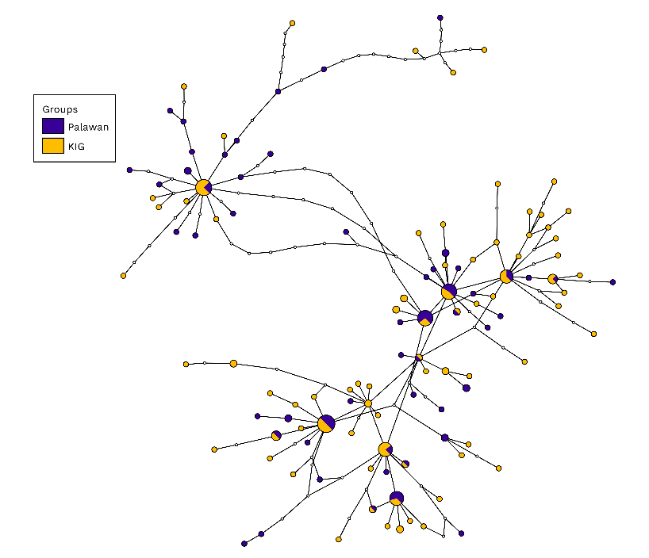
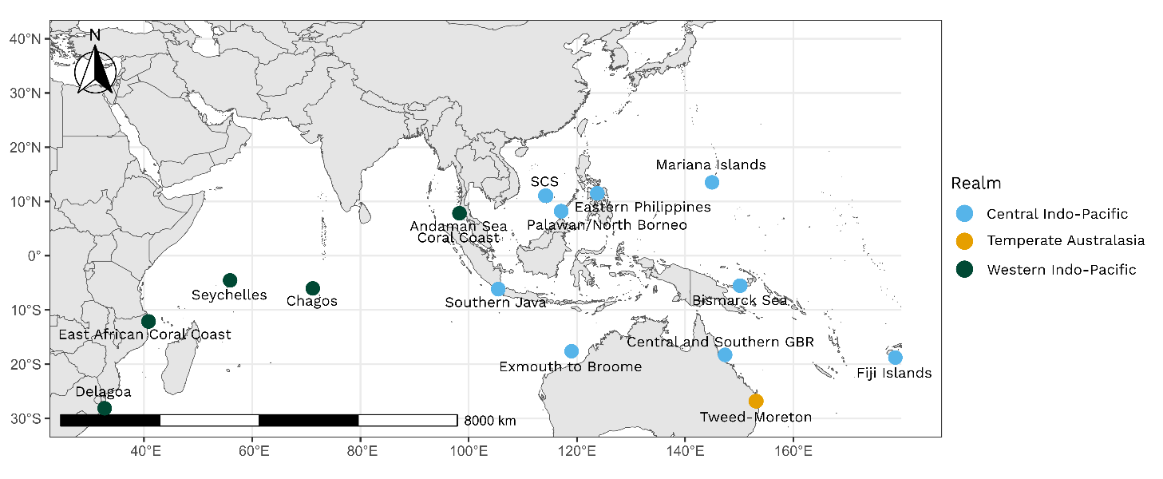
(a)
(c)
(b)
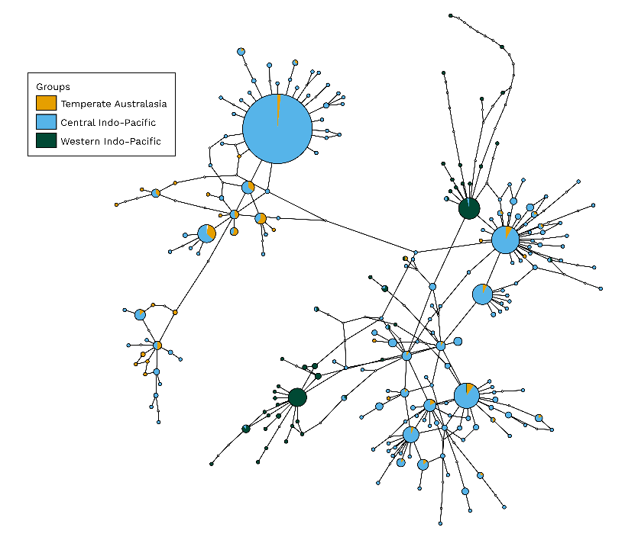

Group A

Group A

Group B
Group B

Fig. S1 a Map of Linckia laevigata samples with COI sequence records (n = 1,554). Sites were pooled into ecoregions and ecoregion points were colored by realm, based on the MEOW system by Spalding et al. (2007). Haplotype network for the b local (n = 205 sequences; 117 haplotypes) and c global datasets (n = 1,554; 241 haplotypes) with sequences grouped according to geographic location

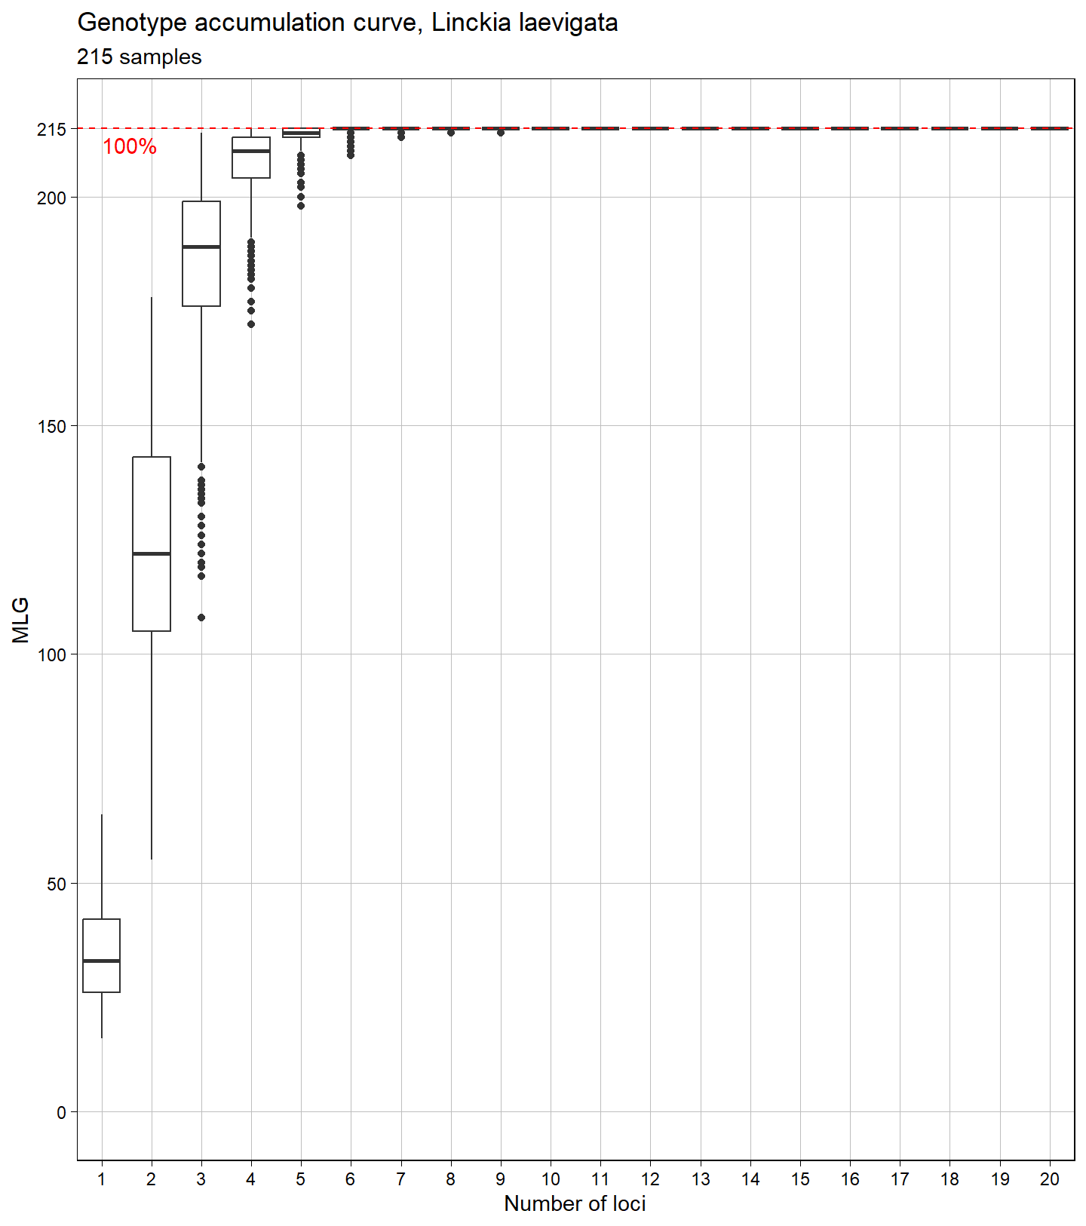
Fig. S2 Genotype accumulation curve for 215 L. laevigata individuals genotyped over 21 microsatellite loci developed by Wainwright et al. (2013). The horizontal axis represents the number of loci randomly sampled up to n-1 loci, the vertical axis shows the number of multilocus genotypes (MLGs) observed. The red dashed line indicates 100% of the total observed MLGs in the dataset
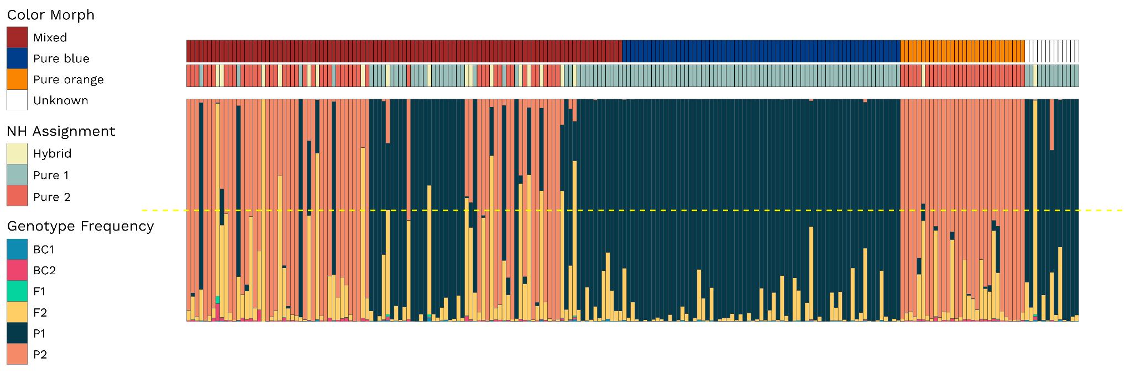
(b)
(a)
(c)
Fig. S3 Histogram of 215 individuals represented by each vertical bar and their a color morph, b genotype frequency class membership, and c proportion of genotype frequencies based on NewHybrids results (q ≥ 0.50). The yellow dotted line represents the threshold for identifying hybrids. Legend colors for each barplot are specified on the left

