Supplementary Information for “Individual differences in infants’ face viewing reflect domain-general visual biases”
Table of contents
1. Additional method specifications 3
1.1. Sample characteristics 3
1.1.1. Experiment 1 3
1.1.2. Experiment 2 3
1.1.3. Experiment 3 4
1.2. Additional stimuli specifications 4
1.2.1. Stimuli 4
1.2.2. Attention-grabbers 5
1.3. Data quality estimates 5
1.3.1. Precision 5
1.3.2. Accuracy 6
1.4. Pre-processing specifications 6
1.4.1. Pre-processing of Experiment 1 6
1.4.2. Pre-processing of Experiment 2 7
1.4.3. Pre-processing of Experiment 3 8
1.4.4. Pre-processing differences between experiments 8
1.4.5. Data quality comparison between Experiment 1,2 and 3 9
1.5. Additional details on statistical analyses 9
1.5.1. Power analysis Experiment 1 10
1.5.2. Power analysis Experiment 2 10
1.5.3. Power analysis Experiment 3 10
1.6. Overview of sensitivity analyses 10
2. Supplementary Results from Experiment 1 11
2.1. Sensitivity analyses 11
2.1.1. Vertical looking height 12
2.1.2. Horizontal looking position 12
2.1.3. First fixation 12
2.1.4. EMI 13
2.1.5. Applying the Experiment 2 pre-processing pipeline to data from Experiment 1 13
2.2. Exploratory analyses 14
2.2.1. Split-half reliability 14
2.2.2. Order effects 14
3. Supplementary Results from Experiment 2 15
3.1. Sensitivity analyses 15
3.1.1. Vertical looking height 15
3.1.2. Horizontal looking position 15
3.1.3. First fixation 16
3.1.4. EMI 16
3.2. Exploratory analyses 16
3.2.1. Split-half reliability 16
4. Supplementary Results from Experiment 3 17
4.1. Sensitivity analyses 17
4.1.1. Vertical looking height 17
4.1.2. Horizontal looking position 17
4.1.3. First fixation 17
4.2. Exploratory analyses 18
4.2.1. Split-half reliability 18
5. Supplementary results for spread-of-fixations (across experiments) 18
5.1. Sensitivity analyses 18
5.2. Exploratory analyses 19
6. Results for association with socio-communicative abilities 19
6.1. Socio-communicative regression models 19
6.2. Sensitivity analyses 20
7. Results for general screen looking (across experiments) 21
8. Results for strict calibration subset analyses 21
9. Supplementary Tables 23
9.1. Supplementary Table 1. 23
9.2. Supplementary Table 2. 24
9.3. Supplementary Table 3. 25
9.4. Supplementary Table 4. 26
9.5. Supplementary Table 5 (Pre-registration deviation table) 27
9.6. Supplementary Table 6. 30
10. Supplementary Figures 31
10.1. Supplementary Fig. 1. 31
10.2. Supplementary Fig. 2. 32
10.3. Supplementary Fig. 3. 33
10.4. Supplementary Fig. 4. 34
10.5. Supplementary Fig. 5. 35
10.6. Supplementary Fig. 6. 36
11. References 37

- Additional method specifications
  - Sample characteristics
    - Experiment 1
The sample was generally from a high socio-economic background, where 72% of caregivers had completed a university degree but with varying family income (63% earned more than 70 000 SEK per month, 21% earned 50-70 000 SEK, 13% earned 30-50 000 SEK, 2% < 30 000 SEK, and 2% unknown). Because collecting information on race is not considered ethically appropriate in the Swedish context, we report parental country of birth instead: the sample consisted of 82% Swedish country of origin, 11% were from the rest of Europe, 2.9% were from Asia, 2.2% were from North America, 1.5% from Africa, and 0.7% were unknown.
    - Experiment 2
The sample was generally from a high socio-economic background where most caregivers (82%) had completed a university degree, but with varying family income (14% earned more than 100 000 SEK per month, 34% earned 80-100 000 SEK, 22% earned 60-80 000 SEK, 16% earned 40-60 000 SEK, 8% earned 20-40 000 SEK, 2% earned <20 000 SEK, and 4% unknown). Most caregivers reported a Swedish country of origin (72%), 13% were from the rest of Europe, 6% from Asia, 2% from Africa, 2% were from South America, 1% from North America and 4% were unknown.
    - Experiment 3
The children were generally from a high socio-economic background, where 88% of parents had completed a university degree of 3 years or more, but with varying family income (12% earned more than 110 000 SEK per month, 20% earned 90-110 000 SEK, 35% earned 70-90 000 SEK, 19% earned 50-70 000 SEK, 11% earned 30-50 000 SEK, 2% earned <30 000 SEK, and 1% unknown). Most caregivers reported a Swedish country of origin (70%). Among the remaining caregivers 21% reported a European background, 3% reported a non-European background, with data unavailable for 6%.
  - Additional stimuli specifications
    - Stimuli
All pictures were horizontally centered on a grey (#aeaeae) background. Faces were placed with eyes and mouth equidistant from the vertical midpoint and objects were centered on the vertical midline. Chin-hairline distance within faces and full non-social object height was approximately 15.6° (range: 15.2-16°). In Experiment 1 stimuli were shown in a two-step semi-random order, where the condition was chosen first (using Tobii pro lab’s shuffle function, with replacement), followed by the exact item within the chosen category (using Tobii pro lab’s shuffle function, without replacement), this unintentionally caused some stimuli to be displayed an additional time at the end of each experiment session (see Supplementary Table 5). Experiment 2 and 3 subsequently used a one-step semi-random order where the exact item was chosen from a pool of all stimuli (using Tobii pro lab’s shuffle function, without replacement).
    - Attention-grabbers
Attention-grabbers (child-friendly cartoon figures accompanied with an attention-grabbing sound) were counterbalanced and randomized through Tobii pro lab’s shuffle function without replacement, ensuring left and right sides were shown an equal amount of time through a set of 4 different attention-grabbers, each displayed on both sides (8 unique videos). Stimuli were displayed gaze-contingent to attention-grabbers. The gaze-contingency criterion required at least 500 ms of consecutive gaze directed at the attention-grabber area before the next stimulus was presented. Brief interruptions in gaze data (up to 200 ms) during identified intervals were allowed, in line with Tobii Pro Lab’s gaze-contingent trigger settings. Alternatively, if the gaze-contingency criterium was not fulfilled within 5s, the next stimulus was displayed automatically to ensure task engagement.
  - Data quality estimates
    - Precision
To calculate precision of the gaze data, we utilized the in-experiment calibration procedure (i.e., the calibration procedure added in addition to the Tobii-standard-calibration, hereafter when referring to the calibration procedure we are referring to the in-experiment calibration procedure). Each experiment session contained two of these calibration-procedures, interspersed by the regular experimental stimuli and attention grabbers. The calibration-procedure contained a colored circle moving between, and standing still, in 5 locations on the screen (midpoint, bottom-right, bottom-left, top-right, and top-left). For each calibration location, we analyzed the period from 100ms after location start to 50ms before location end. Within this span, the RMS-s2s was calculated separately for the horizontal (x) and vertical (y) gaze dimensions in a sliding 100ms window (based on the RMS-S2S approach described by Hessels and Hooge¹). The median RMS-S2S value for each dimension (x,y) was then obtained for each location and averaged across locations, and finally across the two calibration procedures (unless only one was available for a particular child). The resulting horizontal and vertical estimates were combined into a single precision measure using the Euclidean norm ($\sqrt{{\text{RMS}}_{x}^{2}+{\text{RMS}}_{y}^{2}}$).
    - Accuracy
Accuracy error was calculated using the midpoint location of the in-experiment calibration procedure (Section 1.3.1 Precision), prior to correcting for calibration offset. Offset was measured in vertical and horizontal axis, the Pythagorean theorem was applied to get one accuracy offset distance from each of the two calibration procedures, and then these were averaged yielding one distance per participant. In the cases where only one calibration procedure was available, this was used.
  - Pre-processing specifications
After each experiment, the eye-tracking data was exported into a tsv file, these files were pre-processed with custom scripts in R version 4.2.3² using R Studio version 2024.9.1.394³.
    - Pre-processing of Experiment 1
Pre-processing of the time-series gaze signal recorded during stimulus presentation consisted of the following steps: i) Artifact removal: we excluded all gaze samples with a velocity > 30pixels/ms (approximately 800°/s at a 60 cm viewing distance). ii) Gap interpolation and signal smoothing: gaps (< 200ms) were interpolated using a median of values in the 30ms margin before and after the gap. Signal smoothing was applied with a moving average window of 75ms. iii) Midpoint off-line calibration correction: using two in-experiment-calibration procedures (Section 1.3) we computed the average horizontal and vertical off-sets in the midpoint and applied these to the gaze signal separately for the x and y-coordinates (as noted, both faces and objects were mid-centered). iv) Removal of gaze outside the general stimulus area: a fixed-size AOI (x-axis: 450-1470px; y-axis: 70-1010px, screen dimensions: 1920x1080px) was applied. Gaze falling outside of the stimulus-area-AOI (towards the area where attention grabbers were played between trials) was excluded from analyses. v) Fixation filtration: using a dispersion-based filter, was employed with a dispersion threshold of 1°, which averaged to 40px on screen, and a minimum fixation-duration of 50ms. Thresholds were informed by previous literature⁴. To reduce data distortion and increase data retention the thresholds were further adjusted, using a subset of infants before being applied to the full sample.
      - Trial validity
For all main variables except first fixation (i.e., vertical looking height, horizontal looking position, and EMI), trials were excluded if gaze was already within the stimulus-area-AOI (Section 1.4.1) at trial onset or if less than 50% of the trial duration contained valid gaze data within the AOI. Trials for the first fixation variable were valid if the trial contained a valid fixation towards the stimulus-area-AOI (see below) within 1s of stimulus onset.
    - Pre-processing of Experiment 2
The pre-processing of Experiment 2 was identical to that of Experiment 1, with slight adjustments: the criteria for artefact rejection and gap interpolation were adjusted to be more conservative and another event detection algorithm was applied. Gaze samples were rejected if their velocity was larger than 500° per second, gaps (<100ms) were interpolated using a 30ms window on either side. An I2MC-filter⁵ was employed, due to its robustness with low-quality data, using the kollaR-package for R⁶ with a 200-ms window with a step size of 2 samples per window, a minimum fixation duration of 100ms, a merge criteria of 0.7 degrees and 60ms, and two downsampling factors (calculating weights at 120, 60, and 30Hz). Thresholds were informed by previous literature⁵ and further adjusted using a subset of participants prior to formal data analysis and statistical testing.
    - Pre-processing of Experiment 3
As mentioned in the main text, pre-processing of Experiment 3 was identical to that of Experiment 1 with slight adjustments. For the dynamic videos, no event-detection algorithm was applied given the dynamic nature of the stimuli. Furthermore, looking height and horizontal looking position were calculated relative to facial landmarks to account for facial motion. AOIs for eye and mouth were defined from the landmarks extracted with OpenFace⁷ (see Supplementary Fig. 6b).
    - Pre-processing differences between experiments
As noted, to account for expected differences in data quality across age groups, preprocessing and inclusion criteria varied slightly across experiments. Sensitivity analyses confirmed that results are robust to these variations (Section 2.1.5). Here we describe in full the differences between the experiments.
For the static faces and objects in Experiments 1 and 3, a dispersion-based filter was used, whereas Experiment 2 employed the I2MC-filter, which is more robust to noise⁵. Interpolation criteria differed across experiments: Experiments 1 and 3 interpolated gaps shorter than 200ms using a 75ms window surrounding the gap, while Experiment 2 used more conservative settings (gaps <100ms; 30ms window).
Inclusion criteria also differed. All experiments required a minimum of 4 valid trials per condition for inclusion. Experiment 2 and 3 in addition applied data-quality based inclusion-criteria. Specifically, participants were excluded if midpoint calibration offsets differed substantially between calibration procedures (> 2 SD), or exceeded 1° of visual angle (approximately 40 px) in either horizontal or vertical direction in any of the two in-experiment-calibration procedures.
    - Data quality comparison between Experiment 1,2 and 3
A Welch’s one-way ANOVA found no difference in precision between the three experiments (F(2, 105) = 0.16, p = .852). However, there was a significant effect of experiment on accuracy (F(2, 86.1) = 11.7, p < .001). Games-Howell post hoc comparisons indicated that accuracy error was significantly lower in Experiment 3 than in Experiment 1 (mean difference = −7.96, p = .002), and significantly lower in Experiment 3 compared to Experiment 2 (mean difference = −5.36, p < .001). No difference was seen between Experiment 1 and Experiment 2. That is, the accuracy in Experiment 3 was overall better than in the two other experiments. Given that Experiment 2 had more stringent pre-processing and inclusion criteria due to its expected (age related) lower quality, a specific sensitivity analysis was conducted for Experiment 1, using the more conservative settings of Experiment 2 (Section 2.1.5).
  - Additional details on statistical analyses
Analyses were performed in R version 4.2.3² using R Studio version 2024.9.1.394³. Additionally, the follow-up analyses pooling the samples from all studies (described in the Calibration error confounding section of the main manuscript) were performed in jamovi version 2.3.28⁸.
Parametric assumptions were evaluated for all analyses. For correlations, normality was assessed using Q–Q plots and Shapiro–Wilk tests, and Spearman rank correlations were used where appropriate. Regression models were evaluated using residual diagnostics (histograms and Q–Q plots), tests of homoscedasticity (Breusch–Pagan), and multicollinearity (variance inflation factors). Influential observations were assessed using standard influence diagnostics.
    - Power analysis Experiment 1
A power analysis performed prior to data collection using IBM SPSS⁹, indicated that 72 participants would be sufficient to achieve a statistical power of 80% to detect a correlation between face and object looking of 0.4 at α = .05 (two-tailed), while accounting for a data loss rate of approximately 30%.

    - Power analysis Experiment 2
Experiment 2 was a replication of Experiment 1. Therefore it relied on the same power analysis as described above.
    - Power analysis Experiment 3
A power analysis conducted prior to data collection on the regression models examining the association to socio-communication indicated that a sample of 100 infants would provide 80% power to detect an increase in R² corresponding to an effect size of ƒ² = .1 (α = .05, 2 predictors tested, 5 predictors total). The final sample ranged between 94 to 98 infants across analyses. Final models included four predictors, the final predictor (data quality) was dropped since this controlled for in the pre-processing steps (Section 1.4)
  - Overview of sensitivity analyses
The same sensitivity analyses were applied across experiments, although the preregistration status of individual sensitivity analyses differed.
For Experiment 1, preregistered sensitivity analyses included controls for age, sex, and accuracy, as well as corrections for multiple comparisons across the preregistered main and exploratory analyses (n = 4). Additional analyses controlling for sitting height and number of valid trials, as well as analyses examining alternative minimal pre-processing pipelines, were not pre-registered.
Experiment 2 was a direct replication of Experiment 1 and implemented the same sensitivity analyses.
In Experiment 3, preregistered sensitivity analyses included controls for age, sex, and sitting height, as well as corrections for multiple comparisons applied separately to the preregistered main analyses (n = 4) and exploratory analyses (n = 3). Additional analyses examining alternative minimal preprocessing pipelines were not pre-registered. For regression models on socio-communicative ability, we conducted pre-registered sensitivity analyses controlling for language background, and a non-preregistered sensitivity analysis controlling for socio-communicative collinearity. The latter was done by including receptive vocabulary among the covariates when testing associations with non-verbal communication (and vice versa). Isolating variance associated uniquely with each of the two dependent variables was motivated by earlier work linking language specifically to mouth looking and non-verbal communication to eye looking.
- Supplementary Results from Experiment 1
  - Sensitivity analyses
Vertical looking height was pre-specified as the primary outcome measure. Accordingly, robustness checks were more extensive for the vertical analysis.
    - Vertical looking height
To examine the robustness of the correlation between object and face-looking height, we computed a partial Pearson’s correlation controlling for sex, age, number of valid trials, accuracy and sitting height. The correlation remained moderately strong r(61) = .55 , p < .001.
To confirm that the preprocessing steps did not substantially influence the main findings, we computed two additional control analyses with minimal pre-processing. In these we computed a Pearson’s correlation on face and object looking height using the unfiltered average gaze coordinate (without z-score normalization, see main text for details) with and without the standard midpoint-calibration correction. Results were consistent with the original analysis (with correction: r(66) = .42, p < .001; without correction: r(66) = .47, p < .001).
    - Horizontal looking position
We computed a partial Pearson’s correlation between horizontal face and object looking position, controlling for age, sex, valid trials and accuracy. The result was consistent with the original analysis (r(62) = .61 , p < .001).
As a minimal pre-processing control, we computed a Pearson’s correlation between horizontal face and object looking position using the unfiltered gaze coordinate (without z-score normalization, see main text for details), which went in line with the original analysis, showing a moderate correlation (r(66) = .42 , p < .001).
    - First fixation
Similar to the vertical looking height analyses, we conducted a sensitivity analysis for the first fixation where we computed a partial Pearson’s correlation controlling for age, sex, valid trials, accuracy, and sitting height. The result was consistent with the original analysis (r(61) = .67, p < .001).
    - EMI
We computed a partial Spearman’s correlation between EMI and object looking, controlling for age, sex, valid trials, sitting height, and accuracy. The result was in line with the original results, showing a positive correlation between EMI and object looking height (ρ= .30, p = .018).
    - Applying the Experiment 2 pre-processing pipeline to data from Experiment 1
Applying data quality-based exclusion criteria resulted in 12 additional exclusions (drift >2SD n = 6; midpoint offset > 1° of visual angle n = 6). The average precision error for this sample was 0.16° (SD = 0.09°, range = 0.07° – 0.73°), and the average accuracy error in midpoint prior to adjustment was 0.46° (SD = 0.24°, range = 0.03 – 1.16°).
Reprocessing Experiment 1 using the more conservative preprocessing pipeline did not meaningfully alter the pattern or statistical significance of the results. Across primary analyses, effect sizes remained comparable to those reported in the main text (vertical: Pearson’s r(54) = .55; horizontal: Pearson’s r(54) = .63, , EMI: Spearman’s ρ = .48, first fixation: Pearson’s r(54) = .72; all p < .001), and effects remained significant following Bonferroni correction and in controlling for potential covariates. For vertical looking height, controlling for sex, age, number of valid trials, accuracy, and sitting height produced consistent results (Pearson’s r(49) = .53, p < .001), including when omitting manual recalibration (Pearson’s r(54) = .48, p <.001). A comparable pattern was observed for horizontal measures (Pearson’s r(55) = 0.61, p < .001 with controls; Pearson’s r(52) = .37, p = .004 using only raw data) and EMI (Spearman’s ρ = .45, p = .001 with controls). Results for first fixation were likewise stable when including controls (Pearson’s r(49) = .71, p < .001). Overall, these findings indicate that the results of Experiment 1 were robust to reasonable variations in preprocessing choices.
  - Exploratory analyses
    - Split-half reliability
As an exploratory analysis, non-pre-registered, we examined consistency in individual preferences with a split-half reliability analysis across odd and even images. The results indicate that individual differences in gaze position were generally stable across images within each stimulus category. Pearson correlations indicated substantial within-participant consistency for both faces and objects (Vertical: Faces: r(66) = .88, p < .001, 95 % CI [.81, .93], r_{SB} = .94; Objects, : r(66) = .71, p < .001, 95 % CI [.57, .81], r_{SB} = .83; Horizontal: Faces: r(66) = .64, p < .001, 95 % CI [.47, .76], r_{SB} = .78; Objects: r(66) = .50, p < .001, 95 % CI [.29, .66], r_{SB} = .67).
    - Order effects
To explore whether there was a potential difference in association between face and object-looking depending on which stimuli condition preceded the object, we split all objects based on preceding condition. We found no indication of order effects. The average looking height at objects displayed after faces was 53.4% of screen height, whereas the average height at objects displayed after objects was 53.3%. In both subsets, object-looking height was moderately correlated with face-looking height (Pearson’s correlations; post-objects: r(66) = .51, p < .001, 95% CI [.31, .67], post-faces: r(66) = .55, p < .001, 95% CI [.36, .70]). To compare the strength of these associations, we tested the difference between the two overlapping dependent correlations using Williams' test as implemented in the cocor R package. The difference was not statistically significant (t(65) = 0.47, p = .639).
- Supplementary Results from Experiment 2
  - Sensitivity analyses
In sensitivity analyses including demographic data and accuracy, participants were excluded due to missing additional accuracy estimates (n = 11), leaving a sample of 41 participants.
    - Vertical looking height
To examine the robustness of the correlation between object and face-looking height, we computed a partial correlation controlling for sex, age, number of valid trials, accuracy and sitting height, finding the measures to be highly correlated (Spearman’s ρ = .71, p < .001).
To confirm that the preprocessing steps did not substantially alter the outcome, we conducted two minimal pre-processing control analyses, where we computed a Pearson’s correlation on face and object looking height using the unfiltered gaze coordinate (without z-score normalization) with and without the standard midpoint-calibration correction. These two went in line with the original analysis (Pearson’s correlations; with correction: r(50) = .70, p < .001; without correction: r(50) = .72, p < .001).
    - Horizontal looking position
We computed a partial Pearson’s correlation between horizontal face and object looking position, controlling for age, sex, valid trials and accuracy. The result was in line with the original results (r(35) = .74, p < .001).
As a minimal pre-processing control analysis, we computed a Pearson’s correlation between horizontal face and object looking position using the unfiltered gaze coordinate (without z-score normalization), which went in line with the original analysis, showing a strong correlation (r(50) = .69, p < .001).
    - First fixation
Similar to the vertical looking height analyses, we examined first fixation height to faces and objects by computing a partial Pearson’s correlation including age, sex, valid trials, accuracy, and sitting height as controls. This sensitivity analysis went in line with the original analysis (r(34) = .80, p < .001).
    - EMI
We computed a partial Spearman’s correlation between EMI and object looking, controlling for age, sex, valid trials, sitting height, and accuracy. The result was in line with the original results (ρ = .43, p = .008), showing a moderate correlation between EMI and object looking.
  - Exploratory analyses
    - Split-half reliability
Similar to Experiment 1, we performed split-half reliability analyses across odd and even images and Pearson’s correlations indicated substantial within-participant consistency for both faces and objects (Vertical: Faces: r(50) = .88, p < .001, 95% CI [.81, .93], r_{SB} = .94; Objects: r(50) = .79, p < .001, 95% CI [.67, .88], r_{SB} = .88. Horizontal: Faces: r(50) = .75, p < .001, 95% CI [.59, .85], r_{SB} = .86; Objects: r(50) = .48, p < .001, 95% CI [.24, .67], r_{SB} = .65).
- Supplementary Results from Experiment 3
  - Sensitivity analyses
    - Vertical looking height
To examine the robustness of the association between vertical looking height on objects and faces we computed a series of partial correlations as robustness checks. The associations were robust when computing Spearman’s partial correlations controlling for age, sex, number of valid trials, sitting height, and accuracy (Static: ρ = 0.72, p < .001; Dynamic: ρ = 0.53, p < .001).
To control for pre-processing steps taken, we also computed a minimal adjustment check using uncalibrated data using unfiltered gaze coordinate (without z-score normalization) where we computed Spearman’s correlations between objects and faces adding sitting height, age, sex and number of valid trials as controls (Static Faces - Objects: ρ = 0.68, p < .001; Dynamic Faces – Objects: ρ = 0.52, p < .001)
    - Horizontal looking position
To examine the robustness of the association between horizontal looking position in objects and faces, we computed two partial Pearson’s correlations. The associations seen between horizontal looking position in faces and objects remained robust when controlling for valid trials, age and sex (Static: r(93) = 0.72, p < .001; Dynamic: r(93) = .58, p < .001).
    - First fixation
The association between the height of the first fixation towards static faces and static objects remained when computing a partial Person’s correlation controlling for valid trials, age, sex and sitting height (r(92) = 0.71, p < .001).
  - Exploratory analyses
    - Split-half reliability
As a robustness-check (not pre-registered), we examined the split-half reliability of gaze position, by computing Pearson correlations across an odd-even split of trials and applying a Spearman-Brown correction. Gaze position showed high reliability across all stimulus categories. For dynamic faces, odd-even correlations were very strong (vertical: r(96) = .92, p < .001, 95% CI [.88, .94], r_{SB} = .96; horizontal: r(96) = .90, p < .001, 95% CI [.85, .93], r_{SB} = .95). Similarly, static faces showed very strong reliability (vertical: r(96) = .91, p < .001, 95% CI [.88, .94], r_{SB} = .95; horizontal: r(96) = .80, p < .001, 95% CI [.71, .86], r_{SB} = .89). Reliability was somewhat lower, though still high, for objects (vertical: r(96) = .78, p < .001, 95% CI [.68, .85], r_{SB} = .88; horizontal: r(96) = .62, p < .001, 95% CI [.48, .73], r_{SB} = .77). The slightly lower reliability for objects likely reflects their greater variability in feature distributions relative to face stimuli.
- Supplementary results for spread-of-fixations (across experiments)
  - Sensitivity analyses
We computed a partial Pearson’s correlation per experiment where we estimated the association for spread-of-fixations between objects and static faces when controlling for age, sex, and precision error. Results were consistent with the main analysis (Experiment 1 Vertical spread: r(63) = .32, p = .01, Horizontal spread: r(63) = .59, p < .001; Experiment 2 Vertical spread: r(47) = .22, p = .138; Horizontal spread: r(47) = .32, p = .025 ; Experiment 3 Static: Vertical spread: r(93) = .35, p < .001; Horizontal spread: r(93) = .15 , p = .153; Dynamic: Vertical spread: r(93) = .24, p = .017; Horizontal spread: r(93) = .12 , p = .254).
  - Exploratory analyses
To examine within-condition stability for the spread-of-fixations, we computed split-half Pearson’s correlations for spread-of-fixations (Experiment 1 Faces: Vertical spread: r(66) = .53, p < .001, 95 % CI [.33, .68]; Horizontal spread: r(66) = .27, p = .025, 95 % CI [.03, .48]; Objects: Vertical spread: N.S; Horizontal spread: N.S.; Experiment 2 Faces: Vertical spread: r(50) = .66, p < .001; Horizontal spread: r(50) = .39, p = .004; Objects: Vertical spread: r(50) = .35 p = .010; Horizontal spread: N.S.; Experiment 3 see Supplementary Table 4.). Unlike faces, which share a relatively consistent visual structure, objects are inherently more heterogeneous in their visual characteristics. With only a limited number of objects contributing to each split-half estimate, some reduction in the generalizability of the spread measure—and thus lower split-half associations—was therefore expected.
- Results for association with socio-communicative abilities
  - Socio-communicative regression models
For the two regression analyses linking looking to parent rated questionnaires, non-verbal communication (ITC communication subscale) or receptive vocabulary (CDI receptive vocabulary subscale) was entered as dependent variables; age and sex were included as predictors at the first step, followed by the looking variables (EMI to dynamic faces and object looking height) at the second step.
For the non-verbal communication regression model, inspection of residuals, variance inflation factors, and formal tests (studentized Breusch-Pagan, Shapiro-Wilk) indicated that assumptions were met. One moderately influential observation was observed in the first step, but no observation substantially influenced the full model. The initial model was significant (F(2, 94) = 11.89, p < .001, adj. R² = 0.18), with age and sex as significant predictors (Supplementary Table 1). Adding the looking variables did not significantly increase explained variance (ΔR² = 0.016, p = .403).
For the receptive vocabulary regression model, we detected that the distribution of receptive vocabulary was skewed; therefore, values were transformed using a Yeo-Johnson transformation prior to analysis. After transformation, assumptions were met. One potentially influential observation was identified; excluding this observation yielded nearly identical results: indicating robustness. The initial model was significant (F(2, 91) = 60.82, p < .001, adj. R² = 0.56), with age emerging as the only significant predictor (Supplementary Table 1). Adding the looking variables did not significantly increase the explained variance (ΔR² = 0.02, p = .120).
  - Sensitivity analyses
Non-verbal communication and receptive vocabulary scores were moderately correlated (r(92) = .47, p < .001, 95% CI [.30, .62]). Sensitivity analyses, adding the alternate socio-communicative measure at the initial step of the hierarchical models (see Section 1.6 above for rationale), yielded results consistent with the main analyses (Non-verbal communication: First step: F(3, 90) = 10.56, p < .001, adj. R²: .24; Second step: ΔR² = 0.01, p = .443; Receptive vocabulary: First step: F(3, 90) = 45.19, p < .001, adj. R²: .59; Second step: ΔR² = 0.02, p = .118; for predictors see Supplementary Table 2).
Language background could be a potential confound in these analyses, therefore as a sensitivity analysis we restricted the sample to infants with a Swedish language background, this yielded similar results as the main analyses ((Non-verbal communication: First step: F(2, 70) = 5.86, p =.004, adj. R²: .12; Second step: ΔR² = 0.01, p = .706; Receptive vocabulary: First step: F(2, 70) = 43.95, p < .001, adj. R²: .54; Second step: ΔR² = 0.01, p = .559; for predictors see Supplementary Table 3).
- Results for general screen looking (across experiments)
To examine whether the association between object and face-looking was associated with a general screen-watching tendency rather than individual differences in domain-general scanning behaviour, we examined how the looking height generalized to a complex scene of multiple smaller objects. This analysis also entails a further control for calibration error confounding, as calibration error associations should be robust to the exact content of the stimuli.
We found a slight association between the vertical looking height in single item displays and complex scenes; however, this association did not substantially account for the single-item object-face association. When conducting these analyses, we included only complex scene image displays with a minimum of 2s of gaze data and at least 50% of display time attended. Combining data from all experiments we found that vertical looking height was weakly-to-moderately associated between complex scene images and single items (Objects: r(180) = .39, p < .001; Faces: r(180) = .25, p < .001), these associations remained when controlling for participant age and mean vertical offset (Objects: r(175) = .39, p < .001; Faces: r(175) = .23, p = .002). When conducting a partial correlation controlling for the average vertical looking height to complex scene images, the association between object-looking height and face-looking height remained largely unchanged (r(180) = .61, p < .001) and this was the case when examining each Experiment individually as well (Experiment 1: r(65) = .55, p < .001; Experiment 2: r(14) = .76, p < .001; Experiment 3: r(94) = .62, p < .001). The smaller sample size in this analysis for Experiment 2 reflects procedural adaptations made during testing with 3-month-old infants.
- Results for strict calibration subset analyses
To assess whether calibration error could account for the observed associations, we repeated the primary analyses in a subset of participants meeting a highly conservative calibration criterion. Participants were excluded if they displayed an offset greater than 1° of visual angle (approximately 40 px or 1 cm on screen) offset on either the X or Y axis at any calibration point across both additional 5-point calibration procedures. Across all experiments, 32 of 219 participants (15%) met this criterion.
In sum, results were consistent with those obtained in the full sample. Looking height was strongly associated between objects and static faces (Pearson’s r(30) = .64, p < .001, 95% CI [.37, .81]). This remained when restricting the analysis to the initial fixation (r(30) = .75, p < .001, 95% CI [.55, .87]). Similarly, horizontal looking position was strongly associated between the two conditions (r(30) = .73, p < .001, 95% CI [.51, .86]). In addition, eye-preference during static face viewing was moderately associated with object looking height in this subset (Spearman’s ρ = .56, p = .001).
Of the 32 participants included in this subset, 26 were drawn from Experiment 3, consistent with the higher data quality expected in older participants. This enabled an additional examination of associations involving dynamic face viewing. The association between eye preference (EMI) during dynamic face viewing and object looking height was similar to that observed in the full sample (ρ = .62, p < .001).

- Supplementary Tables
  - Supplementary Table 1.
Main hierarchical regression models of socio-communicative abilities as predicted by looking behaviours in Experiment 3.
Model | Variable | Estimate | Std. Error | t value | Pr(>|t|) | Beta | VIFs | Cohen's f2 (partial) | 95% CI
Non-verbal Communication Step 1 | (Intercept) | 12.08 | 1.82 | 6.66 | < .001 | - | - | - | -
 | Age (weeks) | 0.13 | 0.03 | 4.66 | < .001 | 0.43 | 1.02 | 0.21 | [0.08, Inf]
 | SexM | -1.33 | 0.63 | -2.11 | 0.037 | -0.20 | 1.02 | 0.05 | [0.00, Inf]
Non-verbal Communication Step 2 | (Intercept) | 13.03 | 1.97 | 6.60 | < .001 | - | - | - | -
 | EMI Dynamic | -0.95 | 1.27 | -0.75 | 0.455 | -0.08 | 1.27 | <0.01 | [0.00, Inf]
 | Object Looking Height (inverted) | 0.92 | 0.68 | 1.35 | 0.181 | 0.14 | 1.32 | 0.05 | [0.00, Inf]
 | Age (weeks) | 0.12 | 0.03 | 4.26 | < .001 | 0.41 | 1.07 | 0.17 | [0.06, Inf]
 | SexM | -1.40 | 0.63 | -2.21 | 0.030 | 0.21 | 1.03 | 0.05 | [0.00, Inf]
Receptive vocabulary Step 1 | (Intercept) | -3.83 | 1.09 | -3.53 | < .001 | - | - | - | -
 | Age (weeks) | 0.19 | 0.02 | 10.99 | < .001 | 0.76 | 1.02 | 1.33 | [0.87, Inf]
 | SexM | -0.17 | 0.38 | -0.46 | 0.645 | -0.03 | 1.02 | <0.01 | [0.00, Inf]
Receptive vocabulary Step 2 | (Intercept) | 3.92 | 1.19 | -3.29 | 0.001 | - | - | - | -
 | EMI Dynamic | 1.00 | 0.75 | 1.34 | 0.185 | 0.11 | 1.31 | 0.06 | [0.00, Inf]
 | Object Looking Height (inverted) | 0.34 | 0.42 | 0.80 | 0.428 | 0.06 | 1.38 | 0.13 | [0.03, Inf]
 | Age (weeks) | 0.18 | 0.02 | 10.48 | < .001 | 0.74 | 1.08 | 1.22 | [0.77, Inf]
 | SexM | -0.15 | 0.37 | -0.41 | 0.681 | -0.03 | 1.05 | <0.01 | [0.00, Inf]
Note. Bold indicates significant predictors.

  - Supplementary Table 2.
Hierarchical regression models of socio-communicative abilities as predicted by looking behaviours, while controlling for each other in Experiment 3.
Model | Variable | Estimate | Std. Error | t value | Pr(>|t|) | Beta | VIFs | Cohen's f2 (partial) | 95% CI
Non-verbal Communication Step 1 | (Intercept) | 13.5 | 1.92 | 7.03 | < .001 | - | - | - | -
 | Age (weeks) | 0.05 | 0.04 | 1.23 | 0.223 | 0.17 | 2.34 | 0.24 | [0.09, Inf]
 | SexM | -1.16 | 0.62 | -1.85 | 0.067 | -0.17 | 1.02 | 0.04 | [0.00, Inf]
 | Rec. Vocab. | 0.45 | 0.17 | 2.56 | 0.012 | 0.35 | 2.36 | 0.07 | [0.01, Inf]
Non-verbal Communication Step 2 | (Intercept) | 14.67 | 2.13 | 6.90 | < .001 | - | - | - | -
 | EMI Dynamic | -1.42 | 1.27 | -1.11 | 0.269 | -0.12 | 1.31 | <0.01 | [0.00, Inf]
 | Object Looking Height (inverted) | 0.76 | 0.71 | 1.06 | 0.291 | 0.11 | 1.38 | 0.06 | [0.00, Inf]
 | Age (weeks) | 0.04 | 0.04 | 0.99 | 0.323 | 0.14 | 2.44 | 0.19 | [0.07, Inf]
 | SexM | -1.27 | 0.63 | -2.01 | 0.047 | -0.19 | 1.04 | 0.05 | [0.00, Inf]
 | Rec. vocab. | 0.45 | 0.18 | 2.55 | 0.013 | 0.36 | 2.45 | 0.07 | [0.01, Inf]
Receptive vocabulary Step 1 | (Intercept) | -5.63 | 1.27 | -4.44 | < .001 | - | - | - | -
 | Age (weeks) | 0.16 | 0.02 | 9.04 | < .001 | 0.68 | 1.26 | 1.43 | [0.93, Inf]
 | SexM | -0.01 | 0.37 | 0.04 | 0.969 | 0.00 | 1.06 | <0.01 | [0.00, Inf]
 | NV comm. | 0.15 | 0.06 | 2.56 | 0.012 | 0.19 | 1.26 | 0.07 | [0.01, Inf]
Receptive vocabulary Step 2 | (Intercept) | -5.86 | 1.38 | -4.23 | < .001 | - | - | - | -
 | EMI Dynamic | 1.14 | 0.73 | 1.57 | 0.119 | 0.12 | 1.29 | 0.06 | [0.00, Inf]
 | Object Looking Height (inverted) | 0.20 | 0.41 | 0.48 | 0.632 | 0.04 | 1.39 | 0.17 | [0.05, Inf]
 | Age (weeks) | 0.16 | 0.02 | 8.84 | < .001 | 0.66 | 1.31 | 1.33 | [0.85, Inf]
 | SexM | 0.05 | 0.37 | 0.13 | 0.898 | 0.01 | 1.09 | <0.01 | [0.00, Inf]
 | NV comm. | 0.15 | 0.06 | 2.54 | 0.013 | 0.219 | 1.28 | 0.07 | [0.01, Inf]
Note. Bold indicates significant predictors.

  - Supplementary Table 3.
Hierarchical regression models of socio-communicative abilities as predicted by looking behaviours in a Swedish-only subset in Experiment 3.
Model | Variable | Estimate | Std. Error | t value | Pr(>|t|) | Beta | VIFs | Cohen's f2 (partial) | 95% CI
Non-verbal Communication Stage 1 | (Intercept) | 14.23 | 2.05 | 6.93 | < .001 | - | - | - | -
 | Age (weeks) | 0.10 | 0.03 | 3.22 | 0.002 | 0.36 | 1.01 | 0.13 | [0.03, Inf]
 | SexM | -1.08 | 0.71 | -1.52 | 0.133 | -0.17 | 1.01 | 0.03 | [0.00, Inf]
Non-verbal Communication Stage 2 | (Intercept) | 14.96 | 2.25 | 6.65 | < .001 | - | - | - | -
 | EMI Dynamic | -1.10 | 1.42 | -0.78 | 0.444 | -0.10 | 1.26 | <0.01 | [0.00, Inf]
 | Object Looking Height (inverted) | 0.51 | 0.80 | 0.64 | 0.527 | 0.08 | 1.29 | 0.02 | [0.00, Inf]
 | Age (weeks) | 0.10 | 0.03 | 3.00 | 0.004 | 0.34 | 1.06 | 0.12 | [0.02, Inf]
 | SexM | -1.16 | 0.73 | -1.60 | 0.115 | -0.18 | 1.03 | 0.04 | [0.00, Inf]
Receptive vocabulary Stage 1 | (Intercept) | -3.75 | 1.29 | -2.89 | 0 .005 | - | - | - | -
 | Age (weeks) | 0.19 | 0.02 | 9.37 | < .001 | 0.75 | 1.01 | 1.25 | [0.75, Inf]
 | SexM | -0.36 | 0.45 | -0.80 | 0.429 | -0.06 | 1.01 | <0.01 | [0.00, Inf]
Receptive vocabulary Stage 2 | (Intercept) | -3.90 | 1.41 | -2.76 | 0.007 | - | - | - | -
 | EMI Dynamic | 0.68 | 0.89 | 0.76 | 0.453 | 0.07 | 1.26 | 0.05 | [0.00, Inf]
 | Object Looking Height (inverted) | 0.18 | 0.50 | 0.36 | 0.718 | 0.03 | 1.29 | 0.16 | [0.05, Inf]
 | Age (weeks) | 0.18 | 0.02 | 9.02 | < .001 | 0.74 | 1.06 | 1.24 | [0.79, Inf]
 | SexM | -0.31 | 0.46 | -0.67 | 0.504 | -0.05 | 1.03 | <0.01 | [0.00, Inf]
Note. Bold indicates significant predictors.

  - Supplementary Table 4.
Correlations for vertical and horizontal spread in Experiment 3
Vertical spread |  |  |  |  |  | Horizontal spread
 | Objects | Static Faces | Dynamic faces |  |  | Objects | Static Faces | Dynamic faces
Objects | .28, p = .003^{b} | .35, p < .001 | .28, p = .024 |  |  | .25, p = .012^{b} | – | –
Static Faces |  | .55, p <.001^{a,b} | .35, p < .001 |  |  |  | .41, p < .001^{b} | .35, p < .001
Dynamic Faces |  |  | .60, p < .001^{b} |  |  |  |  | .51, p < .001^{a,b}
Note. Spread calculated using MAD.
a Spearman correlation
b Within-condition odd/even split correlation of spread of fixations

  - Supplementary Table 5 (Pre-registration deviation table)

#Experiment | # | Details |  | Original wording | Deviation description
1 | 1 | Type | Methods | After a set of 8 attention-grabber and stimulus pairs there is a pause video, meant to re-capture infant attention before displaying a complex scene functioning as a control. | During pilot-testing of the stimuli, 8 consecutive sets proved too demanding on the infant’s attention. We adjusted the sets to 2 consecutive pairs before the pause-video prior to data collection begun.
1 | 1 | Reason | Plan not possible
1 | 1 | Timing | Before data collection
1 | 2 | Type | Analyses | For all analyses we will control for […] transfer-effects between the conditions […] | We controlled for this in the design of the experiments by randomizing presentation order, but not in the statistical analyses as might have been interpreted by the wording in the pre-registration.
1 | 2 | Reason | Typo
1 | 2 | Timing | Before data collection
1 | 3 | Type | Sample size | We will invite 72 infants of 6 months of age to participate, giving us 80% power of finding a correlation of 0.4 while accounting for a data loss rate of approximately 30% | We had to adjust the possible age range to find enough participants within the timeframe and were only able to invite 69 infants to participate.  The correlations remain when controlling for age. However, we had a higher retention rate than expected thus the lower number of participants are judged to not have impacted the results
1 | 3 | Reason | Plan not possible
1 | 3 | Timing | During data collection
1 | 4 | Type | Data preparation | After excluding trials, we will remove artifacts and interpolate over blinks <200ms. Signal will then be smoothed using a sliding-median window before applying an appropriate fixation filter. | The ambition was to lower computational demands by excluding trials prior to applying the computationally heavy functions. However, this proved similarly demanding and risked introducing error into the first and last fixations. Therefore, we excluded trials after other processing-steps.
1 | 4 | Reason | Oversight
1 | 4 | Timing | Before analyses
1 | 5 | Type | Methods |  | Due to an error in the implementation some stimuli (M=2, chosen at random) were shown an additional time at the end of the stimuli, the duplicates presented at the end were removed from all analyses.  Seeing as all duplicates were shown at the end of the task, these were easy to remove with no expected impact on the data.
1 | 5 | Reason | Error
1 | 5 | Timing | During data collection
1 | 6 | Type | Analyses | Controls were specified as “background variables, accuracy, transfer-effects between conditions, and multiple testing” | Additional controls used were: the number of valid trials, as well as re-running the correlation using non-filtered gaze with and without adjusting for vertical accuracy in calibration mid-point.  Furthermore, after completing all experiments we added a robustness check recomputing the experiment using more conservative inclusion criterias and pre-processing criterias. As well as adding a control for general screen looking in a complex image.
1 | 6 | Reason | New knowledge
1 | 6 | Timing | During data analysis
2 | 1 | Type | Data preparation | Experiment 2 is a replication of Experiment 1 in a younger cohort, however due to expected lower data quality we introduced stricter pre-processing settings and inclusion criteria not introduced in Experiment 1. | A sensitivity analysis for this adjustment is detailed in Section 2.1.5
2 | 1 | Reason | New knowledge
2 | 1 | Timing | Prior to data collection
2 | 2 | Type | Methods | In Experiment 1 an error in implementation inadvertently caused some stimuli to be duplicated, this was corrected for Experiment 2. | Some stimuli (M=2, chosen at random) were shown an additional time at the end of the stimuli, the duplicates presented at the end were removed from all analyses.  Seeing as all duplicates were shown at the end of the task, these were easy to remove with no expected impact on the data.
2 | 2 | Reason | New knowledge
2 | 2 | Timing | Prior to data collection
3 | 1 | Type | Sample size | We will invite 120 participants aged 12-18 months […]. Assuming 100 infants with analyzable data[…] | 119 infants were invited to participate aged 11-20 months. 98 infants remained after exclusions, marginally less than assumed.
3 | 1 | Reason | Plan not possible
3 | 1 | Timing | After data collection
3 | 2 | Type | Analyses | A priori power analysis specified 5 predictors | One predictor (data quality) was dropped due to controlling for this through data cleaning steps (adjusting for midpoint calibration offset and excluding participants with too severe offsets)
3 | 2 | Reason | Error | A priori power analysis specified 5 predictors
3 | 2 | Timing | Prior to data collection | A priori power analysis specified 5 predictors
3 | 3 | Type | Data preparation | We will exclude participants with less than a certain number of trials in either condition | We also excluded participants based on other data quality estimates: too large difference between accuracy measures and an accuracy error larger than 1 visual degree in either of the additional manual recalibrations. Following the exclusion criterias added in Experiment 2.
3 | 3 | Reason | New knowledge
3 | 3 | Timing | During data collection
Note. Following ¹⁰

  - Supplementary Table 6.
List of static face stimuli used. Face images were collected from the CFD-database, images and norming data can be found at CFD | Chicago Face Database.
Stimuli | Database
CFD-AF-233-190-N.jpg | CFD
CFD-AF-246-242-N.jpg | CFD
CFD-AM-207-108-N.jpg | CFD
CFD-AM-241-287-N.jpg | CFD
CFD-BF-002-006-HC.jpg | CFD
CFD-BF-013-005-HC.jpg | CFD
CFD-BM-026-006-HC.jpg | CFD
CFD-BM-037-038-HC.jpg | CFD
CFD-IM-627-178-N.jpg | CFD-INDIA
CFD-LF-230-203-N.jpg | CFD
CFD-MF-317-002-N.jpg | CFD
CFD-WF-001-010-HC.jpg | CFD
CFD-WF-003-007-HC.jpg | CFD
CFD-WF-007-005-HC.jpg | CFD
CFD-WF-012-004-HC.jpg | CFD
CFD-WF-014-009-HC.jpg | CFD
CFD-WF-016-017-HC.jpg | CFD
CFD-WF-020-007-HC.jpg | CFD
CFD-WF-027-007-HC.jpg | CFD
CFD-WF-039-008-HC.jpg | CFD
CFD-WF-238-023-N.jpg | CFD
CFD-WM-003-006-HC.jpg | CFD
CFD-WM-004-005-HC.jpg | CFD
CFD-WM-020-005-HC.jpg | CFD
CFD-WM-021-006-HC.jpg | CFD
CFD-WM-022-003-HC.jpg | CFD
CFD-WM-023-007-HC.jpg | CFD
CFD-WM-025-018-HC.jpg | CFD
CFD-WM-038-007-HC.jpg | CFD
CFD-WM-039-004-HC.jpg | CFD
CFD-WM-230-131-N.jpg | CFD
CFD-WM-252-224-N.jpg | CFD

- Supplementary Figures
  - Supplementary Fig. 1.
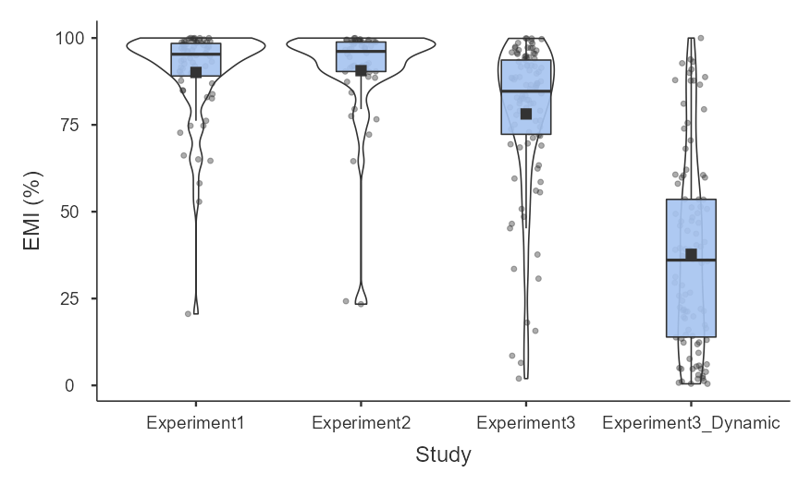
Supplementary Fig. 1. Eye versus mouth looking (EMI) across experiments. Boxplots showing the distribution of EMI for the static faces across the three experiments as well as for the dynamic faces in the last experiment. Square indicates mean. An EMI of 100% entails that the participant looked at the eyes but not at the mouth. An EMI of 0% entails that the participant looked at the mouth but did not look at the eyes

  - Supplementary Fig. 2.
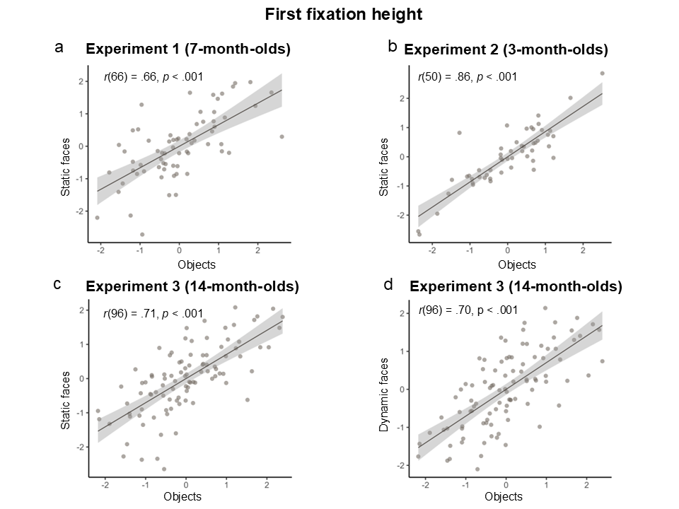
Supplementary Fig. 2. First fixation height across the three experiments, z-score normalized for plotting. a-c. Scatterplots of first fixation height to static faces and static objects across the three experiments. d. Scatterplot of first fixation height to dynamic faces and static objects in Experiment 3.

  - Supplementary Fig. 3.
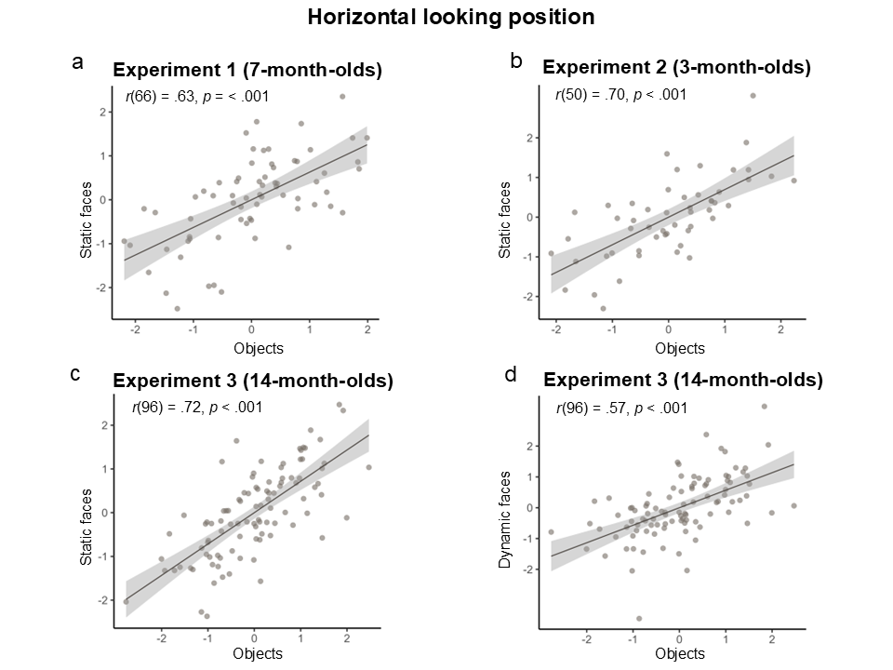
Supplementary Fig. 3. Horizontal looking position across the three experiments, z-score normalized for plotting. a-c. Scatterplots of horizontal looking position for static faces and static objects across the three experiments. d. Scatterplot of horizontal looking position for dynamic faces and static objects in Experiment 3.
  - Supplementary Fig. 4.
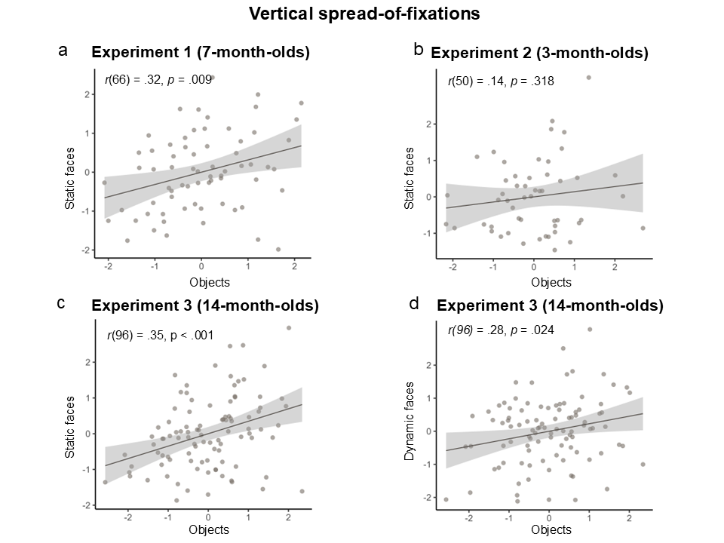
Supplementary Fig. 4. Vertical spread-of-fixations across the three experiments, z-score normalized for plotting. a-c. Scatterplots vertical spread-of-fixations to static faces and static objects across the three experiments. d. Scatterplot of spread-of-fixations to dynamic faces and static objects in Experiment 3.

  - Supplementary Fig. 5.
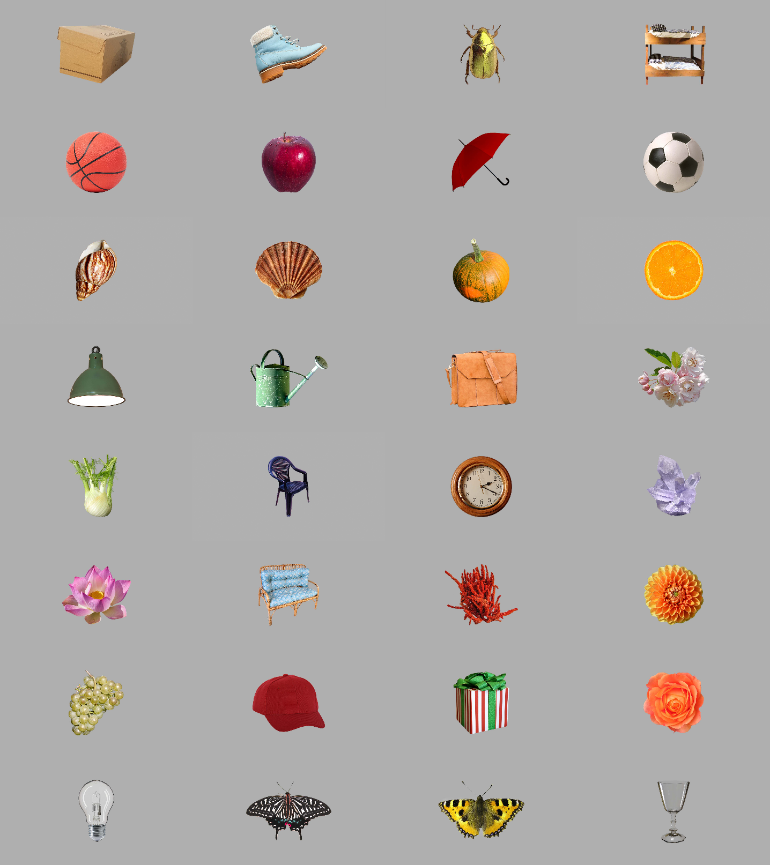
Supplementary Fig. 5. The complete set of objects used. The stimuli were shown one at a time during the session.
  - Supplementary Fig. 6.
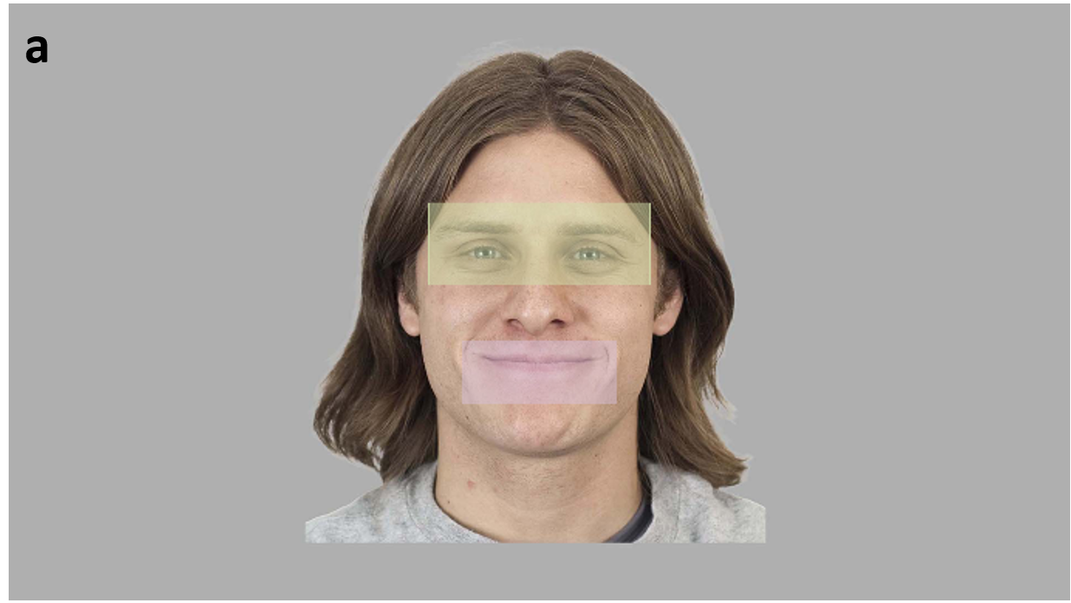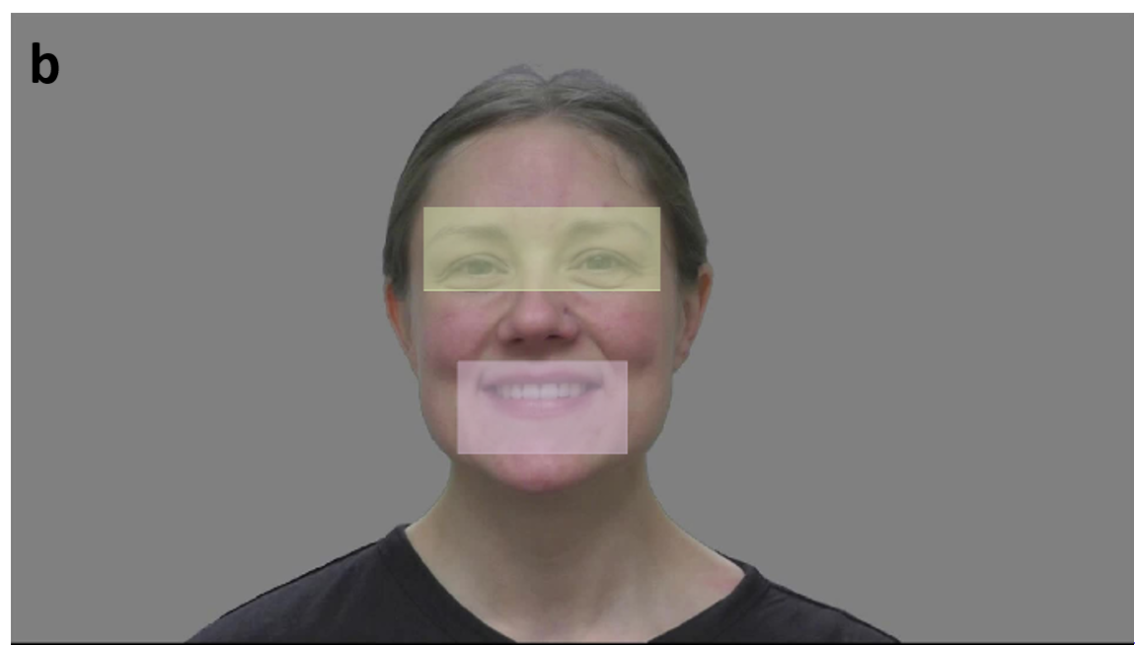
Supplementary Fig. 6. Illustration of mouth and eye Areas-of-Interests (AOIs) used to create the Eye-vs-Mouth-Index (EMI) scores. a. example of a static face used (Experiment 1-3); b. example of a frame from the dynamic faces (Experiment 3 only)

- References
1. Hessels, R. S. & Hooge, I. T. C. Eye tracking in developmental cognitive neuroscience – The good, the bad and the ugly. Developmental Cognitive Neuroscience 40, 100710 (2019).
2. R Core Team. R: A language and environment for statistical computing. R Foundation for Statistical Computing (2023).
3. Posit team. RStudio: Integrated Development Environment for R. Posit Software, PBC (2024).
4. Blignaut, P. Fixation identification: The optimum threshold for a dispersion algorithm. Attention, Perception, & Psychophysics 71, 881–895 (2009).
5. Hessels, R. S., Niehorster, D. C., Kemner, C. & Hooge, I. T. C. Noise-robust fixation detection in eye movement data: Identification by two-means clustering (I2MC). Behav Res 49, 1802–1823 (2017).
6. Kleberg, J. L. et al. Introducing the kollaR package: A user-friendly open-access solution for eye-tracking analysis and visualization. Behav Res 58, 20 (2025).
7. Baltrušaitis, T., Zadeh, A., Lim, Y. C. & Morency, L.-P. Openface 2.0: Facial behavior analysis toolkit. in (2018).
8. The jamovi project. jamovi (2023).
9. IBM SPSS Statistics for Windows. IBM Corp. (2021).
10. Willroth, E. C. & Atherton, O. E. Best Laid Plans: A Guide to Reporting Preregistration Deviations. Advances in Methods and Practices in Psychological Science 7, 25152459231213802 (2024).

