Overcoming Efficiency and Thermal Quenching in Cr³⁺-Activated NIR Phosphors via Donor-Level Engineering​
Junyu Chen, Zixuan Gao, Miaocui Lu, Shufei Qin, Wangchuan Zou, Lige Qiao, Zuizhi Lu*, Yuzhen Zhang*.
Key Laboratory of Chemistry and Engineering of Forest Products, State Ethnic Affairs Commission, Guangxi Key Laboratory of Chemistry and Engineering of Forest Products, Guangxi Collaborative Innovation Center for Chemistry and Engineering of Forest Products, School of Chemistry and Chemical Engineering, Guangxi Minzu University, Nanning 530006, Guangxi, China.
Corresponding Author
*Email: luzuizhi@foxmail.com

Table S1 The various excited-state ZPL energies in the Tanabe-Sugano energy level diagram
Spectra |  | Wavelength (nm) | wave number (cm⁻¹)
PLE | ⁴A₂→⁴T₁ | 260 | 2 387 068
PLE | ⁴A₂→⁴T₂ | 450 | 954 477
PLE | ⁴A₂→²E | 635 | 15 748
PL | ⁴T₂→⁴A₂ | 792 | 1 305 717
Zero phonon line | E(²E_{g}) _{ZPL} | 635 | 15 748
Zero phonon line | E(⁴T_{2g}) _{ZPL} | 668 | 14 970
Stokes | ΔS |  | 2686

Table S2 The calculated results of crystal field parameters
Dq (cm⁻¹) | B (cm⁻¹) | Dq/B | C (cm⁻¹) | C/B
1497 | 656.6 | 2.28 | 3766 | 5.74

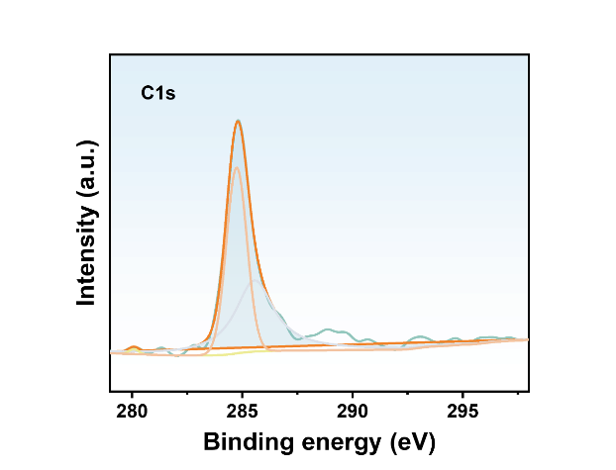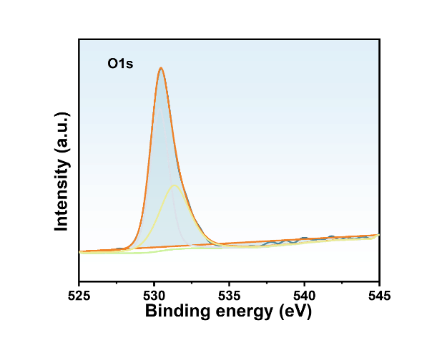
Fig. S1. and S2. The O1s and C1s in XPS spectrum of CGGGO: 1.0 % Cr³⁺ phosphor.
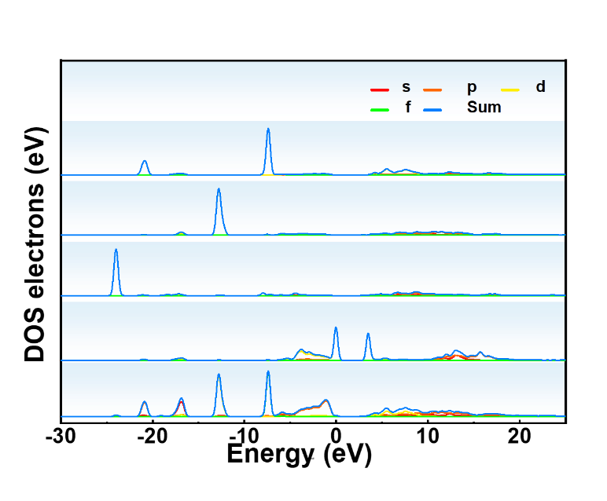
Fig. S3. Density of States Diagram of CGGGO Cr³⁺
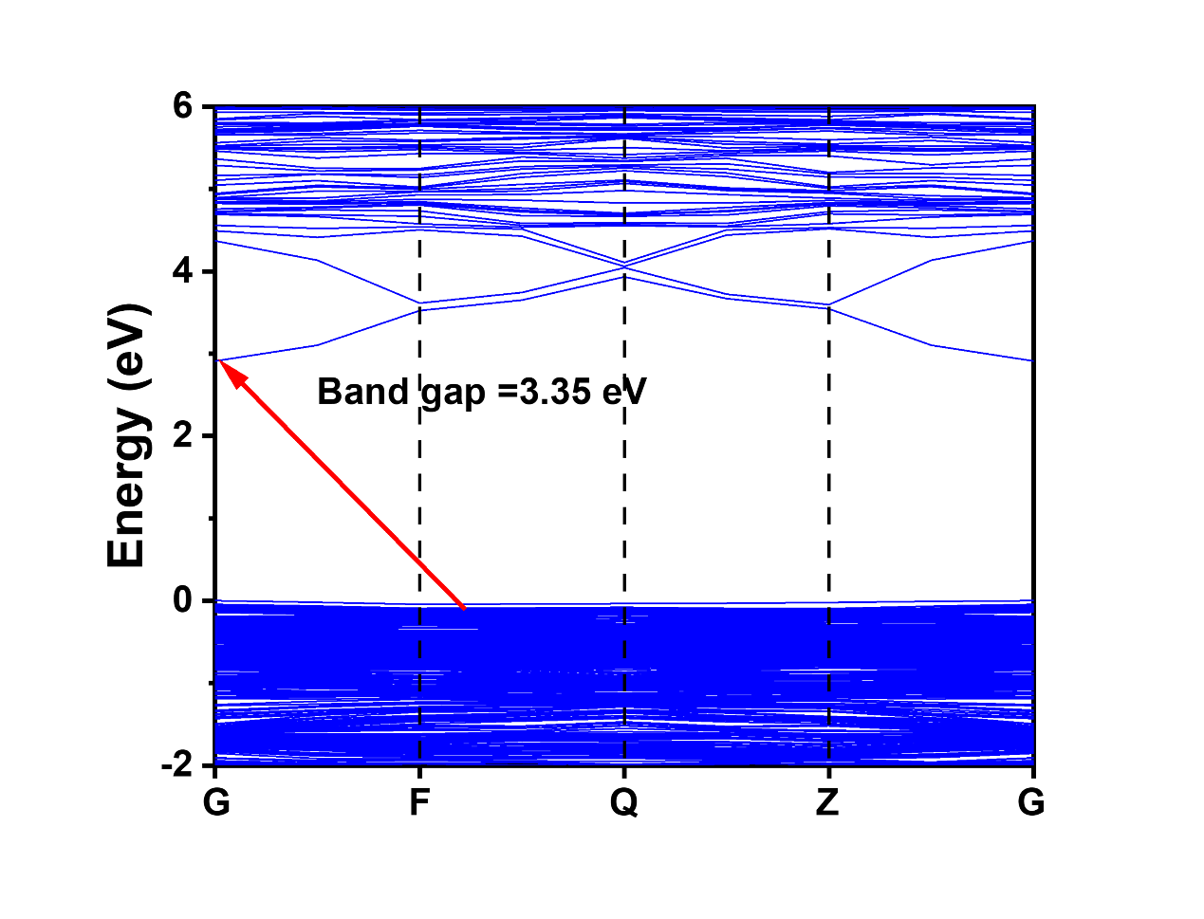
Fig. S4.Calculated indirect band gap of CGGGO.
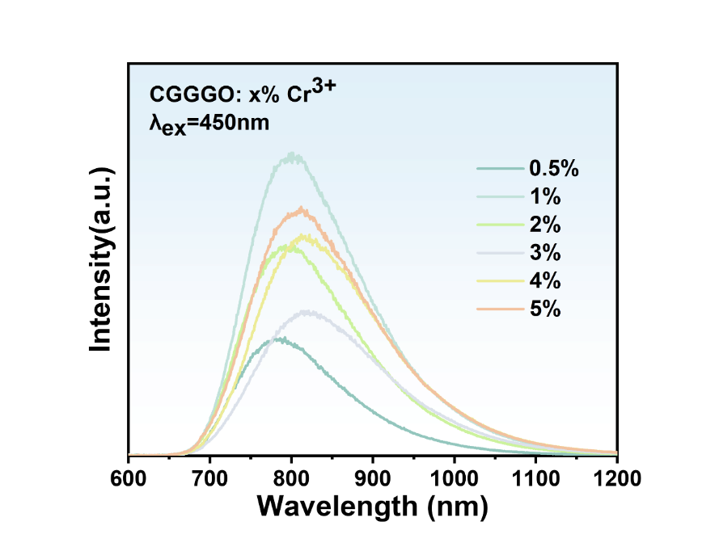
Fig. s5. PL of CGGGO: x Cr³⁺ (x = 0.5-5.0 %) phosphors at 450nm
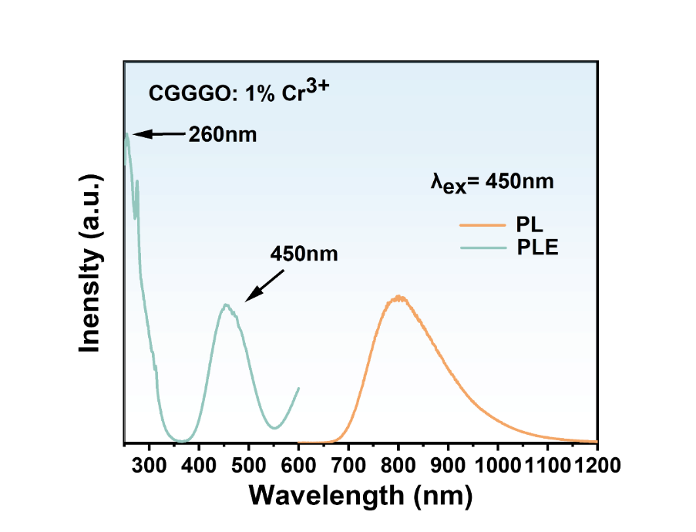
Fig. s5. PL and PLE of CGGGO: 1%Cr³⁺ phosphors at 450nm 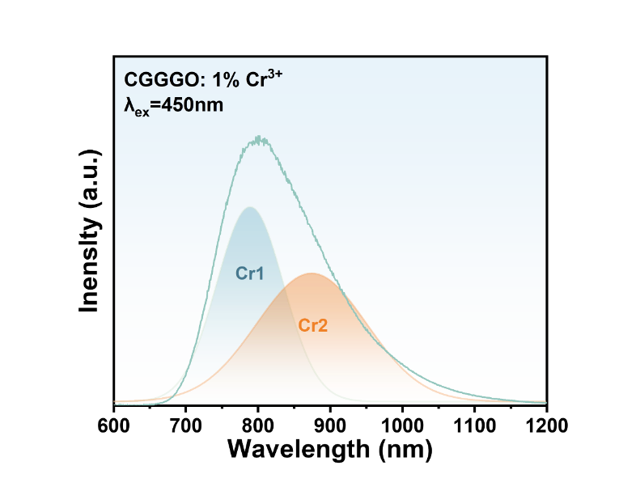
Fig. s6. Gaussian fitting curves of emission spectrum of CGGGO: 1.0 % Cr³⁺ at 450nm.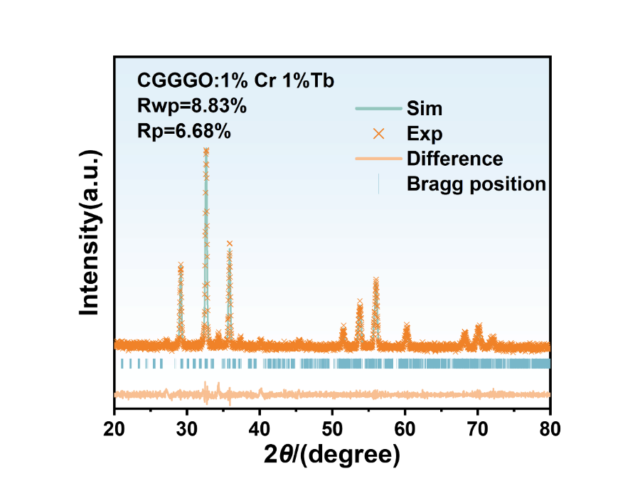
Fig. s7. Rietveld refinement of CGGGO: 1.0 % Cr³⁺ 1% Tb³⁺
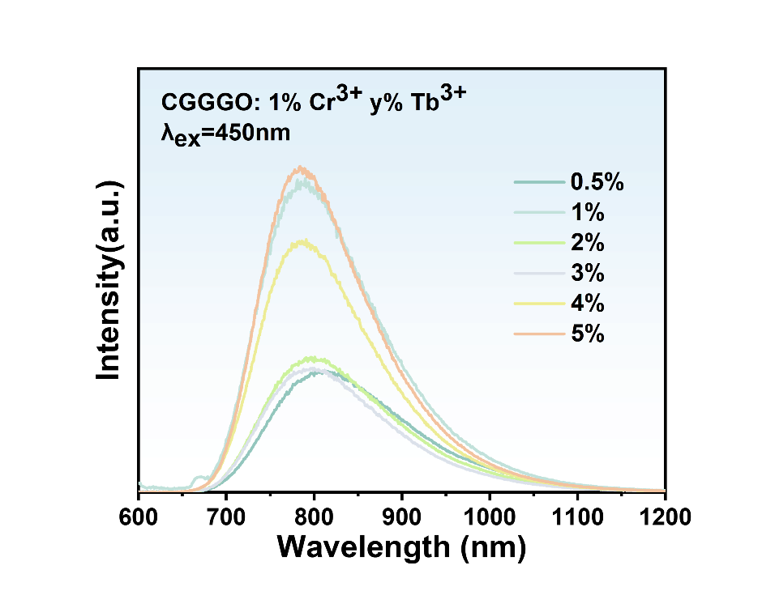
Fig. s8. PL of CGGGO: 1 Cr³⁺ x% Tb³⁺ (x = 0.5-5.0 %) phosphors at 450nm
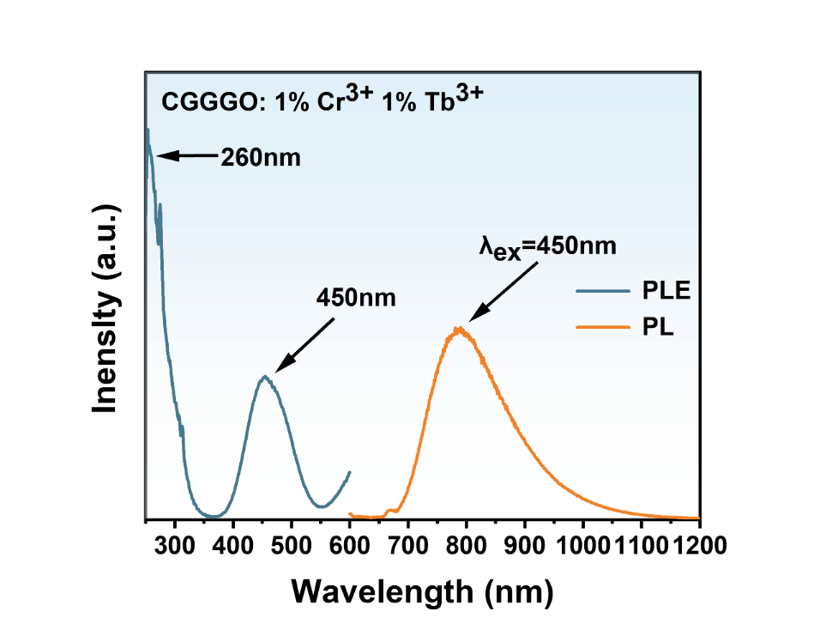
Fig. s9. PL and PLE of CGGGO: 1%Cr³⁺ 1% Tb³⁺ phosphors at 450nm 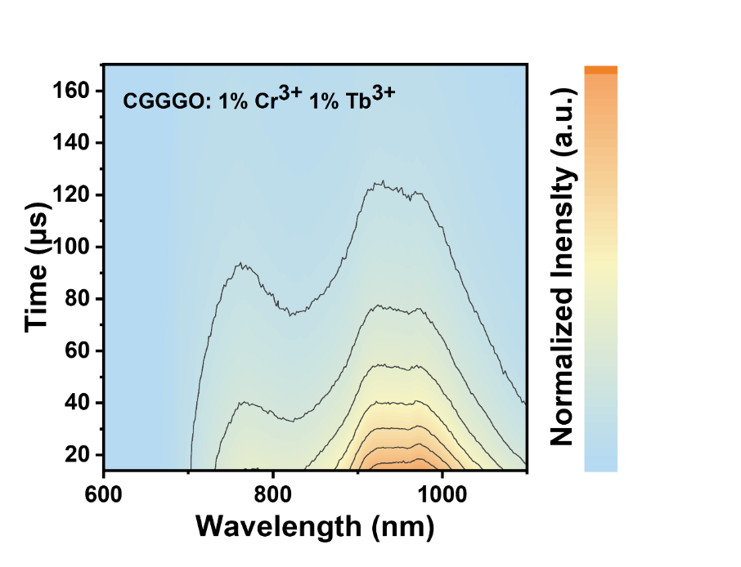
Fig. s10. The TRES of CGGGO: 1%Cr³⁺ 1% Tb³⁺ phosphors

