Hollow Bowl‑Like MXene/FeNi₃ Heterostructures for Electromagnetic Wave Absorption and Photo‑Thermo‑Electric Conversion
Na Chen^{*,1}, Fang-Yuan Yi¹, Zhen-Jie Guan², Kang-Jun Wang^{*,1}, and Jian-Tang Jiang²

¹ College of Chemical Engineering, Shenyang University of Chemical Technology, Shenyang 110142, China
² School of Materials Science and Engineering, Harbin Institute of Technology, Harbin, 150001, China
Corresponding Authors:
E-mail address: na_chen@syuct.edu.cn, wangkj_dut@syuct.edu.cn

1. Materials
Ti₃AlC₂ MAX phase (400 mesh, 99 wt%) was procured from Jilin 11 Technology Co., Ltd. The following reagents were supplied by Guoyao Chemical Reagent Co., Ltd. and used as received without further purification: azobisisobutyronitrile (AIBN), methyl methacrylate (MMA), hydrochloric acid (HCl, 99%), lithium fluoride (LiF, 99%), hydrazine hydrate (N₂H₄·H₂O, 85%), ferrous chloride tetrahydrate (FeCl₂·4H₂O, 99%), nickel chloride tetrahydrate (NiCl₂·6H₂O, 99%), ethylene glycol (EG) and anhydrous methanol (CH₃OH, ≥99.7%). Polyvinylpyrrolidone (PVP) was obtained from Beijing Wokai Biotechnology Co., Ltd.
2. Experimental
2.1 Preparation of Bowl-like MXene
Synthesis of PMMA Spheres. Initially, 0.02 g of AIBN (initiator) and 0.8 g of PVP (stabilizer) were dissolved in 36 mL of methanol. The solution was purged with nitrogen for 30 min to remove dissolved oxygen, after which 2 g of MMA was added. Polymerization was conducted at 55 °C under a continuous nitrogen flow for 4 h, then the temperature was elevated to 70 °C and maintained for an additional 20 h. The obtained product was thoroughly washed with deionized water and dried at ambient temperature, yielding polymethyl methacrylate (PMMA) spheres.
Preparation of Ti₃C₂T_{x} MXene. 1.6 g of LiF was dissolved in 20 mL of 12 M HCl under vigorous stirring at room temperature for 30 min. Thereafter, 1.0 g of the MAX phase precursor was gradually added to the solution over 10 min to control the exothermic reaction and prevent overheating. The resulting mixture was washed via three centrifugation-rinsing cycles using 20 mL of 2 M HCl to remove residual LiF, followed by repeated washing with deionized water until the supernatant reached a pH of ≈6–7. The collected solid was further centrifuged at 3500 r/min to maximize yield, after which the supernatant was retained. Finally, few‑layer Ti₃C₂T_{x} MXene was obtained after freeze‑drying.
Fabrication of PMMA@MXene Spheres. Subsequently, 0.2 g of the as-prepared PMMA was dispersed in 20 mL of deionized water by ultrasonication for 20 min. Under vigorous stirring, 10 mL of an aqueous MXene suspension (8 mg/mL) was introduced dropwise. The mixture was allowed to react overnight, followed by centrifugation at 5000 rpm for 5 min. The collected precipitate was rinsed repeatedly with deionized water and dried overnight under vacuum at room temperature, affording PMMA@MXene spheres.
Preparation of Bowl-like MXene Structures. The PMMA@MXene spheres were subjected to calcination at 450 °C for 90 min under a nitrogen atmosphere, leading to the formation of bowl-like MXene architectures.
2.2 Preparation of Bowl-like MXene/FeNi₃ Heterostructure
Bowl-like MXene/FeNi₃ heterostructure were synthesized via a facile one-step hydrothermal method. First, 0.2 g of bowl-like MXene was dispersed in 100 mL of EG. Subsequently, 0.270 g of FeCl₂·4H₂O and 0.615 g of NiCl₂·6H₂O were added to the suspension. The mixture was placed in a water bath and mechanically stirred at 350 rpm for 20 min to facilitate the electrostatic adsorption of Ni²⁺ and Fe²⁺ onto the MXene surface. Next, 2.0 g of NaOH was introduced and stirred for 10 min, followed by the addition of 5 mL of N₂H₄·H₂O. The reaction was then carried out at 85 °C for 1 h under continuous stirring. The resulting product was collected by centrifugation, washed thoroughly with deionized water and ethanol, and dried in a vacuum oven at 60 °C for 24 h to obtain the MXene/FeNi₃ heterostructure. To study the influence of composition on the material properties, a series of experiments were performed by varying the amount of NiCl₂·6H₂O (0.615, 0.923, and 1.230 g) while keeping the molar ratio of FeCl₃·6H₂O to NiCl₂·6H₂O constant at 1:1. The corresponding samples were designated as BMFN–1, BMFN–2, and BMFN–3, respectively.
2.3 Characterization
The crystalline structure of the as prepared heterostructures was characterized by X-ray diffraction (XRD) on a Bruker D8 ADVANCE diffractometer using Cu Kα radiation (λ = 1.5418 Å). Morphological and microstructural analyses were performed using scanning electron microscopy (SEM) and transmission electron microscopy (TEM) equipped with energy-dispersive X-ray spectroscopy (EDS). Surface chemical states were examined by X-ray photoelectron spectroscopy (XPS) on a Thermo Scientific ESCALAB 250Xi system. Raman spectra were acquired using a Horiba LabRAM HR Evolution spectrometer with a 532 nm laser excitation. Fourier-transform infrared (FT–IR) spectra were recorded on a Shimadzu IRTracer-100 spectrophotometer. Ultraviolet–visible (UV–Vis) transmission spectra were collected in the range of 200–800 nm using a Shimadzu UV-1800 spectrophotometer. Room-temperature electron paramagnetic resonance (EPR) measurements were conducted on a Bruker A300-10/12 spectrometer. Magnetic properties were evaluated at room temperature using a Lake Shore 7404 vibrating sample magnetometer (VSM). Electromagnetic parameters over the frequency range of 2–18 GHz were measured with an Agilent N5230A vector network analyzer (VNA). Electrochemical measurements were performed on a CHI760E electrochemical workstation (Shanghai Chenhua Instrument Co., Ltd.) with a three-electrode configuration, in which the sample was used directly as the working electrode, along with an Ag/AgCl reference electrode and a Pt counter electrode. All electrochemical impedance spectroscopy (EIS) and potentiodynamic polarization tests were carried out in a 3.5 wt% NaCl aqueous solution under ambient conditions.

Fig. S1 XRD pattern of few-layer MXene.

Fig. S2 High resolution XPS spectrum of C 1s.

Fig. S3 High resolution XPS spectrum of Ti 2p.

Fig. S4 High resolution XPS spectrum of O 1s.

Fig. S5 Electromagnetic parameters of few-layer MXene.

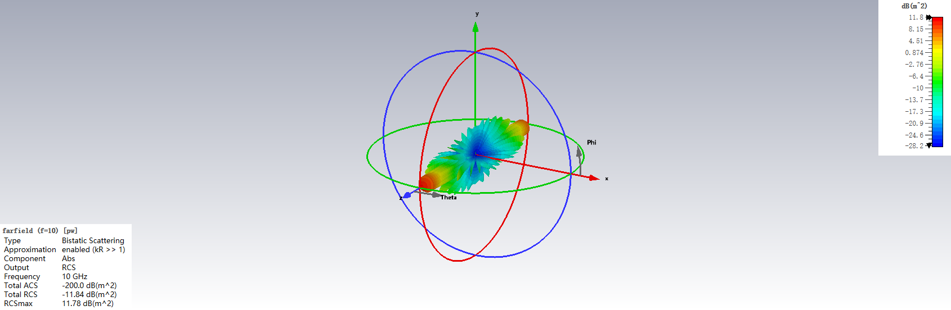
Fig. S6 3D RCS simulation result of perfect conductive plate (PEC).

Fig. S7 EMA performance of few-layer MXene.

Fig. S8 XRD patterns of (a) MXene/Co, (b) MXene/CoNi, (c) MXene/Co₇Fe₃, and (d) MXene/FeCoNi.

Fig. S9 (a) Complex permittivity. (b) Complex permeability. (c) Tangent magnetic and dielectric loss. (d) attenuation constant. Contour map of (e) MXene/Co, (f) MXene/CoNi, (g) MXene/Co₇Fe₃, and (h) MXene/FeCoNi.

Fig. S10 (a) Photothermal temperature curves. (b) open-circuit voltage. (c) short-circuit currents.

