A Weakly Supervised Preprocessing Pipeline for Multi-Modal Image Pair Generation for Image Registration
Daksh Daksh ¹, Anke Kaltbeitzel ¹, Gunnar Glaßer ¹, Katharina Landfester ¹, Ingo Lieberwirth ^{1*}

¹Max Planck Institute for Polymer Research, Ackermannweg 10, 55128 Mainz, Germany.
*Corresponding author (Email: lieberw@mpip-mainz.mpg.de, Tel.: +49 6131 379 580)

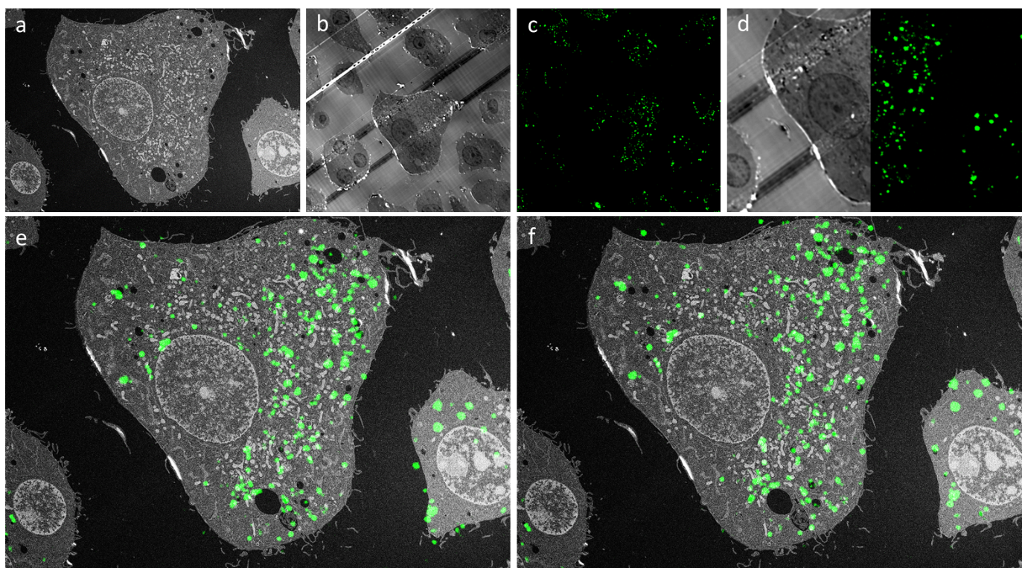
Fig.S1: Registration results displayed with the fluorescence channel of the LM image dataset for the image data presented in the upper panel of Figure 5. a is the raw EM input image, b and c are reflected and fluorescence channels of the raw LM image. Panel d displays the cropped LM image, with the reflective channel on the left and the fluorescence channel on the right. Panel e shows the overlay of the EM and the fluorescence just for the cropped image, whereas in panel f the overlay after machine learning registration is shown.
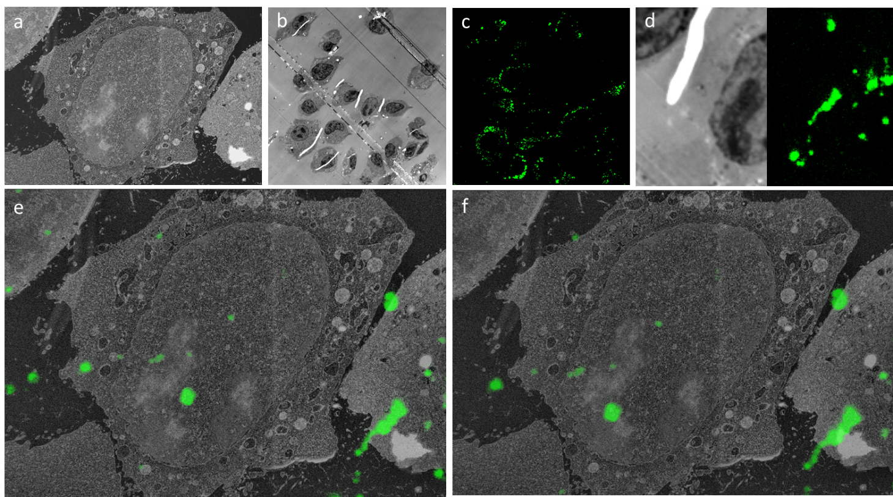

Fig.S2: Same as in Fig. S1 but for the dataset presented in the lower panel of Fig. 5.

