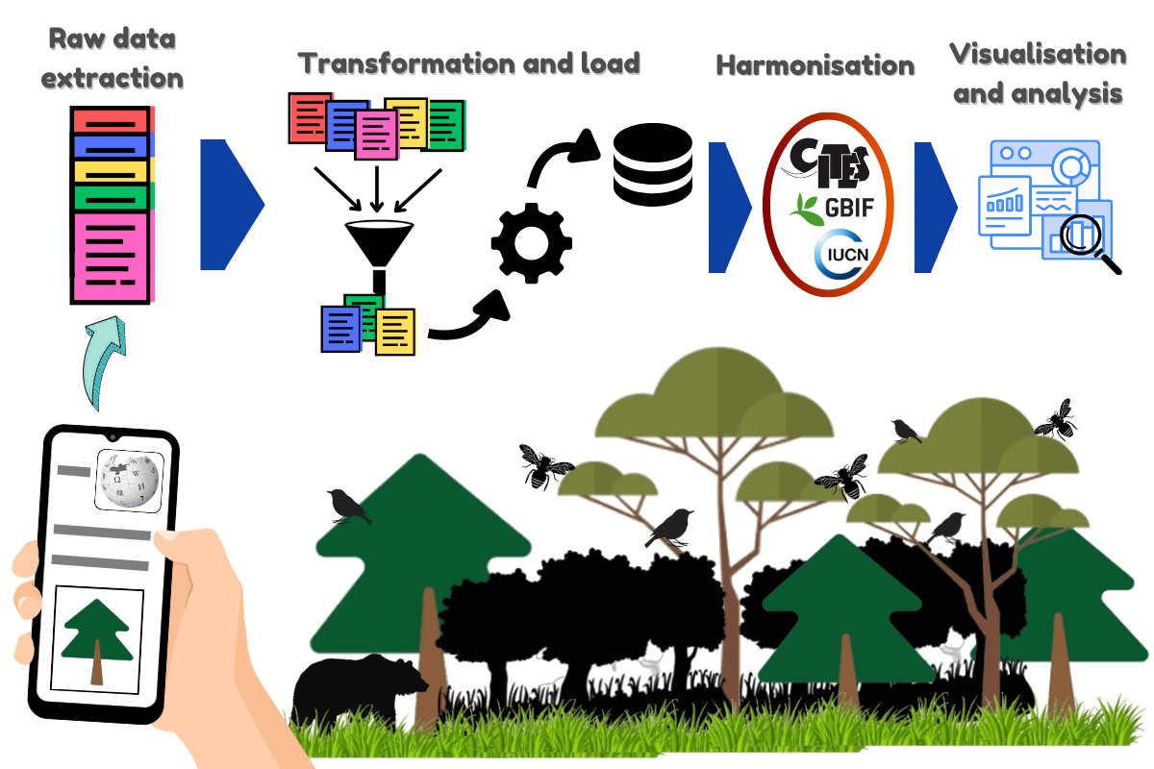
Figure S1: A graphic representation of the conservation culturomics workflow using Wikipedia. Biodiversity information searched or edited on the website is recorded in the website's API, which serves as the basis for raw data extraction. It is transformed through data filtration and other necessary steps for the study, loaded into the final dataset, and harmonised with external datasets such as IUCN, GBIF, CITES, and other similar repositories. The merged data is used for analysis and visualisations required for a particular study.
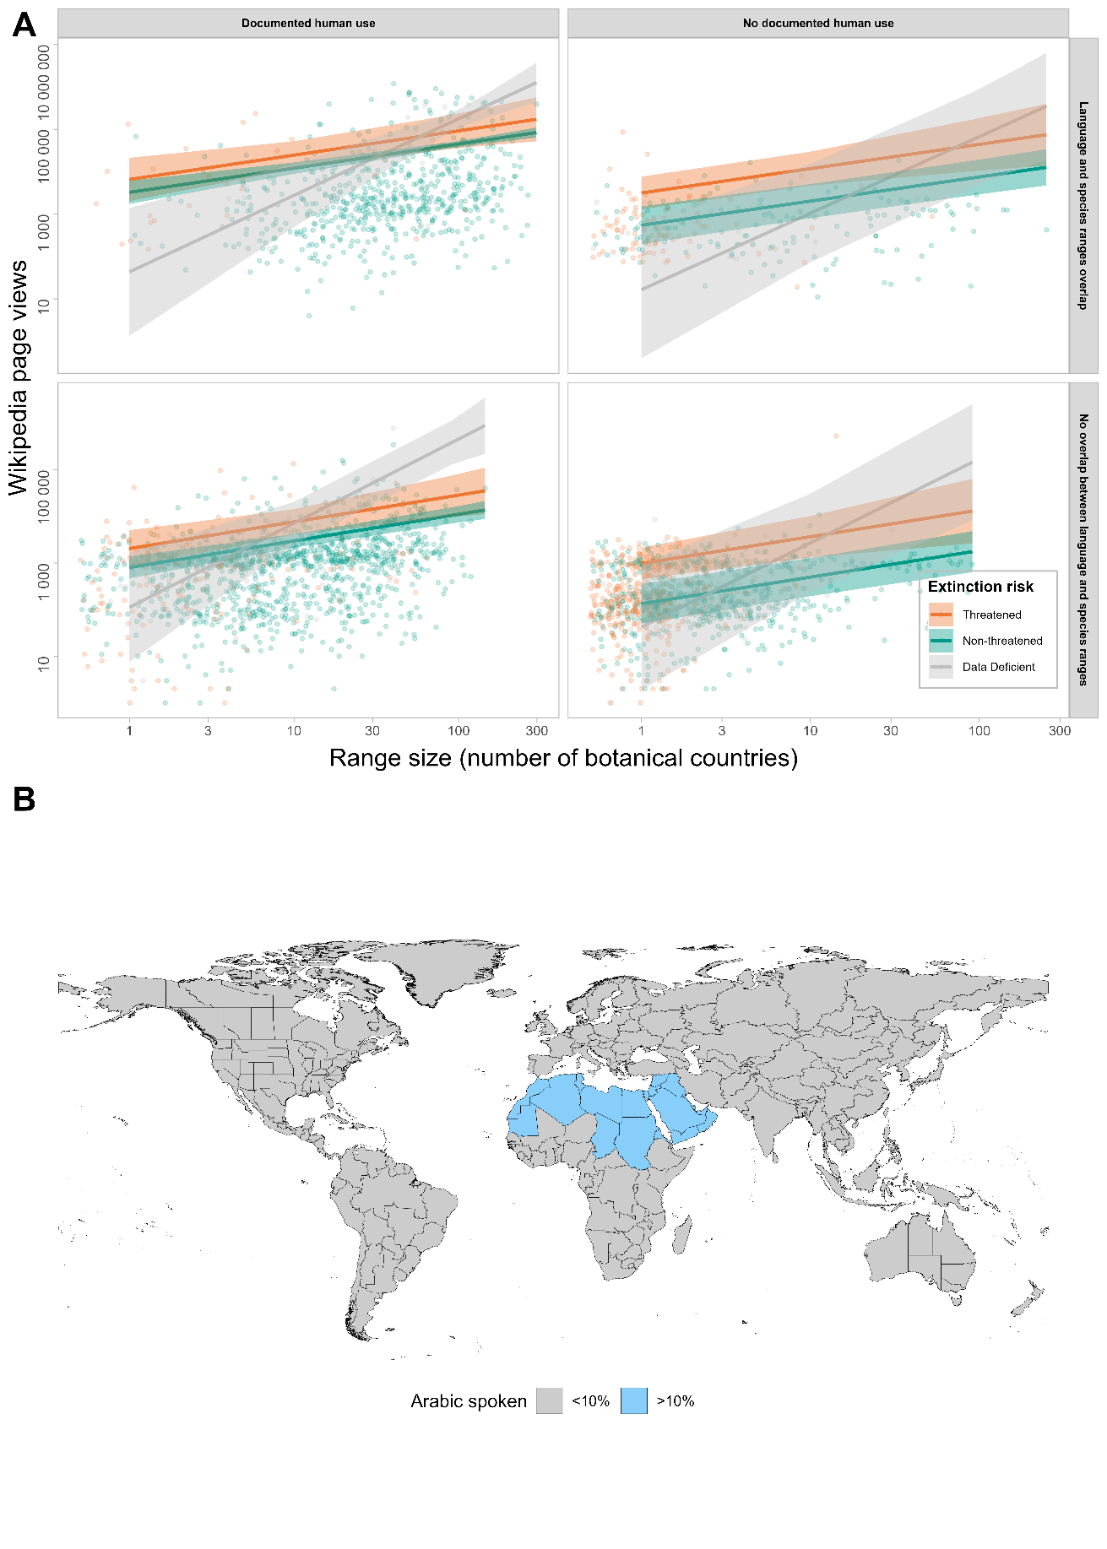
Figure S2(i): Effect of covariates on page views in the local-language Wikipedia. (A) Page views across extinction risk, range size, documented use and geographic overlap; shown here for the Arabic language edition. The threatened species are shown in red-orange, Data Deficient species in grey, and non-threatened species in green. Shaded ribbons show the standard error. (B) The geographical distribution (botanical countries) of the Arabic language Wikipedia, where the Arabic edition of Wikipedia comprises >10% of total Wikipedia views. Blue represents the botanical countries where >10% of the Arabic Wikipedia is used. Grey indicates countries where <10% of Wikipedia views are from the Arabic language edition.

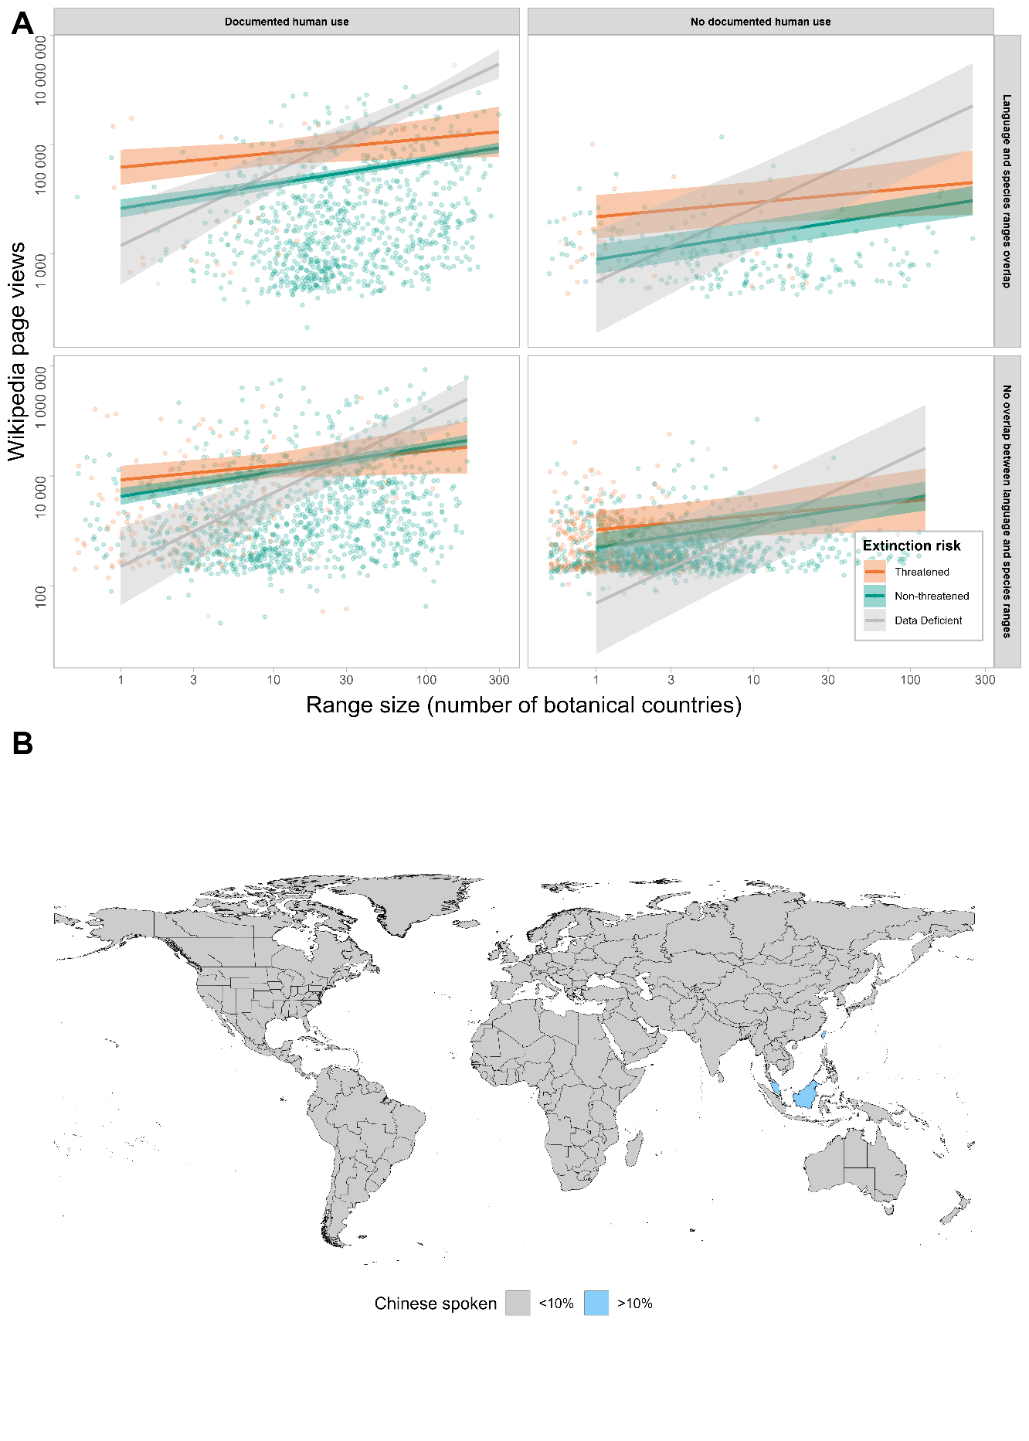
Figure S2(ii): Effect of covariates on page views in the local-language Wikipedia. (A) Page views across extinction risk, range size, documented use and geographic overlap; shown here for the Chinese language edition. The threatened species are shown in red-orange, Data Deficient species in grey, and non-threatened species in green. Shaded ribbons show the standard error. (B) The geographical distribution (botanical countries) of the Chinese language Wikipedia, where the Chinese edition of Wikipedia comprises >10% of total Wikipedia views. Blue represents the botanical countries where >10% of the Chinese Wikipedia is used. Grey indicates countries where <10% of Wikipedia views are from the Chinese language edition.

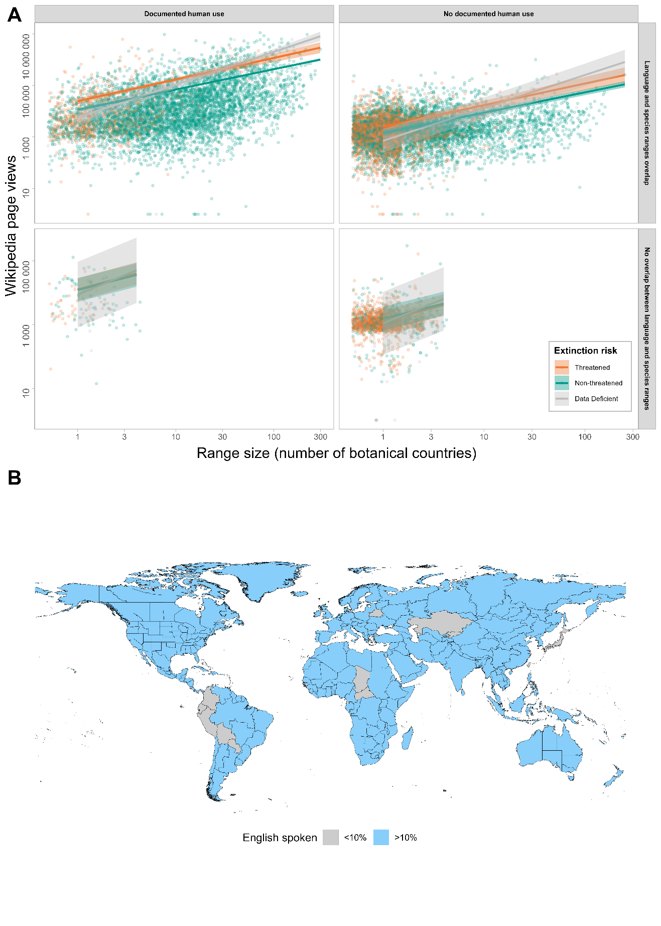
Figure S2(iii): Effect of covariates on page views in the local-language Wikipedia. (A) Page views across extinction risk, range size, documented use and geographic overlap; shown here for the English language edition. The threatened species are shown in red-orange, Data Deficient species in grey, and non-threatened species in green. Shaded ribbons show the standard error. (B) The geographical distribution (botanical countries) of the English language Wikipedia, where the English edition of Wikipedia comprises >10% of total Wikipedia views. Blue represents the botanical countries where >10% of the English Wikipedia is used. Grey indicates countries where <10% of Wikipedia views are from the English language edition.

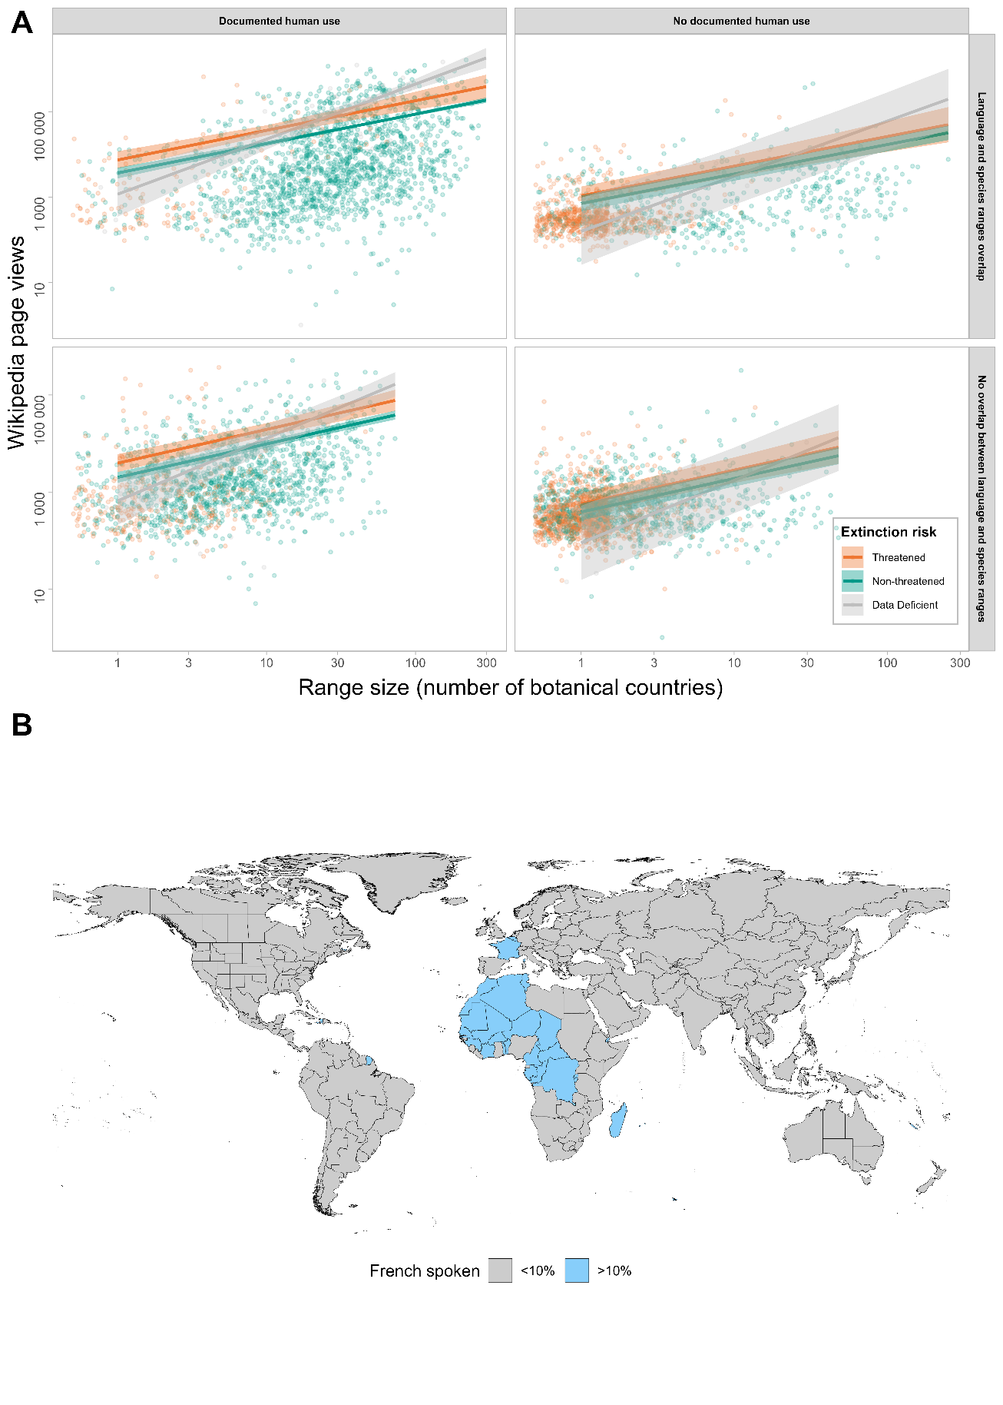
Figure S2(iv): Effect of covariates on page views in the local-language Wikipedia. (A) Page views across extinction risk, range size, documented use and geographic overlap; shown here for the French language edition. The threatened species are shown in red-orange, Data Deficient species in grey, and non-threatened species in green. Shaded ribbons show the standard error. (B) The geographical distribution (botanical countries) of the French language Wikipedia, where the French edition of Wikipedia comprises >10% of total Wikipedia views. Blue represents the botanical countries where >10% of the French Wikipedia is used. Grey indicates countries where <10% of Wikipedia views are from the French language edition.

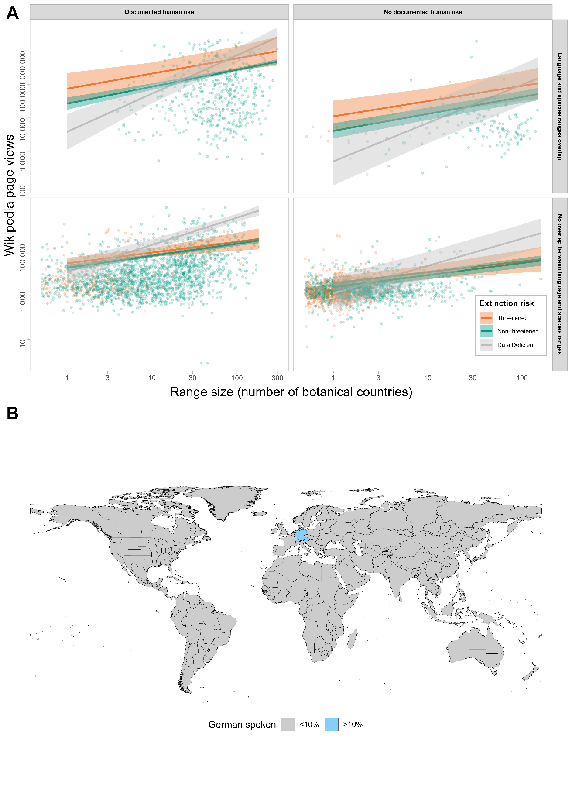
Figure S2(v): Effect of covariates on page views in the local-language Wikipedia. (A) Page views across extinction risk, range size, documented use and geographic overlap; shown here for the German language edition. The threatened species are shown in red-orange, Data Deficient species in grey, and non-threatened species in green. Shaded ribbons show the standard error. (B) The geographical distribution (botanical countries) of the German language Wikipedia, where the German edition of Wikipedia comprises >10% of total Wikipedia views. Blue represents the botanical countries where >10% of the German Wikipedia is used. Grey indicates countries where <10% of Wikipedia views are from the German language edition.

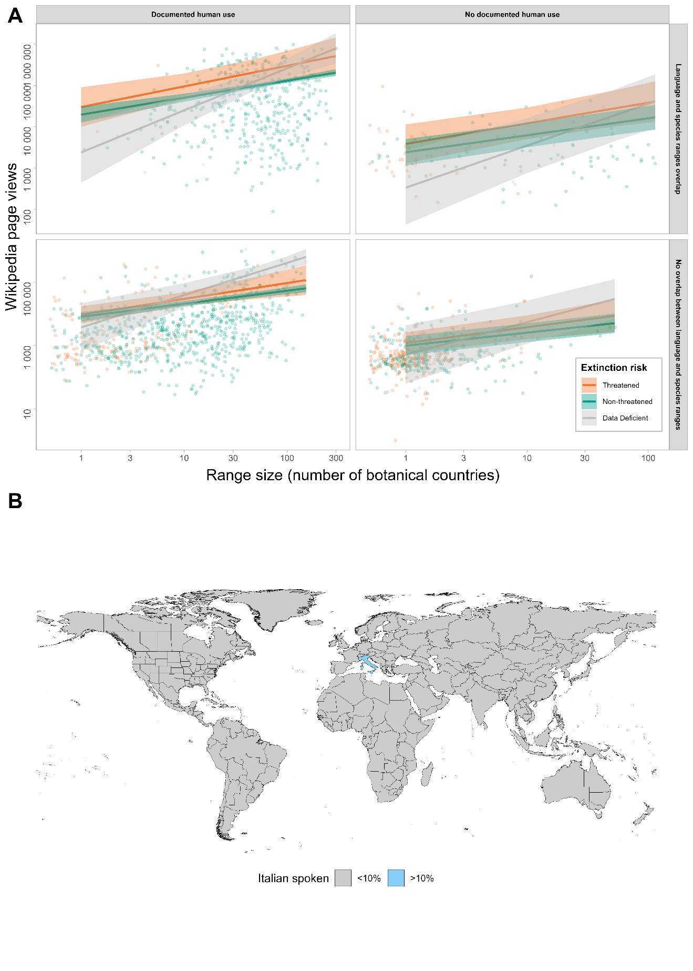
Figure S2(vi): Effect of covariates on page views in the local-language Wikipedia. (A) Page views across extinction risk, range size, documented use and geographic overlap; shown here for the Italian language edition. The threatened species are shown in red-orange, Data Deficient species in grey, and non-threatened species in green. Shaded ribbons show the standard error. (B) The geographical distribution (botanical countries) of the Italian language Wikipedia, where the Italian edition of Wikipedia comprises >10% of total Wikipedia views. Blue represents the botanical countries where >10% of the Italian Wikipedia is used. Grey indicates countries where <10% of Wikipedia views are from the Italian language edition.

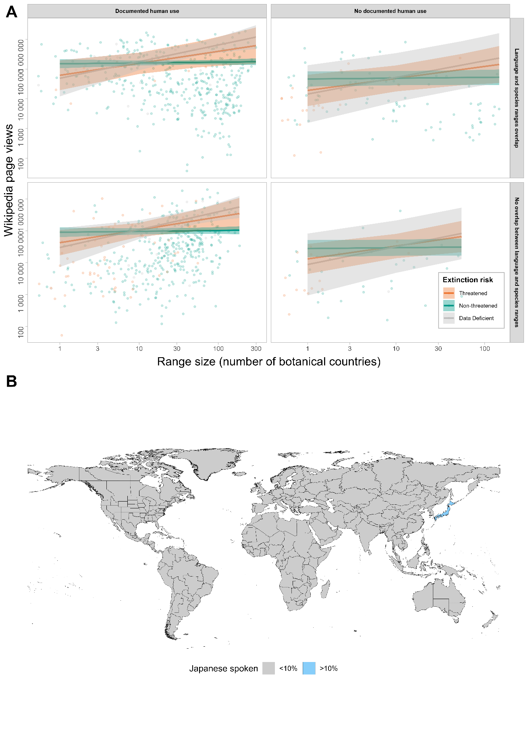
Figure S2(vii): Effect of covariates on page views in the local-language Wikipedia. (A) Page views across extinction risk, range size, documented use and geographic overlap; shown here for the Japanese language edition. The threatened species are shown in red-orange, Data Deficient species in grey, and non-threatened species in green. Shaded ribbons show the standard error. (B) The geographical distribution (botanical countries) of the Japanese language Wikipedia, where the Japanese edition of Wikipedia comprises >10% of total Wikipedia views. Blue represents the botanical countries where >10% of the Japanese Wikipedia is used. Grey indicates countries where <10% of Wikipedia views are from the Japanese language edition.

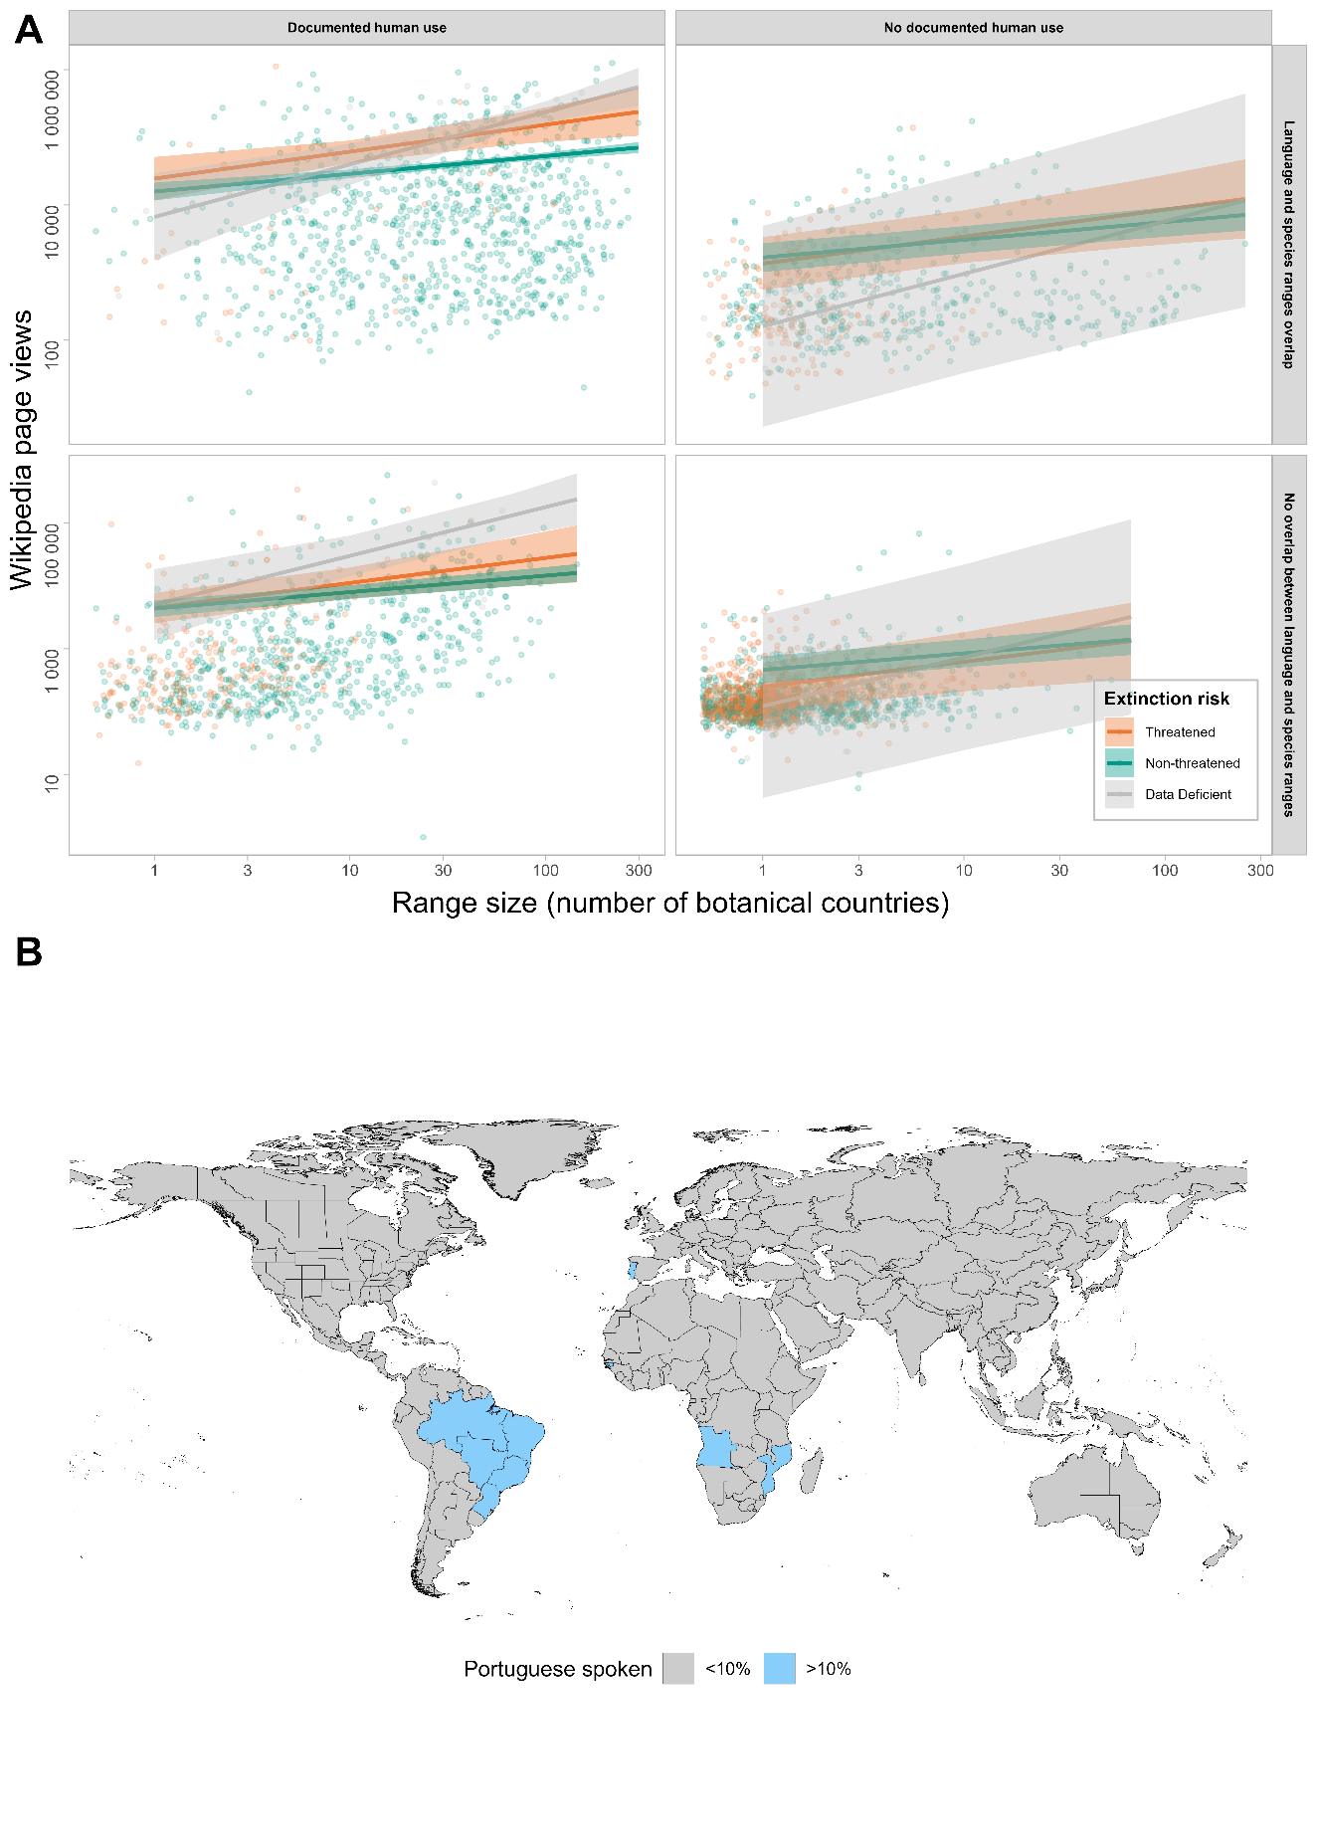
Figure S2(viii): Effect of covariates on page views in the local-language Wikipedia. (A) Page views across extinction risk, range size, documented use and geographic overlap; shown here for the Portuguese language edition. The threatened species are shown in red-orange, Data Deficient species in grey, and non-threatened species in green. Shaded ribbons show the standard error. (B) The geographical distribution (botanical countries) of the Portuguese language Wikipedia, where the Arabic edition of Wikipedia comprises >10% of total Wikipedia views. Blue represents the botanical countries where >10% of the Portuguese Wikipedia is used. Grey indicates countries where <10% of Wikipedia views are from the Portuguese language edition.

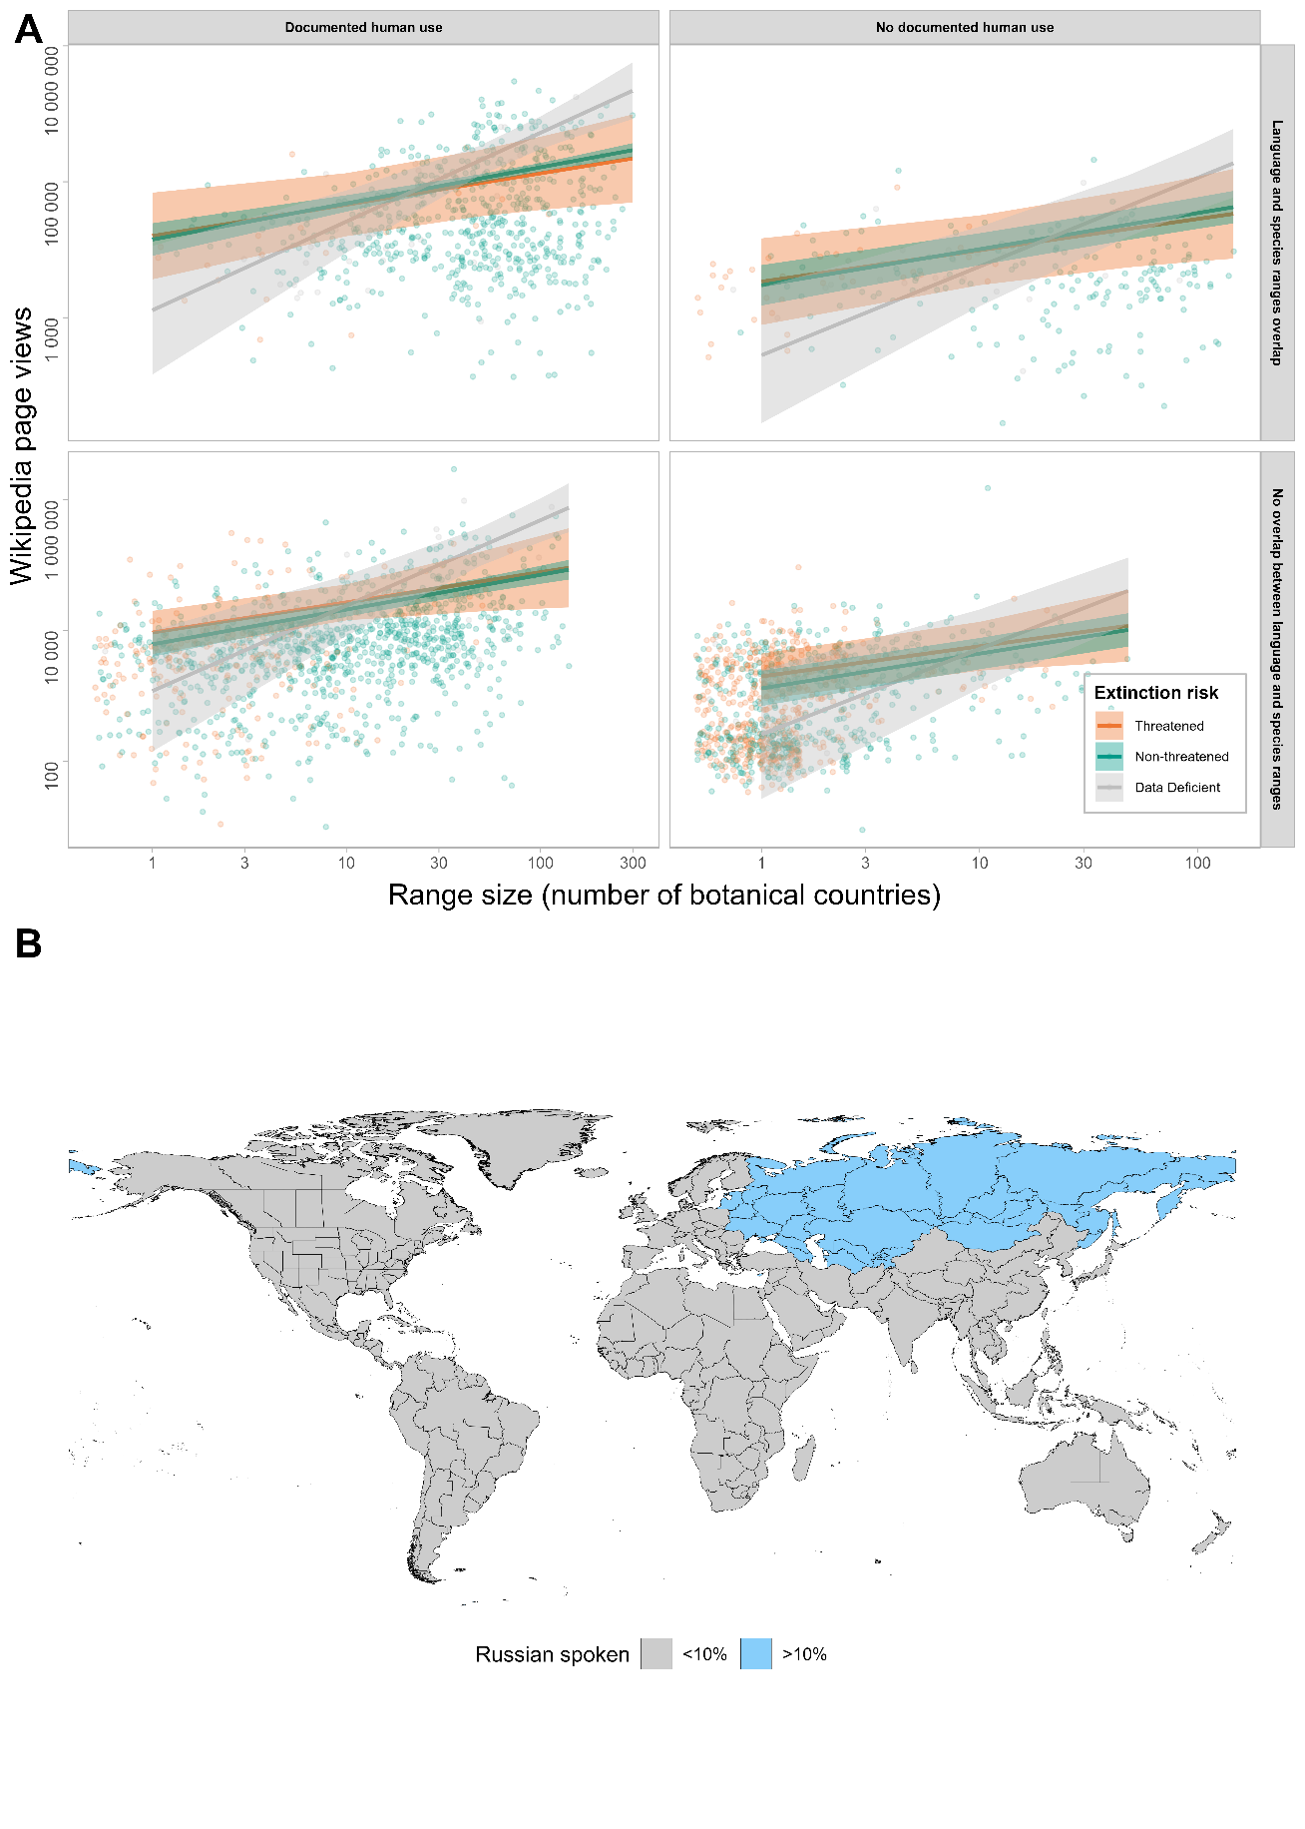
Figure S2(ix): Effect of covariates on page views in the local-language Wikipedia. (A) Page views across extinction risk, range size, documented use and geographic overlap; shown here for the Russian language edition. The threatened species are shown in red-orange, Data Deficient species in grey, and non-threatened species in green. Shaded ribbons show the standard error. (B) The geographical distribution (botanical countries) of the Russian language Wikipedia, where the Russian edition of Wikipedia comprises >10% of total Wikipedia views. Blue represents the botanical countries where >10% of the Russian Wikipedia is used. Grey indicates countries where <10% of Wikipedia views are from the Russian language edition.
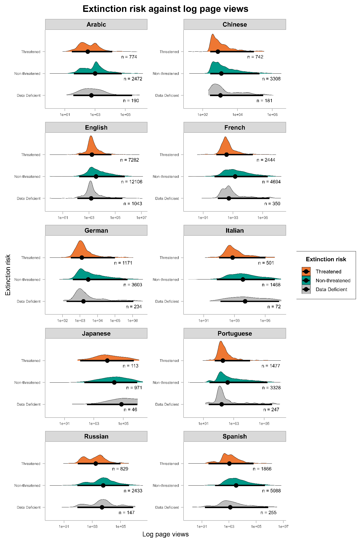
Figure S3: Wikipedia page views (All language editions; log₁₀ transformed) across extinction risk categories. The solid black dots denote the median page views in each category, and the black lines denote the 95% density distribution. The distribution of page views density is shown in the coloured areas. The orange, green and grey plots show the page views distribution for threatened, non-threatened and data-deficient species, respectively. ‘n’ denotes the total species count in each category.
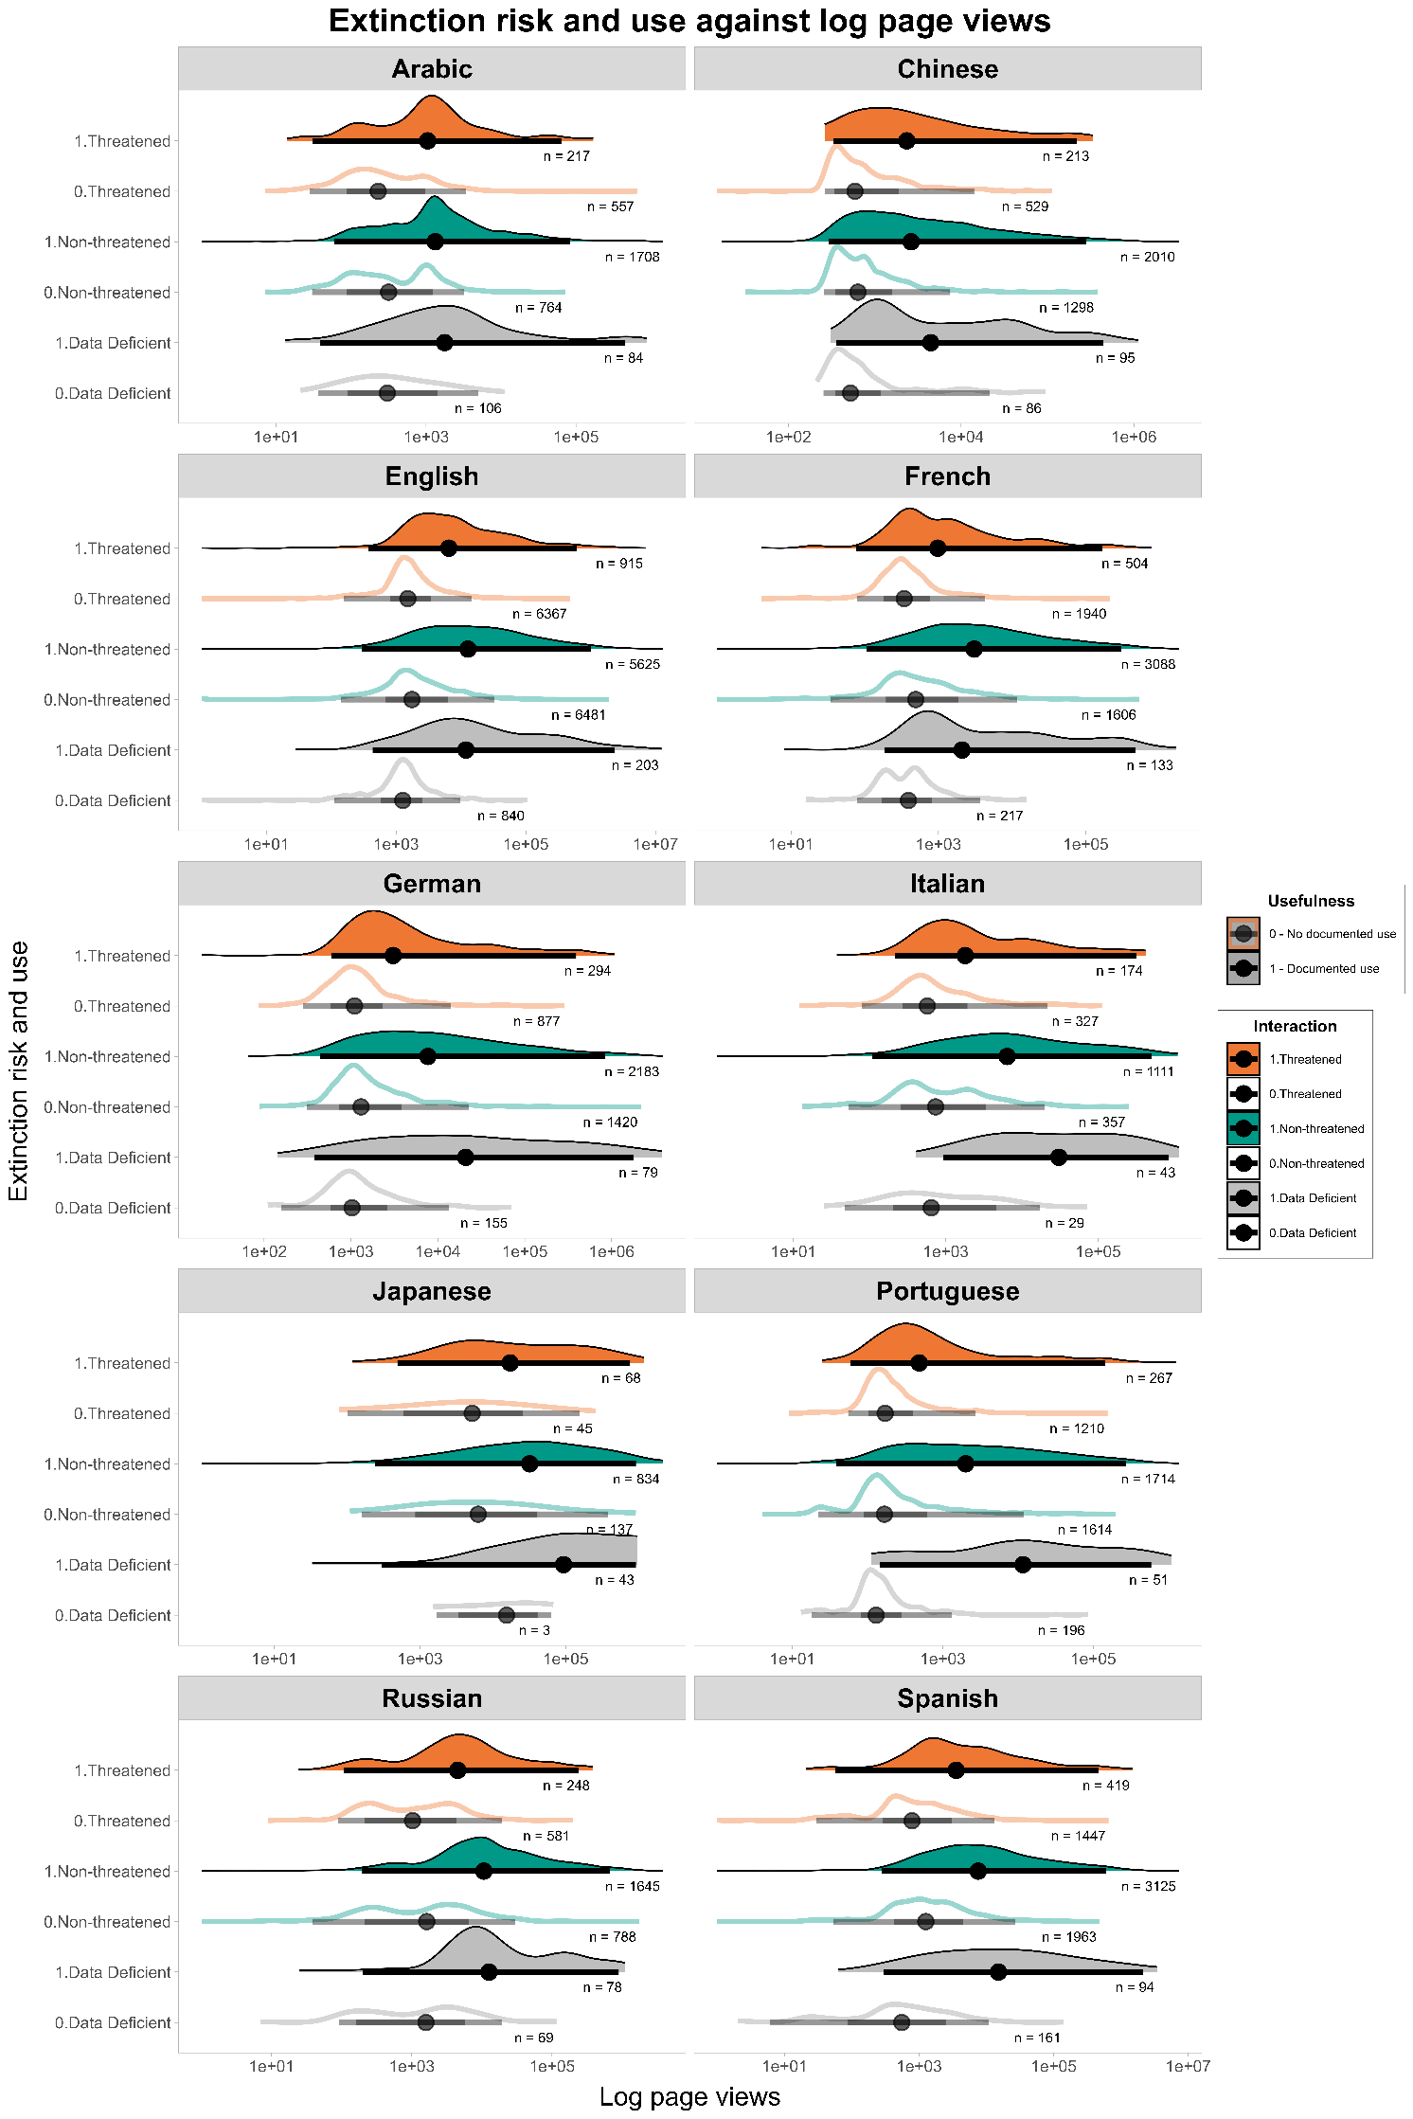
Figure S4: Wikipedia page views and documented use (All language edition; log₁₀ transformed) across extinction risk categories. 1 represents use, while 0 represents non-use. The solid black dots denote the median pageviews in each category, and the black lines denote a 95% density distribution. The density of page views distribution is shown in the coloured areas. Solid plots depict useful plants, and hollow plots depict non-useful plants. Solid red plot - threatened and useful plants; hollow red plot - threatened and non-useful species; solid green plot - non-threatened useful species; hollow green plot - non-threatened and non-useful plants; solid grey plot - data-deficient and useful species; hollow grey plot - data-deficient non-useful plant species. ‘n ’ gives the total number of species for each interaction.

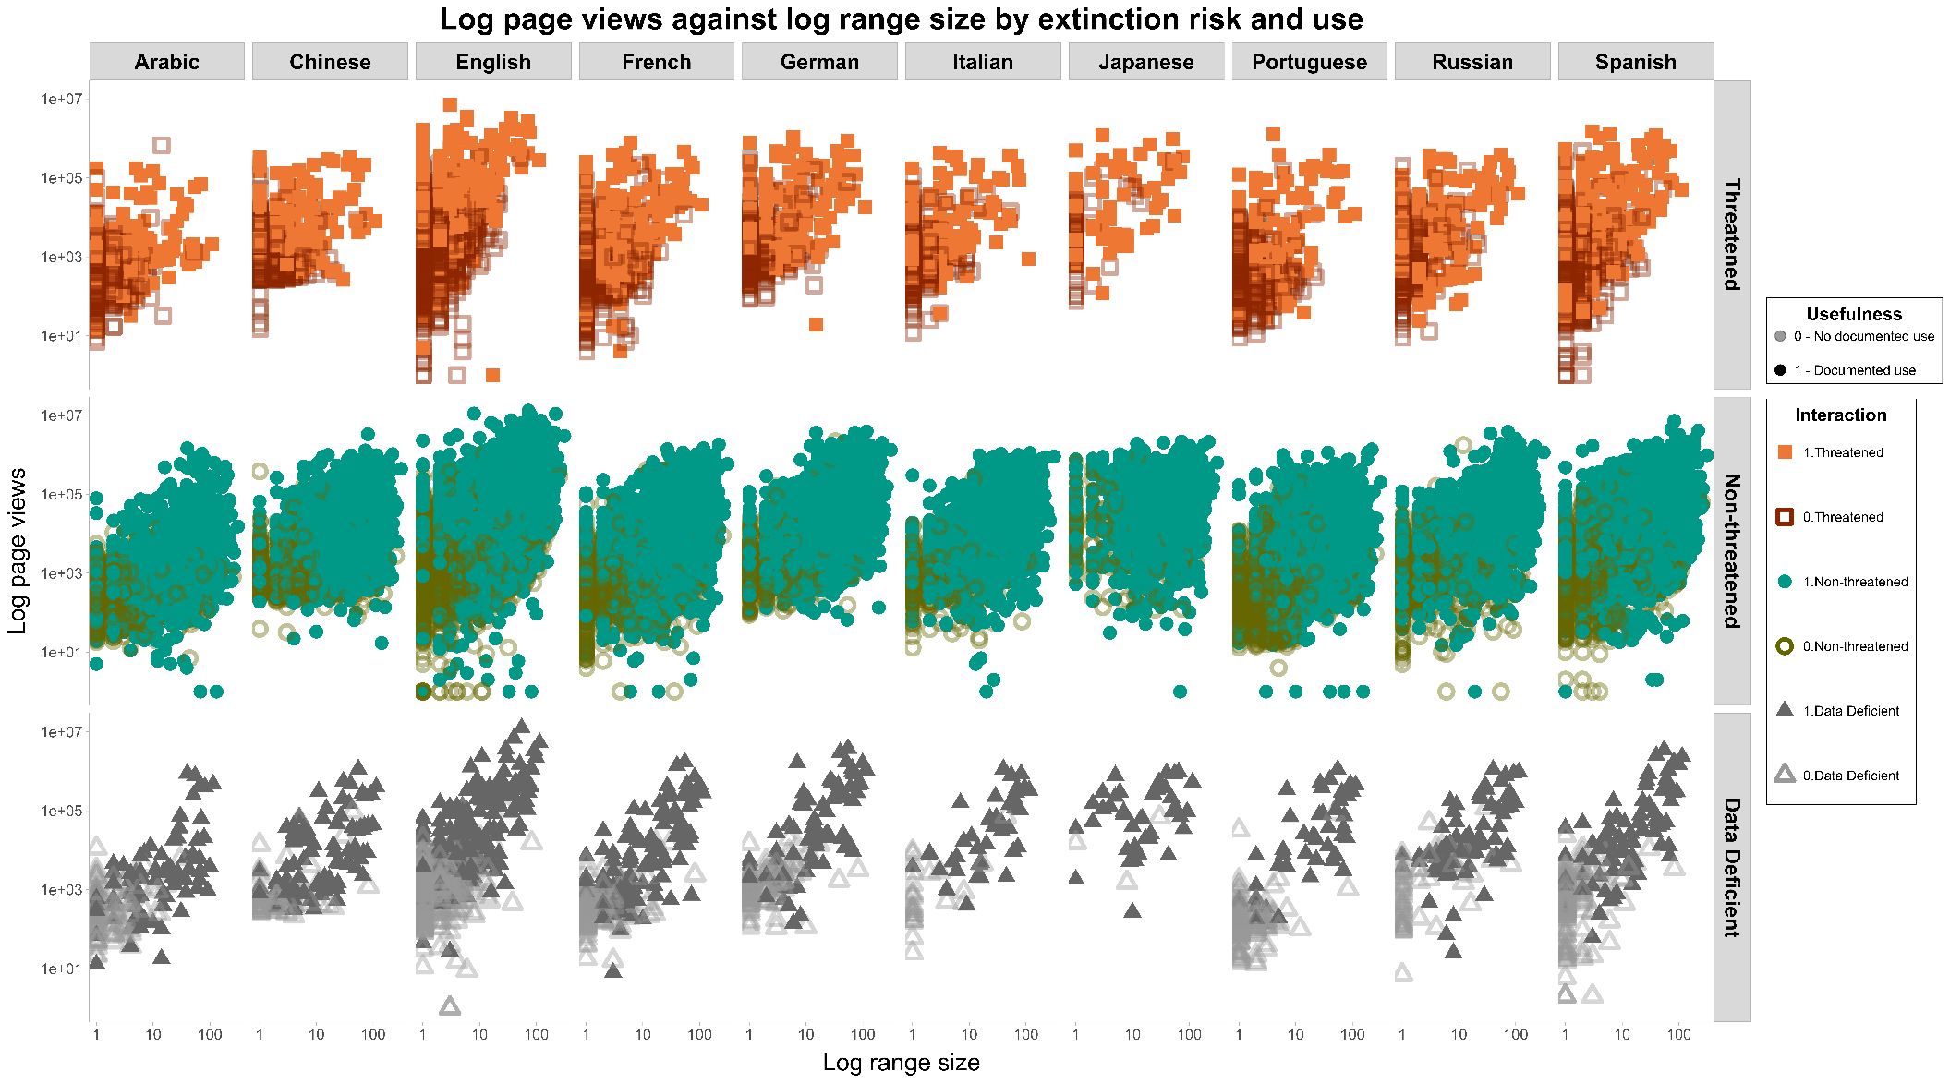

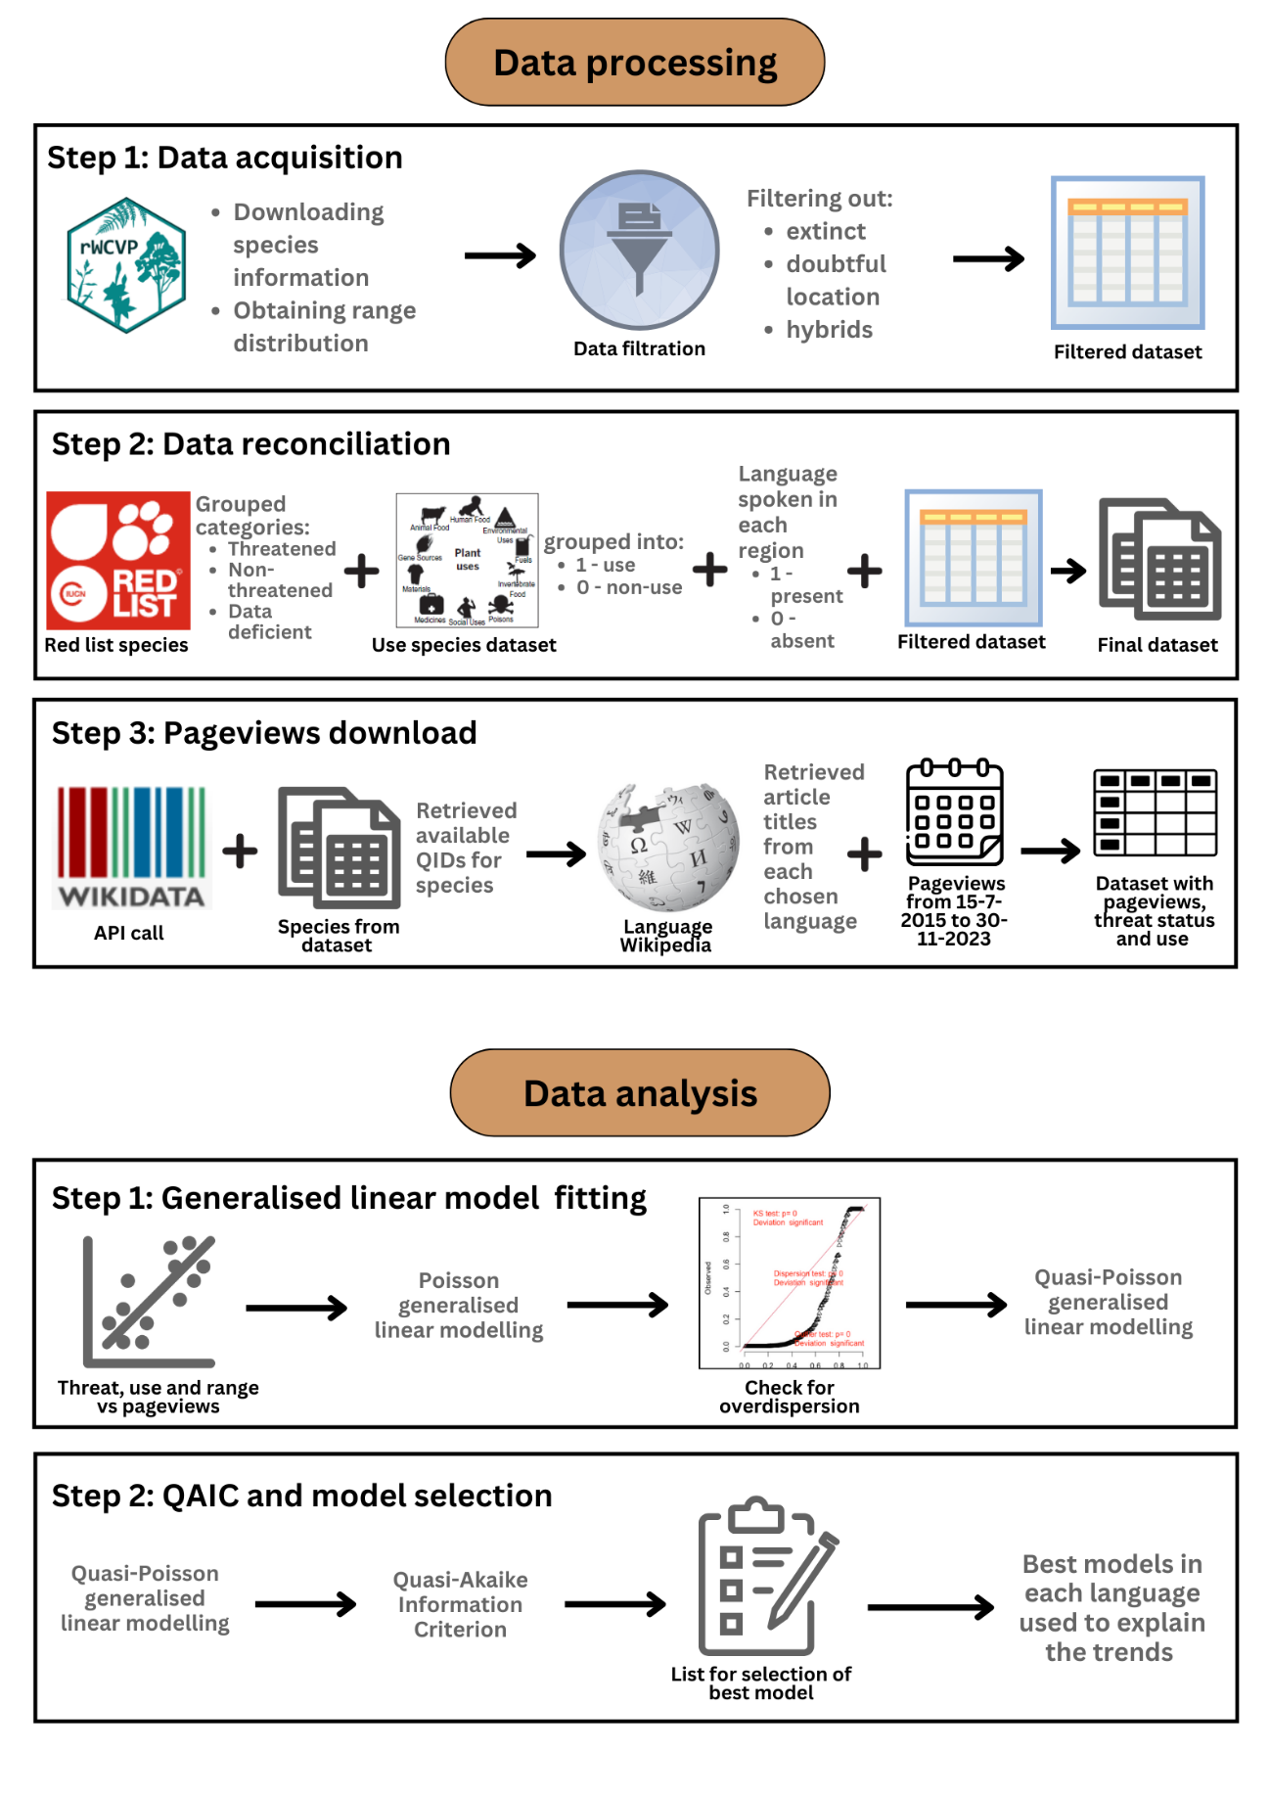
Figure S5: Wikipedia page views, documented use and range size (All language edition; log₁₀ transformed) across extinction risk categories. Solid shapes denote useful and hollow shapes of non-useful plants. Solid red squares - useful and threatened species; hollow red squares - threatened and non-useful species; solid green circles - non-threatened and useful plants; hollow green circles - non-threatened and non-useful plants; solid triangles - data-deficient and useful species; hollow grey triangles - data-deficient and non-useful plants.
Figure S6: Graphical representation of the steps taken for data processing and statistical analysis. Each step indicates the larger part of the methodological workflow. Black arrows indicate every smaller step in the process. The ‘plus’ symbol represents the reconciliation of datasets.

