Supplementary Information

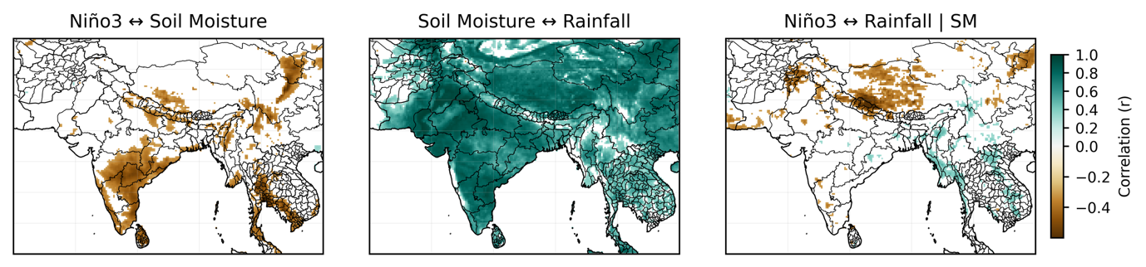

Supplementary Figure S1 Storage-mediated ENSO–rainfall relationships. Correlations between Niño3 and soil moisture (ENSO–SM), soil moisture and rainfall (SM-Rain), and partial correlations between Niño3 and rainfall controlling for soil moisture (ENSO-Rain | SM-controlled). ENSO-rainfall associations weaken after conditioning on soil moisture, indicating that apparent oceanic influence is mediated through terrestrial storage.

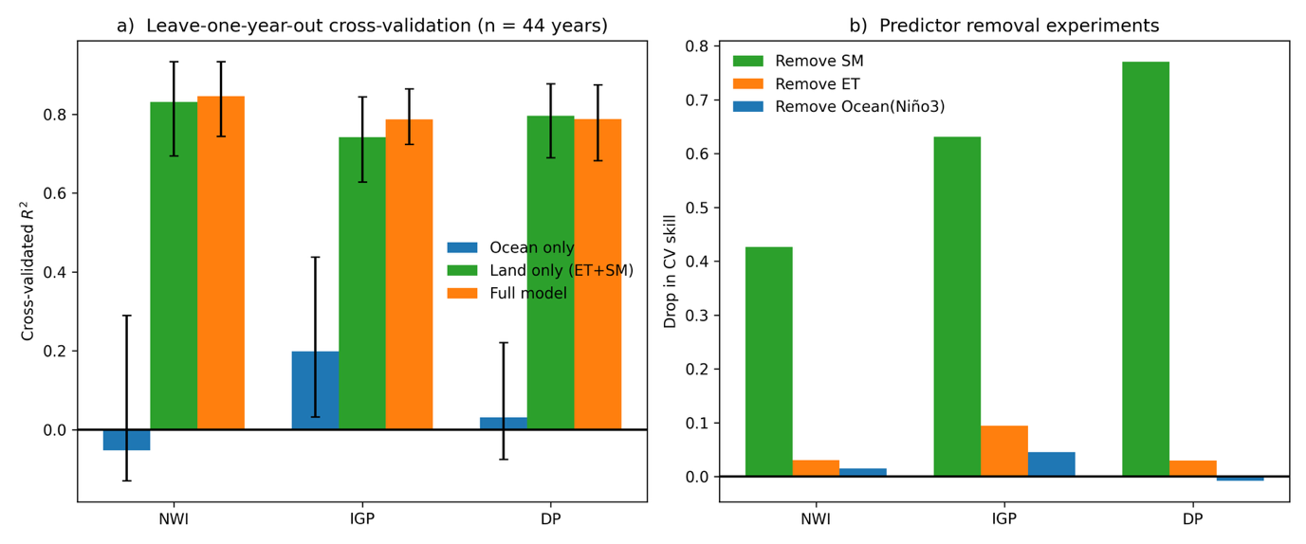

Supplementary Figure S2 Robustness of predictive dominance. (a) Cross-validated skill (R²) for ocean-only, land-only (ET+SM), and full models. (b) Skill loss (ΔR²) when individual predictors are removed from the full model. Land-based predictors retain substantial skill, and removing soil moisture produces the largest degradation, confirming storage-driven predictability.

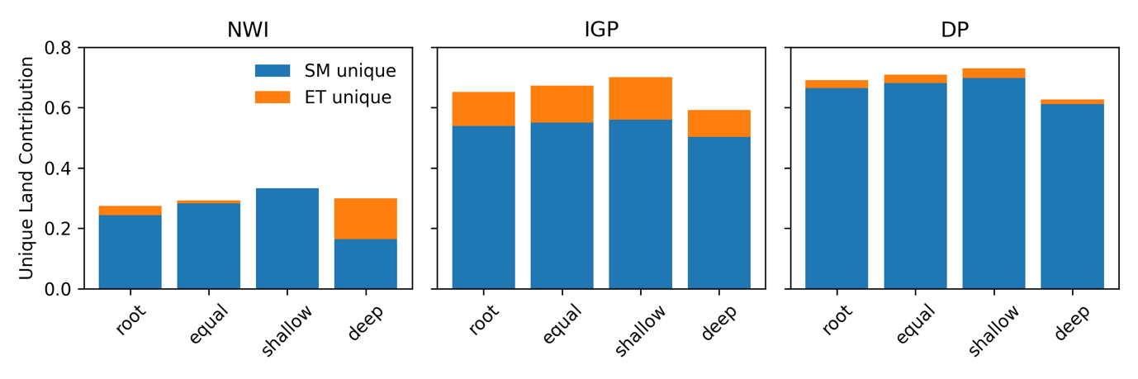

Supplementary Figure S3 Sensitivity of variance partitioning to soil-moisture vertical weighting. Variance partitioning of SM (storage) and ET (flux) under alternative vertical weighting schemes. The dominance hierarchy (DP > IGP > NWI) remains unchanged, indicating that storage-mediated predictability is robust to vertical soil-moisture representation.

Sensitivity to vertical soil-moisture structure

The primary analysis represents terrestrial storage using a root-weighted aggregation of ERA5 soil moisture across four layers (0-7 cm, 7-28 cm, 28-100 cm, and 100-289 cm). To assess sensitivity to vertical assumptions, we recomputed all variance decompositions using three alternative weighting schemes:
- Root-weighted (primary): (0.1, 0.3, 0.3, 0.3)
- Equal weighting: (0.25, 0.25, 0.25, 0.25)
- Shallow-dominated: (0.4, 0.3, 0.2, 0.1)
- Deep-dominated: (0.1, 0.2, 0.3, 0.4)

Across schemes:
- In DP, soil-moisture unique contribution remained >0.60.
- In NWI, storage dominance persisted in all but the deep-dominated case, where soil moisture weakened but remained larger than the oceanic contribution.
- In IGP, soil-moisture unique contribution remained between 0.50 and 0.56.

Oceanic unique contributions remained comparatively small across all configurations. These tests indicate that the dominance structure reflects robust terrestrial storage effects rather than sensitivity to vertical aggregation choice.

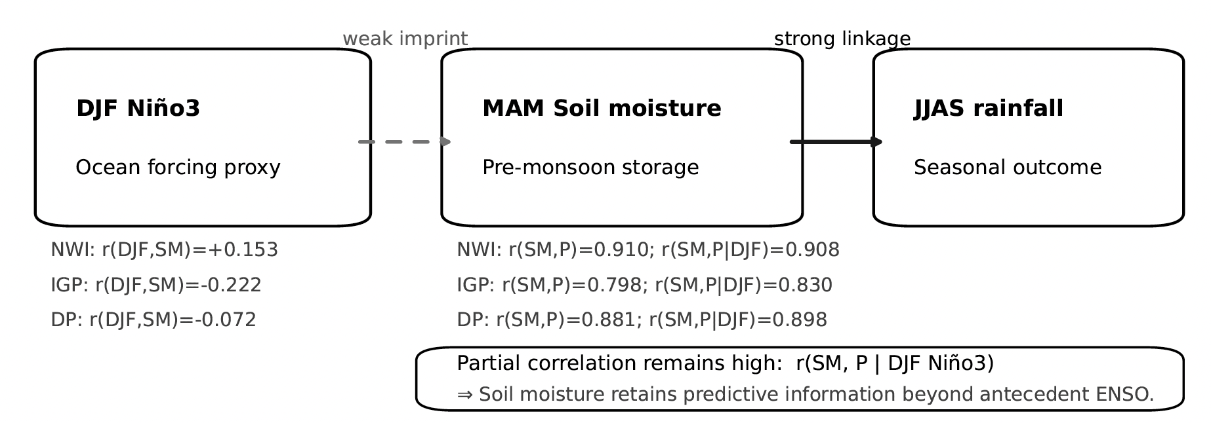

Supplementary Figure S4 Independence of terrestrial memory from antecedent ENSO. Relationships among DJF Niño3 (ENSO), MAM SM, and JJAS rainfall.
Weak ENSO-SM linkage and strong SM-rainfall association indicate that soil moisture provides predictive information beyond antecedent ocean forcing.

