Supplemental figure
Pan-CDK inhibitor CGP-60474 attenuates chronic kidney disease by suppressing myeloid inflammation and restoring tubular metabolism

Alfin Mohammad Abdillah^{1, 2}, Ji Sun Moon¹, Ho Yeop Lee¹, Hyo Ju Jang¹, Nguyen Thi Linh^{1,2}, Cheng Zhang^{4, *}, and Hyon-Seung Yi^{1,2,3, *}

¹Laboratory of Endocrinology and Immune System, Chungnam National University, School of Medicine, 282 Munhwa-ro, Daejeon 35015, Republic of Korea.
²Department of Medical Science, Chungnam National University, School of Medicine, 266 Munhwa-ro, Daejeon 35015, Republic of Korea.
³Department of Internal Medicine, Chungnam National University, School of Medicine, 266 Munhwa-ro, Daejeon 35015, Republic of Korea.
⁴Roger Williams Institute of Liver Studies, School of Immunology & Microbial Sciences, Faculty of Life Sciences and Medicine, King’s College London, Foundation for Liver Research, and King’s College Hospital, London, United Kingdom

*Corresponding author
Fax: +82-42-280-6994;
E-mail: jmpbooks@cnu.ac.kr (HSY); cheng.5.zhang@kcl.ac.uk (CZ)

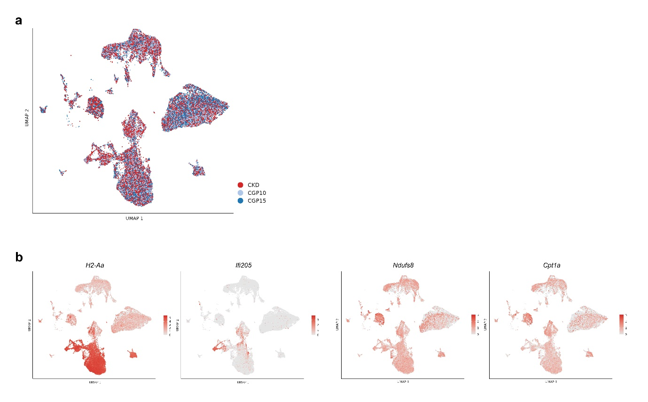
Fig. S1 | Integration quality and representative feature programmes across conditions.
A. Integrated UMAP coloured by condition (CKD, CGP10, CGP15) showing broad mixing across the shared manifold. B. Feature plots illustrating antigen presentation (H2-Aa), interferon-associated activation (Ifi205), and metabolic/mitochondrial genes (Ndufs8, Cpt1a).

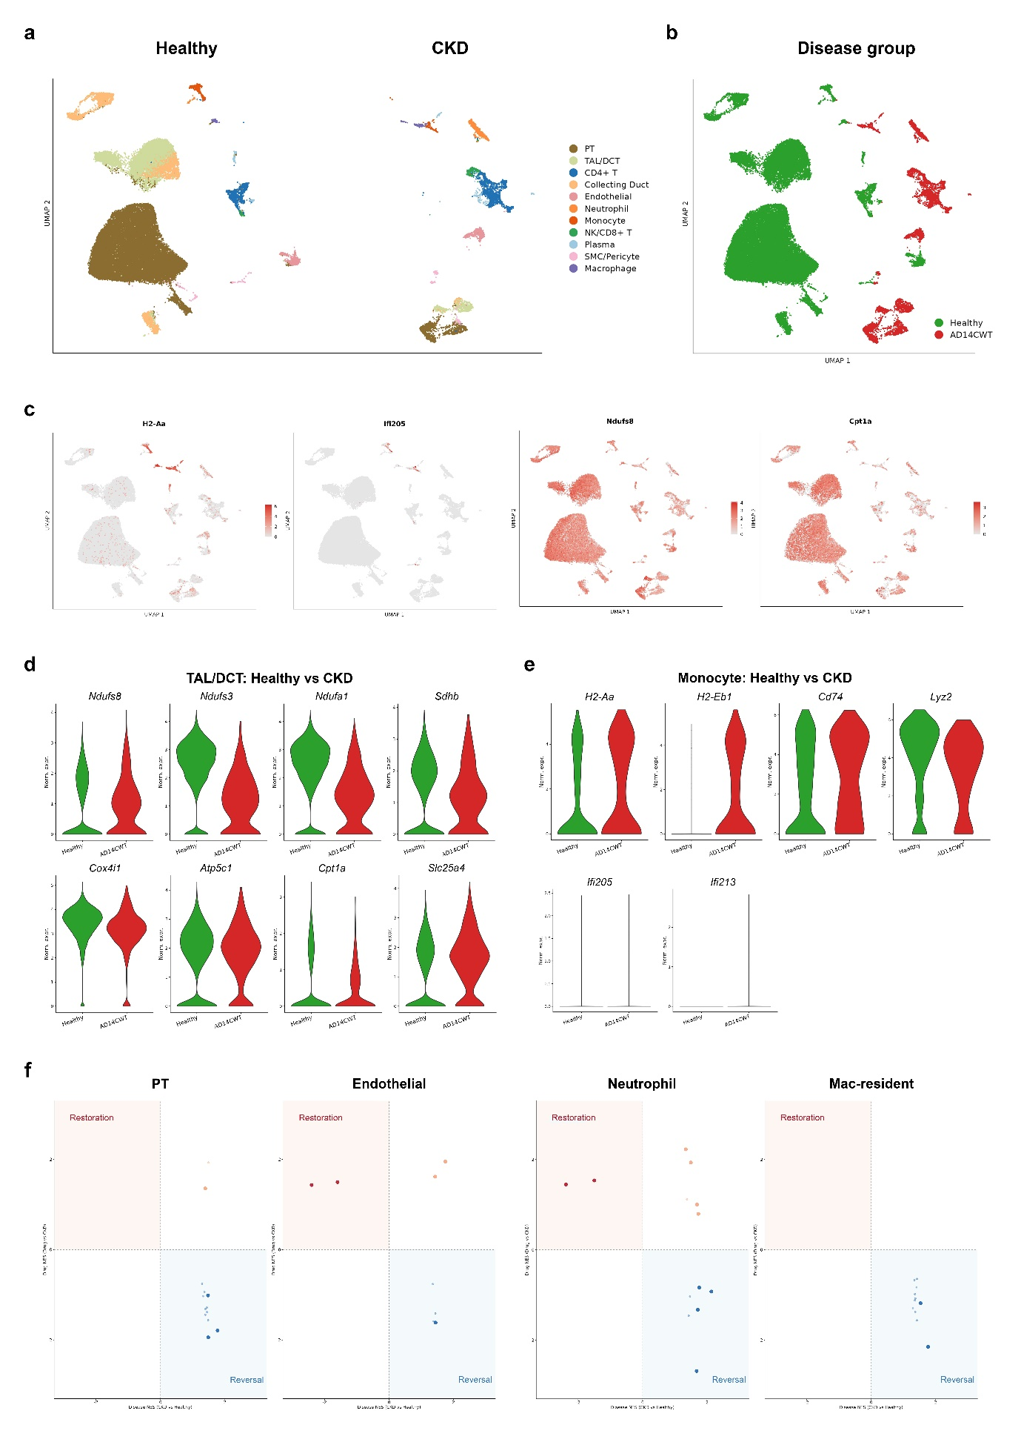
Fig. S2 | Public reference integration anchors disease-direction programmes (healthy versus adenine-injury CKD).
A. UMAPs of public reference datasets (Park et al., GSE107585; Su et al., GSE290664) with major cell type annotations. B. Disease-group UMAP highlighting separation between healthy and adenine-injury CKD samples. C. Feature plots illustrating immune activation (H2-Aa, Ifi205) and tubular metabolic genes (Ndufs8, Cpt1a). D. TAL/DCT violin plots showing reduced mitochondrial/metabolic gene expression in CKD vs healthy reference. E. Monocyte violin plots showing increased antigen presentation and interferon-associated activation in CKD. F. Quadrant summaries relating disease-direction signatures to reversal/restoration patterns.

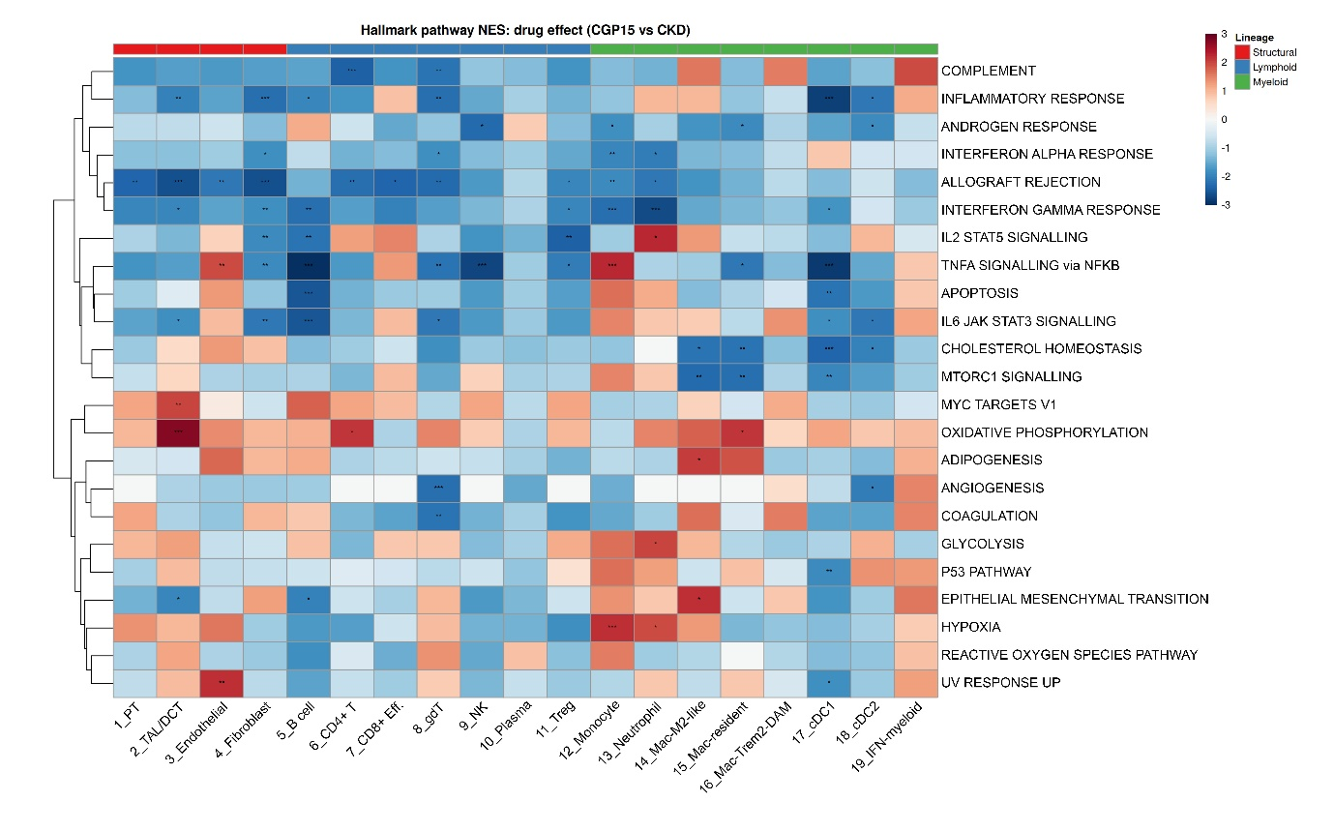
Fig. S3 | Cell-type Hallmark NES map of CGP15 drug effects.
Heatmap of Hallmark pathway NES for CGP15 vs CKD across 19 annotated cell types with lineage annotation (structural, lymphoid, myeloid), highlighting broad suppression of inflammatory programmes and cell-type-specific restoration of metabolic pathways.

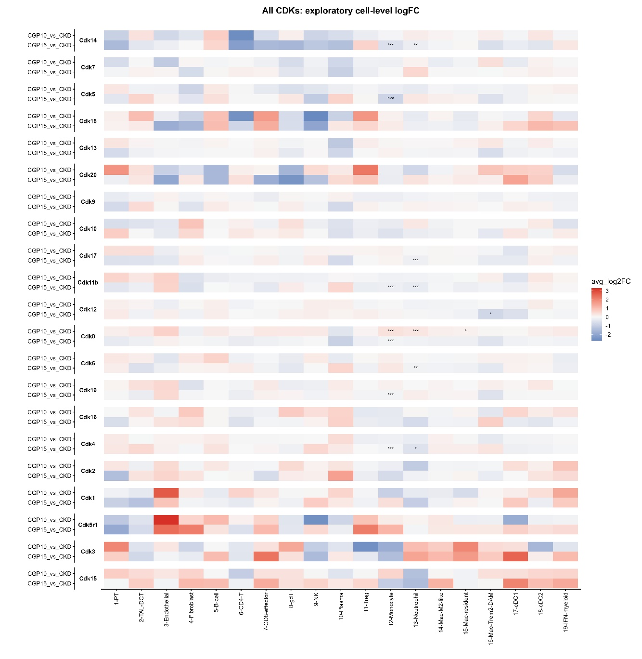
Fig. S4 | Cell–type–resolved exploratory analysis of CDK-family gene expression changes after CGP-60474 treatment
Heatmap of exploratory cell-level log2 fold changes for detected CDK-family genes across annotated kidney cell populations in CGP10 versus CKD and CGP15 versus CKD comparisons. Red denotes higher expression and blue denotes lower expression relative to CKD. Asterisks indicate adjusted P values based on the Benjamini–Hochberg-adjusted Wilcoxon rank-sum test (P < 0.05, *P < 0.01, **P < 0.001, ***P < 0.0001).
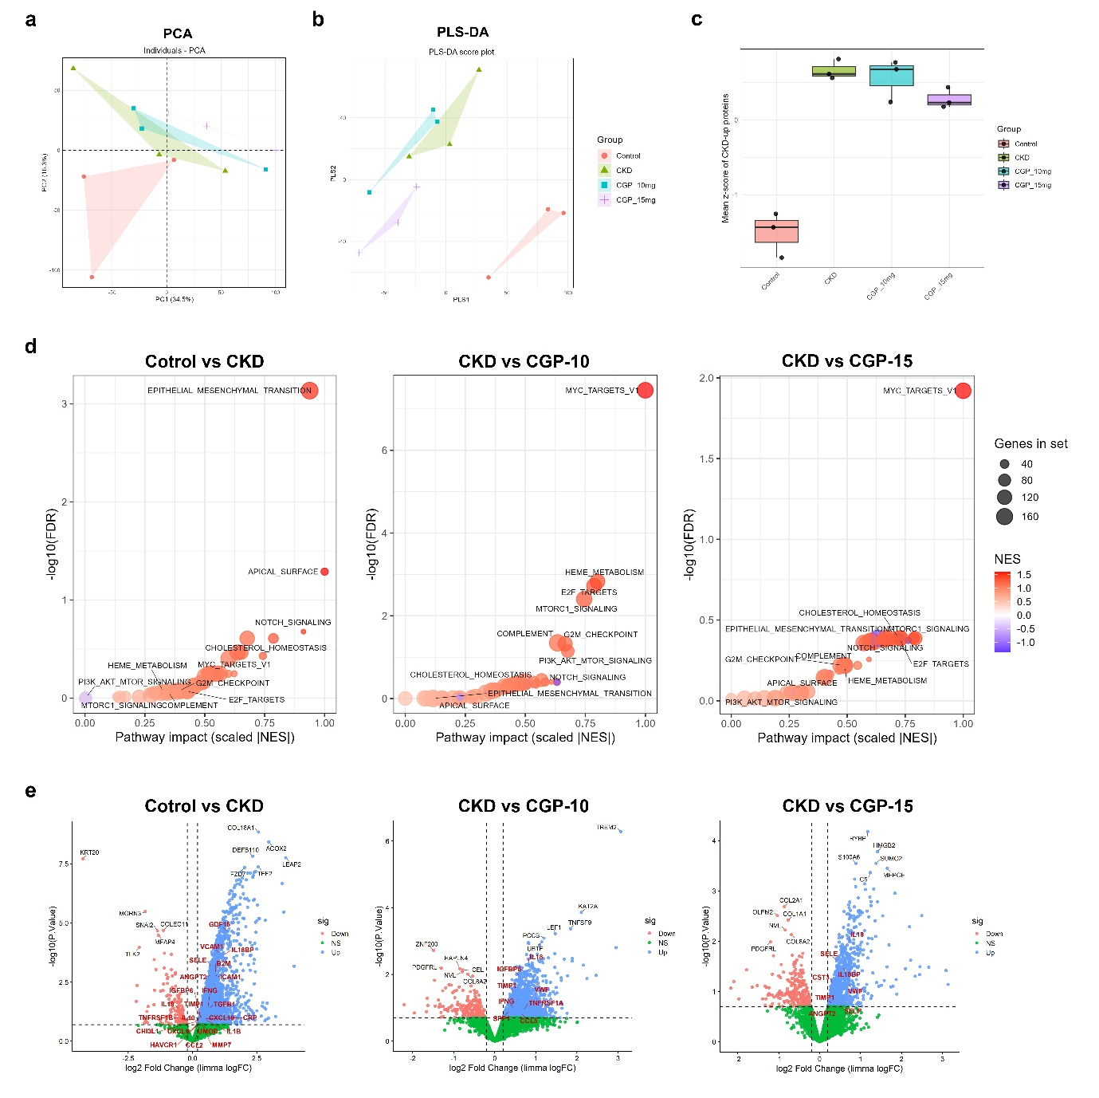
Fig. S5 | Global structure and pathway-impact summaries for serum proteomics (SomaScan).
A. PCA of serum proteomes showing separation across Control, CKD, CGP10, and CGP15. B. PLS-DA score plot highlighting supervised separation by group. C. Mean z-score of CKD-up proteins across groups. D. Pathway-impact summaries across contrasts. E. Volcano plots of differential serum protein abundance across contrasts.
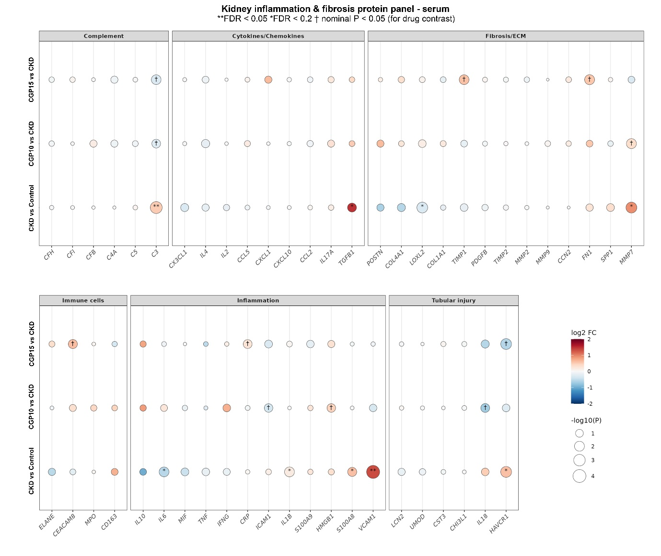
Fig. S6 | Kidney inflammation/fibrosis serum protein panel.
Bubble plot summarizing differential abundance of curated serum proteins grouped into complement, cytokines/chemokines, fibrosis/ECM, immune activation, inflammation, and tubular injury across contrasts (colour, log2 fold change; dot size, −log10(P)).

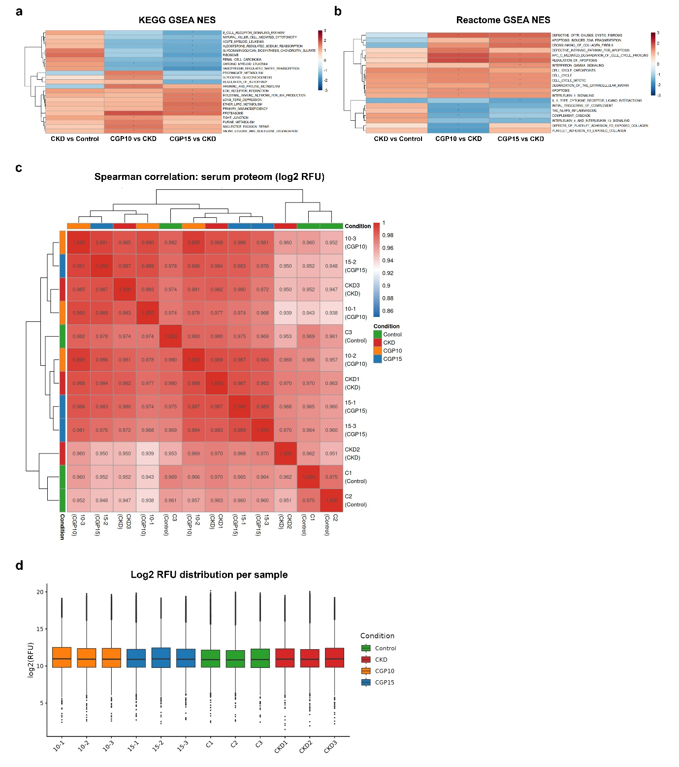
Fig. S7 | Serum proteomics pathway enrichment and QC metrics.
A. KEGG GSEA NES heatmap across disease and treatment contrasts. B. Reactome GSEA NES heatmap across the same contrasts. C. Sample-to-sample Spearman correlation heatmap of serum proteomes (log2 RFU). D. Log2 RFU distribution per sample.
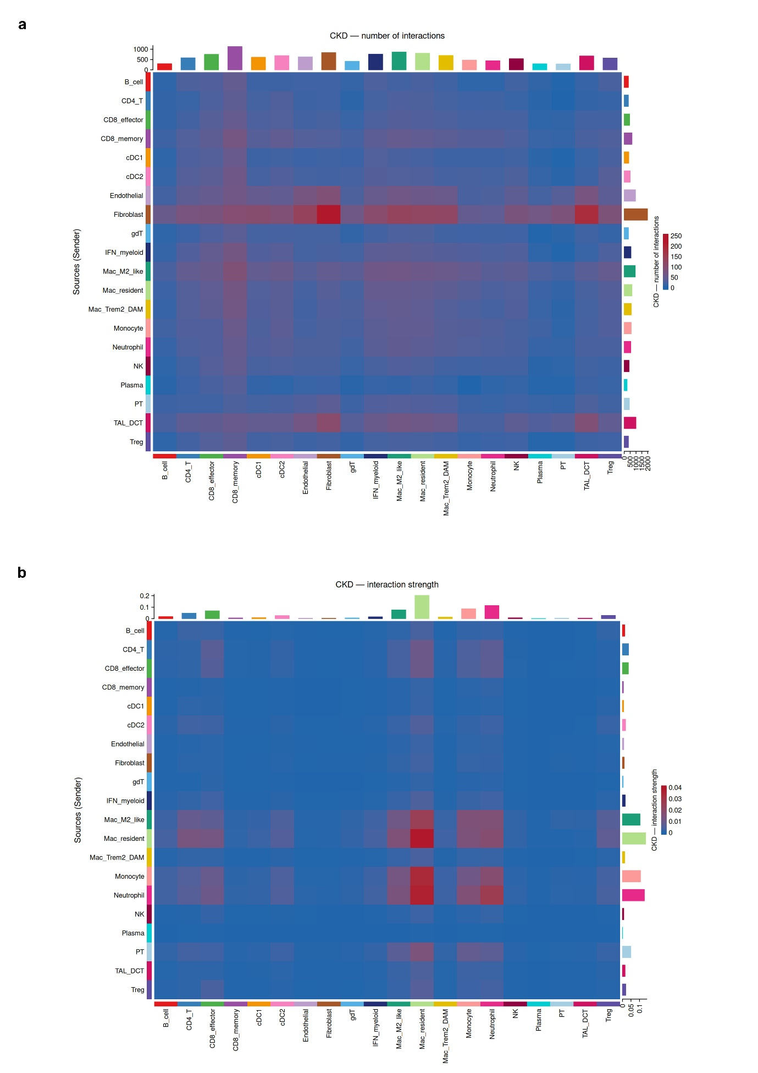
Fig. S8 | CKD cell–cell communication intensity matrices.
A. Heatmap of inferred interaction counts between sender (rows) and receiver (columns) cell types in CKD. B. Heatmap of inferred interaction strength between sender and receiver cell types in CKD.

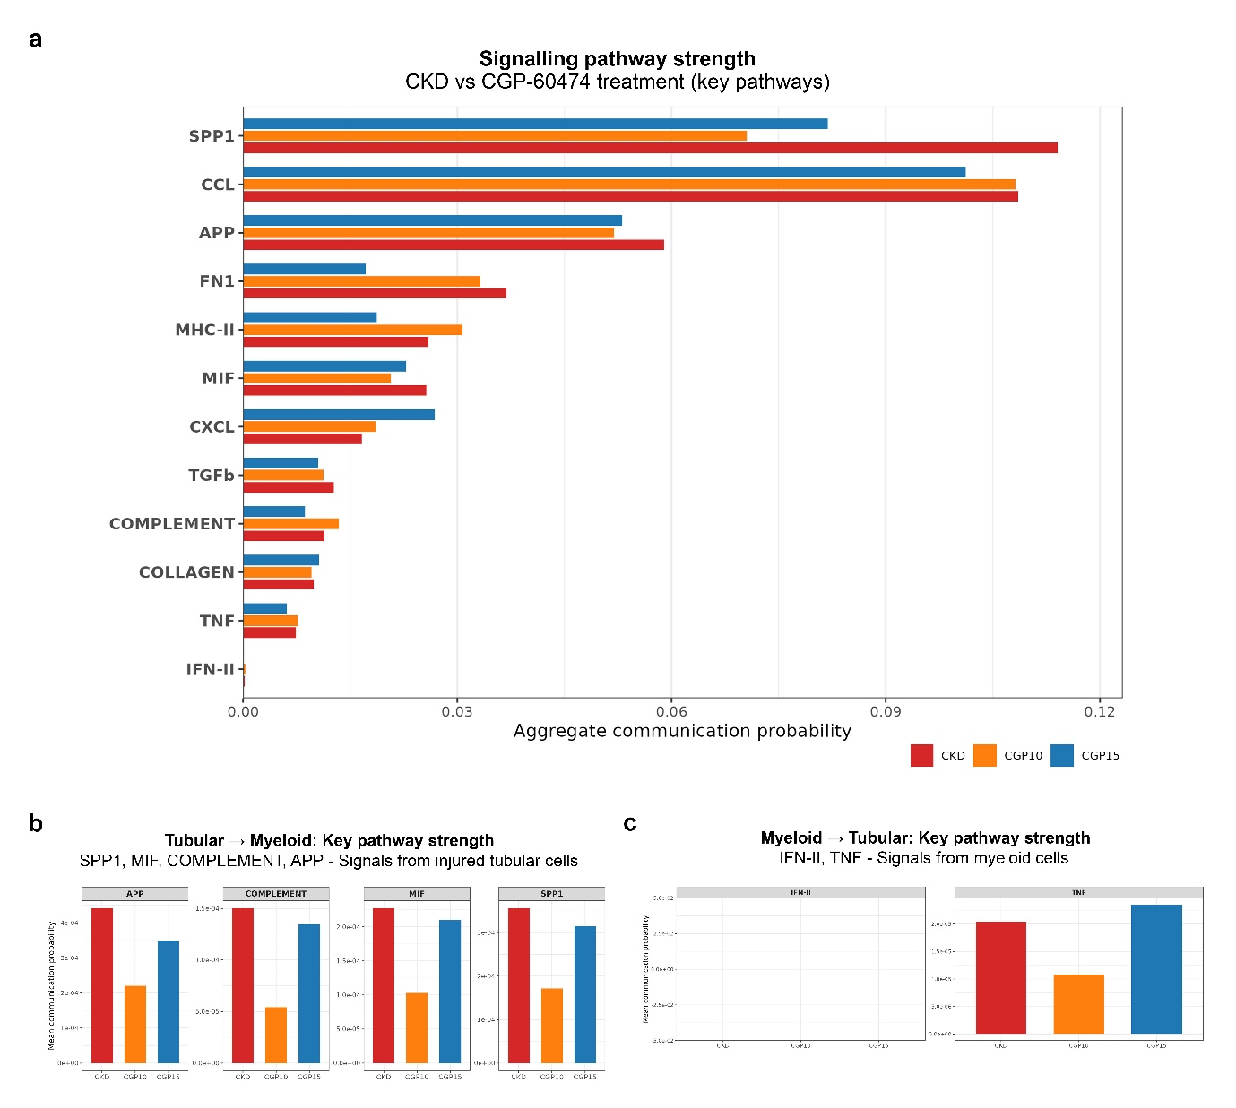
Fig. S9 | Key CellChat pathway strengths across disease and treatment.
A. Aggregate communication probability of selected pathways across CKD, CGP10, and CGP15. B. Tubular → myeloid pathway strengths for key distress axes (APP, complement, MIF, SPP1). C. Myeloid → tubular pathway strengths for inflammatory cytokine axes (IFN-II, TNF).

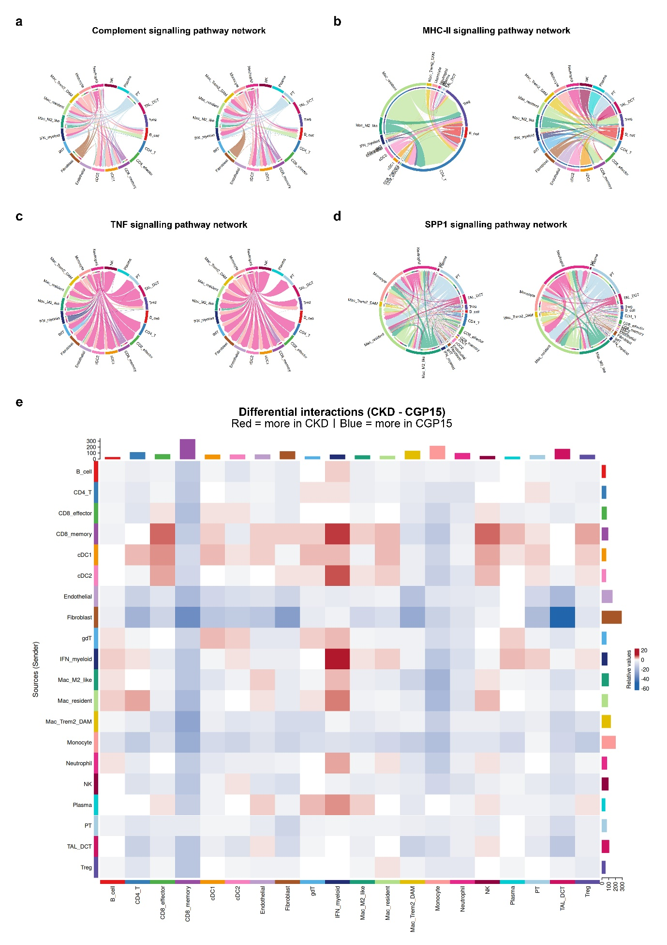
Fig. S10 | Pathway network visualizations and differential interaction map (CKD vs CGP15).
A. Complement signalling pathway networks in CKD and CGP15. B. MHC-II signalling pathway networks in CKD and CGP15. C. TNF signalling pathway networks in CKD and CGP15. D. SPP1 signalling pathway networks in CKD and CGP15. E. Differential interaction heatmap (CKD − CGP15), where red indicates stronger interactions in CKD and blue indicates stronger interactions in CGP15.

