Place of Death | Deaths (1999–2020) | Deaths (2021–2025) | Total | Percentage
Medical Facility - Inpatient | 15,111 | 6,810 | 21,921
Medical Facility - Outpatient or ER | 704 | 315 | 1,019
Medical Facility - Dead on Arrival | 38 | 0 | 38
Medical Facility - Status unknown | 11 | 0 | 11
Total (Medical Facility) | 15,864 | 7,125 | 22,989 | 77.76%
Decedent's home | 878 | 544 | 1,422
Hospice facility | 865 | 693 | 1,558
Nursing home/long term care | 2,147 | 730 | 2,877
Other | 409 | 189 | 598
Place of death unknown | 121 | 0 | 121
Total | 20,284 | 9,281 | 29,565
Supplemental Table 1. Place of Death for Decedents with Head and Neck Injuries and Respiratory Failure, 1999–2025

Supplemental Table 2. Annual Deaths Involving Head and Neck Injuries and Respiratory Failure, Stratified by Sex and Race/Ethnicity, 1999–2025
Year | Overall | Female | Male | White | Black or African American | American Indian or Alaska Native | Hispanic or Latino
1999 | 569 | 219 | 350 | 496 | 60 | N/A | 13
2000 | 513 | 185 | 328 | 451 | 52 | N/A | 21
2001 | 549 | 203 | 346 | 494 | 45 | N/A | 25
2002 | 534 | 189 | 345 | 470 | 48 | N/A | 21
2003 | 567 | 215 | 352 | 498 | 54 | N/A | 23
2004 | 652 | 224 | 428 | 567 | 69 | N/A | 29
2005 | 616 | 236 | 380 | 540 | 63 | N/A | 19
2006 | 653 | 238 | 415 | 586 | 49 | N/A | 14
2007 | 710 | 287 | 423 | 639 | 56 | N/A | 31
2008 | 722 | 293 | 429 | 633 | 73 | N/A | 31
2009 | 785 | 301 | 484 | 697 | 73 | N/A | 37
2010 | 860 | 320 | 540 | 766 | 69 | 10 | 53
2011 | 916 | 326 | 590 | 811 | 70 | N/A | 42
2012 | 976 | 384 | 592 | 887 | 60 | N/A | 40
2013 | 1034 | 379 | 655 | 939 | 66 | N/A | 44
2014 | 1155 | 435 | 720 | 1049 | 78 | N/A | 61
2015 | 1195 | 447 | 748 | 1057 | 95 | 15 | 58
2016 | 1267 | 482 | 785 | 1138 | 91 | N/A | 57
2017 | 1291 | 481 | 810 | 1158 | 88 | 13 | 69
2018 | 1425 | 516 | 909 | 1245 | 113 | 20 | 98
2019 | 1447 | 498 | 949 | 1276 | 114 | 13 | 93
2020 | 1848 | 603 | 1245 | 1595 | 179 | 18 | 125
2021 | 1874 | 618 | 1256 | 1482 | 171 | 13 | 149
2022 | 1908 | 648 | 1260 | 1506 | 156 | 13 | 153
2023 | 1782 | 584 | 1198 | 1413 | 164 | 13 | 110
2024 | 1819 | 650 | 1169 | 1448 | 158 | 14 | 123
2025 | 1907 | 657 | 1250 | 1497 | 160 | 10 | 145

Supplemental Table 3. Annual percent change (APC) of age-adjusted mortality rates per 100,000 for deaths involving head and neck injuries and respiratory failure, stratified by demographic and geographic characteristics, 1999–2025.
Year Interval | APC (95% CI) | P value
Overall
1999–2025 | 4.23 (3.64 to 5.23) | <0.001
Male
1999–2025 | 3.94 (3.40 to 4.82) | <0.001
Female
1999–2022 | 5.44 (4.58 to 24.89) | 0.0104
2022–2025 | -7.75 (-28.78 to 4.48) | 0.2615
25–44 years
1999–2018 | -0.31 (-2.02 to 0.74) | 0.5087
2018–2021 | 21.10 (8.76 to 28.83) | <0.001
2021–2025 | -16.31 (-28.87 to -11.36) | <0.001
45–64 years
1999–2020 | 6.66 (5.64 to 9.67) | <0.001
2020–2025 | -5.09 (-17.67 to 0.55) | 0.0712
65+ years
1999–2001 | -9.83 (-15.00 to 0.80) | 0.0780
2001–2014 | 4.61 (4.17 to 10.39) | <0.001
2014–2018 | 1.20 (-2.16 to 3.45) | 0.4919
2018–2021 | 11.08 (7.46 to 13.77) | <0.001
2021–2025 | -0.62 (-2.98 to 0.83) | 0.3359
White
1999–2025 | 4.49 (4.00 to 5.39) | <0.001
Black or African American
1999–2016 | -0.60 (-2.79 to 1.04) | 0.3571
2016–2020 | 18.93 (8.67 to 31.49) | 0.0264
2020–2025 | 0.43 (-10.83 to 5.50) | 0.8294
American Indian or Alaska Native
2010–2025 | -0.56 (-2.08 to 0.88) | 0.4147
Hispanic or Latino
1999–2025 | 3.33 (2.28 to 5.38) | <0.001
Census Region 1: Northeast
1999–2025 | 2.17 (1.50 to 3.09) | <0.001
Census Region 2: Midwest
1999–2025 | 3.76 (2.95 to 5.09) | <0.001
Census Region 3: South
1999–2025 | 3.17 (2.31 to 4.59) | <0.001
Census Region 4: West
1999–2025 | 5.50 (4.85 to 6.77) | <0.001
Metropolitan
1999–2009 | -0.05 (-2.24 to 1.23) | 0.7914
2009–2012 | 15.95 (8.24 to 20.33) | 0.0020
2012–2018 | -1.16 (-6.13 to 0.28) | 0.0908
2018–2020 | 15.71 (7.59 to 21.97) | <0.001
Non-metropolitan
1999–2020 | 4.38 (3.43 to 5.94) | <0.001
APC indicates annual percent change; CI, confidence interval.

Supplemental Table 4. Overall and Sex-Stratified Age-Adjusted Mortality Rates per 100,000 for Deaths Involving Head and Neck Injuries and Respiratory Failure, 1999–2025
Year | Age-Adjusted Mortality Rate (95% CI)
Year | Male | Female | Overall
1999 | 0.3 (0.3–0.4) | 0.1 (0.1–0.1) | 0.2 (0.2–0.2)
2000 | 0.3 (0.3–0.3) | 0.1 (0.1–0.1) | 0.2 (0.2–0.2)
2001 | 0.3 (0.3–0.3) | 0.1 (0.1–0.1) | 0.2 (0.2–0.2)
2002 | 0.3 (0.3–0.4) | 0.1 (0.1–0.1) | 0.2 (0.2–0.2)
2003 | 0.3 (0.3–0.3) | 0.1 (0.1–0.1) | 0.2 (0.2–0.2)
2004 | 0.4 (0.3–0.4) | 0.1 (0.1–0.1) | 0.2 (0.2–0.2)
2005 | 0.3 (0.3–0.3) | 0.1 (0.1–0.1) | 0.2 (0.2–0.2)
2006 | 0.3 (0.3–0.3) | 0.1 (0.1–0.1) | 0.2 (0.2–0.2)
2007 | 0.3 (0.3–0.4) | 0.1 (0.1–0.2) | 0.2 (0.2–0.2)
2008 | 0.3 (0.3–0.4) | 0.1 (0.1–0.2) | 0.2 (0.2–0.2)
2009 | 0.4 (0.3–0.4) | 0.1 (0.1–0.2) | 0.2 (0.2–0.2)
2010 | 0.4 (0.4–0.4) | 0.2 (0.1–0.2) | 0.3 (0.2–0.3)
2011 | 0.4 (0.4–0.5) | 0.2 (0.1–0.2) | 0.3 (0.2–0.3)
2012 | 0.4 (0.4–0.4) | 0.2 (0.2–0.2) | 0.3 (0.3–0.3)
2013 | 0.5 (0.4–0.5) | 0.2 (0.2–0.2) | 0.3 (0.3–0.3)
2014 | 0.5 (0.4–0.5) | 0.2 (0.2–0.2) | 0.3 (0.3–0.4)
2015 | 0.5 (0.5–0.5) | 0.2 (0.2–0.2) | 0.3 (0.3–0.3)
2016 | 0.5 (0.5–0.5) | 0.2 (0.2–0.3) | 0.3 (0.3–0.4)
2017 | 0.5 (0.4–0.5) | 0.2 (0.2–0.2) | 0.3 (0.3–0.4)
2018 | 0.5 (0.5–0.6) | 0.2 (0.2–0.2) | 0.4 (0.3–0.4)
2019 | 0.5 (0.5–0.6) | 0.2 (0.2–0.2) | 0.4 (0.4–0.4)
2020 | 0.7 (0.7–0.7) | 0.3 (0.2–0.3) | 0.4 (0.4–0.5)
2021 | 0.7 (0.7–0.8) | 0.3 (0.3–0.3) | 0.5 (0.5–0.5)
2022 | 0.7 (0.7–0.7) | 0.3 (0.2–0.3) | 0.5 (0.4–0.5)
2023 | 0.7 (0.6–0.7) | 0.2 (0.2–0.2) | 0.4 (0.4–0.4)
2024 | 0.6 (0.6–0.6) | 0.3 (0.2–0.3) | 0.4 (0.4–0.4)
2025 | 0.7 (0.6–0.7) | 0.2 (0.2–0.3) | 0.5 (0.4–0.5)

Supplemental Table 5. State-Stratified Age-Adjusted Mortality Rates per 100,000 for Deaths Involving Head and Neck Injuries and Respiratory Failure, 1999–2020 and 2021–2025
State | Age-Adjusted Mortality Rate (95% CI)
State | 1999–2020 | 2021–2025
Alabama | 0.6 (0.6–0.6) | 1.0 (0.9–1.1)
Alaska | 0.2 (0.1–0.3) | 0.3 (0.2–0.6)
Arizona | 0.1 (0.1–0.1) | 0.1 (0.1–0.1)
Arkansas | 0.6 (0.6–0.7) | 1.5 (1.4–1.7)
California | 0.3 (0.3–0.3) | 0.6 (0.5–0.6)
Colorado | 0.5 (0.4–0.5) | 1.0 (0.9–1.1)
Connecticut | 0.3 (0.3–0.3) | Unreliable
Delaware | 0.3 (0.2–0.3) | 0.3 (0.2–0.5)
District of Columbia | Unreliable | 0.3 (0.2–0.6)
Florida | 0.1 (0.1–0.1) | 0.1 (0.1–0.1)
Georgia | 0.5 (0.5–0.5) | 0.7 (0.6–0.8)
Hawaii | 0.1 (0.1–0.2) | N/A
Idaho | 0.4 (0.3–0.5) | 0.7 (0.6–0.9)
Illinois | 0.2 (0.2–0.2) | 0.3 (0.3–0.4)
Indiana | 0.4 (0.4–0.5) | 0.4 (0.4–0.5)
Iowa | 0.3 (0.3–0.4) | 0.5 (0.4–0.6)
Kansas | 0.3 (0.2–0.3) | 0.5 (0.4–0.6)
Kentucky | 0.4 (0.3–0.4) | 0.6 (0.5–0.7)
Louisiana | 0.4 (0.3–0.4) | 0.6 (0.5–0.7)
Maine | 0.2 (0.2–0.3) | N/A
Maryland | 0.3 (0.3–0.3) | 1.0 (0.9–1.2)
Massachusetts | 0.2 (0.1–0.2) | 0.3 (0.3–0.4)
Michigan | 0.2 (0.2–0.2) | 0.3 (0.2–0.3)
Minnesota | 0.1 (0.1–0.2) | 0.4 (0.3–0.5)
Mississippi | 0.6 (0.6–0.7) | 1.3 (1.1–1.5)
Missouri | 0.3 (0.2–0.3) | 0.5 (0.5–0.6)
Montana | 0.6 (0.5–0.7) | 3.0 (2.6–3.4)
Nebraska | 0.8 (0.7–0.8) | 1.4 (1.2–1.7)
Nevada | 0.1 (0.1–0.2) | 0.2 (0.2–0.3)
New Hampshire | 0.1 (0.1–0.1) | 0.1 (0.1–0.2)
New Jersey | 0.3 (0.2–0.3) | 0.4 (0.4–0.5)
New Mexico | 0.1 (0.0–0.1) | 0.1 (0.1–0.2)
New York | 0.2 (0.2–0.2) | 0.3 (0.3–0.3)
North Carolina | 0.3 (0.2–0.3) | 0.2 (0.2–0.3)
North Dakota | 0.6 (0.5–0.7) | 1.5 (1.2–1.9)
Ohio | 0.3 (0.2–0.3) | 0.3 (0.3–0.3)
Oklahoma | 0.3 (0.2–0.3) | 0.1 (0.1–0.2)
Oregon | 0.1 (0.1–0.1) | 0.4 (0.3–0.5)
Pennsylvania | 0.3 (0.3–0.3) | 0.4 (0.3–0.4)
Rhode Island | 0.3 (0.3–0.4) | N/A
South Carolina | 0.7 (0.7–0.8) | 1.0 (0.9–1.2)
South Dakota | 0.4 (0.3–0.5) | 0.8 (0.6–1.1)
Tennessee | 0.4 (0.4–0.4) | 0.4 (0.3–0.4)
Texas | 0.2 (0.2–0.2) | 0.3 (0.3–0.4)
Utah | 0.6 (0.6–0.7) | 1.2 (1.0–1.4)
Vermont | 0.2 (0.1–0.2) | N/A
Virginia | 0.2 (0.2–0.2) | 0.2 (0.2–0.2)
Washington | 0.4 (0.4–0.4) | 0.7 (0.6–0.8)
West Virginia | 0.2 (0.2–0.3) | 0.1 (0.1–0.2)
Wisconsin | 0.2 (0.2–0.2) | 0.4 (0.3–0.5)
Wyoming | 0.6 (0.5–0.7) | 1.3 (0.9–1.8)

Supplemental Table 6. Census Region–Stratified Age-Adjusted Mortality Rates per 100,000 for Deaths Involving Head and Neck Injuries and Respiratory Failure, 1999–2025
Year | Age-Adjusted Mortality Rate (95% CI)
Year | Northeast | Midwest | South | West
1999 | 0.2 (0.1–0.2) | 0.2 (0.2–0.2) | 0.3 (0.2–0.3) | 0.1 (0.1–0.2)
2000 | 0.1 (0.1–0.2) | 0.2 (0.1–0.2) | 0.2 (0.2–0.3) | 0.2 (0.1–0.2)
2001 | 0.2 (0.2–0.3) | 0.2 (0.1–0.2) | 0.2 (0.2–0.3) | 0.2 (0.1–0.2)
2002 | 0.2 (0.1–0.2) | 0.1 (0.1–0.2) | 0.2 (0.2–0.2) | 0.2 (0.2–0.2)
2003 | 0.2 (0.1–0.2) | 0.2 (0.1–0.2) | 0.2 (0.2–0.2) | 0.2 (0.1–0.2)
2004 | 0.2 (0.2–0.2) | 0.2 (0.2–0.2) | 0.2 (0.2–0.3) | 0.2 (0.2–0.2)
2005 | 0.2 (0.1–0.2) | 0.2 (0.2–0.2) | 0.2 (0.2–0.2) | 0.2 (0.2–0.2)
2006 | 0.2 (0.2–0.2) | 0.2 (0.2–0.2) | 0.2 (0.2–0.2) | 0.2 (0.1–0.2)
2007 | 0.2 (0.2–0.2) | 0.2 (0.2–0.2) | 0.2 (0.2–0.2) | 0.2 (0.2–0.3)
2008 | 0.2 (0.2–0.2) | 0.2 (0.2–0.2) | 0.3 (0.3–0.3) | 0.2 (0.2–0.3)
2009 | 0.2 (0.2–0.3) | 0.2 (0.2–0.2) | 0.3 (0.3–0.3) | 0.3 (0.2–0.3)
2010 | 0.3 (0.2–0.3) | 0.3 (0.3–0.3) | 0.3 (0.3–0.3) | 0.3 (0.2–0.3)
2011 | 0.3 (0.2–0.3) | 0.2 (0.2–0.3) | 0.3 (0.3–0.3) | 0.2 (0.2–0.3)
2012 | 0.3 (0.3–0.3) | 0.3 (0.2–0.3) | 0.3 (0.3–0.3) | 0.3 (0.3–0.3)
2013 | 0.3 (0.2–0.3) | 0.3 (0.3–0.3) | 0.3 (0.3–0.3) | 0.4 (0.4–0.4)
2014 | 0.3 (0.3–0.4) | 0.3 (0.3–0.3) | 0.4 (0.4–0.4) | 0.3 (0.3–0.4)
2015 | 0.3 (0.3–0.3) | 0.4 (0.3–0.4) | 0.3 (0.3–0.4) | 0.4 (0.4–0.4)
2016 | 0.3 (0.3–0.3) | 0.4 (0.4–0.4) | 0.4 (0.4–0.4) | 0.4 (0.4–0.5)
2017 | 0.3 (0.3–0.3) | 0.4 (0.4–0.4) | 0.4 (0.4–0.4) | 0.4 (0.4–0.4)
2018 | 0.3 (0.3–0.4) | 0.4 (0.4–0.5) | 0.4 (0.4–0.5) | 0.5 (0.5–0.5)
2019 | 0.3 (0.3–0.3) | 0.4 (0.4–0.5) | 0.4 (0.4–0.4) | 0.5 (0.5–0.6)
2020 | 0.3 (0.3–0.3) | 0.4 (0.4–0.4) | 0.5 (0.4–0.5) | 0.5 (0.5–0.5)
2021 | 0.3 (0.3–0.4) | 0.4 (0.4–0.5) | 0.5 (0.5–0.5) | 0.6 (0.6–0.7)
2022 | 0.3 (0.3–0.3) | 0.4 (0.4–0.5) | 0.5 (0.4–0.5) | 0.6 (0.6–0.7)
2023 | 0.3 (0.2–0.3) | 0.4 (0.4–0.5) | 0.5 (0.4–0.5) | 0.5 (0.5–0.6)
2024 | 0.3 (0.3–0.3) | 0.4 (0.4–0.5) | 0.4 (0.4–0.5) | 0.5 (0.5–0.6)
2025 | 0.3 (0.3–0.3) | 0.4 (0.4–0.5) | 0.4 (0.4–0.4) | 0.6 (0.6–0.7)

Supplemental Table 7. Metropolitan and Nonmetropolitan Area–Stratified Age-Adjusted Mortality Rates per 100,000 for Deaths Involving Head and Neck Injuries and Respiratory Failure, 1999–2020
Year | Age-Adjusted Mortality Rate (95% CI)
Year | Metropolitan | Nonmetropolitan
1999 | 0.2 (0.2–0.2) | 0.3 (0.3–0.3)
2000 | 0.2 (0.2–0.2) | 0.2 (0.2–0.3)
2001 | 0.2 (0.2–0.2) | 0.2 (0.2–0.3)
2002 | 0.2 (0.1–0.2) | 0.3 (0.2–0.3)
2003 | 0.2 (0.2–0.2) | 0.3 (0.2–0.3)
2004 | 0.2 (0.2–0.2) | 0.4 (0.3–0.4)
2005 | 0.2 (0.2–0.2) | 0.3 (0.3–0.4)
2006 | 0.2 (0.2–0.2) | 0.3 (0.3–0.4)
2007 | 0.2 (0.2–0.2) | 0.3 (0.3–0.4)
2008 | 0.2 (0.2–0.2) | 0.3 (0.3–0.4)
2009 | 0.2 (0.2–0.3) | 0.3 (0.3–0.4)
2010 | 0.2 (0.2–0.2) | 0.4 (0.4–0.5)
2011 | 0.3 (0.2–0.3) | 0.4 (0.3–0.4)
2012 | 0.3 (0.2–0.3) | 0.4 (0.4–0.5)
2013 | 0.3 (0.2–0.3) | 0.5 (0.4–0.5)
2014 | 0.3 (0.3–0.3) | 0.5 (0.4–0.5)
2015 | 0.3 (0.2–0.3) | 0.5 (0.5–0.6)
2016 | 0.3 (0.3–0.3) | 0.5 (0.5–0.6)
2017 | 0.3 (0.3–0.3) | 0.5 (0.5–0.6)
2018 | 0.3 (0.3–0.4) | 0.5 (0.4–0.6)
2019 | 0.3 (0.3–0.4) | 0.5 (0.5–0.6)
2020 | 0.4 (0.4–0.4) | 0.7 (0.7–0.8)

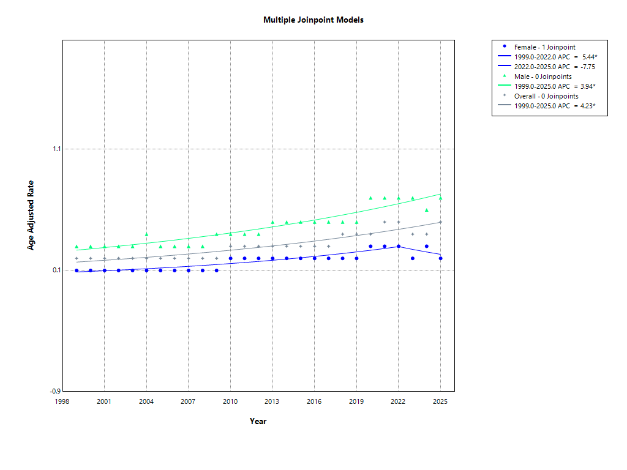

Supplementary Figure 1. Overall and Sex-Specific Trends in Age-Adjusted Mortality Rates, 1999–2025
Joinpoint regression analysis of annual age-adjusted mortality rates for deaths involving head or neck injuries with respiratory failure, overall and stratified by sex, from 1999 to 2025. Points represent observed annual age-adjusted mortality rates, and lines represent fitted Joinpoint trends. Men had consistently higher mortality rates than women throughout the study period. Asterisks indicate annual percent changes significantly different from zero. The 2025 data were considered provisional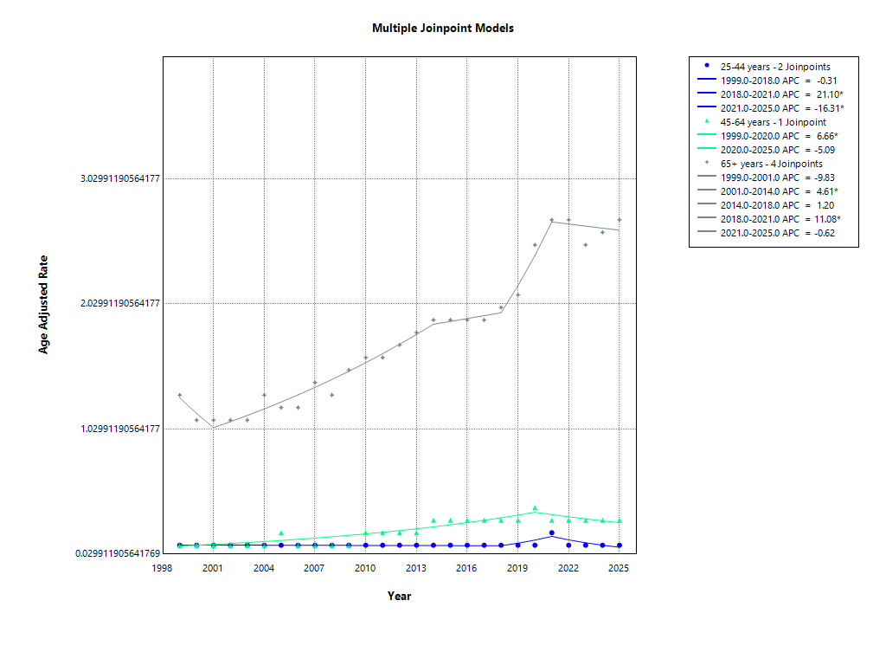

Supplementary Figure 2. Age-Specific Trends in Age-Adjusted Mortality Rates, 1999–2025
Joinpoint regression analysis of annual age-adjusted mortality rates for deaths involving head or neck injuries with respiratory failure, stratified by age group, from 1999 to 2025. Points represent observed annual age-adjusted mortality rates, and lines represent fitted Joinpoint trends. Adults aged 65 years or older had the highest mortality rates across the study period, with lower rates observed among younger adult age groups. Asterisks indicate annual percent changes significantly different from zero.
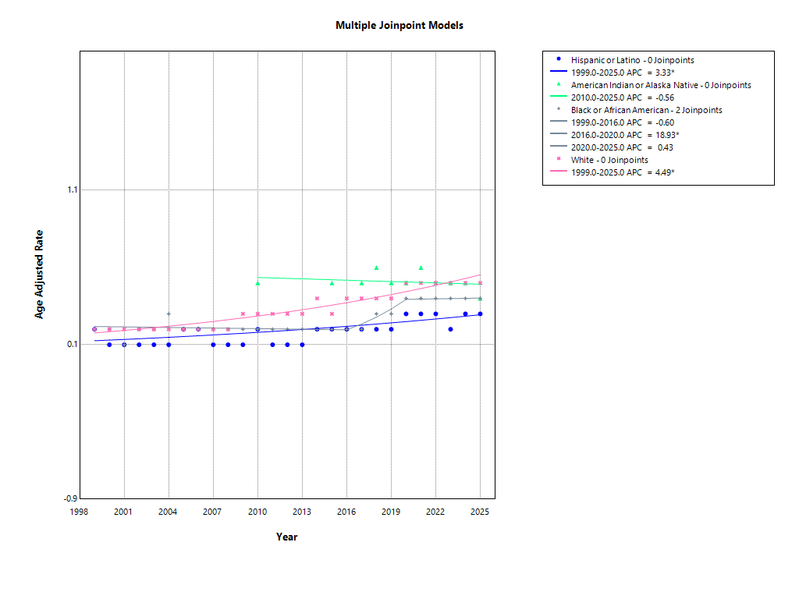

Supplementary Figure 3. Race- and Ethnicity-Specific Trends in Age-Adjusted Mortality Rates, 1999–2025
Joinpoint regression analysis of annual age-adjusted mortality rates for deaths involving head or neck injuries with respiratory failure, stratified by race and ethnicity, from 1999 to 2025. Points represent observed annual age-adjusted mortality rates, and lines represent fitted Joinpoint trends. White individuals generally had the highest mortality rates, whereas Hispanic or Latino individuals had the lowest rates. Data for American Indian or Alaska Native individuals were available beginning in 2010. Asterisks indicate annual percent changes significantly different from zero.

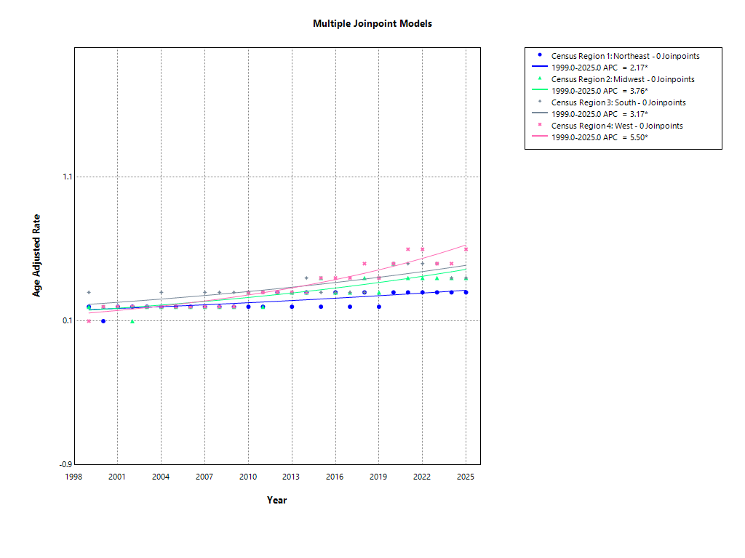

Supplementary Figure 4. Census Region-Specific Trends in Age-Adjusted Mortality Rates, 1999–2025
Joinpoint regression analysis of annual age-adjusted mortality rates for deaths involving head or neck injuries with respiratory failure, stratified by U.S. census region, from 1999 to 2025. Points represent observed annual age-adjusted mortality rates, and lines represent fitted Joinpoint trends. Mortality rates increased across all census regions during the study period, with higher rates generally observed in the West and South. Asterisks indicate annual percent changes significantly different from zero.

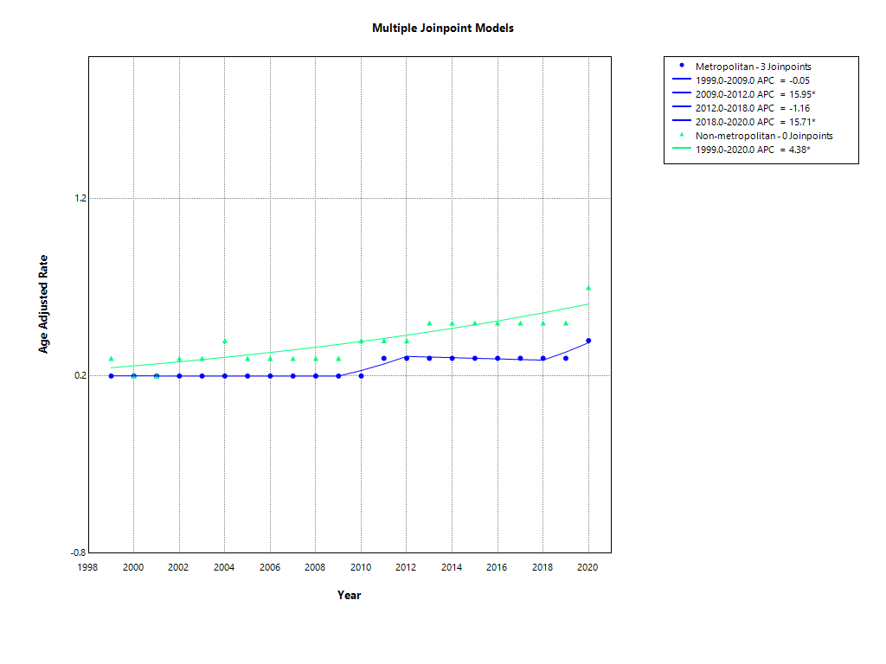

Supplementary Figure 5. Metropolitan and Nonmetropolitan Trends in Age-Adjusted Mortality Rates, 1999–2020
Joinpoint regression analysis of annual age-adjusted mortality rates for deaths involving head or neck injuries with respiratory failure, stratified by metropolitan status, from 1999 to 2020. Points represent observed annual age-adjusted mortality rates, and lines represent fitted Joinpoint trends. Nonmetropolitan areas had consistently higher mortality rates than metropolitan areas throughout the available study period. Asterisks indicate annual percent changes significantly different from zero. Metropolitan status data were available only through 2020.

