Supplementary Material
Clinical and genetic spectrum of pediatric primary immunodeficiency diseases at King Fahad Medical City in Saudi Arabia: a tertiary care centre-based study
Lubna Alhamad et al. 2026

Contents
Supplementary Figures
Figure S1. Top 15 most frequently identified gene defects
Figure S2. Overall prevalence of clinical manifestations
Figure S3. Diagnostic delay, distribution and by classification
Figure S4. Co-occurrence matrix of clinical manifestations
Figure S5. Age at symptom onset versus age at diagnosis
Figure S6. Treatment patterns by PID classification
Figure S7. Patient outcomes by PID classification
Figure S8. Mortality by PID classification
Figure S9. Clinical pathway from classification through HSCT to outcome
Supplementary Tables
Table S1. Full spectrum of specific PID diagnoses grouped by IUIS classification.
Table S2.Detailed prevalence of clinical manifestations
Table S3. Genetic testing status
Table S4. Overall treatment patterns
Table S5. Univariable and multivariable logistic regression for mortality

Supplementary Figures
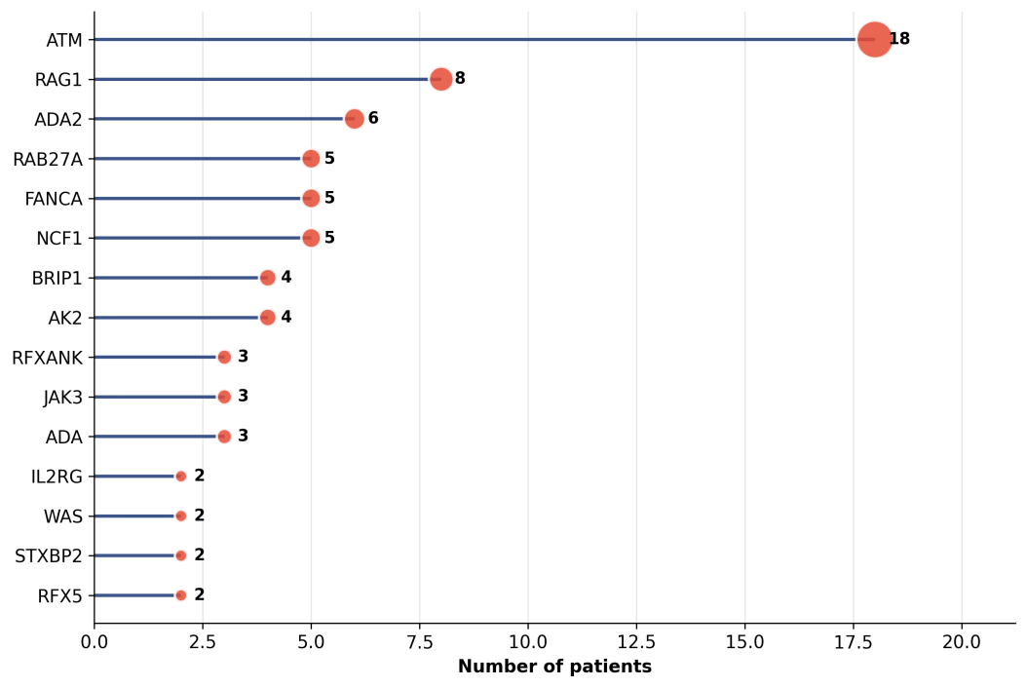
Figure S1. Top 15 most frequently identified gene defects among the 109 patients with a confirmed genetic diagnosis. Dot size is proportional to the number of patients carrying each gene.

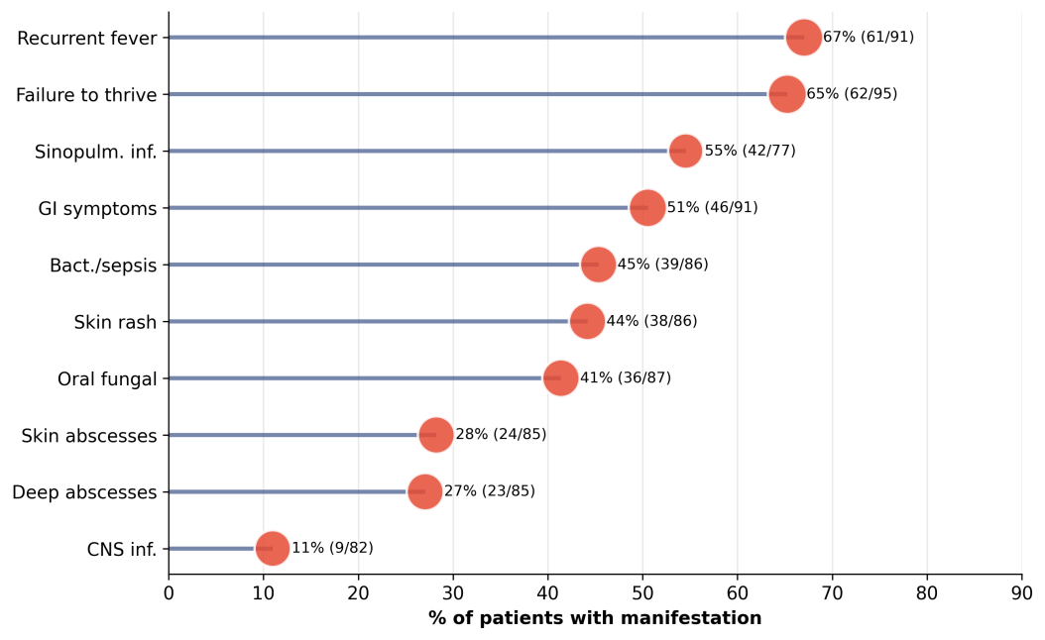
Figure S2. Overall prevalence of clinical manifestations. Each row shows the percentage of patients positive for the manifestation, with counts and denominators to the right. Dot size encodes the number of patients with available data.

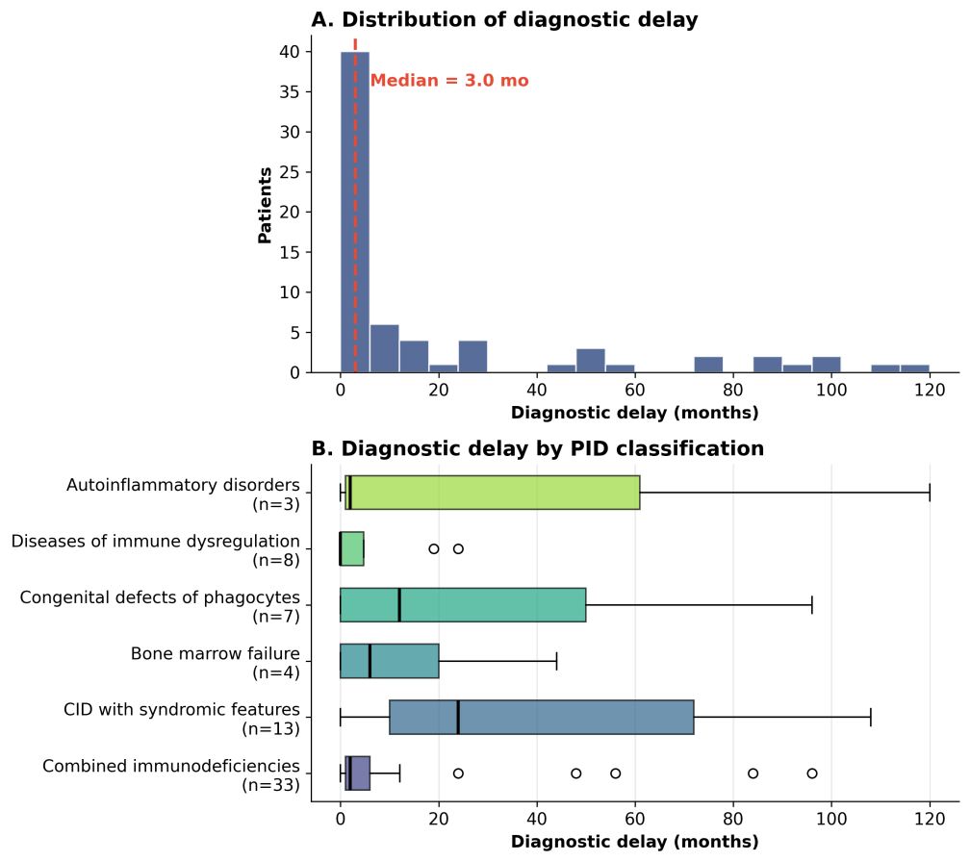
Figure S3. Diagnostic delay. Panel A shows the distribution of the interval between symptom onset and diagnosis among patients with derivable data. Panel B shows delay by IUIS classification. Differences across classifications were not statistically significant.

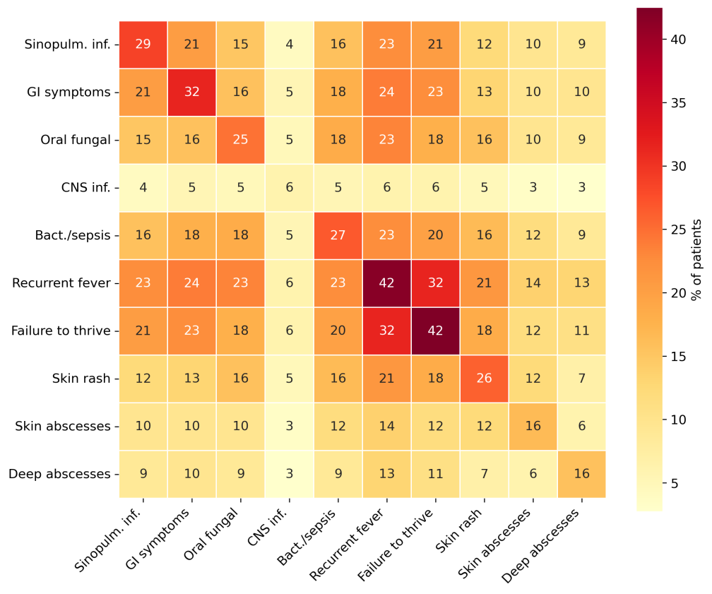
Figure S4. Co-occurrence matrix of clinical manifestations. Each cell shows the percentage of patients with complete manifestation data who had both the row and column manifestations. Diagonal cells show single-manifestation prevalence.

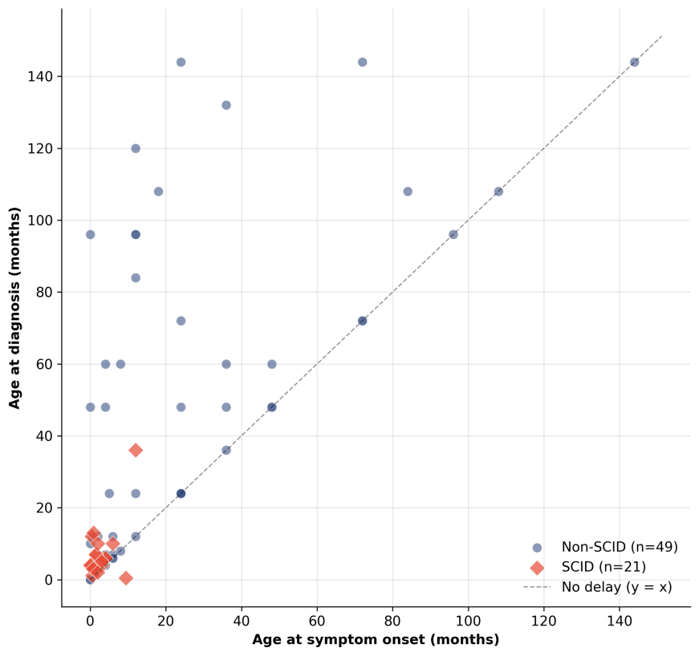
Figure S5. Age at symptom onset versus age at diagnosis. SCID patients, shown as red diamonds, cluster near the origin, reflecting early onset and short diagnostic delay. The dashed line represents equality, and points above it indicate delayed diagnosis.

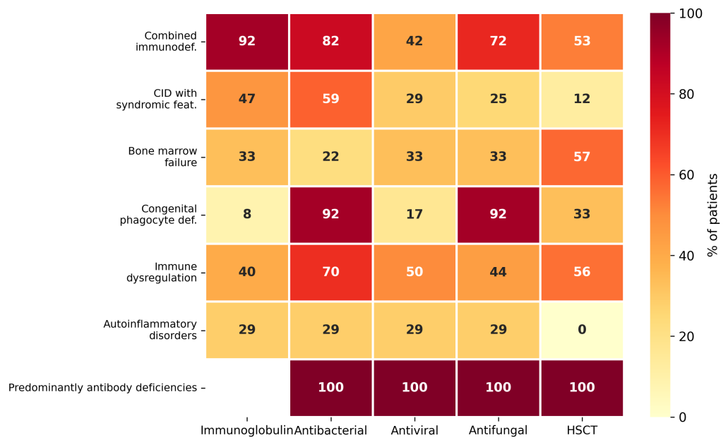
Figure S6. Treatment patterns by IUIS classification. Cells show the percentage of patients in each classification receiving each treatment, among those with available data.

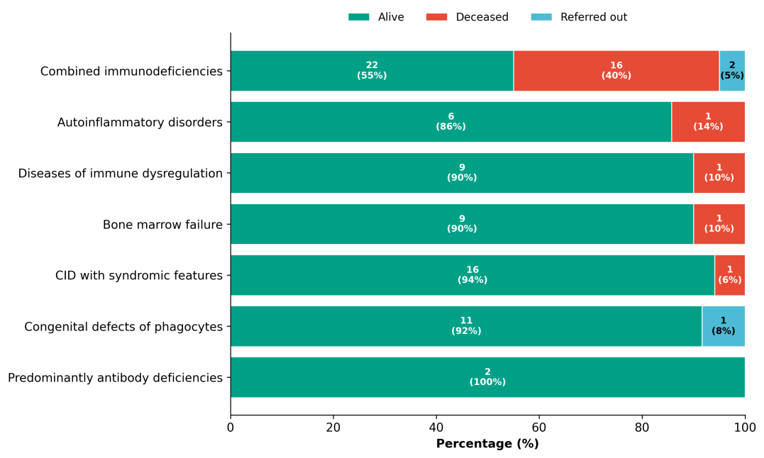
Figure S7. Patient outcomes by IUIS classification. Horizontal stacked bars show the proportion and absolute count of patients who were alive, deceased, or referred out across categories, ordered by mortality.

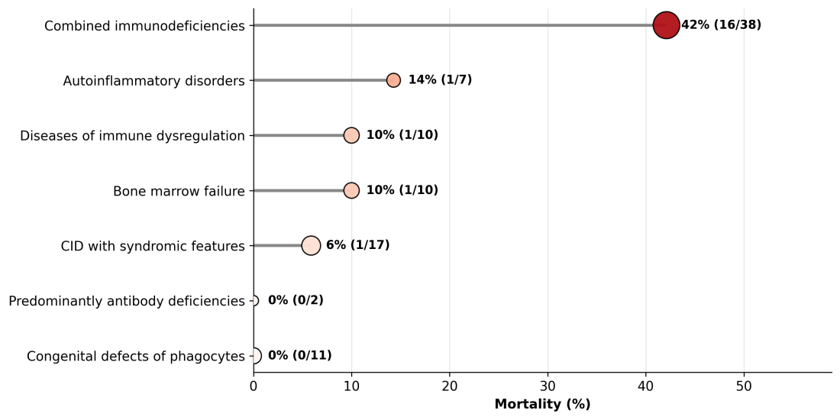
Figure S8. Mortality by IUIS classification. Dot position shows the mortality percentage, dot size is proportional to the number of patients with a documented outcome, and colour darkens with increasing mortality.

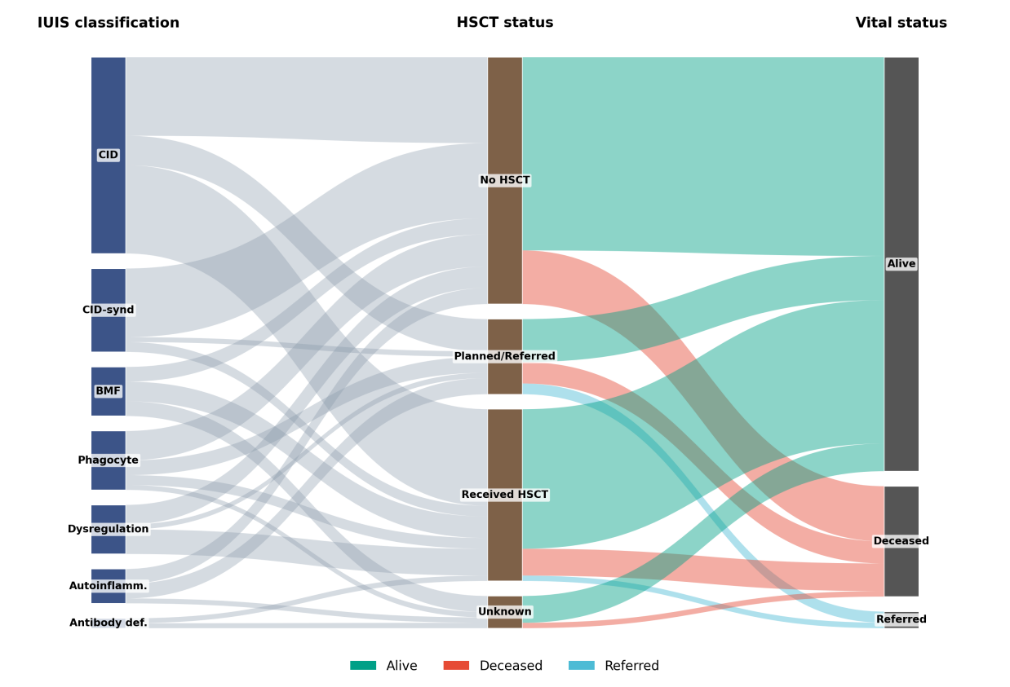
Figure S9. Clinical pathway from IUIS classification, through transplantation status, to final vital status. Flows are coloured by outcome. HSCT, hematopoietic stem cell transplantation.

Supplementary Tables
Table S1. Full spectrum of specific PID diagnoses grouped by IUIS classification.
PID group (diagnosis) | IUIS classification | N
SCID or Omenn syndrome | Combined immunodeficiencies | 31
Ataxia-telangiectasia | CID with syndromic features | 21
Fanconi anaemia | Bone marrow failure | 16
Chronic granulomatous disease | Congenital defects of phagocytes | 15
Bare lymphocyte syndrome | Combined immunodeficiencies | 14
Griscelli syndrome type 2 | Diseases of immune dysregulation | 7
ADA2 deficiency | Autoinflammatory disorders | 4
HLH | Diseases of immune dysregulation | 2
Chediak-Higashi syndrome | Diseases of immune dysregulation | 2
Wiskott-Aldrich syndrome | CID with syndromic features | 2
Antibody deficiency | Predominantly antibody deficiencies | 6
Hereditary angioedema | Complement deficiencies | 1
DOCK8 deficiency | Combined immunodeficiencies | 1
Other single cases | Various | 22
Diagnoses are grouped by canonical name after standardisation of free-text entries. Other single cases includes IPEX, MSMD, and various single-case syndromic forms.

Table S2. Detailed prevalence of clinical manifestations.
Manifestation | n (Yes) | N (with data) | %
Recurrent fever | 61 | 91 | 67.0
Failure to thrive | 62 | 95 | 65.3
Recurrent sinopulmonary infections | 42 | 77 | 54.5
GI symptoms or chronic diarrhoea | 46 | 91 | 50.5
Bacteraemia or sepsis | 39 | 86 | 45.3
Skin rash | 38 | 86 | 44.2
Oral fungal infection | 36 | 87 | 41.4
Skin abscesses | 24 | 85 | 28.2
Deep-seated abscesses | 23 | 85 | 27.1
CNS infection | 9 | 82 | 11.0
Manifestations are ordered by descending prevalence. Denominators vary because some records were incomplete, and a question mark entry was treated as missing.

Table S3. Genetic testing status in the cohort.
Genetic status | n | % of cohort
Causative gene identified | 109 | 74.7
Genetic testing negative | 3 | 2.1
Not done, unavailable, or unknown | 34 | 23.3
Of the 37 patients without an identified gene, 3 had an explicitly negative result and 34 either had not been tested or had results that were not available to the registry.

Table S4. Overall treatment patterns.
Treatment | Yes, n | N (with data) | %
Immunoglobulin replacement | 55 | 96 | 57.3
Antibacterial prophylaxis | 67 | 97 | 69.1
Antiviral prophylaxis | 34 | 95 | 35.8
Antifungal prophylaxis | 54 | 95 | 56.8
HSCT performed | 33 | 80 | 41.2
Percentages use patients with available treatment data as the denominator. HSCT, hematopoietic stem cell transplantation.

Table S5. Univariable and multivariable logistic regression for predictors of mortality.
Predictor | Univariable OR (95% CI) | p | Adjusted OR (95% CI) | p
Age (per year) | 0.83 (0.73-0.96) | 0.009 | 0.94 (0.79-1.12) | 0.474
Male sex | 0.80 (0.30-2.14) | 0.653 | 1.13 (0.34-3.76) | 0.846
SCID diagnosis | 11.14 (3.64-34.11) | <0.001 | 7.55 (1.55-36.72) | 0.012
Combined immunodef. (any) | 10.00 (3.01-33.27) | <0.001 | — | —
Consanguinity | 1.26 (0.43-3.65) | 0.671 | 0.59 (0.15-2.42) | 0.468
Gene identified | 0.57 (0.20-1.63) | 0.293 | — | —
CNS infection | 8.22 (1.77-38.17) | 0.007 | 2.58 (0.42-16.04) | 0.308
Bacteraemia or sepsis | 2.94 (1.07-8.09) | 0.037 | 0.63 (0.13-3.01) | 0.561
Failure to thrive | 4.98 (1.35-18.38) | 0.016 | 3.38 (0.74-15.41) | 0.116
Recurrent sinopulm. infections | 2.78 (1.01-7.62) | 0.047 | — | —
Oral fungal infection | 3.52 (1.27-9.76) | 0.016 | — | —
GI symptoms | 3.66 (1.27-10.56) | 0.017 | — | —
Immunoglobulin replacement | 11.38 (2.47-52.49) | 0.002 | — | —
HSCT performed | 0.65 (0.21-2.00) | 0.456 | — | —
The model was fitted to the 97 patients with a documented outcome, with 20 deaths. The multivariable model included age, sex, SCID status, consanguinity, bacteraemia or sepsis, failure to thrive, and CNS infection. Bold rows denote significant univariable predictors. aOR, adjusted odds ratio. CI, confidence interval. OR, odds ratio.

