Supplementary Material

Supplementary Methods
Group Music and Imagery Intervention Protocol
Group music and imagery (GrpMI) is an adaptation of GrpGIM (Dort, 2015; Grocke, 2019). Summer (2002) summarized GrpMI’s core characteristics across several domains. Thematically, GrpMI addresses a focused spectrum of shared personal issues. The evoked imagery tends to be structured and linear, facilitating verbal description and discussion within the group. The therapeutic process is interactive, interpersonal, and oriented toward the “here and now.” The music selections used in GrpMI, compared to the classical music applied in individual guided music and imagery, are typically less complex, shorter in duration, and more contained in structure.
The experimental group received 8 weekly 90-minute sessions of GrpMI over 8 weeks. A therapy session comprised both a warm-up phase and a Group music and imagery (GrpMI) phase. The warm-up phase, typically lasting 20 minutes, was facilitated by the therapist. It primarily employed recreational music therapy methods, which included activities like music-body percussion, music and dance movement, and improvisational singing or instrumental play. The primary objectives of the warm-up were twofold: first, to activate participants' physical, emotional, and psychological engagement through direct musical experience; and second, to foster trust, acceptance, and empathy​ among group members through non-verbal musical interaction. This process was designed to establish a secure therapeutic rapport and prepare the group for the subsequent GrpMI session.
The core imagery component followed a structured procedure. First, the therapist led a brief relaxation/induction, followed by the play of a music program selected by the therapist. Concurrent with the music, the therapist provided verbal guidance for approximately 10 minutes, offering a semi-structured framework for participants to explore their inner feelings and thoughts related to the chosen theme. Following the guided imagery, participants were invited to engage in mandala drawing for about 15 minutes to further process their experiences while the music continued to play in the background. After the drawing activity concluded and the music ended, the therapist facilitated a post-imagery group discussion for approximately 30 minutes. During this crucial processing phase, group members shared and reflected upon their imagery experiences and their connections to relevant personal life experiences.
The GrpMI session formally began with a preliminary conversation lasting about 20 minutes to establish a focus for the group imagery. In the group discussion, participants were encouraged to share recent life events, their current emotional and mental state on the day of the session, and any other significant topics they wished to bring to the group. The therapist actively facilitated this process, helping members identify and synthesize common themes emerging from their discussion. These collective themes typically fell into two categories: positive themes (e.g., support from family or friends, personal life goals, inner strength, coping strategies) and ​negative themes (e.g., anxiety stemming from life changes, feelings of loneliness, hopes or fears about the future, a sense of meaninglessness). At the conclusion of the discussion, the therapist and group members collaboratively selected one of these themes to serve as the focal point for that session's imagery experience. At the initial stage of the therapeutic program, therapists often suggested positive themes and employed music imagery on a supportive level. This aimed to cultivate a sense of trust and safety within the group while helping members build internal resources and interpersonal support. In later sessions, the therapist was more inclined to follow the group's emergent, "here-and-now" themes to facilitate deeper emotional awareness, expression, and acceptance.
​
Emotional n-back Task Protocol
The emotional working memory task was adapted from the emotional n-back paradigm developed for the Adolescent Brain Cognitive Development (ABCD) Study (Cohen et al., 2016). Facial stimuli consisted of grayscale images of human faces displaying emotional and neutral expressions. Emotional face stimuli were selected from the RADIATE (Racially Diverse Affective Expression) stimulus set (Conley et al., 2018), supplemented by images from the NimStim set of facial expressions (Tottenham et al., 2009). All images were standardized for luminance and contrast and presented at a resolution of 225 × 300 pixels. These stimulus sets have been widely used in large-scale developmental and affective neuroscience studies and provide validated emotional expressions across diverse racial and ethnic backgrounds.

Prior to the formal session, participants were instructed to complete the 0-back and 2-back conditions of the emotional n-back task using E-prime software to ensure task comprehension. For the present study, we focused exclusively on the 2-back trials, as the 0-back condition is relatively simple and the 2-back condition imposes a moderate cognitive load. During each 2-back trial, a single face stimulus was presented centrally on the screen, and participants were guided to indicate whether the current stimulus matched the stimulus presented two trials earlier, irrespective of emotional expression. The task followed a block design, with blocks containing emotional or neutral face stimuli presented in a pseudo-randomized order. Each block consisted of a fixed number of trials, including both target and non-target trials, consistent with the ABCD emotional n-back protocol. Each stimulus was presented for approximately 2000 ms, followed by a brief inter-stimulus interval during which a white fixation cross was displayed. Participants responded via button press during stimulus presentation. Behavioral performance was evaluated using mean accuracy and response time for correct trials across all emotional conditions, and was analyzed separately for each emotional valence. Given that subclinical depression is associated with negative cognitive bias (Everaert et al., 2014; Ferguson et al., 2025; Li et al., 2017), we specifically examined the changes in reaction time and accuracy for negative facial stimuli before and after the intervention.
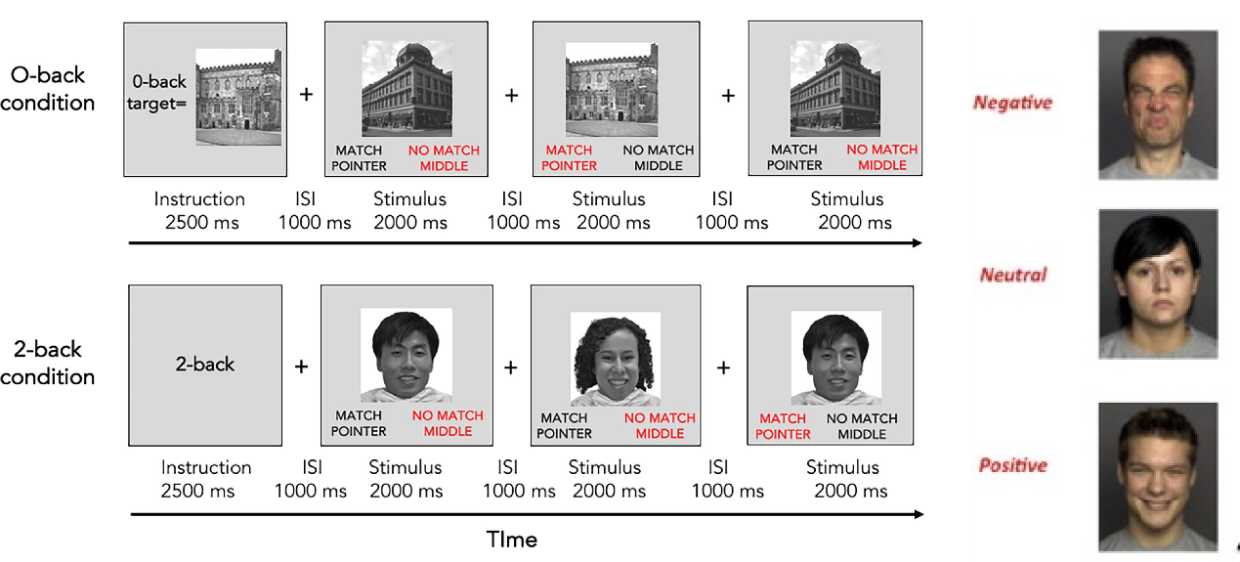
Figure S1. An illustration of the Emotional n-back task. This task includes positive-, neutral-, negative- faces conditions. The inter-stimulus interval is presented with a white fixation cross in the present study. ISI = inter-stimulus interval.

Structural MRI Preprocessing
Using a GE Discovery MR750 3T MRI scanner with an 8-channel head coil, high-resolution T1-weighted structural images were acquired for automated segmentation purpose using the following parameters: TR = 2530 ms, TE = 2.98 ms, voxel size = 1 × 1 × 1 mm³, matrix size = 256 × 256, flip angle = 12°, and 192 slices.

The automated segmentation of hippocampal subregions was based on the shared module for hippocampus parcellation. This tool uses a probabilistic atlas built with ultra-high resolution ex vivo MRI data (~0.1 mm isotropic) to produce an automated segmentation of the hippocampal substructures. It subdivides the hippocampal substructures into head and body, where applicable. The code also generates an additional set of segmentations of each hemisphere at different levels of hierarchy (i.e., with merged labels). More specifically, it generates three additional sets of volumes with the following suffixes: HBT (head/body/tail), FS60, and CA, with this freesurfer command: segment_subregions hippo-amygdala --cross sub-xxx, as implemented in DPABISurf. Segmentations without a hierarchy include all the (relevant) labels in the atlas. The way in which labels are merged in each of the three volumes is summarized in the following table:
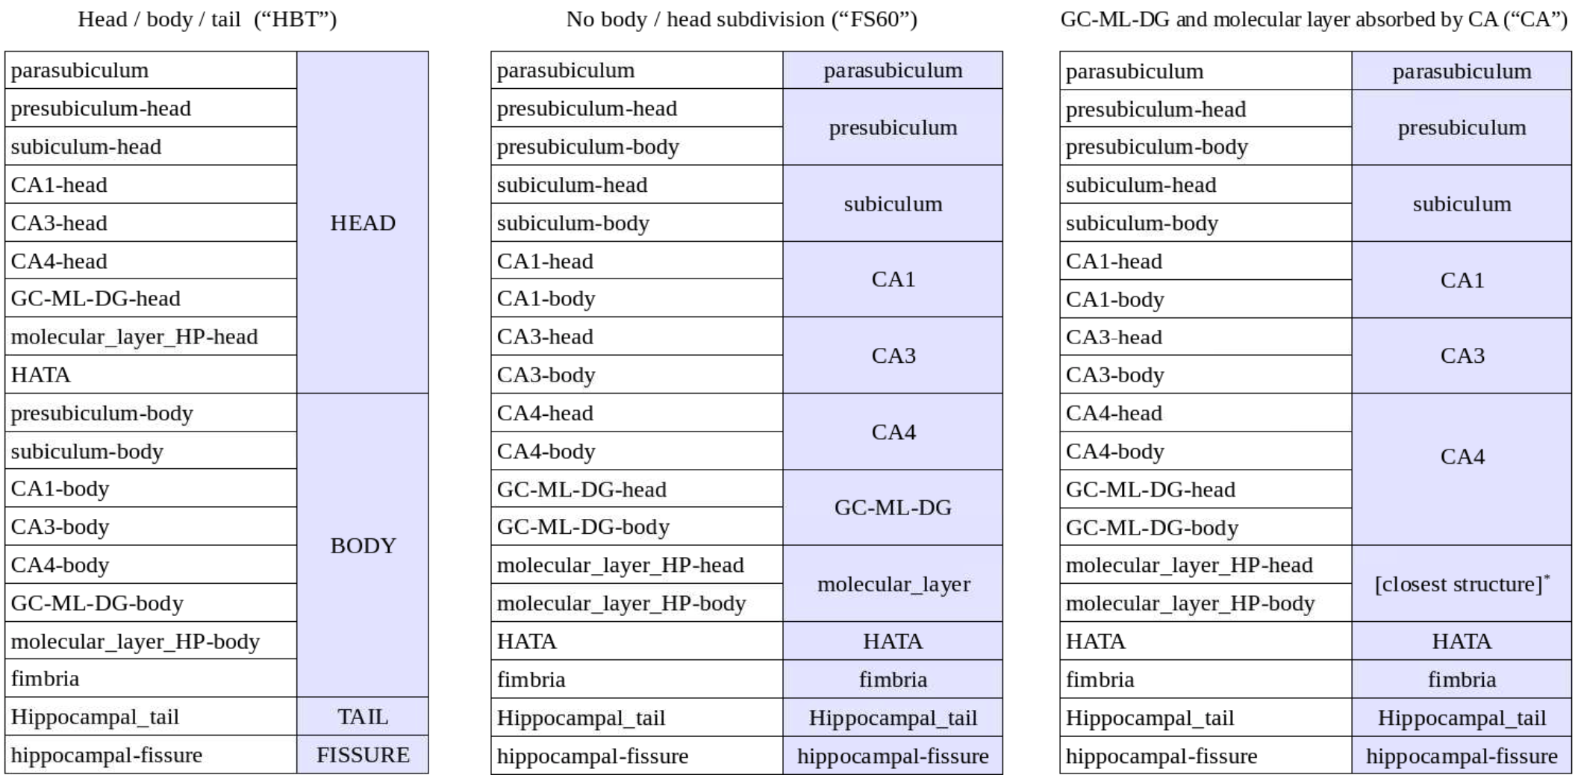
Figure S2. Hippocapal subfield parcellation labels demonstrated for freesurfer automated segmentation.

Secondary Outcomes
Secondary outcomes were evaluated using a diverse and comprehensive list of validated self-report instruments assessing psychological, cognitive, and functional well-being aspects. All measures were administered at baseline (T1) and post-interventions (T2 and T3).

Depressive symptoms were evaluated by two complementary self-report scales to ensure reliable results. The Center for Epidemiologic Studies Depression Scale (CES-D) was applied to measure depressive moods and somatic symptoms in the past week. Additionally, the Beck Depression Inventory (BDI) was also employed to assess depression severity, with 21 items each rated on a 4-point scale. The Patient Health Questionnaire (PHQ-9) was an additional self-reported questionnaire to quickly capture depressive symptoms. Consistent with DSM-5 criteria, higher scores represent greater symptom severity.

Anxiety symptoms were assessed with the Hamilton Anxiety Rating Scale (HAMA) and Generalized Anxiety Disorder scale (GAD). The HAMA-14, also a clinician-rated instrument, was used to evaluate both psychic and somatic anxiety severity. The GAD-7 was administered as a brief self-report measure to identify the severity of generalized anxiety symptoms over the past two weeks, with score thresholds of 5, 10, and 15 representing mild, moderate, and severe anxiety, respectively.

Supplementary Results
Baseline characteristics of completers and dropouts are detailed in Table S1. Attrition analyses revealed no significant differences between the two cohorts regarding baseline depressive severity (p = .75), demographic profiles (Age: p = .57; Education: p = .66), or baseline hippocampal volumes (Left: p = .74; Right: p = .83) and intracranial volume (p = .66). Notably, dropouts exhibited significantly lower baseline working memory accuracy on the 2-back task compared to completers (0.83 vs. 0.90, p = .02). This pattern may indicate that participants with lower baseline cognitive capacity experienced greater task burden, leading to higher attrition.
For self-report questionnaires, most scales revealed no significant baseline differences across groups (p > .05) at T1, except for GSES on which intervention group participants reported significantly higher self-efficacy scores, see Table S2. This observation warrants careful interpretation of the self-efficacy improvements addressed later.
Table S1
Baseline Characteristics of Completers versus Dropouts (Attrition Analysis)
Variable | Completers | Dropouts | Test Statistic | P
Demographics
Age (years) | 26.9 (3.6) | 27.5 (3.2) | 0.58 | .57
Sex (%) | 82.1% Female | 91.7% Female | — | .66
Education (years) | 17.5 (2.5) | 17.9 (2.4) | 0.45 | .66
Estimated Intracranial Volume (mm³) | 1450280 (144520) | 1464604 (146341) | 0.45 | .66
Clinical & Cognitive Baseline
HAMD-17 | 11.28 (2.70) | 11.00 (2.60) | 0.32 | .75
2-back Accuracy | 0.90 (0.08) | 0.83 (0.08) | 2.52 | .02*
2-back Response Time (ms) | 878.3 (110.8) | 872.7 (157.8) | 0.14 | .91
Neuroimaging Baseline
Left Hippocampus Volume (mm³) | 3566.0 (311.3) | 3530.0 (392.5) | 0.62 | .55
Right Hippocampus Volume (mm³) | 3645.3 (318.2) | 3604.0 (422.6) | 0.31 | .76
Note. Values are presented as Mean ± Standard Deviation with two sample Welch t test statistic, except sex distribution, calculated as percentages and assessed by Fischer’s test. For clinical, cognitive, and demographic variables, sample sizes are Completers (n = 39) and Dropouts (n = 13). For neuroimaging variables, sample sizes are Completers (n = 38) and Dropouts (n = 14). *p < 0.05
Table S2.
Baseline Self-Report Questionnaires of the Intervention and Waitlist Control Groups Pre-treatment T1
Questionnaires | Intervention | Waitlist | df | Test Statistics | P value
HAMD-17 | 11.16 (2.62) | 11.32 (2.49) | 49 | 0.25 | .80
HAMA-14 | 10.92 (4.10) | 12.23 (4.69) | 49 | 1.07 | .29
GAD-7 | 10.62 (3.94) | 9.16 (3.91) | 49 | 1.32 | .19
PHQ-9 | 13.38 (2.82) | 12.32 (2.39) | 49 | 1.45 | .15
BDI | 20.27 (5.82) | 18.04 (5.29) | 47 | 1.39 | .17
CES-D | 26.96 (6.76) | 24.74 (7.98) | 47 | 1.06 | .30
Note. Values are presented as Mean ± Standard Deviation with two sample t test statistics. For HAMA-14, PHQ-9, GAD-7, the sample sizes are Intervention (n = 26) and waitlist cohort (n = 25). For BDI and CES-D, the sample sizes are Intervention (n = 26) and waitlist cohort (n = 23). For RRS, the sample sizes are Intervention (n = 17) and waitlist cohort (n = 23). For the remaining three scales, the sample sizes are Intervention (n = 23) and waitlist cohort (n = 23). *p < 0.05

Secondary Outcomes RCT
Linear mixed-effects modeling of secondary affective scales (Figures S3) provided robust, multi-informant validation of the primary clinical findings in the manuscript. Consistent with the HAMD-17 results, the GrpMI intervention yielded highly significant Group × Time interactions across all secondary measures of depression (BDI, CES-D, PHQ-9; all p ≤ 0.013) and anxiety (HAMA-14, GAD-7; all p ≤ 0.017), see Table S3.
Specifically, post-hoc analysis of the estimated marginal means demonstrated that participants in the intervention group exhibited statistically significant reductions in both depressive and anxious symptomatology from baseline to post-intervention. In contrast, the waitlist control group displayed modest nonsignificant declining trajectories. This convergence across diverse clinician-administered and self-reported psychometric instruments strongly corroborates the emotion-regulatory efficacy of the GrpMI intervention in ameliorating comorbid subclinical symptoms.

Table S3.
Linear Mixed-Effects Model Results for Secondary Clinical Outcomes (Group × Time Interactions)
Measure | F-statistic | Num df | Denom df | P-value | $$η_{p}^{2}$$
HAMD-17 | 7.32 | 1 | 44.07 | .01 | 0.14
BDI | 13.16 | 1 | 37.40 | .008 | 0.26
CES-D | 12.12 | 1 | 40.30 | .001 | 0.23
PHQ-9 | 6.35 | 1 | 43.72 | .015 | 0.13
HAMA-14 | 6.65 | 1 | 43.86 | .013 | 0.13
GAD-7 | 8.75 | 1 | 39.83 | .005 | 0.18
Note. $df$ = Satterthwaite-approximated degrees of freedom. Num = Numerator. Denom = Denominator. $η_{p}^{2}$ = partial eta-squared, representing the proportion of variance explained by the interaction.

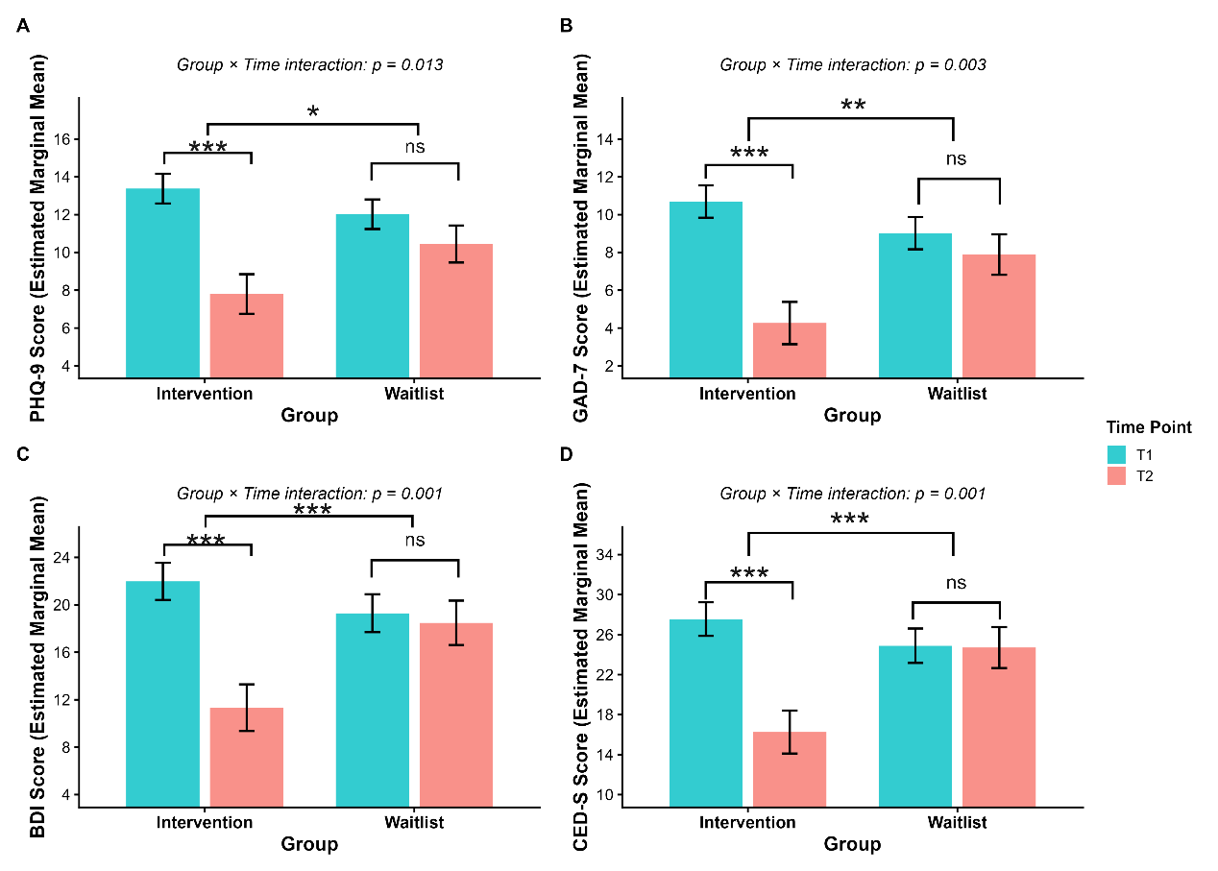
Figure S3. Group differences in self-reported secondary scales across time. Bar plots illustrate the estimated marginal mean scores of the secondary scales for the intervention and waitlist control groups at baseline (T1, red) and post-intervention/observation (T2, blue). Error bars represent standard errors. *p < .05, **p < 0.01, ***p < .001.

Secondary Outcomes Pooled Analysis
Exploratory pooled analyses of secondary psychological constructs (Table S4) suggested improvements after GrpMI across several affective and cognitive-emotional domains. Despite reduced sample sizes due to questionnaire attrition, participants who received GrpMI showed reductions in rumination (Cohen's d = 0.84) and increases in general self-efficacy (Cohen's d = 0.60), in addition to improvements in depressive and anxiety symptoms. Sleep quality and trait mindfulness did not change significantly. These findings are consistent with the hypothesis that GrpMI may engage cognitive-emotional regulation processes, but they should not be interpreted as definitive mechanistic evidence.

Table S4
Exploratory Pooled Within-Subject Analyses of Secondary Psychological Constructs (Pre- vs. Post-Intervention)
Measure | Mean Change | Standard Deviation | Test statistic | df | P value | Cohen’s d
HAMA-14 | -5.06 | 5.14 | 5.57 | 31 | < .001*** | 0.98
GAD-7 | -3.87 | 4.83 | 3.85 | 22 | <.001*** | 0.80
PHQ-9 | -3.64 | 5.31 | 3.21 | 22 | .004** | 0.69
BDI | -8.74 | 9.12 | 4.60 | 22 | <.001*** | 0.96
CES-D | -9.60 | 9.61 | 4.80 | 22 | <.001*** | 0.99
RRS-CV | -0.36 | 0.43 | 3.33 | 15 | .004** | 0.84
GSES | 0.27 | 0.45 | 2.62 | 18 | .017* | 0.60
PSQI | -0.68 | 2.71 | 1.10 | 18 | .286 | 0.25
MAAS | 0.95 | 7.28 | 0.57 | 18 | .576 | 0.13
Note. Mean change represents the mean difference from pre-intervention to post-intervention. Negative values for HAMA, RRS, and PSQI indicate symptom reduction (improvement). Positive values for GSES and MAAS indicate score increases (improvement). *p < .05. **p < .01. ***p < .001.

Exploratory Mediation and Cross-Modal Correlation Analyses
To explore whether the intervention's effect on depressive symptoms was mediated by changes in left hippocampal volume, we conducted a bootstrap mediation analysis (5,000 iterations) using the mediation package in R (Tingley et al., 2014). The mediation model tested the indirect pathway: Group ΔLHV (T2 − T1) ΔHAMD (T2 − T1), using completers with available MRI data.

Path a (Group ΔLHV): The intervention group showed significantly greater left hippocampal volume change compared to the waitlist group (b = 81.32, SE = 30.38, p = .012), consistent with the primary LMM results.
Path b (ΔLHV → ΔHAMD, controlling for Group): Left hippocampal volume change was not significantly associated with HAMD change after controlling for group assignment (b = 0.001, SE = 0.007, p = .867).
Direct effect (c'): The direct effect of group on HAMD change, controlling for ΔLHV, approached significance (b = −2.74, SE = 1.35, p = .051).
Indirect effect (a × b): The bootstrap-estimated indirect effect was 0.10 (95% CI [−1.99, 0.78], p = .858), indicating that left hippocampal volume change did not significantly mediate the intervention's effect on depression severity.
Total effect: The total effect of group on HAMD change was significant (b = −2.64, 95% CI [−4.89, −0.35], p = .024), with the proportion mediated estimated at −3.7%.

Figure S4. The exploratory mediation of estimated causal paths.
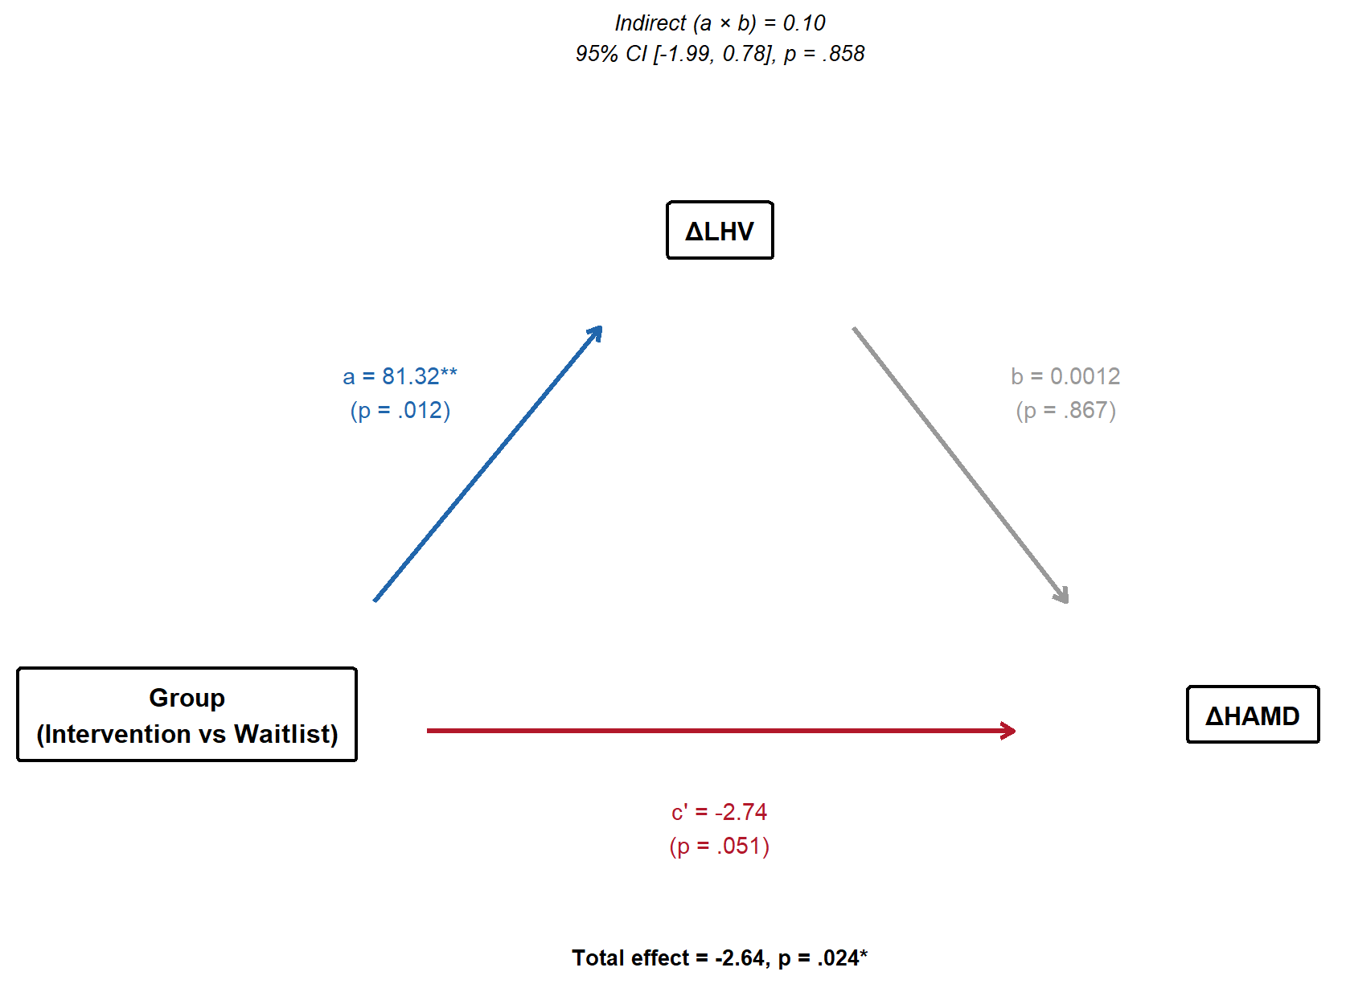

While the intervention significantly influenced both depressive symptoms and left hippocampal volume (paths a and c are significant), the hippocampal change did not statistically account for symptom improvement. Post-hoc power analysis indicated that the current sample (n = 18 in the intervention group) provided only 34% power to detect the observed correlation (r = −.37) between ΔHAMD and ΔLHV. A sample size of approximately 55 would be needed for 80% power at α = .05. Given these constraints, the absence of a significant indirect effect should be interpreted cautiously; the medium effect size (r = −.37) in the expected direction suggests a potential brain-symptom relationship that warrants investigation in larger samples.

To examine relationships among changes across clinical, cognitive, and structural modalities during the randomized phase, partial correlations controlling for group assignment were also computed. The only significant cross-modal association was between 2-back accuracy and response time improvements (r = .39, p = .02), reflecting coherent cognitive change, see Table S4. A marginal association between ΔLHV and ΔEBMrt (r = −.28, p = .07) suggested that greater left hippocampal volume increases were weakly linked to faster response times. For the pooled samples, no correlations reached statistical significance after controlling for cohort source (all p > .13), though the ΔHAMD–ΔLHV association (r = −.16, p = .436) maintained the same negative direction as the RCT-phase analysis, suggesting a consistent trend where greater left hippocampal preservation/growth was associated with more symptom improvement. The ΔLHV–ΔEBMrt association (r = .30, p = .150) also showed directional consistency with the RCT phase.

Table S5
Partial Correlations Among Changes During the Randomized Phase (Controlling for Group)
Variable | 1 | 2 | 3 | 4 | 5
1. ΔHAMD | —
2. ΔAccuracy | -0.10 | —
3. ΔMean reaction time | 0.13 | 0.39* | —
4. ΔLHV | 0.03 | -0.03 | -0.28 | —
5. ΔRHV | -0.00 | -0.00 | -0.11 | -0.16 | —
Note. n = 34–37 (pairwise deletion). †p < .10. *p < .05. **p < .01.

Table S6
Partial Correlations Among Change Scores in the Pooled Sample (Controlling for Cohort Source)
Variable | 1 | 2 | 3 | 4 | 5
1. ΔHAMD | —
2. ΔAccuracy | 0.08 | —
3. ΔMean reaction time | 0.22 | 0.29 | —
4. ΔLHV | -0.16 | 0.10 | 0.30 | —
5. ΔRHV | 0.03 | 0.10 | -0.10 | 0.06 | —
Note. n = 26–28 (pairwise deletion). †p < .10. *p < .05. **p < .01.

Table S7
ChiCTR registered trial primary indicators sheet.
ChiCTR Primary indicators | Current analytic status | Disposition
① Core depressive/anxious symptom cluster (6 items)
HAMD-17 | Fully reported (Primary Outcome) | This report
HAMA-14 | Fully reported (Secondary Outcome) | This report
BDI | Fully reported (main text + Table S3) | This report
PHQ-9 | Fully reported (main text + Table S3) | This report
CES-D | Fully reported (main text + Table S3) | This report
GAD-7 | Fully reported (main text + Table S3) | This report
② Emotion regulation & psychological resources (14 items)
Regulatory Emotional Self-Efficacy Scale (RESE) | Not analyzed in this report | Future report
Ruminative Response Scale (RRS) + analysis of self-generated thoughts | Not analyzed in this report | Future report
Mindful Attention Awareness Scale (MAAS) | Not analyzed in this report | Future report
Toronto Mindfulness Scale (TMS) | Not analyzed in this report | Future report
Multidimensional Assessment of Interoceptive Awareness (MAIA) + interoception accuracy/sensitivity task | Not analyzed in this report | Future report
Toronto Alexithymia Scale (TAS) | Not analyzed in this report | Future report
Acceptance and Action Questionnaire (AAQ-II) | Not analyzed in this report | Future report
Comprehensive assessment of ACT (CompACT) | Not analyzed in this report | Future report
Cognitive Flexibility Questionnaire (CFQ) | Not analyzed in this report | Future report
Attention to Positive and Negative Information Scale (APNI) | Not analyzed in this report | Future report
Self-Compassion Scale | Not analyzed in this report | Future report
Self-Esteem Scale | Not analyzed in this report | Future report
General Self-Efficacy Scale (GSES) | Not analyzed in this report | Future report
CD-RISC10 | Not analyzed in this report | Future report
③ Interpersonal & existential well-being (6 items)
UCLA Loneliness Scale | Not analyzed in this report | Future report
Perceived Social Support Scale (PSSS) | Not analyzed in this report | Future report
Posttraumatic Growth Inventory (PTG) | Not analyzed in this report | Future report
Scale of Life Satisfaction | Not analyzed in this report | Future report
PERMA Profile | Not analyzed in this report | Future report
Pittsburgh Sleep Quality Index (PSQI) | Not analyzed in this report | Future report
④ Behavioral tasks (2 items)
Emotional N-back Task | Fully reported (Primary Outcome) | This report
Stop-signal task | Not analyzed in this report | Future report
⑤ Neuroimaging (4 items)
MRI scans (umbrella category) | Covered by specific modalities below | N/A
Structural MRI scan | Fully reported (Primary Outcome) | This report
Resting-state fMRI scans | Not analyzed in this report | Future report
Diffusion tensor imaging (DTI) | Not analyzed in this report | Future report
⑥ Wearable device data (4 items)
Wearable device PPG | Outside scope of this report | Separate team
Motor activity (ACC/GYRO) | Outside scope of this report | Separate team
Sleep quality (sleep time) | Outside scope of this report | Separate team
Self generated thoughts | Outside scope of this report | Separate team
⑦ Diagnostic screening instrument (1 item)
Clinical interview (MINI) | Used for baseline diagnostic screening | Not a outcome
Note. All 37 indicators listed above are shown with their current analytic status in this report and their disposition. Prepared in accordance with CONSORT 2025 items.

Reference
Cohen, A., Conley, M., Dellarco, D., & Casey, B. (2016). The impact of emotional cues on short-term and long-term memory during adolescence. Proceedings of the Society for Neuroscience.
Conley, M. I., Dellarco, D. V., Rubien-Thomas, E., Cohen, A. O., Cervera, A., Tottenham, N., & Casey, B. J. (2018). The racially diverse affective expression (RADIATE) face stimulus set. Psychiatry Research, 270, 1059–1067. https://doi.org/10.1016/j.psychres.2018.04.066
Dort, C. V. (2015). Music-based mindfulness: Group sessions with adults who have substance addictions. In D. Grocke & T. Moe (Eds.), Guided imagery and music (GIM) and music imagery methods for individua l and group therapy (pp. 221–230). Jessica Kingsley Publishers.
Everaert, J., Duyck, W., & Koster, E. H. (2014). Attention, interpretation, and memory biases in subclinical depression: a proof-of-principle test of the combined cognitive biases hypothesis. Emotion, 14(2), 331–340. https://doi.org/10.1037/a0035250
Ferguson, L. A., Harikumar, A., & Leal, S. L. (2025). Subclinical depressive symptoms and job stress differentially impact memory in working and retired older adults. Sci Rep, 15(1), 3163. https://doi.org/10.1038/s41598-025-87333-9
Grocke, D. E. (2019). Group guided imagery and music (GIM) and group music and imagery (MI): A review of literature. In Guided imagery and music: The Bonny method and beyond (pp. 267–288). Barcelona Publishers.
Li, H., Wei, D., Sun, J., Zhang, Q., & Qiu, J. (2017). Fronto-Limbic Alterations in Negatively Biased Attention in Young Adults with Subthreshold Depression. Front Psychol, 8, 1354. https://doi.org/10.3389/fpsyg.2017.01354
Tingley, D., Yamamoto, T., Hirose, K., Keele, L., & Imai, K. (2014). mediation: R Package for Causal Mediation Analysis. Journal of Statistical Software, 59(5), 1 – 38. https://doi.org/10.18637/jss.v059.i05
Tottenham, N., Tanaka, J. W., Leon, A. C., McCarry, T., Nurse, M., Hare, T. A., Marcus, D. J., Westerlund, A., Casey, B. J., & Nelson, C. (2009). The NimStim set of facial expressions: Judgments from untrained research participants. Psychiatry Research, 168(3), 242–249. https://doi.org/https://doi.org/10.1016/j.psychres.2008.05.006

